

American International University-Bangladesh (AIUB)  
**Department of Computer Science  
Faculty of Science &Technology (FST)  
Fall 20_21**

**Section: J  
Group No: 03**

**TOUR GUIDER SYSTEM**

A software Engineering project submitted

By

|  |  |  |
| --- | --- | --- |
| Serial No. | Student Name | Student ID |
| 02 | HOSSAN, MD. FARHAD | 18-37878-2 |
| 04 | SHIMUL, MD. MAZHARUL ISLAM | 18-37938-2 |
| 05 | MASUD, FARHAN | 18-37960-2 |
| 16 | ZINNATUN, NISSA | 18-38838-3 |

The project will be Evaluated for the following Course Outcomes

|  |  |
| --- | --- |
| Requirements Analysis (functional, quality, and project requirements) [5Marks] | **Total Marks** |
| System Design (UML, UI/UX design) [5Marks] |  |
| Test and Project Management Planning [5Marks] |
| Submission, Completeness, Spelling, Grammar and Organization [5Marks] |

# PRODUCT AND PROJECT DESCRIPTION

## System Features

1. **Choosing the Best Route**

**Functional Requirements**

* 1. The software will provide the best possible route for journey according to the selected destination of the users.
  2. If users select their destination the software will provide the best possible route with the assist of an API called Google Map.

**Priority Level:** High

**Precondition:** User need to provide the destination.

**Cross-references:**

1. **Finding Ideal Hotel**

**Functional Requirements**

* 1. The software will allow the users to find ideal hotel in their selected destination. Google Map, API will be used to perform this operation.
  2. If users select a destination then they will need to go to the Ideal Hotel option.
  3. If the user selects Ideal Hotel option a window will appear and show the information from database records and location from the Google Map of those hotels which will be available in selected destination.

**Priority Level:** Medium

**Precondition:** User need to provide destination.

**Cross-references:**

1. **Nearest Transportation**

**Functional Requirements**

* 1. The software will allow the user to find the nearest Bus stations, Airports, Railways from the current location of the user.
  2. User have to turn on the GPS and then select Nearest Transportations.
  3. Then with the help of Google Map, API the locations of nearest Bus Stations, Airports, Railways will be displayed on the screen.

**Priority Level:** High

**Precondition:** User must turn-on the GPS in the using device.

**Cross-references:**

1. **Weather Update**

**Functional Requirements**

* 1. The software will provide weather update to the user according to the destination and particular time by using an API named Global Weather.
  2. User need to go in Weather Update then select the destination. Particular time session can be given otherwise this feature will show the up-to date weather information.
  3. After providing destination and time to the software this feature will give the weather news of that particular area in a particular time period.

**Priority Level:** High

**Precondition:** User must provide the area.

**Cross-references:**

1. **Create Event**

**Functional Requirements**

* 1. The software will allow the user to create event and give a name of the event.
  2. User will need to enter Create Event. The user will need to provide a name for the event.
  3. By performing the tasks of aforementioned options event will be created.
  4. Event creator will be able to handle the privacy of that event by selecting Event Privacy. User can make the event closed or public from there.
  5. User will be able to set the time frame for the event from the option Set Event Time.
  6. User will be able to approve or cancel the join request of that event as there will be a Join Request window available with option Confirm and Cancel. Join Request option will be found in under the Event Name.
  7. There will be an Event Member List where all of the joined members will be found.
  8. All of the information of the event such as event time, event name, members who will join the event will be stored in the database.
  9. User can delete an existing event by going on Event History. Then find the event name. After that, click Delete.

**Priority Level:** High

**Precondition:** Null

**Cross-references:** 6.1, 6.2

1. **Make Your Groups**

**Functional Requirements**

* 1. The software will allow the user to make groups among the joined event members.
  2. User can find other from the Event Member List of Create Event. From there user can make groups among them.
  3. When user will be making a group with others, a notification will be sent to those whom the user wanted to be joined in the group.
  4. Only if those members accept the request then they will be added in the group. The record will be stored in the database.
  5. User can control the admin panel by go to Settings of the particular feature.
  6. Admin will be able give permission to join or remove anyone from the group.
  7. Members of the group will be able share their thought by using another feature Chatting.

**Priority Level:** High

**Precondition:** Member need to be joined in the particular event.

**Cross-references:** 5.7, 5.8, 7.1, 7.2

1. **Chatting**

**Functional Requirements**

* 1. The software will allow the userto chat with other members of the group in personal or in the group by selecting Chatting.
  2. From there the user can find others who are already added in the group. From database this feature will provide the members who are in the group.
  3. User will be able text others, give voice message, send reply of a particular message, share links, send photos, short videos of length not exceeding the size 25MB. For performing those tasks all of the icons of those sub-features will be on the top of the chat bar.
  4. Besides those the user will be able to mute someone, mute groups, leave groups, creates poll, send emoji, give reply to a particular message with an emoji. These tasks will be performed by selecting those particular sub features and those features will be available in that window.
  5. The user will be able make audio calls and video calls with in personal or in a group. To perform this task user will need to find the member or members and then from Phone Call icons from top of the chat bar can make calls.
  6. User will be able to Delete a conversation. To perform this task user will need to select the member, whom with the user chatted. Then from there the user will find a sub-window. From there the user can find that option to delete the conversation.

**Priority Level:** High

**Precondition:** Members need to be present in the group.

**Cross-references:** 6.4

1. **Writing Vlogs**

**Functional Requirements**

* 1. The software will allow the user to write vlogs in particular topics. By entering Writing Vlogs, the user will get a window form where the user can choose a template for writing vlogs.
  2. After choosing the template the user will be able start writing vlogs right way.
  3. The user can make the vlog public form the privacy settings of this particular feature.
  4. If any vlog is posted by the user other users will be able make comments in the comment section of that vlog.
  5. Other users will be able to give rating for that vlog from the option Rate this Vlogs.
  6. The user will be notified if any other users make comment or give rating in the vlogs.
  7. There will be an option of Share so that, the vlog can be shared in other mediums.

**Priority Level:** High

**Precondition:** Null

**Cross-references:** Null

1. **Gallery**

**Functional Requirements**

* 1. The software will allow the user to use gallery facility to store photos, videos and files.
  2. There will be an option Your Memories under the Gallery section.
  3. If the user wants to upload something then, there will be options from where the user wants to upload the files. User will need to select the files from his desired location.
  4. User will be able make folders in the gallery. User can name those folders. To performs these tasks user can go to Gallery, under the gallery user will find Create Folders. User can provide the folder names from there.
  5. After selecting files and the folders there will be an option Upload in the bottom of the window. If the user clicks it the files will be uploaded.
  6. The user will always be able to delete or add new files in the gallery as all the record and information will be stored in the database.

**Priority Level:** High

**Precondition:** Null

**Cross-references:** Null

1. **Log Out**

**Functional Requirements**

**10.1** The software will allow the user to exit the system by using Logout feature.

**10.2** The user will find Logout on top of every window, after once logged in.

**10.3** By clicking Logout the user will find another window.

**10.4** That window will come with two options Exit and Cancel with a message.

**10.5** If the user click cancel, the use user will be still logged in.

**10.6** If the user click exit, the user will be able to exit the system.

**Priority Level:** High

**Precondition:** User must be logged in, in the system.

**Cross-references:** This feature is connected with Log in feature.

## System Quality Attribute

**Availability:** The software will be available for 24/7. As the software will be using through internet, it will be very easy to perform any operations with the software from anywhere at any time, if not any inconvenient issue occurs.

**Priority Level:** High

**Performance:** Every web page of the software will be downloaded in 10 seconds or less over a 60 Kbps modem connection. So that, the user can get a smooth performance while using the software.

**Priority Level:** High

**Integrity**: The user will have the privilege of authentication if the user wants. Also, the software will ask for authentication if the user changes device. The personal information of one user will be protected because there will be access restrictions of others.

**Priority Level:** High

**Robustness:** The software will automatically exit the system or Logout, if the user has no involvement with the software in 10 minutes, because of avoiding being hacked. The softwarewill save data in every 10 seconds while the user will do any operations. So that, if the user got any inconvenient issue, the user can just start the same operations from where it left.

**Priority Level:** High

**Usability:** A trained user shall be able to submit a complete request for creating an event, deleting, confirming member in 2 minutes.

**Priority Level:** High

**Efficiency:** At least 30 percent of the processor capacity and RAM available to the application shall be unused at the planned peak load conditions. So that, the user can get instant responses form the software, if the number of users is high.

**Priority Level:** Medium

**Reliability:** The software will not fail no more than five experimental runs out of 1000.

**Priority Level:** Medium

**Maintainability:** A user can easily modify any information, if it is given wrong. But for modification, the user must go through security phases.

**Priority Level:** Medium

## Project Requirements

Since, we are developing this project using Scrum so, we will need a team of nine members. As, Scrum is in general Agile practice so, we will need open workplace environment so that, seamless project management can be practiced.

# SYSTEM DESIGN SPECIFICATION

## System Design

**Use Case Diagram**

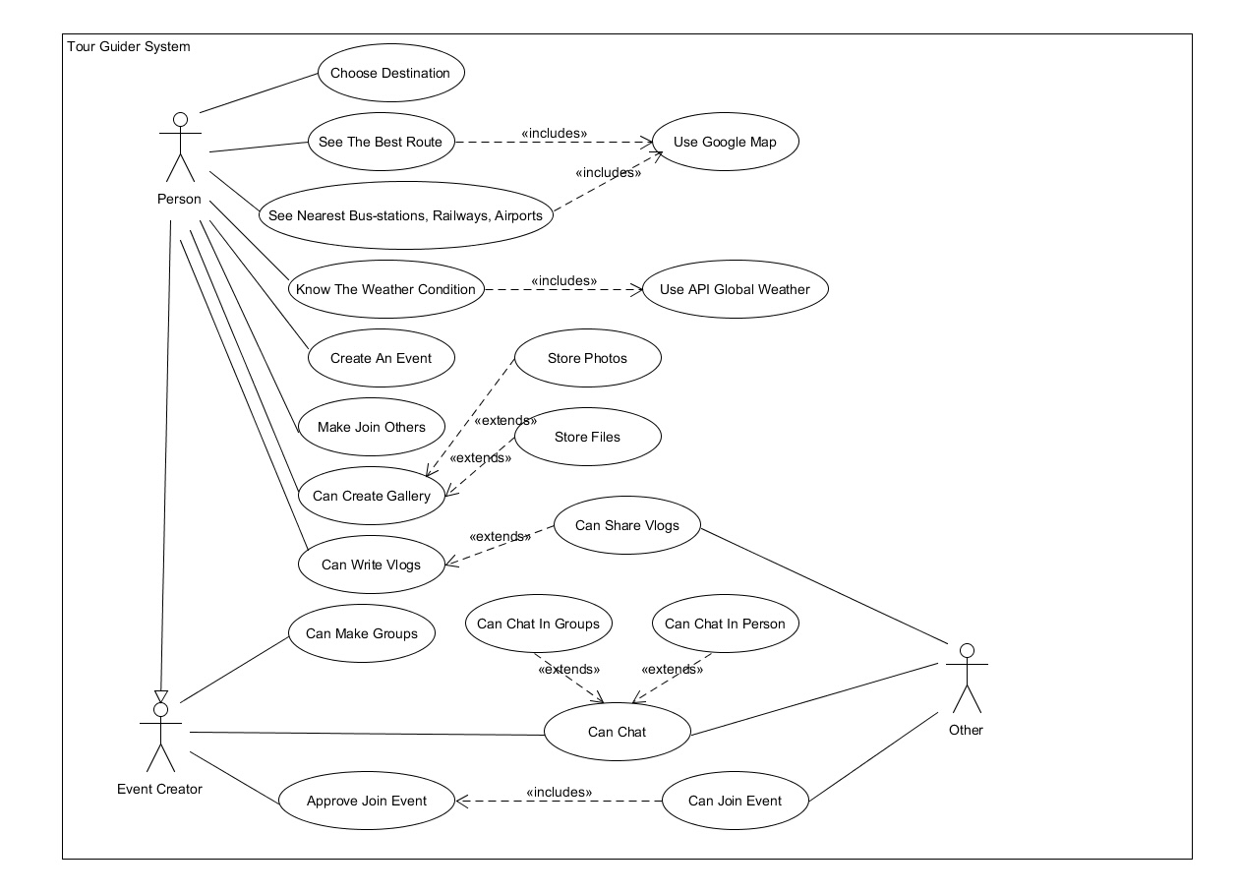

**Class Diagram**

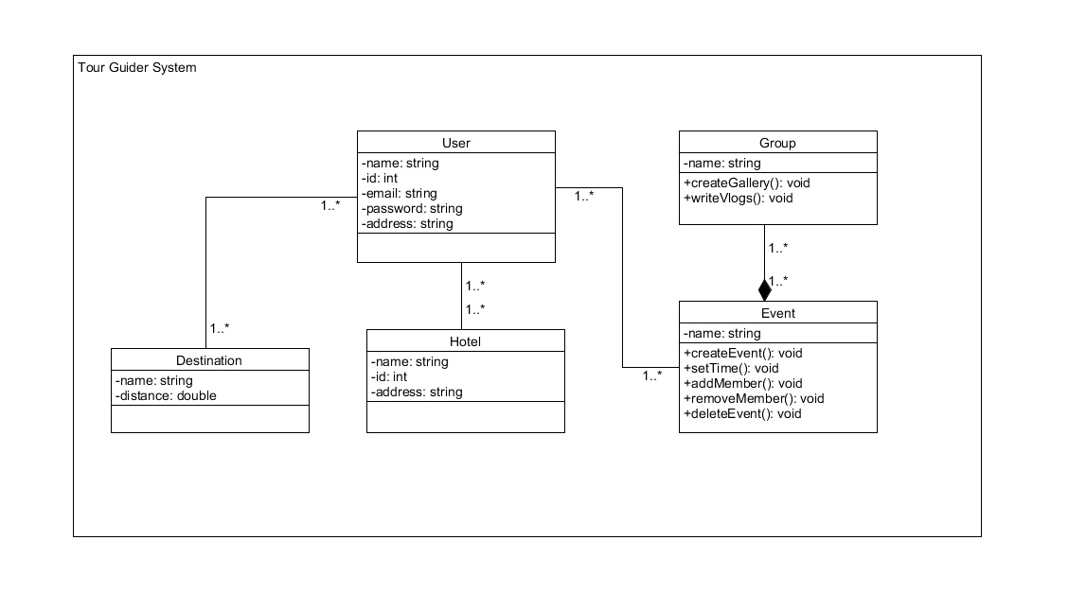

**Sequence Diagram**

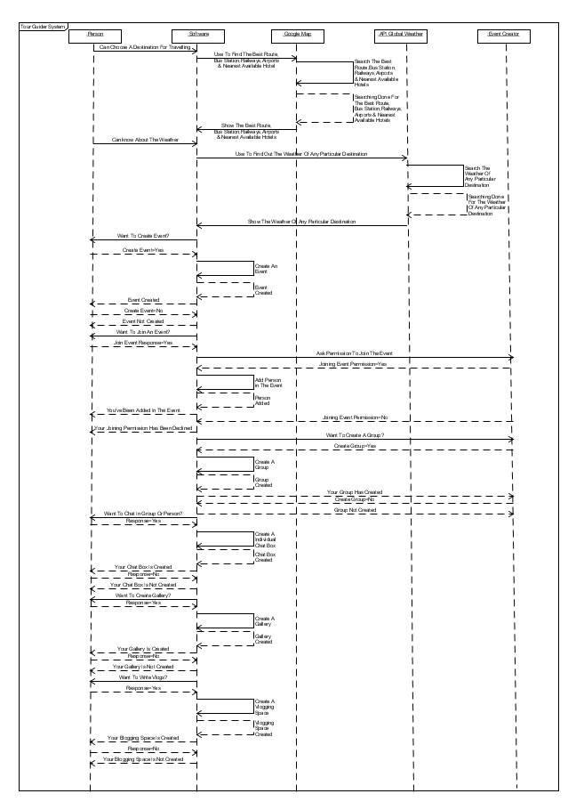

**Activity Diagram**

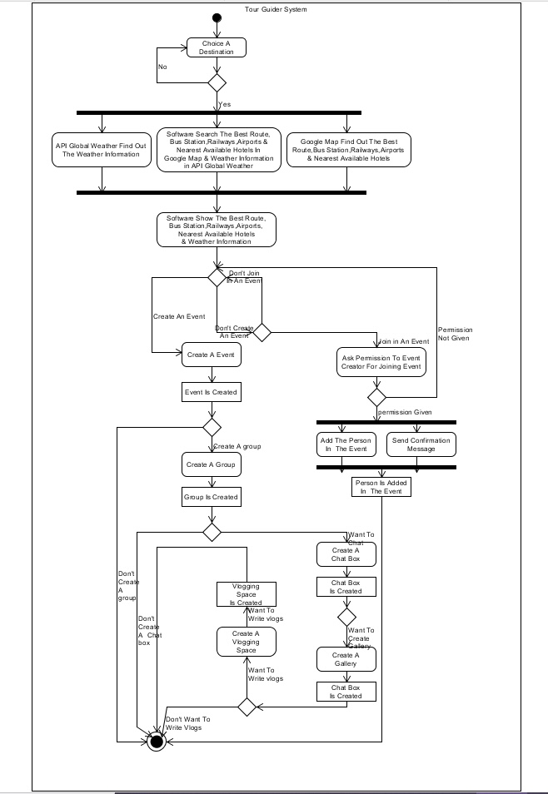

**ER Diagram**

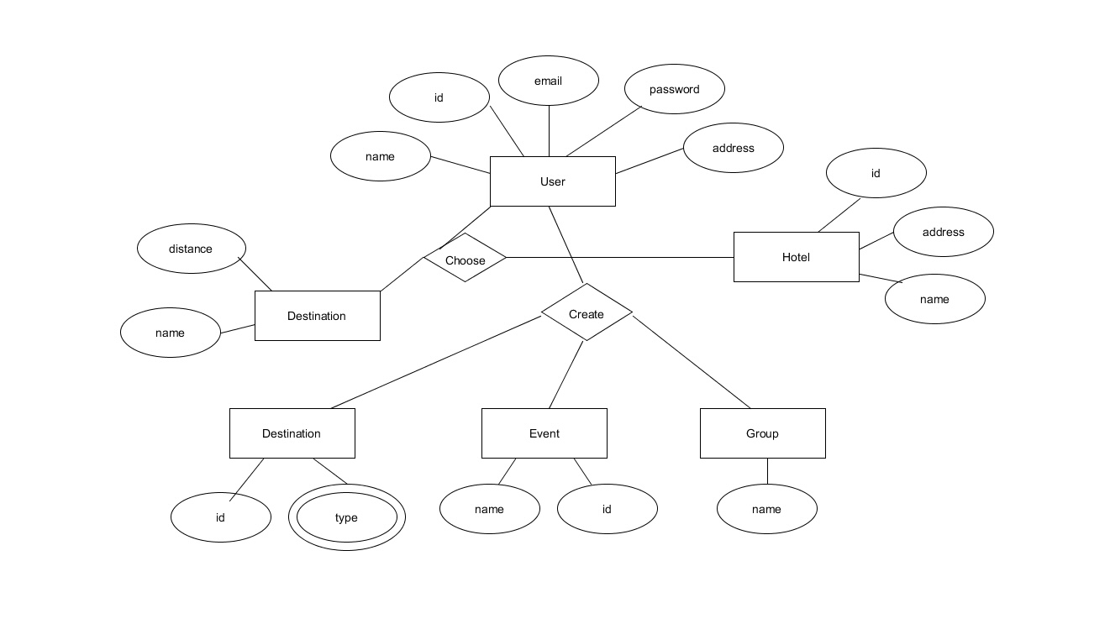

## UI/UX Design

**Interface Design**

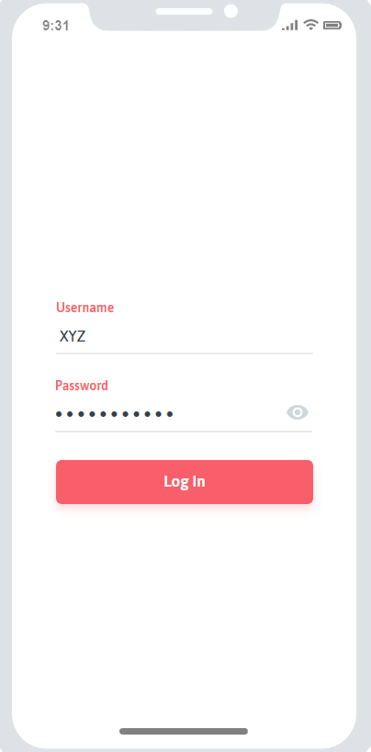 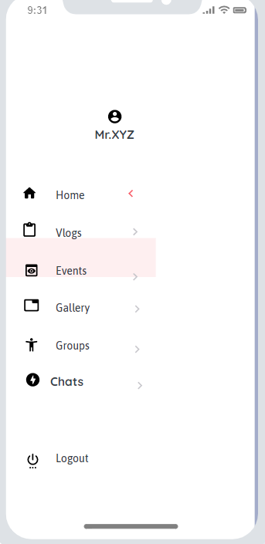

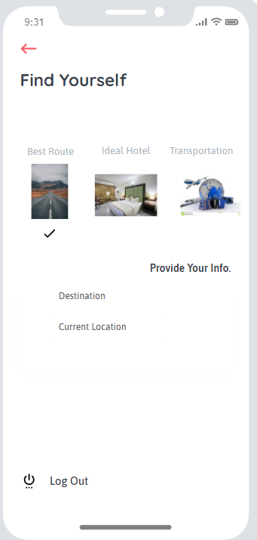 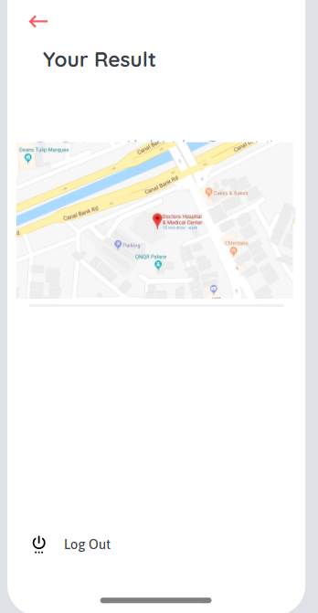

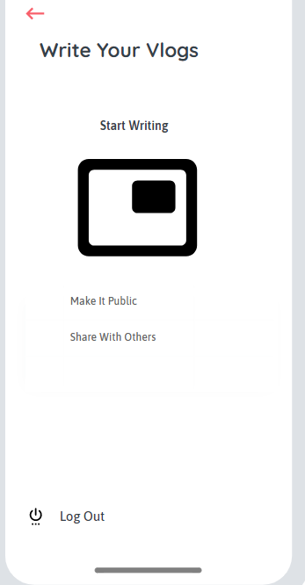 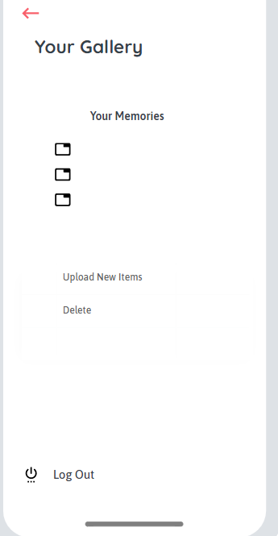

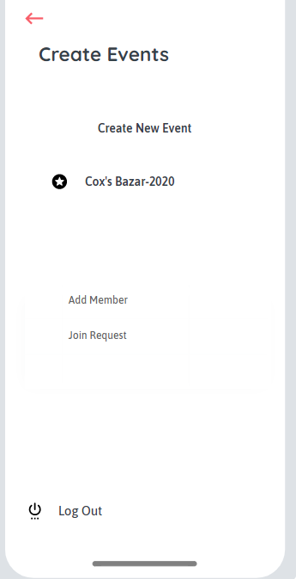 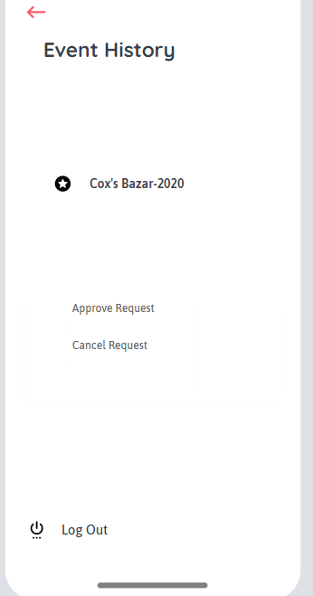

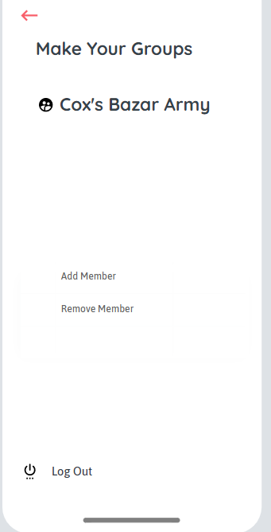

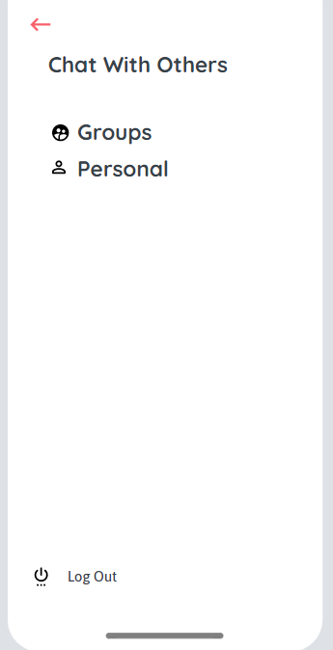

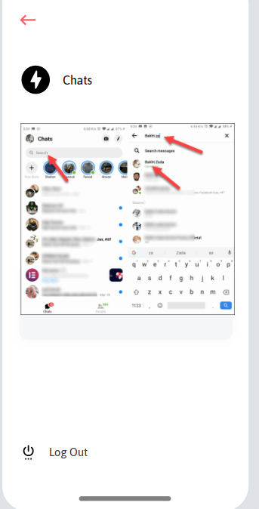

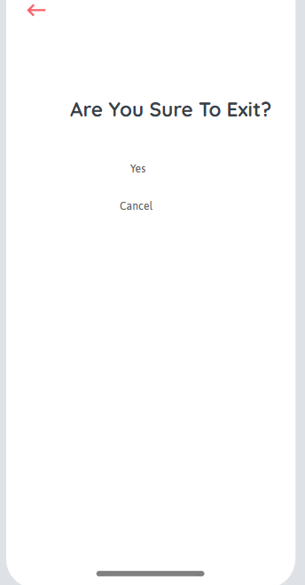

# SYSTEM TEST PLAN

**Test Plan for Functional Requirements:**

|  |  |  |  |  |  |
| --- | --- | --- | --- | --- | --- |
| Project Name: Tour Guider System | | | Test Designed by: Farhad | | |
| Test Case ID: FR_1 | | | Test Designed date: 15-12-20 | | |
| Test Priority (Low, Medium, High): High | | | Test Executed by: Farhad | | |
| Module Name: Choosing the Best Route | | | Test Execution date: 19-12-20 | | |
| Test Title: By providing destination, finding the best route from Google Map | | | | | |
| Description: Test the best route finding from Google Map | | | | | |
| Precondition (If any): User must provide the destination | | | | | |
| Test Steps | Test Data | Expected Results | | Actual Results | Status (Pass/Fail) |
| 1. Go to home 2. Enter Best route 3. Provide destination 4. Click the tik mark | The best route shown from Google Map | User should find the best route | | As expected, | Pass |
| Post Condition: User finds the best route for his destination from Google Map. | | | | | |

|  |  |  |  |  |  |
| --- | --- | --- | --- | --- | --- |
| Project Name: Tour Guider System | | | Test Designed by: Farhad | | |
| Test Case ID: FR_2 | | | Test Designed date: 15-12-20 | | |
| Test Priority (Low, Medium, High): Medium | | | Test Executed by: Farhad | | |
| Module Name: Finding Ideal Hotel | | | Test Execution date: 19-12-20 | | |
| Test Title: By providing destination, finding ideal hotel from Google Map | | | | | |
| Description: Test finding of ideal hotel in selected destination | | | | | |
| Precondition (If any): User need to provide the destination | | | | | |
| Test Steps | Test Data | Expected Results | | Actual Results | Status (Pass/Fail) |
| 1. Go to home 2. Enter Ideal Hotel 3. Provide location 4. Click the tik mark | Ideal hotel location  shown from Google Map in selected destination | User should find the ideal hotel location | | As expected, | Pass |
| Post Condition: User finds the ideal hotel location in selected destination. | | | | | |
| Project Name: Tour Guider System | | | Test Designed by: Farhad | | |
| Test Case ID: FR_3 | | | Test Designed date: 15-12-20 | | |
| Test Priority (Low, Medium, High): High | | | Test Executed by: Farhad | | |
| Module Name: Nearest Transportation | | | Test Execution date: 19-12-20 | | |
| Test Title: By providing current location, nearest transportation system will be shown from Google Map | | | | | |
| Description: Test the nearest transportation finding from Google Map | | | | | |
| Precondition (If any): User must turn on GPS in the device. | | | | | |
| Test Steps | Test Data | Expected Results | | Actual Results | Status (Pass/Fail) |
| 1. Go to home 2. Enter Transportation 3. Provide destination 4. Click the tik mark | The nearest transportation shown from Google Map | User should find the nearest transportation | | As expected, | Pass |
| Post Condition: User finds the nearest transportation from Google Map. | | | | | |

|  |  |  |  |  |  |
| --- | --- | --- | --- | --- | --- |
| Project Name: Tour Guider System | | | Test Designed by: Farhad | | |
| Test Case ID: FR_4 | | | Test Designed date: 15-12-20 | | |
| Test Priority (Low, Medium, High): High | | | Test Executed by: Farhad | | |
| Module Name: Weather Update | | | Test Execution date: 19-12-20 | | |
| Test Title: By providing destination, get the weather update of that destination. | | | | | |
| Description: Test the weather finding from Global Weather | | | | | |
| Precondition (If any): User need to provide the destination | | | | | |
| Test Steps | Test Data | Expected Results | | Actual Results | Status (Pass/Fail) |
| 1. Go to home 2. Enter Weather 3. Provide destination 4. Click the tik mark | Weather update shown from the Global Weather | User should get the weather update | | As expected, | Pass |
| Post Condition: User gets the weather update for the provided destination from Global Weather. | | | | | |

|  |  |  |  |  |  |
| --- | --- | --- | --- | --- | --- |
| Project Name: Tour Guider System | | | Test Designed by: Farhad | | |
| Test Case ID: FR_5 | | | Test Designed date: 15-12-20 | | |
| Test Priority (Low, Medium, High): High | | | Test Executed by: Farhad | | |
| Module Name: Create Event | | | Test Execution date: 19-12-20 | | |
| Test Title: User can create event where others can join. | | | | | |
| Description: Test the event creation and members interaction. | | | | | |
| Precondition (If any): | | | | | |
| Test Steps | Test Data | Expected Results | | Actual Results | Status (Pass/Fail) |
| 1. Go to Create Event 2. Give a name of the event. 3. Add members 4. Request approval 5. Cancelling Request | Event created with a name. Members are interacting in the event. User controlling the members. | User should create the event successfully and managing other members. | | As expected, | Pass |
| Post Condition: User creates the event and interact with other members and manage them. | | | | | |

|  |  |  |  |  |  |
| --- | --- | --- | --- | --- | --- |
| Project Name: Tour Guider System | | | Test Designed by: Farhad | | |
| Test Case ID: FR_6 | | | Test Designed date: 15-12-20 | | |
| Test Priority (Low, Medium, High): High | | | Test Executed by: Farhad | | |
| Module Name: Making Groups | | | Test Execution date: 19-12-20 | | |
| Test Title: User can make group among the event members. | | | | | |
| Description: Test the group the group creation among the event members | | | | | |
| Precondition (If any): Member need to joined in the particular event | | | | | |
| Test Steps | Test Data | Expected Results | | Actual Results | Status (Pass/Fail) |
| 1. Go to Make Groups 2. Add members 3. Request approval 4. Cancelling Request | Group created with event members. Members are interacting in the group. | User should create the group successfully and managing other members. | | As expected, | Pass |
| Post Condition: User creates the group and interact with other members. | | | | | |

|  |  |  |  |  |  |
| --- | --- | --- | --- | --- | --- |
| Project Name: Tour Guider System | | | Test Designed by: Farhad | | |
| Test Case ID: FR_7 | | | Test Designed date: 15-12-20 | | |
| Test Priority (Low, Medium, High): High | | | Test Executed by: Farhad | | |
| Module Name: Chatting | | | Test Execution date: 19-12-20 | | |
| Test Title: User can make chat with group members in personal or in group. | | | | | |
| Description: Test the user can chat with other group members in personal and in groups | | | | | |
| Precondition (If any): Member need to be present in the group | | | | | |
| Test Steps | Test Data | Expected Results | | Actual Results | Status (Pass/Fail) |
| 1. Go to Chatting 2. Choose person or group 3. Make calls and do other operations of messenger. 4. Add members 5. Request approval 6. Cancelling Request | Chatting with others in personal or in group and can make all messenger operations. | User should chat with others in personal or in group. | | As expected, | Pass |
| Post Condition: User chats with other group members in personal or in group. | | | | | |

|  |  |  |  |  |  |
| --- | --- | --- | --- | --- | --- |
| Project Name: Tour Guider System | | | Test Designed by: Farhad | | |
| Test Case ID: FR_8 | | | Test Designed date: 15-12-20 | | |
| Test Priority (Low, Medium, High): High | | | Test Executed by: Farhad | | |
| Module Name: Writing Vlogs | | | Test Execution date: 19-12-20 | | |
| Test Title: User can write vlogs | | | | | |
| Description: Test the user can write vlogs | | | | | |
| Precondition (If any): | | | | | |
| Test Steps | Test Data | Expected Results | | Actual Results | Status (Pass/Fail) |
| 1. Go to Vlogs 2. Write vlogs 3. Can make the vlog public 4. Share with others | Writing vlogs and control privacy as well as sharing with others. | User should write a vlog and control privacy also able to share it with others. | | As expected, | Pass |
| Post Condition: User writes the vlog with privacy control and sharing with others. | | | | | |

|  |  |  |  |  |  |
| --- | --- | --- | --- | --- | --- |
| Project Name: Tour Guider System | | | Test Designed by: Farhad | | |
| Test Case ID: FR_9 | | | Test Designed date: 15-12-20 | | |
| Test Priority (Low, Medium, High): High | | | Test Executed by: Farhad | | |
| Module Name: Gallery | | | Test Execution date: 19-12-20 | | |
| Test Title: User can make gallery and upload files | | | | | |
| Description: Test the files are uploading in the gallery | | | | | |
| Precondition (If any): | | | | | |
| Test Steps | Test Data | Expected Results | | Actual Results | Status (Pass/Fail) |
| 1. Go to Gallery 2. Make folders and upload files 3. Can choose location of files 4. Add new files 5. Delete Existing files | Files uploaded in the folders of the gallery. | User should be able to upload files from choosing location and add or delete more files | | As expected, | Pass |
| Post Condition: User uploads files from choosing location and adding or deleting files from gallery. | | | | | |

|  |  |  |  |  |  |
| --- | --- | --- | --- | --- | --- |
| Project Name: Tour Guider System | | | Test Designed by: Farhad | | |
| Test Case ID: FR_10 | | | Test Designed date: 15-12-20 | | |
| Test Priority (Low, Medium, High): High | | | Test Executed by: Farhad | | |
| Module Name: Log Out | | | Test Execution date: 19-12-20 | | |
| Test Title: User can exit the system | | | | | |
| Description: Test the log out option makes the exit way from the system | | | | | |
| Precondition (If any): User need to logged in once first. | | | | | |
| Test Steps | Test Data | Expected Results | | Actual Results | Status (Pass/Fail) |
| 1. Go to Log Out 2. Choose Yes or Cancel 3. If, Yes, then exit the system 4. Otherwise, stay in the system | Exit the system by choosing Yes after going to Log Out | User should exit the system by choosing Yes from Log Out | | As expected, | Pass |
| Post Condition: User exit the system. | | | | | |

**Test Plan for Non-Functional Requirements:**

|  |  |  |  |  |  |
| --- | --- | --- | --- | --- | --- |
| Project Name: Tour Guider System | | | Test Designed by: Farhad | | |
| Test Case ID: NFR_1 | | | Test Designed date: 17-12-20 | | |
| Test Priority (Low, Medium, High): High | | | Test Executed by: Farhad | | |
| Module Name: Availability | | | Test Execution date: 19-12-20 | | |
| Test Title: Checking the availability of the software | | | | | |
| Description: Test the availability of the software. | | | | | |
| Precondition (If any): | | | | | |
| Test Steps | Test Data | Expected Results | | Actual Results | Status (Pass/Fail) |
| 1. Check the software is available in 24/7 | 24/7 service time of the software | User should get service 24/7 of the software | | As expected, | Pass |
| Post Condition: User experiencing 24/7 service of the software. | | | | | |

|  |  |  |  |  |  |
| --- | --- | --- | --- | --- | --- |
| Project Name: Tour Guider System | | | Test Designed by: Farhad | | |
| Test Case ID: NFR_2 | | | Test Designed date: 17-12-20 | | |
| Test Priority (Low, Medium, High): High | | | Test Executed by: Farhad | | |
| Module Name: Performance | | | Test Execution date: 19-12-20 | | |
| Test Title: Checking the performance of the software | | | | | |
| Description: Test the performance of the software. | | | | | |
| Precondition (If any): | | | | | |
| Test Steps | Test Data | Expected Results | | Actual Results | Status (Pass/Fail) |
| 1. Check whether every web page is downloading in 10 seconds with 60 Kbps modem connection | Every web page is downloading in 10 seconds with 60 Kbps modem connection | User should download every web page in 10 seconds with 60 Kbps modem connection | | As expected, | Pass |
| Post Condition: User downloading every web page in 10 seconds with 60Kbps modem connection | | | | | |

|  |  |  |  |  |  |
| --- | --- | --- | --- | --- | --- |
| Project Name: Tour Guider System | | | Test Designed by: Farhad | | |
| Test Case ID: NFR_3 | | | Test Designed date: 17-12-20 | | |
| Test Priority (Low, Medium, High): High | | | Test Executed by: Farhad | | |
| Module Name: Integrity | | | Test Execution date: 19-12-20 | | |
| Test Title: Checking the integrity level of the software | | | | | |
| Description: Test the security level of the software | | | | | |
| Precondition (If any): | | | | | |
| Test Steps | Test Data | Expected Results | | Actual Results | Status (Pass/Fail) |
| 1. Check whether the data of users are well secure | User’s personal data is in under protection | User’s personal data should be protected and well secure | | As expected, | Pass |
| Post Condition: User’s data is protected and well secure | | | | | |

|  |  |  |  |  |  |
| --- | --- | --- | --- | --- | --- |
| Project Name: Tour Guider System | | | Test Designed by: Farhad | | |
| Test Case ID: NFR_4 | | | Test Designed date: 17-12-20 | | |
| Test Priority (Low, Medium, High): High | | | Test Executed by: Farhad | | |
| Module Name: Robustness | | | Test Execution date: 19-12-20 | | |
| Test Title: Checking the robustness of the software | | | | | |
| Description: Test the robustness of the software | | | | | |
| Precondition (If any): | | | | | |
| Test Steps | Test Data | Expected Results | | Actual Results | Status (Pass/Fail) |
| 1. Check whether the software automatically exit after 10 minutes | Without interaction of 10 minutes software exit itself | User will be turn out of the system after 10 minutes of no interaction | | As expected, | Pass |
| Post Condition: The software itself exit after 10 minutes | | | | | |

|  |  |  |  |  |  |
| --- | --- | --- | --- | --- | --- |
| Project Name: Tour Guider System | | | Test Designed by: Farhad | | |
| Test Case ID: NFR_5 | | | Test Designed date: 17-12-20 | | |
| Test Priority (Low, Medium, High): High | | | Test Executed by: Farhad | | |
| Module Name: Usability | | | Test Execution date: 19-12-20 | | |
| Test Title: Checking the usability of the software | | | | | |
| Description: Test the usability of the software. | | | | | |
| Precondition (If any): | | | | | |
| Test Steps | Test Data | Expected Results | | Actual Results | Status (Pass/Fail) |
| 1. Check whether a complete request cab be submitted in 2 minutes | Creating, adding, deleting request completing in 2 minutes | User should submit a complete request in 2 minutes | | As expected, | Pass |
| Post Condition: User successfully submit a complete request in 2 minutes | | | | | |

|  |  |  |  |  |  |
| --- | --- | --- | --- | --- | --- |
| Project Name: Tour Guider System | | | Test Designed by: Farhad | | |
| Test Case ID: NFR_6 | | | Test Designed date: 17-12-20 | | |
| Test Priority (Low, Medium, High): Medium | | | Test Executed by: Farhad | | |
| Module Name: Efficiency | | | Test Execution date: 19-12-20 | | |
| Test Title: Checking the efficiency of the software | | | | | |
| Description: Test the efficiency of the software. | | | | | |
| Precondition (If any): | | | | | |
| Test Steps | Test Data | Expected Results | | Actual Results | Status (Pass/Fail) |
| 1. Check whether the software can give service in peak load situation | In peak load condition 30 percent of RAM space is free | User should get service smoothly in peak load condition | | As expected, | Pass |
| Post Condition: User experiencing smooth service in peak load condition | | | | | |

|  |  |  |  |  |  |
| --- | --- | --- | --- | --- | --- |
| Project Name: Tour Guider System | | | Test Designed by: Farhad | | |
| Test Case ID: NFR_7 | | | Test Designed date: 17-12-20 | | |
| Test Priority (Low, Medium, High): Medium | | | Test Executed by: Farhad | | |
| Module Name: Reliability | | | Test Execution date: 19-12-20 | | |
| Test Title: Checking the reliability of the software | | | | | |
| Description: Test the availability of the software. | | | | | |
| Precondition (If any): | | | | | |
| Test Steps | Test Data | Expected Results | | Actual Results | Status (Pass/Fail) |
| 1. Check whether the software fails 5 times out of 1000 test runs | The software gives 1000 test runs | The software should not fail no more than 5 times out of 1000 test runs | | As expected, | Pass |
| Post Condition: The software did not fail no more than 5 times out of 1000 test runs | | | | | |

|  |  |  |  |  |  |
| --- | --- | --- | --- | --- | --- |
| Project Name: Tour Guider System | | | Test Designed by: Farhad | | |
| Test Case ID: NFR_8 | | | Test Designed date: 17-12-20 | | |
| Test Priority (Low, Medium, High): Medium | | | Test Executed by: Farhad | | |
| Module Name: Maintainability | | | Test Execution date: 19-12-20 | | |
| Test Title: Checking the maintainability of the software | | | | | |
| Description: Test the maintainability of the software. | | | | | |
| Precondition (If any): | | | | | |
| Test Steps | Test Data | Expected Results | | Actual Results | Status (Pass/Fail) |
| 1. Check whether the user can modify information | Use modify username, password | User should be able to modify information | | As expected, | Pass |
| Post Condition: User successfully modified information | | | | | |