Campaign Data: Use Python to answer the questions below.
- Find out the top 5 months in terms of impressions.
Ans:
import pandas as pd
import matplotlib.pyplot as plt
df = pd.read_excel('Campaign data.xlsx', sheet_name='Sheet1', engine='openpyxl')
pivot_df = df.pivot_table(index=['Date', 'Data source', 'Campaign', 'Media Type', 'City'], columns='Metric', values='Value', aggfunc='sum').reset_index()
pivot_df['Date'] = pd.to_datetime(pivot_df['Date'])
pivot_df['Month'] = pivot_df['Date'].dt.to_period('M')
top_5_months = pivot_df.groupby('Month')['Impressions'].sum().nlargest(5)
top_5_months

- Which model has maximum impressions?
Ans: By model, we have considered campaigns.
max_impressions_model = pivot_df.groupby('Campaign')['Impressions'].sum().idxmax()
max_impressions_model

- Find out the top 3 campaigns in terms of impressions for every message type
Ans:
top_3_campaigns_per_media_type = pivot_df.groupby(['Media Type', 'Campaign'])['Impressions'].sum().reset_index()
top_3_campaigns_per_media_type = top_3_campaigns_per_media_type.groupby('Media Type').apply(lambda x: x.nlargest(3, 'Impressions')).reset_index(drop=True)
top_3_campaigns_per_media_type
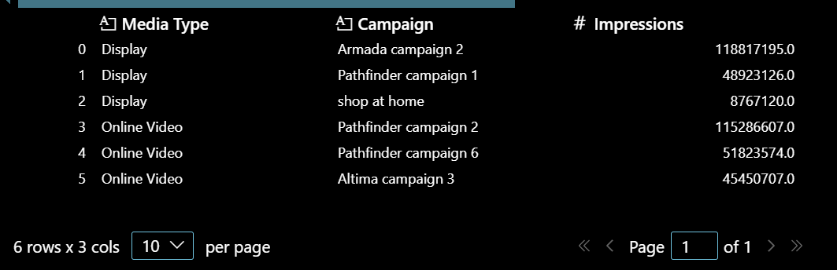
- Does the campaign with maximum impressions also have maximum clicks?
Ans:
max_impressions_campaign = pivot_df.groupby('Campaign')['Impressions'].sum().idxmax()
max_clicks_campaign = pivot_df.groupby('Campaign')['Clicks'].sum().idxmax()
max_impressions_equals_max_clicks = max_impressions_campaign == max_clicks_campaign
max_impressions_equals_max_clicks

- Find out the top 3 campaigns in terms of CPM (CPM stands for cost per mile which means cost per 1000 impressions. CPM = total media cost/total impressions * 1000)
Ans:
pivot_df['CPM'] = pivot_df['Media Cost'] / pivot_df['Impressions'] * 1000
top_3_campaigns_by_cpm = pivot_df.groupby('Campaign')['CPM'].mean().nlargest(3)
top_3_campaigns_by_cpm
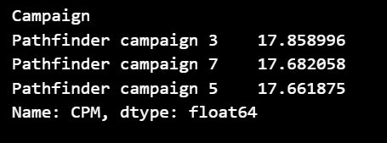
- What is the monthly average media cost for different media types?
Ans:
monthly_avg_media_cost = pivot_df.groupby(['Month', 'Media Type'])['Media Cost'].mean().unstack()
monthly_avg_media_cost
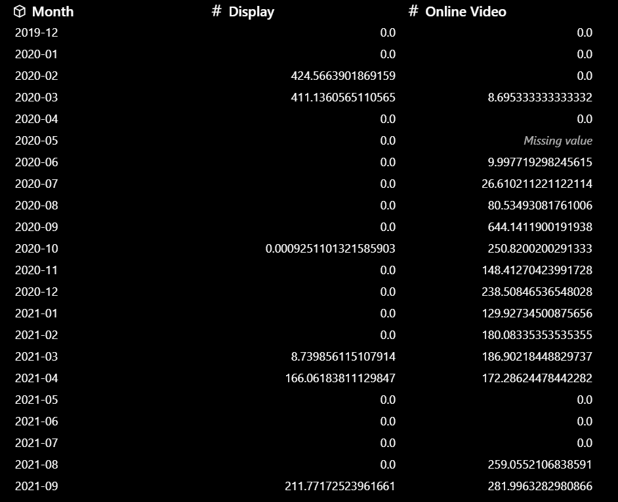
- Which media type is more expensive in terms of CPM?
Ans:
media_type_cpm = pivot_df.groupby('Media Type')['CPM'].mean().idxmax()
media_type_cpm

- When would you use a Pie chart, a Bar chart and a Line Chart? Use the given dataset and provide an example for each type of chart.
Ans:
Pie chart is used when we want to show proportions or percentages of a whole.
Bar chart is used when we want to compare quantities across different categories.
Line Chart is used when we want to show trends over time.
impressions_by_media_type = pivot_df.groupby('Media Type')['Impressions'].sum()
plt.figure(figsize=(8, 6))
impressions_by_media_type.plot.pie(autopct='%1.1f%%')
plt.title('Distribution of Impressions by Media Type')
plt.show()
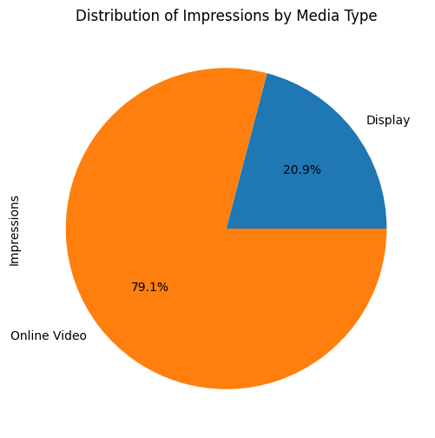
plt.figure(figsize=(10, 6))
top_5_months.plot(kind='bar')
plt.title('Top 5 Months by Impressions')
plt.xlabel('Month')
plt.ylabel('Impressions')
plt.show()
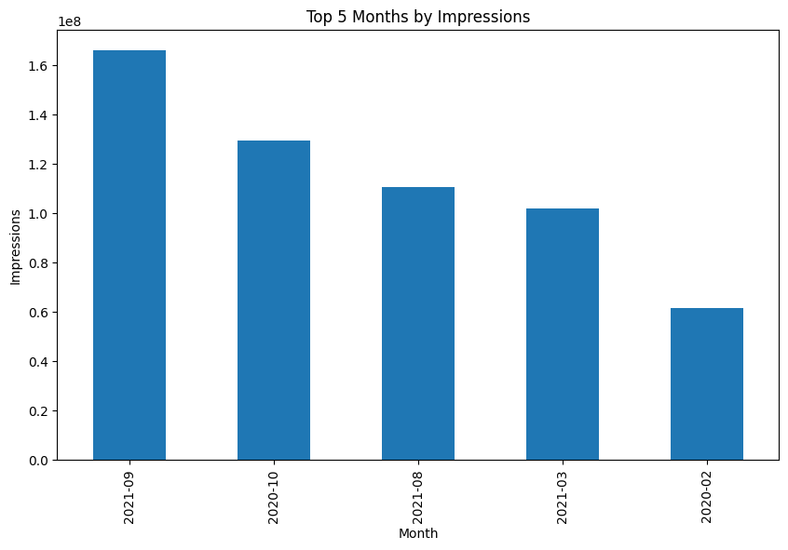
plt.figure(figsize=(12, 8))
monthly_avg_media_cost.plot(kind='line')
plt.title('Monthly Average Media Cost by Media Type')
plt.xlabel('Month')
plt.ylabel('Average Media Cost')
plt.show()
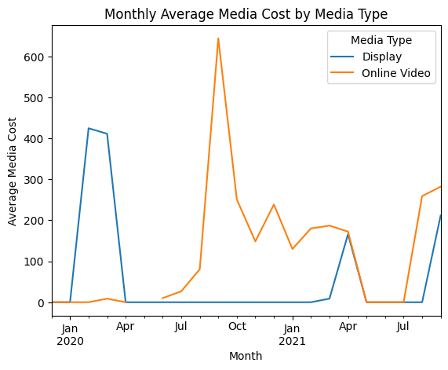
- Modelling Data:
- Analyze Sales of Altima using a Linear Regression model.
Ans: Here we are using a multiple linear regression model to analyze the sales of Altima using Least Squares Method. We are trying to predict it based on other predictor variables.
- Which is your dependent variable?
Ans: Here our dependent variable is sales.
- Which variables are significant in the model?
Ans: Gas_price(p-value=0.001), discount(p-value =0.001), youtube(p-value =0.012) and print(p-value =0.029).
- How did you evaluate them?
Ans:
import pandas as pd
import statsmodels.api as sm
from sklearn.metrics import mean_absolute_percentage_error
from statsmodels.stats.outliers_influence import variance_inflation_factor
# Load the dataset
df = pd.read_excel('Modeling dataset.xlsx', sheet_name='modeling dataset', engine='openpyxl')
# Define the dependent variable (Sales) and independent variables
df['covid_dummy'] = df['month'].apply(lambda x: 1 if x==pd.to_datetime('2020-04-01') else 0)
df['Month index']=pd.to_datetime(df['month']).dt.month
df["Seasonality"] = df.groupby(['Month index'])["sales"].transform('mean')/df['sales'].mean()

def apl_transformation(series, adstock_rate=0.5, power=0.5):
result = []
for i in range(len(series)):
if i == 0:
result.append(series[i] ** power)
else:
result.append((series[i] + adstock_rate * result[i - 1]) ** power)
return result
# Define specific adstock_rate and power values for each tactic from domain knowledge
tactic_params = {
'TV': {'adstock_rate': 0.75, 'power': 0.4},
'YouTube': {'adstock_rate': 0.7, 'power': 0.6},
'Radio': {'adstock_rate': 0.75, 'power': 0.6},
'Print': {'adstock_rate': 0.8, 'power': 0.6}
}
# Apply APL transformation using the specific parameters
for column, params in tactic_params.items():
df[column] = apl_transformation(df[column], adstock_rate=params['adstock_rate'], power=params['power'])
X = df[['covid_dummy', 'gas_price', 'discount', 'TV', 'YouTube', 'Radio', 'Print',"Seasonality"]]
y = df['sales']
X = sm.add_constant(X)
# Fit the linear regression model
model = sm.OLS(y, X).fit()
model_summary = model.summary()
print(model_summary)
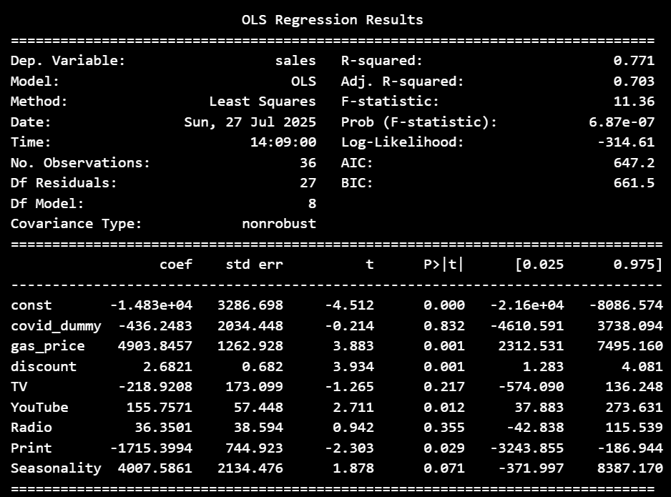
From this table, we can observe the p values(P>|t|) of t-test, which is the test of significance of the beta coefficients. If p-value<0.05, we reject the null hypothesis that beta coefficient=0,that means the variable is significant in predicting sales.
- What is the R2 and Adjusted R2 of the model?
Ans:
r_squared = model.rsquared
adj_r_squared = model.rsquared_adj
r_squared, adj_r_squared

- Do you observe multicollinearity in the independent variables?
Ans:
vif_data = pd.DataFrame()
vif_data['feature'] = X.columns
vif_data['VIF'] = [variance_inflation_factor(X.values, i).round(2) for i in range(X.shape[1])]
vif_data.sort_values('VIF', ascending=False)
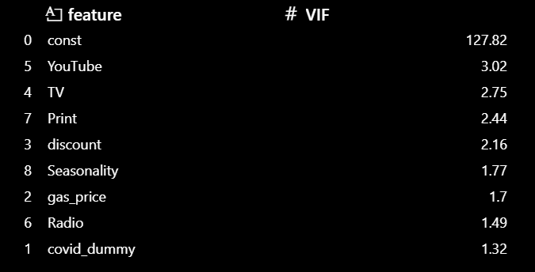
All the VIF values of the predictor variables are below 5, indicating no serious multicollinearity.
- Calculate the MAPE of the model.
Ans:
y_pred = model.predict(X)
mape = mean_absolute_percentage_error(y, y_pred)
mape


