Q1. Merge the three data sets with sales, TV GRPs & Video Impressions.
Ans:
import pandas as pd
file_path = 'Python Questions_IME interview Round.xlsx'
xls = pd.ExcelFile(file_path, engine='openpyxl')
# Load the three tables from the 'PyQ1' sheet
df_sales = pd.read_excel(xls, sheet_name='PyQ1', usecols="A:B", nrows=13)
df_tv_grps = pd.read_excel(xls, sheet_name='PyQ1', usecols="F:G", nrows=6)
df_video_impressions = pd.read_excel(xls, sheet_name='PyQ1', usecols="K:L", nrows=7)
# Rename columns for merging
df_sales.columns = ['Timestamp', 'Sales']
df_tv_grps.columns = ['Timestamp', 'TV GRPs']
df_video_impressions.columns = ['Timestamp', 'Video Impressions']
# Merge the three tables
merged_df = pd.merge(df_sales, df_tv_grps, on='Timestamp', how='outer')
merged_df = pd.merge(merged_df, df_video_impressions, on='Timestamp', how='outer')
# Display the merged table
print(merged_df.iloc[1:,:])
Output:
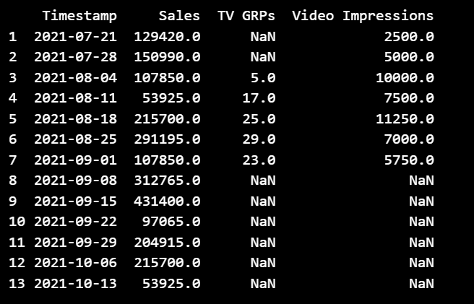
Q3:
P1)create a new column Age_Bucketed, which will categorize ages under:
"<20 years",
"20-30 years",
"30-40 years",
"40-50 years",
">50 years"
Ans:
import pandas as pd
# Define the employee data
data = {
'Name': ['Employee_1', 'Employee_2', 'Employee_3', 'Employee_4', 'Employee_5',
'Employee_6', 'Employee_7', 'Employee_8', 'Employee_9', 'Employee_10',
'Employee_11', 'Employee_12', 'Employee_13', 'Employee_14', 'Employee_15',
'Employee_16', 'Employee_17', 'Employee_18', 'Employee_19', 'Employee_20',
'Employee_21', 'Employee_22', 'Employee_23', 'Employee_24', 'Employee_25',
'Employee_26', 'Employee_27', 'Employee_28', 'Employee_29', 'Employee_30'],
'Salary': [54895.0, 38784.0, 120000.0, 60309.0, 46788.0,
50598.0, 61915.0, 50651.0, 38155.0, 55480.0,
49396.0, 64183.0, 38894.0, 46672.0, 20000.0,
57935.0, 57055.0, 44719.0, 66267.0, 48339.0,
44490.0, 48817.0, 39738.0, 59433.0, 80823.0,
80000.0, 52704.0, 54168.0, 56569.0, 45481.0],
'Age': [49, 48, 34, 33, 59, 36, 34, 30, 36, 29,
29, 54, 55, 29, 53, 34, 23, 41, 58, 41,
45, 22, 39, 47, 22, 30, 53, 33, 23, 52],
'Function': ['HR', 'Sales', 'Manager', 'Manager', 'HR',
'Sales', 'Manager', 'HR', 'Sales', 'HR',
'Sales', 'Developer', 'Developer', 'Sales', 'HR',
'Sales', 'Developer', 'Developer', 'HR', 'Sales',
'HR', 'Manager', 'HR', 'Sales', 'HR', 'Sales',
'Sales', 'Developer', 'Developer', 'HR']
}

# Convert to DataFrame
df = pd.DataFrame(data)

# Display the DataFrame
print(df)

# Define the department to code mapping
department_mapping = {
'HR': 'HR001',
'Sales': 'SAL002',
'Manager': 'MGR003',
'Developer': 'DEV004'
}

# Convert the dictionary to a DataFrame
department_df = pd.DataFrame(list(department_mapping.items()), columns=['Department', 'Department_Code'])

# Display the DataFrame
print(department_df)

def bucket_age(age):
if age < 20:
return '<20 years'
elif 20 <= age <= 30:
return '20-30 years'
elif 30 <= age <= 40:
return '30-40 years'
elif 40 <= age <= 50:
return '40-50 years'
else:
return '>50 years'

df['Age_Bucketed'] = df['Age'].apply(bucket_age)
df.head(5)

Output:
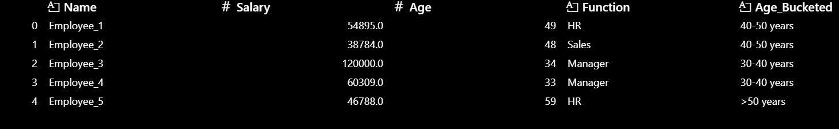
P2) Create a new column to generate function codes for each function using department df
Ans:-
df = df.merge(department_df, left_on='Function', right_on='Department', how='left')
df.drop(columns=['Department'], inplace=True)
df.head(5)
Output:-
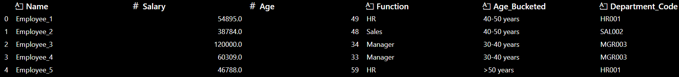
P3) Create a new column to find outliers in the df: "Outlier", "Not an Outlier"
Ans:-
Q1 = df['Salary'].quantile(0.25)
Q3 = df['Salary'].quantile(0.75)
IQR = Q3 - Q1
lower_bound = Q1 - 1.5 * IQR
upper_bound = Q3 + 1.5 * IQR
def detect_outlier(salary):
if salary < lower_bound or salary > upper_bound:
return 'Outlier'
else:
return 'Not an Outlier'

df['Outlier'] = df['Salary'].apply(detect_outlier)
df.head(5)
Output:-
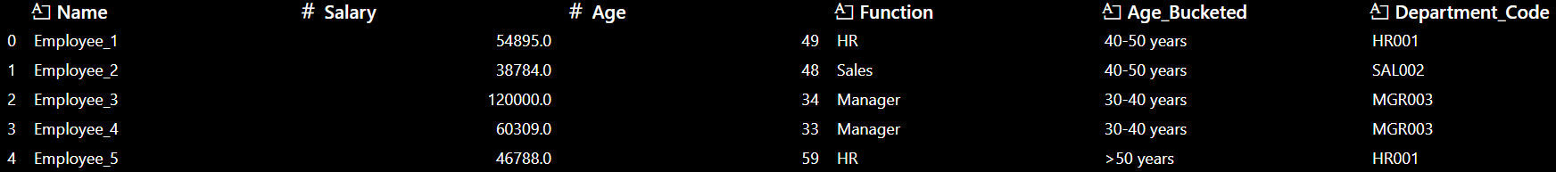
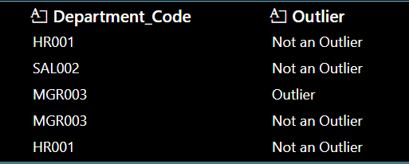
Q2:
- Exploratory Data Analysis (EDA):
Describe your approach to exploring this dataset before modeling. What trends, patterns, or anomalies would you look for, and why? Use this dataset and highlight top 10 findings from the data and sales drivers.
Ans:
- There are 122 rows and 20 columns present in the dataset which consists of 122 week ending dates. It consists of 16 numerical columns and 1 datetime column.
It consists of 1 week ending dates column, 1 sales column and the rest 15 are variables column which can be used as predictors.
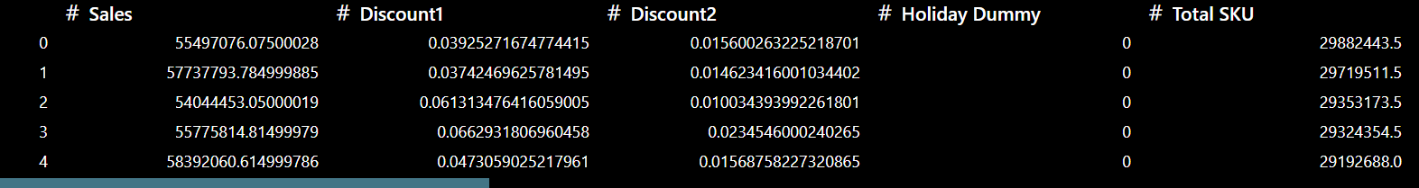
Summary statistics of the numerical columns:
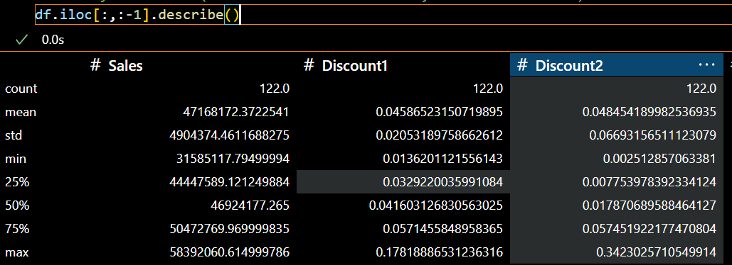
- There are no missing values present in the dataset.
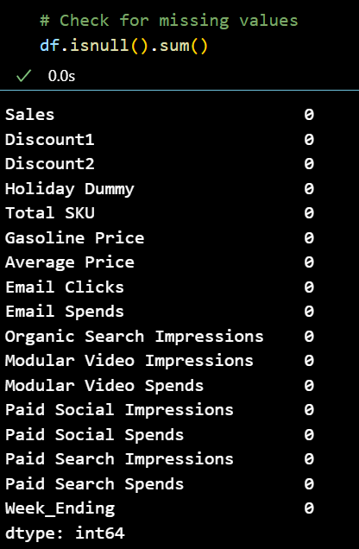
- Correlation Matrix:
# Correlation matrix
correlation_matrix = df.corr()
# Plotting the correlation matrix
plt.figure(figsize=(12, 8))
sns.heatmap(correlation_matrix, annot=True, cmap='coolwarm', linewidths=0.5)
plt.title('Correlation Matrix')
plt.show()
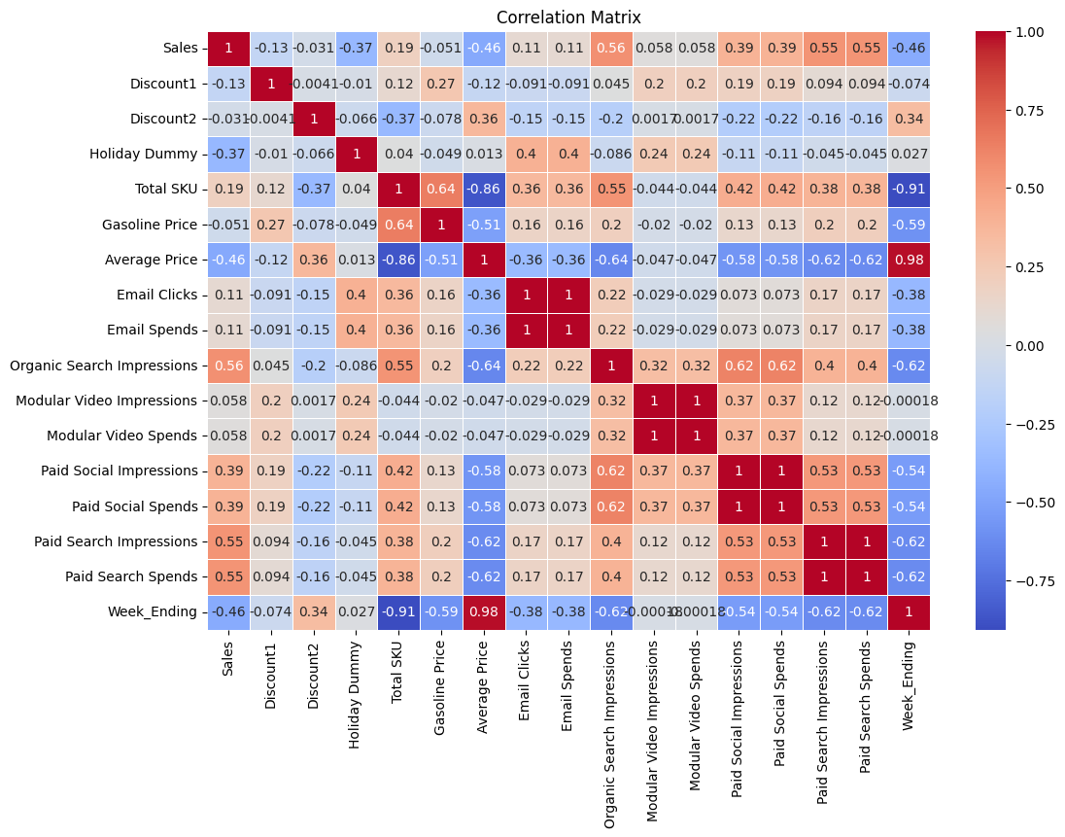
# Correlation between sales and sales drivers
df.corr()['Sales'].sort_values(ascending=False)
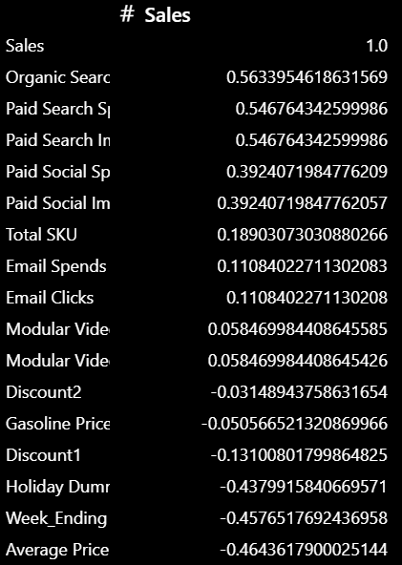
The tactics having higher +ve correlations with sales are key contributors to sales.
- When we compare MAT_2023 vs MAT_2024 sales, we found that there has been a 7.4% decline in sales of our client in Hair Care Category.
- This has resulted from fall in spends and hence impressions from Paid Search(-100%), Paid Social(-38.5%) and Modular Video(-4.9%) tactics.
- This has resulted from fall in Non Paid Marketing Activities such as Email Clicks(-18.4%) and Organic Search Impressions(-18.1%) tactics.
- Among Promotional activities, Discount% is falling in case of Discount1(-4.7%) whereas Discount% is rising in case of Discount2(58%) YOY.
Discount1 ranges up to 18%, and Discount2 up to 34%, suggesting aggressive promotional tactics.
- Base variables such as average price of Hair Care Products is rising(1.7%) and total SKU count is also falling which is also contributing to a decline in sales.
- Economic indicator such as gasoline price has fallen by 6.3%, which causes people to go out and shop as a result of which fall in sales is less.
- Holiday Dummies are present in Thanksgiving and Christmas week which is causing a huge drop in sales as consumers tend to focus on major gifts and deals during this period, potentially diverting spending from non-essential items like hair care. Consumers might be more inclined towards spending money on travel, dining, or entertainment during Thanksgiving rather than on hair care products. This is also applicable for Christmas week.
Tactics | MAT_2023 | MAT_2024 | % Change
Sales | 2,504,608,042 | 2,318,342,593 | -7.4%
Paid Search Impressions | 115,441 | - | -100.0%
Paid Search Spends | 11,442 | - | -100.0%
Paid Social Impressions | 12,896,133,142 | 7,925,554,991 | -38.5%
Paid Social Spends | 177,550,154 | 109,116,701 | -38.5%
Modular Video Impressions | 734,805,855 | 698,770,251 | -4.9%
Modular Video Spends | 51,643,414 | 49,110,770 | -4.9%
Email Spends | 2,055,954 | 1,677,170 | -18.4%
Email Clicks | 23,881,351 | 19,481,504 | -18.4%
Organic Search Impressions | 110,852,945 | 90,736,198 | -18.1%
Discount1 | 0.05 | 0.05 | -4.7%
Discount2 | 0.04 | 0.07 | 58.0%
Gasoline Price | 1,156 | 1,083 | -6.3%
Average Price | 18 | 18 | 1.7%
Total SKU | 1,468,964,823 | 1,335,502,168 | -9.1%
Holiday Dummy | 74,492,041 | 66,466,236 | -10.8%

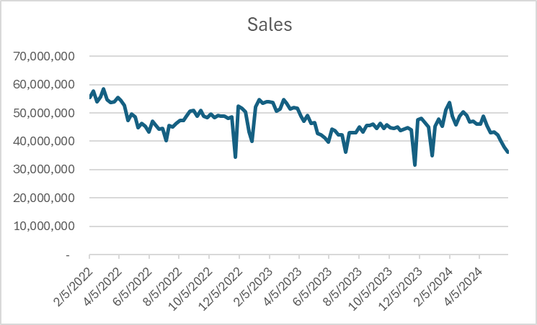
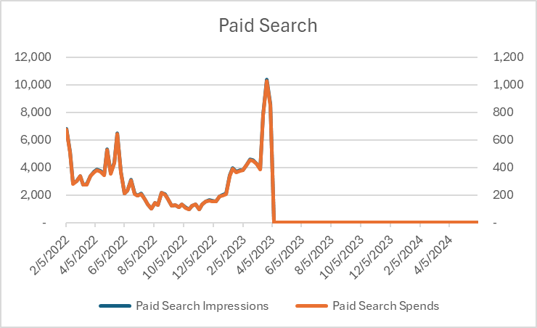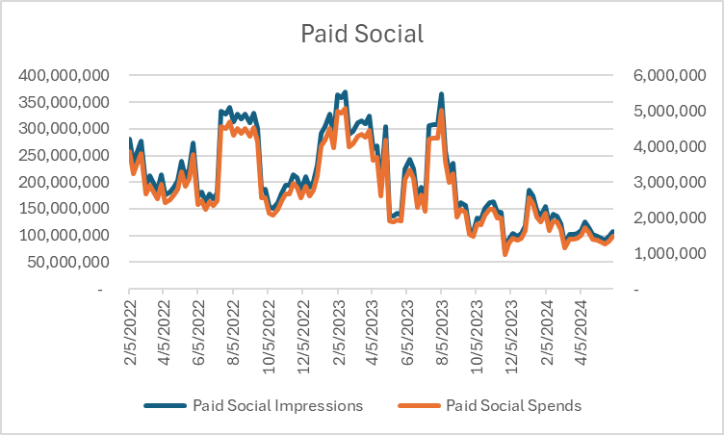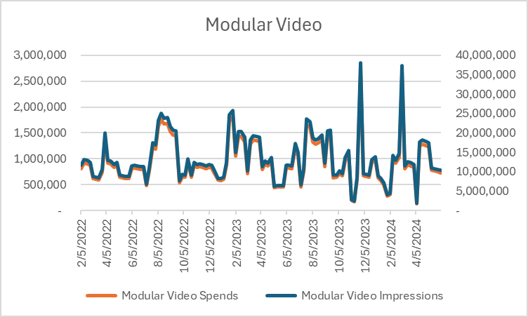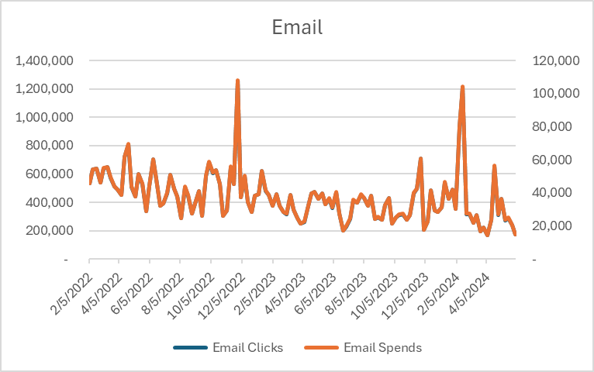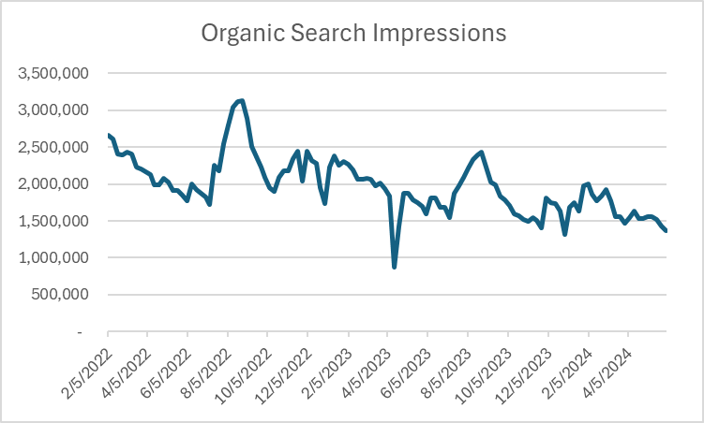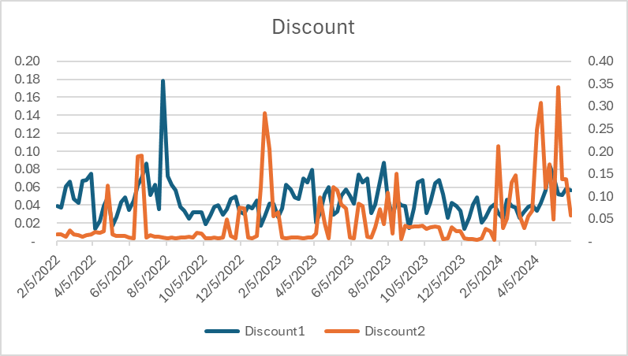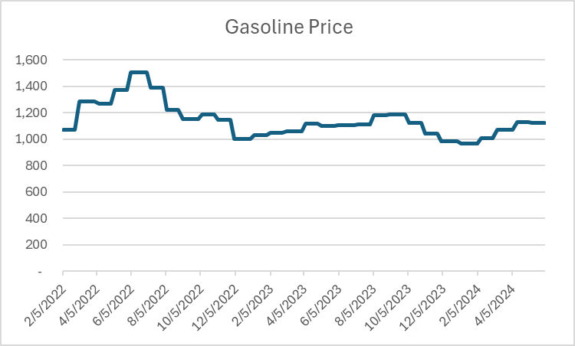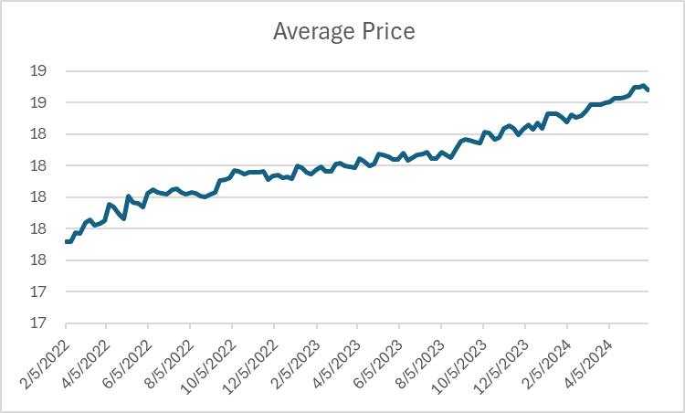
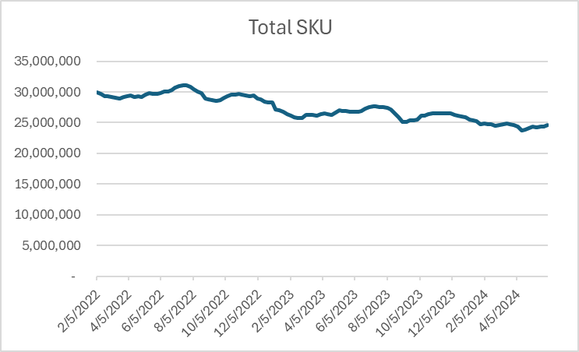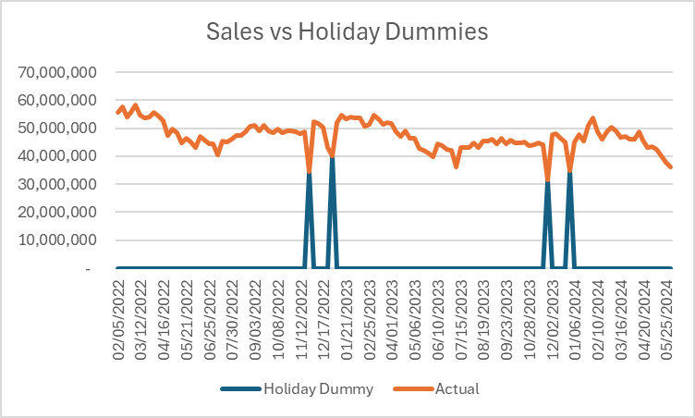
- Modeling Approach:
Outline the steps you would take to build an MMM model for this dataset.
Which variables or transformations would you consider, and how would you handle external economic factors and seasonality in the model? If any derived seasonality variable has been used in the model, please share its calculations.
Write a code in Python for the modeling approach you prefer and run the model with model results highlighting statiscal parameters.
Ans:
- We will use Multiple Constrained Linear Regression(MCLR) Model to estimate the parameters of the model.
- The dependant variable is Sales and the independent variables are 'Paid Search Impressions', 'Paid Social Impressions', 'Modular Video Impressions', 'Email Clicks', 'Organic Search Impressions', 'Discount2', 'Average Price', 'Total SKU', 'Gasoline Price', 'Holiday Dummy' and 'Seasonality'.
- Since the dataset does not contains any missing values, so there is no need of data imputation.
- Assumptions considered: Since MLR contains the assumption that the dependant(Sales) and the independent variables(Marketing tactics) are to be linearly related, so we use the APL(Adstock+Power+Lag) transformation on the marketing tactics so that they are linearly related with sales. For other independent variables, we assumed that they are linearly related with the dependent variable(sales). We also assumed that there is no multicollinearity present in the dataset. We also assumed that the errors, e_{i} ~ N(0, σ²), i.i.d.

- For marketing variables, we have taken only impressions/clicks only. We have not used the spend variables also as they will generate multicollinearity.
- For promotional activities, we have used only 1 variable which is Discount2.We know that discount causes rise in sales(and hence we wanted a +ve correlation with sales) and hence we are trying to use lag of week 1 and 2 for these 2 variables. But it is not helping much. Also, we wanted to reduce multicollinearity as well. Hence, we decided to drop the variable having highest -ve correlation with sales.
- We have added a Holiday Dummy variable as we are seeing huge drop in sales during Christmas and Thanksgiving as people are focussing on gifts and not on non-essential items like hair care products.
- For handling external economic factors such as gasoline price, we have used a rolling average of 4 weeks(as it has the highest -ve correlation with sales among other windows of 3 and 4 weeks including the original variable as we know that gasoline price and sales are inversely related) .
- We have also added a Seasonality variable in the model to account for the seasonal fluctuations in sales. Please find the calculations in the code attached in the mail.
- Please find the attached code in Python in mail for the modelling where we had run the model along with model results highlighting statistical parameters.

- Interpreting Results: How would you interpret the result? What recommendations would you provide to the company?
Do you observe any strong seasonal pattern in the data? If yes, then how would you adjust your recommendations to account for this?
Ans:
- An Adjusted R-squared value of 0.783 means that approximately 78.3% of the variance in the dependent variable (Sales) is explained by the independent variables (marketing channels, promotions, seasonality, etc.) in our regression model, after adjusting for the number of predictors.
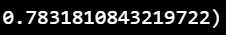
- Mean Absolute Percentage Error(MAPE) measures prediction accuracy, expressing errors as a percentage of the actual values. A MAPE of 3.83% means that, on average, your model's predictions are only 3.83% off from the actual sales values.
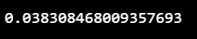

- Actual vs Predicted Plot:
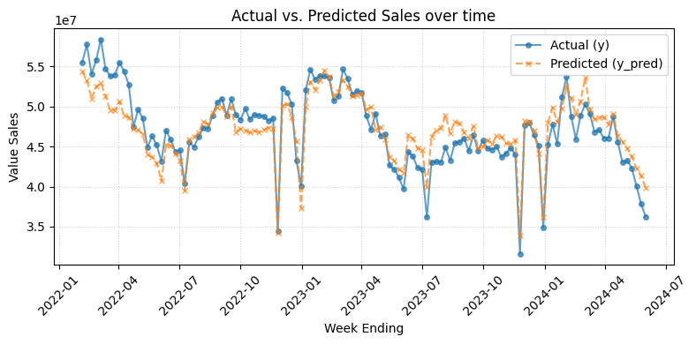
The recommendations that we can provide to the company is:
- Invest more on Paid Search so as to increase organic search as well. Invest more on Paid Social, Modular Video and Email as well. These are top-performing channels with strong positive impact on sales. Strengthen SEO efforts to boost Organic Search visibility. Use high-performing keywords and optimize landing pages for conversions.
- Discount2 has a significant positive effect on sales. Plan targeted promotions using Discount2 during low-demand periods. Avoid overuse to protect margins.
- Monitor Gasoline Prices as a Demand Signal - Gasoline Price has a negative impact on sales. During periods of high fuel prices, offer value-based promotions, emphasize on affordable product lines, shifting marketing tone to emphasize savings.

- Seasonality means recurring patterns in sales that happen at regular intervals — like higher sales during festivals, holidays, or specific months/quarters.
- We can detect this by:
  - Checking if certain weeks or months consistently show spikes or drops.
  - Using seasonality or dummy variables (e.g., Holiday Dummy).
- Yes, we observe a strong seasonal pattern in the data.
Since seasonality is strong, we adjust our recommendations by:
- Adjust Marketing Strategy by Season: Increase spend on high-performing channels (e.g., Paid Social, Modular Video, Email and Paid Search) before and during peak seasons.
- Reduce or reallocate marketing budget during low seasons to avoid waste.
- Launch Discount2-type promotions during seasonal dips to boost sales.
- Avoid unnecessary discounts during natural peaks — let seasonality do the work.
- Ensure SKU availability is high during peak seasons.
- Avoid overstocking during off-seasons.

Optimization:
Describe how you would approach optimizing the marketing activities across channels to maximize sales. Which methods or tools would you consider for this, and what constraints would you apply to ensure realistic recommendations?
Ans:
Suppose we want to maximize the sales of the company by optimizing the marketing spend across channels by using a fixed-budget scenario(Total spend on marketing activities remains same as that of the previous year) for the upcoming year.
For that we need, previous year’s sales, adstock rate, power, spend and weekly marketing activities(impressions/clicks,etc.) values for the previous year for various marketing activities.
Using those we will build response curves of sales of a marketing tactic against spend for all the marketing tactics which have spend in the previous year. Then we go on to allocate spend(total spend across all media channels/1000) incrementally to those tactics which is causing a highest lift in sales(as can be seen from the response curves) given some constraints that:
    - total spend across all media channels remains constant
    - spend of each media channel should lie between +/-25% of what we have stated historically.
These are the 2 constraints that I will apply to ensure realistic recommendations.
Basically, we are shifting spend from a more saturated tactic to a less saturated tactic so that the overall sales gets maximized given constraints.
Tactic | Current Spend | Optimum Spend | Reallocated Spend | % Chg Spend | Current Sales | Optimum Sales | Reallocated Sales | % Chg Sales
Paid Social Impressions | $ 109,116,701 | $ 97,258,301 | ($11,858,400) | (10.9%) | $147,816,378 | $137,957,027 | ($9,859,351) | (6.7%)
Modular Video Impressions | $ 49,110,770 | $ 61,388,463 | $12,277,693 | 25.0% | $57,193,171 | $68,371,040 | $11,177,869 | 19.5%
Email Clicks | $ 1,677,170 | $ 1,257,877 | ($419,292) | (25.0%) | $1,953,190 | $1,691,512 | ($261,678) | (13.4%)
Total | $ 159,904,641 | $ 159,904,641 | $0 | 0.00% | $206,962,738 | $208,019,579 | $1,056,841 | 0.51%

This is the optimization strategy that I will advice the client so that the client’s sales increase by 0.51%.

