SQL Question:
Q1.Create table with column names in E to G taking data from I, J & K column.
Ans:
CREATE TABLE Invoice (
Invoice_ID INT,
Customer_ID INT,
Product_Name VARCHAR(255)
);
INSERT INTO Invoice (Invoice_ID, Customer_ID, Product_Name) VALUES
(1111, 1, 'qq'),
(1112, NULL, 'ww'),
(1113, 10, 'pp'),
(1114, 2, 'lkl'),
(1115, 2, 'lkl'),
(1116, 3, 'asas'),
(1117, 9, 'wef'),
(1118, NULL, 'vxh');
Select * from Invoice;
Output:
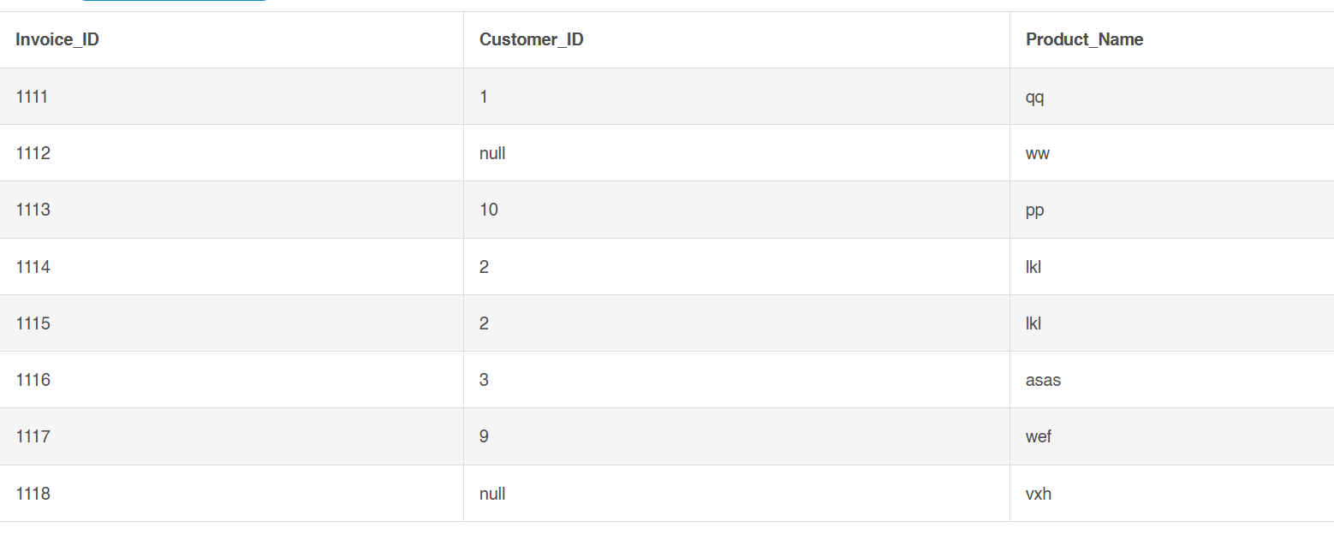
Q2. Write a query to find out list of customers present in CUSTOMER1 table which are not present in CUSTOMER2 table (DON'T USE IN or NOT IN).
Ans:
CREATE TABLE CUSTOMER1 (
Customer_ID INTEGER,
Customer_Name VARCHAR(2)
);

INSERT INTO CUSTOMER1
(Customer_ID, Customer_Name)
VALUES
(1, 'aa'),
(2, 'bb'),
(3, 'cc'),
(5, 'ee');

CREATE TABLE CUSTOMER2 (
Customer_ID INTEGER,
Customer_Name VARCHAR(2)
);
INSERT INTO CUSTOMER2
(Customer_ID, Customer_Name)
VALUES
(1, 'aa'),
(4, 'ff'),
(5, 'ee');
SELECT
c1.Customer_ID,
c1.Customer_Name
FROM
CUSTOMER1 c1
LEFT JOIN
CUSTOMER2 c2
ON
c1.Customer_ID = c2.Customer_ID
WHERE
c2.Customer_ID IS NULL;

Output:
