Stock Earnings Agent — LinkedIn Post
Ready-to-publish copy, followed by the images to attach

Annual reports have more than doubled in length since the 1990s. A single 10-K can now run past 49,000 words — and SEC EDGAR adds about 4,700 new filings every day.

The data is public and free. The hard part is finding the signal buried inside it.

So I built Stock Earnings Agent — an AI research assistant that reads the numbers and the narrative together, then answers in plain language with its sources shown.

And it just got a major visual upgrade.

Every company now opens as a clean, interactive dashboard instead of a wall of tables — the way a professional equity platform presents a stock:

📈 Candlestick price + volume — trend, volatility and conviction at a glance
💰 Revenue, net income & margins — is growth actually turning into profit?
🎯 Analyst price targets — the consensus range and implied upside vs today's price
⚖️ Valuation multiples — P/E, forward P/E, PEG, P/B, P/S and EV/EBITDA side by side
🧭 Financial-health radar — profitability, returns, growth, liquidity and leverage in one shape
⏱️ KPI gauges — the three headline numbers, executive-style

Under the hood:
• Retrieval — document parsing, chunking, Google Gemini embeddings, ChromaDB
• Reasoning — a LangGraph ReAct agent running on Groq
• Access — a Streamlit app and a Model Context Protocol server that share one tested tool layer
• Built to standard — typed configuration, logging, unit and integration tests, and a Docker image

The outcome: work that used to mean an afternoon of cross-referencing spreadsheets and filings becomes one question and one grounded, visual answer.

🔗 Try the live demo: https://stock-earnings-agent.streamlit.app/
📄 Read the full technical write-up: [ PASTE PROJECT DOCUMENT LINK HERE ]
💻 Explore the code: github.com/PritamDas96/stock-earnings-agent

If you work in fintech, retrieval augmented generation, or agentic systems, I would value your feedback. What should it learn to answer next?

Data: SEC (About EDGAR); 10-K length trends via Columbia Law School CLS Blue Sky Blog.

#ArtificialIntelligence #RAG #LLM #Fintech #Python #LangGraph #DataVisualization #MachineLearning #DataScience

Suggested images
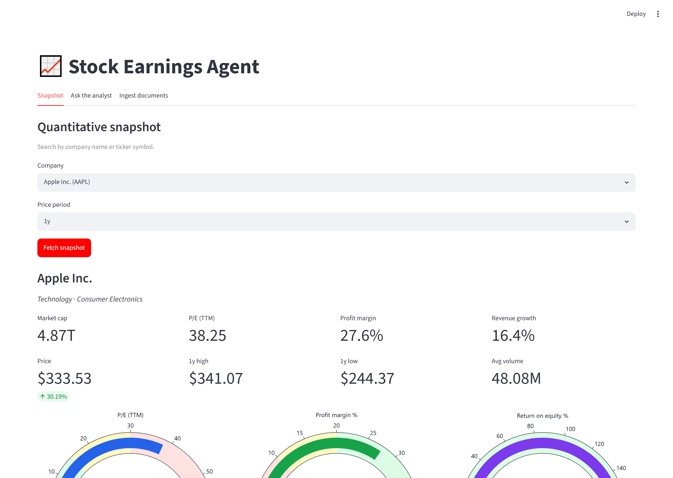
The full visual snapshot — metrics, gauges and six finance charts in one view.

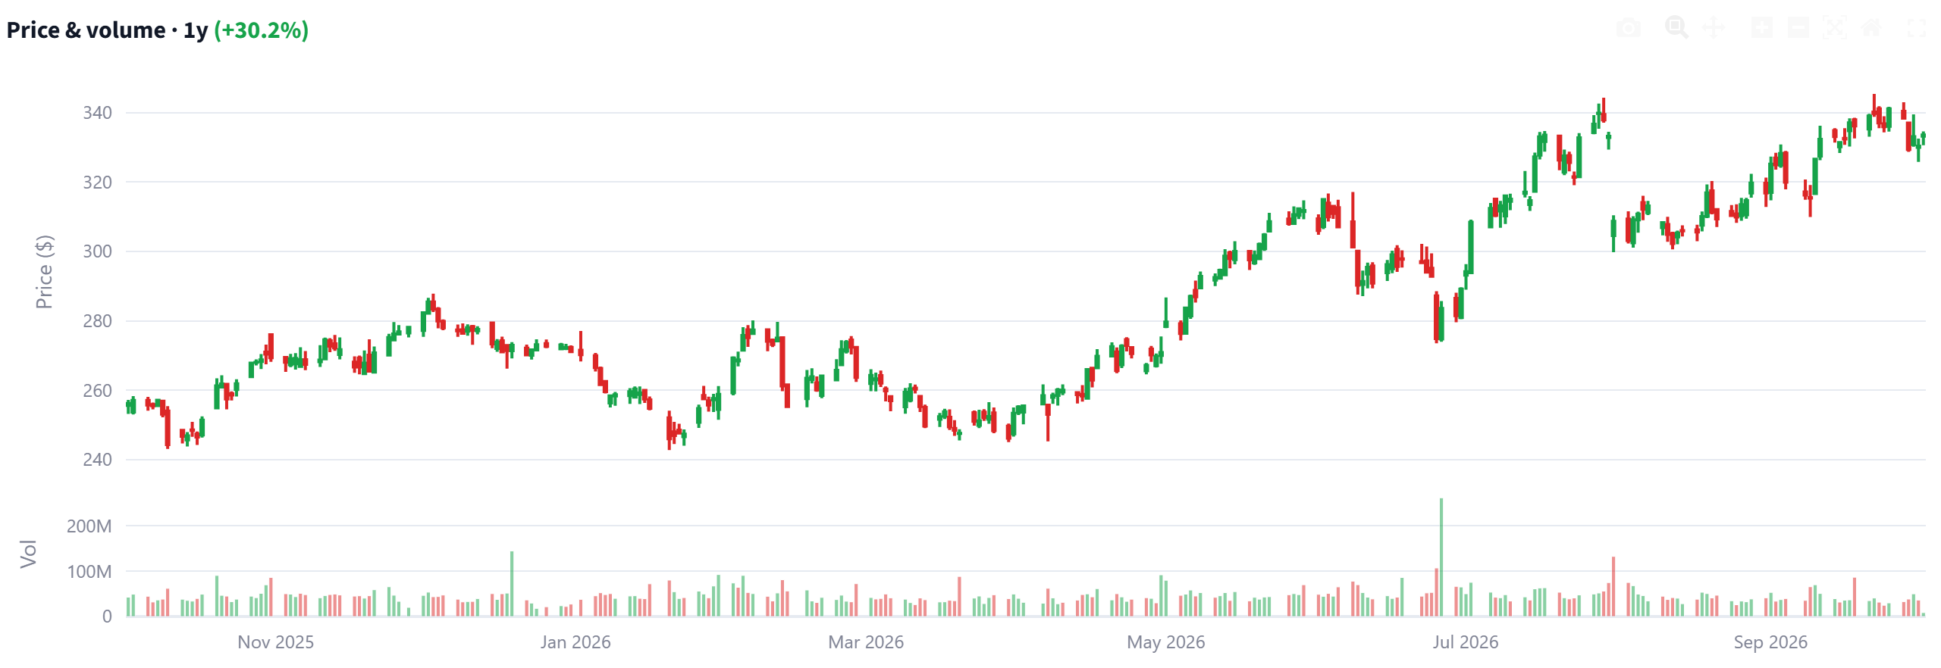
Price & volume — candlestick trend with a volume sub-panel.

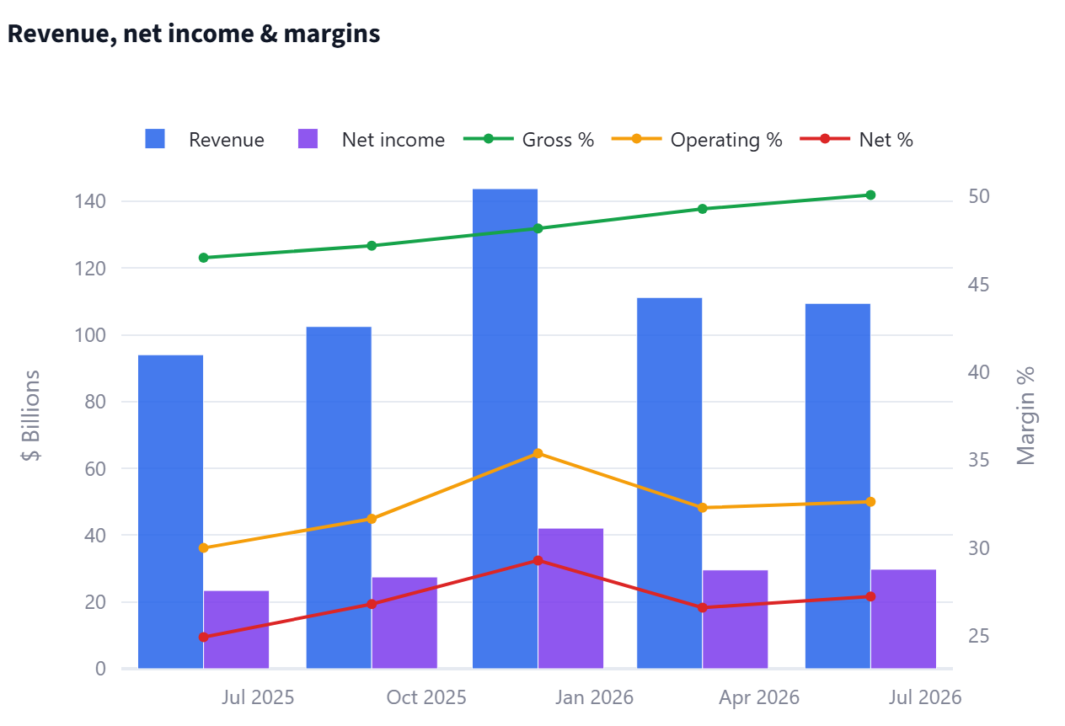
Revenue, net income & margins — is growth turning into profit?

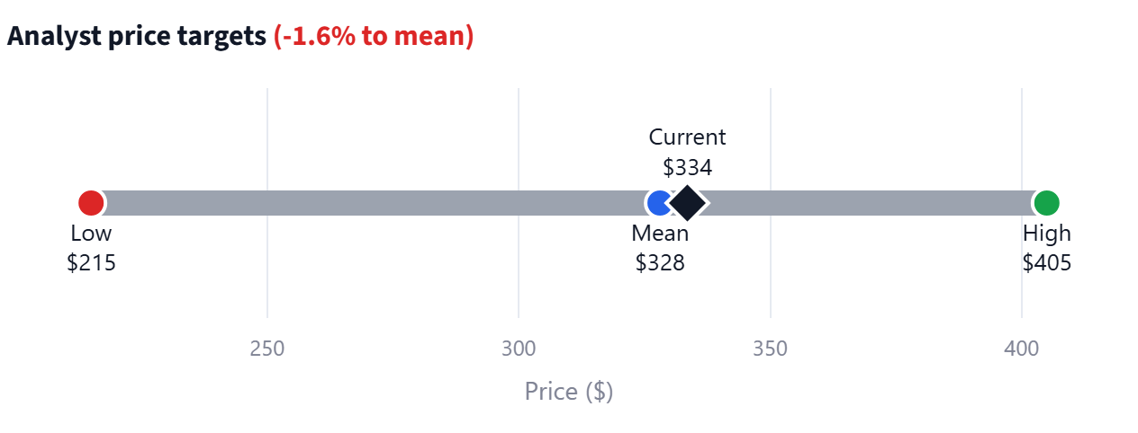
Analyst price targets — consensus range and implied upside.

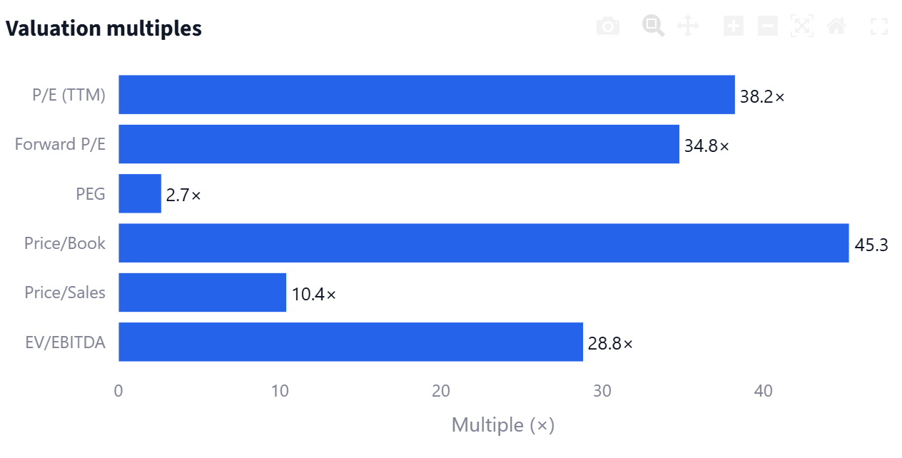
Valuation multiples — the standard lenses side by side.

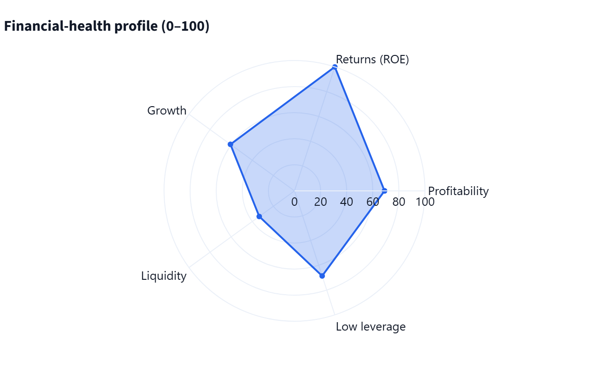
Financial-health profile — strengths and weaknesses in one shape.

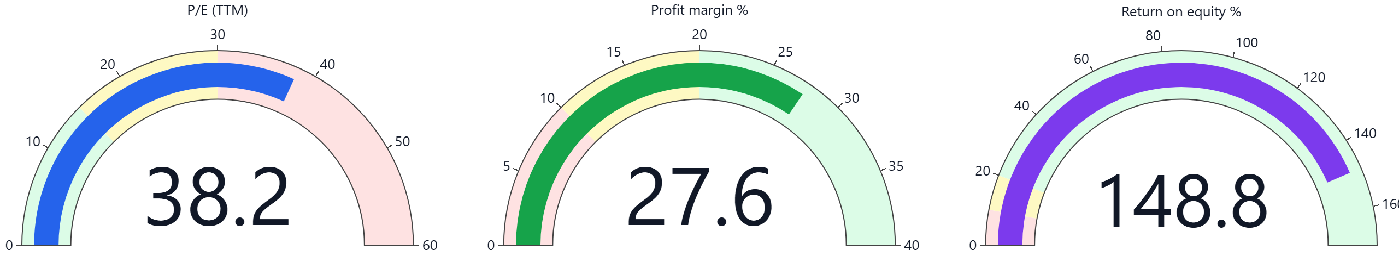
KPI gauges — the three headline numbers, executive-style.

