Hospital Management &
Healthcare Operations Analytics
Project Report
Data-driven analysis of appointments, operations, treatments and billing

1. Executive Summary
This project applies business intelligence and exploratory analytics to a synthetic hospital management dataset. The objective is to convert operational records into management-oriented information covering appointment performance, branch patterns, visit reasons, doctor workload, treatment billing and payment exposure.
The dataset contains 48 patients, 10 doctors and 200 appointment-linked treatment/billing records. Of the 200 appointments, 46 were completed (23.0%), 51 were cancelled (25.5%), 52 were marked no-show (26.0%), and 51 were scheduled.

2. Project Objective
- Measure the current appointment and operational picture through clear KPIs.
- Identify trends and operational drivers by branch, specialization, doctor and visit reason.
- Understand treatment-level billed value and payment-status exposure.
- Translate analytical findings into practical business actions.
- Provide an interactive notebook-based frontend so users can filter and explore the analysis.

3. Dataset Overview
The project uses the Hospital Management Dataset selected for this analysis. The source data is organized into patient, doctor, appointment, treatment and billing information. The analysis-ready file combines these related tables at appointment level for integrated analysis.
Dataset component | Records | Purpose
Patients | 50 | Patient registration and demographic information
Doctors | 10 | Specialization, experience and branch information
Appointments | 200 | Appointment date, reason and status
Treatments | 200 | Treatment type and cost
Billing | 200 | Amount, payment method and payment status
Data-quality checks found no missing values or exact duplicate records in the supplied tables, and the key relationships used for the integrated analysis were valid. The dataset is synthetic; therefore the results should be interpreted as an analytical project demonstration rather than as real hospital performance.

4. Analytical Approach
- Data loading and preparation using Python and pandas.
- Date parsing and creation of month-level analytical fields.
- Joining patient, doctor, appointment, treatment and billing information.
- KPI calculation and status-distribution analysis.
- Driver analysis across branch, specialization, visit reason and doctor.
- Treatment billing and payment-status analysis.
- Monthly trend analysis.
- Business insights and recommended actions based on observed patterns.
- Interactive filtering frontend using ipywidgets within the same notebook.

5. Key Performance Indicators
KPI | Value | Interpretation
Total Patients | 48 | Unique patients
Total Doctors | 10 | Unique doctors
Total Appointments | 200 | Appointment records
Completed Appointments | 46 | 23.0% of appointments
Cancelled Appointments | 51 | 25.5% of appointments
No-show Appointments | 52 | 26.0% of appointments
Scheduled Appointments | 51 | Current status in dataset
Total Billed Value | ₹551,249.85 | Treatment-linked billed amount

6. Appointment Performance
Appointment status is the main operational KPI area. Completed appointments account for 23.0% of the dataset, while cancellations and no-shows together account for 51.5%. Scheduled appointments are retained as a separate category because the dataset does not establish whether they are future appointments or unresolved cases.
Status | Appointments | Share
Completed | 46 | 23.0%
Cancelled | 51 | 25.5%
No-show | 52 | 26.0%
Scheduled | 51 | 25.5%

7. Trend Analysis
Appointment volume varies across the year. April has the highest monthly volume with 25 appointments, while September has the lowest with 11. October records no completed appointments in the supplied data, which is a useful point for operational review but should not be treated as a causal finding without additional information.
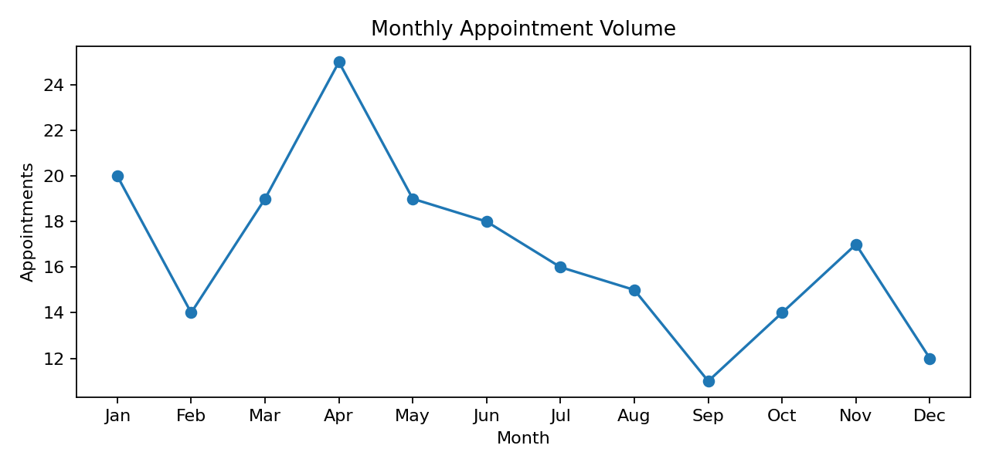

8. Branch and Operational Drivers
Central Hospital has the largest appointment volume, followed by Eastside Clinic and Westside Clinic. Branch-level status patterns differ, so volume alone does not describe operational performance.
Branch | Appointments | Completed % | Cancelled % | No-show %
Central Hospital | 84 | 17.9% | 22.6% | 31.0%
Eastside Clinic | 62 | 25.8% | 24.2% | 21.0%
Westside Clinic | 54 | 27.8% | 31.5% | 24.1%
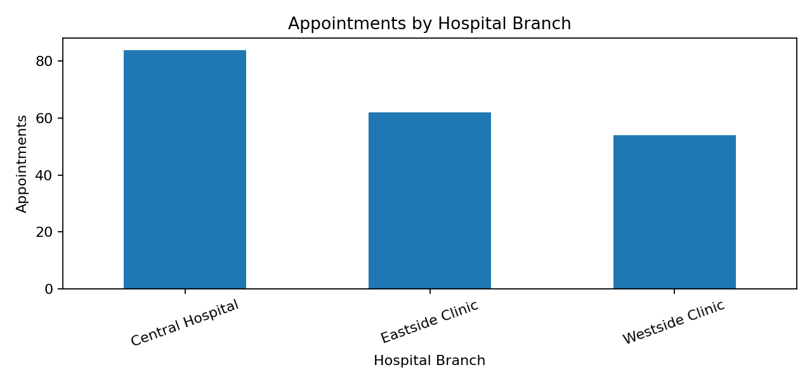

9. Visit Reason and Specialization Analysis
The most frequent visit reason is Checkup (45 appointments), followed by Consultation (43), Therapy (42), Follow-up (41) and Emergency (29). Checkups have the highest completion rate among the listed reasons at 35.6%, while Therapy has a 35.7% no-show rate and Consultation has a 34.9% cancellation rate. These patterns identify areas for targeted operational review.
Visit Reason | Appointments | Completed % | No-show % | Cancelled %
Checkup | 45 | 35.6% | 22.2% | 17.8%
Consultation | 43 | 9.3% | 25.6% | 34.9%
Therapy | 42 | 21.4% | 35.7% | 23.8%
Follow-up | 41 | 29.3% | 14.6% | 24.4%
Emergency | 29 | 17.2% | 34.5% | 27.6%
By specialization, Pediatrics contributes the highest appointment volume (98), followed by Dermatology (70) and Oncology (32). Oncology has the highest completion rate among the three specializations at 31.2%.

10. Doctor Workload
Doctor-level analysis is included to support workload visibility. Sarah Taylor has the highest appointment volume with 29 records and the highest billed value in the dataset at ₹82,696.48. Workload and status distributions should be reviewed together rather than using appointment count alone as a performance measure.
Doctor | Appointments | Completed | Cancelled | No-show | Billed
Sarah Taylor | 29 | 4 | 6 | 9 | ₹82,696.48
David Taylor | 25 | 6 | 7 | 7 | ₹66,585.39
Alex Davis | 24 | 5 | 6 | 6 | ₹69,586.10
Jane Smith | 22 | 6 | 4 | 7 | ₹52,791.41
Jane Davis | 21 | 5 | 8 | 1 | ₹59,803.46

11. Treatment and Billing Analysis
Total treatment-linked billed value is ₹551,249.85. Chemotherapy contributes the highest total billed value at ₹128,855.68, followed by MRI at ₹116,098.16 and X-Ray at ₹110,653.67.
Treatment | Records | Total Billed | Average Cost
Chemotherapy | 49 | ₹128,855.68 | ₹2,629.71
MRI | 36 | ₹116,098.16 | ₹3,224.95
X-Ray | 41 | ₹110,653.67 | ₹2,698.87
Physiotherapy | 36 | ₹99,418.10 | ₹2,761.61
ECG | 38 | ₹96,224.24 | ₹2,532.22
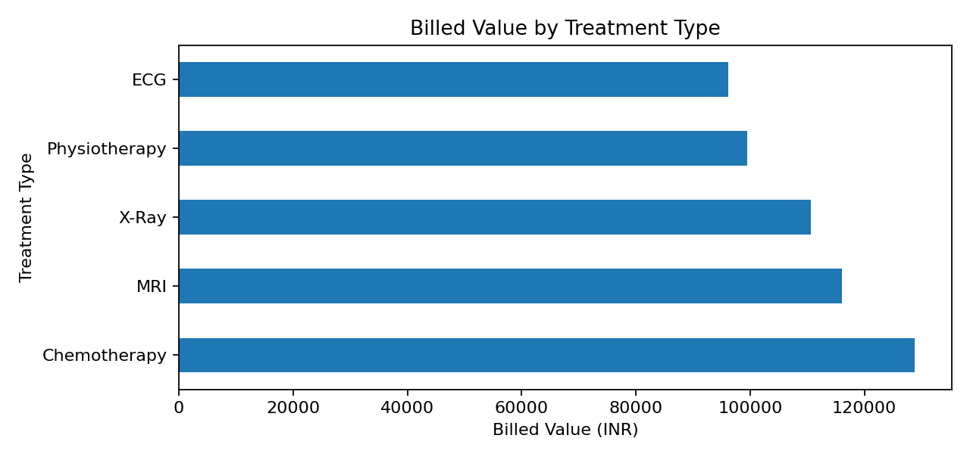

12. Payment Analysis
Payment records are distributed across Paid, Pending and Failed statuses. The dataset contains ₹173,424.90 marked Paid, ₹184,612.01 marked Pending, and ₹193,212.94 marked Failed. These figures represent the supplied dataset's payment-status labels and should not be interpreted as audited financial results.
Payment Status | Bills | Amount
Paid | 64 | ₹173,424.90
Pending | 69 | ₹184,612.01
Failed | 67 | ₹193,212.94

13. Business Insights
- Appointment completion is relatively low in the supplied dataset, while cancellation and no-show statuses form a substantial share of records.
- Central Hospital has the highest appointment volume and also the highest no-show count, making appointment-status monitoring particularly relevant for that branch.
- Consultation appointments show a high cancellation share, while Therapy appointments show a high no-show share; these are suitable targets for targeted follow-up analysis.
- Chemotherapy has the highest total billed value, while MRI has the highest average treatment cost among the five treatment categories.
- Payment exposure is spread across pending and failed statuses, indicating that payment-status monitoring is an important part of the management view.

14. Recommended Business Actions
- Introduce reminder and confirmation workflows for appointments, with special attention to visit types showing higher no-show or cancellation shares.
- Monitor branch-level appointment status weekly so high-volume branches can be reviewed separately from lower-volume locations.
- Review consultation and therapy scheduling patterns to identify operational reasons behind their higher cancellation/no-show shares.
- Use treatment-level billing summaries to support resource and revenue monitoring, while avoiding unsupported profitability claims.
- Create a payment follow-up queue for Pending and Failed records and track resolution over time.
- Extend the dataset in a future phase with wait time, length of stay, clinical outcomes, satisfaction and readmission fields if those questions need to be analyzed.

15. Interactive Frontend
The submitted Jupyter notebook contains both the analytical backend and a lightweight interactive frontend. Users can select Branch, Status and Specialty filters and then apply the selections to refresh KPI summaries, monthly appointment volume, branch volume and treatment billing outputs.

16. Technology Stack
Technology | Use
Python | Core programming and analysis
Pandas | Data loading, cleaning, joining and aggregation
NumPy | Numerical operations
Matplotlib | Analytical charts and dashboard visuals
ipywidgets | Interactive notebook controls
Jupyter Notebook | Combined project code, analysis and frontend

17. Limitations
- The dataset is synthetic and relatively small.
- The available fields do not include patient satisfaction, waiting time, bed utilization, length of stay, clinical outcomes or readmission.
- Billing amount equals treatment cost in the supplied data, so this project does not claim to measure profit or margin.
- The analysis describes observed patterns; it does not establish causal relationships.
- Prediction/ML is not included because the available variables do not define a sufficiently strong predictive objective for this project.

18. Conclusion
The project converts hospital management records into a management-oriented analytics view by moving from KPIs to trends, operational drivers, billing exposure and recommended actions. The combined notebook provides the backend analysis and an interactive frontend in a single submission file, while keeping the solution focused on actionable business intelligence rather than unnecessary complexity.

End of Report

Final Interactive Dashboard Output
The final notebook includes an interactive healthcare analytics dashboard with filters for hospital branch, appointment status, and specialty. The dashboard presents the core operational KPIs and appointment status analysis in the first view.
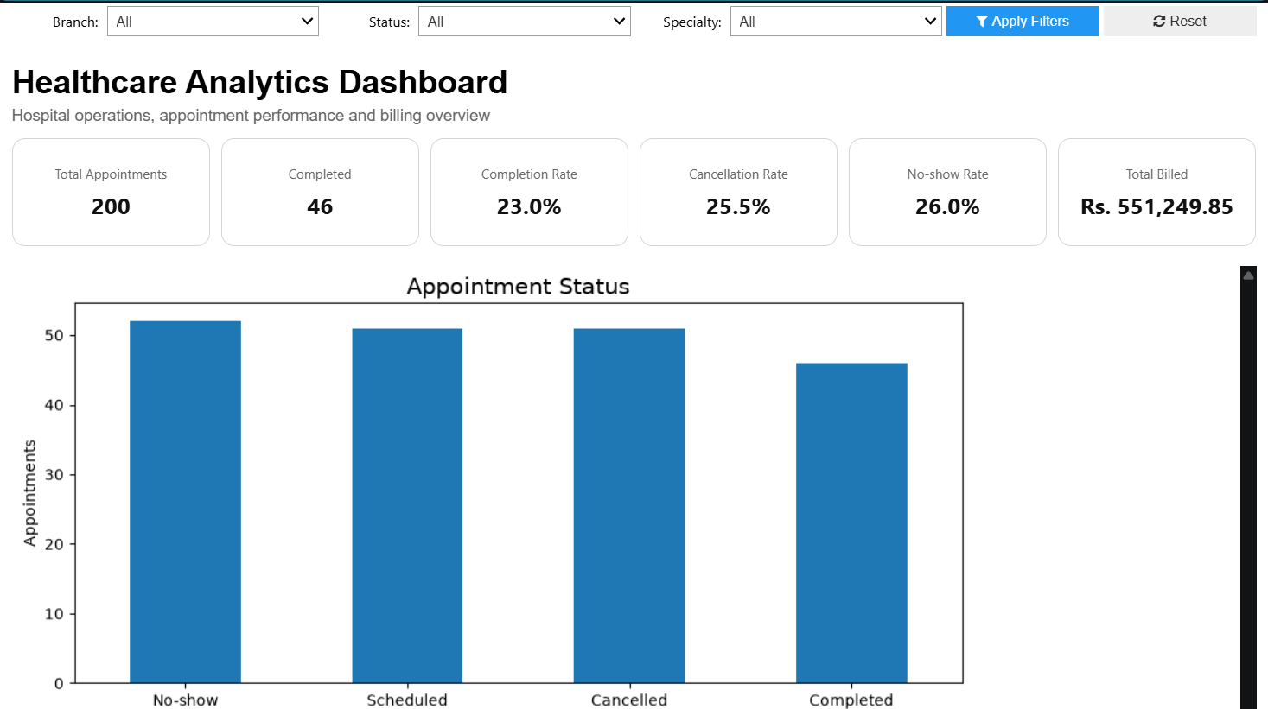
Figure: Final Healthcare Analytics Dashboard showing filters, KPI cards, and appointment status analysis.

