1. Retrieve movies information without mentioning their column names.

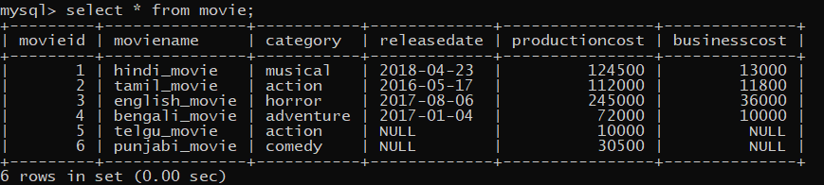

1. List business done by the movies showing only MovieID, MovieName and BusinessCost.

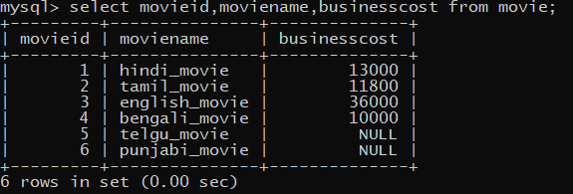

1. List the different categories of movies.



1. Find the net profit of each movie showing its ID, Name and Net Profit. (Hint: Net Profit = BusinessCost – ProductionCost)

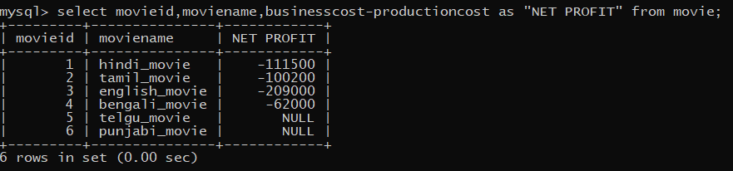

1. List all movies with ProductionCost greater than 80,000 and less than 1,25,000 showing ID, Name and ProductionCost.

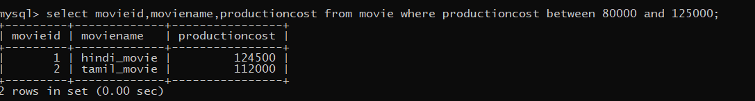

1. List all movies which fall in the category of Comedy or Action.



1. List the movies which have not been released yet.

