1. Create the table Product with appropriate data types and constraints.



1. Identify the primary key in Product.

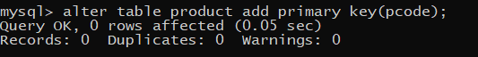

iii.List the Product Code, Product name and price in descending order of their product name. If PName is the same then display the data in ascending order of price.

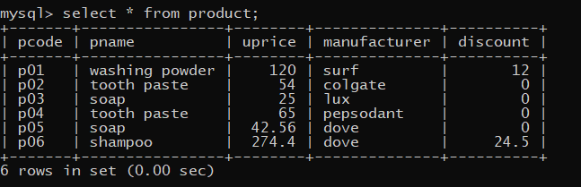

1. Add a new column Discount to the table Product.

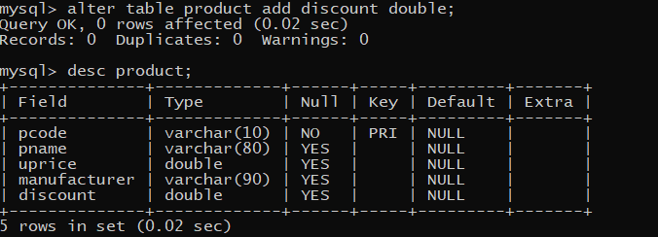

1. Calculate the value of the discount in the table Product as 10 per cent of the UPrice for all those products where the UPrice is more than 100, otherwise the discount will be 0.

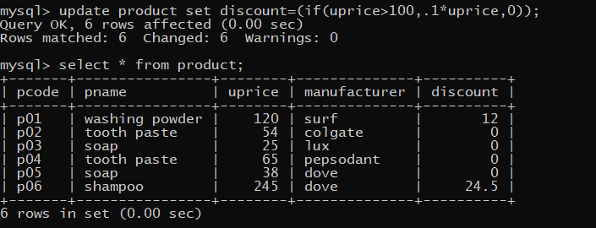

1. Increase the price by 12 per cent for all the products manufactured by Dove.

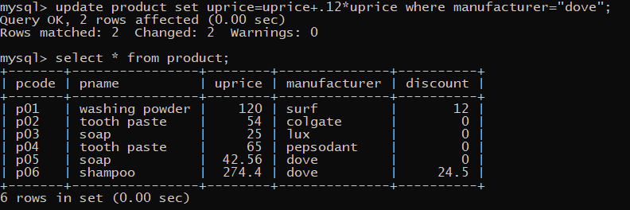

vii.Display the total number of products manufactured by each manufacturer.

