Create the table Student by choosing appropriate data types based on the data given in the table.





Identify the Primary keys from tables Student and Stream. Also, identify the foreign key from the table Stream.



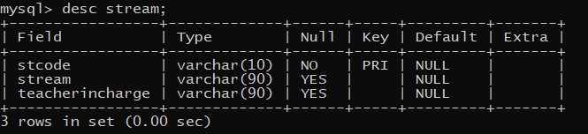

Jay has now changed his stream to Humanities. Write an appropriate SQL query to reflect this change.

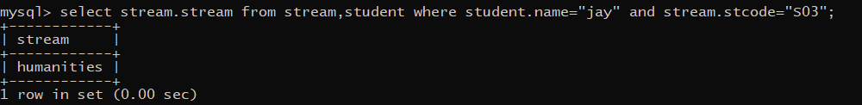

Display the names of students whose names end with the character ‘a’. Also, arrange the students in alphabetical order.

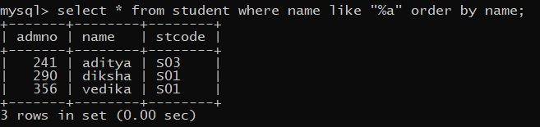

Display the names of students enrolled in Science and Humanities stream, ordered by student name in alphabetical order, then by admission number in ascending order (for duplicating names).

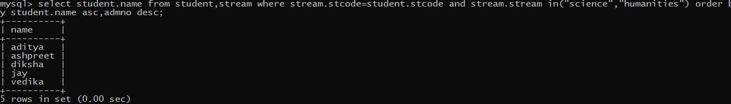

List the number of students in each stream having more than 1 student.



Display the names of students enrolled in different streams, where students are arranged in descending order of admission number.

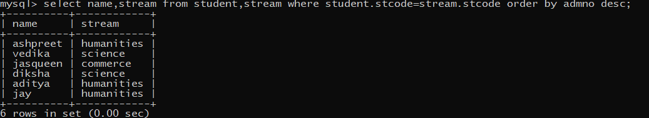

Show the Cartesian product on the Student and Stream table.

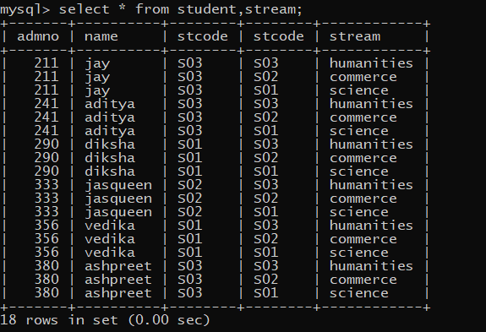

Add a new column ‘TeacherIncharge” in the Stream table. Insert appropriate data in each row.

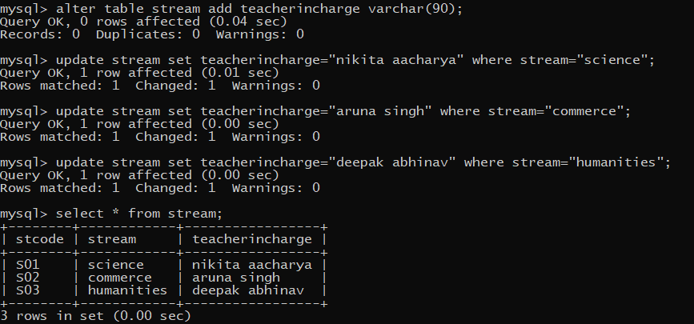

List the names of teachers and students.

