ASSIGNMENT-01

Q1. Task: Creating and Renaming Files/Directories
Command used: mkdir test_dir
touch example.txt
mv example.txt renamed_example.txt
Explanation : mkdir is used for creating the directory.
Touch is used to create an empty file.
mv is used to rename the existing file.
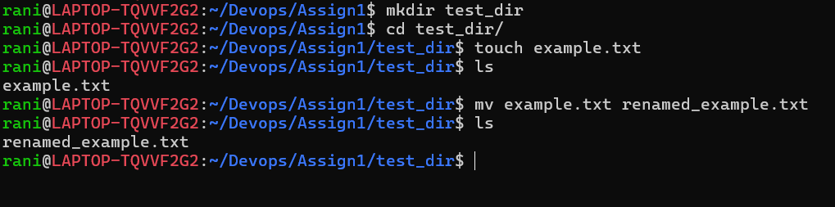

Q2. Task: Viewing File Contents
Command Used: cat /etc/passwd
head -n 5 /etc/passwd
tail -n 5 /etc/passwd
Explanation: cat is used to view or search the contents inside the file
head is used to return the specified number of lines from the top.
tail is used to return the specified number of lines from the bottom.
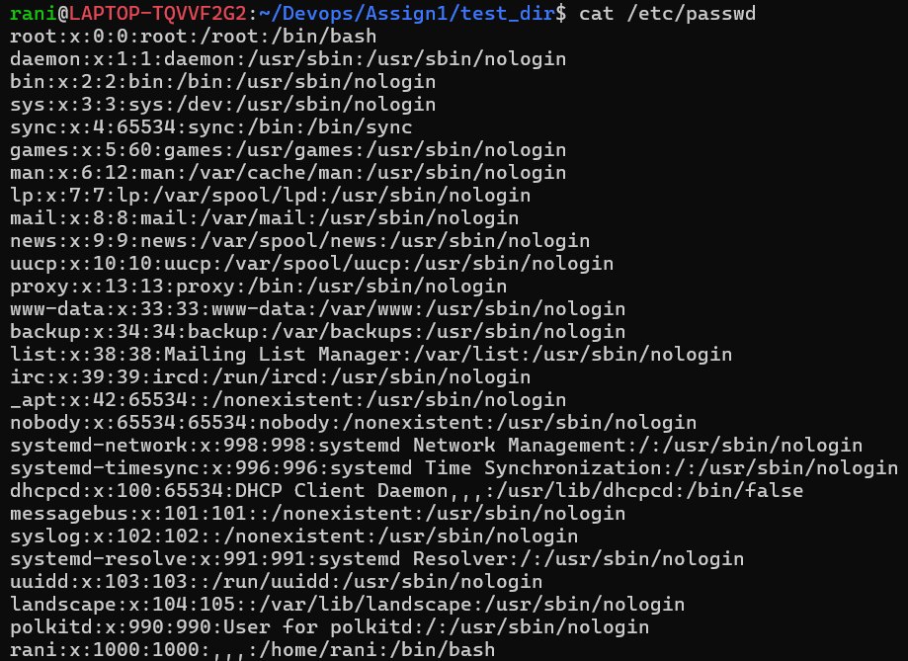
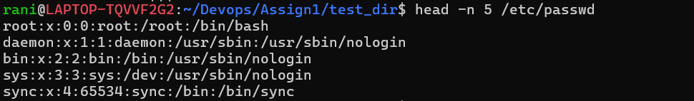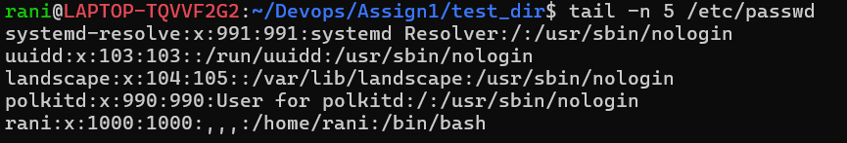

Q3. Task: Searching for Patterns
Command Used: grep root /etc/passwd
Explanation: grep is used to search exactly the lines containing root.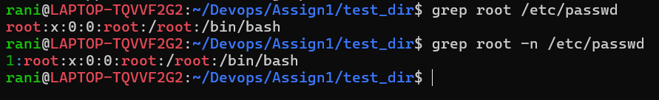

Q4. Task: Zipping and Unzipping
Command Used: zip test_dir test_dir.zip
unzip test_dir.zip -d unzipped_dir

Explanation: zip is used to zip all the files specified
Unzip is used to unzip the specified directory into a new folder
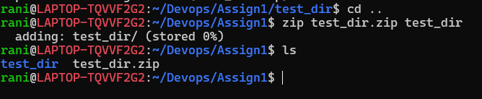
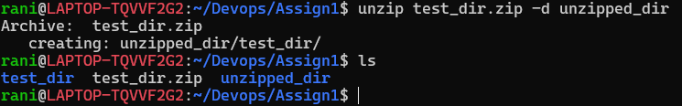

Q5. Task: Downloading Files
Command used : wget https://example.com/sample.txt
Explanation: wget is used to download the files from the api and as it was not a valid api so https://www.wikipedia.org this url was also tested.
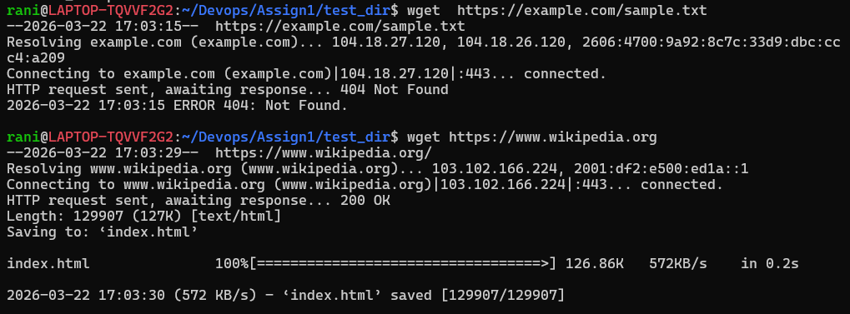

Q6. Task: Changing Permissions
Command Used: touch secure.txt
chmod 444 secure.txt
Explanation: Empty file secure.txt was created using touch.
chmod 444 is used to give permission to read-only for everyone .
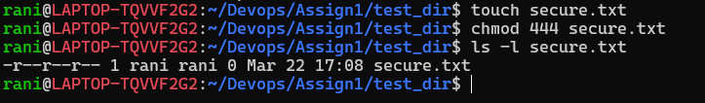

Q7. Task: Working with Environment Variables
Command Used: export MY_VAR=”Hello Linux!”
echo $MY_VAR
Explanation: export is used to set the environmental variables
echo is used to print the text that follows the command.
