**Apparatus:**

1. **Radar System:**
   * 1. HB 100 Radar

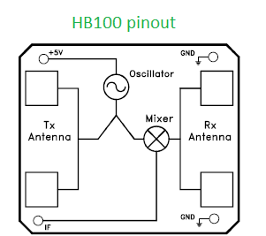

* + 1. 2nd order active bandpass filter

|  |  |
| --- | --- |
| Item | Quantity |
| LM7805 | 1 |
| 1N5819 Schottky diode | 1 |
| 10KΩ 1/8 watt Resistor | 3 |
| 330 KΩ 1/8 watt Resistor | 1 |
| 12 KΩ 1/8 watt Resistor | 1 |
| 27 KΩ 1/4 watt Resistor | 1 |
| 8.2KΩ 1/8 watt Resistor | 2 |
| 1MΩ 1/8 watt Resistor | 2 |
| 100 KΩ 1/8 watt Resistor | 2 |
| 4.7µF 63Volt Capacitor | 3 |
| 2.2nF 100 Volt Capacitor | 2 |
| 10 µF 50Volt Capacitor | 1 |
| 100 µF 63Volt Capacitor | 1 |
| LM324 Quad Opamp | 1 |
| Vero board and wires | ……. |

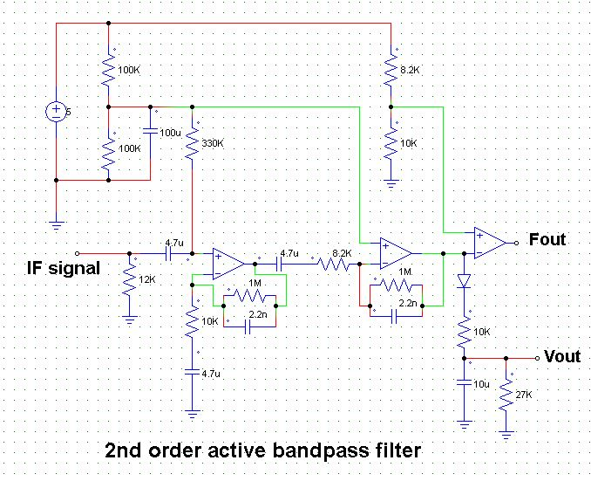

* + 1. 9volt battery
    2. A microcontroller [in this experiment we have used Arduino Uno]

NOTE: 9volt battery is connected to LM7805 to get 5Volt

Fout is connected to pin no 2 and Vout is connected to A0 pin of Arduino Uno,

The lower cut off frequency of the active bandpass filter is 3.38HZ

The higher cut off frequency of the active bandpass filter is 72.343HZ

1. **A moveable Table**
2. **A wall**
3. **Scale to check the distance**

**Experiment:**

* **Detection of stationary object:** The radar system is placed in a moveable table and the table is moved to and fro to capture a wall [stationary object] at a distance of 20 meter.
* **Detection of moveable object:** Theradar system is placed in a table and a hand is moved in front of the radar [4 times].

**Observation:**

* **Detection of stationary object:**

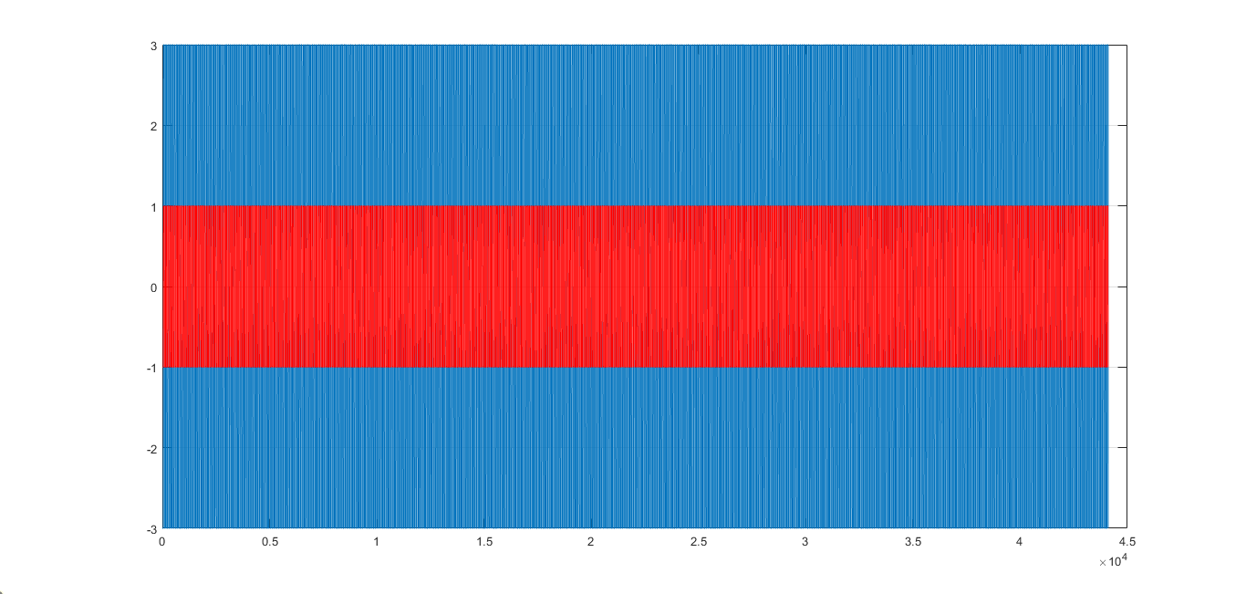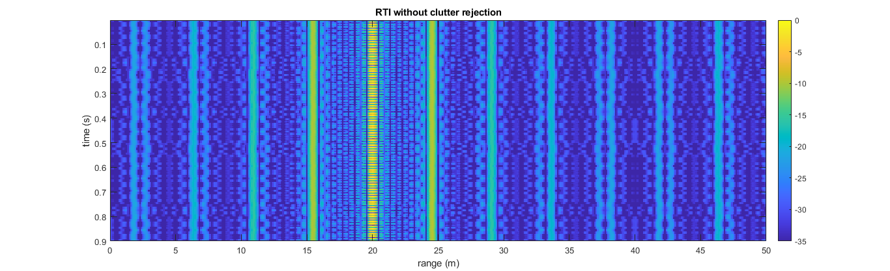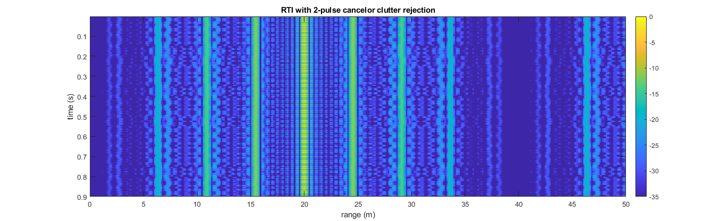

* **Detection of moveable object:**

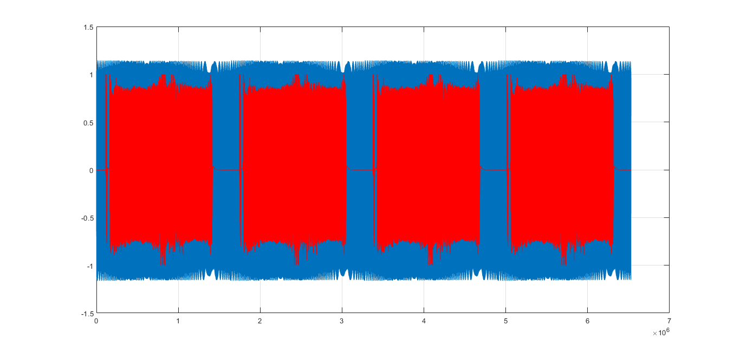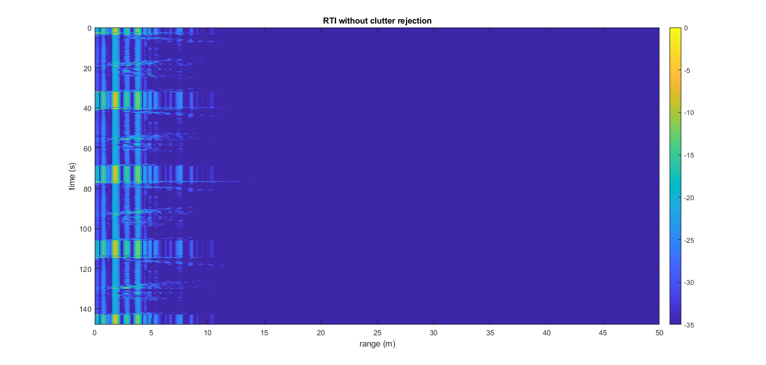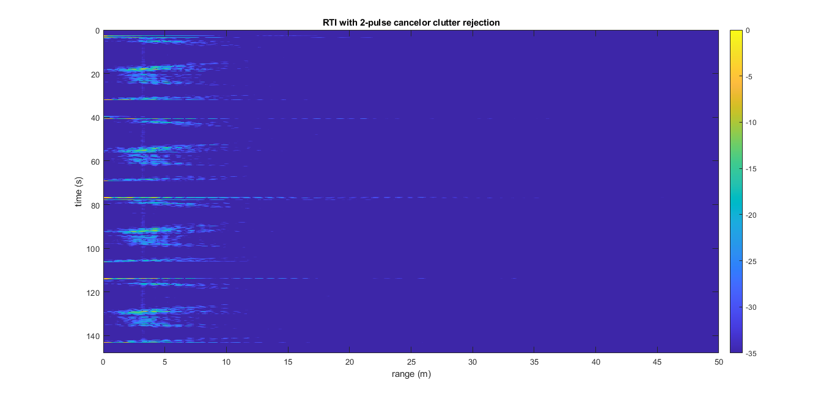

**Note: MATLAB software is used to get the images.**

**Inference:**

* **Detection of stationary object:** From the images we can say that there is wall at a distance of 20 meter.
* **Detection of moveable object:** From the images we can say that there is a object in front of the radar at a distance less than 5 meter and the object comes and goes away four times in front of the radar.