**Corona awareness and help portal with live patients cases**

Submitted in partial fulfillment of the requirements

for the subject of

# Internet Programming Lab

**By:-**

Pritam turalkar

Roll no:- 71

Pratik Utekar

Roll no:- 73

Siddharth soni

Roll no:- 66

# Under the supervision of-

Prof. R. V. Sangle



**DEPARTMENT OF INFORMATION TECHNOLOGY**

**KONKAN GYANPEETH COLLEGE OF ENGINEERING**

**KARJAT-410201**

**2020-2021**

# Certificate

This is to certify that the project entitled “**Corona awareness and help portal with live patients cases”**

is a bonafide work of **Pritam Turalkar**(Roll no :-71) , **Pratik Utekar**(Roll no:- 73) , **Siddharth Soni**(Roll no:- 66) submitted to the **Department of Information Technology** in partial fulfillment of the requirement for the subject of **Internet Programming Lab.**

Supervisor/Guide Head of Department

Prof. R.V. Sangle Prof. J.P. Patil

Department of Computer Engineering Department of Information Technology

ii

# Project report approval

# 

This project report entitled “**Corona awareness and help portal with live patients cases”**

, by **Pritam Turalkar**(Roll no:- 71), **Pratik Utekar**(Roll no:- 73), **Sidharth Soni**(Roll no:- 66) is approved for the partial fulfillment of the requirement for the subject of internet programming lab.

## Examiners

**1………………………………………**

**2………………………………………**

**Date:**

**Place:**

iii

# Declaration

We declare that this written submission represents our ideas in our own words and where other ideas or words have been included. We have adequately cited and referenced the original sources. We also declare that we have adhered to all principles of academic honesty and integrity and have not misrepresented or fabricated or falsified any idea/data/fact /source in our submission. We understand that any violation of the above will be cause for disciplinary action by the institute and can also evoke penal action from the source which have thus nor been properly cited or from whom proper permission has not been taken when needed.

Signature.

Pritam Turalkar

(Roll no.:71)

Signature.

Pratik Utekar

(Roll no.:73)

Signature.

Sidharth Soni

(Roll no.:66)

**Date:**

**Place:**

iv

# Abstract

COVID-19 is the infectious disease caused by the most recently discovered coronavirus. This new virus and disease were unknown before the outbreak began in Wuhan, China, in December 2019

In our website of ‘Corona awareness and help portal with live patients cases’, we show live cases of corona virus along with then we also show dead cases and cured cases we have included map of whole world in which we show cases all over the world .We show updated news about covid 19 and show hospital availability on our website.

If some one is having symptoms related to corona virus then that person can fill the form given on our website and then it will be stored in our data base so that we can provide help to them and they can recover as fast as they can and then We also spread awareness with our website through which virus wont spread everywhere .

v

# Acknowledgment

We would like to express our special thanks of gratitude to our guide Prof. R. V. Sangle for her support in building synopsis as well as our sir Prof. J. P. Patil (HOD.IT) who gave us the golden opportunity to do this wonderful project on the topic “**Corona awareness and help portal with live patients cases”**

which also helped us in doing a lot of research and we came to know about so many new things we are really thankful to them secondly we would also like to thank our parents and friends who helped us a lot in finalizing this project within the limited time frame.

vi

**Contents**

|  |  |  |  |  |
| --- | --- | --- | --- | --- |
| Certificate | | | ii | |
| Project Report Approval | | | iii | |
| Declaration | | | iv | |
| Abstract | | | v | |
| Acknowledgments | | | vi | |
| List of Figures | | | viii | |
| 1. | Introduction | | 1 |  |
|  | 1.1 | Introduction | 1 |  |
|  | 1.2 | Objectives | 2 |  |
|  | 1.3 | Purpose, scope, and application |  |  |
|  | 1.3.1. Purpose  1.3.2. Scope  1.3.3 Applicability | | 2 |  |
|  | 3 |  |
|  | 3 |  |
| 2. | Literature survey | | 4 |  |
| 3. | Requirements and analysis | |  |  |
|  | 3.1 | Problem definition | 5 |  |
|  | 3.2 | Planning and scheduling | 6 |  |
|  | 3.3 | Software and hardware requirements | 7 |  |
| 4. | System design | |  |  |
|  | 4.1.1 Architecture Diagram | | 8 |  |
| 5. | Implementations | |  |  |
|  | 5.1 | Sofware implementation | 9 |  |
| 6. | Conclusions | |  |  |
|  | 6.1 | Conclusion | 23 |  |
|  | 6.2  6.3 | Limitations of the system  Future scope | 23  24 |  |
|  |  |  |  |  |
| Bibliography | | | 25 | |

vii

## List of figures

1)Gant chart( Activity report ) 6

2)Architecture 8

3)Homepage 14

4)Registration 17

5)Login 19

6)About Us 20

7) Contact Us 20

8)Categories 21

9)COD 22

10)Card Payment 22

viii

**Chapter No 1**

## Introduction

**1.1 Introduction:-**

The “Corona awareness and help portal with live patients cases” has been help to override the problems prevailing in the practicing manual system. This website supported to eliminate and in some cases reduce the hardships faced by this existing system. Moreover, this system is designed for the particular need of the company to carry out operations in a smooth and effective manner.

The Website is reduced as much as possible to avoid errors while entering the data. It also provides error messages while entering invalid data. No formal knowledge is needed for the user to use this system. Thus by this all, it proves it is user-friendly. Corona awareness and help portal with live patients cases, as denoted above, can lead to error-free, secure, reliable and fast, management system. It can assist the user to concentrate on their other activities rather concentrate on record-keeping. Thus it will help the organization in better utilization of resources.

Every organization, whether big or small, have challenges to overcome and manage the information of Category. therefore we design exclusive employee management systems that are adapted to your managerial requirements. This is designed to assist in strategic planning and will help you ensure that your organization is equipped with the right level of information and details for your future goals.

### 1.2 OBJECTIVES:-

* It provides the searching facilities based on various factors such as live corona patients world wide
* In our website we show basic info about covid-19 and how did it spread over the world
* In our website we show basic symptoms of covid -19
* We also show precautions to be taken in these days to stay safe and fight against covid 19
* And below precautions we show the form to be filled if you are suffering from any of those symptoms
* The information filled by the person in the form will be stored in data base and higher authority will see what to do
* We show live news related to covid 19 with peoples suffering from virus and those who are dead and cured one too
* We have given a live map in our website which will give you info about covid worldwide
* Even if we move our cursor to a specific country or any state it will hover how many patients are there
* It also shows how many hospitals are available along with ventilators for corona patients and shows Updated news about covid 19

### 1.3 Purpose, scope, and applicability

#### 1.3.1 Purpose: -

The main purpose of the corona awareness and help portal with live patients cases involves the provision of rapidly increasing of cases of covid 19. So it is easy to access the stuff related to covid 19 like live cases which are increasing day by day , count of peoples dying through corona virus and peoples which are cured from this virus and additionally we also spread awareness and precautions to be taken so that it wont spread and we have also given a live map which shows count of entire world you just need to move your cursor. There is a form so the person having symptoms will fill the form and the authorities will take care of it.

#### 1.3.2 Scope: -

Scope of the website created for peoples having some symptoms of corona so they can simply fill the form and then the higher authorities will take care of that patients and quarantine them for some time and provide some medical facilities to them so that he can recover through disease . So it is easy to access the stuff related to covid 19 like live cases which are increasing day by day , count of peoples dying through corona virus and peoples which are cured from this virus and additionally we also spread awareness and precautions to be taken

#### 1.3.3 Applicability:-

This is a website created for peoples having some symptoms of corona so they can simply fill the form and then the higher authorities will take care of that patients and quarantine them for some time and provide some medical facilities to them so that he can recover through disease . Our website also spread awareness about covid 19 and precautions to be taken in this hard time this website also show you live increasing count through out the world and cured and dead counts too

**Chapter 2**

# Literature survey

COVID-19 is the infectious disease caused by the most recently discovered coronavirus. This new virus and disease were unknown before the outbreak began in Wuhan, China, in December 2019 In our website of ‘Corona awareness and help portal with live patients cases’ we show live cases of corona virus along with then we also show dead cases and cured cases we have included map of whole world in which we show cases all over the world. If some one is having symptoms related to corona virus then that person can fill the form given on our website and then it will be stored in our data base so that we can provide help to them and they can recover as fast as they can and then We also spread awareness with our website through which virus wont spread everywhere. So it is easy to access the stuff related to covid 19 like live cases which are increasing day by day , count of peoples dying through corona virus and peoples which are cured from this virus and additionally we also spread awareness and precautions to be taken.

**Chapter 3**

# Requirements and analysis

## 3.1 Problem Definition

The old websites of covid 19 was suffering from drawbacks. Since the whole of the system was to be maintained with hands the process of keeping, maintaining and retrieving the information was very tedious and lengthy. The records were never used to be in a systematic order. There used to be a lot of difficulties in associating any particular context. If any information was to be found it was required to go through the different registers, documents there would never exist anything like report generation. There would always be unnecessary consumption of time while entering records and retrieving records. One more problem was that it was difficult to find errors while entering the records. Once the records were entered it was very difficult to update these records.

The reason behind it is that there is a lot of information to be maintained and have to be kept in mind while running the business. For this reason, we have provided features present system is partially automated, actually, the existing system is quite laborious as one has to enter the same information at three different places.

## 3.2 Planning and scheduling:-

|  |  |  |  |  |
| --- | --- | --- | --- | --- |
| **S.r**  1  2  34  5  6  78 | **Activity**  Formation of group and finalizing the project title  Home page creation  Web Layout Design For Project Has Been Completed  Designed different types of CSS for homepage and implemented the same  Processing of login page and creation of database for login page completed  Remaining database tables creation for project completed  Database connectivity using php and link-up of all pages completed  Hosting a website on public domain has been done | **start date**  07-Aug-20  01- Sep-20  09- Oct-20  17-Oct-20  20-Oct -20  01-Nov-20  06-Nov-20  08-Nov-20 | **end date** 22-22-Aug-20  08-Sep -20  15-Oct-20  20-Oct-20  29-Oct-20  06-Nov-20  08-Nov-20  09-Nov-20 | **duration** |

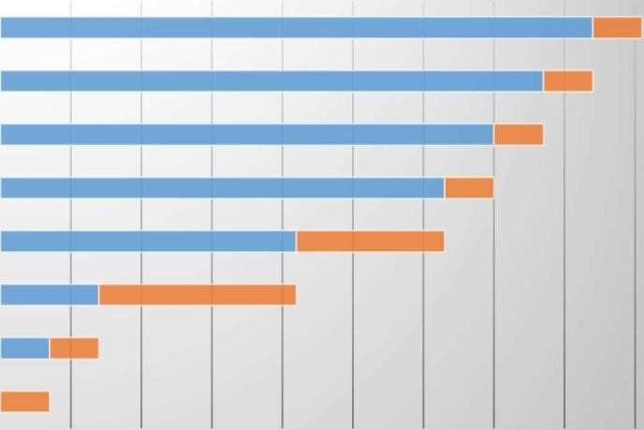

**Chart Title**

HOSTING A WEBSITE ON PUBLIC DOMAIN HAS BEEN

DONE

**88**

**-**

**Nov**

**-**

**20**

**7**

DATABASE CONNECTIVITY USING PHP AND LINK

-

UP OF ALL…

**06**

**-**

**Nov**

**-**

**20**

**7**

REMAINING DATABASE TABLES CREATION FOR PROJECT…

**01**

**-**

**Nov**

**-**

**20**

**7**

PROCEESING OF LOGIN PAGE AND CREATION OF DATABASE FOR…

**20**

**-**

**Oct**

**-**

**20**

**7**

DESIGNED DIFFERENT TYPES OF CSS FOR HOMEPAGE AND…

**17**

**-**

**Oct**

**-**

**20**

**21**

WEBLAYOUT DESIGN FOR PROJECT HAS

BEEN

COMPLETED

**09**

**-**

**Oct**

**-**

**20**

**28**

HOME PAGE CREATION

**01**

**-**

**Seppl**

**-**

**197**

F

OR

M

A

T

I

O

N

O

F

GR

O

U

P

A

N

D

F

I

N

A

L

I

Z

IN

G

T

H

E

P

R

O

J

C

E

T

T

I

T

**1**

L

E

**5**

**-**

**J**

07-Aug-20

**l**

**-**

**1**

**7**

**9**

**Fig1:- Gant chart( Activity report )**

## 3.3 Software and hardware requirements

**Hardware Requirement:**

1. I5 (processor).
2. Hard disk 5 GB
3. Laptop

**Software Requirements:**

1. Web Technologies:- Brackets
2. Language :- HTML , CSS, PHP, JAVASCRIPT
3. Database:- MYSQL
4. Web Server:- XAMPP
5. Operating System: -Windows 10, Linux

**Chapter 4**

# System design

## 4.1.1 Architecture Diagram:-

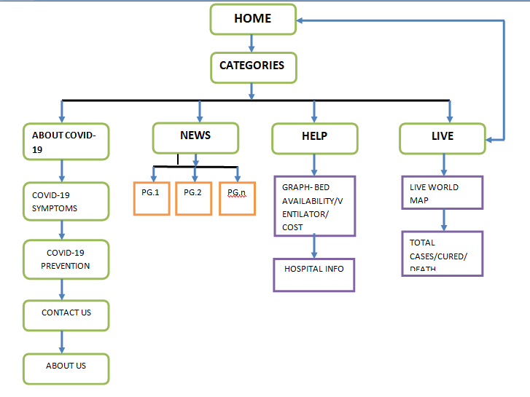

**Chapter 5**

# Implementations

## 5.1 software implementation-

**Home page code:**

<!DOCTYPE html>

<html>

<head>

<title>coronago</title>

<meta charset="utf-8">

<meta name="viewport" content="width=device-width, initial-scale=1.0">

<link rel="stylesheet" type="text/css" href="bootstrap-4.0.0-dist/css/bootstrap.min.css">

<link rel="stylesheet" type="text/css" href="bootstrap-4.0.0-dist/css/bootstrap.css">

<link href="https://fonts.googleapis.com/css2?family=Mulish&display=swap" rel="stylesheet">

<link rel="stylesheet" href="https://cdnjs.cloudflare.com/ajax/libs/font-awesome/4.7.0/css/font-awesome.css" integrity="sha512-5A8nwdMOWrSz20fDsjczgUidUBR8liPYU+WymTZP1lmY9G6Oc7HlZv156XqnsgNUzTyMefFTcsFH/tnJE/+xBg==" crossorigin="anonymous" />

<script type="text/javascript" src="bootstrap-4.0.0-dist/js/jquery-3.2.1.slim.min.js"></script>

<script type="text/javascript" src="bootstrap-4.0.0-dist/js/bootstrap.js"></script>

<script type="text/javascript" src="bootstrap-4.0.0-dist/js/bootstrap.min.js"></script>

<script type="text/javascript" src="bootstrap-4.0.0-dist/js/popper.min.js"></script>

<style type="text/css">

html {

scroll-behavior: smooth;

}

.row{

margin-right: 0!important;

margin-left: 0!important;

}

*{margin: 0; padding: 0; box-sizing: border-box; font-family: 'Mulish', sans-serif;

}

/*.....................................navbar.....................................*/

.nav_style{

background-color: #a29bfe !important ;

}

.nav_style a{ color:white !important;}

/*................................................slider.................................*/

.margin_top{

padding-top: 70px;

}

/*........main_header........... */

.main_header{

height: 450px;

width: 100%;

}

.rightside h1{

font-size: 3rem;

}

.roted img{

animation: rotation 3s linear infinite ;

}

@keyframes rotation{

0%{transform: rotate(0);}

100%{ transform: rotate(360deg); }

}

.leftside img{

animation: scaling 5s linear infinite ;

}

@keyframes scaling{

0%{transform: scale(.75);}

20%{transform: scale(1);}

40%{transform:scale(.75);}

60%{transform: scale(1);}

80%{transform: scale(.75);}

100%{transform: scale(.75);}

}

/*..................About section.................*/

.sub_section{

background-color:#F8F8F8;

}

#mybtn{

display: none;

position: fixed;

bottom: 30px;

right: 40px;

z-index: 99;

border:none;

outline: none;

background-color: #00A8FF;

color: white;

cursor: pointer;

padding: 10px;

border-radius: 10px;

}

#mybtn:hover{

background:#606060 ;

}

@media(max-width: 768px){

.main_header{height: 700px; text-align:center; }

.main_header h1{

text-align:center;

padding: 0;

width: 100%;

font-size: 30px;

}

}

/*..............................About us...................*/

.ourteam{

background-color:#F8F8F8;

padding: 100px 0px 60px;

height: 700px;

width: 100%;

}

.ourteam h1{

font-size: 50px;

font-weight: bold;

}

.ourteamset{

margin-top: 60px;

}

/*............................footer..................................*/

.footer_style{

background-color: #a29bfe!important;

}

.footer_style p{

margin-bottom: 0!important;

}

@media(min-width: 992px){

.carousel-caption h2{

font-size: 50px ;

font-weight: bold;

}

.carousel-caption p{

font-size: 30px;

}

}

@media(min-width:768px)and(max-width:991px){

}

@media(min-width:575px)and(max-width:767px){

}

@media(min-width:480px)and(max-width:574px){

}

@media(max-width:579px){

.carousel-caption h1{

font-size: 22px;

}

.carousel-caption h2{

font-size: 20px ;

font-weight: bold;

}

.carousel-caption p{

font-size: 12px;

}

}

@media(max-width:769px){

.ourteam{

height:1500px !important;

}

}

</style>

</head>

<body>

<!----------------------nav bar --------------------->

<nav class="navbar navbar-expand-sm navbar-dark bg-dark p-3 nav_style fixed-top">

<div class="container">

<a href="index.php" class="navbar-brand"><b>COVID-19</b></a>

<button class="navbar-toggler" data-toggle="collapse" data-target="#itemhide">

<span class="navbar-toggler-icon"></span>

</button>

<div class="collapse navbar-collapse " id="itemhide" >

<ul class="navbar-nav ml-auto" >

<li class="nav-item">

<a href="#aboutid" class="nav-link">About</a>

</li>

<li class="nav-item">

<a href="#symptonsid" class="nav-link">Symptoms</a>

</li>

<li class="nav-item">

<a href="#preventionid" class="nav-link">Prevention</a>

</li>

<li class="nav-item">

<a href="#contactid" class="nav-link">Contact</a>

</li>

<li class="nav-item">

<a href="#about_us" class="nav-link">AboutUs</a>

</li>

<li class="nav-item">

<a href="NEWS.html" class="nav-link"><b>NEWS</b></a>

</li>

<li class="nav-item">

<a href="hospitalstatus.php" class="nav-link"><b>HELP</b></a>

</li>

<li class="nav-item">

<a href="map.html" class="nav-link" style="background-color: #6762a3;"><b>LIVE.</b></a>

</li>

</div>

</ul>

</div>

</nav>

<!-- .........................................slider.............................. -->

<div id="carouselExampleIndicators" class="carousel slide margin_top" data-ride="carousel">

<ol class="carousel-indicators">

<li data-target="#carouselExampleIndicators" data-slide-to="0" class="active"></li>

<li data-target="#carouselExampleIndicators" data-slide-to="1"></li>

<li data-target="#carouselExampleIndicators" data-slide-to="2"></li>

<li data-target="#carouselExampleIndicators" data-slide-to="3"></li>

</ol>

<div class="carousel-inner" >

<div class="carousel-item active ">

<img class="d-block w-100 " src="images/coronago.jpg" alt="First slide">

<div class="carousel-caption">

<h2>Follow Rules & Avoid Covid-19</h2>

<p>stay alert stay safe</p>

</div>

</div>

<div class="carousel-item">

<img class="d-block w-100" src="images/coronago0k.jpg" alt="Second slide">

<div class="carousel-caption ">

<h2>Clean Hands Are Safe Hands</h2>

<p>stay alert stay safe</p>

</div>

</div>

<div class="carousel-item">

<img class="d-block w-100" src="images/coronago1k.jpg" alt="Third slide">

<div class="carousel-caption">

<h2>Know About Covid-19</h2>

<p>stay alert stay safe</p>

</div>

</div>

<div class="carousel-item">

<img class="d-block w-100" src="images/coronago2k.jpg" alt="forth slide">

<div class="carousel-caption">

<h2>War Against Covid-19</h2>

<p>stay alert stay safe</p>

</div>

</div>

</div>

</div>

<div class="main_header">

<div class="row h-100 w-100" >

<div class="col-xl-5 col-lg-5 col-md-5 col-sm-12 col-12 order-lg-1 order-2">

<div class="leftside w-100 h-100 d-flex justify-content-center align-items-center">

<img src="images/unity.png" width="300" height="300">

</div>

</div>

<div class="col-xl-7 col-lg-7 col-md-7 col-sm-12 col-12 order-lg-2 order-1">

<div class="rightside w-100 h-100 d-flex justify-content-center align-items-center">

<h1>Let's Stay Safe & Fight Together Against Cor<span class="roted"><img src="images/covid2.png" width="100" height="100">

</span>na Virus</h1>

</div>

</div>

</div>

</div>

<!--------About section---------->

<div class="container-fluid sub_section pt-5 pb-5 mt-1"id="aboutid">

<div class="section_header text-center mb-5 mt-4">

<h1><b>About COVID - 19</b></h1>

</div>

<div class="row pt-5">

<div class="col-lg-5 col-md-6 col-sm-6 col-12 pl-5">

<img src="images/coronadetail.png" class="img-fluid">

</div>

<div class="col-lg-6 col-md-6 col-sm-6 col-12">

<h2>What is COVID-19 (Corona-Virus)</h2>

<p>COVID-19 is the infectious disease caused by the most recently discovered coronavirus. This new virus and disease were unknown before the outbreak began in Wuhan, China, in December 2019 </p>

<p>Most people infected with the COVID-19 virus will experience mild to moderate respiratory illness and recover without requiring special treatment. Older people, and those with underlying medical problems like cardiovascular disease, diabetes, chronic respiratory disease, and cancer are more likely to develop serious illness.</p>

</div>

</div>

</div>

<!-- ..................corona symptons ..............-->

<div class="container-fluid pt-5 pb-5 mt-1"id="symptonsid">

<div class="section_header text-center mb-5 mt-4">

<h1><b>Coronavirus Symptoms</b></h1>

</div>

<div class="container">

<div class="row">

<div class="col-lg-4 col-md-4 col-12 mt-5">

<figure class="text-center">

<img src="images/cough.png" class="img-fluid" width="120" height="120">

<figcaption>Cough</figcaption>

</figure>

</div>

<div class="col-lg-4 col-md-4 col-12 mt-5">

<figure class="text-center">

<img src="images/runnynose1.png" class="img-fluid" width="90" height="90">

<figcaption>Runny nose</figcaption>

</figure>

</div>

<div class="col-lg-4 col-md-4 col-12 mt-5">

<figure class="text-center">

<img src="images/fever.svg" class="img-fluid" width="120" height="110">

<figcaption>Fever</figcaption>

</figure>

</div>

<div class="col-lg-4 col-md-4 col-12 mt-5">

<figure class="text-center">

<img src="images/cold.png" class="img-fluid" width="105" height="105">

<figcaption>Cold</figcaption>

</figure>

</div>

<div class="col-lg-4 col-md-4 col-12 mt-5">

<figure class="text-center">

<img src="images/Tiredness.png" class="img-fluid" width="120" height="120">

<figcaption>Tiredness</figcaption>

</figure>

</div>

<div class="col-lg-4 col-md-4 col-12 mt-5">

<figure class="text-center">

<img src="images/breathing.png" class="img-fluid" width="120" height="120">

<figcaption>Difficulty Breathing (Severe Cases)</figcaption>

</figure>

</div>

</div>

</div>

</div>

<!-- 6 Steps Prevention Against Coronavirus .............-->

<div class="container-fluid pt-5 pb-5 mt-1 sub_section"id="preventionid">

<div class="section_header text-center mb-5 mt-4">

<h1><b>6 Steps Prevention Against Coronavirus</b></h1>

</div>

<div class="container">

<div class="row">

<div class="col-lg-4 col-md-4 col-12 mt-5">

<div class="row">

<div class="col-lg-4 col-md-4 col-12">

<figure class="text-center">

<img src="images/handwash.png" class="img-fluid" width="90" height="90">

</figure>

</div>

<div class="col-lg-8 col-md-8 col-12">

<p> Wash your hands regularly for 20 seconds, With soap and water or alcohol-based hand rub</p>

</div>

</div>

</div>

<div class="col-lg-4 col-md-4 col-12 mt-5">

<div class="row">

<div class="col-lg-4 col-md-4 col-12">

<figure class="text-center">

<img src="images/mask.png" class="img-fluid" width="90" height="90">

</figure>

</div>

<div class="col-lg-8 col-md-8 col-12">

<p> Cover your nose and mouth with a disposable tissue or flexed elbow when you cough or sneeze</p>

</div>

</div>

</div>

<div class="col-lg-4 col-md-4 col-12 mt-5">

<div class="row">

<div class="col-lg-4 col-md-4 col-12">

<figure class="text-center">

<img src="images/distance.png" class="img-fluid" width="90" height="90">

</figure>

</div>

<div class="col-lg-8 col-md-8 col-12">

<p> Avoid close contact(1 meter or 3 feet) with people who are unwell</p>

</div>

</div>

</div>

<div class="col-lg-4 col-md-4 col-12 mt-5">

<div class="row">

<div class="col-lg-4 col-md-4 col-12">

<figure class="text-center">

<img src="images/home.png" class="img-fluid" width="100" height="100">

</figure>

</div>

<div class="col-lg-8 col-md-8 col-12">

<p> Stay home and self-isolate from others in the household if you feel unwell</p>

</div>

</div>

</div>

<div class="col-lg-4 col-md-4 col-12 mt-5">

<div class="row">

<div class="col-lg-4 col-md-4 col-12">

<figure class="text-center">

<img src="images/tvnews.png" class="img-fluid" width="100" height="100">

</figure>

</div>

<div class="col-lg-8 col-md-8 col-12">

<p> Stay informed by watching news & follow the recommended practices</p>

</div>

</div>

</div>

<div class="col-lg-4 col-md-4 col-12 mt-5">

<div class="row">

<div class="col-lg-4 col-md-4 col-12">

<figure class="text-center">

<img src="images/seek.png" class="img-fluid" width="90" height="90">

</figure>

</div>

<div class="col-lg-8 col-md-8 col-12">

<p> If you have fever, cough and difficulty breathing, seek medical care early</p>

</div>

</div>

</div>

</div>

</div>

</div>

<!-- ........................Contact Us ASAP.................... -->

<div class="container-fluid pt-5 pb-5 mt-1 "id="contactid">

<div class="section_header text-center mb-5 mt-4">

<h1><b>Contact Us ASAP</b></h1>

</div>

<div class="container">

<div class="row">

<div class="col-lg-8 offset-lg-2 col-12">

<form action="" method="POST">

<div class="form-group">

<label>Username:</label>

<input type="text" class="form-control" placeholder="name" name="username" autocomplete="off" required>

</div>

<div class="form-group">

<label>Mobile no:</label>

<input type="number" class="form-control" placeholder="mobile" name="mobile" autocomplete="off" required>

</div>

<div class="form-group">

<label>Email:</label>

<input type="email" class="form-control" placeholder="name@example.com" name="email" required>

</div>

<div class="form-group">

<label> Select Symptoms:</label><br>

<div class="custom-control custom-checkbox

custom-control-inline text-capitalize">

<input type="checkbox" class="custom-control-input" id="customcheckbox1" name="coronasym[]" value="cold">

<label class="custom-control-label" for="customcheckbox1">Cold</label>

</div>

<div class="custom-control custom-checkbox

custom-control-inline text-capitalize">

<input type="checkbox" class="custom-control-input" id="customcheckbox2" name="coronasym[]" value="fever">

<label class="custom-control-label" for="customcheckbox2">Fever</label>

</div>

<div class="custom-control custom-checkbox

custom-control-inline text-capitalize">

<input type="checkbox" class="custom-control-input" id="customcheckbox3" name="coronasym[]" value="breath">

<label class="custom-control-label" for="customcheckbox3">Difficulty in Breath</label>

</div>

<div class="custom-control custom-checkbox

custom-control-inline text-capitalize">

<input type="checkbox" class="custom-control-input" id="customcheckbox4" name="coronasym[]" value="weak">

<label class="custom-control-label" for="customcheckbox4">Feeling Weak</label>

</div>

</div>

<div class="form-group">

<label for="exampleFormControlTextarea1">Address:</label>

<textarea class="form-control" id="exampleFormControlTextarea1" rows="3" name="msg"></textarea>

</div>

<button type="submit" class="btn btn-primary" name="submit">Submit</button>

</form>

</div>

</div>

</div>

</div>

<!-- ............................about us.....................................-->

<section class="ourteam" id="about_us">

<div class="container text-center">

<h1>OUR AMAZING TEAM</h1>

<p>great team great work</p>

<div class="row ourteamset">

<div class="col-lg-4 col-md-4 col-sm-10 col-12 d-block m-auto">

<figure class="figure">

<img src="images/sidhart.jpg" height="250px" width="250px" class="figure-img img-fluid rounded-circle">

<figcaption>

<h4>Siddharth Soni</h4>

<p class="figure-caption">Web Designer</p>

</figcaption>

</figure>

</div>

<div class="col-lg-4 col-md-4 col-sm-10 col-12 d-block m-auto">

<figure class="figure">

<img src="images/PritamTuralkar.jpg" height="250px" width="250px" class="figure-img img-fluid rounded-circle">

<figcaption>

<h4>Pritam Turalkar</h4>

<p class="figure-caption">Head of Project</p>

<p class="figure-caption">Web Designer/Developer</p>

</figcaption>

</figure>

</div>

<div class="col-lg-4 col-md-4 col-sm-10 col-12 d-block m-auto">

<figure class="figure">

<img src="images/pratiku.jpg" height="250px" width="250px" class="figure-img img-fluid rounded-circle">

<figcaption>

<h4>Pratik Utekar</h4>

<p class="figure-caption">Web Designer</p>

</figcaption>

</figure>

</div>

</div>

</div>

</div>

</section>

<!-- .............top cursor.............. -->

<div class="container scrolltop float-right pr-5">

<i class="fa fa-arrow-up" onclick="topFunction()" id="mybtn"></i>

</div>

<!-- ......................footer......................... -->

<footer class="mt-5">

<div class="footer_style text-white text-center container-fluid">

<p>@copyright by pritam groups 2020-2021</p>

</div>

</footer>

<script type="text/javascript">

mybutton=document.getElementById("mybtn");

window.onscroll=function(){scrollFunction()};

function scrollFunction()

{

if(document.body.scrollTop >100 || document.documentElement.scrollTop>100){

mybutton.style.display="block";

}else

{

mybutton.style.display="none";

}

}

function topFunction(){

document.body.scrollTop =0 ;

document.documentElement.scrollTop =0;

}

</script>

</body>

</html>

<?php

include 'dbcon.php';

if(isset($_POST['submit'])){

$username=$_POST['username'];

$mobile=$_POST['mobile'];

$email=$_POST['email'];

$symp=$_POST['coronasym'];

$msg=$_POST['msg'];

$chk="";

foreach ($symp as $chk1) {

$chk .= $chk1.",";

}

$insertquery="insert into coronacase(username, mobile, email, symp, address )

values('$username','$mobile','$email','$chk','$msg') ";

$query=mysqli_query($con, $insertquery);

if($query){

?>

<script type="text/javascript">alert("inserted successfuly");</script>

<?php

}else{

?>

<script type="text/javascript">alert("insertion fail");</script>

<?php

}

}

?>



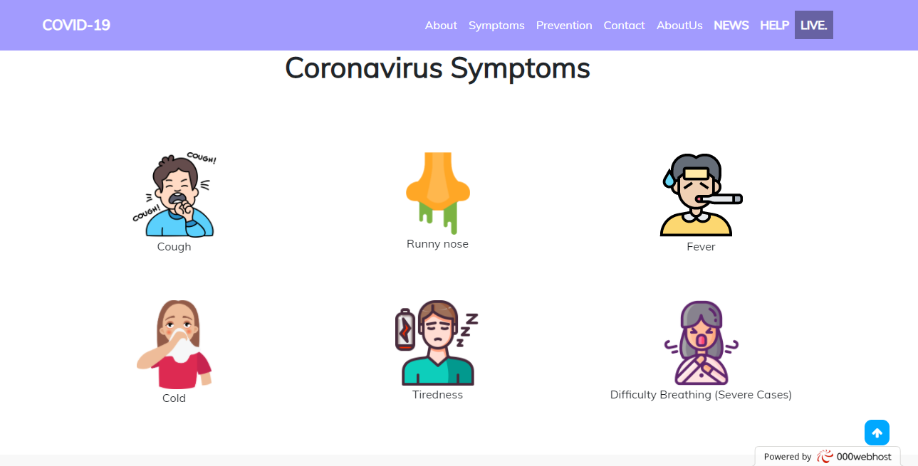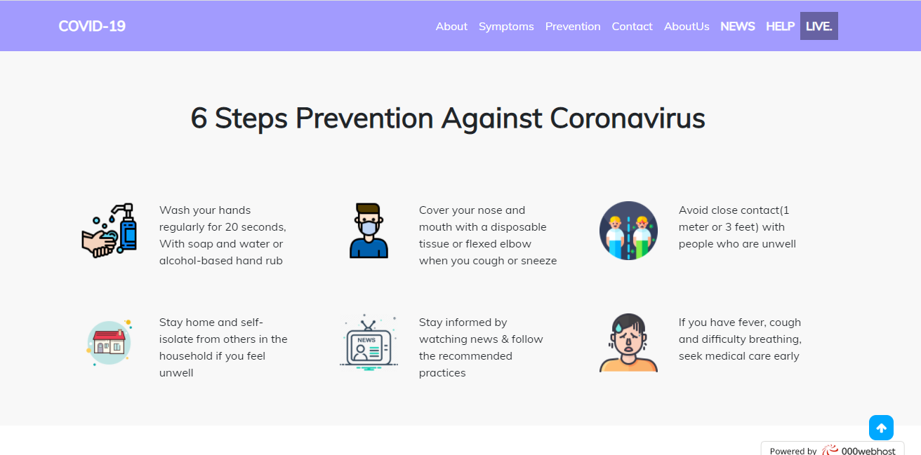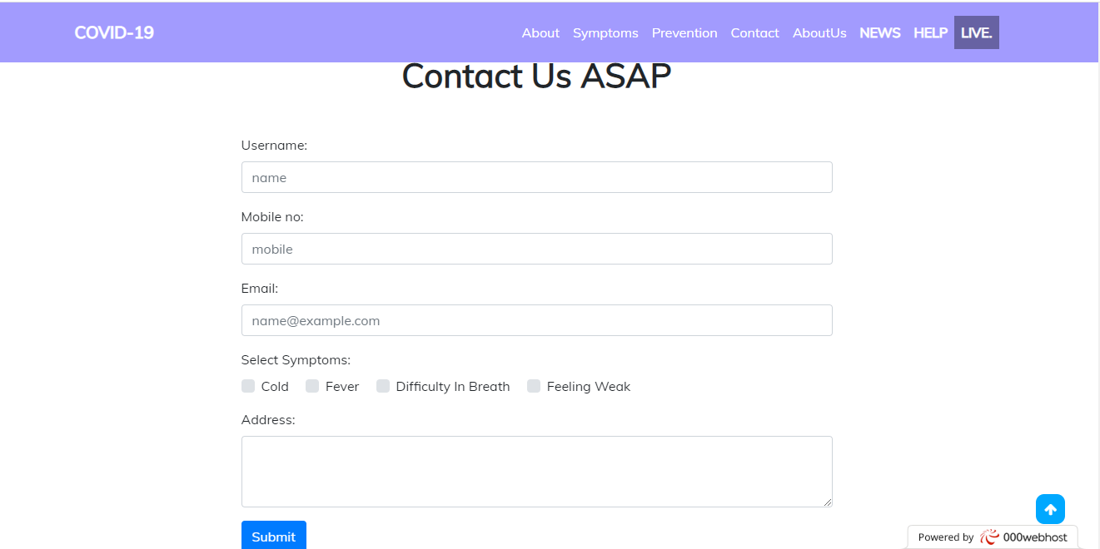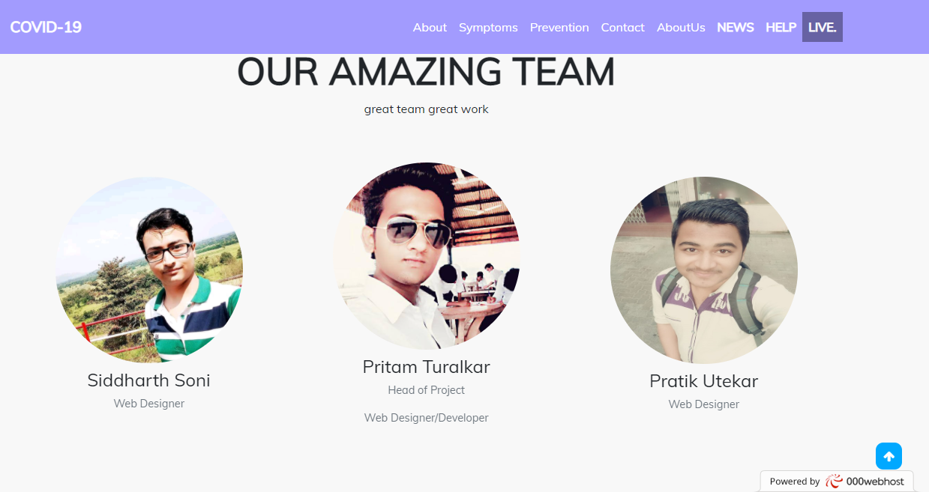

Fig1: Homepage

**Database Connection:**

<?php

$server='localhost';

$user='root';

$password='';

$db='coronadb';

$con=mysqli_connect($server,$user,$password,$db);

/*if($con){

?>

<script type="text/javascript">alert("connection succesful");</script>

<?php

}else{

?>

<script type="text/javascript">alert("connection fail");</script>

<?php

}

*/

?>

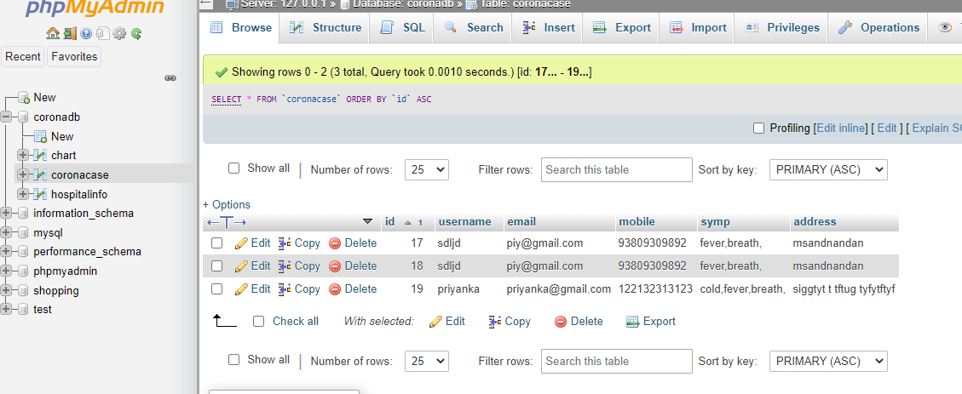

Fig2: Patient contact detail

**NEWS Page code:**

<html>

<head>

<meta charset="utf-8">

<meta http-equiv="X-UA-Compatible" content="IE=edge">

<meta name="viewport" content="width=device-width, initial-scale=1">

<title>NEWS</title>

<link href="https://fonts.googleapis.com/css2?family=Mulish&display=swap" rel="stylesheet">

<link rel="stylesheet" href="https://maxcdn.bootstrapcdn.com/bootstrap/4.0.0/css/bootstrap.min.css" integrity="sha384-Gn5384xqQ1aoWXA+058RXPxPg6fy4IWvTNh0E263XmFcJlSAwiGgFAW/dAiS6JXm" crossorigin="anonymous">

<link rel="stylesheet" href="https://stackpath.bootstrapcdn.com/font-awesome/4.7.0/css/font-awesome.min.css">

<script src="https://code.jquery.com/jquery-3.2.1.slim.min.js" integrity="sha384-KJ3o2DKtIkvYIK3UENzmM7KCkRr/rE9/Qpg6aAZGJwFDMVNA/GpGFF93hXpG5KkN" crossorigin="anonymous"></script>

<script src="https://cdnjs.cloudflare.com/ajax/libs/popper.js/1.12.9/umd/popper.min.js" integrity="sha384-ApNbgh9B+Y1QKtv3Rn7W3mgPxhU9K/ScQsAP7hUibX39j7fakFPskvXusvfa0b4Q" crossorigin="anonymous"></script>

<script src="https://maxcdn.bootstrapcdn.com/bootstrap/4.0.0/js/bootstrap.min.js" integrity="sha384-JZR6Spejh4U02d8jOt6vLEHfe/JQGiRRSQQxSfFWpi1MquVdAyjUar5+76PVCmYl" crossorigin="anonymous"></script>

<style>

* {

font-family: 'Mulish', sans-serif;

}

body

{

background-color: white;

}

.single-blog

{

box-shadow: 0px 0px 20px 1px rgba(0,0,0,0.2);

padding: 10px;

margin-top: 30px;

background-color: #fff;

}

.single-blog1

{

box-shadow: 0px 0px 20px 1px rgba(0,0,0,0.2);

border: 1px ;

margin-top: 10px;

background-color: #fff;

}

.single-blog img

{

width:100%;

}

.single-blog1 img

{

width:100%;

}

.blog-meta

{

font-size: 14px;

margin-bottom: 2px;

}

.single-blog span

{

float:right;

font-size: 12px;

color: cornflowerblue;

}

.single-blog1 span

{

float:right;

font-size: 12px;

color: cornflowerblue;

}

.blog-text

{

font-size: 14px;

text-align: justify ;

}

.single-blog h2

{

margin-top: 10px;

font-size: 16px;

color: #007bff;

}

.single-blog h2 a

{

text-decoration: none;

}

.read-more-btn

{

background-image: linear-gradient(to right, #1c03b5,#5c8bef);

padding: 5px 12px 8px;

border-radius: 20px;

line-height: 20px;

font-size: 14px;

color:#fff;

border:none !important;

}

.read-more-btn:hover

{

background-image: linear-gradient(to right, #006417,

#00b128);

text-decoration: none;

color:#fff;

}

/*.....................................navbar.....................................*/

.nav_style{

background-color: #a29bfe !important ;

}

.nav_style a{

color: white !important;

}

/*............................footer..................................*/

.footer_style{

background-color: #a29bfe!important;

width: 100% !important;

}

.footer_style p{

margin-bottom: 0!important;

text-align: center;

}

/*......................scrolltop button...................................................*/

#mybtn:hover{

background:#606060 ;

}

#mybtn{

display: none;

position: fixed;

bottom: 30px;

right: 40px;

z-index: 99;

border:none;

outline: none;

background-color: #00A8FF;

color: white;

cursor: pointer;

padding: 10px;

border-radius: 10px;

}

</style>

</head>

<body>

<!----------------------nav bar --------------------->

<nav class="navbar navbar-expand-sm navbar-dark bg-dark p-3 nav_style fixed-top">

<div class="container">

<a href="index.php" class="navbar-brand"><b>COVID-19</b></a>

<button class="navbar-toggler" data-toggle="collapse" data-target="#itemhide">

<span class="navbar-toggler-icon"></span>

</button>

<div class="collapse navbar-collapse " id="itemhide" >

<ul class="navbar-nav ml-auto" >

<li class="nav-item">

<a href="index.php#aboutid" class="nav-link">About</a>

</li>

<li class="nav-item">

<a href="index.php#symptonsid" class="nav-link">Symptoms</a>

</li>

<li class="nav-item">

<a href="index.php#preventionid" class="nav-link">Prevention</a>

</li>

<li class="nav-item">

<a href="index.php#contactid" class="nav-link">Contact</a>

</li>

<li class="nav-item">

<a href="index.php#about_us" class="nav-link">AboutUs</a>

</li>

<li class="nav-item">

<a href="NEWS.html" class="nav-link" ><b>NEWS</b></a>

</li>

<li class="nav-item">

<a href="hospitalstatus.php" class="nav-link"><b>HELP</b></a>

</li>

<li class="nav-item">

<a href="map.html" class="nav-link" style="background-color: #6762a3;"><b>LIVE.</b></a>

</li>

</div>

</ul>

</div>

</nav>

<div class="container">

<br>

<br>

<div class="row">

<div class="col-md-7">

<div class="single-blog1">

<a href="https://www.youtube.com/watch?v=MRkoyixoWPc&ab_channel=BBCNews"><img src="newsimg/nwsmap.PNG" height="500" ></a>

</div>

</div>

<div class="col-md-5">

<div class="single-blog1">

<a href="https://www.youtube.com/watch?v=C5YqcZeEAz0"><img src="newsimg/18.webp" width="100" height="250" ></a>

</div>

<div class="single-blog1">

<a href="https://www.youtube.com/watch?v=oW3aIG8LkGE"><img src="newsimg/22.webp" width="100" height="240" ></a>

</div>

</div>

<div class="col-md-4">

<div class="single-blog">

<a href="

https://www.youtube.com/watch?v=fEhBivmJ864"><img src="newsimg/29.webp" ></a>

<h2><a href="https://www.youtube.com/watch?v=fEhBivmJ864">WHO update on latest developments in the Covid-19 pandemic </a></h2>

<p class ="blog-text">Top officials from the World Health Organization (WHO), including director-general Tedros Adnahom Ghebreyesus, give a press briefing on Covid-19.

</p>

</div>

</div>

<div class="col-md-4">

<div class="single-blog">

<a href="https://www.youtube.com/watch?v=5DGwOJXSxqg"><img src="newsimg/mqdefault_6s (1).webp" ></a>

<h2><a href="https://www.youtube.com/watch?v=5DGwOJXSxqg">COVID-19 Animation: What Happens If You Get Coronavirus?</a></h2>

<p class ="blog-text">This video 3D animation on COVID-19: What Happens If You Get Coronavirus is a collaboration between Nucleus Medical Media and our friends.</p>

</div>

</div>

<div class="col-md-4">

<div class="single-blog">

<a href="https://www.youtube.com/watch?v=GUWKL3Fu9WA"><img src="newsimg/1.webp" ></a>

<h2><a href="https://www.youtube.com/watch?v=GUWKL3Fu9WA">Global coronavirus cases surpassed 400,000</a></h2>

<p class ="blog-text">Global coronavirus cases surpassed 400,000, according to data collated by Johns Hopkins University. Almost 17,000 people have now died, while more than 100,000 have recovered.

</p>

</div>

</div>

<div class="col-md-4">

<div class="single-blog">

<a href="https://www.youtube.com/watch?v=oujlUWnlcEk"><img src="newsimg/2.webp" ></a>

<h2><a href="https://www.youtube.com/watch?v=oujlUWnlcEk">Worldwide coronavirus cases keep surging, forcing new restrictions and lockdowns</a></h2>

<p class ="blog-text">Worldwide coronavirus infections have passed 30 million according to the latest figures from Johns Hopkins University.

</p>

</div>

</div>

<div class="col-md-4">

<div class="single-blog">

<a href="

https://www.youtube.com/watch?v=1DJGd9_XoiI"><img src="newsimg/3.webp" ></a>

<h2><a href="https://www.youtube.com/watch?v=1DJGd9_XoiI">Coronavirus around the world</a></h2>

<p class ="blog-text">Britain has surpassed Italy’s coronavirus death toll with over 32,000 deaths, making the UK the country with the highest number of COVID-19 related deaths in Europe.

</p>

</div>

</div>

<div class="col-md-4">

<div class="single-blog">

<a href="https://www.youtube.com/watch?v=QjEfy54R3mc"><img src="newsimg/30.webp" ></a>

<h2><a href="https://www.youtube.com/watch?v=QjEfy54R3mc">Johnson & Johnson pauses COVID-19 vaccine trial</a></h2>

<p class ="blog-text">A late-stage study of Johnson & Johnson's COVID-19 vaccine candidate has been paused while the company investigates about that. </p>

</div>

</div>

<div class="col-md-4">

<div class="single-blog">

<a href="

https://www.youtube.com/watch?v=KtOVzPJfKmI"><img src="newsimg/8.webp" ></a>

<h2><a href="https://www.youtube.com/watch?v=KtOVzPJfKmI">Coronavirus India Update: Russia Corona Vaccine के असर पर India का क्या कहना है?</a></h2>

<p class ="blog-text">भारत में कोरोना के नए मामले रोज़ नया रिकॉर्ड बना रहे हैं. अब एक दिन में 90 हज़ार से ज्यादा मामले सामने आए हैं और दुनिया में अमरीका के बाद कोरोना सबसे ज़्यादा

</p>

</div>

</div>

<div class="col-md-4">

<div class="single-blog">

<a href="https://www.youtube.com/watch?v=Zex4BKIZAsg"><img src="newsimg/24.webp" ></a>

<h2><a href="https://www.youtube.com/watch?v=Zex4BKIZAsg">Travel & migration: COVID-19 pandemic</a></h2>

<p class ="blog-text">00:00 The Spanish government says the country is safe to visit, despite a surge in coronavirus cases. The statement comes after the UK reimposed a quarantine on travellers returning from Spain. </p>

</div>

</div>

<div class="col-md-4">

<div class="single-blog">

<a href="https://www.youtube.com/watch?v=xHCXO49mOUU"><img src="newsimg/25.webp" ></a>

<h2><a href="https://www.youtube.com/watch?v=xHCXO49mOUU">If China’s coronavirus vaccines work, which countries will get them and for how much?</a></h2>

<p class ="blog-text">Among about 300 coronavirus vaccine candidates being developed around the world, at least nine were undergoing phase 3 human trials .

</div>

</div>

<div class="col-md-4">

<div class="single-blog">

<a href="https://www.youtube.com/watch?v=oSHXOlnmNXI"><img src="newsimg/26.webp" ></a>

<h2><a href="https://www.youtube.com/watch?v=oSHXOlnmNXI">What If You Hospitalized With COVID-19?</a></h2>

<p class ="blog-text">This scenario shows what might happen in the hospital in the unlikely event that you develop severe COVID-19 symptoms. What treatments can improve your condition?

</p>

</div>

</div>

<div class="col-md-4">

<div class="single-blog">

<a href="

https://www.youtube.com/watch?v=mbLMnxhDgGk"><img src="newsimg/27.webp" ></a>

<h2><a href="https://www.youtube.com/watch?v=mbLMnxhDgGk">What if a COVID-19 Vaccine Is Never Developed?</a></h2>

<p class ="blog-text">The Coronavirus Pandemic is still in full force and scientists and researchers are doing whatever they can to develop a vaccine.

</p>

</div>

</div>

<div class="col-md-4">

<div class="single-blog">

<a href="

https://www.youtube.com/watch?v=fPbYaTKKtmA"><img src="newsimg/28.webp" ></a>

<h2><a href="https://www.youtube.com/watch?v=fPbYaTKKtmA">Corona Virus Disease / COVID-19: Sahi aur Galath coronavirus disease ke baare me</a></h2>

<p class ="blog-text">How COVID-19 Spreads

----------------------------------------

Person-to-person spread

The virus is thought to spread mainly from person-to-person.

</p>

</div>

</div>

<div class="col-md-4">

<div class="single-blog">

<a href="https://www.youtube.com/watch?v=BKxnX3-yvng"><img src="newsimg/31.webp" ></a>

<h2><a href="https://www.youtube.com/watch?v=BKxnX3-yvng">Coronavirus - The Latest: Is England heading for a two-week lockdown?</a></h2>

<p class ="blog-text">Coronavirus podcast will analysis the impact on health, business and travel in the UK and beyond

</p>

</div>

</div>

<div class="col-md-4">

<div class="single-blog">

<a href="

https://www.youtube.com/watch?v=AM0nGSvO6ts"><img src="newsimg/4.webp" ></a>

<h2><a href="https://www.youtube.com/watch?v=AM0nGSvO6ts">India COVID epicenter 90,000 daily cases </a></h2>

<p class ="blog-text">India is on way to becoming world's largest Covid-19 hotspot. With 4.3 million cases, India surpassed Brazil with 2nd-highest number of infections.

</p>

</div>

</div>

<div class="col-md-4">

<div class="single-blog">

<a href="

https://www.youtube.com/watch?v=aK8roDIeXL8"><img src="newsimg/36.webp" ></a>

<h2><a href="https://www.youtube.com/watch?v=aK8roDIeXL8">Dr. Izzy Gerstenbluth: Latest updates COVID-19 | 20-10-2020</a></h2>

<p class ="blog-text">Dr. Izzy Gerstenbluth shares the current situation in Curaçao regarding corona virus.

</p>

</div>

</div>

</div>

</div>

<!-- ......................footer......................... -->

<footer class="mt-5">

<div class="footer_style text-white text-center container-fluid">

<p>@copyright by pritam groups 2020-2021</p>

</div>

</footer>

<!-- .............top cursor.............. -->

<div class="container scrolltop float-right pr-5">

<i class="fa fa-arrow-up" onclick="topFunction()" id="mybtn"></i>

</div>

<script type="text/javascript">

mybutton=document.getElementById("mybtn");

window.onscroll=function(){scrollFunction()};

function scrollFunction()

{

if(document.body.scrollTop >100 || document.documentElement.scrollTop>100){

mybutton.style.display="block";

}else

{

mybutton.style.display="none";

}

}

function topFunction(){

document.body.scrollTop =0 ;

document.documentElement.scrollTop =0;

}

</script>

</body>

</html>

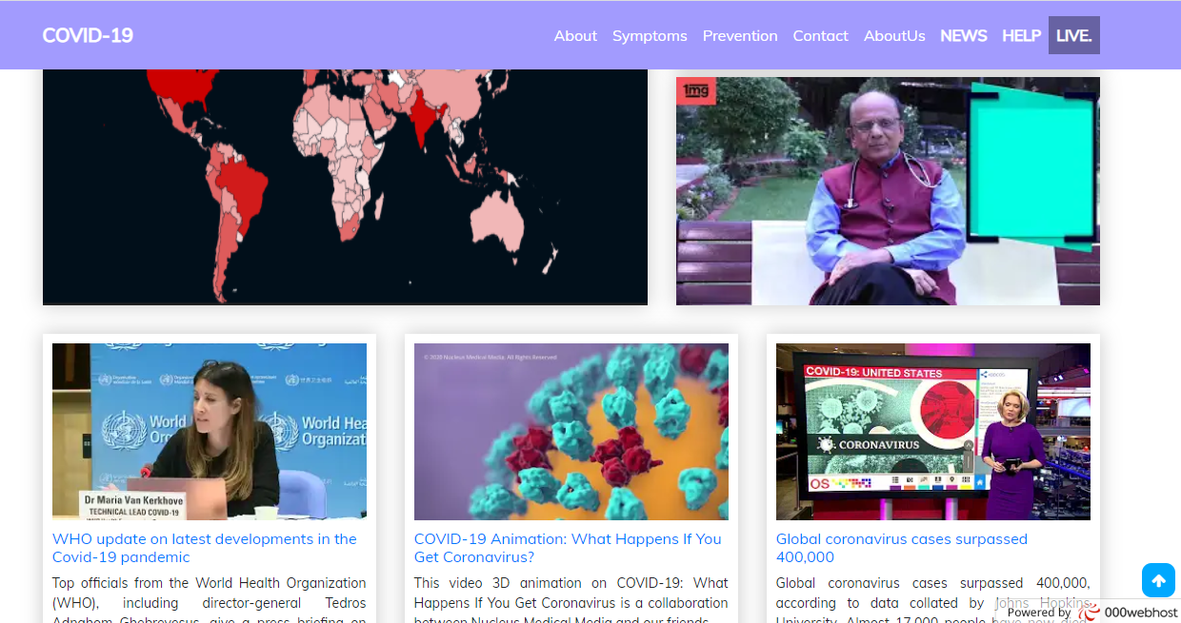

Fig3: NEWS PAGE

**HELP(Hospital Status):**

<!DOCTYPE html>

<html>

<head>

<title>hospital information</title>

<meta charset="utf-8">

<meta name="viewport" content="width=device-width, initial-scale=1.0">

<link rel="stylesheet" type="text/css" href="bootstrap-4.0.0-dist/css/bootstrap.min.css">

<link rel="stylesheet" type="text/css" href="bootstrap-4.0.0-dist/css/bootstrap.css">

<link href="https://fonts.googleapis.com/css2?family=Mulish&display=swap" rel="stylesheet">

<link rel="stylesheet" href="https://cdnjs.cloudflare.com/ajax/libs/font-awesome/4.7.0/css/font-awesome.css" integrity="sha512-5A8nwdMOWrSz20fDsjczgUidUBR8liPYU+WymTZP1lmY9G6Oc7HlZv156XqnsgNUzTyMefFTcsFH/tnJE/+xBg==" crossorigin="anonymous" />

<link rel="stylesheet" href="//cdnjs.cloudflare.com/ajax/libs/morris.js/0.5.1/morris.css">

<script type="text/javascript" src="bootstrap-4.0.0-dist/js/jquery-3.2.1.slim.min.js"></script>

<script type="text/javascript" src="bootstrap-4.0.0-dist/js/bootstrap.js"></script>

<script type="text/javascript" src="bootstrap-4.0.0-dist/js/bootstrap.min.js"></script>

<script type="text/javascript" src="bootstrap-4.0.0-dist/js/popper.min.js"></script>

<script src="//cdnjs.cloudflare.com/ajax/libs/raphael/2.1.0/raphael-min.js"></script>

<script src="//cdnjs.cloudflare.com/ajax/libs/morris.js/0.5.1/morris.min.js"></script>

<style type="text/css">

/*table{

border-collapse:collapse;

width:50%;

color:red;

font-family: monospace;

font-size: 25px;

text-align: left;

}

th{

background-color: #588c7e;

color: white;

}

tr:nth-child(even){

background-color:#f2f2f2 ;

width: 100%;

}*/

* {

font-family: 'Mulish', sans-serif;

}

body

{

background-color: white;

}

#custom {

font-family: Arial, Helvetica, sans-serif;

border-collapse: collapse;

width: 100%;

margin-top: fixed;

}

#custom td, #custom th {

border: 1px solid #ddd;

padding: 8px;

}

#custom tr:nth-child(even){background-color: #f2f2f2;}

#custom tr:hover {background-color: #ddd;}

#custom th {

padding-top: 12px;

padding-bottom: 12px;

text-align: left;

background-color: #4CAF50;

color: white;

}

/*.....................................navbar.....................................*/

.nav_style{

background-color: #a29bfe !important ;

}

.nav_style a{ color:white !important;}

/*............................footer..................................*/

.footer_style{

background-color: #a29bfe!important;

width: 100% !important;

}

.footer_style p{

margin-bottom: 0!important;

text-align: center;

}

/*......................scrolltop button...................................................*/

#mybtn:hover{

background:#606060 ;

}

#mybtn{

display: none;

position: fixed;

bottom: 30px;

right: 40px;

z-index: 99;

border:none;

outline: none;

background-color: #00A8FF;

color: white;

cursor: pointer;

padding: 10px;

border-radius: 10px;

}

/*-------------------------------------------graph --------------------------------------*/

.highcharts-figure, .highcharts-data-table table {

min-width: 360px;

max-width: 800px;

margin: 1em auto;

}

.highcharts-data-table table {

font-family: Verdana, sans-serif;

border-collapse: collapse;

border: 1px solid #EBEBEB;

margin: 10px auto;

text-align: center;

width: 100%;

max-width: 500px;

}

.highcharts-data-table caption {

padding: 1em 0;

font-size: 1.2em;

color: #555;

}

.highcharts-data-table th {

font-weight: 600;

padding: 0.5em;

}

.highcharts-data-table td, .highcharts-data-table th, .highcharts-data-table caption {

padding: 0.5em;

}

.highcharts-data-table thead tr, .highcharts-data-table tr:nth-child(even) {

background: #f8f8f8;

}

.highcharts-data-table tr:hover {

background: #f1f7ff;

}

/*

.chart{

margin: 30px auto;

width: 1300px;

height: 450px;

}

#chart_wrap{

padding-bottom: 40%;

height: 0;

top: 0;

left: 0;

}

#curve_chart{

top: 0;

left: 0;

width: 100%;

height: 500px;

}

*/

@media(max-width:1650px){

#chart_wrap{

padding-bottom: 5%;

top: 0;

left: 0;

}

#curve_chart{

width: 100%;

height: 500px;

}

}

@media(max-width:280px){

#chart_wrap{

padding-bottom: 5%;

top: 0;

left: 0;

}

#curve_chart{

width: 100%;

height: 500px;

}

}

@media(max-width:360px){

#curve_chart{

width: 100%;

height: 500px;

}

.conte{

padding-top:0%;

}

}

@media(max-width:420px){

#chart_wrap{

padding-bottom: 5%;

top: 0;

left: 0;

}

#curve_chart{

width: 100%;

height: 500px;

}

}

}

@media(max-width:580px){

#chart_wrap{

padding-bottom: 5%;

top: 0;

left: 0;

}

#curve_chart{

width: 100%;

height: 500px;

}

}

@media(max-width:780px){

#chart_wrap{

padding-bottom: 5%;

top: 0;

left: 0;

}

#curve_chart{

width: 100%;

height: 500px;

}

}

@media(max-width:1024px){

#chart_wrap{

padding-bottom: 5%;

top: 0;

left: 0;

}

#curve_chart{

width: 100%;

height: 500px;

}

}

</style>

<script type="text/javascript" src="https://www.gstatic.com/charts/loader.js"></script>

<script type="text/javascript">

google.charts.load('current', {'packages':['corechart']});

google.charts.setOnLoadCallback(drawChart);

function drawChart() {

var data = google.visualization.arrayToDataTable([

['month', 'Bed Availability', 'Ventilator','Test cost'],

<?php

include 'dbcon.php';

$query="select * from chart";

$res=mysqli_query($con,$query);

while($data=mysqli_fetch_array($res)){

$month=$data['month'];

$vacancy=$data['total_vacancy'];

$ventilator=$data['total_ventilator'];

$cost=$data['cost'];

?>

['<?php echo $month;?>',<?php echo $vacancy;?>,<?php echo $ventilator; ?>,<?php echo $cost;?>],

<?php

}

?>

]);

var options = {

title: 'Total Bed Availability, Ventilator, Test cost per month in [2020] Jan to Nov',

curveType: 'function',

legend: { position: 'bottom' }

};

var chart = new google.visualization.LineChart(document.getElementById('curve_chart'));

chart.draw(data, options);

}

$(window).resize(function(){

drawChart1();

drawChart2();

});

</script>

</head>

<body>

<!----------------------nav bar --------------------->

<nav class="navbar navbar-expand-sm navbar-dark bg-dark p-3 nav_style fixed-top">

<div class="container">

<a href="index.php" class="navbar-brand"><b>COVID-19</b></a>

<button class="navbar-toggler" data-toggle="collapse" data-target="#itemhide">

<span class="navbar-toggler-icon"></span>

</button>

<div class="collapse navbar-collapse " id="itemhide" >

<ul class="navbar-nav ml-auto" >

<li class="nav-item">

<a href="index.php#aboutid" class="nav-link">About</a>

</li>

<li class="nav-item">

<a href="index.php#symptonsid" class="nav-link">Symptoms</a>

</li>

<li class="nav-item">

<a href="index.php#preventionid" class="nav-link">Prevention</a>

</li>

<li class="nav-item">

<a href="index.php#contactid" class="nav-link">Contact</a>

</li>

<li class="nav-item">

<a href="index.php#about_us" class="nav-link">AboutUs</a>

</li>

<li class="nav-item">

<a href="index.php#NEWS.html" class="nav-link"><b>NEWS</b></a>

</li>

<li class="nav-item">

<a href="hospitalstatus.php" class="nav-link"><b>HELP</b></a>

</li>

<li class="nav-item">

<a href="map.html" class="nav-link" style="background-color: #6762a3;"><b>LIVE.</b></a>

</li>

</div>

</ul>

</div>

</nav>

<br>

<br>

<br>

<br>

<div class="container">

<h1 class="display-4"></h1>

<h3 style="color: #6762a3;"><b>List of COVID-19 Hospitals and Asymptomatic Centers, Monthly Status</b></h3>

</div>

<!-------------------------------- graph ---------------------------------------- -->

<div id="chart_wrap">

<div id="curve_chart" class="chart"></div>

</div>

<br>

<br>

<br>

<br>

<!-- -----------------------------------------table-------------------------------------------------------------- -->

<div class="conte" style="overflow-x:auto; ">

<div class="container" >

<table id="custom">

<tr>

<th>No.</th>

<th>Hospital</th>

<th>Hospital Add</th>

<th>Bed Availability</th>

<th>Ventilator</th>

<th>Test cost</th>

</tr>

<?php

include 'dbcon.php';

// $con = mysqli_connect("localhost", "root","","coronadb");

$sql= "SELECT id, hospital_name, hospital_add, vacancy, ventilator, cost from hospitalinfo";

$result = $con-> query($sql);

if($result-> num_rows > 0){

while ($row = $result-> fetch_assoc()) {

echo "<tr><td>".$row["id"]."</td><td>".$row["hospital_name"]."</td><td>".$row["hospital_add"]."</td><td>".$row["vacancy"]."</td><td>".$row["ventilator"]."</td><td>".$row["cost"]."</td></tr>";

}

echo "</table>";

}

else

{

echo "0 result";

}

$con-> close();

?>

</table>

</div>

</div>

<!-- ......................footer......................... -->

<footer class="mt-5">

<div class="footer_style text-white text-center container-fluid">

<p>@copyright by pritam groups 2020-2021</p>

</div>

</footer>

<!-- .............top cursor.............. -->

<div class="container scrolltop float-right pr-5">

<i class="fa fa-arrow-up" onclick="topFunction()" id="mybtn"></i>

</div>

<script type="text/javascript">

mybutton=document.getElementById("mybtn");

window.onscroll=function(){scrollFunction()};

function scrollFunction()

{

if(document.body.scrollTop >100 || document.documentElement.scrollTop>100){

mybutton.style.display="block";

}else

{

mybutton.style.display="none";

}

}

function topFunction(){

document.body.scrollTop =0 ;

document.documentElement.scrollTop =0;

}

</script>

</body>

</html>

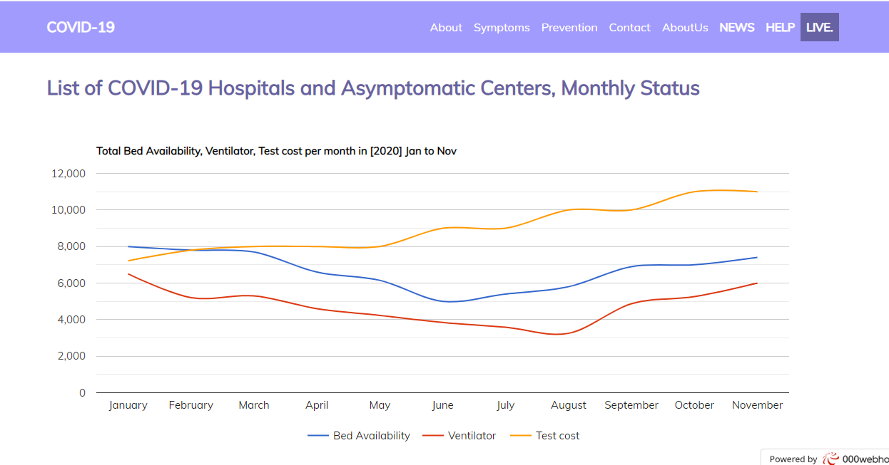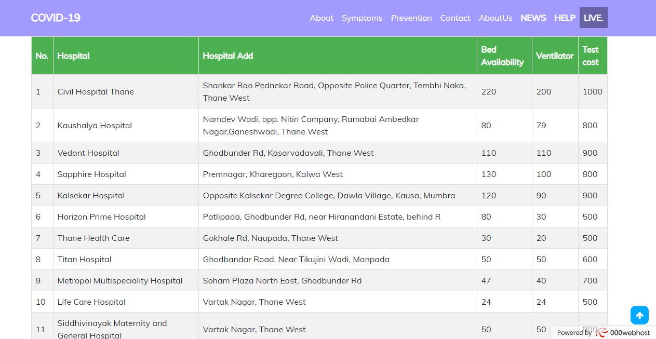

Fig4: Hospital status

**DATABASE:** 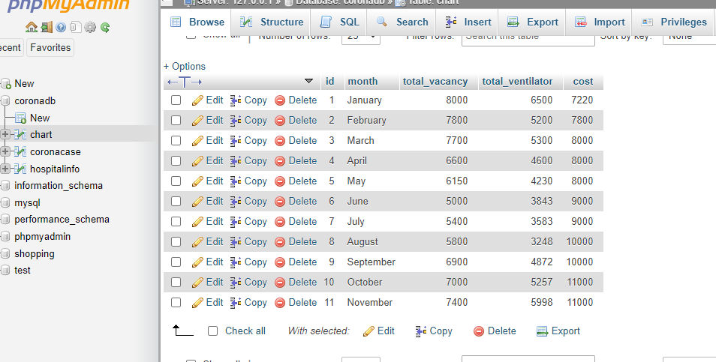

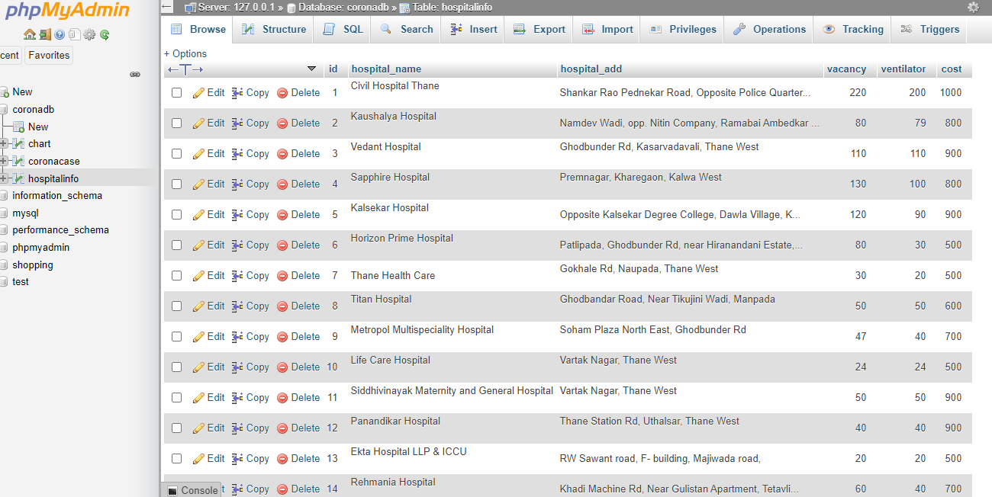

Fig5: Hospital status

**LIVE(World Map):**

<!DOCTYPE html>

<html lang="en">

<head>

<meta charset="utf-8">

<meta name="viewport" content="width=device-width, initial-scale=1.0">

<link rel="stylesheet" type="text/css" href="bootstrap-4.0.0-dist/css/bootstrap.min.css">

<link rel="stylesheet" type="text/css" href="bootstrap-4.0.0-dist/css/bootstrap.css">

<link href="https://fonts.googleapis.com/css2?family=Mulish&display=swap" rel="stylesheet">

<link rel="stylesheet" href="https://cdnjs.cloudflare.com/ajax/libs/font-awesome/4.7.0/css/font-awesome.css" integrity="sha512-5A8nwdMOWrSz20fDsjczgUidUBR8liPYU+WymTZP1lmY9G6Oc7HlZv156XqnsgNUzTyMefFTcsFH/tnJE/+xBg==" crossorigin="anonymous" />

<script type="text/javascript" src="bootstrap-4.0.0-dist/js/jquery-3.2.1.slim.min.js"></script>

<script type="text/javascript" src="bootstrap-4.0.0-dist/js/bootstrap.js"></script>

<script type="text/javascript" src="bootstrap-4.0.0-dist/js/bootstrap.min.js"></script>

<script type="text/javascript" src="bootstrap-4.0.0-dist/js/popper.min.js"></script>

<title>Document</title>

</head>

<body>

<div class="container">

<div class="row">

<div class="col-lg-3 col-md-3 col-2">

</div>

</div>

</div>

<!-- <nav class="navbar navbar-expand-sm navbar-dark bg-dark p-3 nav_style fixed-top">

<div class="container">

<a href="index.php" class="navbar-brand"><b>COVID-19</b></a>

<button class="navbar-toggler" data-toggle="collapse" data-target="#itemhide">

<span class="navbar-toggler-icon"></span>

</button>

<div class="collapse navbar-collapse " id="itemhide" >

<ul class="navbar-nav ml-auto" >

<li class="nav-item">

<a href="index.php" class="nav-link">Home</a>

</li>

<li class="nav-item">

<a href="#" class="nav-link">News</a>

</li>

<li class="nav-item">

<a href="donate/fifth.html" class="nav-link">Donate</a>

</li>

<li class="nav-item">

<a href="map.html" class="nav-link" style="background-color: #6762a3;"><b>LIVE .</b></a>

</li>

</div>

</ul>

</div>

</nav>

-->

<style>

*{

padding: 0;

margin: 0;

font-family: sans-serif;

;

}

/* width */

::-webkit-scrollbar {

width: 10px;

}

/* Track */

::-webkit-scrollbar-track {

box-shadow: inset 0 0 5px grey;

border-radius: 10px;

}

/* Handle */

::-webkit-scrollbar-thumb {

background: black;

border-radius: 10px;

}

.mapcontainer{

position: absolute;

width: 100%;

height: 80%;

overflow: hidden;

align-content: center;

float: center;

}

.upper{

position: absolute;

z-index: 2;

top:0;

width: 50%;

left: 25%;

background: #a29bfeb3;

padding: 10px;

margin-top: 2%;

}

.stat{

float: left;

width: 30%;

text-align: center;

font-size: 20px;

font-weight:bolder ;

color: white;

}

@media(max-width:579px){

.upper{

position: absolute;

z-index:2;

top:0;

width: 50%;

left: 20%;

background: #a29bfeb3;

padding: 4px;

}

.stat{

float: left;

width: 100%;

text-align: center;

font-size: 10px;

font-weight:bolder ;

color: white;

padding-left: 30px;

padding-right: 30px;

}

}

@media(max-width:768px){

.upper{

position: absolute;

z-index:2;

top:0;

width: 50%;

left: 20%;

background: #a29bfeb3;

padding: 4px;

}

.stat{

float: left;

width: 20%;

text-align: center;

font-size: 10px;

font-weight:bolder ;

color: white;

padding-left: 30px;

padding-right: 30px;

}

}

@media(max-width:373px){

.upper{

position: absolute;

z-index:2;

top:0;

width: 80%;

left: 13%;

background: #a29bfeb3;

padding: 1px;

}

.stat{

float: left;

width: 10%;

text-align: center;

font-size: 11px;

font-weight:bolder ;

color: white;

padding-left: 30px;

padding-right: 30px;

}

}

.data-table-container{

top: 80%;

position: absolute;

width: 34%;

height: 100%;

overflow: none;

background-color: #222222;

color: white;

}

.data-table-parent{

position: absolute;

top:10%;

height:90%;

width: 90%;

overflow: auto ;

}

.data-table{

width: 100%;

}

.data-table tr td{

border-bottom: 1px solid white;

padding: 2px;

}

#total-cases-container{

left: 0;

float: left;

padding-left: 2%;

}

#death-cases-container{

right: 33%;

float: center;

}

#cured-cases-container{

right: 0;

}

.waiting{

position: absolute;

top:45%;

left:25%;

}

.bg-dark {

background-color: #a29bfe!important;

}

.btn{

padding: 0%;

}

</style>

<div class="waiting"><h1>Please Wait, while fetching a data</h1></div>

<div class="upper">

<div class="stat" id="totalCases"></div>

<div class="stat" id="totalCured"></div>

<div class="stat" id="totalDeath"></div>

<div class="container">

<div class="row">

<div class="col-lg-1 col-md-1 col-1">

<a href="index.php" class="btn btn-warning "><b>Back</b></a>

</div>

</div>

</div>

</div>

<div class="mapcontainer" id="mapcontainer" ></div>

<div class="data-table-container" id="total-cases-container" >

<h3 style="color:#007bff;">Total Cases:</h3> <br />

<div class="stat" id="totalCases" style="color: yellow"></div>

<div class="data-table-parent">

<table class="data-table" id="total-cases-table" cellspacing="0"></table>

</div>

</div>

<div class="data-table-container" id="death-cases-container">

<h3 style=" color: #dc3545;"> Death Cases: </h3><br />

<div class="stat" id="totalDeath" style="color: red"></div>

<div class="data-table-parent">

<table class="data-table" id="death-cases-table" cellspacing="0"></table>

</div>

</div>

<div class="data-table-container" id="cured-cases-container">

<h3 style=" color: #28a745;"> Cured Cases: </h3> <br />

<div class="stat" id="totalCured" style="color: green"></div>

<div class="data-table-parent">

<table class="data-table" id="cured-cases-table" cellspacing="0"></table>

</div>

</div>

<link rel="stylesheet" type="text/css" href="jquery-jvectormap-2.0.5/jquery-jvectormap-2.0.5.css"></link>

<script src="jQuery.js"></script>

<script src="jquery-jvectormap-2.0.5/jquery-jvectormap-2.0.5.min.js"></script>

<script src="jquery-jvectormap-2.0.5/world.js"></script>

<script type="text/javascript">

function loadmap(){

$.ajax({

url : "https://corona.lmao.ninja/v3/covid-19/countries",

error: function(){

alert("Problem with fetching a data from API, please try again later...");

},

success: function(data){

console.log(data);

var infectedData={};

var countryWiseDeaths={};

var countryWiseCured={};

var worldCases=0;

var worldCured=0;

var worldDeaths=0;

var totalCasesHTML="";

var deathCasesHTML="";

var curedCasesHTML="";

for(var i=0; i< data.length; i++){

var elem = data[i];

var cases= elem.cases;

var country = elem.countryInfo.iso2;

infectedData[country]= cases;

countryWiseDeaths[country]=elem.deaths;

countryWiseCured[country]=elem.recovered;

worldCases +=cases;

worldCured +=elem.recovered;

worldDeaths +=elem.deaths;

totalCasesHTML +="<tr>";

totalCasesHTML +="<td>"+ cases +"<br /><b>" + elem.country +"</b></td>"

totalCasesHTML +="</tr>";

deathCasesHTML +="<tr>";

deathCasesHTML +="<td>"+ elem.deaths +"<br /><b>" + elem.country +"</b></td>"

deathCasesHTML +="</tr>";

curedCasesHTML +="<tr>";

curedCasesHTML +="<td>"+ elem.recovered +"<br /><b>" + elem.country +"</b></td>"

curedCasesHTML +="</tr>";

}

$("#total-cases-table").html(totalCasesHTML);

$("#death-cases-table").html(deathCasesHTML);

$("#cured-cases-table").html(curedCasesHTML);

var totalCuredcurepercentage= parseFloat((worldCured/worldCases)*100).toFixed(2);

var totalDeathcurepercentage= parseFloat((worldDeaths/worldCases)*100).toFixed(2);

$('#totalCases').html("Total Cases <br />"+worldCases);

$('#totalCured').html("Total Cured <br />"+worldCured);

$('#totalDeath').html("Total Deaths <br />"+worldDeaths);

$('#mapcontainer').vectorMap({

map: 'world_merc',

series: {

regions: [{

values: infectedData,

scale: ['#FFFFFF', '#cc0000'],

normalizeFunction: 'polynomial'

}]

},

backgroundColor:"#010f1a",

onRegionTipShow: function(e, el, code){

var html ="";

html +="<br /> Cases:"+ infectedData[code];

var deathPercentage = parseFloat((countryWiseDeaths[code]/infectedData[code])*100).toFixed(2);

html +="<br /> Deaths:"+ countryWiseDeaths[code] + "("+deathPercentage+"%)";

html +="<br /> Cured:"+ countryWiseCured[code];

el.html(el.html()+ html );

}

});

// console.log(infectedData);

}

})

// $('#mapcontainer').vectorMap({map: 'world_merc'});

}

loadmap();

setInterval(function() {

loadmap();

},60000)

</script>

</body>

</html>

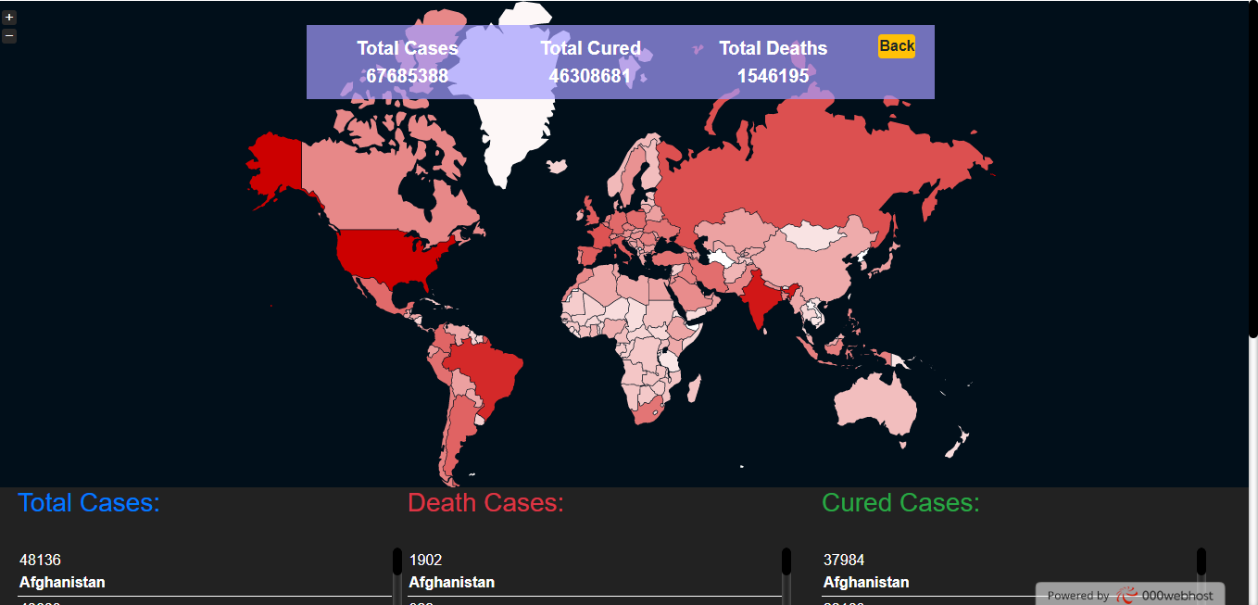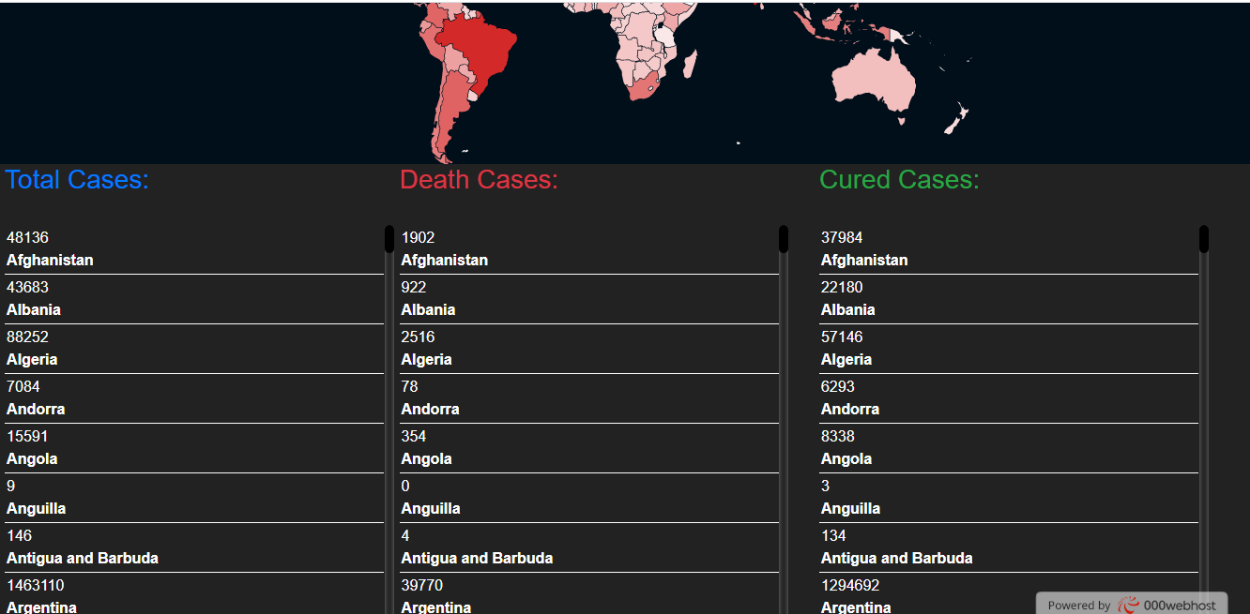

Fig6: World map live cases

**Chapter 6**

# Conclusion

## 6.1 Limitations:-

* We cant transfer money to a person through our website if he needs money. 
* Because of the api it takes more time to load so it consumes more time to load. 
* Api is not available on internet freely so we cannot change its data shown in our website  

## 6.2 Conclusion:-

We made such website which is actually very helpful to provide correct information about Covid-19. It includes total number of cases,number of people who are diagnosed with Covid-19 also number of peoples gets discharged till date.Overall it creates awareness about Covid-19. However if your self-assessment through this website shows a strong likelihood of Covid-19 infection,this data will be uploaded to a server for government inspection and use.

## 6.3 Future Scope:-

* Social awareness about COVID-19.
* Provide correct information about COVID-19.
* Scaling up country readiness and response operations.
* Health care management Professionals will see newer possibilities and scope in the health care Industry.

**Bibliography:**

[www.wikipedia.com](http://www.wikipedia.com/)

[www.slideshare.net](http://www.slideshare.net/)

[www.w3schools.com](http://www.w3schools.com/)

[www.tutorialspoint.com](http://www.tutorialspoint.com/)

[www.youtube.com/jpweb](http://www.youtube.com/jpweb)

www,github.com