**Fixes**:

**HOMEPAGE**

* Mini Order form should also get fixed to header and stay constant throughout the page. Refer Myassignmenthelp.com.
* Effects timing inconsistent.
* Header for each section should be having bold/good font.(e.g How we work,OAH Features etc).
* Icons needed for how we work section and other possible places. Mark
* Add signup to the header part. Mark
* Try to highlight parts in section where mouse goes in an out. (how we work highlight if mouse moves on to each of the 3 parts) mark
* Mini Order Form:
  + Date Validation should be done again, past date should not be allowed. Current version is not blocking calendar, the validation brings up popup but still feeds the form. Replace it with red error message below the field.
  + 1page= 250 words
  + Subject should get auto filled (To be provided by us).
  + Name should allow only alphabets and space. Check for Numbers and special characters.
  + Email validation should be there for “.com/.***” too.
* Callback form:

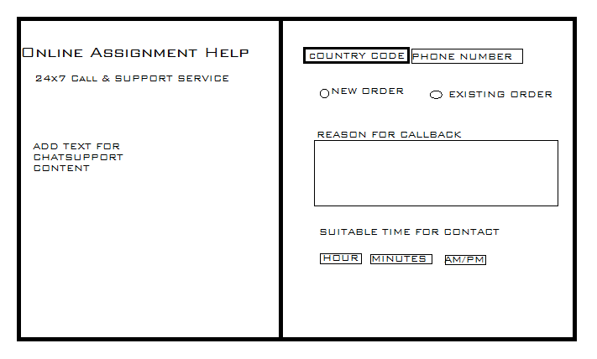

**Signup Page:**

Social Network connectivity

Email triggering.

**User Dashboard**

User DB is incomplete, should be provided by us so that you can collect and display such data

**Tables and Forms:**

**Mini Order**:

|  |  |  |
| --- | --- | --- |
| Order No | “TMP+DeadLine+SubjectInitials+OrderIdAutogen” | Generated backend |
| Date | Date on which order was placed(System time) | Generated backend |
| Contact Number | ISD+10 digit(Telephone number validation) | Mandatory for user |
| Name | Abc ABC(Only alphabet and space) | Optional |
| Email | Email id validation (***@**.**) | Mandatory Userfilled |
| Subject | Subject autofill PROVIDED BY US | Mandatory Userfilled |
| No. of pages | Number | Optional |

**Callback Order**

|  |  |  |
| --- | --- | --- |
| Order No | “TMP+DeadLine+SubjectInitials+OrderIdAutogen” | Generated backend |
| Date | Date on which order was placed(System time) | Generated backend |
| Contact Number | ISD+10 digit(Telephone number validation) | Mandatory for userfilled |
| Reason | Abc ABC(Only alphabet and space) | Optional |
| Type | New/Existing Order | Mandatory Userfilled |
| Time | Timestamp | Mandatory UserFilled |

**Signup Form**

|  |  |  |
| --- | --- | --- |
| User id | Unique | Generated backend |
| Name | Alphabets | Optional |
| Email | **Otp validation** | Mandatory for userfilled |
| Phone number |  | Mandatory for userfilled |
| Study Level | Graduate/Post Graduate/Under Grad/Phd/High school | Mandatory for userfilled |

**Order Form (Break into two parts)**

|  |  |  |
| --- | --- | --- |
| Order id | “OAH+DeadLine+SubjectInitials+No.ofordersByUser+OrderIdAutogen”  OAH12122018HIST1 | Generated backend |
| Name d | Alphabets | Optional |
| Email | **Email confirmation** | Mandatory for userfilled |
| Phone d number | ISD+10Digits | Mandatory for userfilled |
| Deadline Date d | Date time | Mandatory for userfilled |
| No. of Pages d | Number | Optional |
| Study Level | Graduate/Post Graduate/Under Grad/Phd/High school | Mandatory for userfilled |
| Reference Style | Styles will be provided by us | Mandatory for userfilled |
| Description |  | Mandatory for userfilled |
| Attach file |  | Optionals |

**Admin Dashboard:**

**Full Control with Export to excel button**

|  |  |
| --- | --- |
| OrderId | Derived |
| Entry Date | Derived |
| Word count | Derived |
| Country | Derived |
| Subject | Derived |
| Deadline | Derived |
| Amount Quoted | **Manually Maintained** |
| Study level | Derived |
| Comments | **Manually Maintained** |

**User Dashboard:**

|  |  |
| --- | --- |
| Orderid |  |
| Subject |  |
| Price Quoted |  |
| Final Price |  |
| Comments |  |
| RATINGS |  |
|  |  |

**Road Map For Frontend priority wise:**

* **Bug Fixes**
* **Footer complete(Please let me know of any requirement)**
* **Services complete(10 headers and 10 sub headers) to be provided by us**
* **Order page**
* **Admin page**