1. Frontend (Node.js with Express):
- Create a frontend using Express and Node.js.
- Include a form similar to the one from the Flask Assignment 2.
- Configure the form to send a request to the Flask backend.
- Backend (Flask):
- Use the Flask backend to handle the form submission and process the data.
- Folder Structure:
- Organize the project with separate folders for the frontend and backend.
- Docker Configuration:
- Create a Dockerfile for both the frontend and backend.
- Write a .yaml file (Docker Compose) to connect both services in the same network.
- Upload both images to docker hub and push your whole code to github and add the node_modules and other non required files(.vscode) in .gitignore
Link - https://github.com/Toto3107/flaskp
Submission Guidelines -: 1. Upload the terminal screen shots and all your project
code or files on github.
2. Share your github repo link
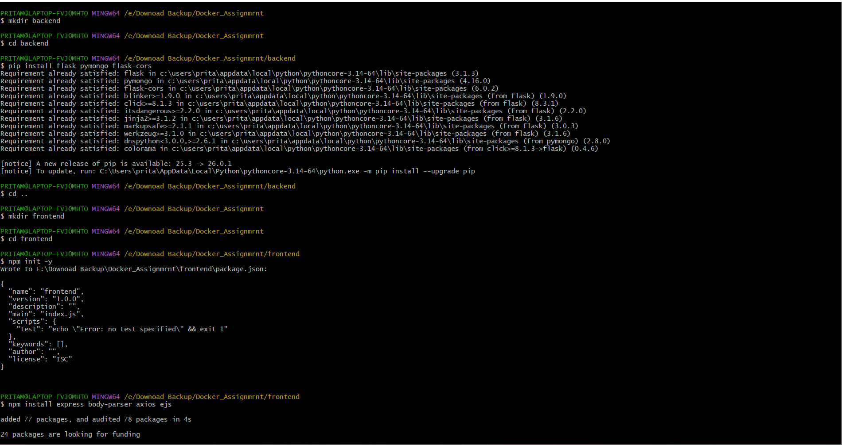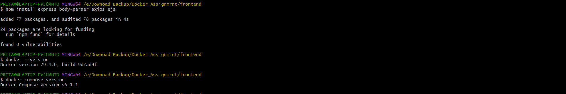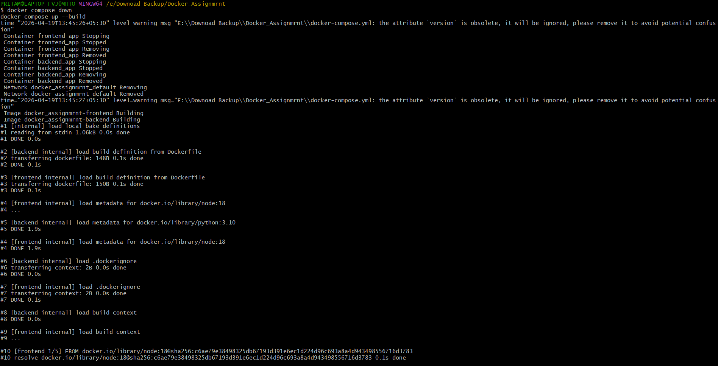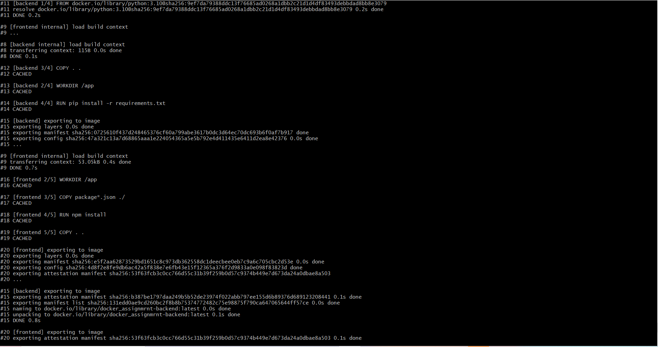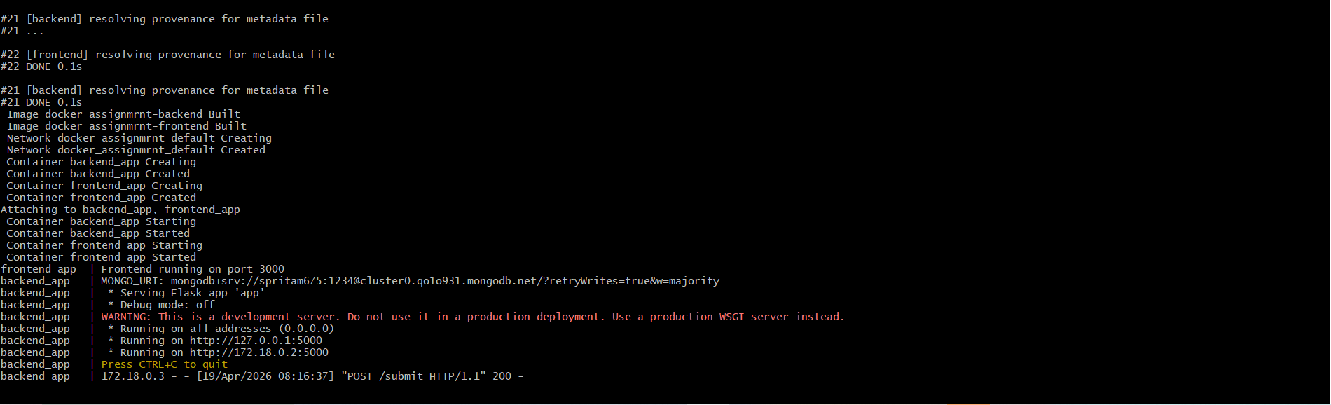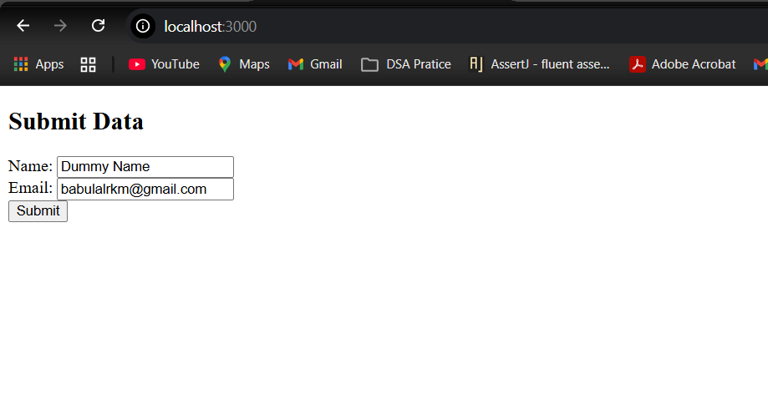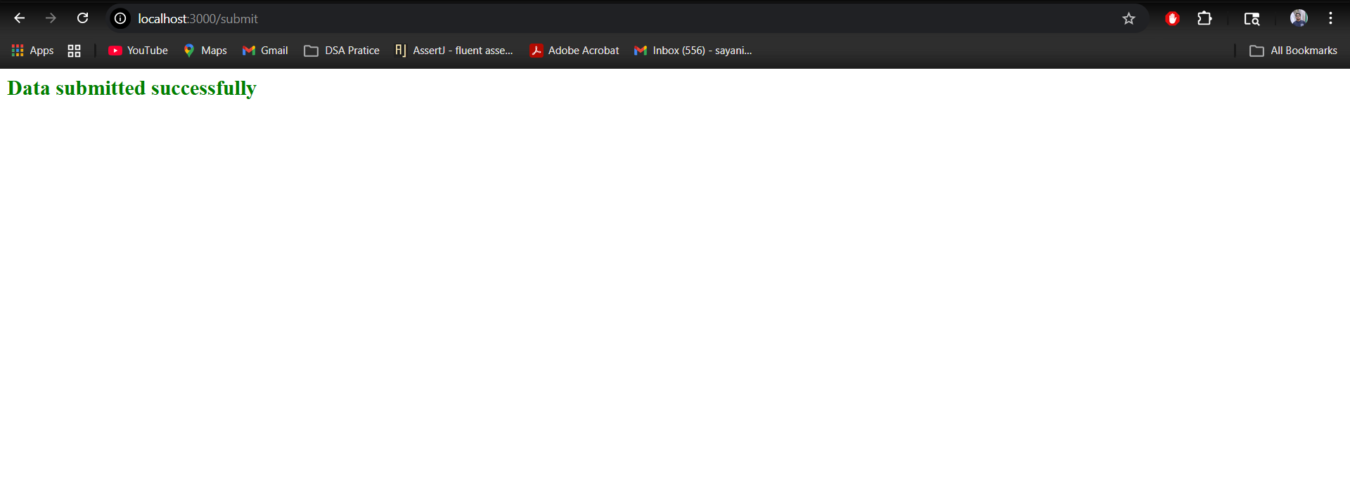
📎 Explanation
- Built a full-stack application using Node.js (Express) for frontend and Flask (Python) for backend.
- Created a form in the frontend to collect user data (name and email).
- Configured the frontend to send a POST request to the Flask backend on form submission.
- Developed a Flask API (/submit) to handle incoming data.
- Connected the backend to MongoDB Atlas to store submitted data.
- Implemented success and error handling:
  - Success → redirect to success page
  - Error → show message on same page
- Organized the project into separate folders: frontend and backend.
- Created Dockerfiles for both frontend and backend services.
- Used Docker Compose to run both services in a single network and enable communication.
- Uploaded the complete project to GitHub and pushed Docker images to Docker Hub, while excluding unnecessary files using .gitignore.

