GROUP 3 — HARDWARE, ROBOTICS & EDGE
DAY 1 · END-OF-DAY PROCESS REPORT
2026-08-11 | Today's Lead: Suraj Surve | Observation Lead: Hemanth Reddy
Contributors: Arya Barge · Manya Shukla · Dhruv Patel · Hemanth Reddy · Ashmit Pandey
Mission gate: Exists → Powers on/runs → Interfaces → Produces measurable output → Telemetry captured → Integrates → Reusable

0. EXECUTIVE SUMMARY
Today produced the first photographic evidence of physical hardware in Group 3's history. Manya supplied 14 photographs of 3D-printed structural components, backed by a formal Mechanical & Structural Verification matrix and a corrected inventory. That moves her prototype from reported to EVIDENCED.
No system reached "Powers on / runs." Both quadrupeds are pre-assembly: 0 of 8 actuators on either. Per Suraj: "They both are in their initial stage. Testing needs to happen post 3D print assembly."
The runtime side reached "Produces measurable output + Telemetry captured" with captured evidence — a live fail-closed enforcement gate, 165 passing tests, and a real reasoning decision.
Group 3's honest position tonight: verified physical parts (not an assembled machine), a verified software runtime (not connected to hardware), and a precisely quantified shortfall between them.
Gate | Manya's prototype | Arya's prototype | Dhruv's control path | Hemanth's runtime
1 Exists | YES — photo-verified parts | CAD only | Electronics NOT finalised | YES
1b Assembles / articulates | NO — Not Assembled | NO | — | —
2 Powers on / runs | NO — 0/8 actuators | NO — 0/8 actuators | NO | YES
3 Interfaces | NO | NO | documented only | YES — verified live
4 Measurable output | NO | NO | external dataset | YES — captured
5 Telemetry captured | NO | NO | external dataset | YES — captured
6 Integrates | NO | NO | NO | NO — contract-only
7 Reusable | Potentially | Potentially | — | YES (software)

1. WHAT EACH MEMBER DELIVERED

1.1 Suraj — Hardware/Robotics System Convergence
Assignment item | Delivered | Status
Coordinate complete Group 3 verification | Ran the day; corrections issued 08:05 | DONE
Establish current status of each capability | Ruled: two separate prototypes, both initial-stage | DONE
Identify systems with working hw/fw/sw/control | Established none past 3D-print assembly | DONE
Drive one complete system-level proof | NOT ACHIEVED on hardware — no actuators exist | BLOCKED (correctly)
Maintain morning + EOD updates | Morning direction + 1108 report consolidation | DONE
Consolidate blockers and dependencies | Assigned electronics ownership to Dhruv | DONE

Decisions issued today:
- 08:05 — H Frame → 3D print required; M2.5 nuts → hardware procurement, not 3D print
- Two prototypes ruling — M2.5 correct for Manya's SCALED print model
- Verification target — check mechanical linkages on printed parts; motors/actuators not required
- Stage clarification — both prototypes initial-stage; testing post 3D-print assembly
- Electronics ownership assigned to Dhruv

1.2 Manya — Mechanical / Structural / Actuation Verification [STRONGEST EVIDENCE TODAY]
Assignment item | Delivered | Status
Verify structural/mechanical/actuation components | Mechanical & Structural Verification matrix — 16 rows, 8 columns | DONE
Validate load/actuation assumptions vs hardware | "After test NA" — correctly deferred; no actuators to test | HONESTLY DEFERRED
Document component interfaces and constraints | Constraints recorded: H-frame size, print time | DONE
Identify reusable modules vs prototype-specific | Every row classified. Leg Assembly = PROTOTYPE ONLY | DONE — answers the mission question
Provide evidence of actual operation | 14 PHOTOGRAPHS of printed components | DONE — first physical evidence in the group

She also corrected her own inventory beyond what Suraj asked — two changes nobody requested: Smaller Disc 4→0 (to be printed), lower link 4→2. Self-correction without prompting is the strongest process signal of the day.

1.3 Dhruv — Telemetry / Control / Execution Integration
Assignment item | Delivered | Status
Verify actual control/execution path | "NA" | CORRECTLY RECORDED AS NA
Establish command → controller → actuator → telemetry | Dataset picked from online (torque etc.); telemetry ready via py code | Code exists; data is EXTERNAL, not from the robot
Verify state propagation, APIs/interfaces | "NA" | CORRECTLY RECORDED
Capture runtime logs and telemetry evidence | Dataset evidence based on AI leverage | NOT runtime evidence from the assigned system
Identify what connects to BHIV execution/observability | Live integration post testing on both prototypes | Deferred, correctly
Reported a provisional control path | RPi 4 + PCA9685 + 8x MG996R; RPi4 → I2C → PCA9685 → PWM → MG996R | PROVISIONAL — electronics not finalised. Final BOM follows body completion

Recorded fairly: Dhruv wrote "NA" three times rather than claiming partial success — non-negotiable #2 applied to his own work. His telemetry code is real; the data exercising it is an online dataset, not robot telemetry, which he stated plainly. No overclaim was made. He also challenged an unverified actuator claim of mine — see §6.

1.4 Arya — Terrain / Gait / Stability / Mechanical Integration
Assignment item | Delivered | Status
Verify locomotion vs existing implementation | Group consolidation records "Yet to report" | PENDING
Demonstrate terrain/gait/stability where hw available | No hardware available; gait sim promised by EOD | PENDING
Document mechanical and control interfaces | M3 fasteners confirmed from live SolidWorks assembly | DONE
Separate demonstrated from planned capability | Pre-labelled the sim "simulation, not a physical demonstration" — unprompted | DONE — rule-4 discipline applied voluntarily
Capture video and measurable runtime evidence | 4 CAD assembly views shared; gait video pending | PENDING

Note on her four images: they are SolidWorks CAD renders, not photographs (title bars show SOLIDWORKS/MBD/RoboDK; status "Under Defined · Editing Assembly"; Motion Study 1 tab present). This is NOT a misrepresentation — for a terrain/gait assignment, CAD plus a motion study is the correct artifact and she labelled it correctly in advance. Recorded because rule 1 distinguishes a model from a physical object.

1.5 Ashmit — Evidence / Capability Packaging
Assignment item | Delivered | Status
Consolidate hardware/robotics evidence | "Unable to compile due to software restrictions" | BLOCKED — reported, not hidden
Track each capability V0–V4 | Not produced; scale never defined | NOT DONE
Record owner/status/interface/telemetry/deps/blocker | Not produced | NOT DONE
Prepare reusable capability packets | Redirected: packets to go direct to Suraj | REROUTED

Recorded per rule 9 ("A failed experiment is acceptable. Hiding the failure is not"): Ashmit reported the blocker rather than going silent. The V0–V4 scale remains undefined group-wide — an open dependency, not a personal failure.

2. HEMANTH — EDGE / SYSTEM ORCHESTRATION
Scope note. My brief says "map the hardware/edge systems to the wider BHIV runtime." That is both halves: the Group 3 hardware AND the BHIV runtime it must attach to. The runtime components I own — Sarathi, PIG, AQIAIC — are BHIV runtime capabilities from the Day-1 reusable inventory, so they are in scope as the DESTINATION, not as a separate project report.

2.1 Map the hardware/edge systems to the wider BHIV runtime
The composed path — everything except the leftmost box already exists and was verified today:
┌──────────────┐ observation ┌──────────────┐ decision ┌──────────┐ sealed ┌───────────┐
│ Vana / G3 │ ─────────────► │ AQIAIC │ ───────────► │ Sarathi │ ─────────► │ Bucket │
│ edge device │ (+confidence │ reason OR │ (+ trace_id) │ enforce │ │InsightFlow│
│ /analyze │ or abstain) │ abstain │ │ seal │ │KARMA/PRANA│
└──────┬───────┘ └──────┬───────┘ └────┬─────┘ └───────────┘
│ │ │
└───────────────────────────────┴───────────────────────────┘
recorded in PIG: WorkItem · Deliverable · EvidenceReference
append-only · bitemporal · sha256-replayable
Day-1 BHIV reusable inventory mapped against what I verified:
BHIV capability (Day-1 list) | Verified state today | Edge relevance
TANTRA / Sarathi | LIVE — sarathi-9n5g.onrender.com, fail-closed proven | Actuation authority for any robot command
Capability Registry | Exists — src/pig/runtime/capabilities/ | Register a Vana sensing capability
Replay | Exists — pig/replay_engine.py, tantra_replay.go | Replay recorded evidence
Bucket | reference-standby — adapter ready, NO live endpoint | Observation storage
InsightFlow | reference-standby, digest-only contract | Telemetry (never gates execution)
PRANA / KARMA | env-gated, NO endpoints | Behaviour signals / outcome evidence
GC / TMS / MDU | contract-only — opaque seams, internals unknown | Governance boundary
Execution Registry | 0 matches in the three repos I hold | Unknown
InsightBridge / InsightCore / QCG / MASTERDB | 0 matches | Unknown
Samachar | public catalogue = Coming Soon; AQIAIC registry = interface_only | Declared ObservationSource — the port a sensor occupies
SANSKAR | 16 matches, ALL the personal name "Sanskar" — no system found | —
UniGuru / RAG | Live publicly (uni-guru.in) | Not edge-relevant
Niyantran / SETU / Pravah | Published Live | Group 4 territory

2.2 How commands, telemetry, device state and failures move between edge and software
Flow | Mechanism | Verified?
Command → device | POST /v1/enforce → 9-check verification → sealed envelope → ExecutionHandler → HTTP POST of signed CapabilityToken | Gate verified live; webhook NEVER exercised by hardware
Device → telemetry | /v1/observe (intake) → /v1/downstream-ack (signed receipt) | BOTH return 404 on the deployment
Device state | trace_id through every hop; chain_binding_hash binds every artifact | Contract verified
Failure | FAIL-CLOSED — verification failure halts the chain; no fall-through to allow | PROVEN LIVE
Observation → evidence | PIG: WorkItem + Deliverable + one EvidenceReference per reading | 165 tests pass
Reasoning | AQIAIC POST /decision — confidence band + honest abstention | Real decision produced

2.3 Verify available communication interfaces — KEY EDGE FINDING
Probed 18 endpoints against the live deployment — every entry below was individually tested:
LIVE and responding | Returns 404 — NOT DEPLOYED
/health · /health/deep (3/3 checks, router 4/4) | /v1/evaluators/* — register/challenge, register/complete, JWKS
/metrics · /metrics/prometheus | /v1/observe — observation intake
/v1/bridge/info | /v1/downstream-ack — signed receipt callback
/v1/enforce (POST → fail-closed) | /v1/audit
/v1/ingest-decision (POST → fail-closed) | /v1/handshake, /v1/handshake-peer
/sarathi/enforce (POST → fail-closed) | /bucket/artifacts
/sarathi/validate-token (GET → ERR_TOKEN_MISSING) | /v1/handshake-peer

CONSEQUENCE: the missing routes are exactly the ones an edge device needs — onboarding (evaluator registration + JWKS for key distribution), observation intake, and acknowledgement. A Vana edge node CANNOT register against the live service today, and CANNOT close the telemetry loop.
Hypothesis, stated as hypothesis: the deployment reports service_version 8.0.0 (and 5.0.0 on deep health) while repo documentation describes v15.11 — so Render is probably running an older build. Redeploying would likely restore these routes. Not yet confirmed.

2.4 Dependencies on existing execution, telemetry and storage
Dependency | State | Blocks
Sarathi execution webhook | Built, env-switched (SARATHI_WEBHOOK_URL) | Nothing — ready
Device-side webhook receiver | DOES NOT EXIST | Actuation. Group 3 build item
Sarathi onboarding routes | 404 on deployment | Device registration
Bucket endpoint | No live URL | Observation persistence
InsightFlow endpoint | No live URL | Telemetry
Device identity at fleet scale | UNSOLVED — peer-key pinning suits a few servers, not many field devices | Fleet deployment. Group 4 dependency
AQIAIC deployment | Local only | Reasoning in production
PIG host process | Unowned | Evidence recording

2.5 One concrete edge-to-runtime integration proof — DELIVERED
"Where possible" — hardware side impossible (no powered device exists). Runtime side proven.
PROOF 1 — Fail-closed enforcement, verified live
POST https://sarathi-9n5g.onrender.com/v1/enforce
Body: {"decision_id":"VANA-EDGE-TEST-001","action":"actuator.move",
"payload":{"joint":"hip_fl","angle":15}}
→ HTTP 400
{"detail":"one or more X-Sarathi-* headers missing",
"error":"ERR_INBOUND_SIGNATURE_MISSING","issuer_id":""}
It refused. It did not fall through to allow. An unsigned actuator command was rejected by the live gate — the single most important safety property for a robot, proven on a running service rather than a diagram.
PROOF 2 — Deterministic evidence spine
python -m pytest tests -q → 165 passed in 7.17s · python demo/run_demo.py → completed, printing "All outputs above were produced by the real capability."
PROOF 3 — Reasoning with honest abstention
python run_engine.py examples/payloads/sell_store_with_enwr.json → decision dec_a24e0274030ece3735f6c31764e1907e, STORE_WITH_ENWR, confidence_band: high, confidence_score: 0.855, best 8054.1 / avg 7554.1 / worst, abstained: false.
Repo integrity: all three BHIV repos unmodified — git status --porcelain still returns the recorded baselines (24 AQIAIC, 10 PIG). Suites run with -p no:cacheprovider and PYTHONDONTWRITEBYTECODE=1.
HONEST STATUS: contract-only for hardware. Runtime half proven; device half absent.

3. PHYSICAL EVIDENCE RECEIVED — Manya's printed components
14 photographs, timestamps visible in-frame (13:17 / 13:24, 11-08-2026), taken at a workstation with the inventory spreadsheet open on screen.
Photo | Contents observed | Maps to inventory row
WA0003 | 8 flat discs, 4 mounting holes each, visible FDM layer lines | disc(1) — 8/8 Available
WA0007 | 4 U-channel brackets, open-top | c-bracket type — 4/4
WA0012 | 4 U-channel brackets, taller, slot/hook feature at top | second c-bracket type — 4/4
WA0015 | 2 cylindrical links | lower link — 2 of 4 — EXACTLY matches corrected qty
WA0016 | 4 cylindrical links | link1 — 4/4
WA0004–06, 08–11, 13–14 | Further component groups, same session | Supporting

What the photographs PROVE: the printed structural components physically exist, in the quantities the corrected inventory states. WA0015 showing exactly 2 lower links — matching the self-correction from 4 → 2 — is strong internal corroboration.
What they do NOT prove: no assembly, no actuators, no powered operation. Consistent with the verification matrix, which records Leg Assembly = "Not Assembled".
Print-quality observation (neutral): visible stringing artifacts on several parts — normal FDM behaviour, cosmetic. Worth a retraction/temperature tweak before final parts, not a defect.
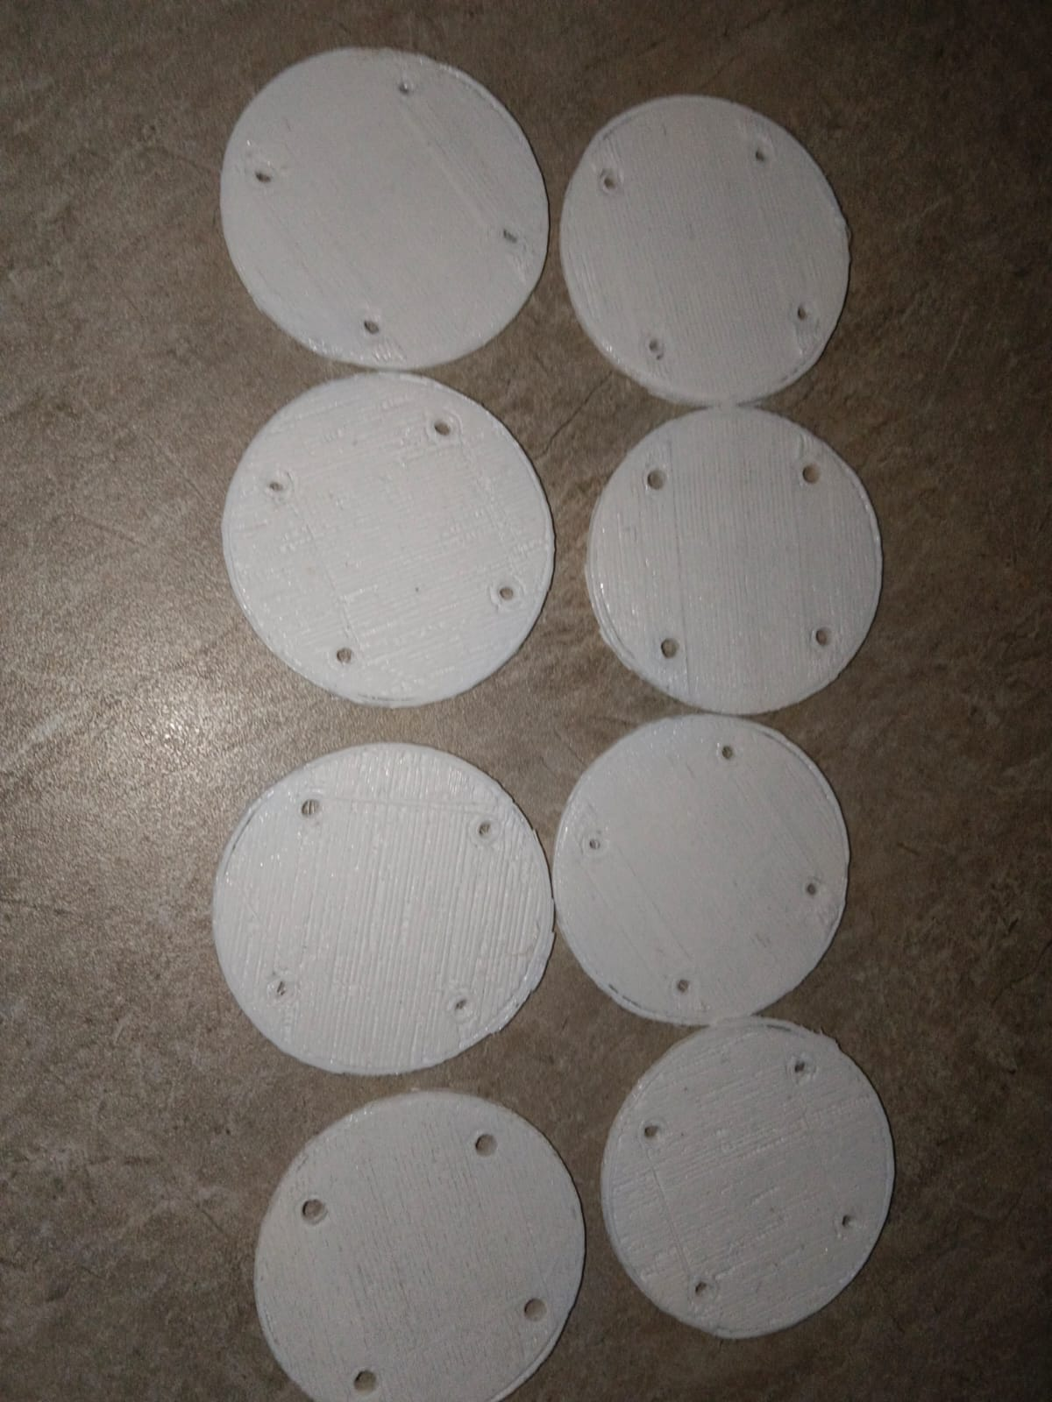
WA0003 — disc(1) x8, joint connection discs (8/8 available)
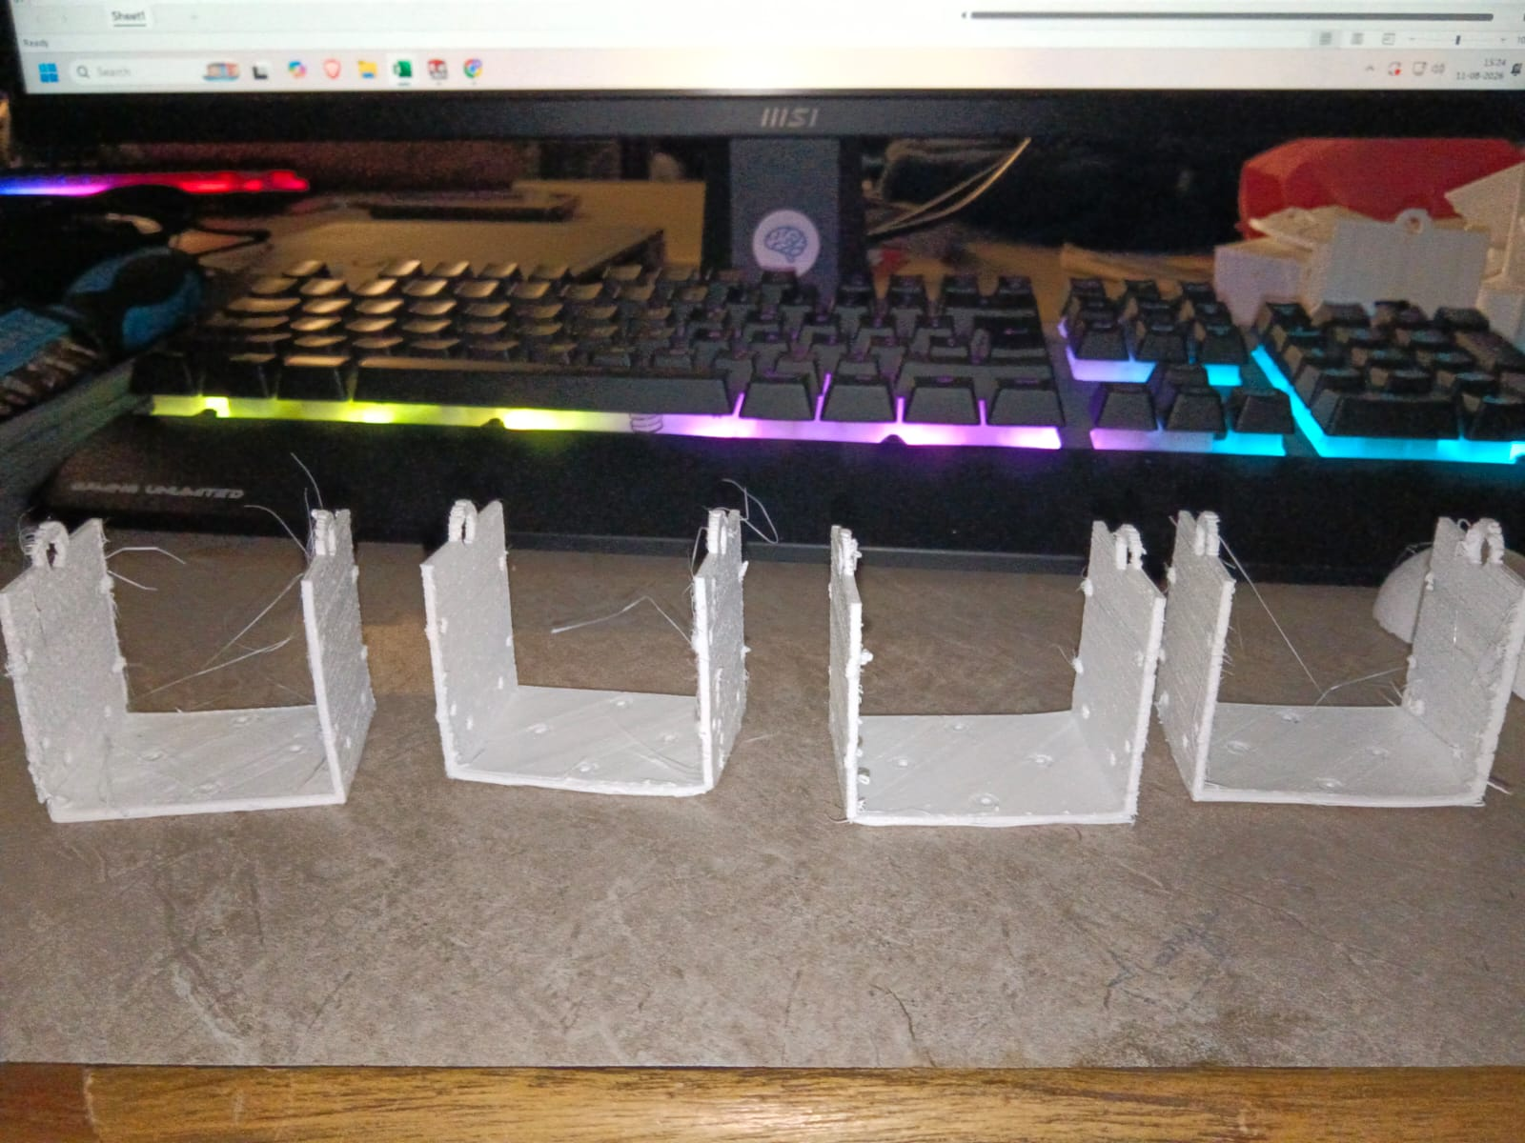
WA0007 — C-brackets x4, mechanical interface (4/4 available)
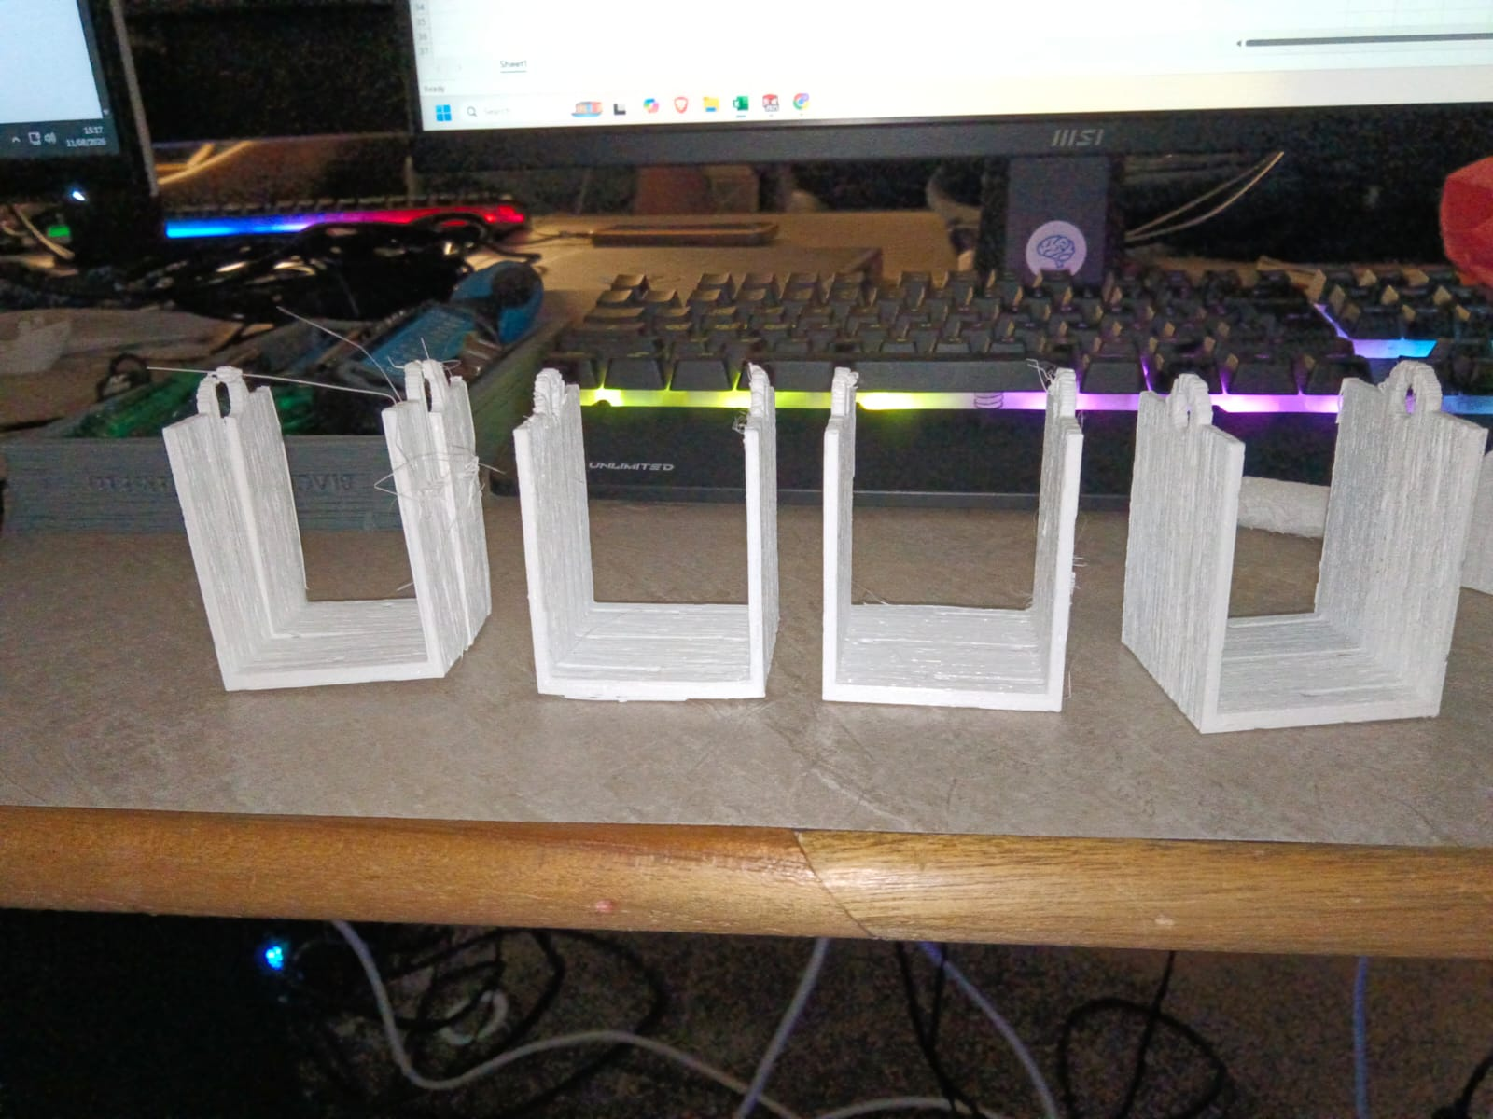
WA0012 — C-brackets x4, second type (4/4 available)
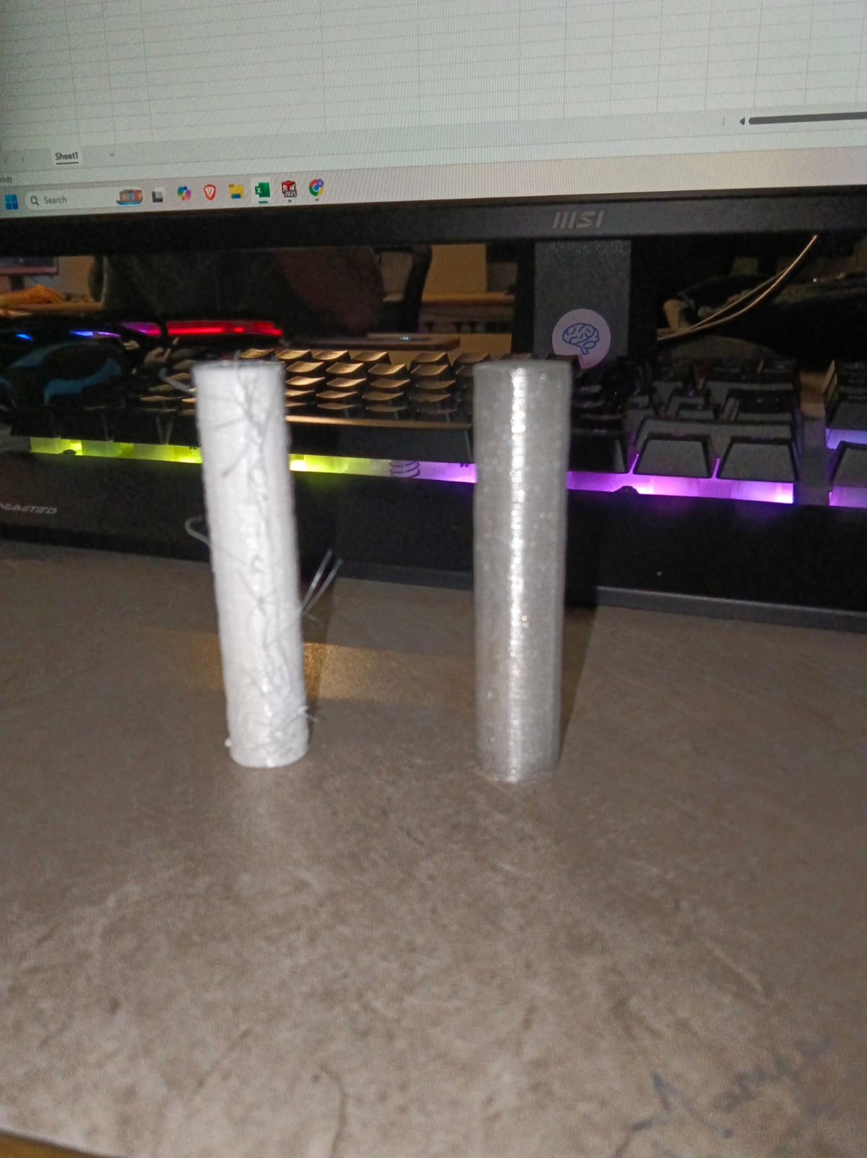
WA0015 — lower link x2 — matches corrected quantity 2 of 4
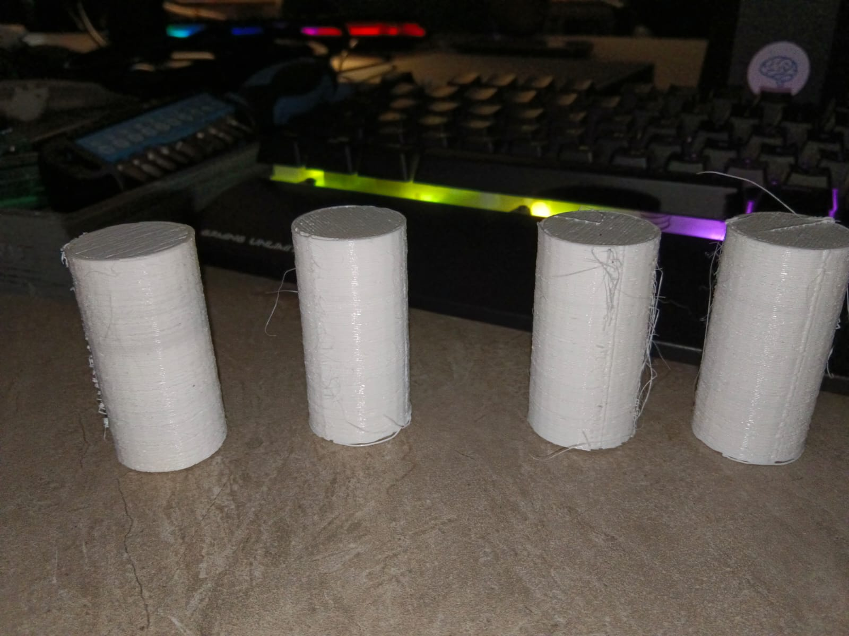
WA0016 — link1 x4, upper leg links (4/4 available)

Arya — CAD assembly views (recorded as CAD evidence, NOT physical hardware):
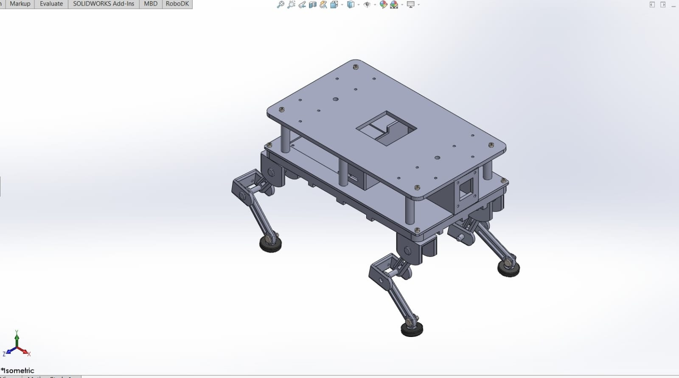
Arya — SolidWorks isometric assembly view (CAD, not a photograph)
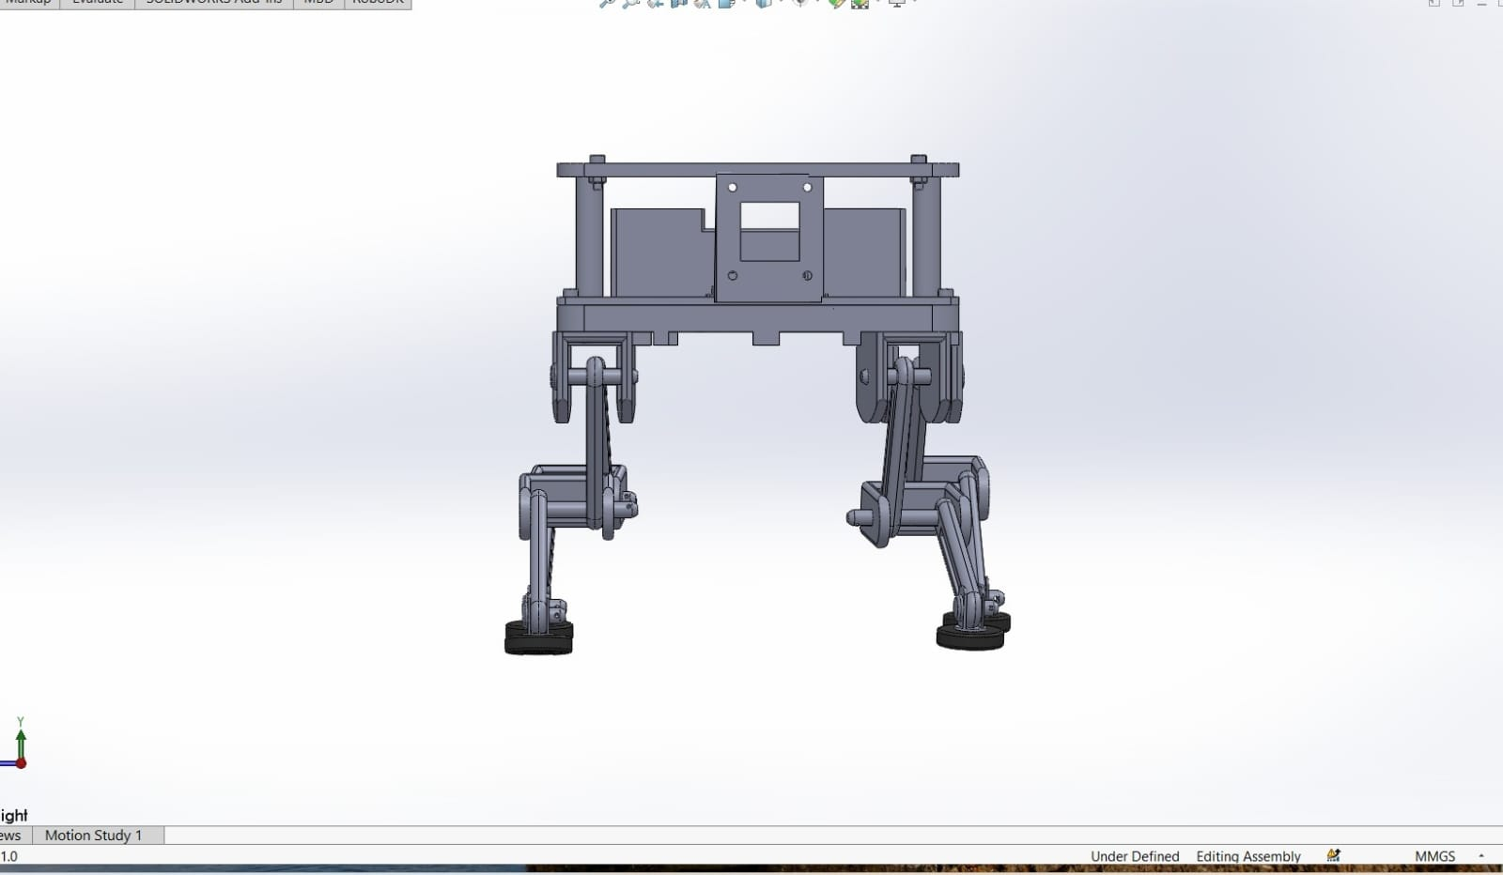
Arya — front view; status bar reads "Under Defined · Editing Assembly"; Motion Study 1 tab present

4. INVENTORY — CONSOLIDATED (Manya's corrected inventory + verification matrix)
Component | Category | BOM | Avail | Physical status | Assembly verif. | Test status | Evidence | Reusable
Ground Reference | Structural | 1 | 1 | To be 3D printed | Pending | Pending | Not available | Potentially
H Frame1 | Structural | 1 | 1 | To be 3D printed (Suraj's correction) | Pending | Pending | Not available | Potentially
RX_64 | Actuation | 4 | 0 | PENDING | Pending | Not physically tested | Not available | Potentially
c bracket | Mech. interface | 4 | 4 | Available | VERIFIED | Not operationally tested | AVAILABLE | Potentially
disc(1) | Structural | 8 | 8 | Available | VERIFIED | Not operationally tested | AVAILABLE | Potentially
link1 | Structural | 4 | 4 | Available | VERIFIED | Not operationally tested | AVAILABLE | Potentially
c bracket2 | Mech. interface | 4 | 4 | Available | VERIFIED | Not operationally tested | AVAILABLE | Potentially
RX_28 | Actuation | 4 | 0 | PENDING | Pending | Not physically tested | Not available | Potentially
C bracket 3 | Mech. interface | 4 | 4 | Available | VERIFIED | Not operationally tested | AVAILABLE | Potentially
Smaller Disc | Structural | 4 | 0 | To be 3D printed (self-corrected 4→0) | Pending | Not operationally tested | Available | Potentially
lower link | Structural | 4 | 2 | Available (self-corrected 4→2) | VERIFIED | Not operationally tested | AVAILABLE | Potentially
Foot | Structural | 4 | 4 | Available | VERIFIED | Not operationally tested | AVAILABLE | Potentially
M2.5 x 16 bolts | Fasteners | 96 | 96 | Available | VERIFIED | Not operationally tested | AVAILABLE | Potentially
M2.5 nuts | Fasteners | 96 | 0 | Hardware procurement (Suraj's correction) | Pending | Pending physical actuation | Not available | Potentially
Leg Assembly | Mech. assembly | — | — | NOT ASSEMBLED | Pending | Pending physical actuation | Not available | PROTOTYPE ONLY
Quadruped Locomotion | System capability | — | — | Simulation demonstrated | Verified | PHYSICAL RUNTIME PENDING | Not available | —

The shortfall, precisely quantified:
To 3D print | To procure
Ground Reference x1 · H Frame1 x1 · Smaller Disc x4 · lower link x2 | RX_64 x4 · RX_28 x4 · M2.5 nuts x96
= 8 parts | = 8 actuators + fasteners

Physically in hand: 30 printed components + 96 bolts. Documented constraints (Manya): H-frame size, print time.

5. NON-NEGOTIABLES — COMPLIANCE
# | Rule | Status | Evidence
1 | No hardware capability accepted from a diagram alone | HELD | Arya's CAD renders recorded as CAD, not hardware. Manya's photos accepted as physical because they ARE photographs
2 | No "working" claim without physical/software runtime evidence | HELD | Dhruv recorded "NA" 3x. His telemetry data labelled external dataset, not robot telemetry. Sarathi graded V3 not V4 — total_routed: 0
3 | Separate hardware exists / software exists / integrated works / production-ready | HELD | §0 gate table separates all four. Hardware exists YES; integrated works NO
4 | Every serious capability requires a short runtime video | NOT MET | ZERO videos exist. Manya's linkage video, Arya's gait sim, and 3 terminal captures all outstanding
5 | Preserve device identity, ownership, provenance, telemetry | HELD | Every document attributed by author + timestamp; photos carry in-frame timestamps; repo HEADs + sha256 recorded
6 | Do not create new hardware architecture merely to demonstrate | HELD | No new design proposed by anyone. Edge proof used EXISTING endpoints only
7 | Failures, unavailable hardware, missing interfaces recorded explicitly | HELD | 8 missing Sarathi routes · 0/8 actuators · Ashmit's tooling block · Dhruv's 3x NA · 2 errors of my own — all recorded

6. PROCESS OBSERVATIONS
What went right — and it was a good day for process
Members applied the non-negotiables to each other, and to themselves.
- Dhruv challenged an unverified claim of mine. I had told him Manya's RX actuators implied serial-bus telemetry and no PCA9685. He replied: "I would not claim the RX-64/RX-28 path or remove the PCA9685 based on the current BOM." He was right. That is rule 2 enforced against the observation lead — the healthiest signal today.
- Manya self-corrected twice, unprompted (Smaller Disc 4→0, lower link 4→2) and produced the group's first physical evidence.
- Arya pre-labelled her simulation as "simulation, not a physical demonstration" BEFORE being asked.
- Ashmit reported a blocker rather than going quiet — rule 9 working as intended.
- Suraj decided quickly, and his mechanical-linkage target converted an impossible task into an achievable one WITHOUT inventing new architecture (rule 6).
Errors made and corrected — including mine
Error | By | Correction
Read Manya's and Arya's inventories as ONE robot → reported 6 false "contradictions" | Hemanth | Two separate prototypes. 4 questions withdrawn
Flagged M2.5 vs M3 as a procurement risk | Hemanth | NO risk — M2.5 correct for the scaled model. Withdrawn
Told Dhruv the RX path meant "no PCA9685" | Hemanth | Caught by Dhruv. True only for Manya's model
Graded Sarathi V4 | Hemanth | V3 — total_routed: 0, no peer round-trip ever occurred

No silent architectural change occurred. My Day-2 morning concern that the actuator had been swapped without escalation does not hold — the RX units belong to a different prototype, not a changed one.
Process gaps
- Rule 4 unmet across the board — no runtime videos from anyone, including me.
- V0–V4 scale never defined, so no capability was graded on the group's intended scale.
- Arya's locomotion verification recorded as "Yet to report" at consolidation time.
- Ashmit blocked by tooling — capability packaging did not happen; packets rerouted to Suraj.

7. REQUIRED EVIDENCE CHAIN — per capability
Hardware/source → software/firmware → command/input → execution → physical/system output → telemetry/log → interface → video → integration status → blocker → reuse potential

C-1 · Manya's RX Quadruped (structural)
Field | Value
Hardware/source | 30 printed components + 96 M2.5 bolts — PHOTO-VERIFIED
Software/firmware | None
Command/input | None — no actuators
Execution | NOT ASSEMBLED
Physical output | None
Telemetry/log | None
Interface | Mechanical only; RX_64/RX_28 mounts (unpopulated)
Video | PENDING
Integration status | Not started
Blocker | 8 actuators · 8 parts to print · 96 nuts to procure
Reuse potential | Potentially reusable (Manya's classification); Leg Assembly = Prototype Only

C-2 · Manya's Quadruped Locomotion (capability)
Field | Value
Hardware/source | None
Software/firmware | SolidWorks Motion Analysis, RX configuration
Command/input | Simulated gait
Execution | SIMULATION DEMONSTRATED — flat, inclined, declined
Physical output | PHYSICAL RUNTIME PENDING
Telemetry/log | None
Interface | CAD/simulation only
Video | PENDING
Integration status | Not started
Blocker | No actuators
Reuse potential | Simulation methodology reusable; NOT a demonstrated physical capability

C-3 · Arya's BOM Quadruped
Field | Value
Hardware/source | None built — CAD assembly only
Software/firmware | None
Command/input | None
Execution | —
Physical output | —
Telemetry/log | —
Interface | M3 fasteners CONFIRMED from live assembly; I2C · DVP+SCCB · 8x PWM · Wi-Fi/BLE (designed)
Video | Gait sim promised EOD, pre-labelled simulated
Integration status | Not started
Blocker | Parts not printed; 0/8 actuators
Reuse potential | Costed BOM reusable as a cost anchor

C-4 · Dhruv's control path
Field | Value
Hardware/source | None verified
Software/firmware | Python telemetry code — EXISTS
Command/input | RPi4 → I2C → PCA9685 → PWM → MG996R (PROVISIONAL — electronics not finalised, unexercised)
Execution | "NA"
Physical output | "NA"
Telemetry/log | EXTERNAL online dataset (torque etc.) — NOT robot telemetry
Interface | Provisional only; NO final BOM exists yet — by design, pending body completion
Video | None
Integration status | Live integration post testing on both prototypes
Blocker | No hardware; electronics not yet selected
Reuse potential | Telemetry code potentially reusable once fed real data

C-5 · Sarathi — Policy Enforcement Point
Field | Value
Hardware/source | Software service — github.com/BHIV-Engineering-Exchange/bhiv-sarathi
Software/firmware | Go; DEPLOYED on Render
Command/input | POST /v1/enforce + 9 X-Sarathi-* headers + Ed25519 signature
Execution | VERIFIED LIVE — unsigned request → HTTP 400 ERR_INBOUND_SIGNATURE_MISSING
Physical/system output | Structured JSON verdict + error code
Telemetry/log | /metrics, /metrics/prometheus, /health/deep 3/3, router 4/4, uptime ~54 h
Interface | HTTPS/JSON — 9 endpoints verified live, 9 confirmed 404 (18 probed)
Video | PENDING (terminal capture)
Integration status | contract-only for hardware — total_routed: 0, no peer round-trip ever
Blocker | Onboarding/observe/ack routes not deployed; no device-side receiver
Reuse potential | HIGH — actuation authority + production-hardened execution webhook

C-6 · PIG — evidence spine
Field | Value
Hardware/source | Python library, bhiv-ProjectIntelligenceGraph @ 411ba79
Software/firmware | stdlib + jsonschema; pig CLI
Command/input | pytest tests -q · demo/run_demo.py · pig validate/replay/conformance/lookup/runtime/resolve/bench
Execution | 165 PASSED in 7.17s; demo completed
Physical/system output | Deterministic graph state; sha256 content hashes; tri-identity lookups
Telemetry/log | Observability module; pig bench reproducible
Interface | Python API + CLI; http_ingest.py generic PULL connector
Video | PENDING
Integration status | Library by design — correct end state
Blocker | Contract on unmerged branch; no host process owns it
Reuse potential | HIGH — WorkItem/Deliverable/EvidenceReference, bitemporal, replay-verified

C-7 · AQIAIC — reasoning engine
Field | Value
Hardware/source | Python service @ 75dafc5
Software/firmware | FastAPI; 36 endpoints
Command/input | python run_engine.py examples/payloads/sell_store_with_enwr.json
Execution | RAN TODAY
Physical/system output | dec_a24e0274..., STORE_WITH_ENWR, confidence 0.855, best/avg/worst, abstained:false
Telemetry/log | /metricz, /health, /livez, /readyz, /audit, /freshness
Interface | HTTP/JSON local — POST /decision, POST /aqiaic/plant/analyze (image upload), GET /aqiaic/pig/publish
Video | PENDING
Integration status | Production-ready, NOT deployed. Plant upstream = reference-standby
Blocker | Not deployed; thresholds uncalibrated
Reuse potential | HIGH — reasoning with honest abstention; PlantEvidence.kind already includes 'sensor'

8. TODAY'S REAL TARGET — the seven questions answered
Question | Answer
Which robotics systems actually work? | NONE. Neither quadruped is assembled or powered. Both are pre-assembly by design stage
Which hardware components are operational? | None operational. But 30 printed structural components + 96 bolts physically exist and are PHOTO-VERIFIED, assembly-verified, classified "Not Operationally Tested"
Which control/telemetry interfaces exist? | On hardware: none exercised. PROVISIONAL only (RPi4→I2C→PCA9685→PWM→MG996R); electronics not finalised. On runtime: 7 live Sarathi routes verified, including a fail-closed enforcement gate
Which systems can communicate with BHIV runtime? | NO hardware can today. The runtime side is live and verified, but onboarding, observation-intake and acknowledgement routes return 404 — an edge node cannot register
What can genuinely be reused by VANA? | SOFTWARE: Sarathi (actuation authority + execution webhook), PIG (evidence spine), AQIAIC (reasoning with abstention). MECHANICAL: Manya's components, classified Potentially Reusable by their owner
What is still prototype-only? | Leg Assembly — Manya's own classification. Both quadrupeds as complete systems
What is missing? | 8 actuators · 8 parts to print · 96 nuts · ALL control electronics (MCU/battery/IMU/camera — now owned by Dhruv) · device-side webhook receiver · Sarathi edge routes · fleet device identity · PROCUREMENT OWNERSHIP

9. BLOCKERS AND DEPENDENCIES
# | Blocker | Owner | Impact | Recovery
1 | 0 of 8 actuators (RX_64 x4, RX_28 x4) | Unassigned | Blocks gates 2–7 on both prototypes | Procure
2 | Control electronics — MCU, battery, IMU, camera in no inventory | DHRUV (resolved today) | Blocked both prototypes permanently | Dhruv to state on-hand vs to-buy
3 | 8 parts still to print + H-frame size/print-time constraint | Manya | Blocks leg assembly | Print queue
4 | 96 M2.5 nuts | Suraj → procurement | Blocks assembly | Ordered per 08:05 instruction
5 | Procurement ownership — budget, approver, lead time | UNASSIGNED (from Day 0) | Nothing can be bought | NEEDS AN OWNER
6 | Sarathi edge routes 404 — evaluators/JWKS, observe, downstream-ack, audit | Hemanth | Edge node cannot register or return telemetry | Verify deployment version; redeploy
7 | Device-side webhook receiver does not exist | Group 3 + 4 | No actuation path terminates on a device | Build
8 | Device identity at fleet scale | Group 4 | Fleet deployment unsolved | Design decision
9 | V0–V4 scale undefined | Ashmit (tooling-blocked) | No capability graded on intended scale | Define, or adopt the gate ladder
10 | No runtime videos (rule 4) | All | Non-negotiable unmet | Record
11 | No final electronics BOM exists — BY DESIGN: body first, BOM after | Dhruv | Control path cannot be verified until it is fixed | Sequenced — final BOM follows body completion
12 | Torque check WHEN electronics are chosen — MG996R (~9–11 kg·cm, verify datasheet) sits well under the ~40/35 kg·cm design assumption | Dhruv | Would invalidate the load analysis IF MG996R is confirmed | Check at selection time — not urgent while provisional

10. TOMORROW'S CRITICAL PATH
- Print the 8 outstanding parts → enables leg assembly → enables the mechanical-linkage verification Suraj specified (no actuators needed). The group's only route to a physical runtime artifact this week.
- Assign procurement. Unresolved since Day 0 and gating everything physical.
- Dhruv: electronics selection follows body completion (his stated sequence). When the parts are chosen, run the torque check against the actual actuator before ordering.
- Record the outstanding videos (rule 4) — the cheapest compliance win available.
- Verify the Sarathi deployment version. If Render runs an older build, redeploying restores edge onboarding and telemetry routes — my highest-value single action.
- Define V0–V4, or adopt the gate ladder in §0 as the group scale.
- Attempt the first two-system round-trip — AQIAIC GET /aqiaic/pig/publish → PIG http_ingest. Would be Group 3's first genuine INTEGRATION proof (gate 6).

APPENDIX A — EVIDENCE REGISTER
ID | Claim | Type | Artifact | Verdict
E-1 | Printed structural components physically exist | PHOTOGRAPH x14, in-frame timestamps | manya-images/ | ACCEPTED
E-2 | Component status, assembly verification, reusability | Document | Mechanical Structural Verification.pdf | ACCEPTED
E-3 | Corrected quantities (Smaller Disc 4→0, lower link 4→2) | Document | updated inventory.pdf | ACCEPTED
E-4 | Arya's fastener spec = M3 | Owner statement from live assembly | Message | ACCEPTED
E-5 | Arya's assembly geometry | CAD RENDERS x4 | images/ | CAD only — NOT hardware
E-6 | Sarathi live + fail-closed | Captured HTTP | evidence/EDGE-RUNTIME-PROOF/ | ACCEPTED
E-7 | Sarathi edge routes not deployed | Captured probe, 10 endpoints | same | ACCEPTED
E-8 | PIG works — 165 tests + demo | Captured terminal | evidence/DAY2-RUNTIME/pig-proof.md | ACCEPTED
E-9 | AQIAIC produces real decisions | Captured terminal | evidence/DAY2-RUNTIME/aqiaic-proof.md | ACCEPTED
E-10 | BHIV repos unmodified by testing | git status = 24 / 10 | same | ACCEPTED
E-11 | Dhruv's control path | Owner statement | PROVISIONAL — no final BOM exists yet | NOT FINALISED (by design)
E-12 | Dhruv's telemetry evidence | EXTERNAL online dataset | Not supplied | NOT robot telemetry
E-13 | Tender imposes no motor restriction | Document read in full | Tender_Document_IS202600023301.pdf | ACCEPTED
E-14 | Any hardware powers on | — | NONE | NOT CLAIMED

APPENDIX B — TENDER REVIEW (closed on Suraj's instruction)
Read Tender_Document_IS202600023301.pdf (URSC / Dept. of Space, 52 pp.) in full. NO MOTOR RESTRICTIONS — none of the 12 technical specs mentions motors, actuators, servos, torque or drive type; it is a performance-based specification.
Suraj's response: "Right no motor restrictions. Tender filled already and that's a different story. This document was sent only to avoid confusion regarding why two separate BOM and prototypes." — CLOSED; no further action. Full analysis retained at findings/group3/TENDER_MOTOR_SPEC_ANALYSIS.md.

Every accepted claim has a captured artifact with the exact command or file behind it. My own errors are recorded in §6 rather than quietly amended.

