Name : Pritesh Zade

Reg.No : 2022BIT035

**MID**

**Que 1.**

1. Representation of 10 in binary = 1010

After i shift = 10100

After ii shift = 101000

After iii shift = 1010000=80

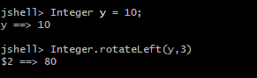

1. As == operator check the address

If addresses are equal it will print true

As both string are equal it will point to same object therefore it will give true.

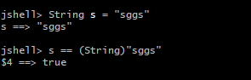

1. bracket will return the value assigned to y

therefore (y=17) will return 17

so, 10+17=27.



1. It will throw an error as it is wrong syntax for type conversion

Bracket should be over datatype

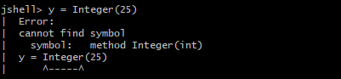

1. It will perform type casting of integer to short

Size of short = 65536;

Range [-32768,32767]

9042024%65536= 63592

65536-63592 = 1944;

Therefore -1944;



**Que 2.**

**A.**When we compile certain file and then when we run the class if we pass the class that is not present inside the compiled file then it throws this error

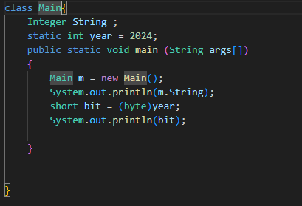

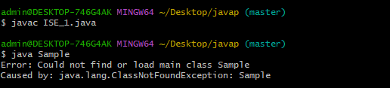

**B.**

This error is thrown when we intialise the string and we starts string content with single quote but if do not mention ending double quotes.

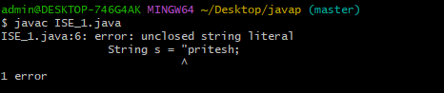

**C.**

This error is thrown when we want to get certain character of string and we define that specific character such as string index . for ex – s[0],where s is a string

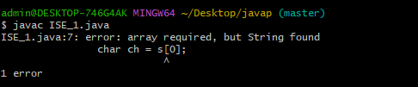

**Que 3.**

javac --source 21 --enable-preview FileName.java

* Javac will compile the java source code
* Source21 represents the version of java source code to be compiled.
* Enable preview option enables preview features in the Java compiler.

**Que 5.**

This code will create three objects those are:

First object of ”MID” will be created and will be pointed by str1.

Then “Term” Object will be created because of new Keyword and will be pointed by str2

str3 will point to object pointed by str1

str4 will point to Object pointed by str2

now again “Term” Object will get created because of new keywordand will be pointed by str5.

**Que 4.**

**A.**

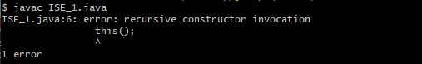

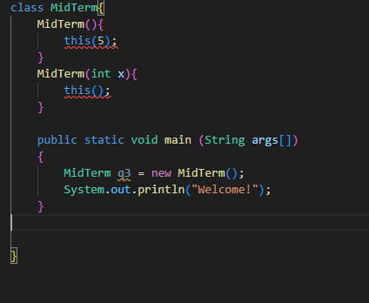

**B.**

There will be no impact by concating the string as its result is not been stored anywhere

Thus only Examination : Mid will get printed



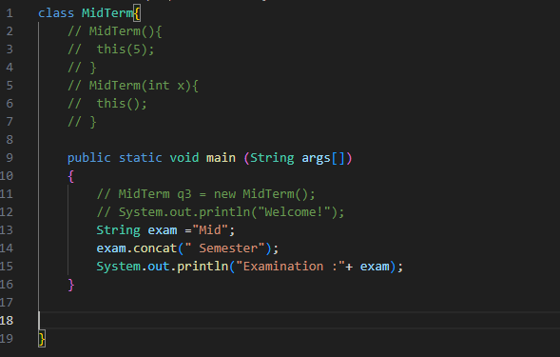

C.

Due continuous formation of objects stack will get overflowed

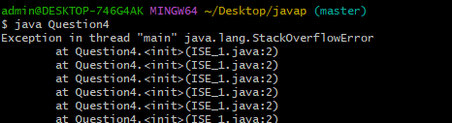

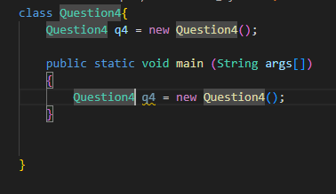

D.

First parent class will get loaded and its static blocks will get run then child class will get load and it static block will get run then during object creation first parent class init block and constructor will run then child class.

