NAME : Pritesh Zade

Reg.No : 2022BIT035

**ISE-1**

**Que 1.A**

This type of error is shown when the variable is declared inside the function without assigning any value to variable .

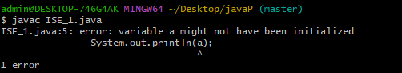

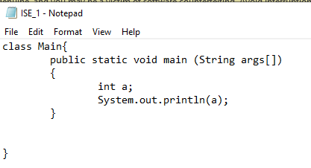

**Que 1.B**

First we find for substring of registration number from index 5 to 8 then we will equate it with another String whose content is “BIT”

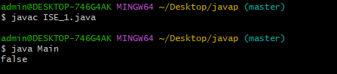

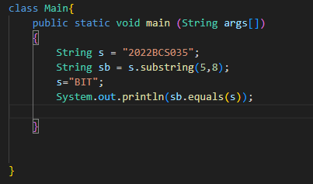

**Que 2.**

1. String keyword defines that the function or variable is class member it can be called without using and object.
2. As Integer is declared inside class and outside the function integer will be intiallised with 0 value automatically by JVM.

2024 will be converted to byte as it is type conversion

2024%256=232

256-232=24

Therefore it will print -24 as a output.

