**CHESSBOARD**

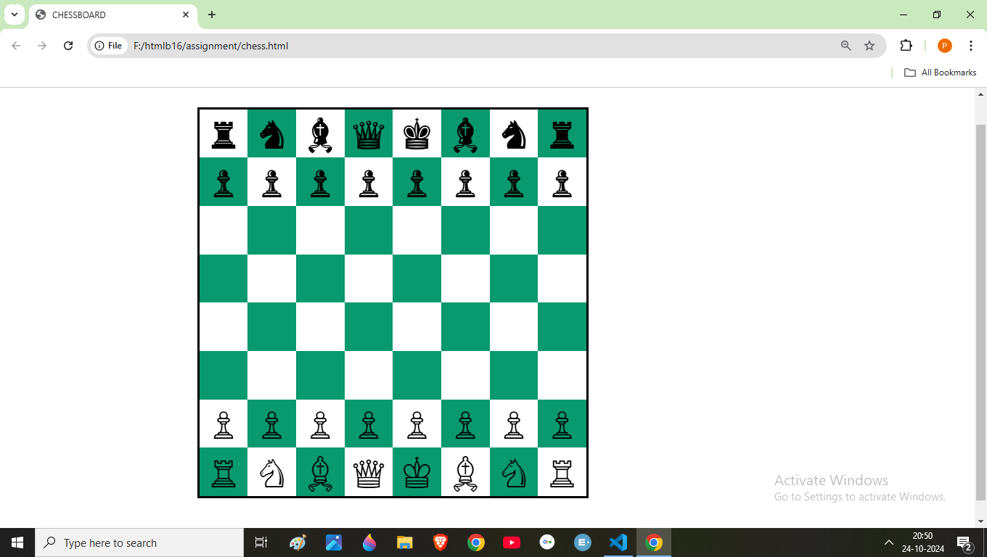

**Code: HTML**

<!DOCTYPE html>

<html lang="en">

<head>

    <meta charset="UTF-8">

    <meta name="viewport" content="width=device-width, initial-scale=1.0">

    <title>CHESSBOARD</title>

    <link rel="stylesheet" type="text/css" href="chess.css">

</head>

<body>

   <div class="chessbox">

    <div class="box white">&#9820;</div>

    <div class="box black">&#9822;</div>

    <div class="box white">&#9821;</div>

    <div class="box black">&#9819;</div>

    <div class="box white">&#9818;</div>

    <div class="box black">&#9821;</div>

    <div class="box white">&#9822;</div>

    <div class="box black">&#9820;</div>

    <div class="box black">&#9823;</div>

    <div class="box white">&#9823;</div>

    <div class="box black">&#9823;</div>

    <div class="box white">&#9823;</div>

    <div class="box black">&#9823;</div>

    <div class="box white">&#9823;</div>

    <div class="box black">&#9823;</div>

    <div class="box white">&#9823;</div>

    <div class="box white"></div>

    <div class="box black"></div>

    <div class="box white"></div>

    <div class="box black"></div>

    <div class="box white"></div>

    <div class="box black"></div>

    <div class="box white"></div>

    <div class="box black"></div>

    <div class="box black"></div>

    <div class="box white"></div>

    <div class="box black"></div>

    <div class="box white"></div>

    <div class="box black"></div>

    <div class="box white"></div>

    <div class="box black"></div>

    <div class="box white"></div>

    <div class="box white"></div>

    <div class="box black"></div>

    <div class="box white"></div>

    <div class="box black"></div>

    <div class="box white"></div>

    <div class="box black"></div>

    <div class="box white"></div>

    <div class="box black"></div>

    <div class="box black"></div>

    <div class="box white"></div>

    <div class="box black"></div>

    <div class="box white"></div>

    <div class="box black"></div>

    <div class="box white"></div>

    <div class="box black"></div>

    <div class="box white"></div>

    <div class="box white">&#9817;</div>

    <div class="box black">&#9817;</div>

    <div class="box white">&#9817;</div>

    <div class="box black">&#9817;</div>

    <div class="box white">&#9817;</div>

    <div class="box black">&#9817;</div>

    <div class="box white">&#9817;</div>

    <div class="box black">&#9817;</div>

    <div class="box black">&#9814;</div>

    <div class="box white">&#9816;</div>

    <div class="box black">&#9815;</div>

    <div class="box white">&#9813;</div>

    <div class="box black">&#9812;</div>

    <div class="box white">&#9815;</div>

    <div class="box black">&#9816;</div>

    <div class="box white">&#9814;</div>

</div>

</body>

</html>

**Code: CSS**

.chessbox

{

display: grid;

width: 800px;

grid-template-columns: repeat(8, 1fr);

grid-template-rows: repeat(8, 1fr);

border: 5px solid black;

margin-left: 20%;

margin-right: 15%;

margin-top: 5%;

margin-bottom: 5%;

}

.box{

    display: flex;

    justify-content: center;

    align-items: center;

    font-size: 5em;

}

.white

{

    background-color: white;

    width: 100px;

    height: 100px;

}

.black{

    background-color: rgb(8, 153, 110);

    width: 100px;

    height: 100px;

}