Program Outputs:

Run 1 with 30 bits of initial key and hamming code (15, 11)

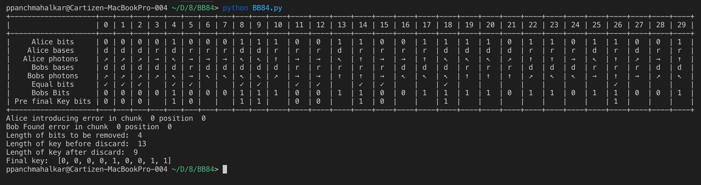

Run 2 with 500 bits of initial key and hamming code (31, 26)

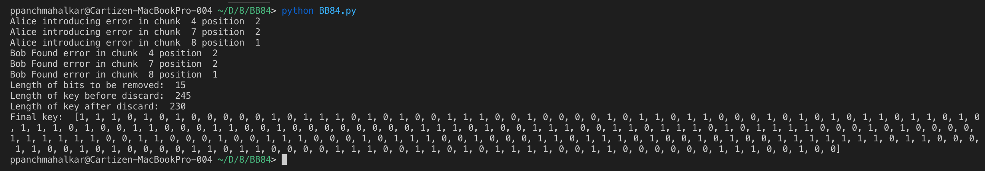

I introduced random errors in random chunks and used the parity check matrices to trace out those errors. Discarded 15 bits as 5 parity bits were exchanged thrice.