**SENTIMENTAL ANALYSIS FOR MARKETING:**

**Introduction:**

Sentiment analysis is a valuable tool in marketing for understanding how Customers perceive your brand, products, or services.

It helps you gauge the Sentiment expressed in customer feedback, social media mentions, reviews, and other forms of user-generated content.

By analyzing sentiment, you can uncover Valuable insights that can inform your marketing strategies and decision-making Processes.

**DATASET LINK:**[**https://www.kaggle.com/datasets/crowdflower/twitter-airline-sentiment**](https://www.kaggle.com/datasets/crowdflower/twitter-airline-sentiment)

**DATACARD:**

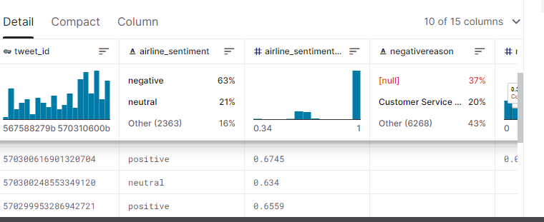

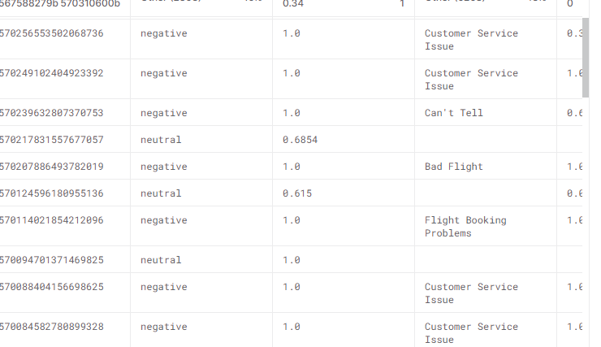

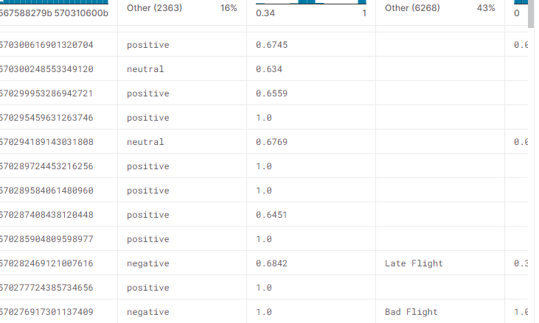

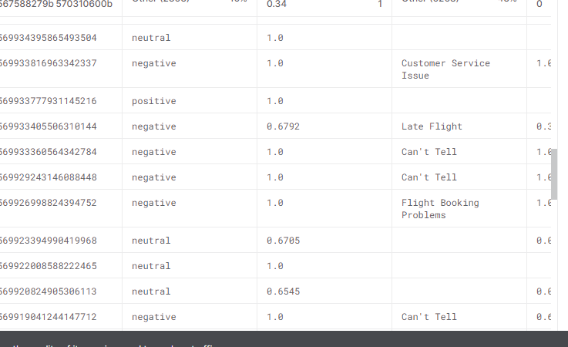

**EDA on One Piece Reviews:**

<https://www.kaggle.com/datasets/crowdflower/twitter-airline-sentiment>

In this notebook I will perform a simple EDA on the dataset I gathered from IMDB on the reviews on first ever successful live action of an anime "One Piece Live Action". Is this live action successful or not we will find out after the EDA

**SAMPLE CODE:**

import pandas as pd

import numpy as np

from matplotlib import pyplot as plt

import seaborn as sns

data=pd.read_csv("/kaggle/input/one-piece-live-action-imdb-reviews/reviews.csv")

data.head()

data.shape()

data.info()

data.isna().sum()

data['Rating']=data['Rating'].fillna(data['Rating'].mean())

print('Average rating on One piece live adaption is ',data['Rating'].mean())

value_counts = data['Rating'].value_counts()

value_counts()

data['Rating'].value_counts().plot.bar(title='Rating Graph of One Piece Live Action')

data['Review'][0]

sent_data=pd.read_csv('/kaggle/input/twitter-airline-sentiment/Tweets.csv')

sent_data.head()

columns=['tweet_id', 'airline_sentiment_confidence',

'negativereason', 'negativereason_confidence', 'airline',

'airline_sentiment_gold', 'name', 'negativereason_gold',

'retweet_count', 'tweet_coord', 'tweet_created',

'tweet_location', 'user_timezone']

def clean_text(text):

text = text.lower()

text = nltk.word_tokenize(text)

text = [t for t **in** text if len(t) > 1]

text = [stemmer.stem(word) for word **in** text if word **not** **in** stopwords]

text = ' '.join(text)

return text

from sklearn.feature_extraction.text import CountVectorizer

cv = CountVectorizer(max_features=20000)

X = cv.fit_transform(sent_data['text']).toarray()

y=sent_data["airline_sentiment"].to_numpy()

y

print(np.unique(y))

print(np.bincount(y))

**SAMPLE OUTPUT:**

(878, 4)

Title 0

Review 0

Date 0

Rating 8

dtype: int64

Rating

10.000000 432

9.000000 171

8.000000 93

7.000000 52

5.000000 27

1.000000 27

6.000000 26

3.000000 17

2.000000 13

4.000000 12

8.517241 8

Name: count, dtype: int64

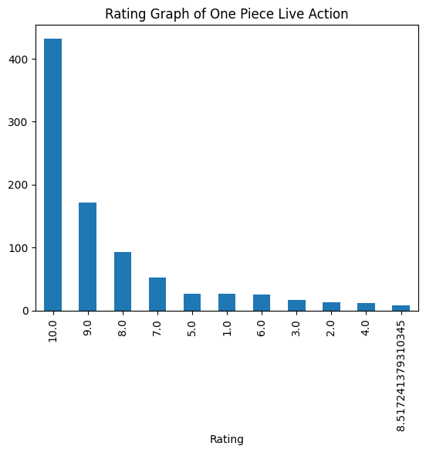

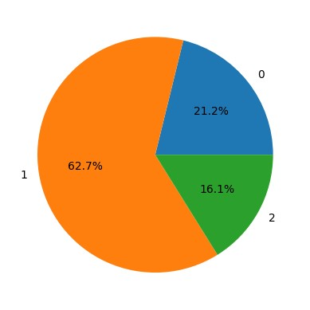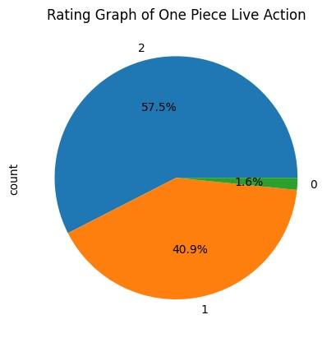

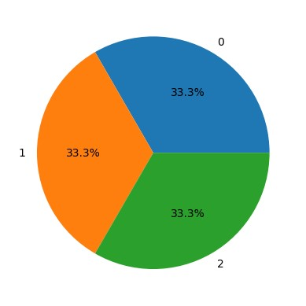

Guy mess seating. reserve seat friend guy gave seat away ... want free internet'

array([0, 2, 0, ..., 0, 1, 0])

"Being a one piece fan myself, I was a bit insecure about starting the series but boy do I never got off my bed through all these 8 episodes. The Live Adaptation is way beyond my expectations and I seriously cried and laughed along every emotional and comforting moment. NETFLIX PLEASE RELEASE SEASON 2. The portrayal of Monkey D Luffy was perfect as well as other characters. Every Episode had its own main character and the introduction to each and every straw pirate crew was done with utmost respect and love 💕. Can't wait for more pirate crew members to be introduced in the later seasons especially Nico Robin."

0 Title 878 non-null object

1 Review 878 non-null object

2 Date 878 non-null object

3 Rating 870 non-null float64

dtypes: float64(1), object(3)

memory usage: 27.6+ KB

Rating

10.000000 432

9.000000 171

8.000000 93

7.000000 52

5.000000 27

1.000000 27

6.000000 26

3.000000 17

2.000000 13

4.000000 12

8.517241 8

Name: count, dtype: int64

'@VirginAmerica you guys messed up my seating.. I reserved seating with my friends and you guys gave my seat away ... 😡 I want free internet'

**CONCLUSION:**

The benefits of sentiment analysis include the following: Collecting large amounts of unstructured data from various sources. Tracking real-time customer feedback and sentiment about an organization's brand, products and services. Providing feedback on ways to improve products, services and customer experience.