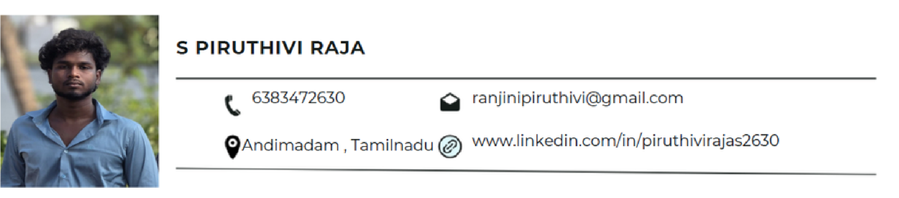

ABOUT ME

B. Tech Information Technology student with strong knowledge in Frontend Development, Java, Python, and Database Management, seeking an entry-level Software Developer or IT Internship role to apply programming, problem-solving, and technical skills.

EDUCATION

2022- 2026 MAM College of Engineering and Technology
Anna University B. Tech Information Technology I Percentage–7.5 CGPA
2020 - 2022 Don Bosco Hr. Sec. School
HSC I Percentage - 79.9%
2019 - 2020 Don Bosco Hr. Sec. School
SSLC I Percentage - 87%

INTERNSHIP EXPERIENCE

Front End Developer Intern — T4TEQ Software Solutions, Trichy. (Developed responsive web pages using HTML, CSS, and JavaScript)
Junior Software Developer Intern — Gradtwin Technology private limited, Sholinganallur, Chennai.

TECHNICAL SKILLS

Programming Languages: Java, Python, C
Web Technologies: HTML, CSS, JavaScript, Django
Core Concepts: DBMS, Frontend Development
Database: MySQL, MongoDB (Basics)
Tools: MS Office

PROJECTS
Hospital Appointment Booking And Generate Digital Token System -a digital solution that allows patients to book consultations via web or mobile apps, replacing manual queues with electronic tokens (mPass) for OPD, labs, and clinics

CERTIFICATIONS

Frontend -HTML, CSS, JS, Django
Backend - Python, Java,

PERSONAL DETAILS

Name:S Piruthivi Raja
Gender: Male
Hobbies: Cricket
Date of Birth:21/12/2004
Address for Communication: 1015, colony Street, Melaneduvai,
pattanankurichi (PO). Andimadam (TK), Ariyalur (DT).

