**How to create Repository in GitHub:**

* 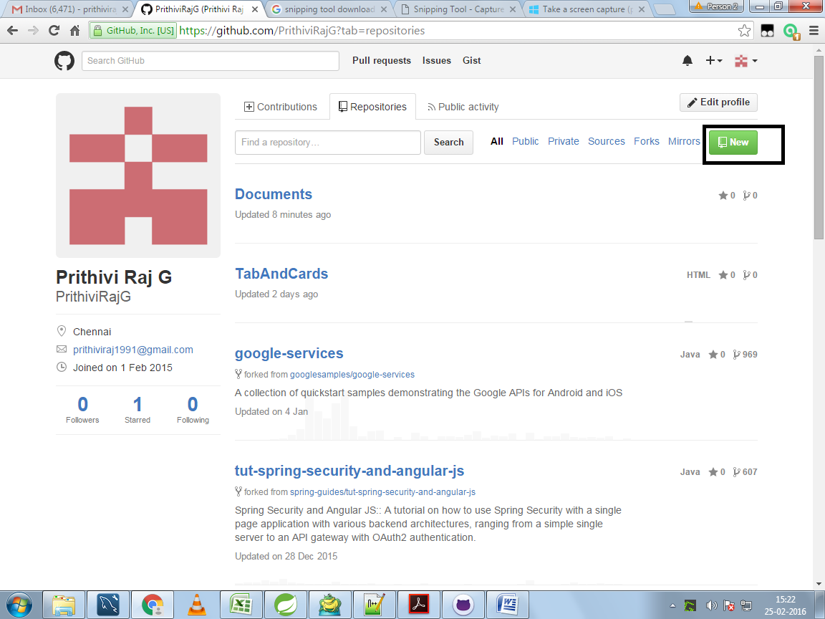
* Click on the new button and give name for repository
* Install github desktop if it is not already existing
* Edit read me file and commit changes
* Click and drag the files to upload the files into repository
* 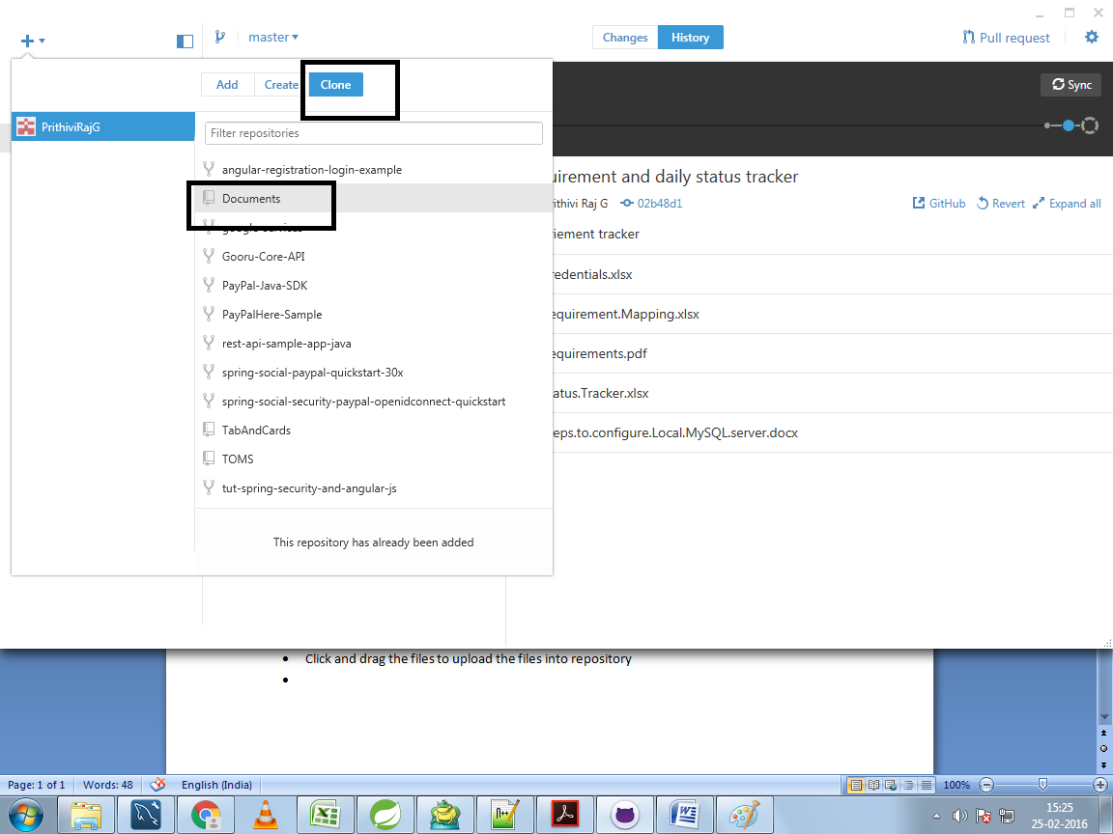
* In github desktop select the repository to be cloned to your local maching
* Select the path where it has to cloned and do changes