1. Starting with the **train.py** file to train the model

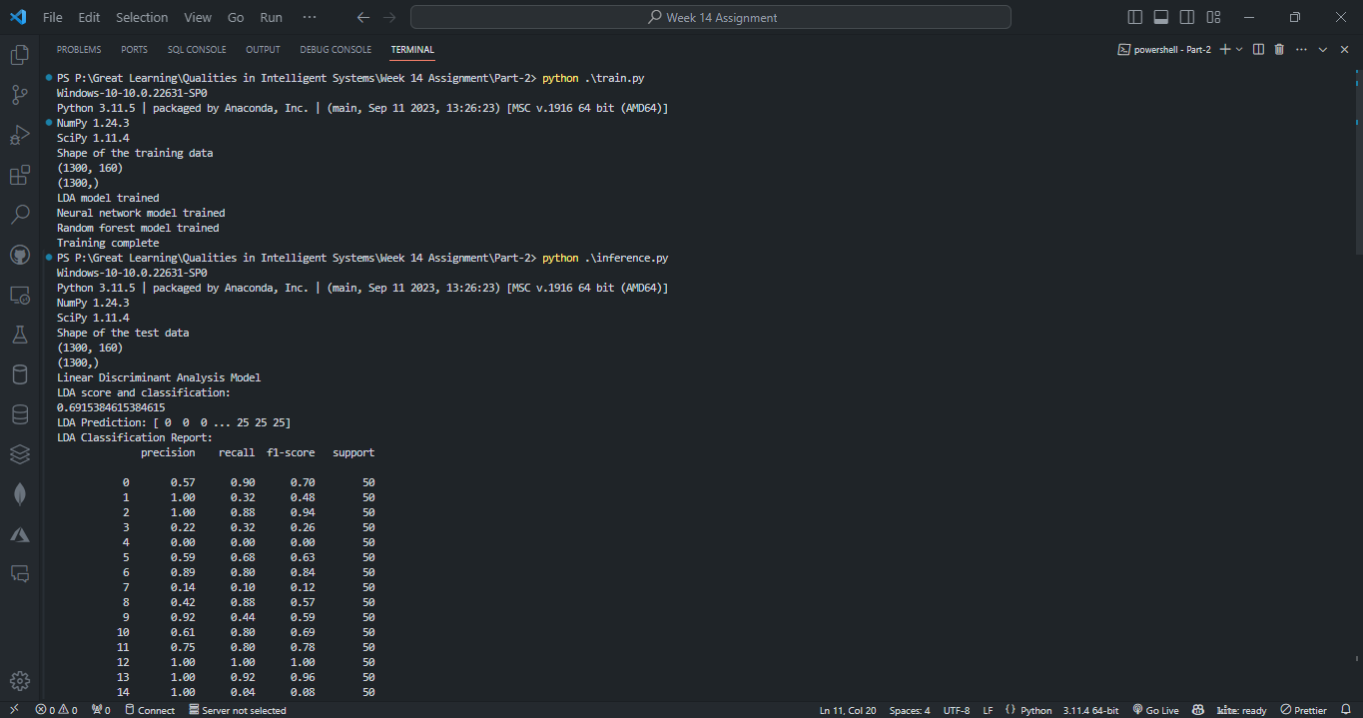

1. Then running the **inference.py** file to test the model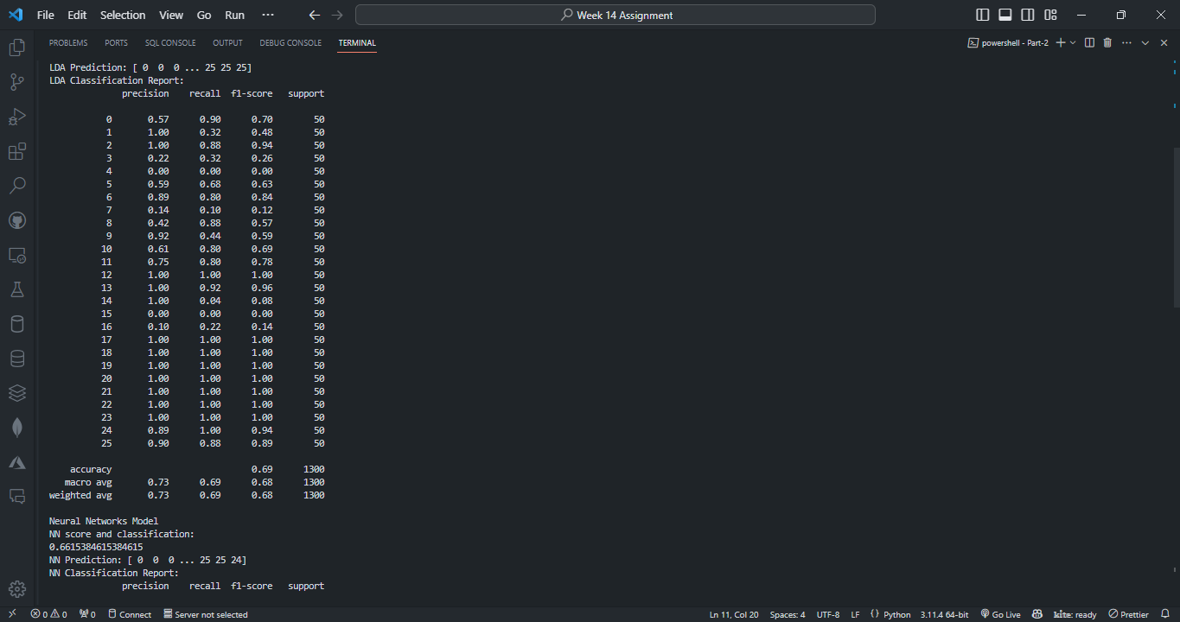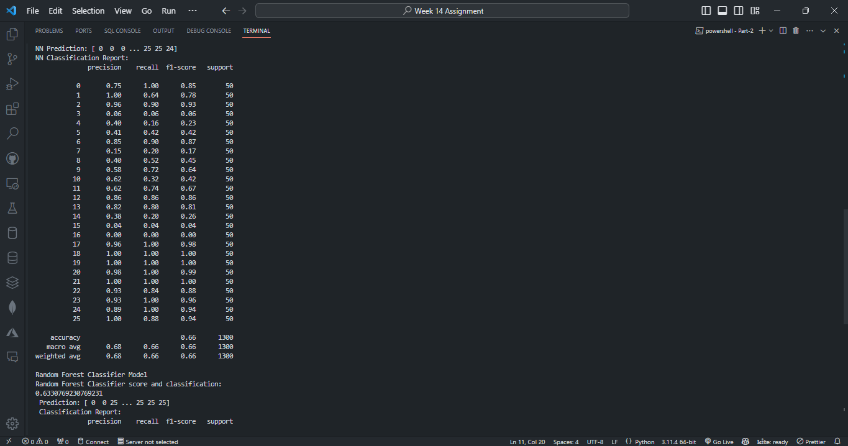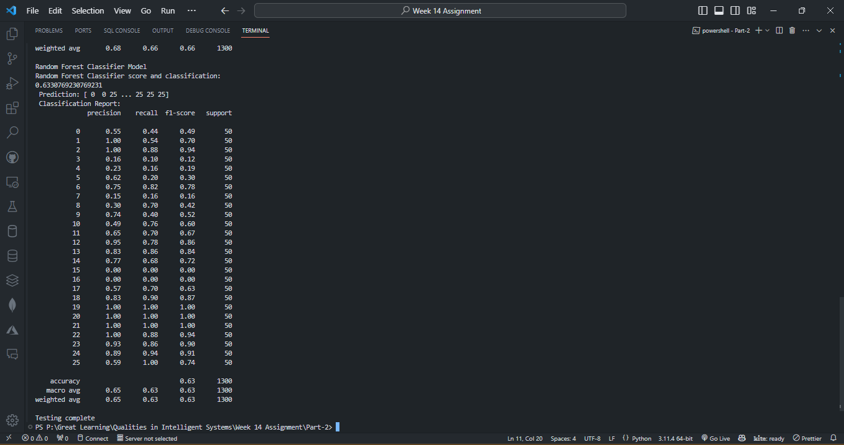
2. Building the Docker image with name **eeg_prediction**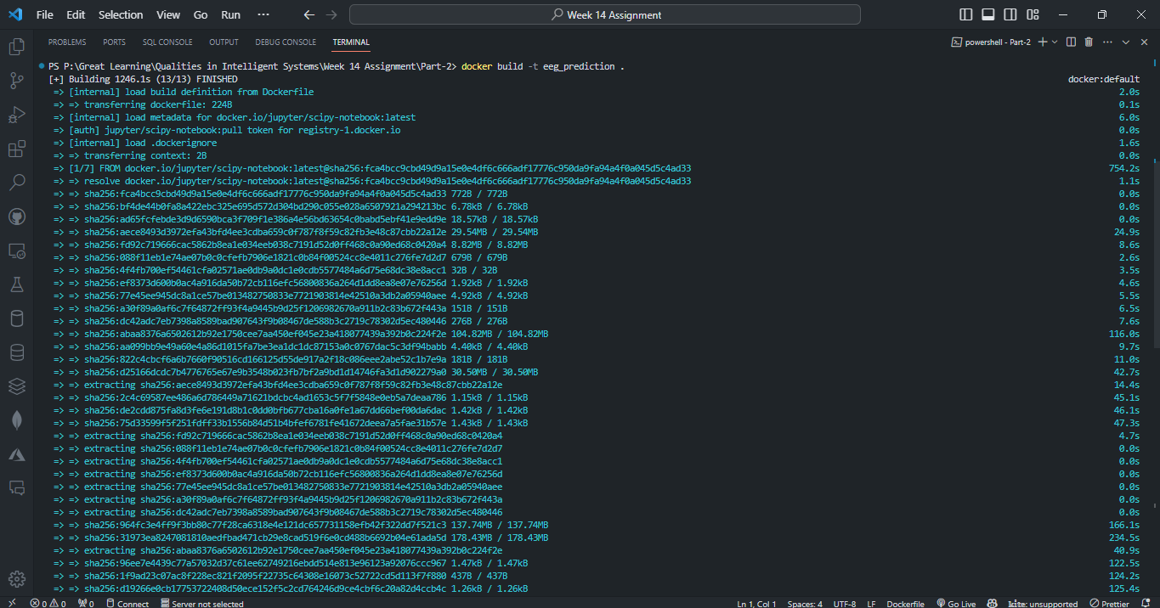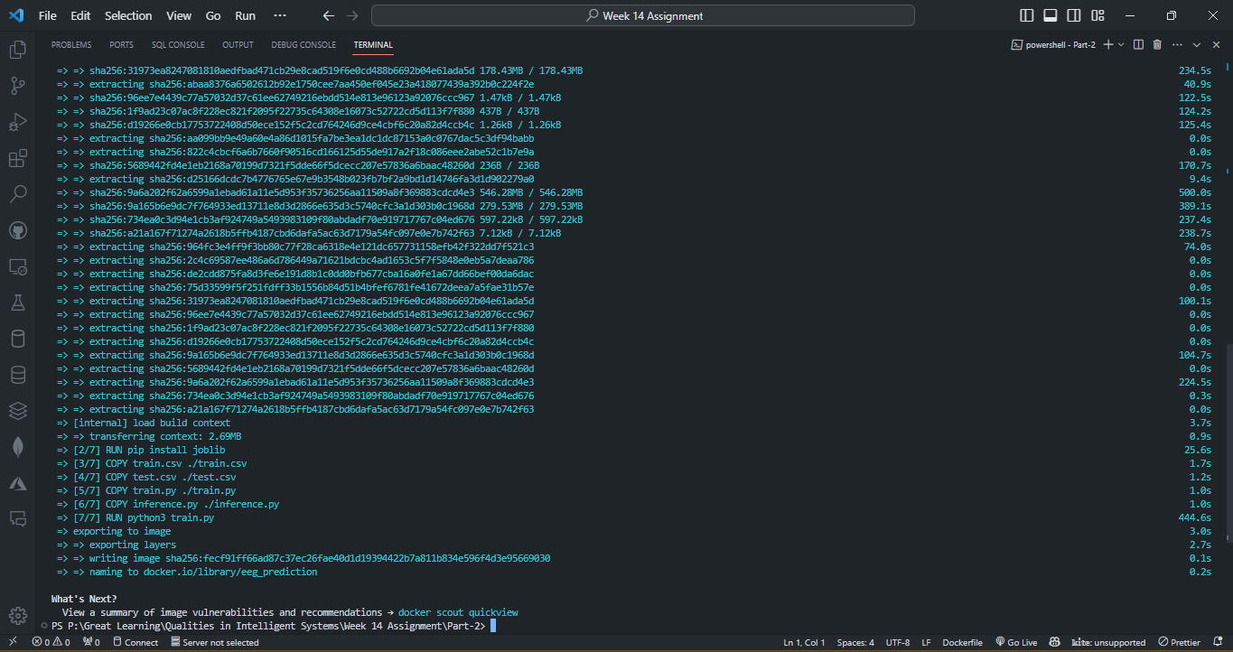
3. To view the Docker Image run **docker images**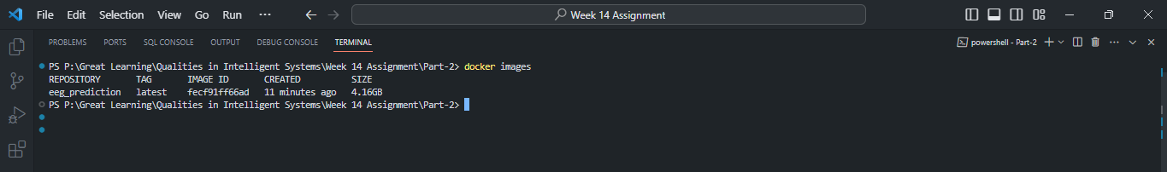
4. Tagging the docker image and then pushing my docker image to my dockerhub account using the command

**docker tag eeg_prediction prithunagar1234/eeg_prediction**

**docker push prithunagar1234/eeg_prediction:latest**

