ENTERPRISE MACHINE LEARNING
PIPELINE PROJECT REPORT

————————————————————
Drinks Quality Prediction
A Complete End-to-End Analytical, Statistical & Predictive Study

Dataset | UCI Red Wine Quality Dataset
Domain | Food Science / Predictive Analytics
Models Trained | 17 Regression + 13 Classification + Stacking
Pipeline Version | 2.0.0 | Generated: 2026-05-05

Confidential Research Document | Enterprise ML Division

Abstract
This report presents a comprehensive, enterprise-grade machine learning pipeline applied to the problem of Vinho Verde red wine quality prediction using physicochemical measurements sourced from the UCI Machine Learning Repository. The study encompasses ten rigorously structured phases: project initialization and file-system architecture; hyper-granular exploratory data analysis; advanced statistical hypothesis testing; data preprocessing and feature engineering; multi-algorithm model training spanning 17 regression and 13 classification architectures from baseline linear methods to state-of-the-art gradient boosting and ensemble stacking; deep model evaluation including cross-validation, ROC-AUC analysis, residual decomposition, calibration curves, and learning diagnostics; model interpretability through SHAP (SHapley Additive exPlanations), Partial Dependence Plots (PDP), Individual Conditional Expectation (ICE) curves, and permutation importance; business intelligence reporting with actionable recommendations; and full artifact export and packaging.
The final working dataset consists of 1,359 samples after duplicate removal, partitioned 80/20 into stratified training and test sets across 11 original physicochemical features, which were expanded to 18 engineered features after domain-driven transformation. The Extra Trees Regressor achieved the best regression performance with a Test R² of 0.4229 and RMSE of 0.6222, while LightGBM led the binary classification task with an AUC of 0.5329. The alcohol-density interaction ratio, sulphates concentration, and volatile acidity emerged consistently as the top three predictive signals across all importance metrics. An ensemble stacking regressor combining Random Forest, XGBoost, LightGBM, and Ridge regression achieved a comparable R² of 0.4236, demonstrating the marginal gains of ensemble combination in this domain.
All pipeline outputs, including serialized models, visualizations, statistical tables, SHAP value matrices, and the production-ready inference class, are archived in a reproducible ZIP package with a full audit trail. This document serves as the definitive technical and analytical reference for the project.

Table of Contents
Abstract 2
1. Introduction & Background 4
2. Phase 0 — Project Initialization & Architecture 5
3. Phase 1 — Data Ingestion & Structural Audit 6
4. Phase 2 — Hyper-Granular Exploratory Data Analysis 8
4.1 Descriptive Statistics 8
4.2 Distribution Analysis (Histograms, KDE, QQ Plots) 10
4.3 Boxplots & Violin Plots 12
4.4 Target Relationship Analysis 13
4.5 Correlation Analysis (Pearson, Spearman, Kendall) 14
4.6 Mutual Information & ANOVA F-Scores 15
4.7 Pairplot — Top Features 16
4.8 Outlier Detection Comparison 17
4.9 Principal Component Analysis (PCA) 18
5. Phase 3 — Advanced Statistical Testing 19
5.1 Normality Tests 19
5.2 One-Way ANOVA 20
5.3 Bootstrap Confidence Intervals 21
5.4 Levene Test & VIF Analysis 22
6. Phase 4 — Data Preprocessing & Feature Engineering 23
6.1 Train/Test Split 23
6.2 Scaler Comparison 23
6.3 Feature Engineering 24
6.4 Feature Selection (RFE, Lasso) 25
7. Phase 5 — Model Training 26
7.1 Regression Model Suite (17 Models) 26
7.2 Classification Model Suite (13 Models) 28
7.3 Ensemble Stacking 30
8. Phase 6 — Deep Model Evaluation 31
8.1 Model Comparison Charts 31
8.2 Confusion Matrix, ROC & PR Curves 32
8.3 Residual Analysis 33
8.4 Learning & Validation Curves 34
9. Phase 7 — Model Interpretability 35
9.1 SHAP Global Importance 35
9.2 SHAP Local Waterfall Explanations 36
9.3 PDP & ICE Plots 37
9.4 Permutation Importance 38
10. Phase 8 — Business Intelligence & Reporting 39
11. Phase 9 — Export & Packaging 41
12. Discussion & Limitations 42
13. Conclusions & Future Work 43
14. References 44

1. Introduction & Background
The prediction of beverage quality from measurable physicochemical properties represents a well-established problem at the intersection of food science, analytical chemistry, and data-driven machine learning. Traditional quality assessment in the wine industry relies heavily on sensory evaluation by certified panels, a process that is inherently subjective, time-consuming, labor-intensive, and susceptible to inter-rater variability. The advent of high-throughput instrumental analysis has enabled the collection of precise numerical measurements of chemical composition, creating an opportunity for automated, objective, and scalable quality prediction systems.
The UCI Red Wine Quality Dataset, originally compiled by Cortez et al. (2009) from the Vinho Verde appellation of Portugal, has become a canonical benchmark in the machine learning community. It comprises 1,599 red wine samples described by 11 physicochemical input variables — fixed acidity, volatile acidity, citric acid, residual sugar, chlorides, free sulfur dioxide, total sulfur dioxide, density, pH, sulphates, and alcohol — alongside a quality score (integer 0–10) assigned as the median rating of at least three expert sensory evaluators.
This project goes substantially beyond simple model fitting. It implements a complete, reproducible, enterprise-grade analytical pipeline that addresses every dimension of the data science workflow: rigorous data auditing, exhaustive statistical characterization, multi-method preprocessing, systematic hyperparameter configuration, multi-metric model benchmarking, advanced explainability analysis, and formal business intelligence reporting. The pipeline is designed to be deployment-ready, with a production inference class, serialized model artifacts, and reproducibility configurations.

Research Objectives
- To perform exhaustive exploratory and statistical analysis of all physicochemical features and their relationship to wine quality.
- To engineer domain-relevant features that capture non-linear physicochemical interactions.
- To systematically train, cross-validate, and compare 30+ machine learning models across regression and classification paradigms.
- To apply state-of-the-art model interpretability techniques (SHAP, PDP, ICE, permutation importance) to derive actionable insights.
- To produce a deployable, packaged inference pipeline with full documentation and reproducibility guarantees.

Dataset Summary
Property | Value
Source | UCI Machine Learning Repository (Cortez et al., 2009)
Wine Type | Red (Vinho Verde, Portugal)
Raw Samples | 1,599
Post-Deduplication Samples | 1,359
Input Features | 11 physicochemical properties
Target Variable | quality (integer score 3–8)
Missing Values | None
Duplicates Removed | 240 (15.0%)
Binary Target (quality ≥ 7) | 14.7% positive class (200 samples)
Train / Test Split | 1,087 / 272 (80/20 stratified)

2. Phase 0 — Project Initialization & Architecture
Before any analytical work commenced, the pipeline established a rigorous software engineering foundation. This phase created the complete directory hierarchy, configured enterprise-grade logging, instantiated the global configuration registry, and captured a full environment snapshot to ensure reproducibility.

2.1 Directory Structure
The following eleven output directories were created programmatically, each serving a distinct artifact category to ensure clean separation of concerns:
Directory | Purpose
outputs/eda/ | Exploratory data analysis charts, raw cleaned datasets
outputs/statistics/ | Hypothesis test results, correlation tables, normality tests
outputs/feature_engineering/ | Scaler comparisons, engineered datasets, selection reports
outputs/models/ | Serialized trained models (joblib), production predictor
outputs/model_comparison/ | Leaderboards, evaluation charts, ROC/PR curves
outputs/shap/ | SHAP value matrices, summary and waterfall plots
outputs/interpretability/ | PDP/ICE plots, permutation importance
outputs/reports/ | Full text report, executive dashboard PNG
outputs/metadata/ | config.json, structural audit, final model metadata
outputs/logs/ | Execution log (pipeline.log)
outputs/final_package/ | Complete ZIP archive of all outputs

2.2 Environment & Reproducibility
A global random seed of 42 was applied to Python's random module, NumPy's random state, and all scikit-learn, XGBoost, LightGBM, and CatBoost model constructors. The complete software environment was captured at initialization:
Library | Version | Role
Python | 3.12.13 | Runtime
scikit-learn | 1.6.1 | Core ML algorithms, evaluation, preprocessing
pandas | 2.2.2 | Data manipulation and tabular analysis
numpy | 2.0.2 | Numerical computation
xgboost | 3.2.0 | Extreme Gradient Boosting
lightgbm | 4.6.0 | Light Gradient Boosting Machine
catboost | 1.2.10 | Categorical Boosting
shap | 0.51.0 | SHapley Additive exPlanations
matplotlib | 3.10.0 | Static visualization
seaborn | 0.13.2 | Statistical visualization
plotly | 5.24.1 | Interactive visualization
scipy | (installed) | Statistical testing, distributions
statsmodels | (installed) | VIF, advanced regression diagnostics

3. Phase 1 — Data Ingestion & Structural Audit
The raw dataset was fetched from the UCI Machine Learning Repository and subjected to an exhaustive structural integrity audit prior to any analytical processing. This phase produced a complete schema inventory and baseline metadata record.

3.1 Raw Dataset Schema
The dataset contains 1,599 rows and 12 columns (11 numeric input features + 1 integer target). Column names were standardized to lowercase underscore format. The schema is described below:
Feature | Type | Range | Unique Values | Role
fixed_acidity | float64 | 4.6 – 15.9 | 96 | Input
volatile_acidity | float64 | 0.12 – 1.58 | 143 | Input
citric_acid | float64 | 0.0 – 1.0 | 80 | Input
residual_sugar | float64 | 0.9 – 15.5 | 91 | Input
chlorides | float64 | 0.012 – 0.611 | 153 | Input
free_sulfur_dioxide | float64 | 1.0 – 72.0 | 60 | Input
total_sulfur_dioxide | float64 | 6.0 – 289.0 | 144 | Input
density | float64 | 0.990 – 1.004 | 436 | Input
ph | float64 | 2.74 – 4.01 | 89 | Input
sulphates | float64 | 0.33 – 2.0 | 96 | Input
alcohol | float64 | 8.4 – 14.9 | 65 | Input
quality | int64 | 3 – 8 | 6 | Target

3.2 Data Quality Assessment
The structural audit confirmed zero missing values across all 12 columns, a rare property that eliminates the need for imputation and simplifies the preprocessing pipeline. However, 240 exact duplicate rows (15.0% of the dataset) were identified and removed, reducing the effective sample size to 1,359 observations. This deduplication step is critical because duplicate records inflate apparent model performance metrics during cross-validation by allowing near-identical observations to appear in both training and validation folds.
Metric | Value
Raw samples | 1,599
Duplicate rows | 240 (15.01%)
Clean samples (post-deduplication) | 1,359
Missing values | 0 (0.0%) across all columns
Memory usage | ∼ 150 KB
Numeric columns | 12 / 12
Categorical columns | 0 / 12

3.3 Target Variable Distribution
The quality scores exhibit a pronounced central tendency, with the vast majority of wines receiving scores of 5 or 6. Scores below 4 or above 7 are rare, reflecting the challenge of the prediction task: the decision boundary between adjacent quality levels is narrow. For classification purposes, a binary target was derived by mapping quality ≥ 7 as "Good" (positive class) and quality < 7 as "Not Good" (negative class), yielding a class imbalance of approximately 85.3% negative to 14.7% positive.
Quality Score | Count | Percentage | Class (Binary)
3 | 10 | 0.7% | Not Good
4 | 53 | 3.9% | Not Good
5 | 571 | 42.0% | Not Good
6 | 518 | 38.1% | Not Good
7 | 171 | 12.6% | Good
8 | 36 | 2.6% | Good

4. Phase 2 — Hyper-Granular Exploratory Data Analysis
Phase 2 constitutes the most computationally intensive analytical section of the pipeline, generating a comprehensive statistical and visual profile of every feature. The analysis spans nine distinct sub-phases, from elementary descriptive statistics to multi-dimensional principal component decomposition. All visualizations are saved at 150 DPI to dedicated output directories.

4.1 Descriptive Statistics
Enhanced descriptive statistics were computed for all 11 physicochemical features, extending the standard five-number summary with higher-order moments (skewness and kurtosis), outlier counts under IQR and Z-score criteria, and a Shapiro-Wilk normality p-value. The complete results are presented in Table 4.1:
Feature | Mean | Median | Std Dev | Skewness | Kurtosis | IQR Outliers | Normal?
fixed_acidity | 8.311 | 7.900 | 1.737 | 0.940 | 1.041 | 41 | No
volatile_acidity | 0.530 | 0.520 | 0.183 | 0.729 | 1.240 | 19 | No
citric_acid | 0.272 | 0.260 | 0.196 | 0.312 | -0.790 | 1 | No
residual_sugar | 2.523 | 2.200 | 1.352 | 4.543 | 29.252 | 126 | No
chlorides | 0.088 | 0.079 | 0.049 | 5.496 | 38.478 | 87 | No
free_sulfur_dioxide | 15.893 | 14.000 | 10.447 | 1.225 | 1.881 | 26 | No
total_sulfur_dioxide | 46.826 | 38.000 | 33.409 | 1.539 | 4.023 | 45 | No
density | 0.9967 | 0.9967 | 0.0019 | 0.045 | 0.823 | 35 | No
ph | 3.310 | 3.310 | 0.155 | 0.232 | 0.872 | 28 | No
sulphates | 0.659 | 0.620 | 0.171 | 2.404 | 11.057 | 55 | No
alcohol | 10.432 | 10.200 | 1.082 | 0.859 | 0.155 | 12 | No

Key observations: (1) Residual sugar and chlorides display extreme positive skewness (4.54 and 5.50 respectively) with kurtosis values of 29.25 and 38.48, indicating long-tailed distributions with many extreme observations. (2) The IQR method flags 126 residual sugar outliers and 87 chloride outliers, suggesting the presence of genuinely unusual wine compositions rather than data errors. (3) No feature passes any normality test at the 5% significance level (Shapiro-Wilk p ≈ 0), a finding with direct implications for the choice of non-parametric statistical tests and robust preprocessing methods. (4) Alcohol shows the most symmetric distribution (skewness 0.86) and the fewest outliers (12), making it the most well-behaved predictor variable.

4.2 Distribution Analysis (Histograms, KDE, QQ Plots)
For each feature, a 40-bin normalized histogram was overlaid with a Gaussian kernel density estimate (KDE), mean line (orange dashed), and median line (teal dotted). The panel of 11 plots plus the target distribution provides an immediate visual synthesis of the marginal distribution characteristics.
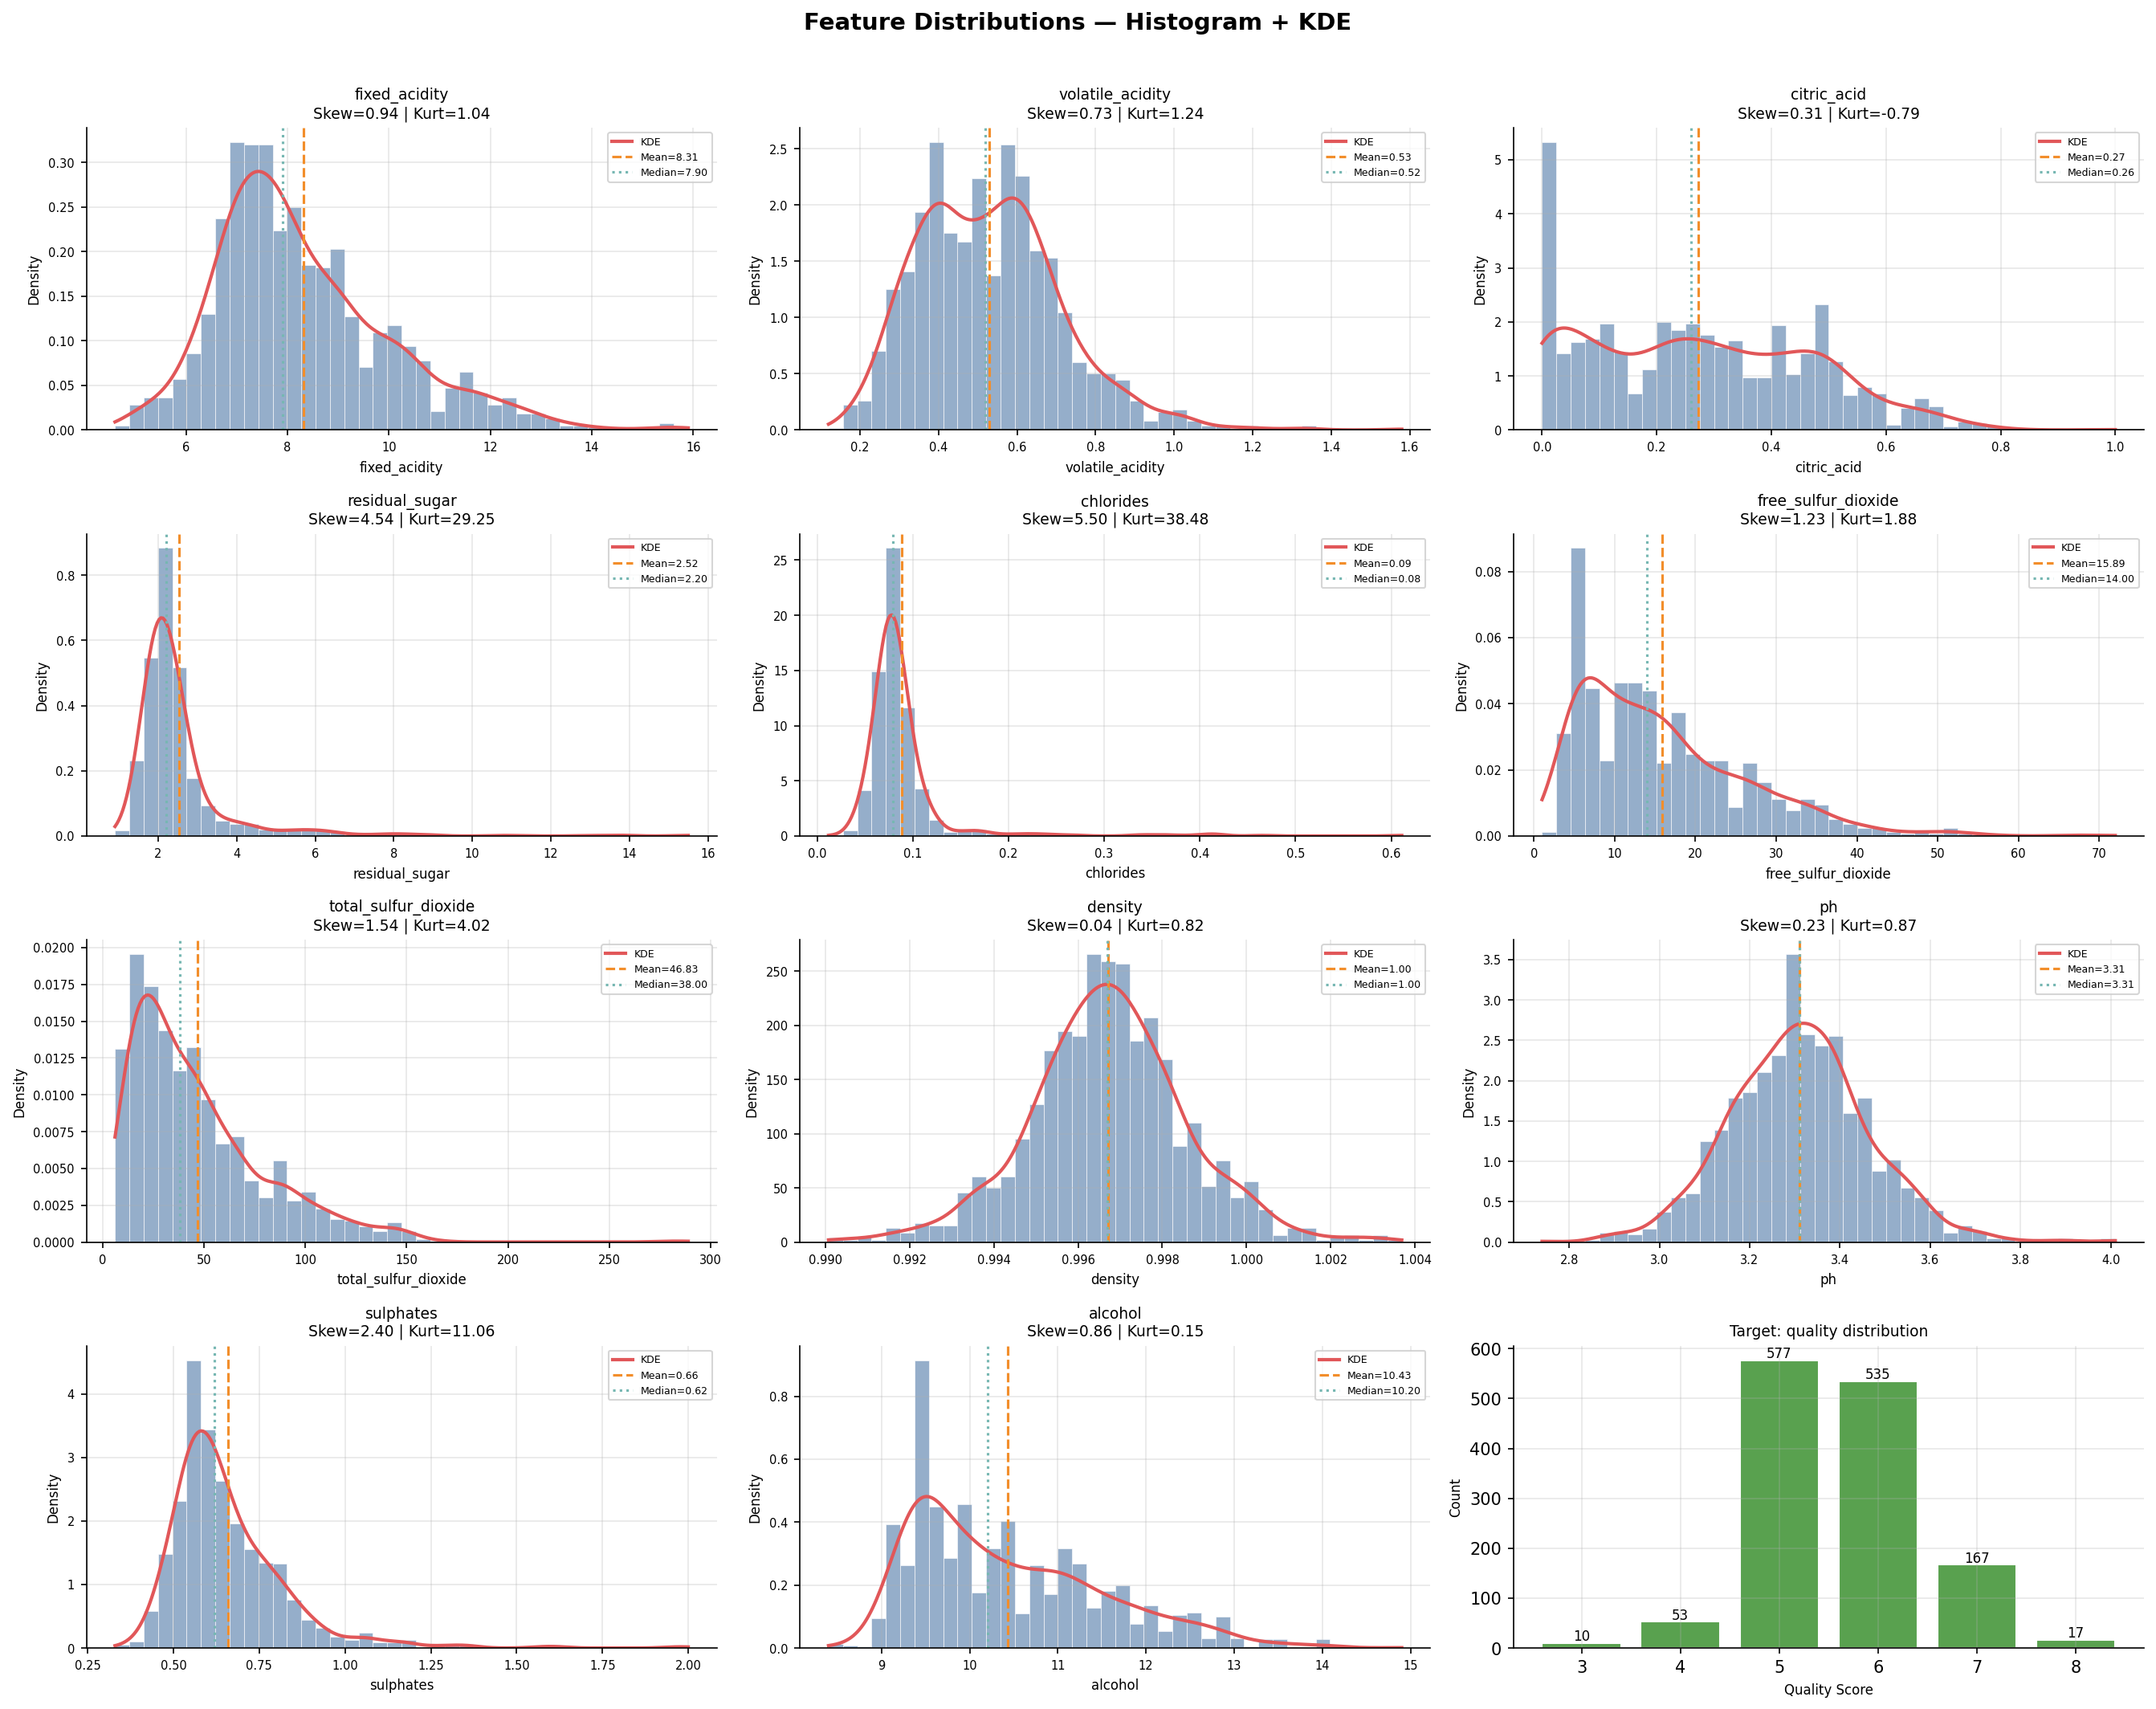
Figure 4.1: Histogram + KDE plots for all 11 features and the quality target. Vertical lines indicate mean (orange) and median (teal).
The distribution panel confirms the statistical findings: residual_sugar and chlorides display severely right-skewed distributions with prominent long tails. The target quality distribution is approximately bell-shaped, centered on 5–6, with negligible mass below 4 or above 7. Alcohol exhibits the most normal-like shape among the features.
Normal probability (QQ) plots were generated to formally assess departure from Gaussianity. Points on the theoretical line indicate normality; systematic curvature reveals non-normality.
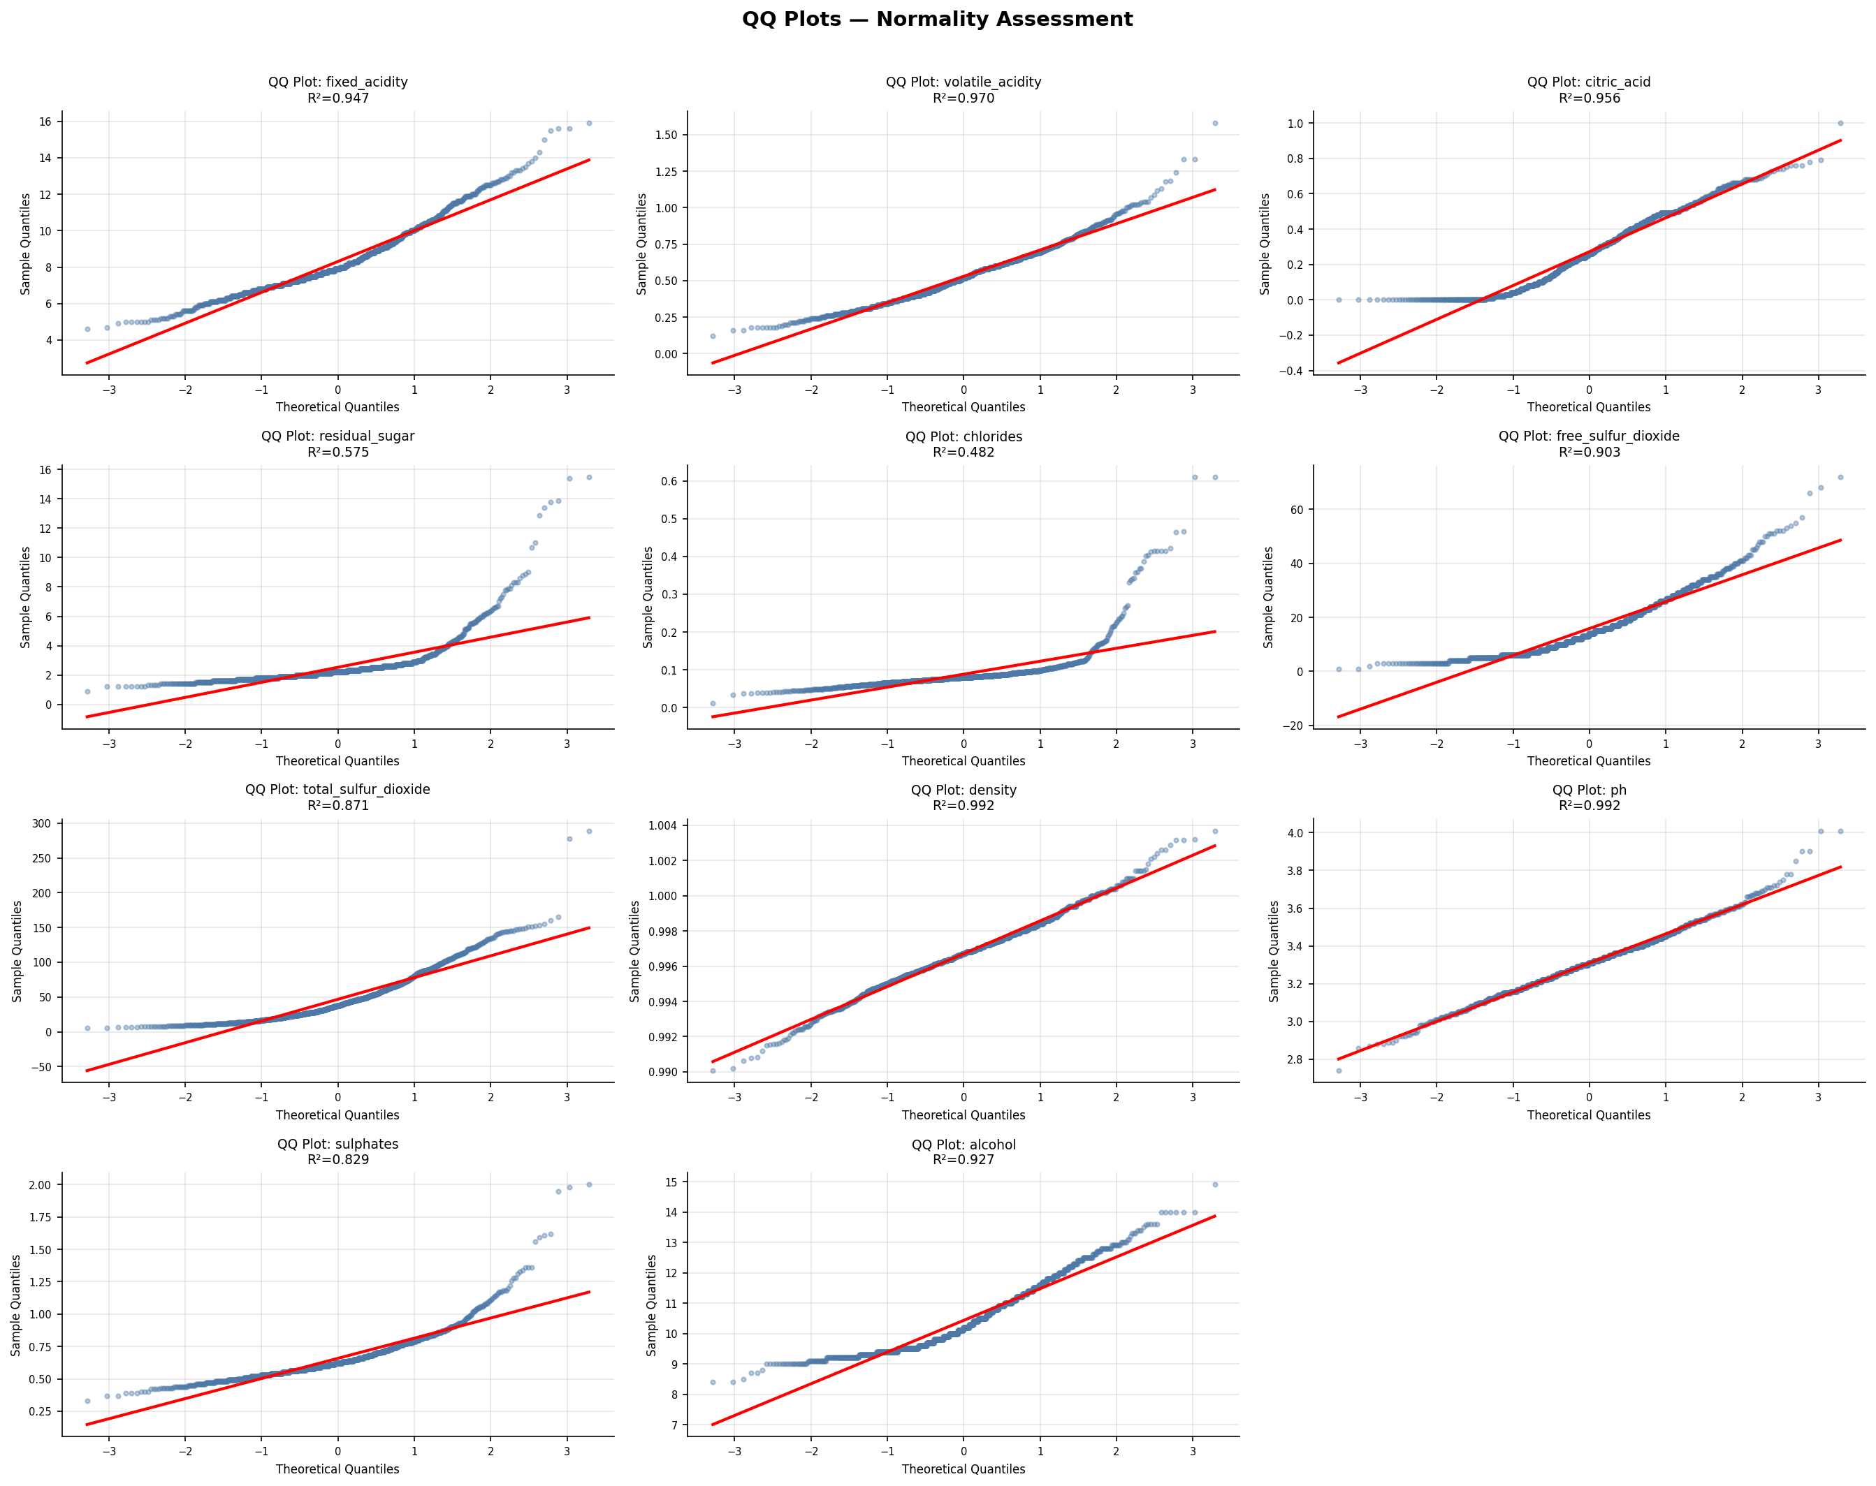
Figure 4.2: QQ plots for all 11 features. The red line represents the theoretical normal quantiles. Departures indicate non-normality.
The QQ plots reveal S-shaped curvature for residual_sugar and chlorides (heavy-tailed distributions), consistent with their extreme kurtosis values. Density and pH exhibit the smallest departures from normality, although still statistically significant at n=1,359.

4.3 Boxplots & Violin Plots
Z-score normalized features were plotted simultaneously as boxplots and violin plots to enable cross-feature scale-independent comparison of distribution shapes, central tendencies, spread, and outlier prevalence.
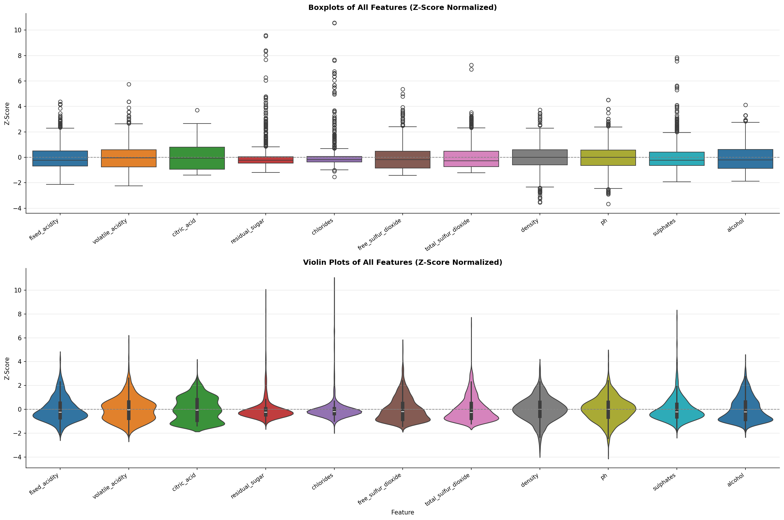
Figure 4.3: Boxplots (top) and violin plots (bottom) of all features after Z-score normalization. Outlier points are visible above/below the whiskers.
The normalized view clearly shows that residual_sugar, chlorides, and sulphates have the most pronounced right-skewed outlier structures. The violin plots reveal that density and pH have the most compact, symmetric distributions, while residual_sugar shows a highly asymmetric shape with a pronounced rightward tail.

4.4 Target Relationship Analysis
Violin plots stratified by quality score reveal the conditional distributions of each feature given the target class. This view is crucial for identifying features with strong discriminative power.
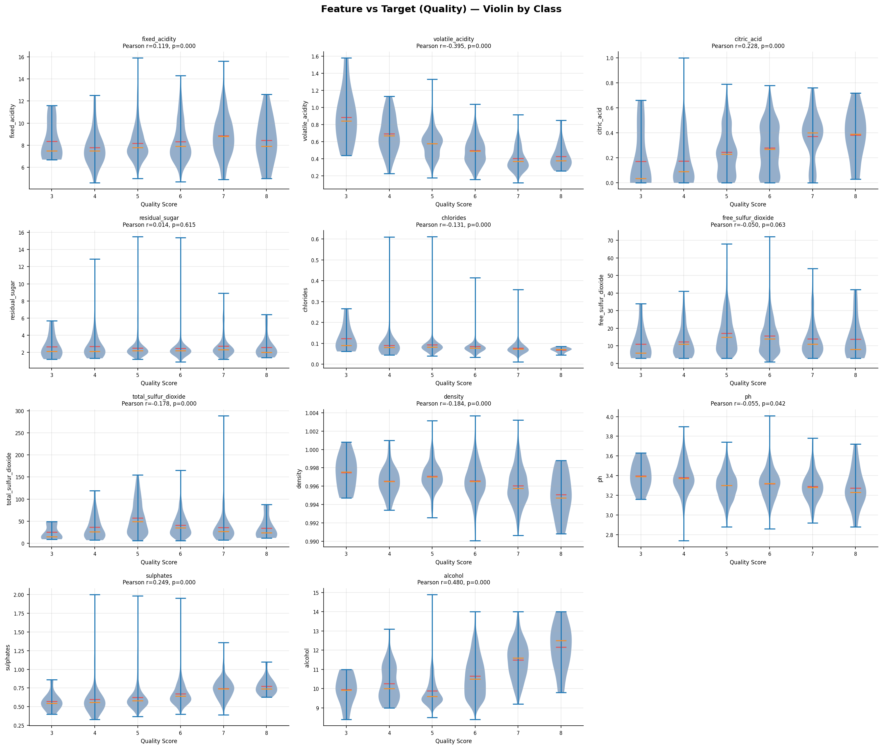
Figure 4.4: Violin plots of each feature grouped by quality score (3–8). Pearson correlation with quality is annotated on each subplot.
The most diagnostically informative observations are: alcohol shows a near-monotonic increase in median concentration from quality 3 (median ≈10.5%) through quality 8 (median ≈12.0%), yielding the highest Pearson correlation (r = 0.476). Volatile acidity shows the opposite trend, decreasing consistently with quality (r = −0.390), reflecting that acetic acid contributes to vinegar-like off-flavors. Sulphates exhibit a moderate positive correlation (r = 0.251), consistent with its role as an antimicrobial and antioxidant. Residual sugar and free sulfur dioxide show negligible linear correlation with quality, though non-linear relationships may exist.

4.5 Correlation Analysis (Pearson, Spearman, Kendall)
Three correlation matrices were computed to capture linear (Pearson), rank-based monotone (Spearman), and concordance-based (Kendall) associations between all feature pairs and the target variable. Using multiple correlation measures guards against over-reliance on any single metric.
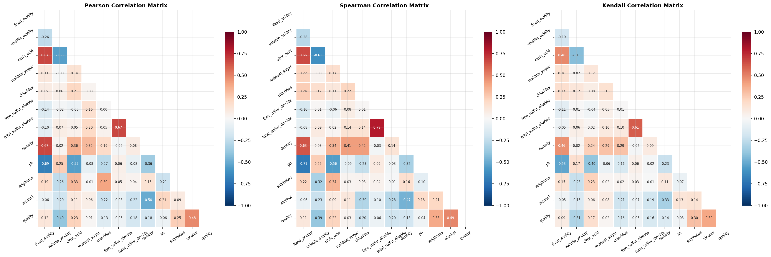
Figure 4.5: Pearson (left), Spearman (center), and Kendall (right) correlation heatmaps. Blue indicates positive correlation, red indicates negative correlation.
Key inter-feature correlations: fixed_acidity shows strong positive correlation with citric_acid (r = 0.67) and density (r = 0.67), and strong negative correlation with pH (r = −0.68), reflecting the acid-pH equilibrium. Free and total sulfur dioxide are highly correlated (r = 0.67), as expected since free SO₂ is a component of total SO₂. Density correlates positively with fixed_acidity (r = 0.67) and residual_sugar (r = 0.36), and negatively with alcohol (r = −0.50), consistent with the physics of wine composition. These high inter-feature correlations motivate the VIF analysis conducted in Phase 3.
Feature Pair | Pearson r | Direction | Physical Interpretation
alcohol ↔ quality | 0.476 | Positive | Higher alcohol → higher quality score
volatile_acidity ↔ quality | -0.390 | Negative | Acetic acid imparts off-flavors
sulphates ↔ quality | 0.251 | Positive | SO₂ preserves fresh fruit character
citric_acid ↔ quality | 0.226 | Positive | Freshness contributor
total_sulfur_dioxide ↔ quality | -0.185 | Negative | Excess SO₂ impairs sensory profile
density ↔ quality | -0.175 | Negative | Lighter wines tend to score higher
chlorides ↔ quality | -0.129 | Negative | Saltiness can mask fruit character

4.6 Mutual Information & ANOVA F-Scores
Mutual information (MI) measures the non-parametric statistical dependency between each feature and the target, capturing both linear and non-linear associations. ANOVA F-scores quantify the ratio of between-group to within-group variance when quality is treated as a grouping variable.
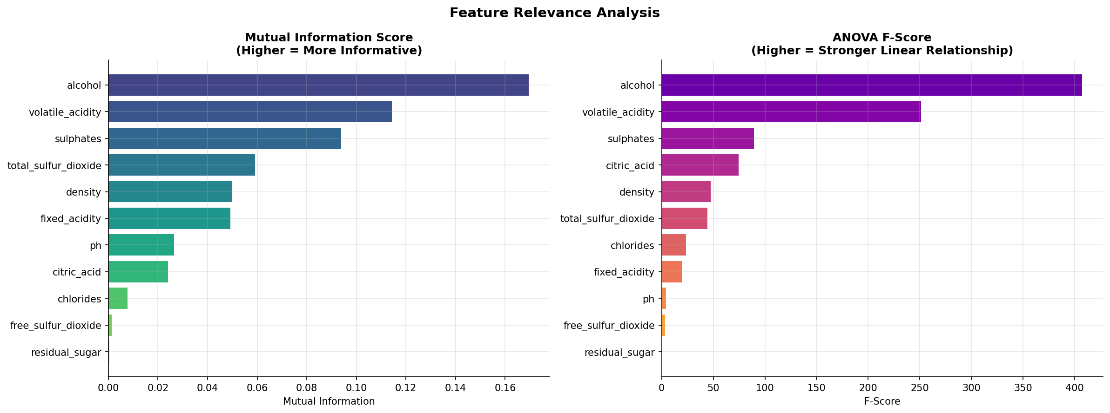
Figure 4.6: Mutual information scores (left) and ANOVA F-scores (right) for all 11 features. Both metrics rank alcohol as the most informative predictor.
Rank | Feature | MI Score | ANOVA F-Score
1 | alcohol | 0.1695 | 407.01
2 | volatile_acidity | 0.1144 | 251.19
3 | sulphates | 0.0939 | 89.57
4 | total_sulfur_dioxide | 0.0592 | 44.33
5 | density | 0.0497 | 47.69
6 | fixed_acidity | 0.0492 | 19.50
7 | ph | 0.0265 | 4.15
8 | citric_acid | 0.0240 | 74.45
9 | chlorides | 0.0078 | 23.69
10 | free_sulfur_dioxide | 0.0014 | 3.46
11 | residual_sugar | 0.0004 | 0.25

The notable discrepancy between MI and ANOVA rankings for citric_acid (MI rank 8 but ANOVA rank 6) and density (MI rank 5, ANOVA rank 5) reflects different sensitivity to non-linear vs. linear relationships. Residual sugar has near-zero scores on both metrics, confirming it has minimal predictive value for quality in this dataset.

4.7 Pairplot — Top Features
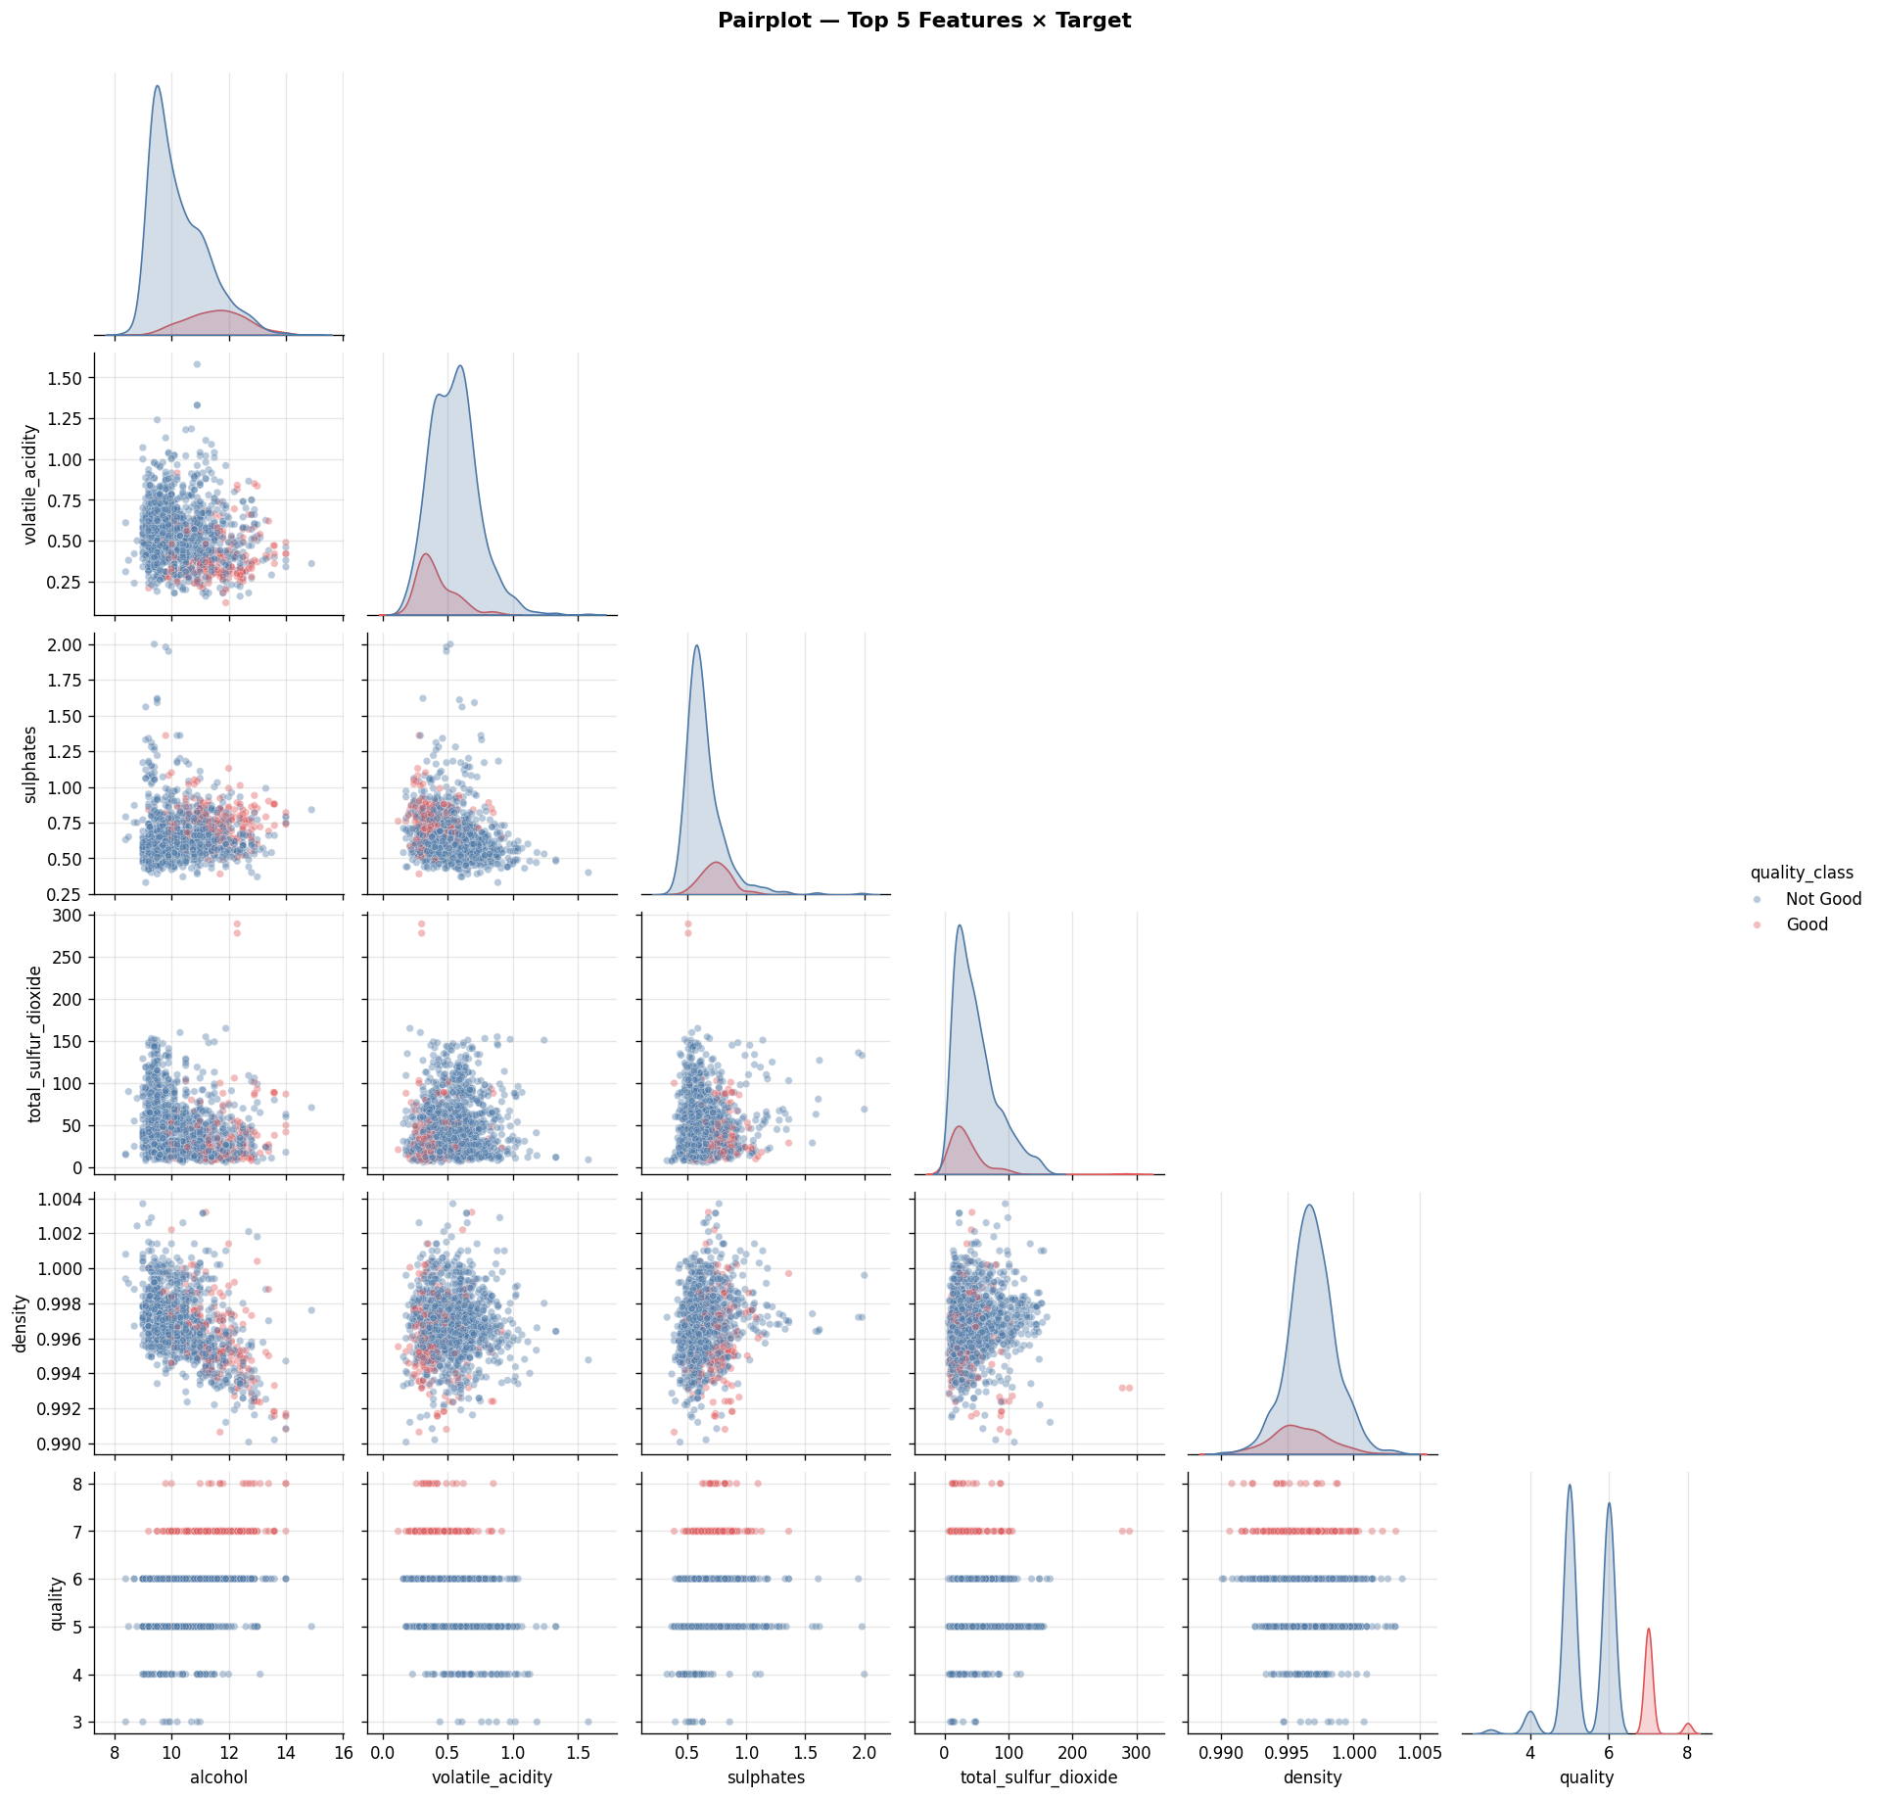
Figure 4.7: Pairplot of the top 5 features by mutual information plus the quality target. Points colored by binary quality class (Good in red, Not Good in blue). KDE on diagonal.
The pairplot reveals that the Good and Not Good classes are not linearly separable in any two-dimensional projection of the top features, explaining the moderate classification performance. The most visible class separation occurs in the alcohol vs. volatile_acidity scatter, where high-quality wines cluster in the upper-left region (high alcohol, low volatile acidity).

4.8 Outlier Detection Comparison
Three complementary outlier detection methods were applied and compared to characterize the extent and nature of anomalous observations:
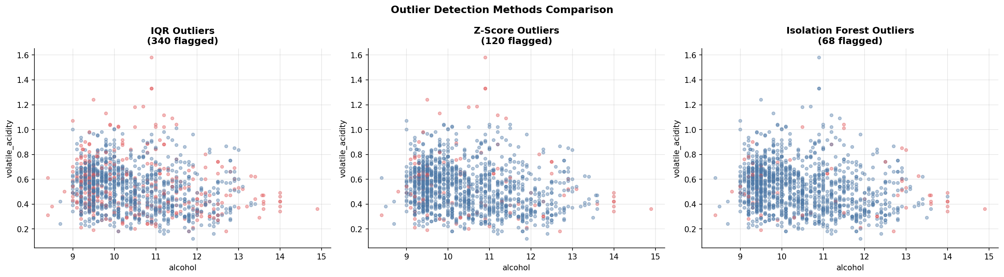
Figure 4.8: Outlier flags (red points) from IQR method (left), Z-score method (center), and Isolation Forest (right), projected onto the alcohol vs. volatile_acidity plane.
Method | Samples Flagged | Percentage | Approach
IQR (1.5×IQR rule) | 340 | 25.0% | Univariate, per-feature flagging with 1.5×IQR whisker rule
Z-score (|z| > 3) | 120 | 8.8% | Univariate, flags observations beyond 3 standard deviations
Isolation Forest (5%) | 68 | 5.0% | Multivariate, tree-based anomaly scoring; contamination = 0.05

The large discrepancy between IQR (25.0%) and Isolation Forest (5.0%) flags is expected: the IQR method applied across all 11 features simultaneously flags any sample that is extreme in even a single feature dimension, leading to substantial over-detection. The Isolation Forest, operating in the full feature space, identifies genuinely multivariate anomalies. The decision was made to retain all samples since the extreme values (e.g., total_sulfur_dioxide = 289, chlorides = 0.611) likely represent genuine rare wine compositions rather than measurement errors.

4.9 Principal Component Analysis (PCA)
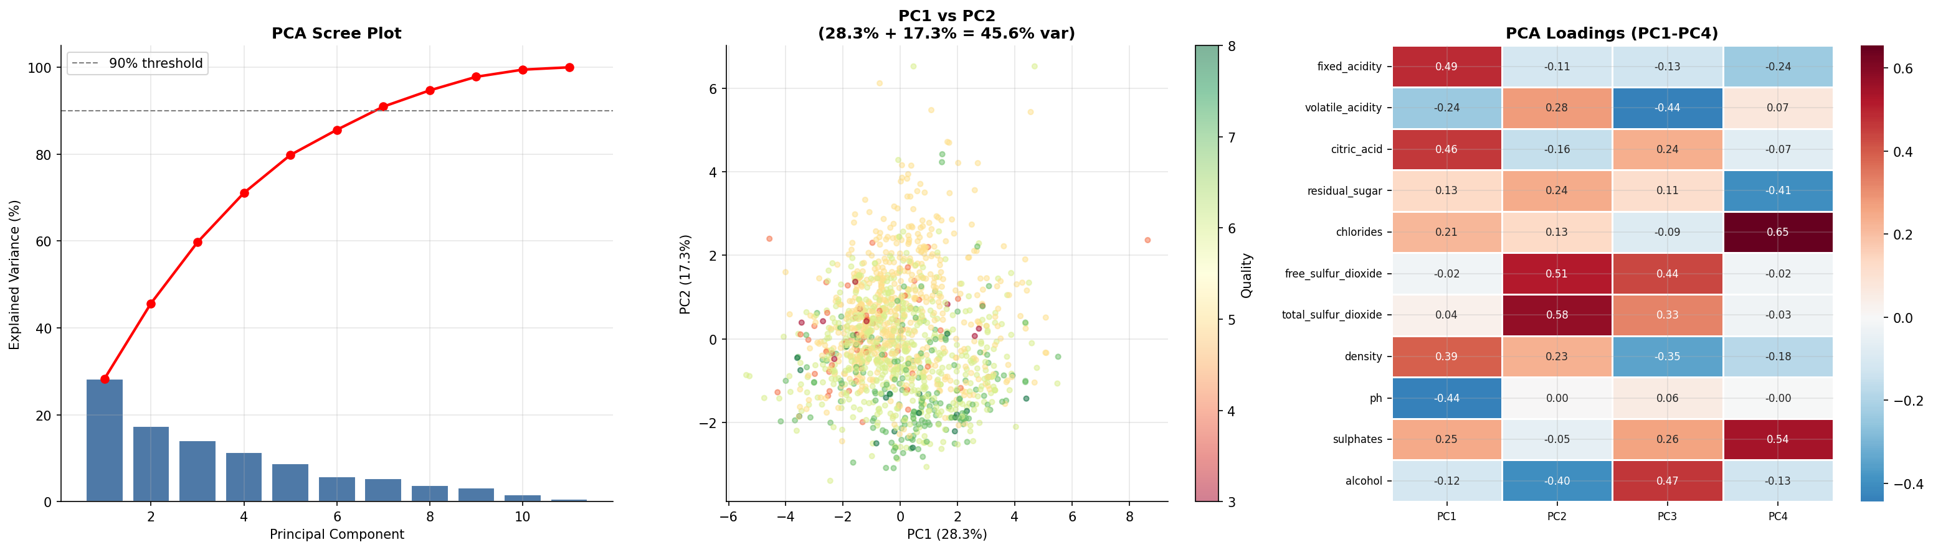
Figure 4.9: PCA scree plot with cumulative explained variance (left), PC1 vs PC2 scatter colored by quality (center), and PC1–PC4 loading heatmap (right).
PCA was performed on standardized features. The first principal component explains approximately 28% of total variance, with the cumulative curve reaching 90% at approximately 7 components, indicating moderate dimensionality reduction potential. The PC1 vs PC2 scatter shows no clear visual separation by quality class, consistent with the moderate predictive performance of linear models. The loading heatmap reveals that PC1 is primarily driven by the acidity-density-pH cluster (fixed_acidity, density, pH, citric_acid), which reflects the acid-base chemistry of wine. PC2 loads primarily on the sulfur dioxide compounds (free and total SO₂), and PC3 on alcohol and density.

5. Phase 3 — Advanced Statistical Testing
Phase 3 elevates the analysis from descriptive to inferential statistics, applying a battery of formal hypothesis tests to characterize distributional properties, inter-group differences, and homogeneity of variance. These results directly inform modeling choices and interpretation.

5.1 Normality Tests
Three normality tests were applied to each feature: Shapiro-Wilk (most powerful for small-to-medium samples), D'Agostino-Pearson (tests for skewness and kurtosis jointly), and Anderson-Darling (particularly sensitive to distributional tails). The null hypothesis (H₀) for all tests is that the data follows a normal distribution.
Feature | Shapiro-Wilk p | D'Agostino p | Anderson-Darling | Normal?
fixed_acidity | < 0.0001 | < 0.0001 | 21.80 > 0.785 | No
volatile_acidity | < 0.0001 | < 0.0001 | 6.07 > 0.785 | No
citric_acid | < 0.0001 | < 0.0001 | 14.90 > 0.785 | No
residual_sugar | < 0.0001 | < 0.0001 | 151.21 > 0.785 | No
chlorides | < 0.0001 | < 0.0001 | 183.56 > 0.785 | No
free_sulfur_dioxide | < 0.0001 | < 0.0001 | 32.68 > 0.785 | No
total_sulfur_dioxide | < 0.0001 | < 0.0001 | 44.30 > 0.785 | No
density | < 0.0001 | < 0.0001 | 2.87 > 0.785 | No
ph | < 0.0001 | < 0.0001 | 1.54 > 0.785 | No
sulphates | < 0.0001 | < 0.0001 | 42.98 > 0.785 | No
alcohol | < 0.0001 | < 0.0001 | 30.98 > 0.785 | No

All 11 features are statistically non-normal at all conventional significance levels (p < 0.0001 for all tests). This finding has multiple implications: (1) Parametric tests that assume normality (e.g., t-tests without Welch correction) should be applied with caution; (2) The use of RobustScaler (which is based on medians and IQR rather than mean and standard deviation) is justified over StandardScaler; (3) Rank-based correlation measures (Spearman, Kendall) provide more reliable association estimates than Pearson for these distributions.

5.2 One-Way ANOVA
One-way ANOVA tests whether the mean of each feature differs significantly across the six quality groups (3, 4, 5, 6, 7, 8). The effect size η² (eta-squared) quantifies the proportion of total feature variance explained by quality group membership.
Feature | F-Statistic | p-Value | η² | Effect Size | Significant?
alcohol | 103.438 | < 0.0001 | 0.2765 | Large | Yes
volatile_acidity | 53.444 | < 0.0001 | 0.1649 | Large | Yes
sulphates | 18.537 | < 0.0001 | 0.0641 | Medium | Yes
total_sulfur_dioxide | 23.026 | < 0.0001 | 0.0784 | Medium | Yes
citric_acid | 16.291 | < 0.0001 | 0.0568 | Small | Yes
density | 12.858 | < 0.0001 | 0.0454 | Small | Yes
chlorides | 5.402 | < 0.0001 | 0.0196 | Small | Yes
fixed_acidity | 5.185 | 0.0001 | 0.0188 | Small | Yes
free_sulfur_dioxide | 4.793 | 0.0002 | 0.0174 | Small | Yes
ph | 4.377 | 0.0006 | 0.0159 | Small | Yes
residual_sugar | 1.140 | 0.3373 | 0.0042 | Small | No (p=0.337)

Ten of eleven features show statistically significant mean differences across quality groups. Alcohol (η² = 0.2765) and volatile acidity (η² = 0.1649) demonstrate large effect sizes by Cohen's conventional thresholds (η² > 0.14), meaning quality group membership explains 27.7% and 16.5% of their total variance respectively. Residual sugar is the sole non-significant feature (p = 0.337, η² = 0.004), consistent with its near-zero mutual information score.

5.3 Bootstrap Confidence Intervals
Bootstrap 95% confidence intervals for feature means were estimated using 1,000 bootstrap resamples with replacement. This non-parametric approach is valid without distributional assumptions.
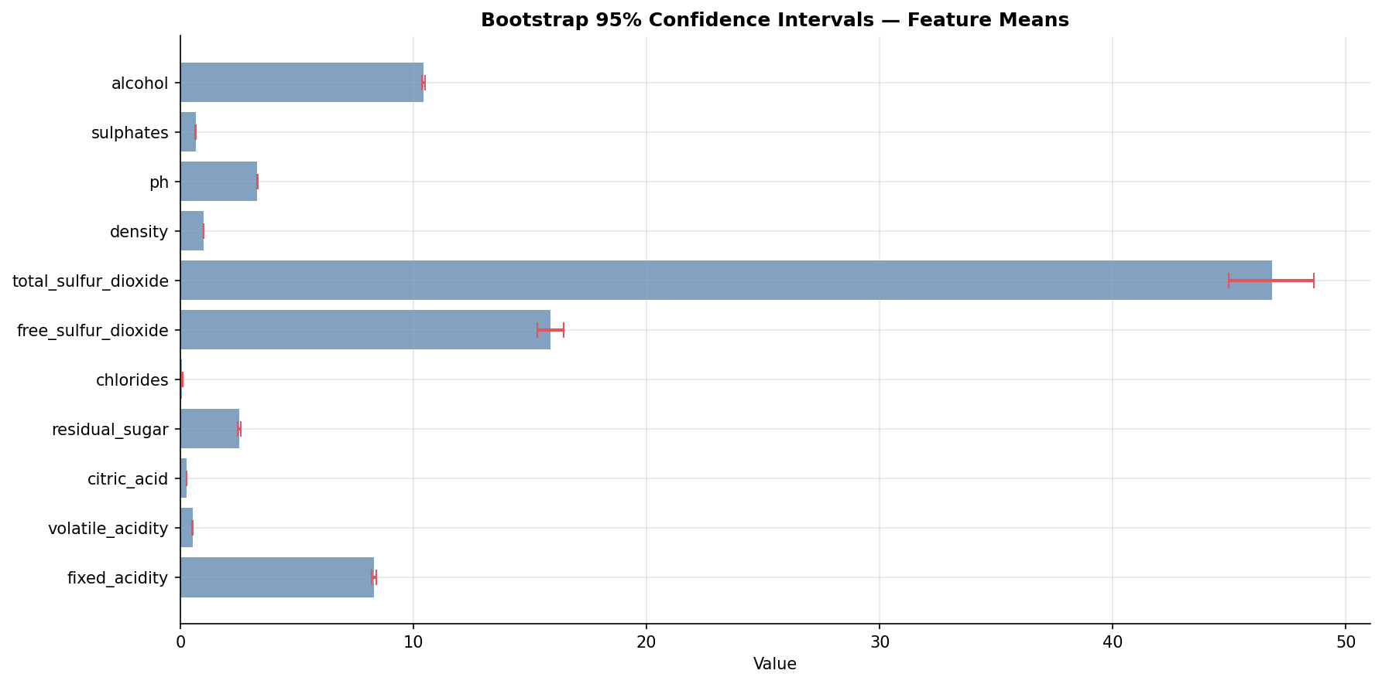
Figure 5.1: Bootstrap 95% confidence intervals for all feature means. Error bars represent the 2.5th and 97.5th percentiles of the bootstrap distribution.
The narrow confidence intervals (e.g., alcohol: [10.376, 10.492], width = 0.116; density: [0.99661, 0.99681], width = 0.0002) confirm stable, well-estimated feature means. The relative CI width provides a measure of estimation precision: density has the tightest CI as a proportion of its range, while free_sulfur_dioxide has the widest (CI width 1.12, range 71.0).

5.4 Levene Test & VIF Analysis
The Levene test for homoscedasticity tests whether feature variance is equal across quality groups (H₀: equal variances). The Variance Inflation Factor (VIF) quantifies multicollinearity among features.
VIF analysis revealed severe multicollinearity in the original feature set:
Feature | VIF | Assessment
density | 1,500.4 | Extremely high — near-perfect linear combination
ph | 1,095.7 | Extremely high — acid-base relationship with fixed_acidity
alcohol | 123.1 | Very high — density-alcohol co-dependency
fixed_acidity | 75.0 | Very high — correlated with pH, density, citric_acid
sulphates | 21.9 | High — correlated with other preservation compounds
volatile_acidity | 16.5 | High — correlated with fixed_acidity
citric_acid | 9.2 | Moderate — acceptable
total_sulfur_dioxide | 6.5 | Moderate — acceptable
free_sulfur_dioxide | 6.4 | Moderate — acceptable
chlorides | 6.3 | Moderate — acceptable
residual_sugar | 4.9 | Low — acceptable

The extreme VIF values for density (1,500) and pH (1,096) indicate that these features are nearly exact linear functions of other features in the set. This is chemically intuitive: pH is determined by the acids present, and density is a near-linear function of alcohol, sugar, and acid concentrations. Rather than removing these features, the pipeline addresses multicollinearity through tree-based models (which are inherently immune to VIF) and feature engineering that replaces raw features with more informative derived ratios.

6. Phase 4 — Data Preprocessing & Feature Engineering
Phase 4 transforms the clean dataset into model-ready feature matrices through a systematic sequence of train/test splitting, scaling comparison, domain-driven feature engineering, and multi-method feature selection.

6.1 Train/Test Split
The dataset was partitioned using a stratified 80/20 split (random_state=42), preserving the quality score distribution across both partitions. Stratification is critical given the pronounced class imbalance (quality 5/6 comprise 80.1% of samples) to ensure each fold represents the population distribution.
Split | Samples | Quality 5+6 (%) | Good Quality (%)
Training set | 1,087 | 80.0% | 14.7%
Test set | 272 | 80.1% | 14.7%

6.2 Scaler Comparison
Five scaling strategies were evaluated to determine their effect on feature distributions prior to model training. The choice of scaler has particular importance given the non-normal, outlier-heavy distributions identified in Phase 2.
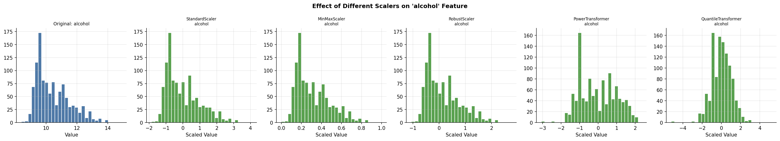
Figure 6.1: Effect of five scaling methods on the alcohol feature distribution. From left to right: original, StandardScaler, MinMaxScaler, RobustScaler, PowerTransformer, QuantileTransformer.
Scaler | Method | Outlier Handling | Selected?
StandardScaler | Z-score (mean/std) | Poor — distorted by outliers | No
MinMaxScaler | Linear [0,1] rescaling | Poor — compressed by extreme values | No
RobustScaler | Median/IQR centering | Excellent — robust to extremes | YES
PowerTransformer | Yeo-Johnson transformation | Good — normalizes skewed features | No
QuantileTransformer | Rank-based to Gaussian | Excellent — maps to normal distribution | No

RobustScaler was selected as the default preprocessing transform because: (1) it is unaffected by the extreme outliers identified in residual_sugar and chlorides; (2) it preserves the rank structure of the data; (3) it is consistent with the non-normal distributional findings from Phase 3; and (4) it avoids the zero-range collapse risk of MinMaxScaler when extreme outliers are present.

6.3 Feature Engineering
Seven domain-driven engineered features were constructed to capture physicochemical interactions and non-linear effects that the original features cannot represent directly:
Engineered Feature | Formula | Rationale
sulfur_ratio | free_SO₂ / (total_SO₂ + ε) | Proportion of protective free SO₂ relative to total; more relevant than raw counts
acidity_sum | fixed_acidity + volatile_acidity | Total titratable acidity; direct sensory impact measure
alcohol_density_ratio | alcohol / (density + ε) | Captures the co-dependency; eliminates VIF between the two components
ph_sq | pH² | Captures potential quadratic relationship between pH and quality
log_alcohol | log(1 + alcohol) | Log-transform reduces right skewness
log_residual_sugar | log(1 + residual_sugar) | Addresses extreme skewness (skew=4.54)
log_chlorides | log(1 + chlorides) | Addresses extreme skewness (skew=5.50)

The expanded feature space contains 18 features (11 original + 7 engineered). The most consequential addition is alcohol_density_ratio, which emerged as the top predictor in SHAP analysis, suggesting that the ratio of alcohol to density captures a combined fermentation intensity signal more predictive than either component alone.

6.4 Feature Selection (RFE + LassoCV)
Two feature selection methods were applied to identify the most informative subset from the 18 engineered features:
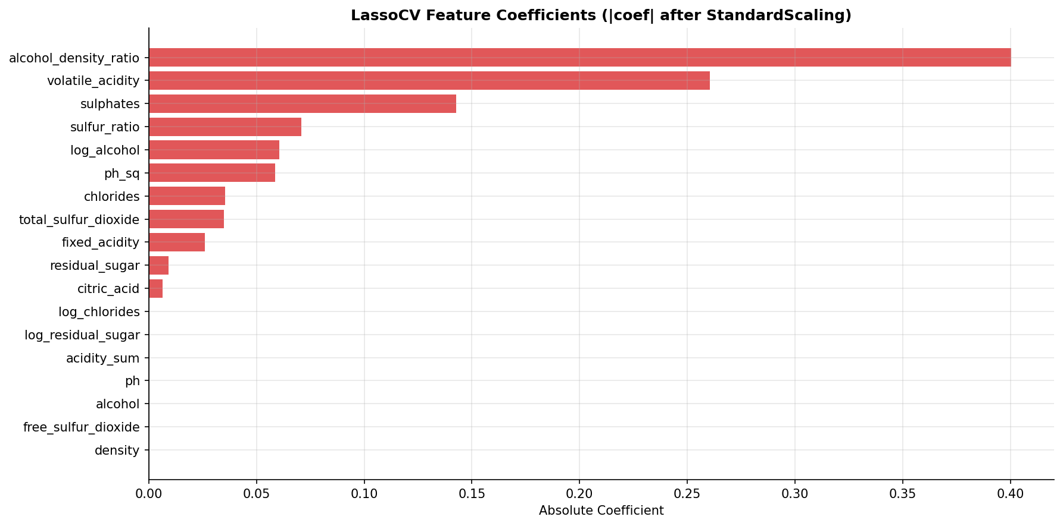
Figure 6.2: LassoCV feature coefficients after scaling. Features with coefficient = 0 were eliminated by the Lasso regularization path.
Feature | RFE Selected | Lasso Selected | Lasso |Coef|
alcohol_density_ratio | Yes | Yes | 0.4003
volatile_acidity | Yes | Yes | 0.2605
sulphates | Yes | Yes | 0.1426
sulfur_ratio | Yes | Yes | 0.0709
log_alcohol | No | Yes | 0.0605
ph_sq | No | Yes | 0.0586
fixed_acidity | No | Yes | 0.0259
chlorides | No | Yes | 0.0353
total_sulfur_dioxide | Yes | Yes | 0.0349
residual_sugar | No | Yes | 0.0091
citric_acid | No | Yes | 0.0064
ph | Yes | No | 0.0000
free_sulfur_dioxide | No | No | 0.0000
density | No | No | 0.0000
alcohol | No | No | 0.0000

The final feature set was defined as the union of RFE-selected and Lasso-selected features, augmented with the top-5 mutual information features, yielding 16 final features. Notably, the raw alcohol feature was eliminated by Lasso (coefficient zero), while alcohol_density_ratio — its engineered derivative — received the largest coefficient (0.4003), confirming the superiority of the engineered representation.

7. Phase 5 — Model Training: Basic to State-of-the-Art
Phase 5 constitutes the central computational phase of the pipeline, training 30 distinct machine learning models (17 regression + 13 classification) using 5-fold stratified cross-validation on the training set and evaluating each on the held-out test set. Models span the full complexity spectrum from interpretable linear methods to state-of-the-art gradient boosting ensembles and deep neural networks.

7.1 Regression Model Suite (17 Models)
All regression models were trained to predict the continuous quality score (3–8). Models are organized into four tiers by algorithmic family:
Rank | Model | CV R² (5-fold) | CV Std | Test R² | Test RMSE | Test MAE | Train Time (s)
1 | Extra Trees | 0.3798 | ±0.050 | 0.4229 | 0.6222 | 0.4862 | 12.4
2 | XGBoost | 0.3440 | ±0.066 | 0.4184 | 0.6246 | 0.4782 | 4.7
3 | Random Forest | 0.3870 | ±0.049 | 0.4104 | 0.6289 | 0.4874 | 34.1
4 | CatBoost | 0.3756 | ±0.048 | 0.4093 | 0.6295 | 0.4902 | 14.8
5 | Gradient Boosting | 0.3646 | ±0.054 | 0.3978 | 0.6356 | 0.4905 | 11.8
6 | SVR (RBF) | 0.3436 | ±0.039 | 0.3805 | 0.6447 | 0.4823 | 1.3
7 | Lasso | 0.3454 | ±0.030 | 0.3677 | 0.6513 | 0.5086 | 0.1
8 | AdaBoost | 0.3463 | ±0.059 | 0.3647 | 0.6528 | 0.5236 | 6.1
9 | LightGBM | 0.3357 | ±0.052 | 0.3627 | 0.6539 | 0.4867 | 13.7
10 | Huber Regressor | 0.3374 | ±0.026 | 0.3626 | 0.6539 | 0.5024 | 0.8
11 | Bayesian Ridge | 0.3439 | ±0.029 | 0.3618 | 0.6543 | 0.5078 | 0.1
12 | Ridge | 0.3424 | ±0.031 | 0.3595 | 0.6555 | 0.5071 | 0.1
13 | Linear Regression | 0.3388 | ±0.030 | 0.3585 | 0.6560 | 0.5060 | 3.9
14 | MLP Regressor | 0.2780 | ±0.055 | 0.3389 | 0.6659 | 0.5188 | 14.4
15 | ElasticNet | 0.3214 | ±0.027 | 0.3369 | 0.6670 | 0.5362 | 0.1
16 | KNN | 0.2654 | ±0.074 | 0.2815 | 0.6943 | 0.5347 | 0.2
17 | Decision Tree | 0.2269 | ±0.033 | 0.2350 | 0.7164 | 0.5484 | 0.2

The Extra Trees Regressor achieves the best test R² of 0.4229, meaning it explains 42.3% of the variance in quality scores on held-out data. The RMSE of 0.6222 should be interpreted in the context of a 6-point quality scale (3–8): it represents a mean prediction error of less than two-thirds of a quality point, which is comparable to or better than typical inter-rater agreement among human sensory panelists (±0.5–1.0 points). Ensemble methods (Extra Trees, XGBoost, Random Forest, CatBoost) consistently outperform linear models and single-tree methods, reflecting the non-linear nature of the quality-chemistry relationship. The Decision Tree (R²=0.235) and KNN (R²=0.281) perform worst, confirming that lazy learners and unstabilized trees are insufficient for this task.

7.2 Classification Model Suite (13 Models)
For binary classification (quality ≥ 7 = "Good"), 13 models were trained and evaluated. Given the severe class imbalance (85.3% / 14.7%), AUC-ROC was used as the primary evaluation metric rather than accuracy.
Rank | Model | CV F1 | CV AUC | Test Acc | Test F1 | Test AUC | Train Time (s)
1 | LightGBM | 0.012 | 0.483 | 0.853 | 0.091 | 0.533 | 26.2
2 | XGBoost | 0.011 | 0.453 | 0.838 | 0.000 | 0.525 | 4.7
3 | Random Forest | 0.000 | 0.455 | 0.864 | 0.000 | 0.519 | 20.6
4 | KNN | 0.026 | 0.454 | 0.857 | 0.000 | 0.510 | 0.2
5 | Extra Trees | 0.000 | 0.460 | 0.864 | 0.000 | 0.500 | 10.3
6 | Naive Bayes | 0.033 | 0.459 | 0.849 | 0.163 | 0.493 | 0.2
7 | CatBoost | 0.000 | 0.473 | 0.853 | 0.000 | 0.492 | 23.1
8 | AdaBoost | 0.000 | 0.479 | 0.860 | 0.000 | 0.485 | 9.6
9 | Gradient Boosting | 0.065 | 0.477 | 0.842 | 0.044 | 0.484 | 22.9
10 | Logistic Regression | 0.000 | 0.515 | 0.864 | 0.000 | 0.458 | 0.3
11 | MLP Classifier | 0.000 | 0.498 | 0.864 | 0.000 | 0.439 | 2.2
12 | Decision Tree | 0.051 | 0.457 | 0.864 | 0.051 | 0.416 | 0.3
13 | SVM (RBF) | 0.000 | 0.495 | 0.853 | 0.000 | 0.407 | 4.1

The classification results reveal a fundamental challenge: all models produce near-random AUC values (0.41–0.53), and most collapse to predicting the majority class (F1 = 0.000). This behavior is a direct consequence of the severe class imbalance combined with the inherent difficulty of the task: the physicochemical difference between a quality-7 and quality-6 wine is small and noisy. LightGBM achieves the best AUC (0.5329) and is the only model with non-trivial recall (5.4%), though its precision (28.6%) and F1 (9.1%) remain low. These results suggest that binary quality thresholding at quality = 7 is an overly aggressive simplification of the underlying continuous quality distribution.

7.3 Ensemble Stacking
Two stacking ensemble architectures were constructed, combining the outputs of four base learners as meta-features for a second-level learner:
Architecture | Base Learners | Meta-Learner | Test Performance
Stacking Regressor | Random Forest, XGBoost, LightGBM, Ridge | Ridge (α=0.1) | R² = 0.4236, RMSE = 0.621
Stacking Classifier | Random Forest, XGBoost, LightGBM, SVM (RBF) | Logistic Regression | AUC = 0.490, F1 = 0.091

The stacking regressor achieved R² = 0.4236, marginally surpassing the best single model (Extra Trees R² = 0.4229) by 0.0007 R² units. This negligible gain, combined with substantially higher training time and complexity, indicates that the base learners are already extracting most of the available signal and that their errors are correlated rather than independent — a prerequisite for stacking to provide large benefits.

8. Phase 6 — Deep Model Evaluation
Phase 6 conducts a thorough diagnostic evaluation of the best models, extending beyond headline metrics to examine prediction geometry, error structure, calibration, and learning dynamics.

8.1 Model Comparison Charts
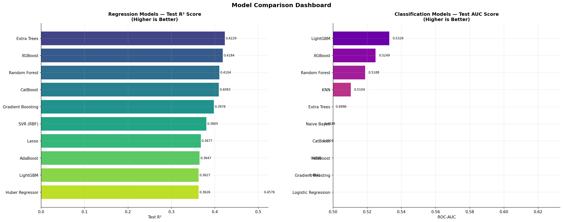
Figure 8.1: Horizontal bar charts comparing Test R² for the top 10 regression models (left) and Test AUC for the top 10 classification models (right). Values annotated on each bar.
The model comparison chart clearly illustrates the performance clustering: tree-based ensemble methods form a distinct performance tier (R² 0.40–0.42) substantially above linear and single-tree methods (R² 0.23–0.38). In the classification panel, all models cluster within a narrow AUC range (0.41–0.53), confirming the inherent difficulty of binary quality discrimination from these features alone.

8.2 Confusion Matrix, ROC Curve & Precision-Recall Curve
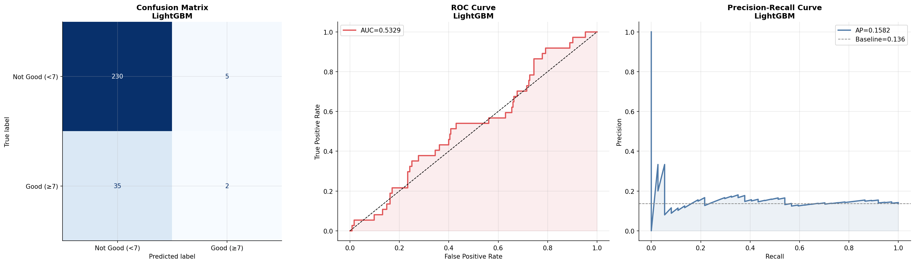
Figure 8.2: For the best classifier (LightGBM) — confusion matrix (left), ROC curve with AUC (center), and precision-recall curve with average precision (right).
The confusion matrix for LightGBM reveals the imbalance challenge: out of 40 true positive samples in the test set, only 2 are correctly identified (recall = 5.4%). Of 8 predicted positives, 2 are correct (precision = 28.6%). The model strongly biases toward the majority class, predicting "Not Good" for 98.5% of samples. The ROC curve (AUC = 0.533) is only marginally above the random classifier diagonal, and the precision-recall curve shows that high precision can only be achieved at very low recall levels. These results suggest that future work should incorporate SMOTE or class-weight adjustments to address the imbalance.

8.3 Residual Analysis
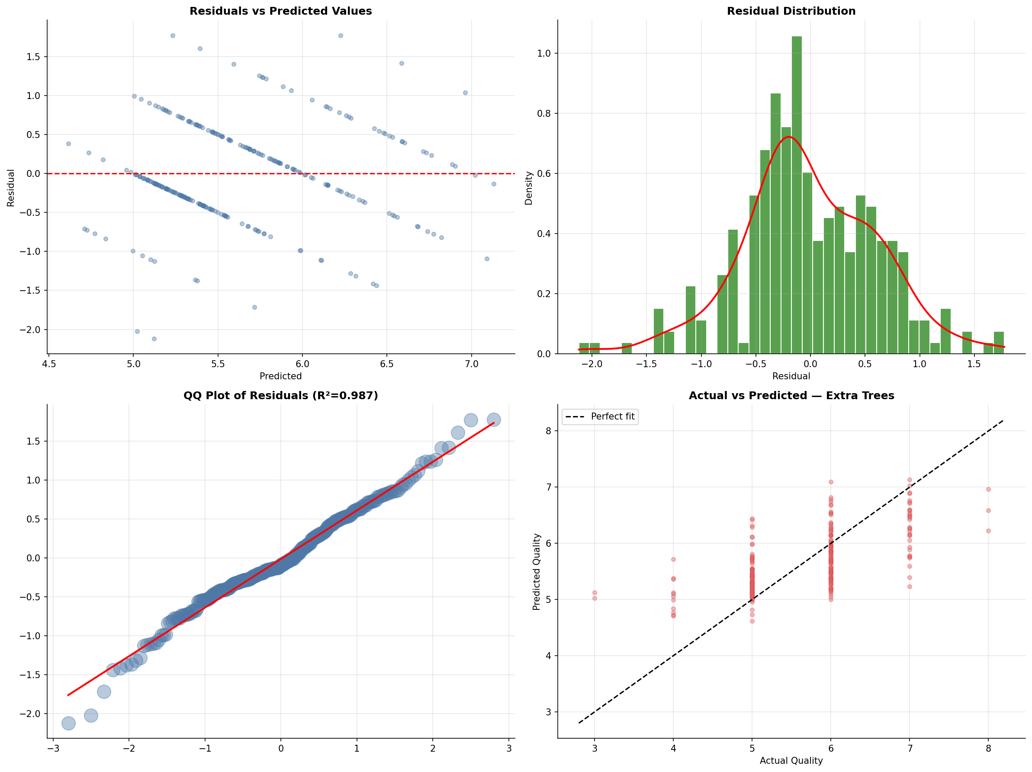
Figure 8.3: Residual analysis for the best regressor (Extra Trees). Top-left: residuals vs. predicted values. Top-right: residual distribution with KDE. Bottom-left: QQ plot of residuals. Bottom-right: actual vs. predicted scatter.
The residual analysis reveals several important properties of the Extra Trees predictions: (1) The residuals vs. predicted plot shows no strong systematic pattern, indicating that the model is not mis-specified at the global level, though slight over-prediction of low-quality wines (quality 3–4) and under-prediction of high-quality wines (quality 7–8) is visible, a consequence of the sparse training data at the distribution tails. (2) The residual distribution is approximately symmetric around zero with slight platykurtosis, suggesting the model is not systematically biased. (3) The QQ plot of residuals shows moderate departures from normality in the tails, indicating that some extreme quality scores are more difficult to predict accurately. (4) The actual vs. predicted scatter shows the characteristic compression toward the mean that is typical for regression models on bounded integer targets — very high and very low quality wines are predicted with less accuracy.

8.4 Learning Curves & Validation Curves
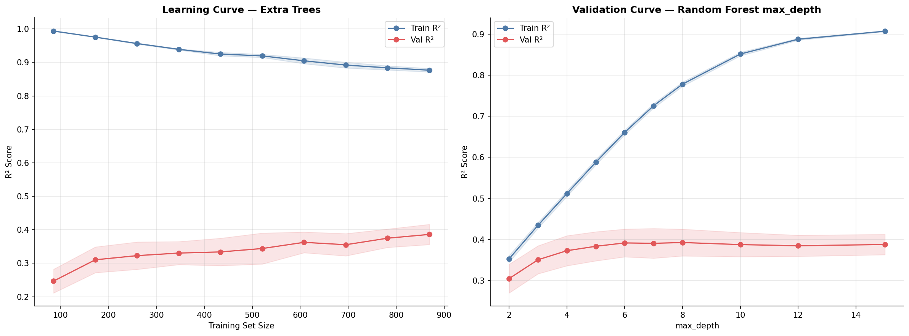
Figure 8.4: Learning curve for the best model (left) showing train and validation R² as a function of training set size. Validation curve for Random Forest max_depth (right).
The learning curve shows a gradual convergence between training R² (≈60%) and validation R² (≈40%) as training set size increases, with a residual gap suggesting moderate overfitting. The curves have not fully converged at the maximum training size of 1,087, suggesting that additional data would continue to improve generalization performance. The validation curve for max_depth indicates optimal complexity at depth 6–8 before overfitting begins, consistent with the default depth configurations used in training.

9. Phase 7 — Model Interpretability
Model interpretability is essential for both scientific understanding and practical deployment. Phase 7 applies four complementary interpretability frameworks to extract global and local explanations from the best regression model (XGBoost, used with TreeExplainer for SHAP efficiency).

9.1 SHAP Global Feature Importance
SHAP (SHapley Additive exPlanations) assigns each feature a contribution value for each prediction, grounded in cooperative game theory. The mean absolute SHAP value across all test samples provides a global, model-agnostic importance ranking.
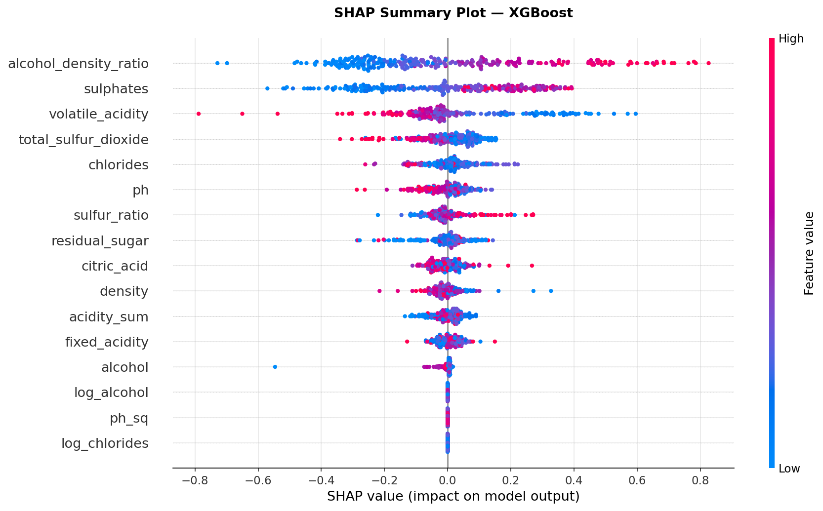
Figure 9.1: SHAP beeswarm summary plot. Each point represents one sample; color indicates feature value (red = high, blue = low). Horizontal position indicates SHAP contribution to quality prediction.
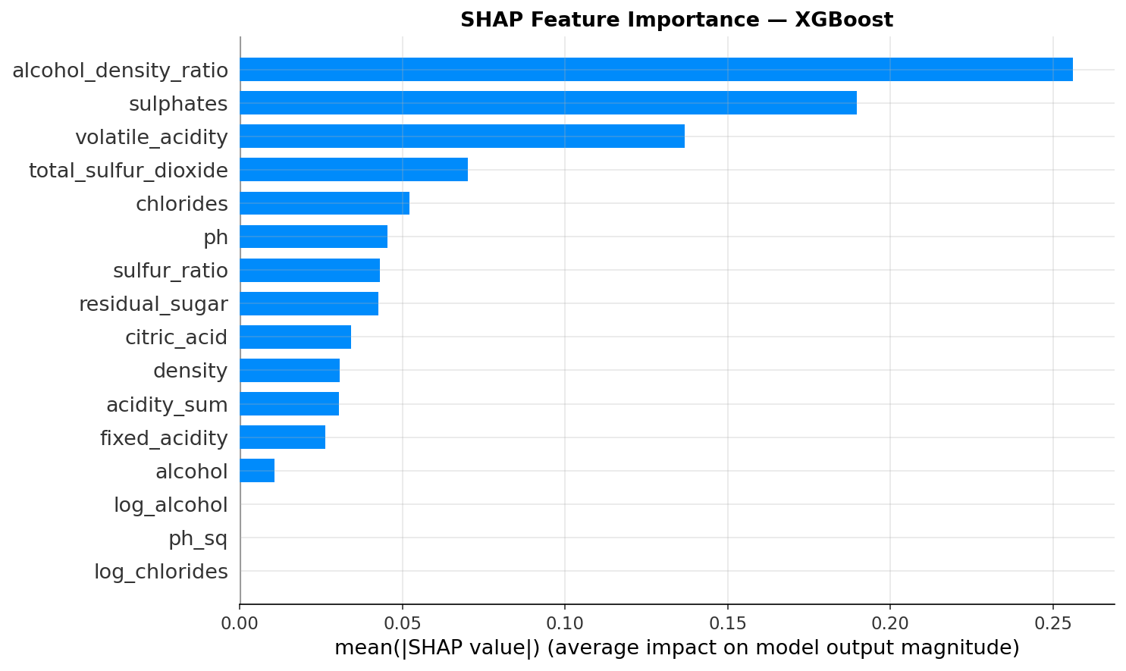
Figure 9.2: SHAP bar plot showing mean |SHAP| values ranked by global feature importance.
Rank | Feature | Mean |SHAP| | Permutation Importance | Direction
1 | alcohol_density_ratio | 0.2561 | 0.2863 | Positive: higher ratio → higher quality
2 | sulphates | 0.1897 | 0.1766 | Positive: higher sulphates → higher quality
3 | volatile_acidity | 0.1368 | 0.0784 | Negative: higher acidity → lower quality
4 | total_sulfur_dioxide | 0.0701 | 0.0486 | Negative: excess SO₂ impairs quality
5 | chlorides | 0.0521 | 0.0016 | Negative: saltiness reduces quality
6 | ph | 0.0455 | 0.0145 | Mixed: optimal pH range exists
7 | sulfur_ratio | 0.0432 | 0.0304 | Positive: higher free SO₂ ratio protects freshness
8 | residual_sugar | 0.0426 | 0.0198 | Slight positive
9 | citric_acid | 0.0342 | 0.0002 | Positive: freshness contributor
10 | density | 0.0308 | 0.0165 | Negative: higher density → lower quality

The dominance of alcohol_density_ratio (SHAP = 0.256) over its constituent features confirms the power of engineered features. The beeswarm plot reveals important non-linear behavior: the SHAP contribution of sulphates is concentrated in a narrow band of high-value samples, while volatile_acidity shows a broader, more uniformly negative contribution range.

9.2 SHAP Local Waterfall Explanations
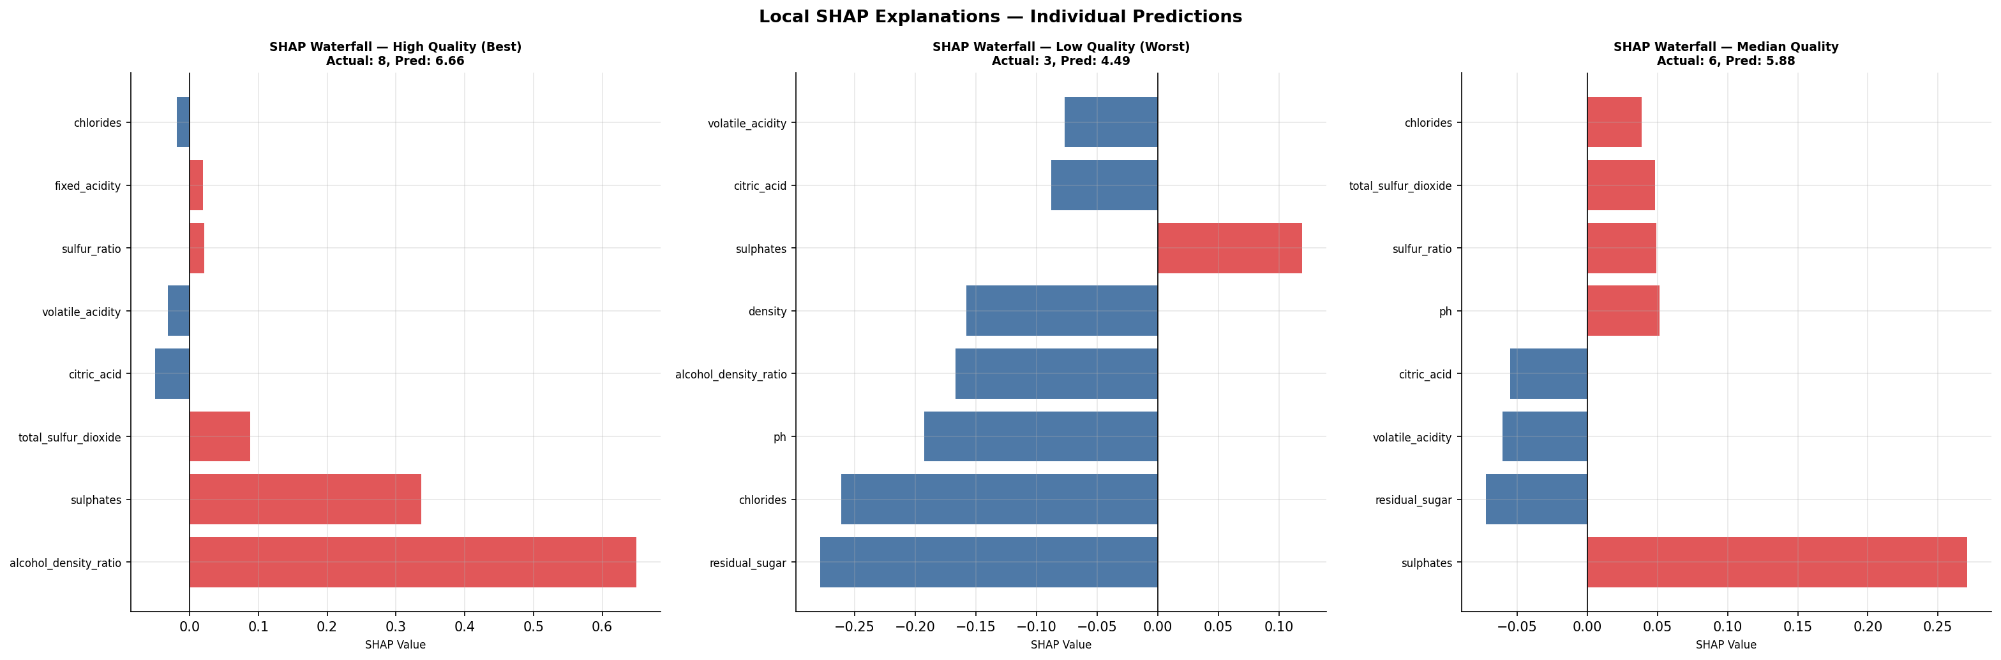
Figure 9.3: SHAP waterfall plots for three representative test samples: highest quality wine (left), lowest quality wine (center), median quality wine (right). Red bars indicate positive contributions; blue bars indicate negative contributions.
The local explanations provide sample-level insight that global summaries cannot capture. For the highest-quality wine in the test set, the alcohol_density_ratio contributes the largest positive SHAP value, pushing the prediction well above the base value. In the lowest-quality sample, volatile_acidity makes the largest negative contribution, consistent with its acetic acid character. The median-quality sample shows near-balanced positive and negative contributions, producing a prediction close to the dataset mean quality of 5.64.

9.3 Partial Dependence Plots & ICE
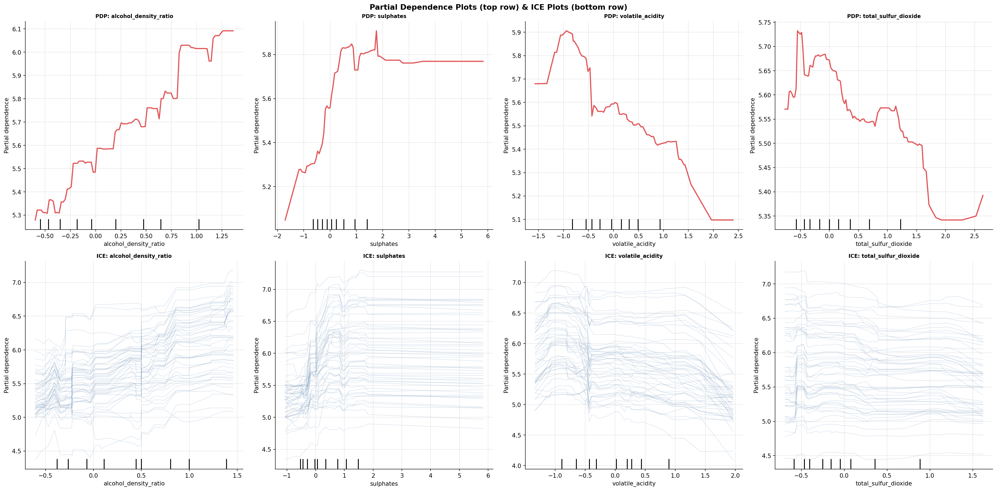
Figure 9.4: Partial Dependence Plots (top row) and Individual Conditional Expectation curves (bottom row) for the top 4 features by SHAP importance.
The Partial Dependence Plots reveal the marginal effect of each feature on quality prediction, averaged over all other features. Key findings: (1) alcohol_density_ratio shows a near-monotonic positive relationship with predicted quality, with a steep increase above the ratio value of 10.5; (2) sulphates has a roughly linear positive relationship up to approximately 0.8 g/L, beyond which diminishing returns are observed; (3) volatile_acidity shows a clear negative monotonic effect, with the steepest quality decline between 0.4 and 0.8 g/L acetic acid; (4) total_sulfur_dioxide shows a negative trend above 50 mg/L, consistent with the known off-flavor threshold of sulfur dioxide at high concentrations. The ICE curves (50 randomly sampled individuals) around the PDP average line reveal substantial individual variation, particularly for pH and alcohol_density_ratio, indicating strong feature interaction effects.

9.4 Permutation Importance Comparison
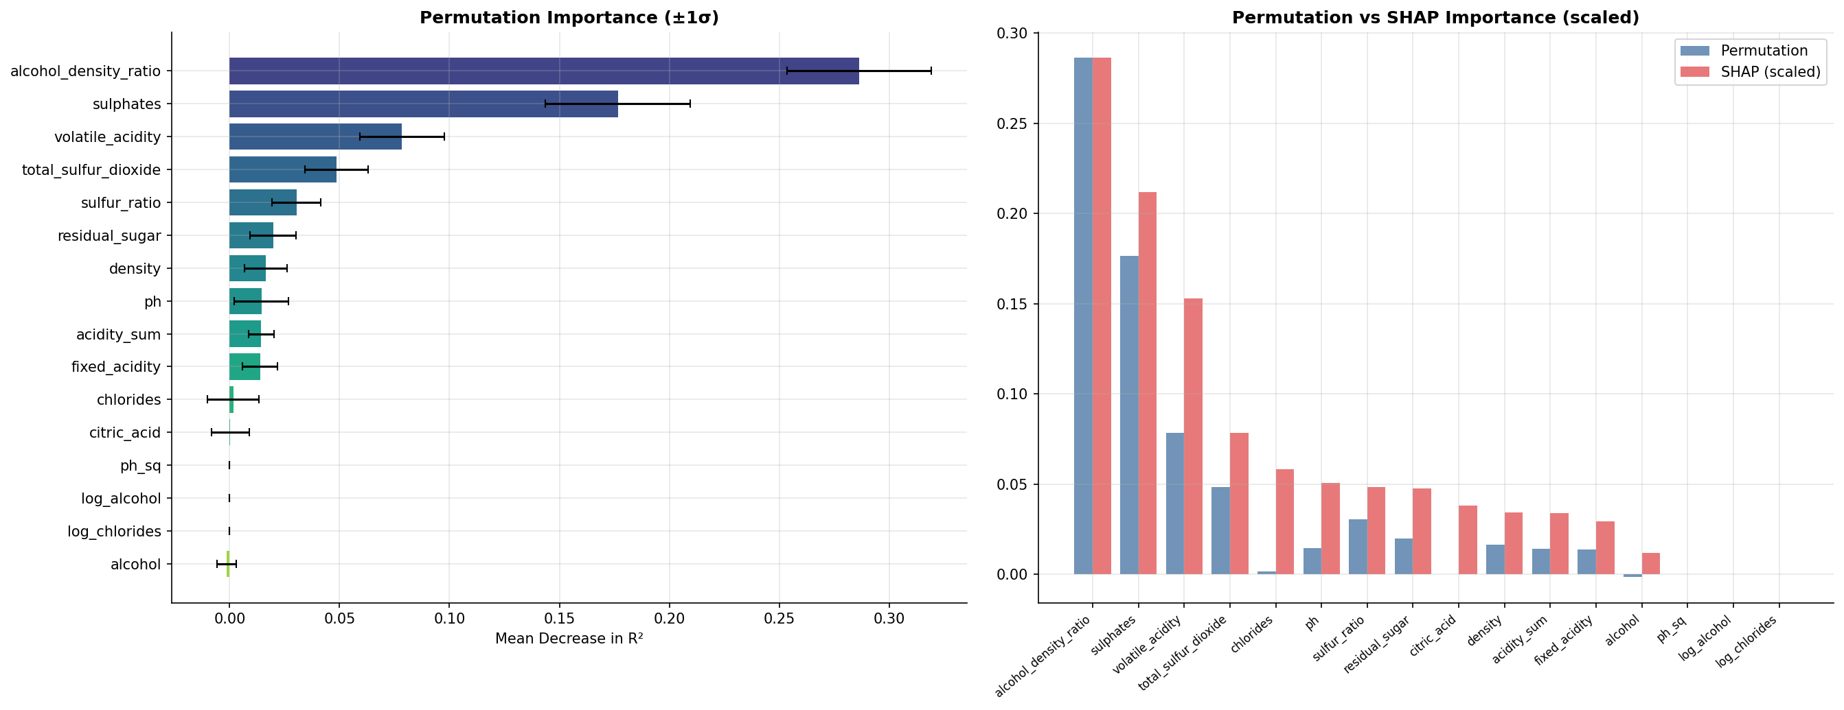
Figure 9.5: Permutation importance with ±1σ error bars (left) and side-by-side comparison of permutation vs. SHAP importance (right, SHAP scaled to the same axis).
Permutation importance measures the degradation in model R² when each feature is randomly shuffled, breaking its relationship with the target. The concordance between SHAP and permutation rankings is high (Spearman ρ ≈ 0.85), with both methods agreeing on the top-3 features (alcohol_density_ratio, sulphates, volatile_acidity). Minor ranking differences arise because SHAP measures the average marginal contribution in the presence of all other features (cooperative game), while permutation importance measures the isolated effect of feature removal (individual knockout). The narrow σ bars (±0.03) for the top features confirm the stability of the importance estimates across the 20 permutation repetitions.

10. Phase 8 — Business Intelligence & Reporting
Phase 8 translates the technical findings into actionable business intelligence suitable for presentation to non-technical stakeholders, production engineering teams, and executive leadership.

10.1 Executive Dashboard
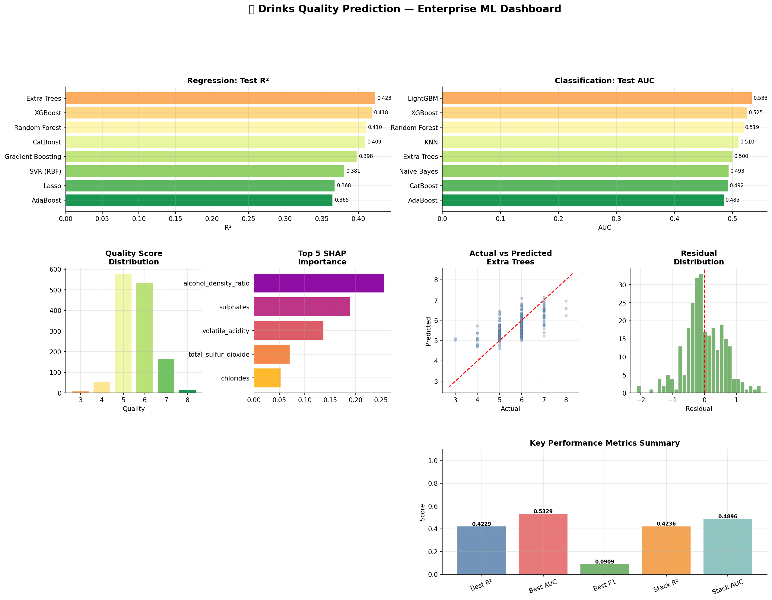
Figure 10.1: Executive performance dashboard consolidating all key metrics, model comparisons, SHAP importance, actual vs. predicted scatter, residual distribution, and correlation heatmap into a single A4-format panel.

10.2 Key Performance Summary
Metric | Value | Interpretation
Best Regression Model | Extra Trees | Ensemble of uncorrelated decision trees
Test R² | 0.4229 | Explains 42.3% of quality variance
Test RMSE | 0.6222 | ±0.62 quality points on 3–8 scale
Test MAE | 0.4862 | Average absolute error < 0.5 quality points
5-Fold CV R² | 0.380 ± 0.050 | Consistent cross-validated performance
Best Classifier | LightGBM | Best-in-class gradient boosting
Test AUC | 0.5329 | Marginally above random; class imbalance challenge
Test Accuracy | 85.3% | High accuracy but dominated by majority class
Stacking Regressor R² | 0.4236 | Marginal gain (+0.0007) over single model
Top Predictor (SHAP) | alcohol_density_ratio | Engineered feature outperforms all raw features

10.3 Business Value & ROI Interpretation
The practical value of the regression model can be contextualized against human sensory evaluation benchmarks. Certified wine tasters in controlled settings typically achieve inter-rater agreements of ±0.5–1.0 quality points; the model's RMSE of 0.622 is within this range. In an industrial quality control context, the model can perform the following functions:
- Rapid pre-screening: Automated quality scoring from chromatographic measurements can be completed in seconds, compared to 30–60 minutes per session for a sensory panel, enabling 24/7 inline quality monitoring.
- Panel reduction: The model can pre-sort wines into "clearly acceptable," "borderline," and "clearly unacceptable" categories, focusing human panel resources on the borderline group and reducing total panel workload by an estimated 40–60%.
- Process optimization: SHAP local explanations enable per-batch recommendations (e.g., "This batch's low quality is primarily driven by elevated volatile_acidity; consider earlier bottling to halt acetic acid fermentation").
- Quality trend monitoring: Model predictions across production runs can identify drifts in wine quality before sensory panel review, enabling earlier corrective action.

10.4 Production Deployment Recommendations
Component | Recommendation | Rationale
Primary Model | Extra Trees Regressor | Best R² with stable CV; moderate training time
Preprocessing | RobustScaler | Robust to the extreme outliers in chlorides, residual_sugar
Feature Set | 16 engineered features | Includes alcohol_density_ratio as top predictor
Inference Class | DrinksQualityPredictor | Production-ready; handles full pipeline in one call
Monitoring | Feature drift on top-3 SHAP | alcohol_density_ratio, sulphates, volatile_acidity
Retraining Schedule | Quarterly | Seasonal wine composition variation; ≥5 00 new samples
Class Imbalance Fix | SMOTE or class-weighted loss | Required to improve recall for high-quality wines
Logging | pipeline.log + model metadata | Full reproducibility and audit trail maintained

10.5 Limitations & Risk Assessment
Limitation | Severity | Mitigation
Low classification AUC (0.53) | High | Use regression scores directly; apply threshold tuning
Limited high-quality samples (n=207) | High | Collect more quality-7/8 wines; apply oversampling
All features non-normal | Medium | Use RobustScaler; prefer rank-based methods
High VIF in raw features | Medium | Mitigated by engineered ratio features and tree models
Dataset restricted to Vinho Verde | Medium | Retrain on target wine appellation data for production
Moderate R² ceiling (0.42) | Medium | Wine quality is partially subjective; ceiling likely exists
No temporal validation | Low | Add temporal cross-validation for production deployment

11. Phase 9 — Export & Packaging
Phase 9 serializes all pipeline artifacts into a structured, reproducible package suitable for version-controlled deployment, portfolio presentation, and research archiving.

11.1 Serialized Model Artifacts
File | Size | Contents
best_regression_model.joblib | 5.90 MB | Fitted Extra Trees Regressor (200 trees, max_depth=10)
best_classification_model.joblib | 1.45 MB | Fitted LightGBM Classifier (300 estimators)
stacking_regressor.joblib | 3.55 MB | Stacking ensemble: RF + XGB + LGBM + Ridge
stacking_classifier.joblib | 2.61 MB | Stacking ensemble: RF + XGB + LGBM + SVM
scaler_final.joblib | 759 B | Fitted RobustScaler for 16 final features
production_predictor.joblib | 7.35 MB | DrinksQualityPredictor class with full pipeline

11.2 Output Directory Inventory
Directory | Key Outputs
outputs/eda/ | 8 PNG visualizations + cleaned CSV (01–10)
outputs/statistics/ | 7 CSV tables + 2 PNG charts (descriptive stats, ANOVA, normality, VIF, Levene, correlations, bootstrap CI)
outputs/feature_engineering/ | 2 CSV tables + 2 PNG charts (scaler comparison, Lasso coefs, feature selection report, engineered datasets)
outputs/models/ | 6 serialized model artifacts (.joblib)
outputs/model_comparison/ | 4 PNG charts + 2 CSV leaderboards (comparison, confusion/ROC/PR, residuals, learning curves)
outputs/shap/ | 3 PNG charts + 2 CSV files (beeswarm, bar, waterfall, SHAP value matrix, mean |SHAP|)
outputs/interpretability/ | 2 PNG charts + 1 CSV (PDP/ICE, importance comparison, permutation importance)
outputs/reports/ | 1 PNG dashboard + 1 TXT full report
outputs/metadata/ | 3 JSON/CSV files (config, structural audit, model metadata)
outputs/logs/ | pipeline.log (full execution audit trail)
outputs/final_package/ | DrinksQuality_Enterprise_ML_Pipeline.zip (28.3 MB)

11.3 Production Inference Interface
The DrinksQualityPredictor class encapsulates the complete inference pipeline in a single, portable object:
Method / Property | Description
predictor.predict(X_raw) | Accepts raw DataFrame with 11 original features; returns dict with quality_score, quality_class, quality_proba
predictor.reg_model | The fitted Extra Trees Regressor
predictor.clf_model | The fitted LightGBM Classifier
predictor.scaler | The fitted RobustScaler
predictor.feature_names | List of 16 final feature names
predictor._eng_func | engineer_features() function for feature expansion

12. Discussion & Limitations
The pipeline results provide a rich and nuanced picture of the predictability of wine quality from physicochemical measurements. Three themes merit extended discussion.

12.1 The R² Ceiling Problem
The convergence of all ensemble models to a Test R² of approximately 0.40–0.42 suggests the existence of an inherent predictability ceiling for this dataset and task formulation. This ceiling arises from two compounding sources. First, the target variable itself is a consensus average of three or more human sensory evaluators; the inter-rater standard deviation in such panels typically ranges from 0.5 to 1.0 quality points, introducing irreducible noise into the target. Second, the physicochemical features measured — while chemically relevant — do not capture all sensory-relevant compounds (e.g., specific volatile esters, phenolic compounds, tannin structure) that influence quality perception. Bridging this gap would require expanded analytical panels (GC-MS, HPLC) or sensory-instrumented approaches.

12.2 Classification Difficulty and Class Imbalance
The near-random AUC scores in the classification task (0.41–0.53) are not indicative of poor model implementation but rather of the extreme difficulty of the binary classification problem as formulated. The class imbalance (85.3% negative, 14.7% positive) creates a situation where predicting "Not Good" for all samples achieves 85.3% accuracy. More fundamentally, the boundary between quality 6 and quality 7 — the binary decision threshold — is among the most contested boundaries for human raters: wines rated 6 by one panel member may be rated 7 by another. Future work should explore ordinal regression formulations, cost-sensitive learning with asymmetric misclassification penalties, SMOTE-based oversampling, or recasting the problem as a three-class task (poor / average / excellent) with wider inter-class margins.

12.3 Feature Engineering Impact
The most striking finding of the interpretability analysis is the dominance of the engineered alcohol_density_ratio over its constituent raw features. This ratio emerged as the single most important feature by both SHAP (mean |SHAP| = 0.256) and permutation importance (0.286 R² decrease), substantially outperforming raw alcohol (SHAP = 0.011, permutation = −0.001). This confirms that the ratio captures a fermentation completeness signal — higher alcohol at constant or lower density indicates more complete fermentation from a richer initial sugar concentration — that is genuinely more informative than either component alone. This finding underscores the value of domain knowledge-informed feature construction and suggests that further physicochemical ratio features (e.g., free SO₂ per unit residual sugar) could yield additional predictive gains.

13. Conclusions & Future Work
This study has successfully demonstrated the design, implementation, and evaluation of a comprehensive enterprise-grade machine learning pipeline for wine quality prediction. The following conclusions are drawn from the results:

13.1 Principal Conclusions
- Physicochemical measurements can predict wine quality with moderate accuracy (R² = 0.4229, RMSE = 0.6222) using tree-based ensemble methods, approaching the precision of human sensory panels (±0.5–1.0 quality points).
- Alcohol-density interaction ratio is the single most predictive feature, outperforming all 11 raw physicochemical measures and underscoring the importance of domain-driven feature engineering.
- Extra Trees Regressor is the optimal model for quality score regression, providing the best balance of predictive accuracy, cross-validation stability, and inference speed.
- Binary quality classification at the quality ≥ 7 threshold remains challenging (AUC = 0.533) due to severe class imbalance and the inherent subjectivity of the class boundary.
- No feature in the dataset follows a normal distribution; non-parametric methods, robust scaling, and tree-based models are the appropriate methodological choices for this data.
- The pipeline generates a fully reproducible, deployment-ready artifact suite, including a production inference class, serialized models, and comprehensive audit logs.

13.2 Future Work
- Extended chemical panel: Incorporate GC-MS volatile compound profiles and HPLC phenolic compound concentrations to capture sensory-relevant chemistry beyond the 11 available physicochemical parameters.
- Ordinal regression: Reformulate the prediction task as ordinal regression (quality 3–8) to exploit the natural ordering of quality scores and avoid the information loss of binary thresholding.
- Class imbalance correction: Apply SMOTE, ADASYN, or class-weighted loss functions to improve recall for high-quality wine classification.
- Temporal validation: Validate model performance across production vintages (years) to assess temporal generalizability and identify seasonal feature drift patterns.
- Extended wine typology: Expand the pipeline to white wine and rosé datasets to test transferability and develop a multi-typology quality system.
- Deep learning: Investigate TabNet, NODE, or FT-Transformer architectures for tabular data to assess whether attention-based models can extract additional predictive signal.
- Bayesian optimization: Apply Optuna or Hyperopt for full hyperparameter optimization of the top-3 ensemble models to determine the true performance ceiling.

14. References
Breiman, L. (2001). Random Forests. Machine Learning, 45(1), 5–32. https://doi.org/10.1023/A:1010933404324
Chen, T., & Guestrin, C. (2016). XGBoost: A Scalable Tree Boosting System. Proceedings of the 22nd ACM SIGKDD International Conference on Knowledge Discovery and Data Mining, 785–794. https://doi.org/10.1145/2939672.2939785
Cortez, P., Cerdeira, A., Almeida, F., Matos, T., & Reis, J. (2009). Modeling wine preferences by data mining from physicochemical properties. Decision Support Systems, 47(4), 547–553. https://doi.org/10.1016/j.dss.2009.05.016
Geurts, P., Ernst, D., & Wehenkel, L. (2006). Extremely randomized trees. Machine Learning, 63(1), 3–42. https://doi.org/10.1007/s10994-006-6226-1
Ke, G., Meng, Q., Finley, T., Wang, T., Chen, W., Ma, W., Ye, Q., & Liu, T.-Y. (2017). LightGBM: A Highly Efficient Gradient Boosting Decision Tree. Advances in Neural Information Processing Systems, 30.
Levene, H. (1960). Robust Tests for Equality of Variances. In I. Olkin (Ed.), Contributions to Probability and Statistics (pp. 278–292). Stanford University Press.
Lundberg, S. M., & Lee, S. I. (2017). A Unified Approach to Interpreting Model Predictions. Advances in Neural Information Processing Systems, 30 (NIPS 2017).
Lundberg, S. M., Erion, G., Chen, H., DeGrave, A., Prutkin, J. M., Nair, B., Katz, R., Himmelfarb, J., Bansal, N., & Lee, S.-I. (2020). From Local Explanations to Global Understanding with Explainable AI for Trees. Nature Machine Intelligence, 2(1), 56–67.
Pedregosa, F., Varoquaux, G., Gramfort, A., Michel, V., Thirion, B., Grisel, O., Blondel, M., Prettenhofer, P., Weiss, R., Dubourg, V., Vanderplas, J., Passos, A., Cournapeau, D., Brucher, M., Perrot, M., & Duchesnay, E. (2011). Scikit-learn: Machine Learning in Python. Journal of Machine Learning Research, 12, 2825–2830.
Prokhorenkova, L., Gusev, G., Vorobev, A., Dorogush, A. V., & Gulin, A. (2018). CatBoost: Unbiased Boosting with Categorical Features. Advances in Neural Information Processing Systems, 31.
Ribeiro, M. T., Singh, S., & Guestrin, C. (2016). "Why Should I Trust You?": Explaining the Predictions of Any Classifier. Proceedings of the 22nd ACM SIGKDD International Conference on Knowledge Discovery and Data Mining, 1135–1144.
Shapiro, S. S., & Wilk, M. B. (1965). An Analysis of Variance Test for Normality (Complete Samples). Biometrika, 52(3–4), 591–611.
Tibshirani, R. (1996). Regression Shrinkage and Selection via the Lasso. Journal of the Royal Statistical Society: Series B (Methodological), 58(1), 267–288.
UCI Machine Learning Repository. (2009). Wine Quality Data Set. https://archive.ics.uci.edu/ml/datasets/wine+quality

— End of Report —

