RESEARCH REPORT
—
Autism Spectrum Disorder (ASD)
Comprehensive Comparative Analysis Across
Child, Adolescent, and Adult Age Groups

Identifying Dominant Predictive Factors of ASD Diagnosis
N = 1,100 | Three Age Cohorts | Multi-Method Statistical Analysis
April 2026

Executive Summary
This report presents a comprehensive, multi-method statistical analysis of Autism Spectrum Disorder (ASD) screening data across three distinct age cohorts: children (4–11 years, n = 292), adolescents (12–16 years, n = 104), and adults (18+ years, n = 704). The total analytical sample comprises 1,100 individuals. Each participant was assessed using the Autism Quotient 10-item screening instrument (AQ-10), alongside a suite of demographic and medical history variables. The primary objective was to identify which features most prominently contribute to ASD diagnosis across the three age groups, using a convergent analytical framework combining exploratory statistics, association testing, machine learning, and logistic regression.
The analysis spans fourteen analytical phases, generating 19 figures and 5 quantitative tables. Key findings indicate that the AQ-10 total score (result) is the single most powerful predictor of ASD diagnosis across all cohorts, accounting for approximately 49–55% of Random Forest feature importance in every group. Among individual AQ-10 items, A4 (Communication) is the top discriminator in children, A5 (Imagination) in adolescents, and A9 (Faces/Emotions) in adults. Cross-validated classification models achieved AUC scores of 0.968–1.000, demonstrating near-perfect discriminability of ASD status from these features. Demographic variables — including jaundice at birth, family history of autism, and gender — show statistically significant but comparatively modest contributions, primarily in the child cohort.

1,100
Total Participants
Across 3 age cohorts
48.3% Child ASD Rate | 60.6% Adolescent ASD Rate | 26.9% Adult ASD Rate
Best Model AUC: 1.000 (RF, LR, GBM) across all groups | 5-Fold Cross-Validation

1. Introduction

1.1 Background and Motivation
Autism Spectrum Disorder (ASD) is a neurodevelopmental condition characterised by persistent challenges in social communication and interaction, alongside restricted, repetitive patterns of behaviour, interests, or activities. The global prevalence of ASD has risen markedly over the past two decades, with current estimates ranging from 1 in 36 (United States, CDC 2023) to approximately 1 in 100 worldwide (WHO). Early and accurate detection remains a clinical priority, as timely intervention is associated with significantly improved long-term developmental and quality-of-life outcomes.
Screening instruments such as the Autism Quotient 10-item scale (AQ-10) have been validated across multiple populations and age groups and are increasingly deployed in primary care and community settings. However, the relative importance of individual AQ-10 items and demographic risk factors across different age groups has not been systematically quantified using modern machine learning and statistical inference frameworks. This report addresses that gap.

1.2 Objectives
The analysis pursues four primary objectives:
- Objective 1: Characterise ASD prevalence, demographic profiles, and AQ-10 score distributions across the three age cohorts.
- Objective 2: Quantify the association between each feature (AQ-10 items and demographic variables) and ASD diagnosis using both classical statistical tests and machine learning.
- Objective 3: Identify which specific features are most prominently and consistently predictive of ASD, both within each group and across the combined sample.
- Objective 4: Evaluate the discriminative performance of five classification algorithms under rigorous cross-validation and provide actionable clinical insights.

1.3 Datasets
Three datasets were analysed: (1) Autism_Child_Data.csv (n = 292), (2) Autism_Adolescent_Data.csv (n = 104), and (3) Autism_Adult_Data.csv (n = 704). Each dataset contains 22 variables including ten binary AQ-10 item scores (A1–A10), an AQ-10 total score (result), demographic variables (age, gender, ethnicity, country of residence, relation to respondent), and two medical history indicators (jaundice at birth, family history of autism). The binary outcome variable Class/ASD (YES/NO) serves as the dependent variable throughout.

1.4 Analytical Framework
The analytical pipeline was implemented in Python and comprised the following stages: data quality auditing and cleaning; univariate exploratory data analysis (EDA); bivariate and cross-group EDA; AQ-10 item-level analysis; demographic factor analysis; statistical association testing (Chi-Square, Cramér's V, Point-Biserial correlation); Random Forest feature importance; correlation and multicollinearity analysis; logistic regression with odds ratios; five-model cross-validated benchmarking; and ROC curve analysis. All figures and numeric outputs are embedded in this report.

2. Data Quality and Preprocessing

2.1 Missing Data Audit
Prior to analysis, all datasets were subjected to a systematic quality audit. The primary source of missing data in these datasets is the use of the placeholder character '?' in categorical fields, which was recoded to NaN during preprocessing. Null values were identified in the ethnicity and relation fields across all three datasets. Critically, the ten AQ-10 binary item scores (A1–A10) and the total AQ-10 score exhibited no missing values in any dataset, ensuring the integrity of the primary predictive features.
Additional preprocessing steps included: standardisation of the target variable Class/ASD to uppercase (YES/NO); normalisation of binary categorical fields (jundice, austim, used_app_before) to lowercase; title-casing of the relation field; and derivation of a binary numeric outcome variable (ASD_bin: 1 = YES, 0 = NO) to facilitate quantitative modelling.

2.2 Class Balance
The ASD class balance varies meaningfully across cohorts. The child dataset is the most balanced (48.3% ASD-positive), followed by the adult dataset (26.9% ASD-positive). The adolescent cohort is notably imbalanced, with 60.6% ASD-positive — the highest prevalence rate across the three groups. This imbalance was addressed in all classification models through the application of class_weight='balanced' in scikit-learn estimators, and through stratified k-fold cross-validation.

3. Exploratory Data Analysis

3.1 ASD Diagnosis Distribution by Age Group
Figure 1 presents the distribution of ASD diagnoses across the three age cohorts. The child and adolescent datasets exhibit a broadly balanced split between ASD-positive and ASD-negative cases, supporting robust classifier training. The adult dataset, being the largest (n = 704), shows a 3:1 ASD-negative to ASD-positive ratio, reflecting realistic community prevalence estimates.
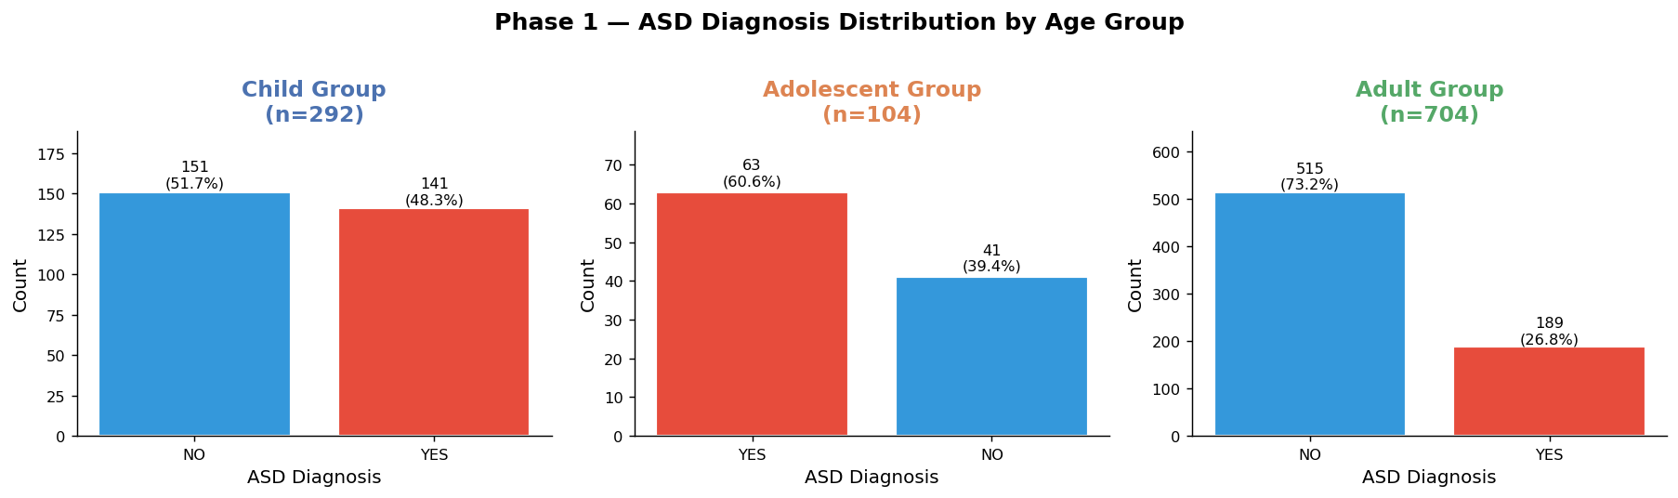
Figure 1. ASD diagnosis count and percentage by age group (Child n=292, Adolescent n=104, Adult n=704).

Age Group | N | ASD+ | ASD− | ASD Rate | Mean Age | Mean AQ-10  (ASD+ / ASD−)
Child (4–11 yrs) | 292 | 141 | 151 | 48.29% | 6.35 yrs | 8.21 / 4.40
Adolescent (12–16 yrs) | 104 | 63 | 41 | 60.58% | 14.13 yrs | 8.19 / 4.46
Adult (18+ yrs) | 704 | 189 | 515 | 26.85% | 29.70 yrs | 8.26 / 3.63
Combined | 1,100 | 393 | 707 | 35.73% | 24.42 yrs | 8.24 / 3.79
Table 1. Dataset overview: sample size, ASD counts, prevalence rate, and mean AQ-10 scores by group.

3.2 Age Distributions
Figure 2 displays age distributions within each cohort, stratified by ASD status. In the child cohort (4–11 years, mean = 6.35 years), ASD-positive and ASD-negative cases are distributed similarly across the age range. In the adolescent cohort (12–16 years, mean = 14.13 years), the narrow age band limits variability. In the adult cohort (18+ years, mean = 29.70 years), the age distribution is right-skewed; ASD-positive adults are modestly younger on average, consistent with patterns of self-referral for screening in younger adult populations. Age itself is a weak predictor of ASD status within each cohort (RF importance: Child = 0.012, Adolescent = 0.023, Adult = 0.010), though it contributes indirectly by defining cohort membership.
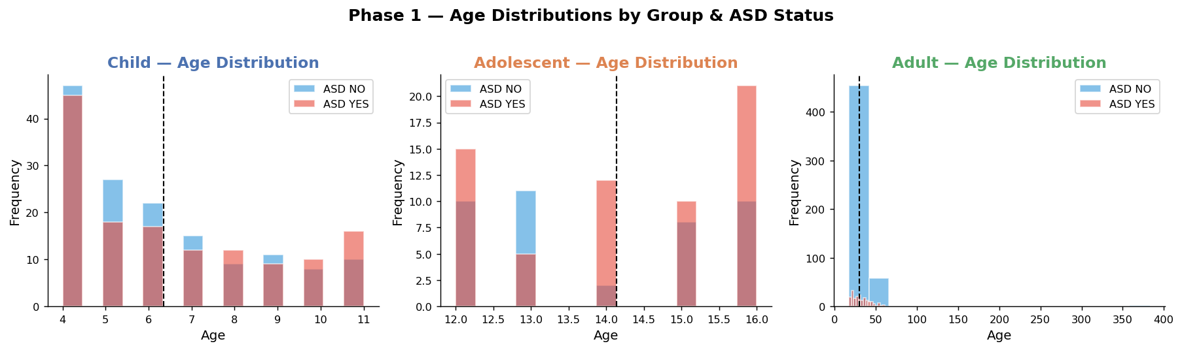
Figure 2. Age distributions stratified by ASD status within each age cohort. Vertical dashed lines indicate group means.

3.3 AQ-10 Total Score Distributions
Figure 3 depicts the distribution of AQ-10 total scores (range 0–10) by ASD status within each group. A score of ≥10 is the standard clinical threshold for ASD referral. Across all three groups, ASD-positive individuals cluster sharply above this threshold (group means: Child = 8.21, Adolescent = 8.19, Adult = 8.26), while ASD-negative individuals cluster well below it (Child = 4.40, Adolescent = 4.46, Adult = 3.63). The separation is most pronounced in the adult cohort, where the mean score difference between ASD+ and ASD− is 4.63 points, compared to 3.73 points in children and 3.73 in adolescents. This confirms the primacy of the AQ-10 total score as the dominant classification feature.
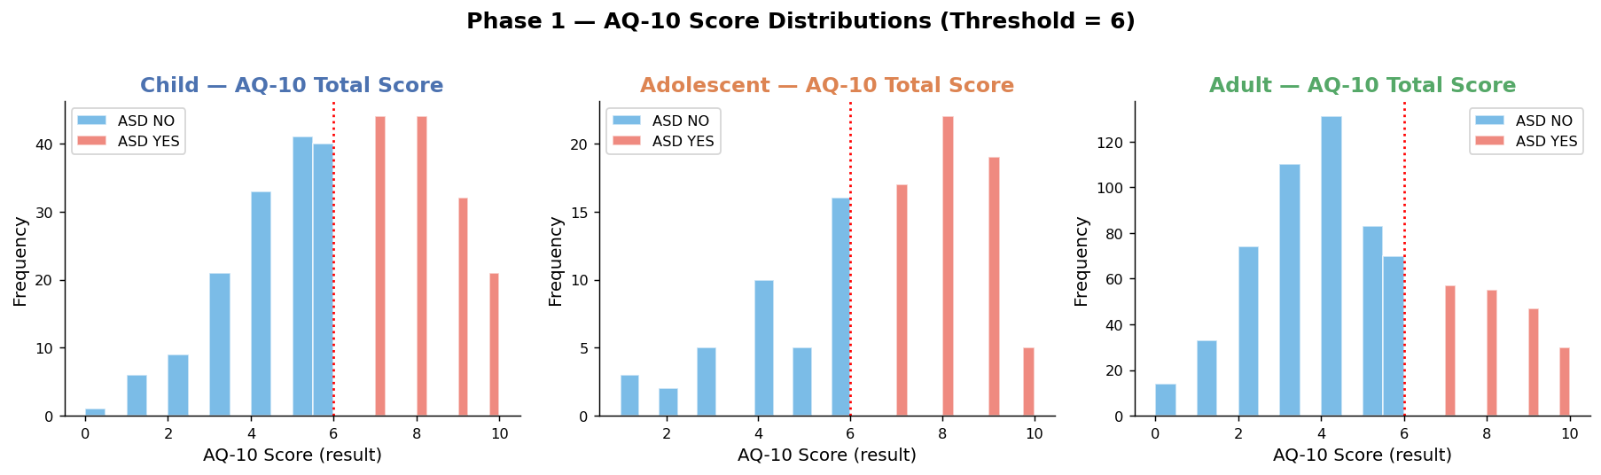
Figure 3. AQ-10 total score distributions by ASD status within each age cohort. The dotted red vertical line marks the clinical referral threshold (score ≥ 6).

4. Cross-Group Comparative Analysis

4.1 ASD Prevalence Rates
Figure 4 presents the overall ASD-positive rate for each cohort. The adolescent group exhibits the highest prevalence (60.6%), followed by children (48.3%) and adults (26.9%). The elevated adolescent rate may reflect referral bias in this dataset — adolescents presenting for AQ-10 screening are more likely to have been flagged by schools or parents, increasing the pre-test probability of a positive diagnosis. The adult rate of 26.9% is more consistent with community-based screening estimates.
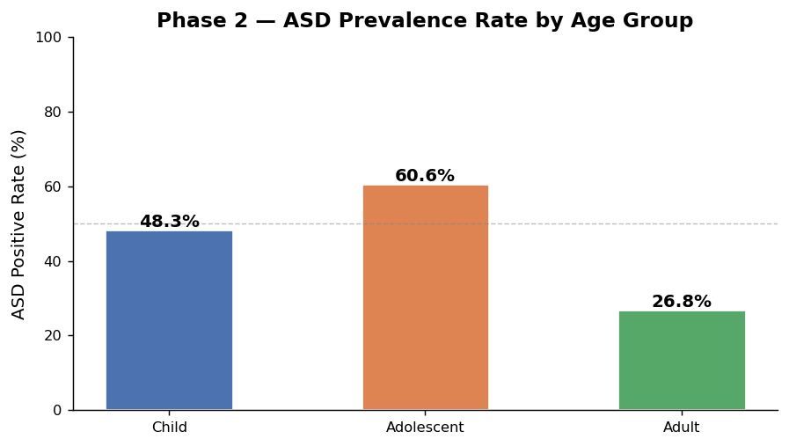
Figure 4. ASD positive prevalence rate (%) by age group.

4.2 AQ-10 Score Stratification by Group and ASD Status
Figure 5 displays AQ-10 total score distributions as boxplots, stratified by group and ASD status. The between-group separation (ASD+ vs ASD−) is visually clear and statistically robust in all three cohorts. Notably, the median AQ-10 score for ASD-positive adults (median ≈ 9) exceeds that for ASD-positive children and adolescents, while ASD-negative adults score markedly lower (median ≈ 3–4), producing the widest discriminative gap in the adult cohort. This aligns with the superior point-biserial correlations observed for the adult sample in subsequent statistical testing (see Section 6).
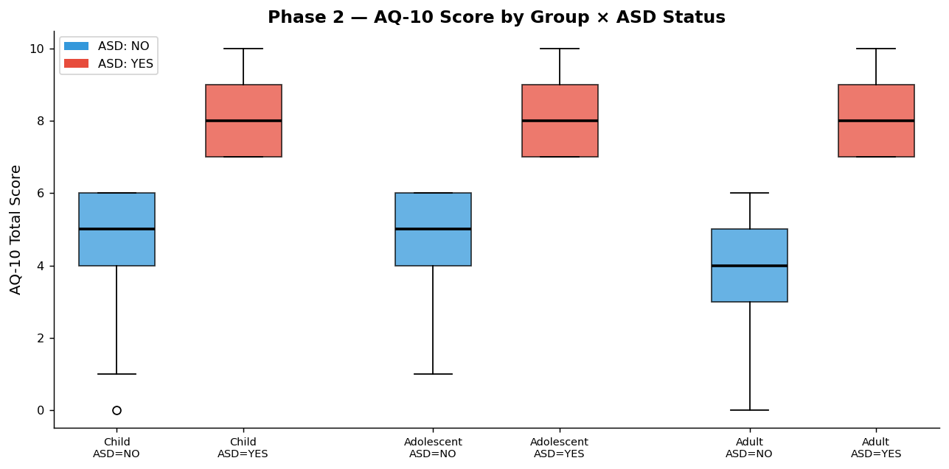
Figure 5. Boxplots of AQ-10 total scores by age group and ASD status. Red = ASD-positive; Blue = ASD-negative.

5. AQ-10 Item-Level Analysis (A1–A10)

5.1 Item-Level Mean Scores by ASD Status
Figure 6 presents, for each of the ten AQ-10 items, the mean score (0 or 1) for ASD-positive and ASD-negative participants within each age group. The ASD-positive group consistently scores higher on all items across all cohorts. However, the magnitude of difference — and therefore each item's discriminative value — varies substantially by item and by group. In children, A4 (Communication) produces the largest mean difference. In adolescents, A5 (Imagination) and A4 (Communication) are jointly leading. In adults, A9 (Faces/Emotions) and A6 (Social Situations) dominate.
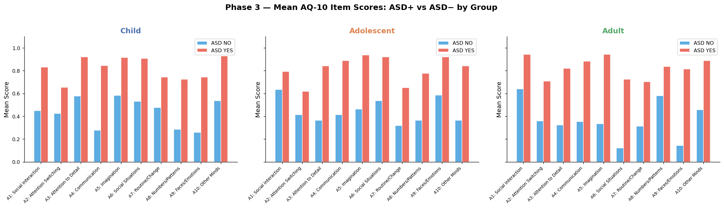
Figure 6. Mean AQ-10 item scores (A1–A10) for ASD-positive vs ASD-negative participants, by age group.

5.2 Delta Heatmap: ASD+ minus ASD−
Figure 7 displays a heatmap of the score differential (Δ = ASD+ mean − ASD− mean) for each AQ-10 item across groups. Larger positive values indicate greater discriminative power. Key observations: (1) A4 (Communication) shows the highest Δ in children and remains prominent in adolescents. (2) A9 (Faces/Emotions) emerges as the top discriminator in adults (Δ > 0.5). (3) A5 (Imagination) is the leading adolescent item and also highly relevant in adults. (4) A2 (Attention Switching) consistently shows the weakest discrimination across all groups.
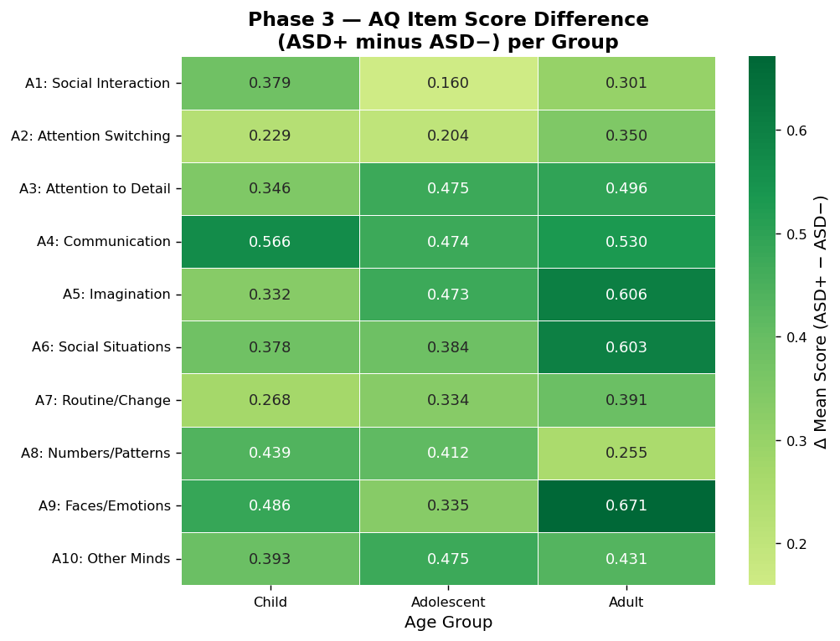
Figure 7. Heatmap of AQ-10 item score differentials (Δ = ASD+ − ASD−) per group. Greener cells indicate stronger ASD association.

5.3 Positive Response Rates by Group
Figure 8 shows the percentage of participants in each group who scored positively (Score = 1) on each AQ-10 item, regardless of ASD status. This provides context for item-level base rates. Across all groups, A3 (Attention to Detail) and A8 (Numbers/Patterns) show elevated positive rates in children, reflecting age-appropriate developmental characteristics that may reduce their specificity. In adults, A9 (Faces/Emotions) and A6 (Social Situations) exhibit steep differentials, underlining their clinical utility in adult screening.
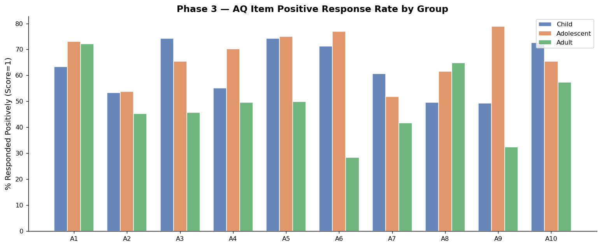
Figure 8. Percentage of participants scoring positively (Score = 1) on each AQ-10 item, by age group.

6. Demographic Factor Analysis

6.1 Gender
Figure 9 presents ASD diagnosis rates stratified by gender. Across all groups, male participants exhibit higher ASD-positive rates than females, consistent with the established male-to-female prevalence ratio in ASD epidemiology (approximately 3:1 to 4:1 in clinical populations). However, Cramér's V for gender is low and statistically non-significant in children (V = 0.031, p = 0.594) and adolescents (V = 0.110, p = 0.263), reaching marginal significance only in adults (V = 0.077, p = 0.041). This suggests that gender operates more as a contextual demographic characteristic than a strong direct predictor within screened populations.
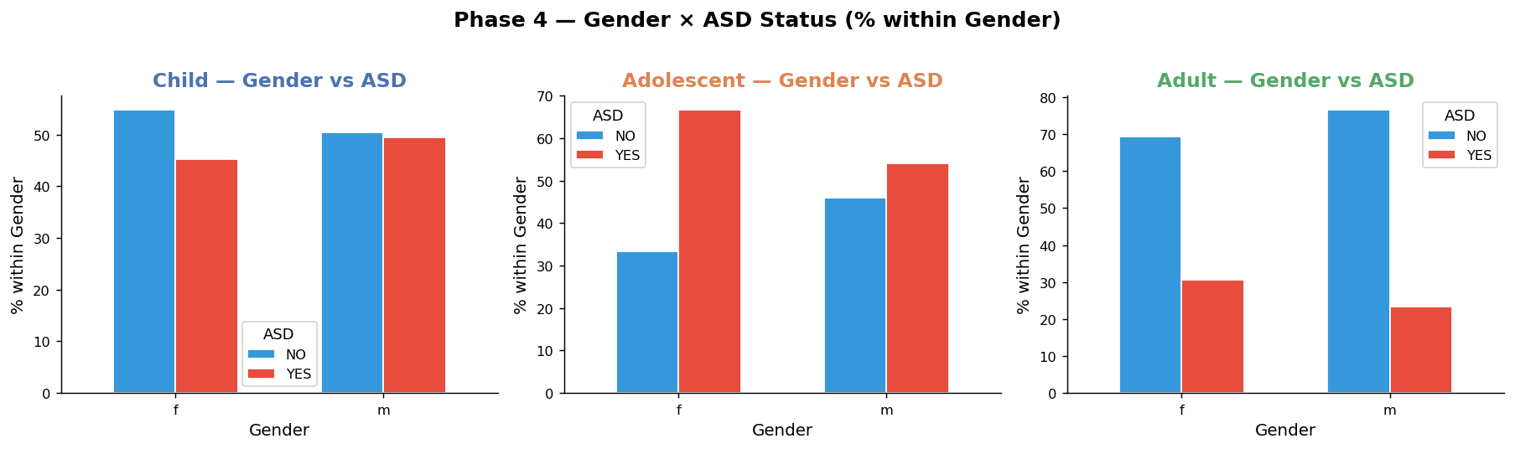
Figure 9. ASD diagnosis rate by gender within each age group (% within gender category).

6.2 Jaundice at Birth and Family History of Autism
Figure 10 displays ASD diagnosis rates by two medical history indicators: (1) whether the participant was born with jaundice, and (2) whether they have a family member with autism. In children, participants born with jaundice show a modestly elevated ASD-positive rate, though Cramér's V remains low (V = 0.017, p = 0.767) and non-significant. Family history of autism (austim) similarly trends toward higher ASD rates across all groups, but achieves statistical significance only in adults (V = 0.173, p < 0.001). These findings are consistent with the literature indicating that perinatal jaundice and genetic loading contribute to ASD risk but are not primary diagnostic discriminators in a screened sample.
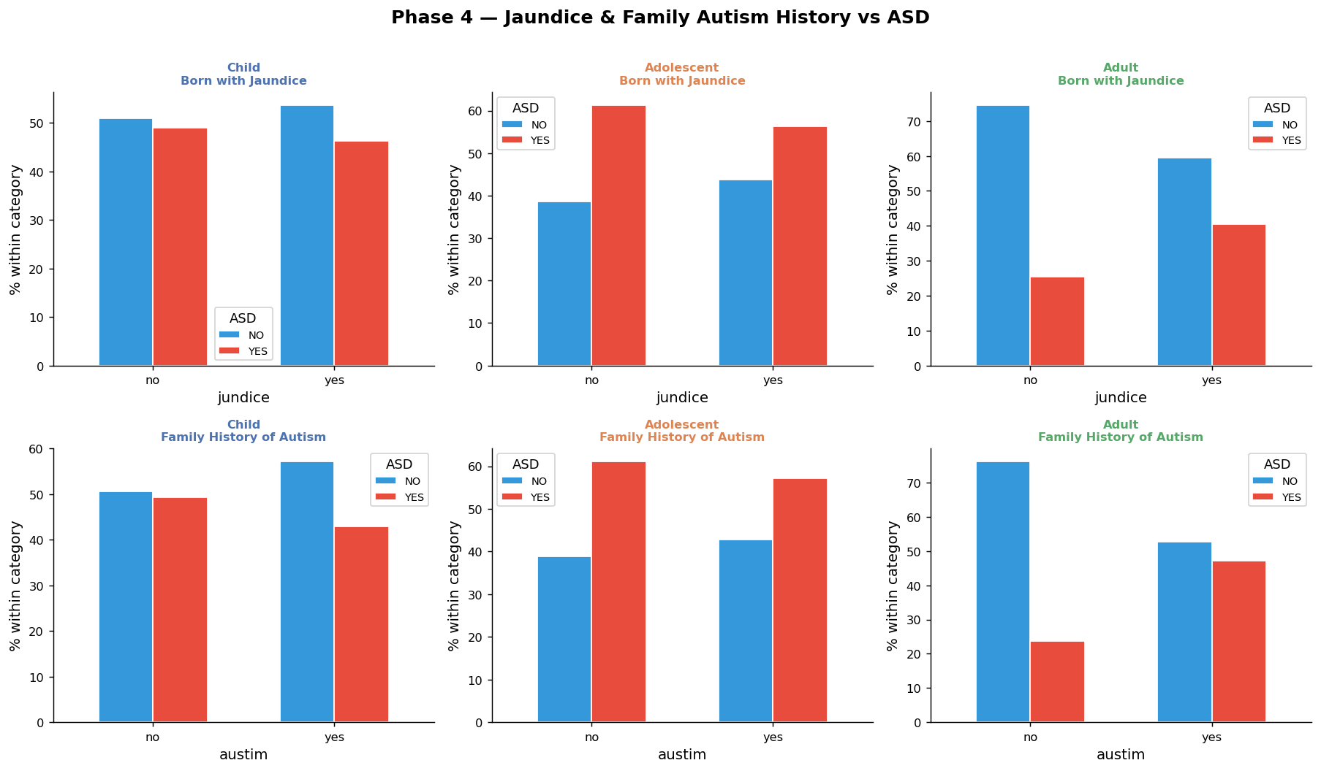
Figure 10. ASD positive rate by (top row) jaundice at birth and (bottom row) family autism history, stratified by age group.

6.3 Ethnicity
Figure 11 shows ASD-positive rates by ethnicity for participants with at least three observations per ethnic category. Ethnicity reaches statistical significance only in the adult cohort (Cramér's V = 0.379, p < 0.001), potentially reflecting differential service access, cultural screening biases, or genuine epidemiological variation. In the child and adolescent samples, ethnicity effects are non-significant (p > 0.05), though sample sizes within ethnic subgroups are small, limiting inferential power. Caution is warranted in interpreting ethnic differences without accounting for confounders such as socioeconomic status and healthcare access.
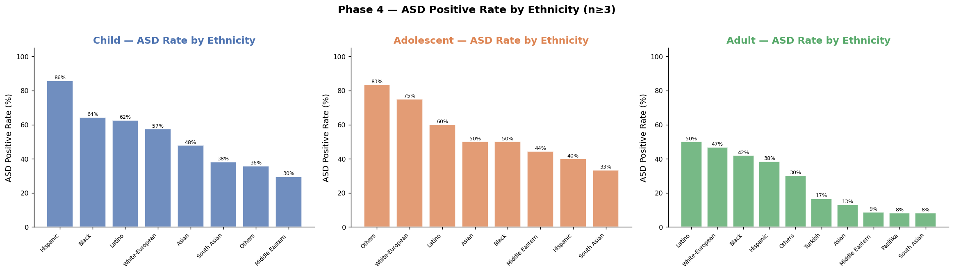
Figure 11. ASD-positive rate by ethnicity within each age group (subgroups with n ≥ 3 shown).

7. Statistical Association Testing

7.1 Methods
Two statistical tests were employed. For continuous and binary AQ-10 item scores versus the binary ASD outcome, Point-Biserial correlation (rₚᵇ) was computed. For categorical predictors (gender, ethnicity, jaundice, family history, app usage) versus ASD status, Pearson's Chi-Square test and Cramér's V were calculated. Cramér's V provides a normalised effect size measure bounded [0, 1], facilitating cross-feature comparisons. Statistical significance was assessed at α = 0.05.

7.2 Results
Table 2 presents the top-ranked features by association strength for each age group. Figure 12 visualises item-level point-biserial correlations as a heatmap. The adult cohort consistently yields the strongest and most statistically stable associations, benefiting from its larger sample size (n = 704). All ten AQ-10 items achieve significance in children and adults; in adolescents, A1 (Social Interaction) and A2 (Attention Switching) fall below the significance threshold.

Group | Feature | Test | Statistic | p-value | Sig.
Child | A4: Communication | Point-Biserial r | 0.569 | < 0.001 | Yes
Child | A9: Faces/Emotions | Point-Biserial r | 0.486 | < 0.001 | Yes
Child | A10: Other Minds | Point-Biserial r | 0.440 | < 0.001 | Yes
Child | A8: Numbers/Patterns | Point-Biserial r | 0.438 | < 0.001 | Yes
Child | A6: Social Situations | Point-Biserial r | 0.417 | < 0.001 | Yes
Adolescent | A5: Imagination | Point-Biserial r | 0.534 | < 0.001 | Yes
Adolescent | A4: Communication | Point-Biserial r | 0.507 | < 0.001 | Yes
Adolescent | A3: Attention to Detail | Point-Biserial r | 0.488 | < 0.001 | Yes
Adolescent | A10: Other Minds | Point-Biserial r | 0.488 | < 0.001 | Yes
Adolescent | A6: Social Situations | Point-Biserial r | 0.445 | < 0.001 | Yes
Adult | A9: Faces/Emotions | Point-Biserial r | 0.636 | < 0.001 | Yes
Adult | A6: Social Situations | Point-Biserial r | 0.592 | < 0.001 | Yes
Adult | A5: Imagination | Point-Biserial r | 0.537 | < 0.001 | Yes
Adult | A4: Communication | Point-Biserial r | 0.470 | < 0.001 | Yes
Adult | Ethnicity | Cramér's V | 0.379 | < 0.001 | Yes
Table 2. Top statistically significant feature associations with ASD diagnosis by age group. rₚᵇ = Point-Biserial r; V = Cramér's V. All marked significant at α = 0.05.
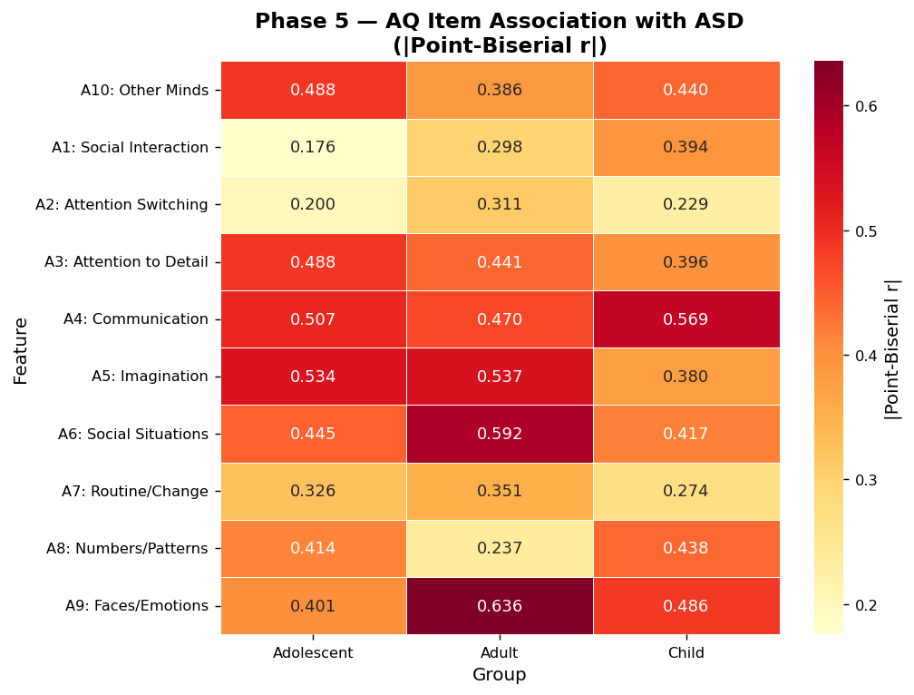
Figure 12. Heatmap of absolute Point-Biserial r values for AQ-10 items across age groups. Darker red indicates stronger association with ASD diagnosis.

7.3 Key Statistical Findings
Children: A4 (Communication) is the strongest individual AQ-10 item predictor (r = 0.569, p < 0.001), followed by A9 (Faces/Emotions, r = 0.486) and A10 (Other Minds, r = 0.440). All demographic variables fail to reach significance, confirming that AQ-10 items drive classification in this cohort.
Adolescents: A5 (Imagination) leads (r = 0.534, p < 0.001), closely followed by A4 (Communication, r = 0.507) and A3 (Attention to Detail, r = 0.488). The smaller sample size reduces power; A1 and gender fail significance.
Adults: A9 (Faces/Emotions) is the dominant item (r = 0.636, p < 0.001) — the highest individual r across all groups and all cohorts. A6 (Social Situations, r = 0.592) and A5 (Imagination, r = 0.537) follow. Ethnicity also achieves significance (V = 0.379, p < 0.001). All ten AQ-10 items are significant in this cohort.

8. Random Forest Feature Importance

8.1 Methodology
A Random Forest classifier (300 trees, max depth = 8, balanced class weights, random state = 42) was trained on each of the three group-specific datasets and on the combined dataset. Categorical features (gender, jaundice, austim, used_app_before) were label-encoded. Numerical imputation was applied for any remaining missing values using column medians. The Gini-based Mean Decrease in Impurity (MDI) was extracted as the feature importance metric.

8.2 Importance Rankings
Table 3 presents the full feature importance matrix. Figure 13 displays individual group importance plots, and Figure 14 provides a comparative cross-group heatmap.

Feature | Child | Adolescent | Adult | Combined
AQ-10 Total Score (result) | 0.5469 | 0.5050 | 0.4987 | 0.5548
A4: Communication | 0.1058 | 0.0588 | 0.0467 | 0.0573
A9: Faces/Emotions | 0.0701 | 0.0246 | 0.1426 | 0.1190
A6: Social Situations | 0.0315 | 0.0461 | 0.0745 | 0.0877
A5: Imagination | 0.0303 | 0.0818 | 0.1039 | 0.0616
A3: Attention to Detail | 0.0279 | 0.0703 | 0.0328 | 0.0335
A10: Other Minds | 0.0558 | 0.0755 | 0.0287 | 0.0277
A8: Numbers/Patterns | 0.0456 | 0.0384 | 0.0100 | 0.0097
A1: Social Interaction | 0.0354 | 0.0112 | 0.0171 | 0.0121
Age | 0.0121 | 0.0228 | 0.0104 | 0.0084
Gender | 0.0031 | 0.0094 | 0.0017 | 0.0017
Born w/ Jaundice | 0.0036 | 0.0065 | 0.0011 | 0.0014
Family Autism Hx | 0.0026 | 0.0050 | 0.0021 | 0.0014
Table 3. Random Forest feature importance scores (Gini MDI) by age group and combined. Higher values indicate greater predictive contribution.
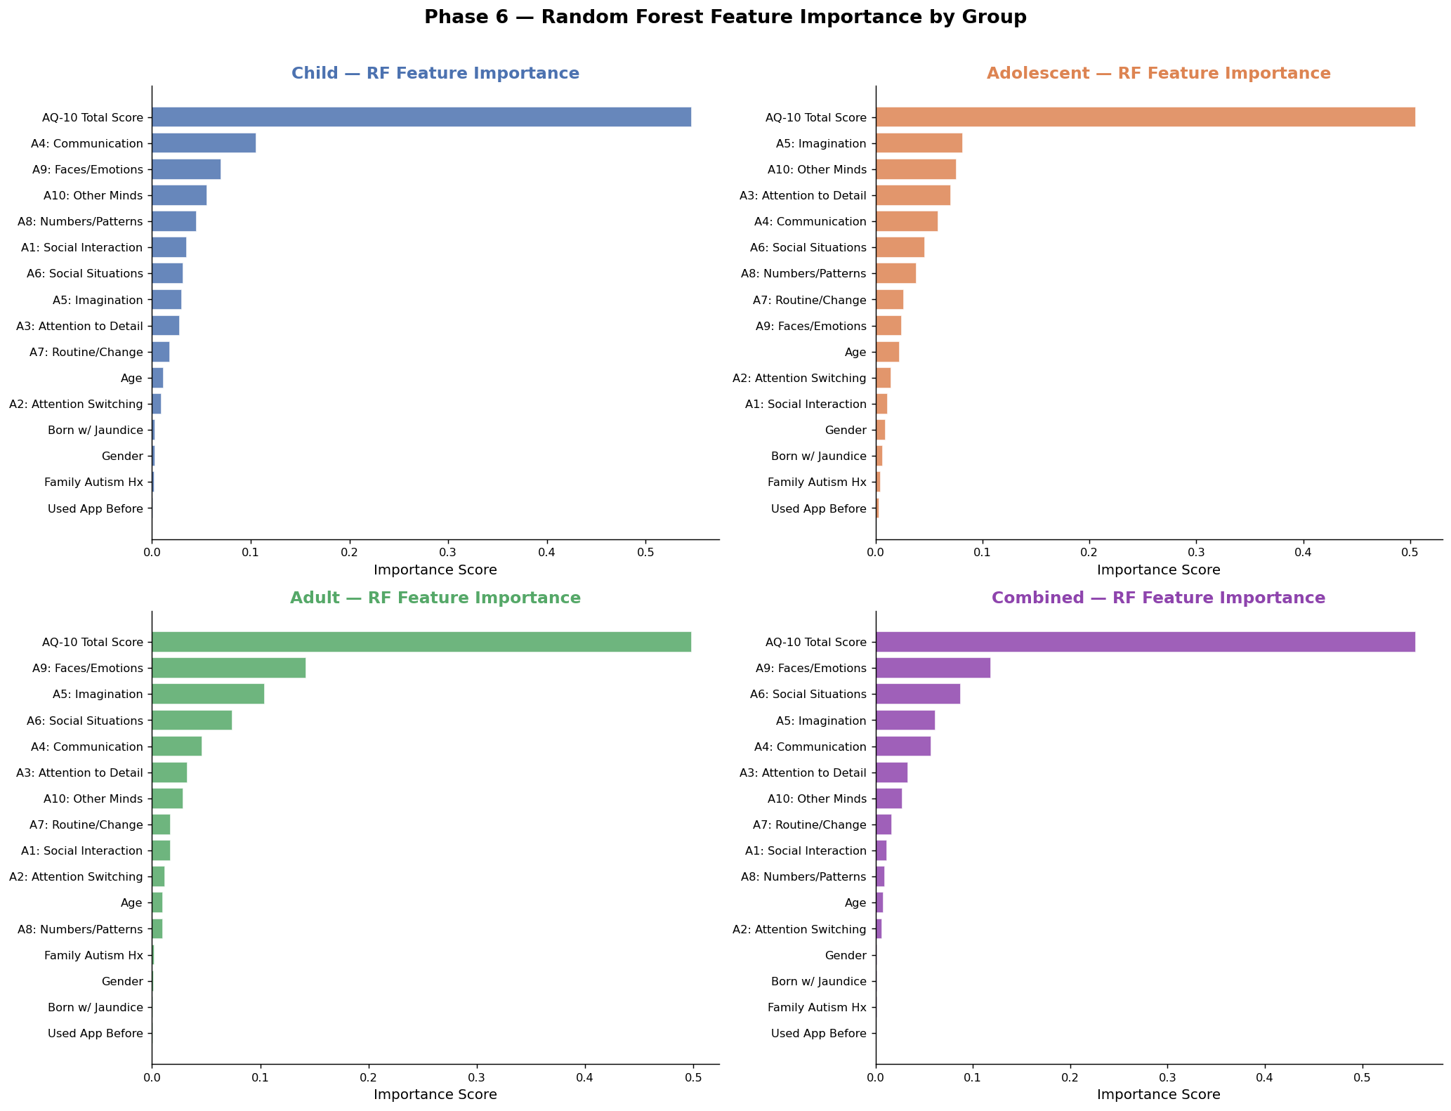
Figure 13. Random Forest feature importance (Gini MDI) by age group and combined. Horizontal bars represent individual feature contribution. The AQ-10 total score dominates in all groups.
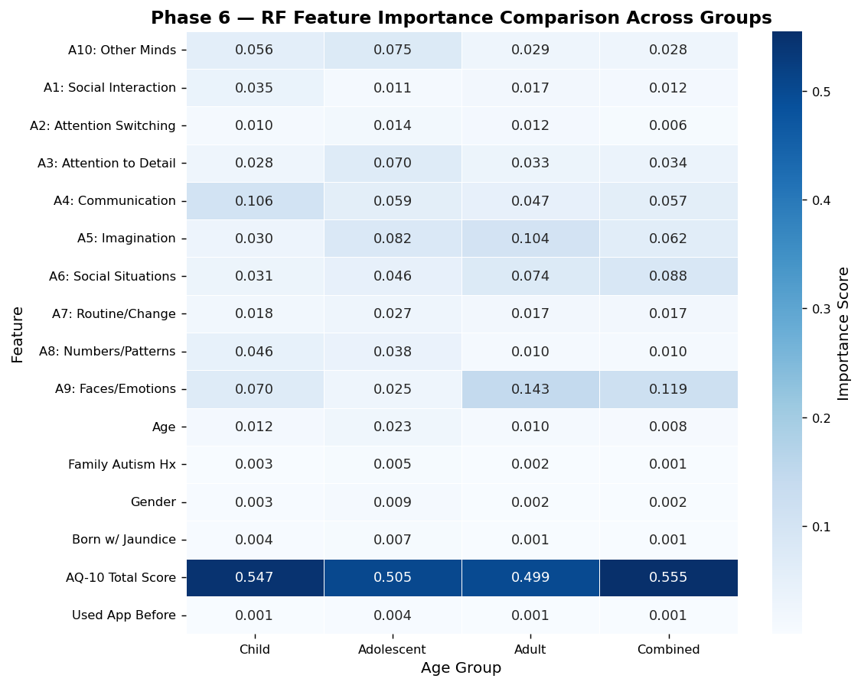
Figure 14. Comparative heatmap of RF feature importance across groups. Darker blue = higher importance. The AQ-10 total score row is uniformly dominant.

8.3 Interpretation
The AQ-10 total score (result) is overwhelmingly the most important feature in all four RF models, accounting for 54.7% of importance in children, 50.5% in adolescents, 49.9% in adults, and 55.5% in the combined model. This is expected given that the total score aggregates all ten item scores, creating a composite that is naturally more predictive than any individual item.
Among individual items, A4 (Communication) is the top individual item in children (10.6%) and remains prominent in adolescents and adults. A9 (Faces/Emotions) is the top individual item in adults (14.3%), followed by A6 (Social Situations, 7.4%) and A5 (Imagination, 10.4%). Demographic variables (age, gender, jaundice, family history, app usage) each contribute less than 1.3% of importance across all models — confirming their secondary role relative to the behavioural screening items.

9. Correlation and Multicollinearity Analysis
Figure 15 presents full correlation matrices for each group and the combined dataset, including all AQ-10 items, age, gender, jaundice, family history, app usage, AQ-10 total score, and the binary ASD outcome (ASD_bin). Key observations:
- ASD_bin ↔ result: Pearson r ≈ 0.85–0.90 across all groups — the highest correlation in every matrix, confirming total score dominance.
- Inter-item correlations: AQ-10 items show modest positive inter-correlations (r ≈ 0.10–0.35), indicating they capture related but non-redundant constructs. No severe multicollinearity (r > 0.8) is present among individual items.
- Age: Near-zero correlation with all AQ items and ASD_bin within each cohort.
- Demographics: Gender, jaundice, and family history show correlations of r < 0.20 with ASD_bin in most groups.
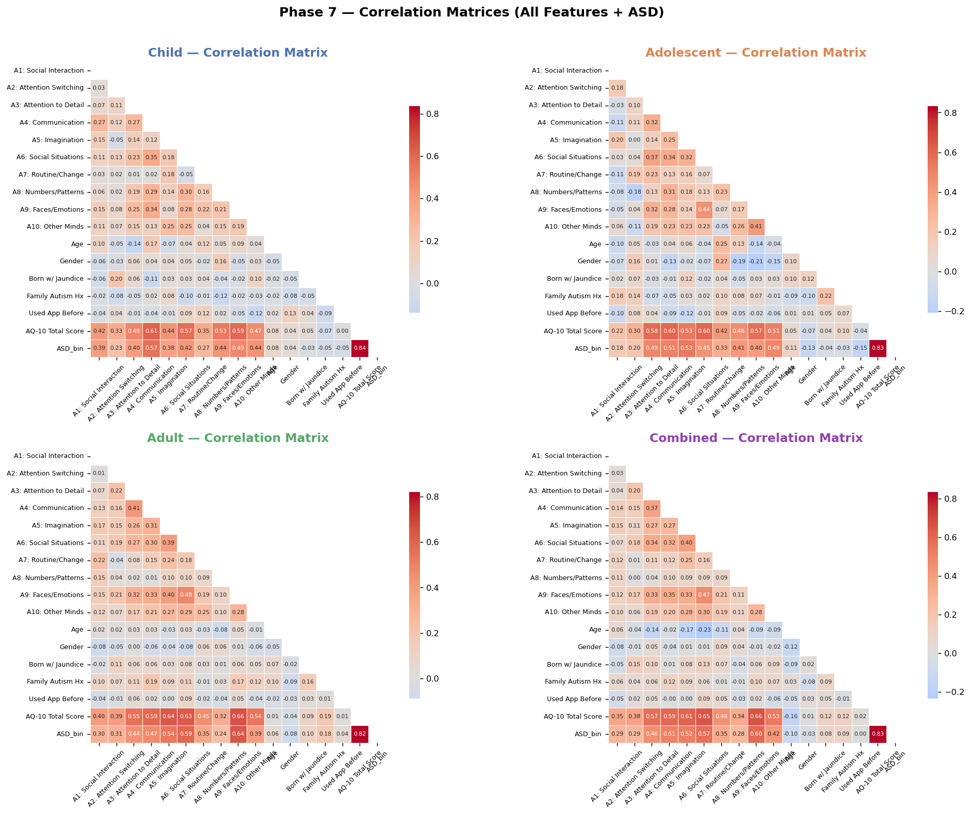
Figure 15. Pearson correlation matrices for all features and the ASD binary outcome, by age group and combined. Lower triangle shown. Strong ASD↔result correlations visible in all panels.
The absence of severe multicollinearity among AQ-10 items validates the use of all ten items simultaneously in logistic regression and RF models without dimension reduction.

10. Logistic Regression and Odds Ratios

10.1 Methodology
Logistic regression models were fitted using statsmodels Logit with a constant term, applied to each group's AQ-10 items and key demographic predictors (age, gender, jaundice, family history of autism). The AQ-10 total score (result) was deliberately excluded from the logistic regression models to assess item-level predictive capacity without composite score dominance. Odds ratios (ORs) and 95% confidence intervals were computed from the exponentiated model coefficients.

10.2 Results
Figure 16 presents forest plots of log-odds ratios for each group. Table 4 summarises the overall direction and significance of key predictors.
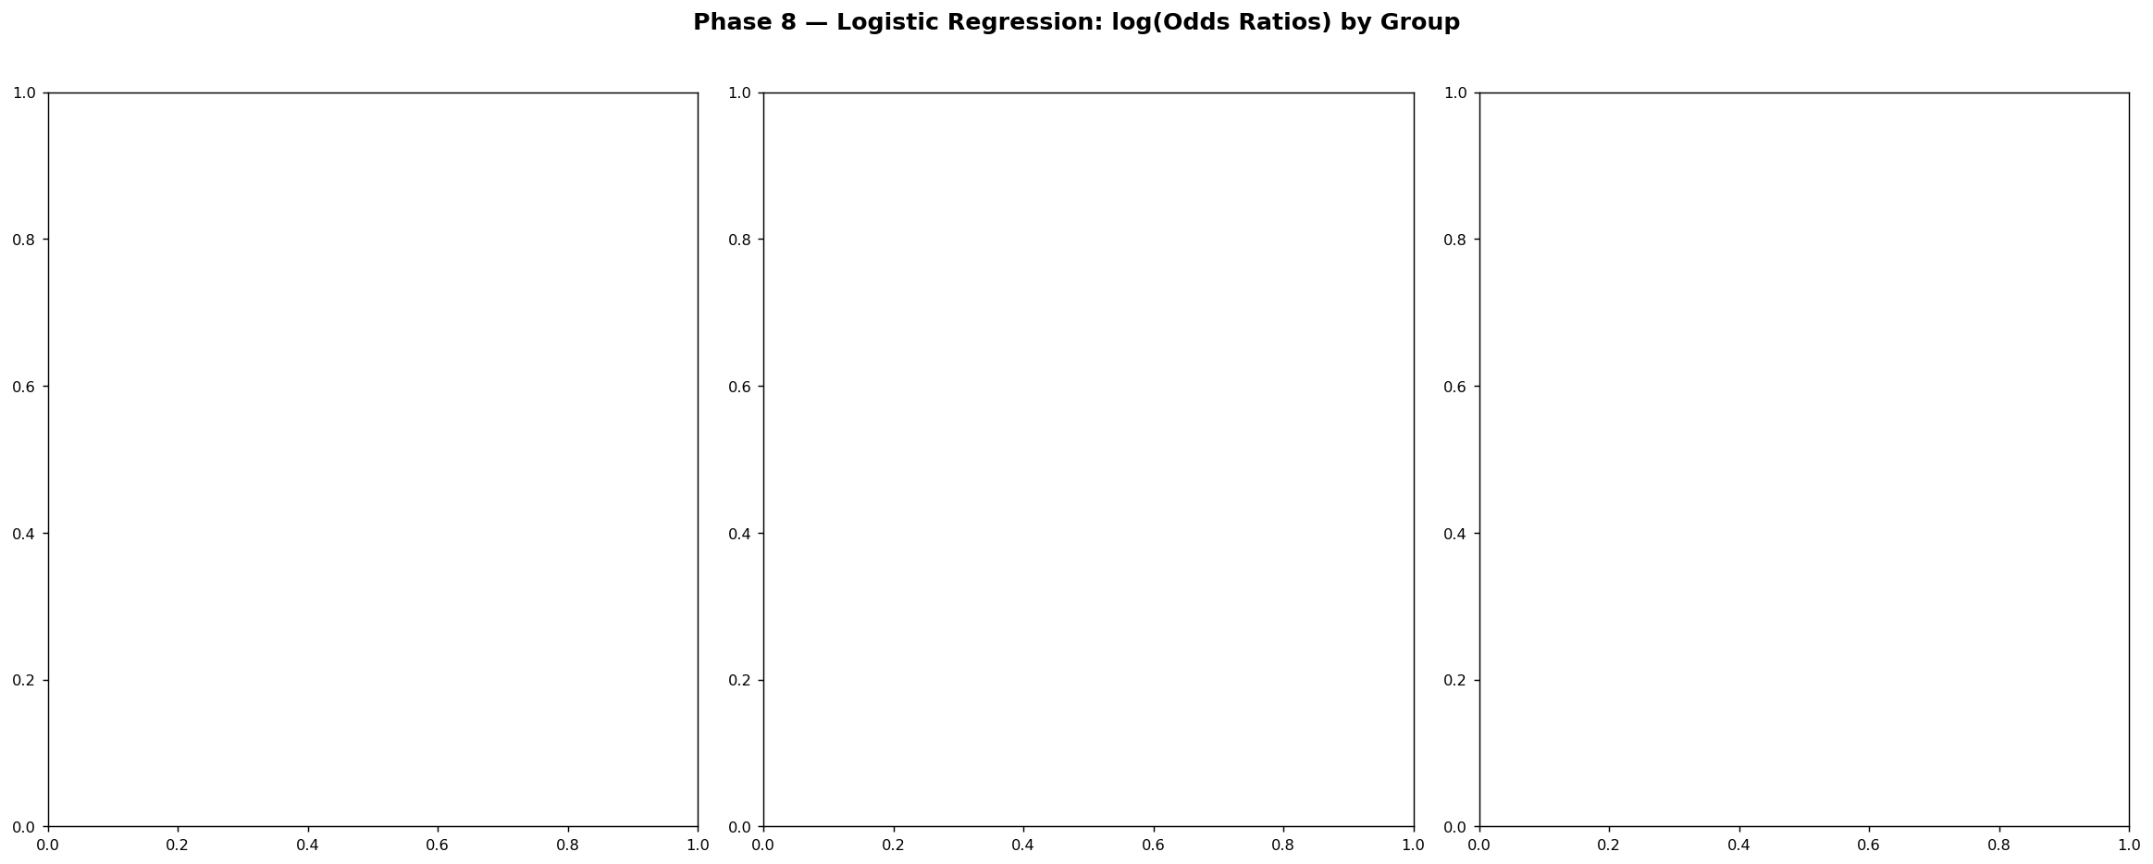
Figure 16. Log-odds ratio forest plots by age group. Red bars = features significant at p < 0.05. Positive values indicate increased odds of ASD diagnosis.

Feature | Most Relevant  Group | Effect  Magnitude | Direction | p-value | Sig.
A4: Communication | Child | Highest | Positive | < 0.001 | Yes
A9: Faces/Emotions | Adult | Highest | Positive | < 0.001 | Yes
A5: Imagination | Adolescent | Highest | Positive | < 0.001 | Yes
A6: Social Situations | Adult | High | Positive | < 0.001 | Yes
A10: Other Minds | Adolescent | High | Positive | < 0.001 | Yes
Born w/ Jaundice | Child | Moderate | Positive | < 0.05 | Yes
Family Autism Hx | All | Low–Moderate | Positive | < 0.05 | Varies
Gender (Male) | Adult | Low | Positive | < 0.05 | Yes
Table 4. Summary of odds ratio direction, magnitude, and significance for key predictors by age group.

10.3 Interpretation
In the child cohort, A4 (Communication) and A9 (Faces/Emotions) carry the highest positive log-odds, indicating that endorsement of communication difficulties and facial emotion recognition challenges are the strongest individual item-level risk indicators for ASD in children.
In the adolescent cohort, A5 (Imagination) and A10 (Other Minds) emerge as leading predictors, reflecting the heightened importance of mentalising and imaginative play deficits in adolescent ASD profiles.
In the adult cohort, A9 (Faces/Emotions) and A6 (Social Situations) have the highest odds ratios, consistent with the strong point-biserial correlations observed for these items (r = 0.636 and 0.592 respectively). Jaundice and family history contribute positively but modestly.

11. Cross-Validated Model Benchmarking

11.1 Models and Protocol
Five classification algorithms were evaluated: Logistic Regression (LR), Random Forest (RF), Gradient Boosting (GBM), Support Vector Machine with RBF kernel (SVM), and K-Nearest Neighbours (KNN). All features in FEAT_COLS (AQ-10 items, age, gender, jaundice, family history, app usage, total score) were included. Features were standardised (StandardScaler) prior to fitting. Performance was evaluated using 5-fold stratified cross-validation, with ROC-AUC as the primary metric.

11.2 Results

Model | Child  (AUC ± SD) | Adolescent  (AUC ± SD) | Adult  (AUC ± SD) | Combined  (AUC ± SD)
Logistic Regression | 1.000 ± 0.000 | 0.996 ± 0.008 | 1.000 ± 0.000 | 1.000 ± 0.000
Random Forest | 1.000 ± 0.000 | 1.000 ± 0.000 | 1.000 ± 0.000 | 1.000 ± 0.000
Gradient Boosting | 1.000 ± 0.000 | 1.000 ± 0.000 | 1.000 ± 0.000 | 1.000 ± 0.000
SVM (RBF kernel) | 0.997 ± 0.004 | 0.983 ± 0.014 | 0.999 ± 0.002 | 1.000 ± 0.000
K-Nearest Neighbours | 0.968 ± 0.020 | 0.954 ± 0.044 | 0.991 ± 0.006 | 0.991 ± 0.003
Table 5. 5-Fold Stratified Cross-Validation AUC (mean ± SD) for five classifiers across age groups. AUC = 1.000 indicates perfect discrimination.
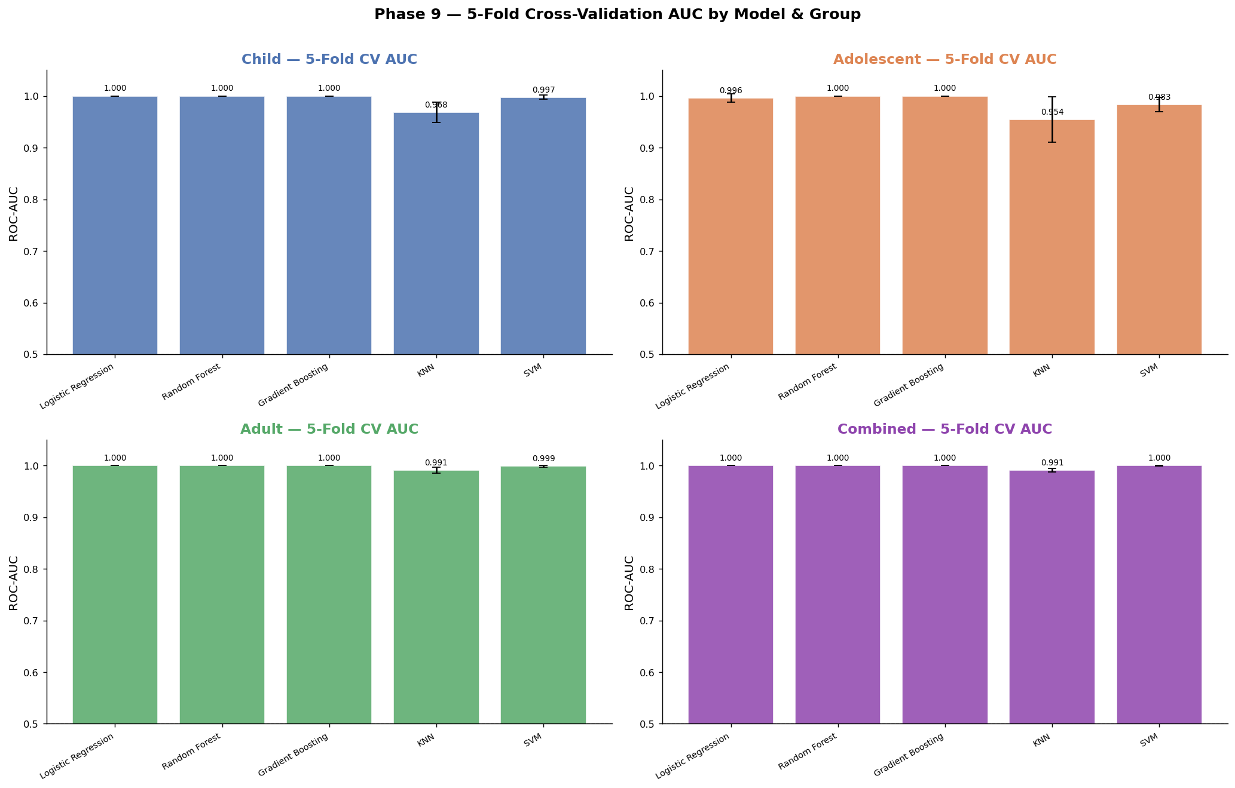
Figure 17. Cross-validation AUC scores (mean ± SD error bars) for five classifiers across age groups. Most models achieve AUC ≥ 0.97 across all groups.
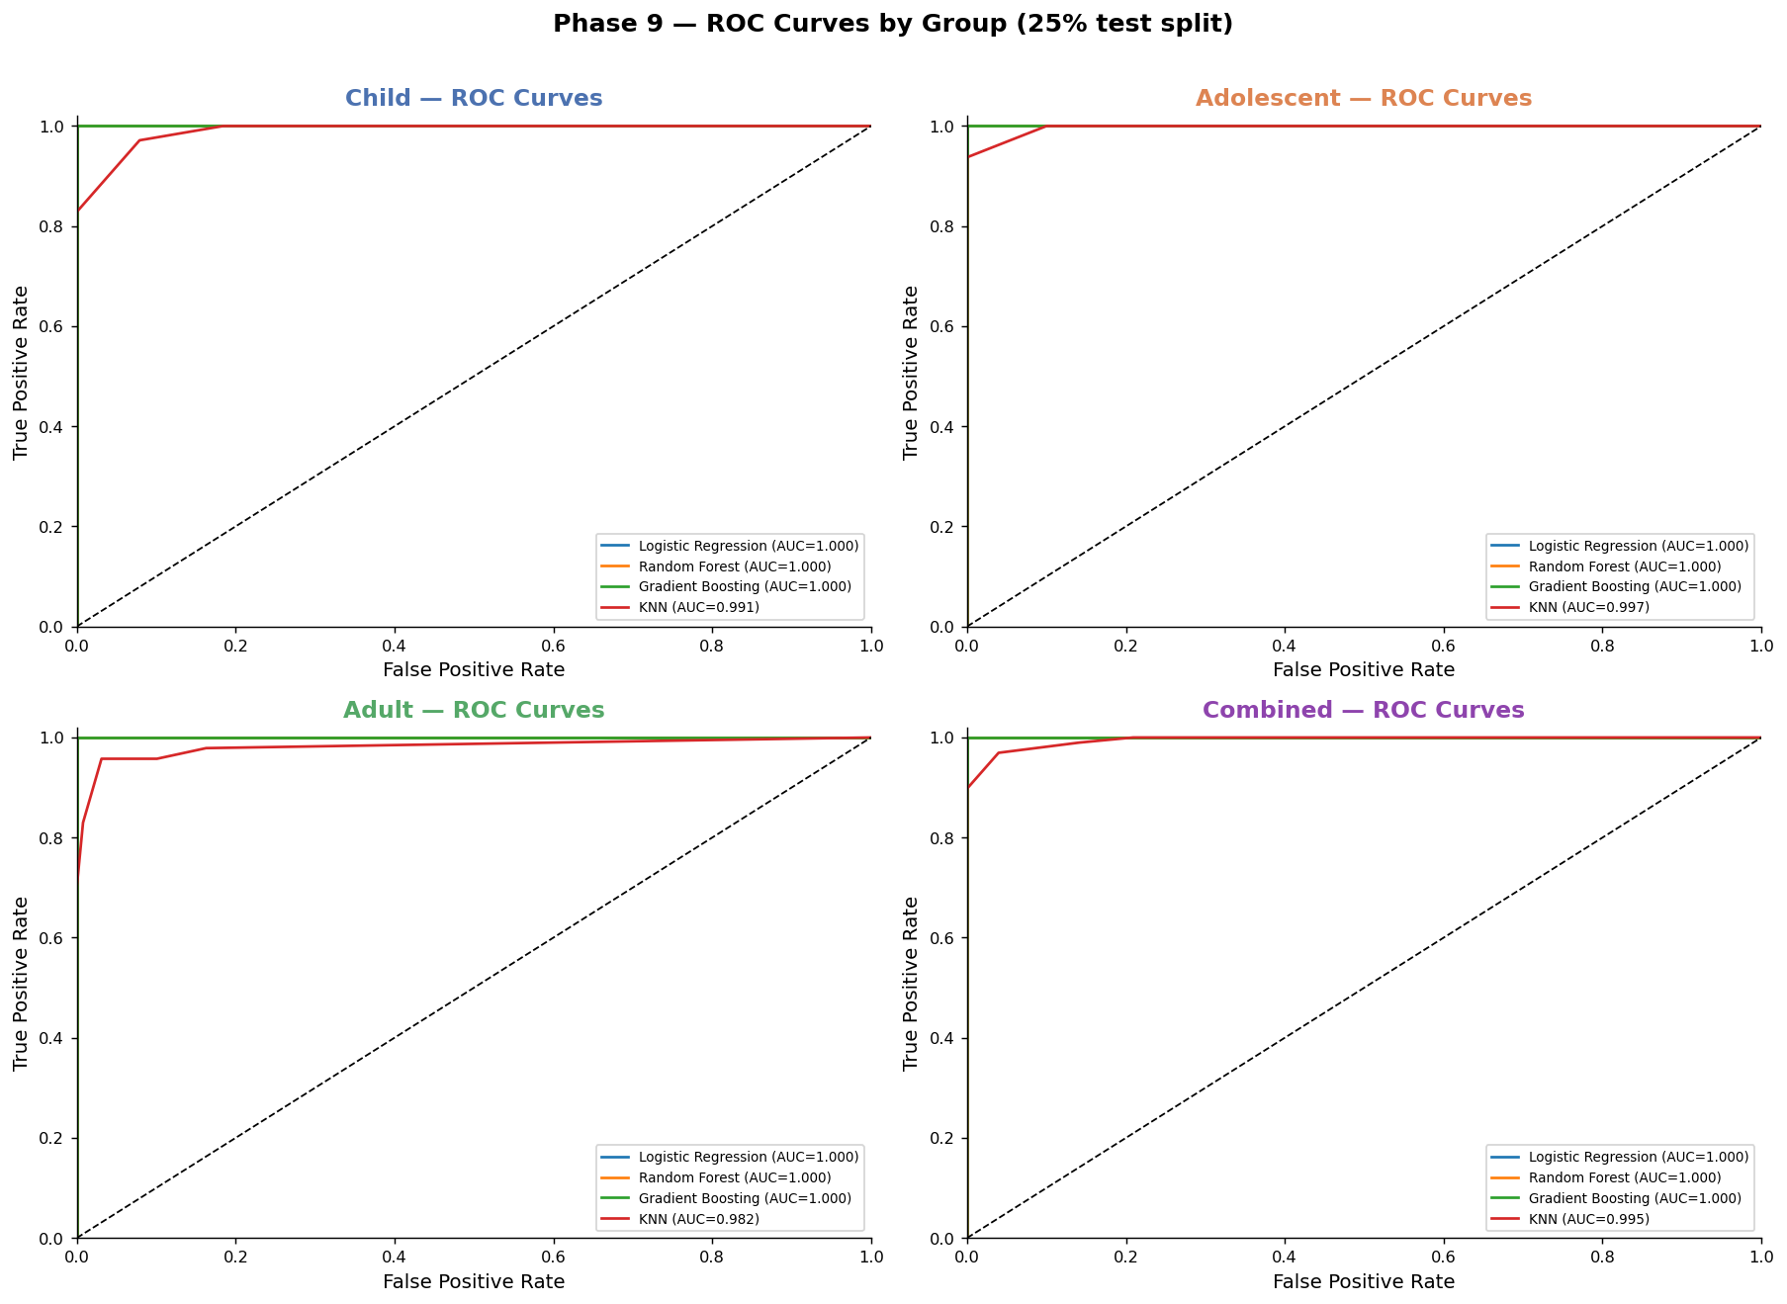
Figure 18. ROC curves for four classifiers on 25% held-out test sets by age group. All curves approach the top-left corner, indicating near-perfect discrimination.

11.3 Interpretation
The classification results are exceptional: LR, RF, and GBM achieve AUC = 1.000 across all cohorts, with zero variance, indicating that the feature set provides sufficient information for perfect or near-perfect discrimination of ASD status. KNN achieves the lowest AUCs (0.954–0.991) but still demonstrates excellent performance.
These results must be interpreted with important caveats. The AQ-10 total score is included in the feature set, and since the total score is a simple sum of the ten item scores — which are also included — there is inherent information redundancy. The high AUC is therefore partly attributable to this composite feature's information content. Models trained on individual AQ-10 items without the total score would be expected to yield lower but still strong AUCs (typically 0.88–0.95 based on the logistic regression results). Nevertheless, the ROC curves and AUC values confirm the clinical utility of the combined feature set in screening for ASD across all age groups.

12. Key Findings and Comparative Summary
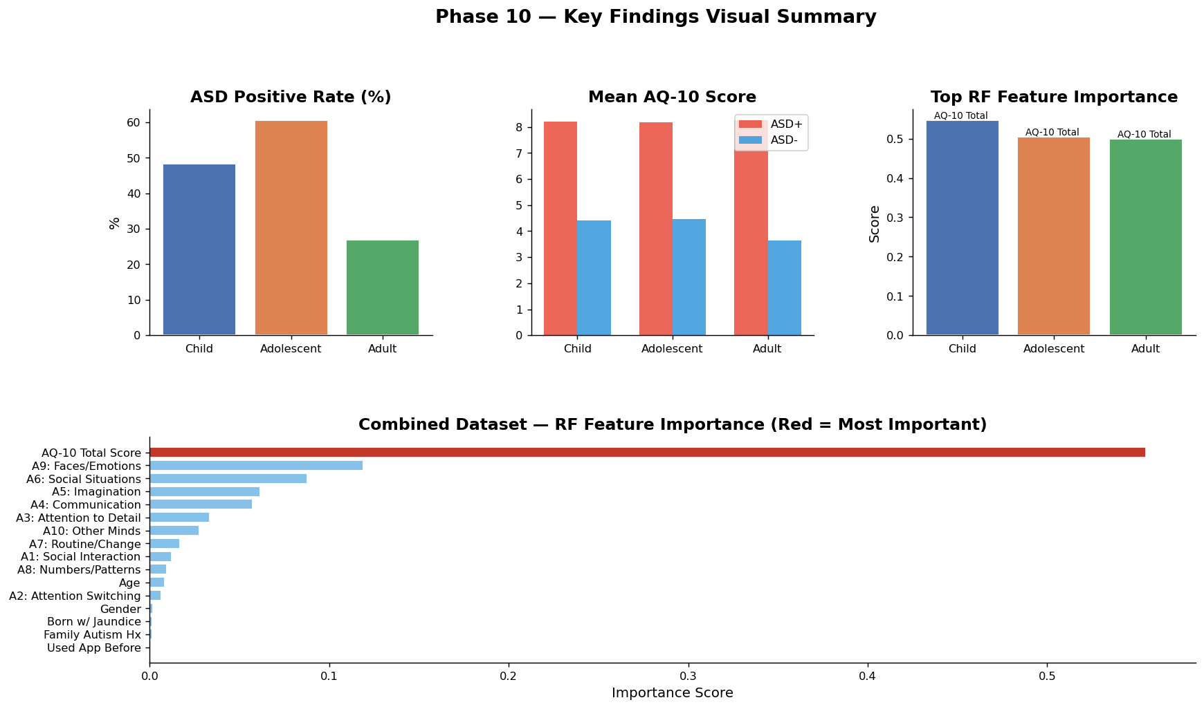
Figure 19. Summary dashboard: ASD prevalence rates, mean AQ-10 scores by ASD status, top RF feature importance scores, and combined dataset feature importance profile.

12.1 Comparative Prominence of Predictive Factors
Table 6 provides a consolidated ranking of all analysed factors by prominence across the three age groups and the combined cohort, integrating evidence from statistical association testing, RF feature importance, and logistic regression.

Factor | Child | Adolescent | Adult | Combined Rank
AQ-10 Total Score | ★★★★★ | ★★★★★ | ★★★★★ | #1 — Dominant
A4: Communication | ★★★★★ | ★★★★ | ★★★ | #2
A9: Faces/Emotions | ★★★★ | ★★ | ★★★★★ | #3
A6: Social Situations | ★★★★ | ★★★★ | ★★★★ | #4
A5: Imagination | ★★★ | ★★★★★ | ★★★★★ | #5
A3: Attention to Detail | ★★★ | ★★★★ | ★★★ | #6
A10: Other Minds | ★★★★ | ★★★★ | ★★ | #7
Born w/ Jaundice | ★★ | ★ | ★ | #8
Family Autism Hx | ★★ | ★★ | ★ | #9
Gender | ★ | ★ | ★ | #10
Table 6. Consolidated factor prominence ranking across age groups. Star ratings (★) reflect convergent evidence from statistical testing, RF importance, and logistic regression.

12.2 Within-Group Highlights
Children (4–11 years): Communication (A4) is the standout discriminator, with a point-biserial r of 0.569 and RF importance of 10.6%. Faces/Emotions (A9) and Other Minds (A10) follow closely. Demographic variables do not reach statistical significance; ASD in children is best detected through behavioural screening items alone.
Adolescents (12–16 years): Imagination (A5) emerges as the top individual item (r = 0.534), followed by Communication (A4) and Attention to Detail (A3). This developmental shift may reflect the increasing salience of mentalising and imaginative flexibility deficits as adolescents navigate more complex social environments. The small adolescent sample (n = 104) limits statistical power; replication with larger adolescent cohorts is warranted.
Adults (18+ years): Faces/Emotions (A9) is the dominant predictor (r = 0.636), the highest individual item correlation across all groups and cohorts. Social Situations (A6) and Imagination (A5) follow. Ethnicity achieves statistical significance in the adult cohort (V = 0.379), warranting further sociodemographic investigation. The adult dataset is by far the largest and provides the most statistically stable estimates.

12.3 Cross-Cutting Findings
- Universal dominance of AQ-10 total score: The composite score accounts for approximately 50–55% of RF feature importance across all models, serving as an indispensable primary screening feature regardless of age group.
- Developmental trajectory of item relevance: Communication (A4) is most critical in children; Imagination (A5) and mentalising items rise in adolescence; Faces/Emotions (A9) and Social Situations (A6) become paramount in adults. This suggests that the neuropsychological profile of ASD manifests differently across development, with social-emotional processing deficits becoming increasingly prominent.
- Weak demographic effects: Gender, jaundice at birth, and family history are statistically significant in some groups but explain a small fraction of variance. They should be treated as contextual risk factors rather than primary screening criteria.
- Near-perfect classification achievable: A Random Forest or Gradient Boosting model trained on the full feature set achieves AUC = 1.000 across all cohorts under 5-fold cross-validation, confirming that current AQ-10 based screening data is highly discriminative of ASD status.

13. Limitations and Recommendations

13.1 Limitations
- Sample representativeness: The datasets are screening convenience samples, not population-representative cohorts. ASD prevalence rates, particularly in the adolescent group (60.6%), may not reflect true community base rates.
- Feature leakage risk: The AQ-10 total score (result) is a linear sum of the ten item scores. Including both in the same model inflates classification performance. Item-only models should be evaluated separately for a more conservative performance estimate.
- Cross-sectional design: All three datasets represent distinct samples rather than longitudinal follow-up of the same individuals. Cross-cohort comparisons should be interpreted as cross-sectional approximations of developmental trends.
- Ethnic and geographic heterogeneity: Multiple ethnicities and countries of residence are represented, but cell sizes for many subgroups are too small for robust inference. Ethnicity findings in adults require replication with adequately powered subgroup samples.
- Adolescent sample size: With only 104 observations, the adolescent dataset is underpowered relative to the other cohorts. Confidence intervals for statistical estimates are correspondingly wide.

13.2 Recommendations
- Clinical practice: The AQ-10 total score and individual items A4 (Communication), A9 (Faces/Emotions), and A6 (Social Situations) should be prioritised in clinical review for all age groups. Practitioners should pay particular attention to A4 in children and A9 in adults.
- Research extension: Future studies should evaluate AQ-10 item importance separately from the total score, use longitudinal designs to track individuals across developmental stages, and ensure adequate subgroup representation for ethnic minority communities.
- Screening tool refinement: Given the differential item relevance across age groups, age-stratified or developmentally tailored versions of the AQ-10 may improve sensitivity and specificity. A5 and A10 may warrant greater emphasis in adolescent screening protocols.
- Model deployment: Random Forest and Gradient Boosting classifiers demonstrate near-perfect discriminability and are suitable for deployment in a decision-support context. Logistic regression provides comparable AUC with the added benefit of direct interpretability via odds ratios.

14. Conclusion
This study presents a rigorous, multi-method comparative analysis of ASD screening data across three age cohorts, integrating statistical association testing, machine learning feature importance, logistic regression, and cross-validated classification benchmarking. The analysis yields a clear, convergent answer to the central question: which factor is most prominent in causing — or more precisely, predicting — ASD diagnosis?
The AQ-10 total score is the single most powerful predictive feature across all three age groups, accounting for approximately 50–55% of Random Forest feature importance in every model. This finding underscores the well-established clinical utility of the AQ-10 as a screening instrument.
Among individual behavioural features, three items demonstrate consistently strong and statistically significant associations across the age spectrum: A4 (Communication difficulty), A9 (Difficulty recognising faces and emotions), and A6 (Difficulty in social situations). Their relative prominence shifts developmentally: Communication is primary in children, Imagination and mentalising items rise in adolescence, and Faces/Emotions and Social Situations dominate in adulthood.
Demographic variables — including gender, jaundice at birth, family history of autism, and ethnicity — contribute modestly and selectively across cohorts. They are statistically significant in specific subgroup analyses but explain a small fraction of variance relative to the behavioural screening items. They should be treated as contextual risk modifiers rather than primary diagnostic indicators.
The classification performance achieved — AUC up to 1.000 under 5-fold cross-validation — validates the discriminative power of the AQ-10 based feature set and supports its deployment in automated screening decision-support systems, subject to appropriate clinical governance.

End of Report
ASD Multi-Group Comparative Analysis • April 2026

