Week 4

By Prithu Adhikari

Sec E

## **Importing and Using Functions**

Task 1:Write some code that imports the math *module*, then calculates and prints the square root of the number 2401. Use the sqrt() function provided by the math module.

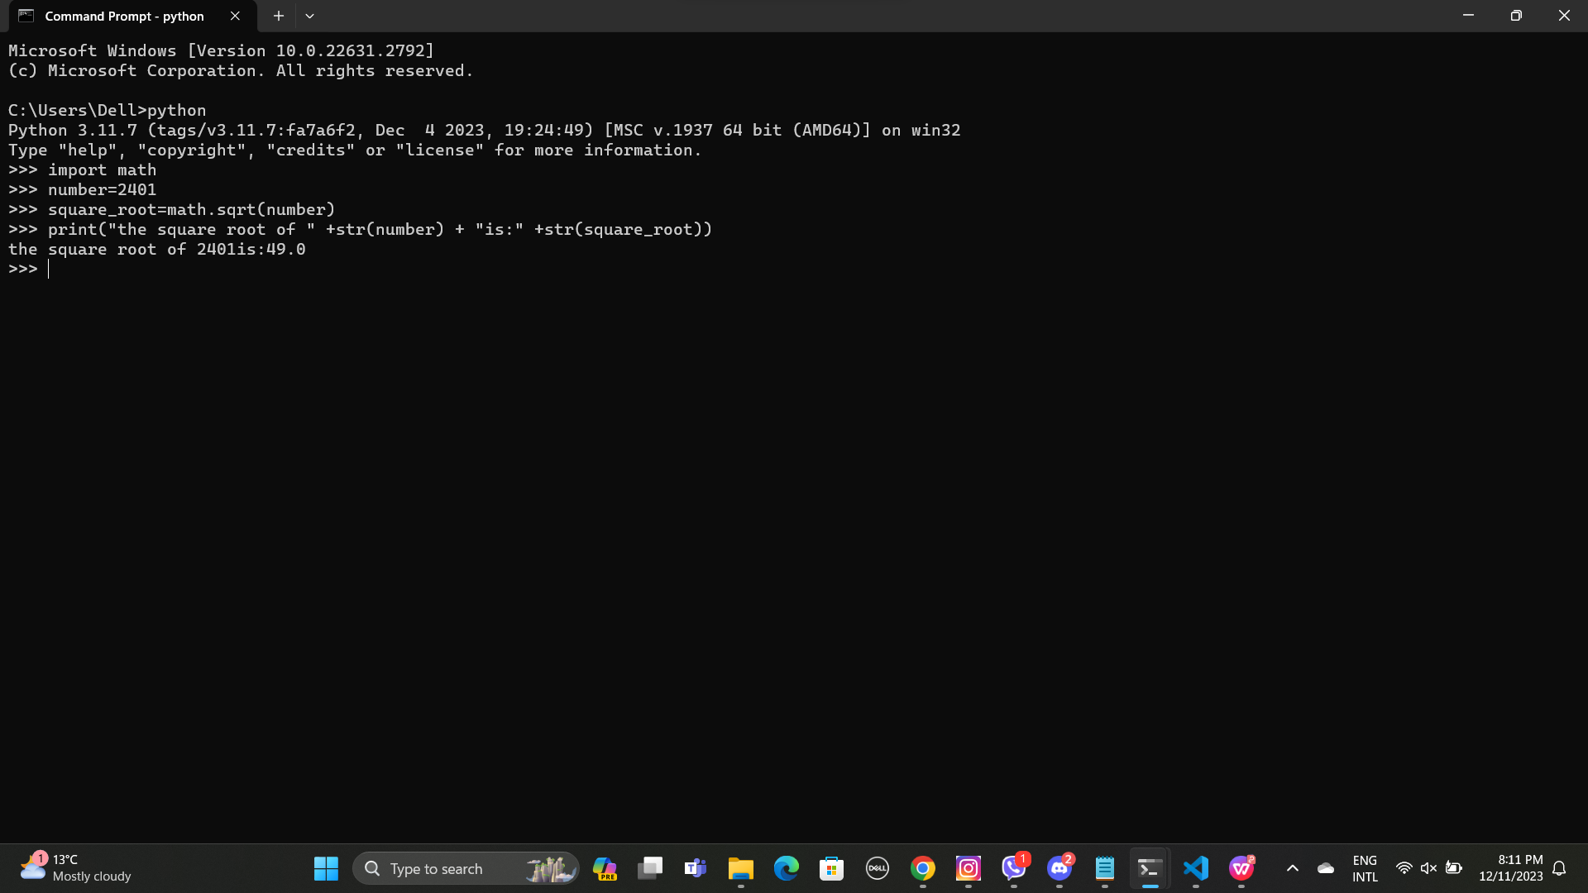

Task 2:Write some code that imports only the log2() function from the math *module*, then call this function to calculate the log base 2 value of 1024. Print the result to the screen.

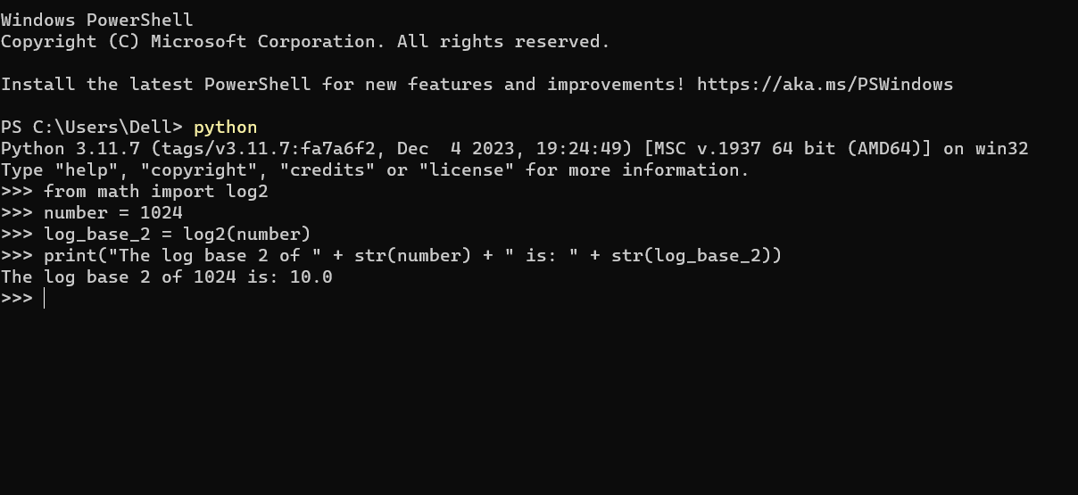

**Defining Functions**

def display_Twice(msg):

print(msg)

print(msg)

**TASK 3**: Input the above function definition. Once that is done make several calls to the function passing different argument values for testing.

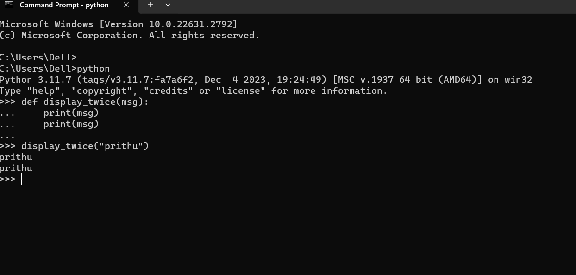

Task 4:Re-Input the above function definition, but this time add a docstring that includes a description of the function’s purpose. Once that is done enter a command such as help(displayTwice) and see what it displays.

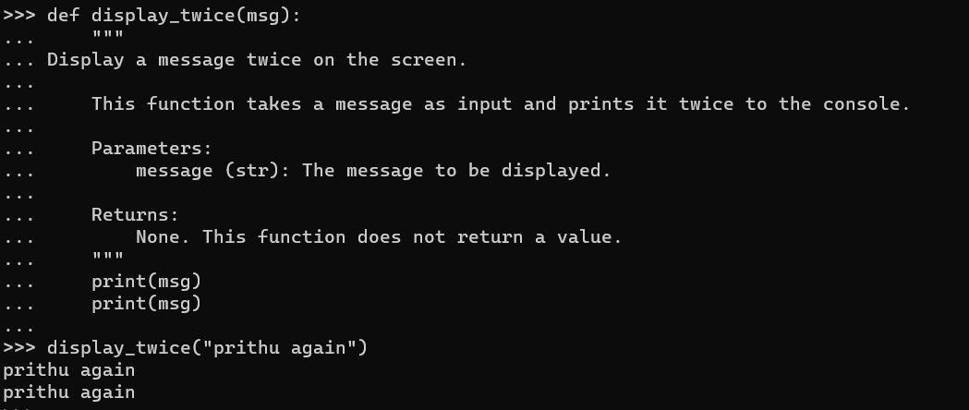

def findMax(a,b):

"""Finds the maximum of two values."""

if ( a > b ):

max = a

else:

max = b

return max

Task 5:Input the above function definition. Once that is done make several calls to the function passing different argument values and displaying the returned value.

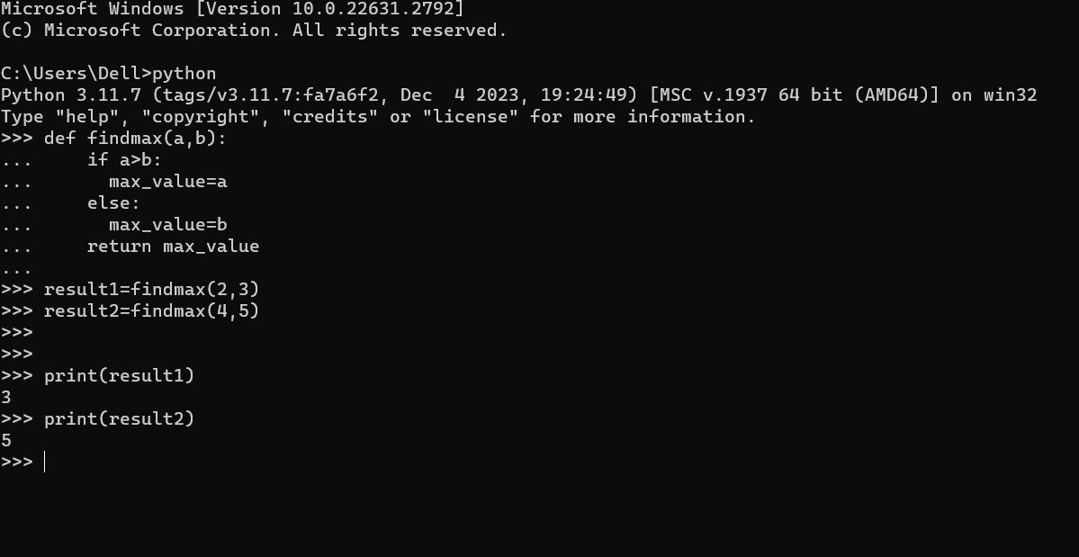

Task 6 :Enter the example function shown above, then try calling it using the *keyword arguments* in several different orders.

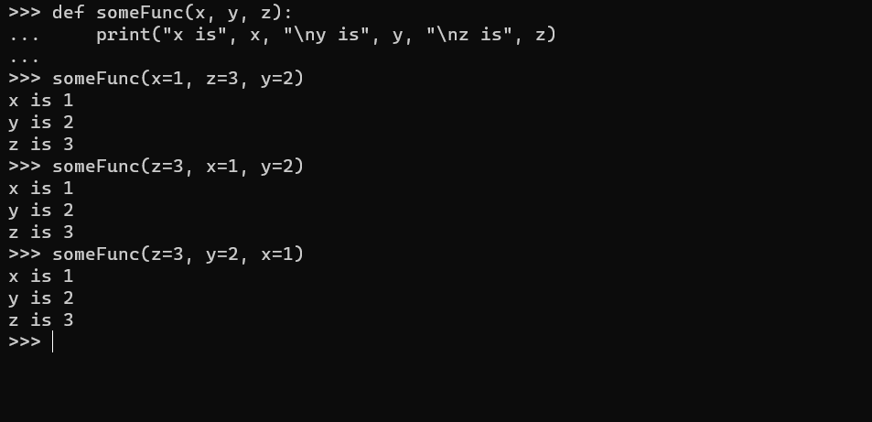

Task7:The built-in print() function supports a keyword argument called sep. This is used to decide what character to display between each of the provided positional parameters. Write some code that makes several calls to the print() function while setting the sep argument to values other than a space (which is the default)

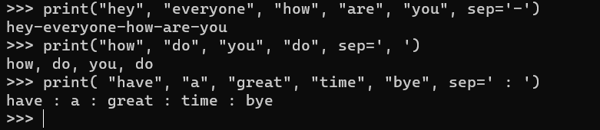

def calcAve(*numbers):

total = 0

for num in numbers:

total += num

return total/len(numbers)

Task 8:Enter the example function shown above, then try calling it several times, passing a different number of numeric arguments each time. Note: variadic arguments are normally defined last in the formal parameter list (and can only be followed by keyword type parameters).

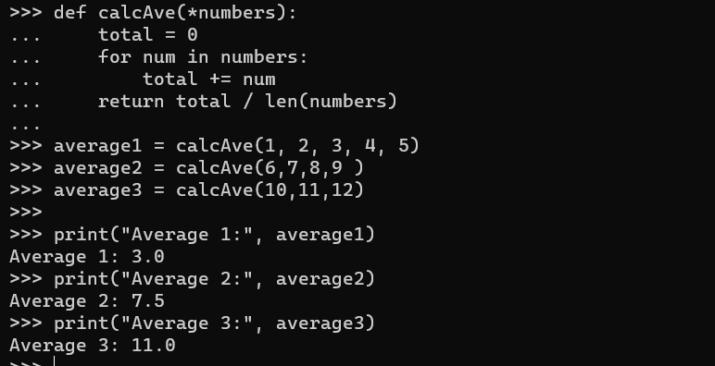

hypot = lambda a,b : math.sqrt(a * a + b * b)

**TASK9**: Enter the example lambda expression shown above, then find out the data type of the

hypot variable using a call to the type () function. Notice the result.

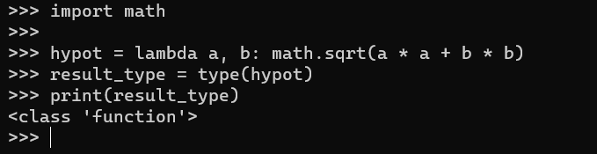

Task 10:Write a lambda expression that takes two formal parameters, hours and minutes. The expression should calculate and return the total number of equivalent seconds. Assign the expression to a variable called to_seconds, then call the function several times for testing.

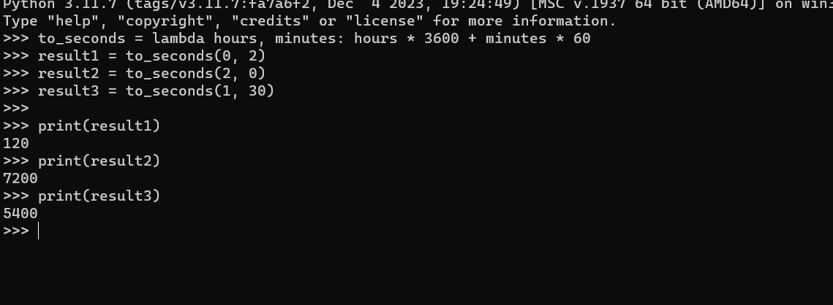

TASK 11:Improve your previous lambda expression so that if only one argument is passed within a call, then the number of minutes defaults to 0, as detailed below:

>>> to_seconds(1) 3600

>>> to_seconds(2) 7200

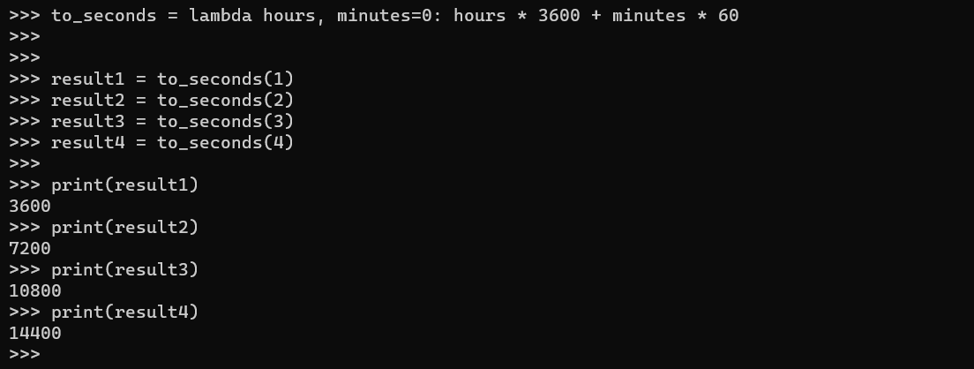

**Key Terminology**

**TASK**: Look at each of the phrases below and ensure you understand what each of these means.

For any that you do not understand, do a little research to find a definition of each term. This research may involve looking back over these notes, or the associated lecture notes. It may also involve searching for these terms on the Internet.

● Module

**Ans** They are simply file with .py extension containing python code that can be imported inside another python program.

● The Python Standard Library

**Ans** The Python Standard Library is a collection of script modules accessible to a Python

program. ● Formal Parameters

**Ans** Formal parameters are the variables defined by the function that receives values when the function is called.

● Actual Parameters (argument values)

**Ans** the actual value that is passed into the method by a caller.

● Default and Keyword Arguments

**Ans** Default Arguments in Python represent the function arguments that will be used if no arguments are passed to the function call. Keyword Arguments are values that, when passed into

a function, are identifiable by specific parameter names.

● Lambda Expression

Ans A lambda expression is a short block of code which takes in parameters and returns a value.