Week 7

Prithu Adhikari

**TASK**: Try creating a set by entering the code below. Then use the print() function to display the contents of the set. Notice how the output varies from the entered values.

names = {"John", "Eric", "Terry", "Michael", "Graham", "Terry"}

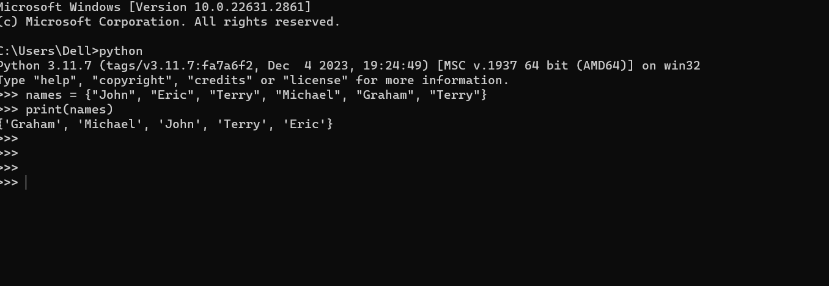

**TASK**: Enter the code below, then make a call to the print() function to display the contents of the set.

sentence = "this is a sentence containing some letters"

unique_letters = {x for x in sentence}

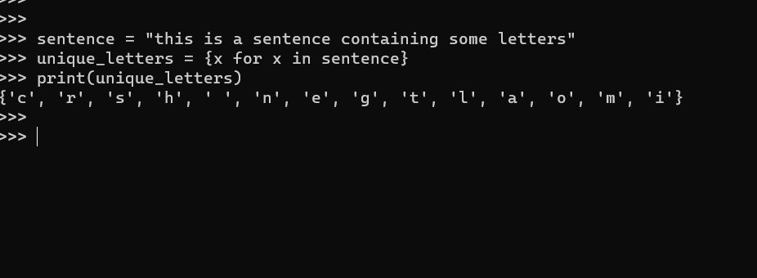

**TASK**: Rewrite the previous code so that it checks that the input name is NOT within the set of known names. Hint: use the not in operator

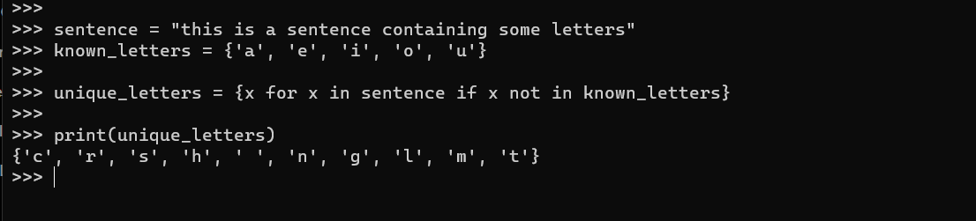

**TASK**: Use the built-in help() function to view all the methods available on the set type.

If we assume we have the following sets:

staff = {"Pete", "Kelly", "Jon", "Paul", "Sally", "Sue"}

directors = {"Kelly", "Rupert", "Cyril", "Jon"}

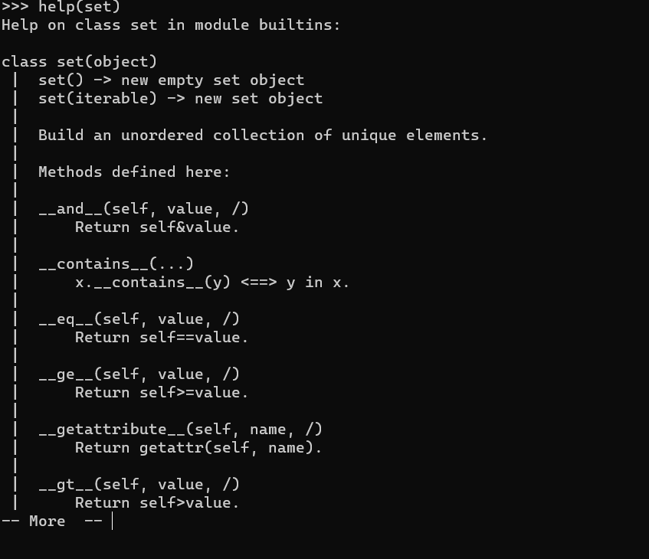

**TASK**: Create the two initial sets, staff and directors as shown in the first example above. Perform the four mathematical set operations shown, but use the equivalent *method* calls to achieve the same results

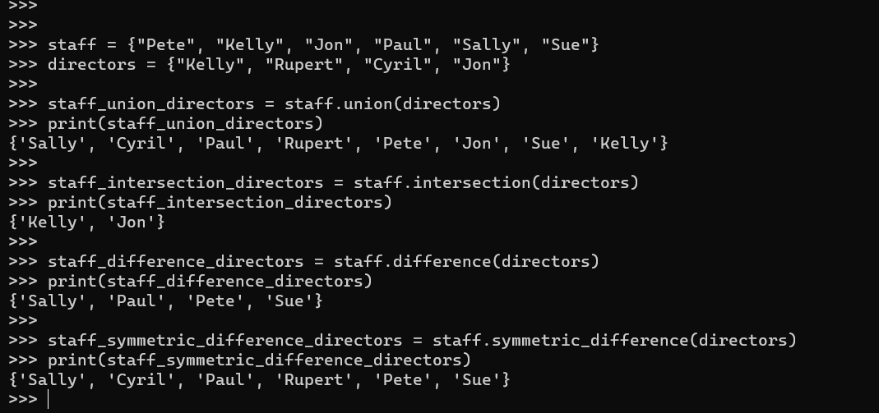

**TASK**: Create the set shown below then use the *mutator* version of the union method, which is update() to add the two missing vowels to the set.

vowels = set({"a", "e", "i"})

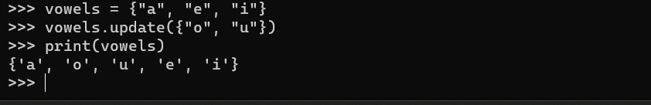

**TASK**: Write code based on the previous two examples, but use the equivalent *method* calls to achieve the same results.

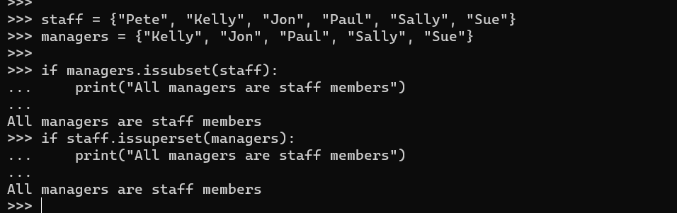

**TASK**: Use the built-in help() function to view all the methods available on the frozenset type.

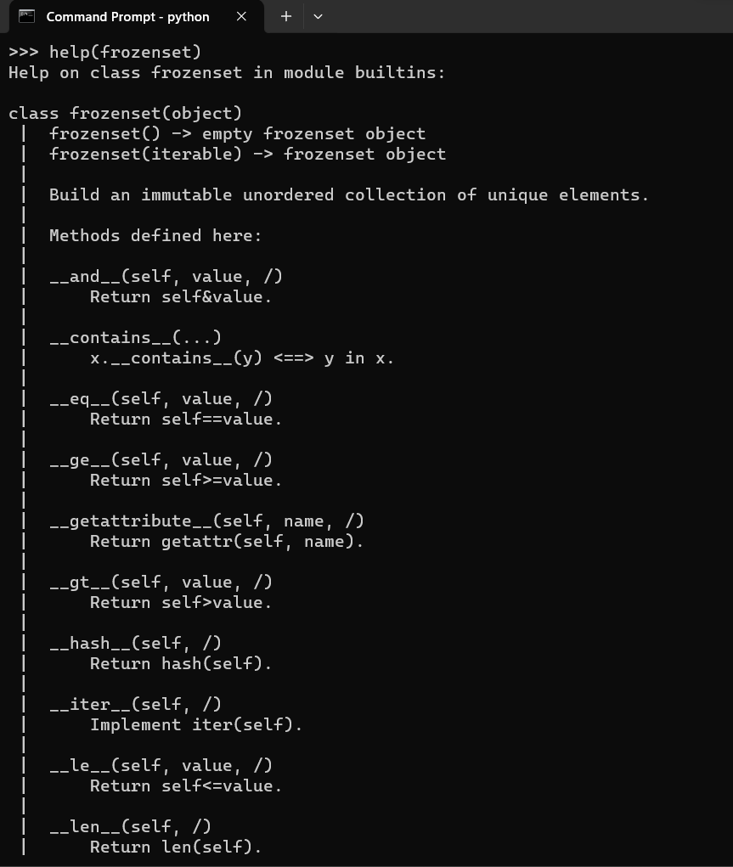

**TASK**: Enter the code below, then make a call to the print() function to display the contents of the dictionary.

import math

roots = {n : math.sqrt(n) for n in range(1,26)}

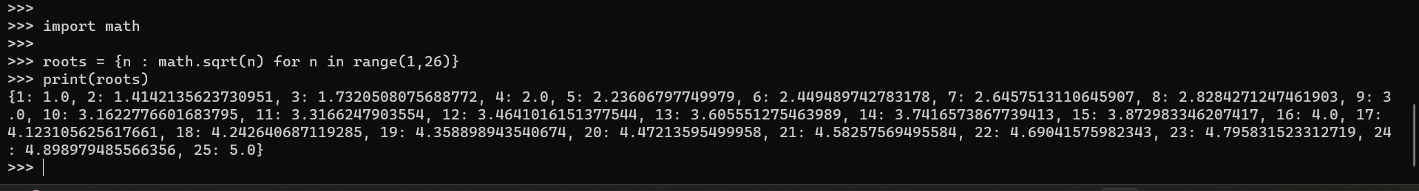

**TASK**: Write some code which adds a new fruit called "kiwi" to the stock dictionary, with an initial stock level of 10.

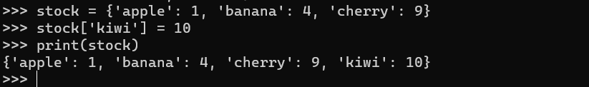

**TASK**: Use the built-in help() function to view all the methods available on the dict type. Then write some code that uses the popitem() method to remove some *key:value* pairs from the stock dictionary.

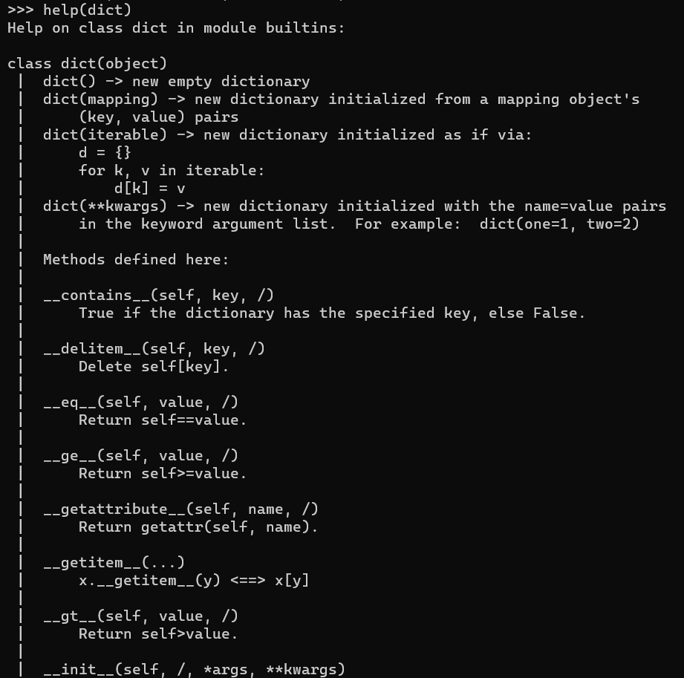

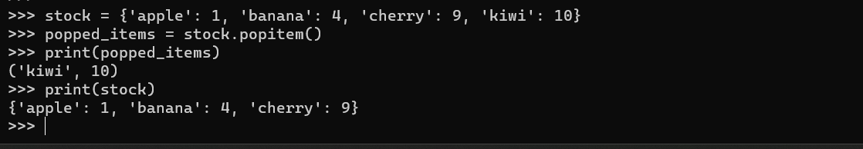

**TASK**: Write some code that iterates over the contents of the roots dictionary created within an earlier task. For each entry, print the message -

“The square root of <num> is <sqrt>”

Where <num> shows the number, and <sqrt> shows the square root of that number.

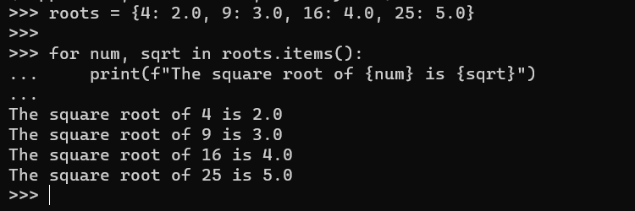

**TASK**: Look at each of the phrases below and ensure you understand what each of these means. For any that you do not understand, do a little research to find a definition of each term. This research may involve looking back over these notes, or the associated lecture notes. It may also involve searching for these terms on the Internet.

* Set
* Set operations
* Set comprehension
* Dictionary
* *key:value* pair

Set:

Definition: In mathematics and computer science, a set is a collection of distinct elements, where the order of elements doesn't matter. Sets are often used in programming to represent a group of unique values.

Set Operations:

Definition: Set operations refer to mathematical operations performed on sets, such as union, intersection, difference, and symmetric difference. These operations allow you to combine, compare, or manipulate sets.

Set Comprehension:

Definition: Set comprehension is a concise way to create sets in Python. It involves using a single line of code to define a set by specifying a rule or condition for its elements. The syntax typically involves curly braces and an expression.

Dictionary:

Definition: In Python, a dictionary is a collection of key-value pairs. It is an unordered, mutable data type that allows you to store and retrieve values using unique keys. Each key in a dictionary must be unique.

Key-Value Pair:

Definition: A key-value pair is a fundamental concept in data structures, particularly in dictionaries. It consists of two linked items: a key, which is a unique identifier, and a value, which is associated with that key. The key is used to access the corresponding value in a collection or mapping.