***Task 2:-***

Identify a Problem Statement Within your Chosen Domain and devise a solution for it. Then, articulate the problem and your proposed solution.

***Html:-***

<!DOCTYPE html>

<html>

<head>

  <title>Simple To-Do List</title>

  <link rel="stylesheet" type="text/css" href="style.css">

</head>

<body>

  <h1>My To-Do List</h1>

  <div id="task-list">

    <input type="text" id="new-task" placeholder="Enter a task">

    <button id="add-task">Add Task</button>

    <ul id="tasks">

*<!-- Task items will be added here dynamically -->*

    </ul>

  </div>

  <script src="script.js"></script>

</body>

</html>

***Css:-***

body {

    font-family: Arial, sans-serif;

    text-align: center;

    background-color: #f5f5f5;

  }

  h1 {

    color: #333;

  }

  #task-list {

    background-color: #fff;

    border: 1px solid #ccc;

    margin: 20px auto;

    padding: 20px;

    width: 80%;

  }

  ul {

    list-style-type: none;

    padding: 0;

  }

  li {

    background-color: #e6e6e6;

    border: 1px solid #ccc;

    margin: 10px 0;

    padding: 10px;

    display: flex;

    justify-content: space-between;

  }

  button.delete {

    background-color: #ff6666;

    color: white;

    border: none;

    padding: 5px 10px;

    cursor: pointer;

  }

***Js:-***

document.addEventListener("DOMContentLoaded", **function** () {

**const** newTaskInput = document.getElementById("new-task");

**const** addTaskButton = document.getElementById("add-task");

**const** tasksList = document.getElementById("tasks");

    addTaskButton.addEventListener("click", **function** () {

**const** taskText = newTaskInput.value.trim();

      if (taskText) {

**const** taskItem = document.createElement("li");

        taskItem.innerHTML = `

          <span>${taskText}</span>

          <button class="delete">Delete</button>

        `;

        taskItem.querySelector("button.delete").addEventListener("click", **function** () {

          taskItem.remove();

        });

        tasksList.appendChild(taskItem);

        newTaskInput.value = "";

      }

    });

  });

***Output:-***

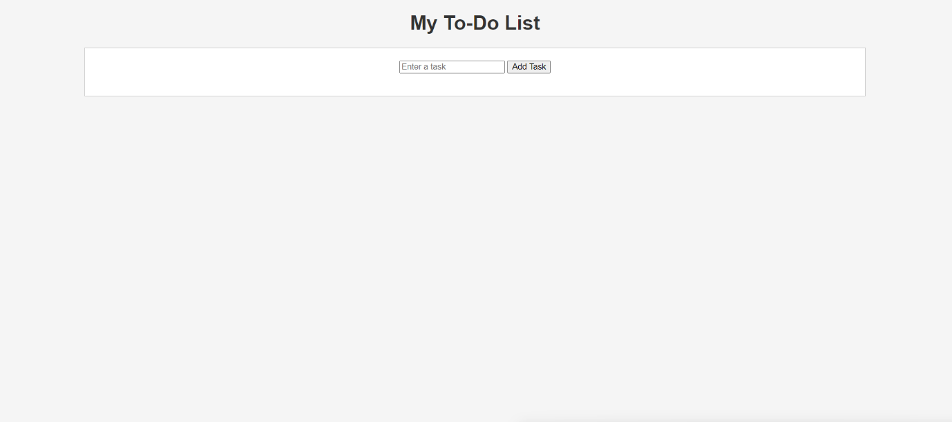

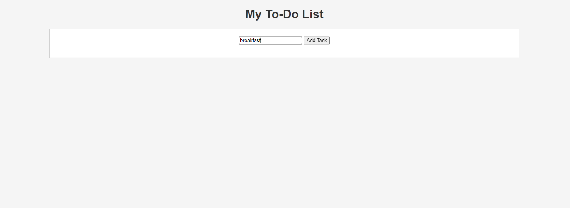

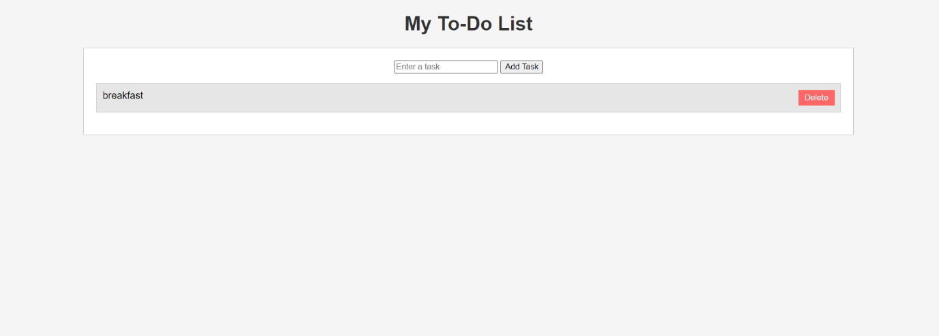

**We can also add multiple to-do things.**

