Intro to Java
(CSL215)
Lab Workbook


Faculty name Student name: prithvi
Roll No:24csu345
Semester:3rd
Group:AI 8

Github link:

Department of Computer Science and Engineering
The NorthCap University, Gurugram- 122017, India
Session 2025-26

Index

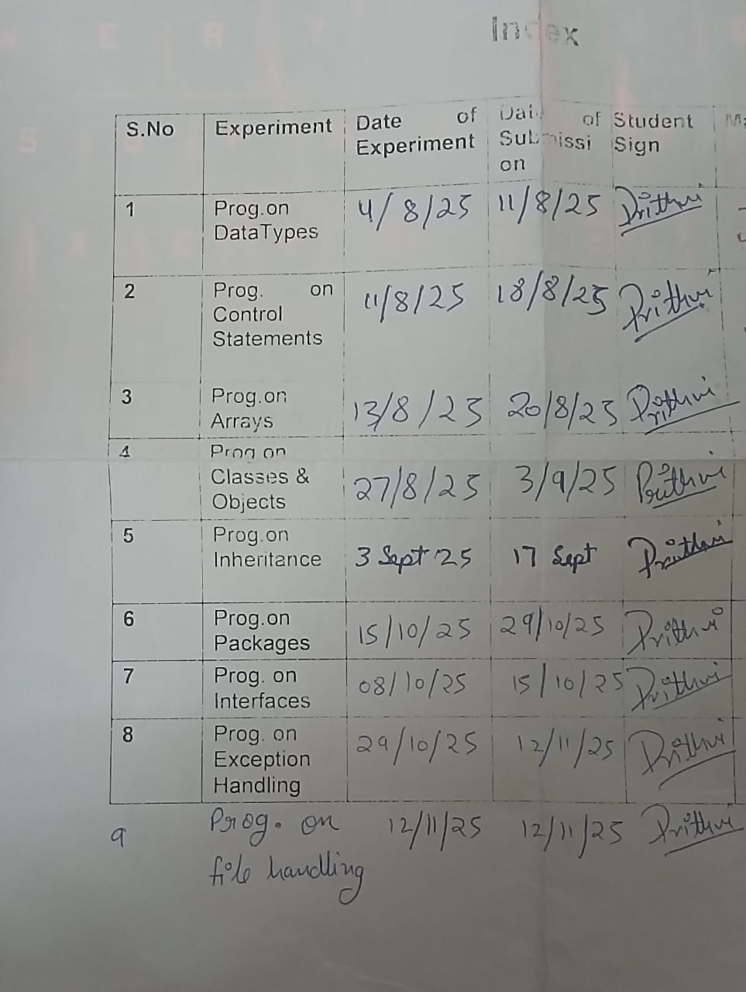

PRACTICAL NO. 1
Student Name and Roll Number:Monish /24csu321

Semester /Section:

Link to Code:

Date:

Faculty Signature:

Objective(s):

- Perform variable assignment.
- Use comments in code
- Use operator precedence and operator associativity.
- Effectively use arithmetic expressions in Java

Outcome:

Student will be familiarizing with the data types in Java.

Problem Statement:
Q1. Write a program that takes two integers (values to be given within the program) and displays the output of the following operators: addition, subtraction, multiplication, division and modulus.
Definition of Done:
DoD 1: Assign two numbers to two variables.
DoD2: Use separate variables to store the results.

Q2. Write a Java program to convert minutes into the number of years, months and days.
Definition Of Done :
DoD 1: Ask the user to input the minutes
DoD 2: Display years and months and days in the sequence yy-mm-dd.

Q3 Write a Java program to convert temperature from Fahrenheit to Celsius. Formula:
$$C=\frac{\left(F-32\right)*5}{9}$$
Definition of Done (DoD):
- DoD 1: The program should ask the user to enter temperature in Fahrenheit.
- DoD 2: The program should calculate the Celsius equivalent.
- DoD 3: The program should display the result.

Q4 Write a Java program to find the sum of digits of a 3-digit number entered by the user.
Definition of Done (DoD):
- DoD 1: The program should ask the user to enter a 3-digit number.
- DoD 2: The program should extract digits using division and modulus operators.
- DoD 3: The program should display the sum of digits.

Q5. Reverse a 3-digit Number
Write a Java program to reverse a 3-digit number entered by the user.
Definition of Done (DoD):
- DoD 1: The program should ask the user to enter a 3-digit number.
- DoD 2: The program should reverse the number using division and modulus operators.
- DoD 3: The program should display the reversed number.

Background Study: Data Types in Java
Primitive data types: The primitive data types include boolean, char, byte, short, int, long, float and double.
Non-primitive data types: The non-primitive data types include Classes, Interfaces, and Arrays.

Question Bank:
- Why Java is considered dynamic?
- What is Java Virtual Machine and how it is considered in context of Java’s platform independent feature?
- List two Java IDE’s?List some Java keywords(unlike C, C++ keywords)?
4. Consider the following class:
public class IdentifyMyParts {
public static int x = 7;
public int y = 3;
}
- What are the class variables?
b) What are the instance variables?
5. Differentiate between instance variable and a class variable.
6. Explain how to create instance of a class by giving an example
7. What is singleton class? Where is it used?
8. What is a native method?
9. Difference between a public and a non-public class

Flipped practicals
1. What is the output from the following code:
IdentifyMyParts a = new IdentifyMyParts();
IdentifyMyParts b = new IdentifyMyParts();
a.y = 5;
b.y = 6;
a.x = 1;
b.x = 2;
System.out.println("a.y = " + a.y);
System.out.println("b.y = " + b.y);
System.out.println("a.x = " + a.x);
System.out.println("b.x = " + b.x);
System.out.println("IdentifyMyParts.x = " + IdentifyMyParts.x);

2. What's wrong with the following program?
public class SomethingIsWrong {
public static void main(String[] args) {
Rectangle myRect;
myRect.width = 40;
myRect.height = 50;
System.out.println("myRect's area is " + myRect.area());
}
}

Student Work Area
Algorithm/Flowchart/Code/Sample Outputs
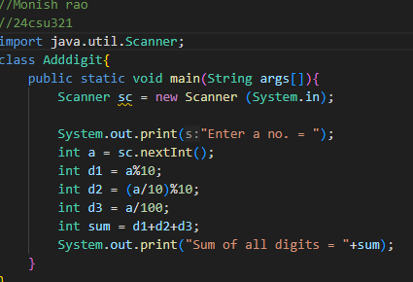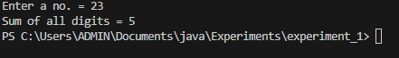
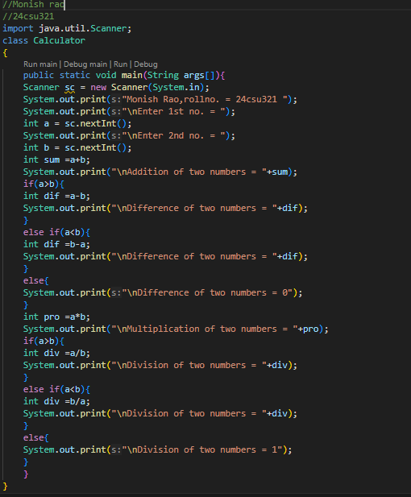
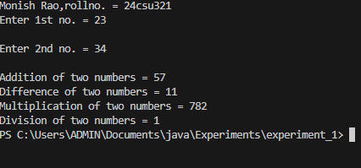

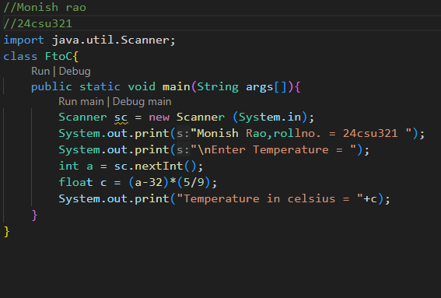
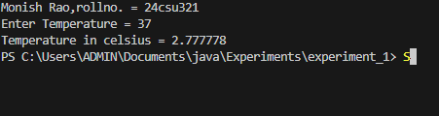

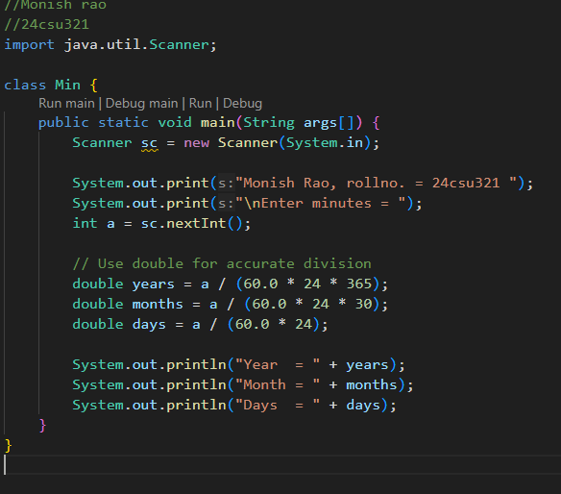
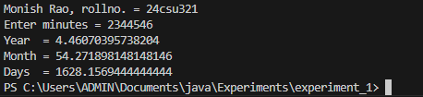

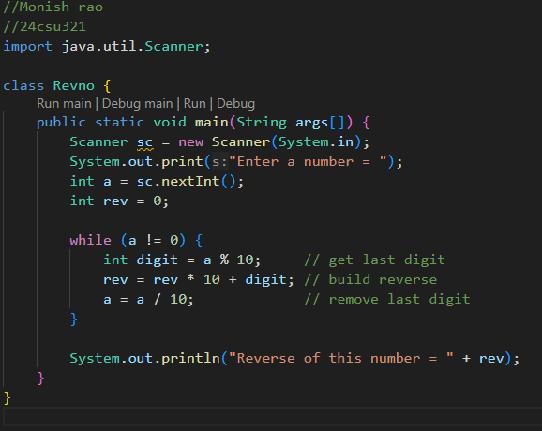
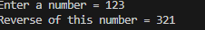

ANSWERS
Ans1. Java supports dynamic memory management and loads classes at runtime, which makes it flexible and efficient.
Ans2. JVM (Java Virtual Machine) converts Java code into bytecode, and this bytecode can run on any system. That’s why Java is platform independent.
Ans3. Examples of Java IDEs are Eclipse and IntelliJ IDEA. Some Java keywords that are not present in C/C++ are:
- new – used to create objects
- import – used to import classes and packages
Ans4.
a) Class Variable – x (because it is static)
b) Instance Variable – y
Ans5.
- Instance Variable – A variable that belongs to an object (non-static).
- Class Variable – A variable declared with the static keyword and shared by all objects.
Ans6. Student s = new Student(); → here s is an instance (object) of class Student.
Ans7. A Singleton class allows creation of only one object in the whole application. It is mostly used for things like logging or database connections.
Ans8. A native method is written in C/C++ but called in Java using the native keyword. It is used when we need faster execution.
Ans9.
- Public Class – Can be accessed from anywhere and the file name must be same as the class name.
- Non-Public Class – Can only be accessed within the same package.

FLIPPED PRACTICALS
ANS 1=
a.y = 5
b.y = 6
a.x = 2
b.x = 2
IdentifyMyParts.x = 2
ANS 2=
public class SomethingIsWrong {
public static void main(String[] args) {
Rectangle myRect = new Rectangle(); (Corrected Version)
myRect.width = 40;
myRect.height = 50;
System.out.println("myRect's area is " + myRect.area());
}
}

PRACTICAL NO. 2
Student Name and Roll Number: Monish /24csu321

Semester /Section:

Link to Code:

Date:

Faculty Signature:

Objective
To familiarize the students with control statements in JAVA

Program Outcome
Through this practical, students will learn about the control statements

Problem Statement
- Write a Java program to display the character rhombus structure. You can assume a character to create rhombus/diamond, left and right triangle, pyramid.
Definition of Done:
DoD1: The program asks the user for the number of rows for the rhombus structure from the user
DoD 2: After a successful run, the program should ask the user if he wants to try the program for some other value, and should exit only when the user wants to exit (by pressing the character ‘N’).

- Write a Java program to solve quadratic equations (use if, else if and else).
Definition of Done:
DoD 1: The program asks the values of coefficients of a quadratic equation.
DoD 2: The program should display the roots or an appropriate message.

- Write a Java program that asks the user to provide a single character from the alphabet. Print Vowel or Consonant, depending on the user input. If the user input is not a letter (between a and z or A and Z), or is a string of length > 1, print an error message.
Definition of Done:
DoD 1: The program asks an input from the user.
DoD 2: A single character input is taken from the user or an error message is
generated.
DoD 3: The program should print “Vowel” if the entered character is a vowel and
“Consonant” if the entered character is a consonant.
- Write a Java program to check whether a number entered by the user is prime or not using control statements.
Definition of Done (DoD):
- DoD 1: The program should ask the user to enter an integer.
- DoD 2: The program should check whether the number is prime using loops/conditionals.
- DoD 3: The program should display a clear message: “Number is Prime” or “Number is Not Prime”.
- Write a Java program to generate and display the Fibonacci series up to n terms using control statements:
Definition of Done (DoD):
- DoD 1: The program should ask the user to enter the number of terms (n).
- DoD 2: The program should use only loops/conditionals to generate the series (no functions).
- DoD 3: The program should display the series in proper format.
Background Study:
Java compiler executes the java code from top to bottom. The statements are executed according to the order in which they appear. However, Java provides statements that can be used to control the flow of java code. Such statements are called control flow statements.
Java provides three types of control flow statements.
- Decision Making statements
- Loop statements
- Jump statements

Question Bank
1. The most basic control flow statement supported by the Java programming language is the ___ statement.
2. The ___ statement allows for any number of possible execution paths.
3. The ___ statement is similar to the while statement, but evaluates its expression at the ___ of the loop.
4. How do you write an infinite loop using the for statement?
5. How do you write an infinite loop using the while statement?
6. Which looping process checks the test condition at the end of the loop?
7. Why do we use continue statement?
8. What is the size of boolean variable?
9. Which looping process is best used when the number of iterations is known?
Flipped Practicals
1. Consider the following code snippet.

if (aNumber >= 0)
if (aNumber == 0)
System.out.println("first string");
else System.out.println("second string");
System.out.println("third string");

a)What output do you think the code will produce if aNumber is 3?
b) Write a test program containing the previous code snippet; make aNumber 3. What is the output of the program? Is it what you predicted? Explain why the output is what it is; in other words, what is the control flow for the code snippet?
c) Using only spaces and line breaks, reformat the code snippet to make the control flow easier to understand.
d) Use braces, { and }, to further clarify the code.

2. What's wrong? for (int k = 2, k <= 12, k++)
3. If there is more than one statement in the block of a for loop, what must be placed at the beginning and the ending of the loop block?
4. What value is stored in num at the end of this looping?
for (num = 1; num <= 5; num++)

Student Work Area
Algorithm/Flowchart/Code/Sample Outputs
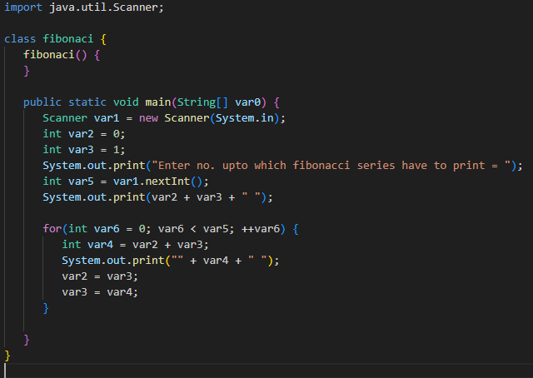
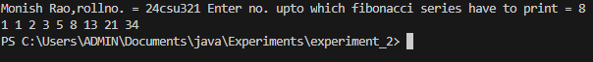

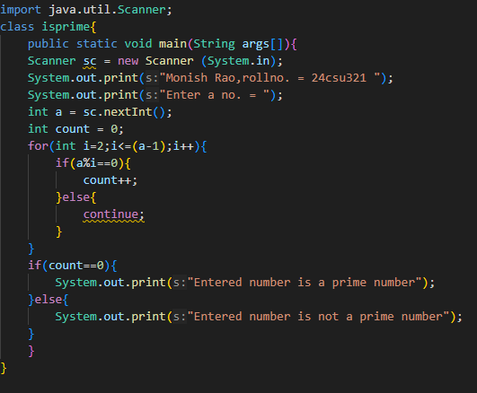
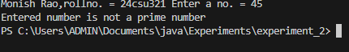

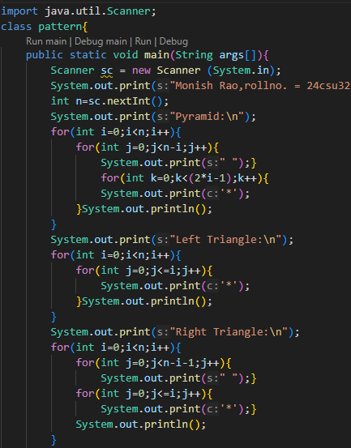
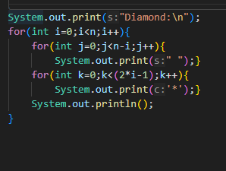
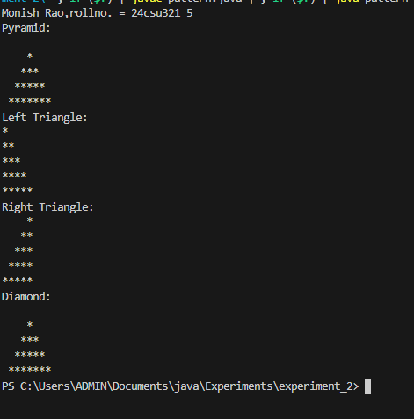

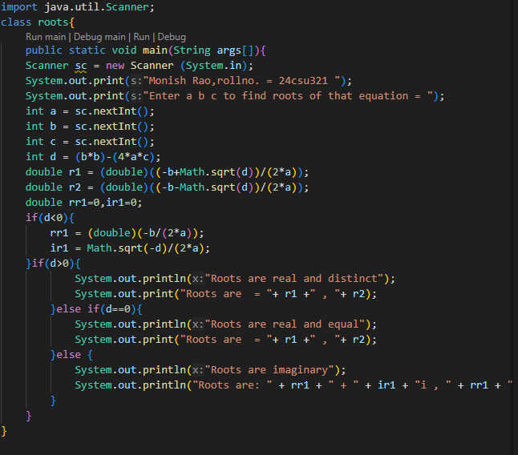
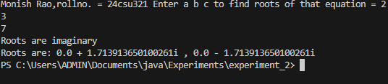

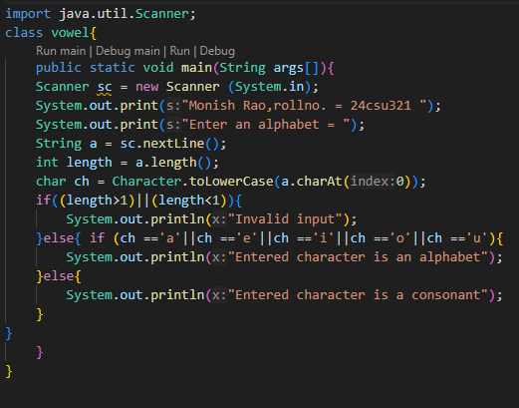
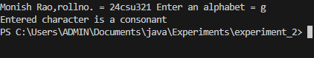

Question Bank
A1. if statement
A2. switch statement
A3. do-while statement
A4. (;;) { }
A5. while(true) { }
A6. do-while loop
A7. To skip the current iteration and move to the next loop iteration
A8. 1 byte
A9. For loop
Flipped Practicals
A1. a) second string
third string
b) second string
third string
c) if (aNumber >= 0)
if (aNumber == 0)
System.out.println("first string");
else
System.out.println("second string");
System.out.println("third string");
d) if (aNumber >= 0) {
if (aNumber == 0) {
System.out.println("first string");
} else {
System.out.println("second string");
}
}
System.out.println("third string");
A2. Commas are used instead of semicolans
A3. Curly braces around the block {}
A4. 6
PRACTICAL NO. 3
Student Name and Roll Number: Monish /24csu321

Semester /Section:

Link to Code:

Date:

Faculty Signature:

Objective
To familiarize the students with if-else loop.
Program Outcome
The students will learn the concept of looping in C. They will be able to understand the different types of statements encountered in C.
Problem Statement
- While purchasing certain items, a discount of 10% is offered if the quantity purchased is more than 1000. If quantity and price per item are input through the keyboard, write a program to calculate the total expenses.
- The marks obtained by a student in 5 different subjects are input through the keyboard. The student gets a division as per the following rules: Percentage above or equal to 60 - First division Percentage between 50 and 59 - Second division Percentage between 40 and 49 - Third division Percentage less than 40 - Fail Write a program to calculate the division obtained by the student.
- Write a program to check whether a triangle is valid or not, when the three angles of the triangle are entered through the keyboard. A triangle is valid if the sum of all the three angles is equal to 180 degrees.
- Write a program in C to read the age and display whether the candidate is eligible to vote or not.
Definition of Done:
- The program should ask the user to enter an integer. If it is floating, ask the user to enter appropriate number
- The program should use if-else statement

Objective
To familiarize the students with array in JAVA.
Program Outcome
The students will learn the concept of arrays in Java.
Problem Statement
1. Write a Java program to find the maximum and minimum value of an array.
Definition of Done:
DoD 1: The program should ask the user to enter the elements of the array.
DoD 2: The program should display the maximum and minimum elements of the array.
2. Write a Java program to find the index of an array element in an array of size n. The program should not use any function other than main ( ) functions.
Definition of Done:
DoD 1: The program should ask the user to enter the elements of the array.
DoD 2: The program should ask the user to enter a number to search.
DoD 3: The program should display the elements of the array entered.
DoD 4: The program should display the index of the number if the item is present or display -1 of the element is not present.

3. Write a Java Program to count even and odd numbers in an array.
Definition of Done
DoD 1: The program should ask the user to enter the elements of the array.
DoD 2: Even elements will be stored in EvenArray[] and odd elements will be stored in oddArray[].
DoD 3: Display all three arrays along with their length.
4. Write a Java program to read numbers in an integer array of size 5 and display the following (using functions for each functionality):
i) Sum of all the elements
ii) Sum of alternate elements in the array.
Definition of Done
DoD 1: The program should ask the user to enter the elements of the array.
DoD 2: The program should display a menu with the above choices and ask the user to choose one of the choices.
  - Write a Java program to read numbers in an integer array of size 5 and display the array in reverse order:
Definition of Done (DoD):
DoD 1: The program should ask the user to enter the elements of the array.
DoD 2: The program should display the reversed array.
- Write a Java program to read numbers in an integer array of size 5 and remove duplicate elements from the array.
Definition of Done (DoD):
DoD 1: The program should ask the user to enter the elements of the array.
DoD 2: The program should display the array after removing duplicates.
Background Study:
Java array is an object which contains elements of a similar data type. Additionally, The elements of an array are stored in a contiguous memory location. It is a data structure where we store similar elements. We can store only a fixed set of elements in a Java array.
Array in Java is index-based, the first element of the array is stored at the 0th index, 2nd element is stored on 1st index and so on.
Question Bank:
1. Can you pass the negative number as an array size?
2. Can you change the size of the array once you define it?
3. What is an anonymous array?
4. What is the difference between int[] a and int a[] ?
5. What are jagged arrays in java? Give example.
Flipped Practicals
1.Which of these is an incorrect array declaration?
a) int arr[] = new int[5]
b) int [] arr = new int[5]
c) int arr[] = new int[5]
d) int arr[] = int [5] new
2. What will be the output of the following program?
public class MyFirst {
public static void main(String[] args) {
MyFirst obj = new MyFirst(n);
}
static int a = 10;
static int n;
int b = 5;
int c;
public MyFirst(int m) {
System.out.println(a + ", " + b + ", " + c + ", " + n + ", " + m);
}
// Instance Block
{
b = 30;
n = 20;
}
// Static Block
static
{
a = 60;
}
}

Student Work Area
Algorithm/Flowchart/Code/Sample Outputs
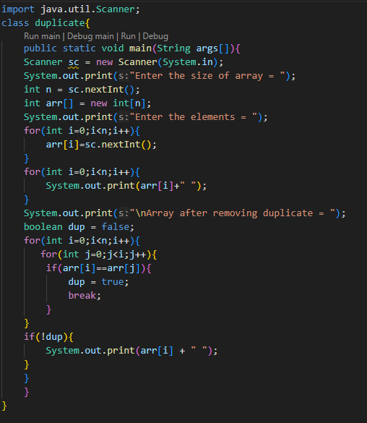
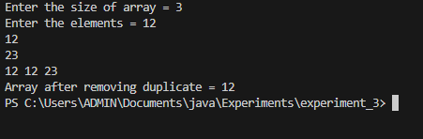

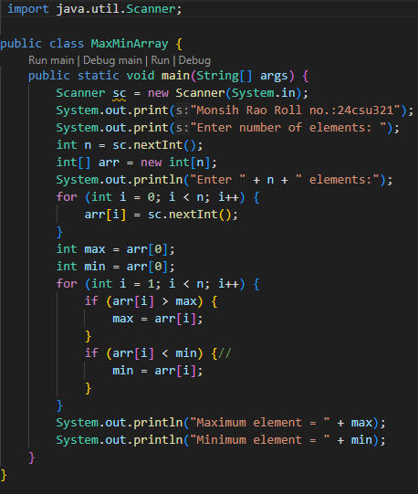
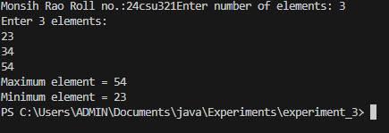

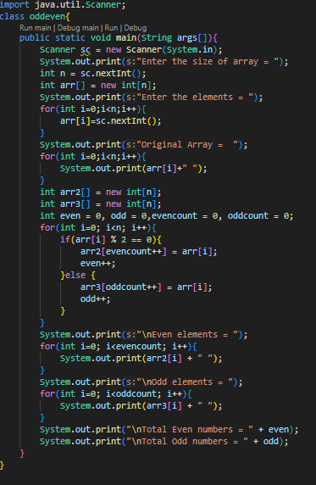
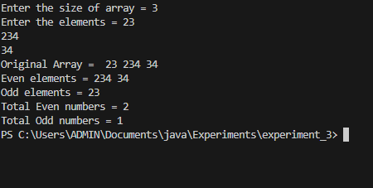

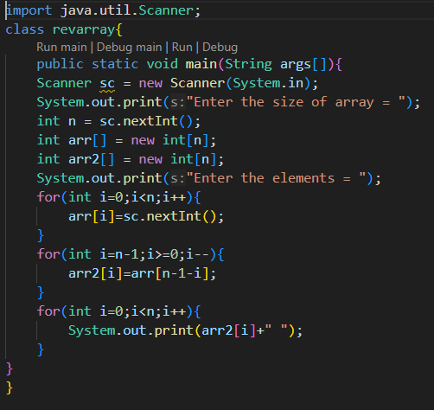
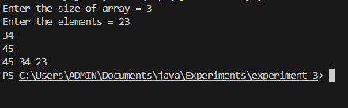

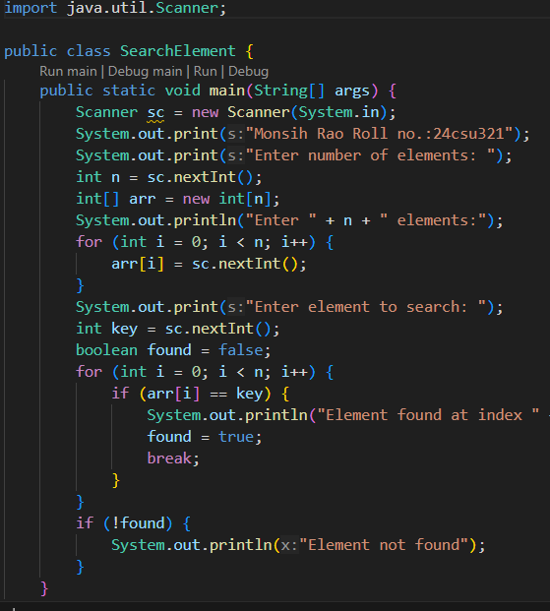
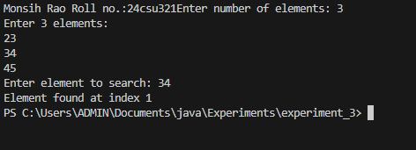
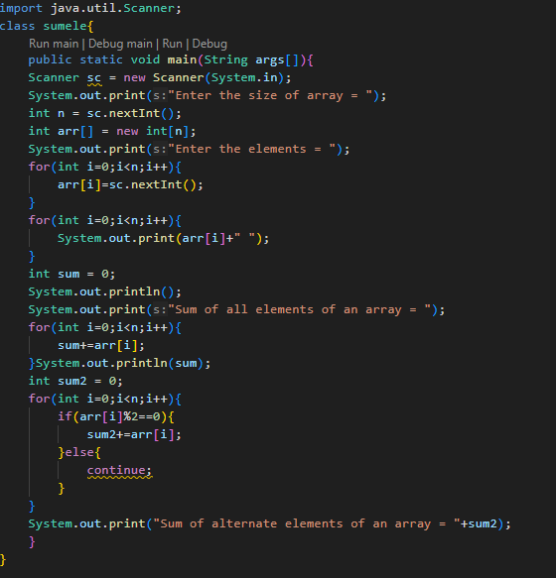
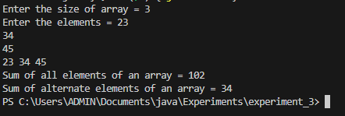

Question bank
1.No, you cannot pass a negative number as an array size.
So Java allows compilation but fails at runtime with NegativeArraySizeException
2. In Java, once you define an array, its size cannot be changed.
3.An anonymous array is an array without a name.
You create it and use it immediately (for one-time use).It is not stored in a variable, so you can’t access it later.
4. No difference between int[] a and int a[].
int[] a is preferred in Java for readability and avoiding confusion.
5. A jagged array (also called array of arrays) is a 2D array with rows of different lengths.
Unlike a normal 2D array (matrix) where all rows have the same number of columns,
in a jagged array, each row can have a different number of columns.
Question bank
A1. No
A2. No
A3. An anonymous array is an array created without assigning it to a Variable
A4. No difference
A5. Jagged arrays are arrays of arrays where inner arrays can have different lengths
Flipped Practical
A1. int arr[] = int [5] new
A2. 60, 30, 0, 20, 0

PRACTICAL NO: 4
Student Name and Roll Number: Monish /24csu321

Semester /Section: AD

Link to Code:

Date: 01/09/25

Faculty Signature:

Objective
To familiarize the students with classes and objects.
Program Outcome
The students will learn the concept of classes and objects.
Problem Statement

1.Create a class named 'Student' with String variable 'name' and integer variable 'roll_no'. Assign the value of roll_no as '2' and that of name as "John" by creating an object of the class Student.
2. Write a program to print the area and perimeter of a triangle having sides of 3, 4 and 5 units by creating a class named 'Triangle' without any parameter in its constructor.
3. Write a program to print the area of a rectangle by creating a class named 'Area' taking the values of its length and breadth as parameters of its constructor and having a method named 'returnArea' which returns the area of the rectangle. Length and breadth of the rectangle are entered through the keyboard.
4. Print the sum, difference and product of two complex numbers by creating a class named 'Complex' with separate methods for each operation whose real and imaginary parts are entered by the user.
5. Write a program to calculate the distance between two points (x1, y1) and (x2, y2). All numbers and return values should be of type double.
Definition of Done:
DoD 1: Two java files to be defined. One for class definitions and another for the application
DoD 2: A class point is defined with two float variables for x1 and x2 and the following functionality:
i. Non-parametrized and parameterized constructors are defined.
ii. Get and set methods are defined for all the instance variables.
iii. Distance function is defined to calculate the distance between two points.
iv. Display function is defined with width of 7 and precision of 2.
Write this program with a static method definition for calculating the distance between two points.

Background Study
In object-oriented programming technique, we design a program using objects and classes. An object in Java is the physical as well as a logical entity, whereas, a class in Java is a logical entity only.
An object is an instance of a class. A class is a template or blueprint from which objects are created. So, an object is the instance(result) of a class.

Question Bank

1. Can we call sub class constructor from super class constructor?
2. What is constructor chaining?
3. What is No-arg constructor?
4. What happens if you keep return type for a constructor?
5. What is the use of private constructor?
6. Can we use this() and super() in a method?
7. Can we define a method with same name of class?
Flipped Practicals

1. What will be the output of the following Java program?
class A
{
int i;
int j;
A()
{
i = 1;
j = 2;
}
}
class Output
{
public static void main(String args[])
{
A obj1 = new A();
A obj2 = new A();
System.out.print(obj1.equals(obj2));
}
}
a) false
b) true
c) 1
d) Compilation Error

Student Work Area
Algorithm/Flowchart/Code/Sample Outputs
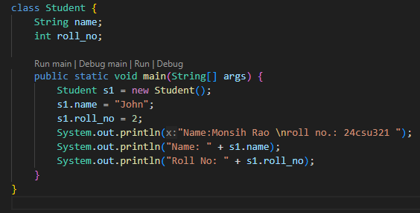
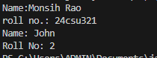
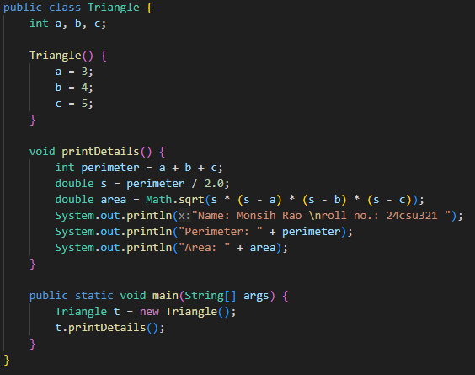
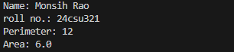
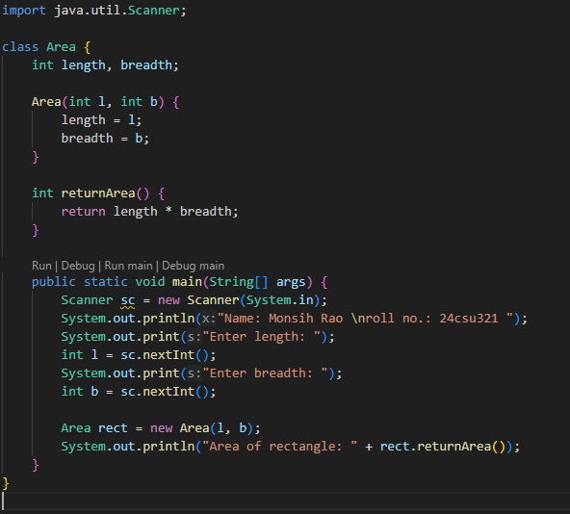
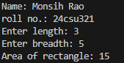
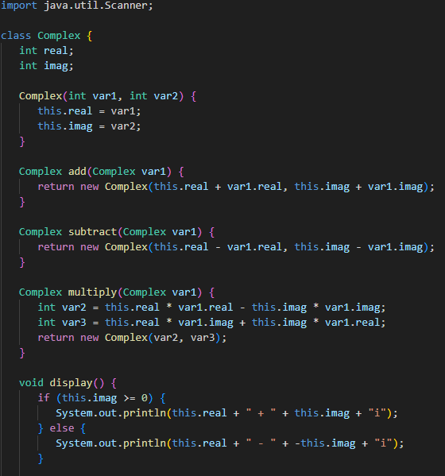
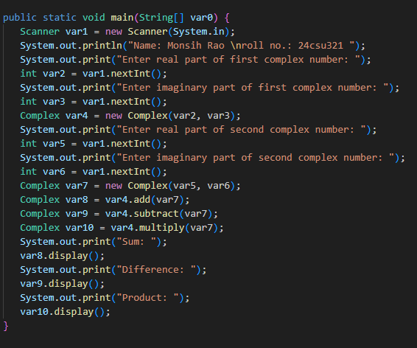
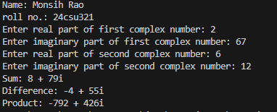
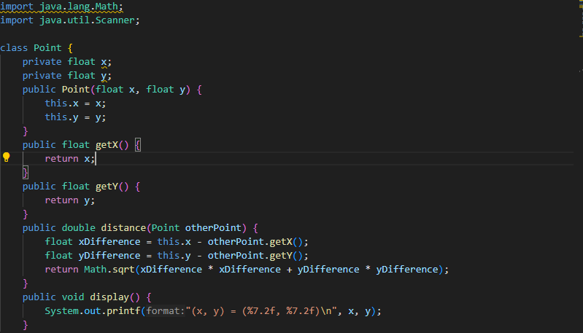
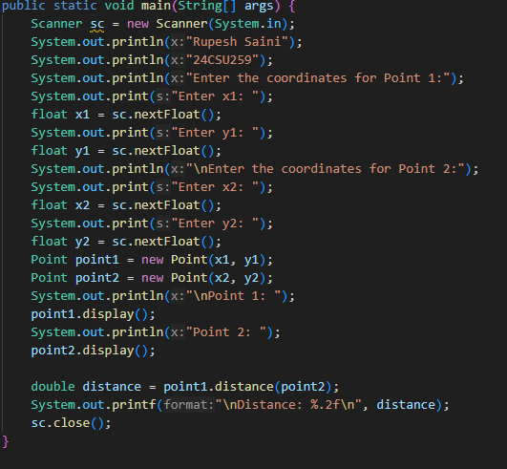
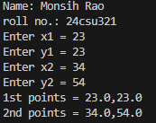

Question Bank
A1. No
A2. Constructor chaining is the process of calling one constructor from another
within the same class or between parent and child classes.
A3. A no-arg constructor is a constructor that takes no parameters.
A4. If you keep a return type for a constructor, it becomes a normal method and
not a constructor.
A5. A private constructor is used to restrict object creation from outside the class.
A6. No, this() and super() can only be used inside a constructor, not in a method.
A7. Yes
Flipped practicals
- Compilation Error

PRACTICAL NO: 5
Student Name and Roll Number: Monish /24csu321

Semester /Section:

Link to Code:

Date:

Faculty Signature:

Objective
To familiarize the students with the concept of Inheritance.
Program Outcome
The students will learn the concept of inheritance.
Program Statement
- Create a class named 'Shape' with a method to print "This is This is shape". Then create two other classes named 'Rectangle', 'Circle' inheriting the Shape class, both having a method to print "This is rectangular shape" and "This is circular shape" respectively. Create a subclass 'Square' of 'Rectangle' having a method to print "Square is a rectangle". Now call the method of 'Shape' and 'Rectangle' class by the object of 'Square' class.

2. Create three classes:
Class Vehicle:
Vehicle Class will contain a display() function, which will say "This is a Vehicle".
Class Car:
Car Class will derive the Vehicle Class and overwrite its display() function. it will say "This is a Car".
Class Bike:
Bike Class will derive the Vehicle Class and overwrite its display() function. it will say "This is a Bike".

Write an application that reads an Integer N, which will denote the number of tyres in the vehicle. You have to create an object of the appropriate class according to the value of N and use it display() function.
If N = 2, Create a Bike Object.
If N = 4, Create a Car Object.
Create a Vehicle Object, otherwise.

Definition of Done:
DoD 1: Each class definition is stored in its own .java file.
DoD 2: Switch statement is used for identifying the appropriate class for which the object is to be invoked.
3. Define a class Box with the following instance variables: width, height and depth, all of type float. Create a new class BoxWeigth that extends Box to include weight as an instance variable. Write an application that tests the functionalities of both these classes.
Definition of Done:
DoD 1: Three java files to be defined. One for each class definition: Box, BoxWeight and BoxWeightDemo.
DoD 2: Box and BoxWeight should have three types of constructors defined: clone of an object, all dimensions specified as arguments, no argument.
DoD 3: Super is used to call base class constructors in derived class
DoD 4: Get and set functions defined as applicable in Box and BoxWeight classes.
DoD 5: Function to display volume in Box class and weight in BoxWeigth class
Background Study
Inheritance can be defined as the process where one class acquires the properties (methods and fields) of another. With the use of inheritance the information is made manageable in a hierarchical order.
The class which inherits the properties of other is known as subclass (derived class, child class) and the class whose properties are inherited is known as superclass (base class, parent class).

extends Keyword
extends is the keyword used to inherit the properties of a class. Following is the syntax of extends keyword.
Syntax
class Super {
.....
.....
}
class Sub extends Super {
.....
.....
}

Question Bank

1. What is the use of super keyword?
2. Can an interface be final?
3. Can an abstract class implement an interface?
4. Can you declare an interface method static?
Flipped Questions
Q1. What is the output of the following?
class A
{
{
System.out.println(1);
}
}

class B extends A
{
{
System.out.println(2);
}
}

class C extends B
{
{
System.out.println(3);
}
}

public class MainClass
{
public static void main(String[] args)
{
C c = new C();
}
}

Q2. What is the output of the following?

class A
{
public A()
{
System.out.println("Class A Constructor");
}
}

class B extends A
{
public B()
{
System.out.println("Class B Constructor");
}
}

class C extends B
{
public C()
{
System.out.println("Class C Constructor");
}
}

public class MainClass
{
public static void main(String[] args)
{
C c = new C();
}
}

Student Work Area
Algorithm/Flowchart/Code/Sample Outputs

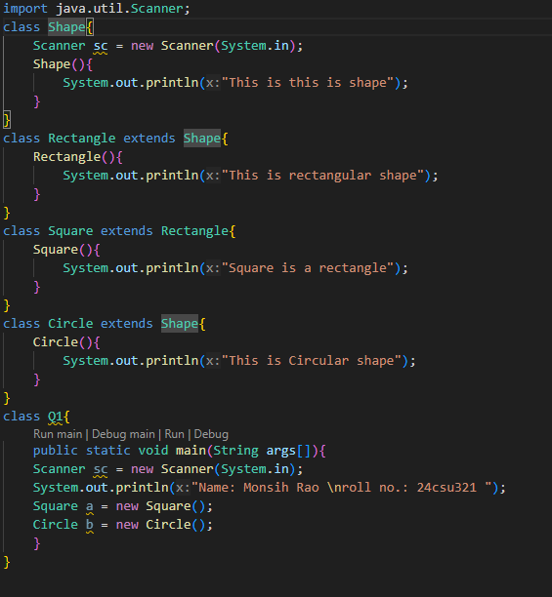
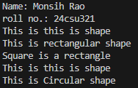
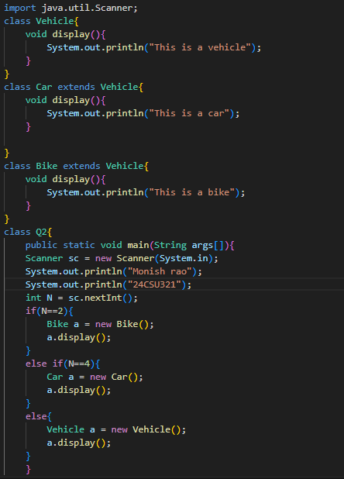
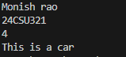

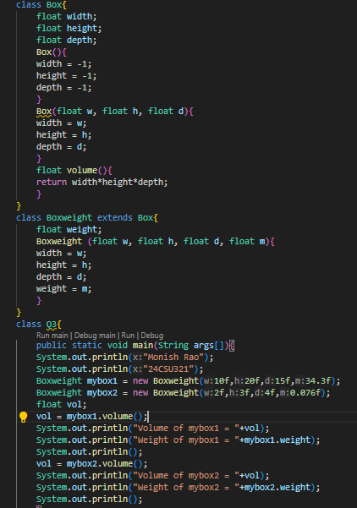
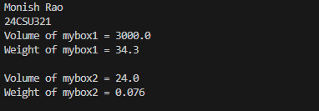
Question Bank:
Ans 1. To refer to the parent class (call parent methods/constructors, access parent variables).
Ans 2. No, because interfaces are meant to be implemented, and final prevents inheritance/implementation.
Ans 3. Yes, an abstract class can implement an interface (but it doesn’t need to provide implementations for all methods).
Ans 4. No, interface methods are implicitly abstract and public (until Java 7). From Java 8 onward, only static methods with a body are allowed.

Flipped Questions:
Ans 1. 1
2
3
Ans 2. Class A Constructor
Class B Constructor
Class C Constructor

PRACTICAL NO. 6
Student Name and Roll Number:

Semester /Section:

Link to Code: https://github.com/Monishyadav/Java-experiments/tree/main/Experiment_6

Date:

Faculty Signature:

Objective
To familiarize the students with the concept of Interfaces in Java.
Program Outcome
The students will be able to understand where and how interfaces are implemented.
Problem Statement
1. 1. a) Write a program in java to check if a class can extends another class and/ can implement one and more than one interface.
b) Write a program in java to check if an interface can extend other interface.
c) Write a program in java to check if an interface can also extend multiple interfaces.

2. Define the interface / class hierarchy as detailed in the following class diagram
Definition of Done:
DOD 1: The class definitions are defined as per the class diagram.
DOD 2: Each class definition is stored in its own .java file.
DOD 3: Base class constructors are invoked using super keyword
DOD 4: Function overriding is applied wherever applicable.

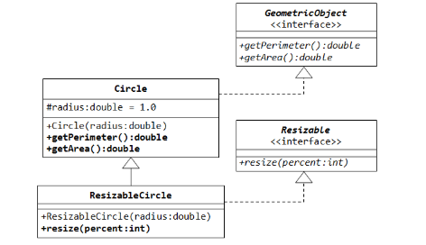
3. We have to calculate the area of a rectangle, a square and a circle. Create an abstract class 'Shape' with three abstract methods namely 'RectangleArea' taking two parameters, 'SquareArea' and 'CircleArea' taking one parameter each. The parameters of 'RectangleArea' are its length and breadth, that of 'SquareArea' is its side and that of 'CircleArea' is its radius. Now create another class 'Area' containing all the three methods 'RectangleArea', 'SquareArea' and 'CircleArea' for printing the area of rectangle, square and circle respectively. Create an object of class 'Area' and call all the three methods.

4. Create an abstract class 'Bank' with an abstract method 'getBalance'. $100, $150 and $200 are deposited in banks A, B and C respectively. 'BankA', 'BankB' and 'BankC' are subclasses of class 'Bank', each having a method named 'getBalance'. Call this method by creating an object of each of the three classes.

5. We have to calculate the percentage of marks obtained in three subjects (each out of 100) by student A and in four subjects (each out of 100) by student B. Create an abstract class 'Marks' with an abstract method 'getPercentage'. It is inherited by two other classes 'A' and 'B' each having a method with the same name which returns the percentage of the students. The constructor of student A takes the marks in three subjects as its parameters and the marks in four subjects as its parameters for student B. Create an object for each of the two classes and print the percentage of marks for both the students.

Background Study

An interface in Java is a blueprint of a class. It has static constants and abstract methods.
The interface in Java is a mechanism to achieve abstraction. There can be only abstract methods in the Java interface, not method body. It is used to achieve abstraction and multiple inheritance in Java.
In other words, you can say that interfaces can have abstract methods and variables. It cannot have a method body.

Flipped Practicals

1. What is the output of this program?
interface calculate {
void cal(int item);
}
class display implements calculate {
int x;
public void cal(int item) {
x = item * item;
}
}
class interfaces {
public static void main(String args[]) {
display arr = new display;
arr.x = 0;
arr.cal(2);
System.out.print(arr.x);
}
}
a) 0
b) 2
c) 4
d) None of the mentioned
2. Which of the following package stores all the standard java classes?
a) lang
b) java
c) util
d) java.packages
3. Determine output of the following code.
interface A { }
class C { }
class D extends C { }
class B extends D implements A { }
public class Test extends Thread{
public static void main(String[] args){
B b = new B();
if (b instanceof A)
System.out.println("b is an instance of A");
if (b instanceof C)
System.out.println("b is an instance of C");
}
}

- b is an instance of A.
- b is an instance of C.
- b is an instance of A followed by b is an instance of C.

Question Bank

- Can an interface be final?
- Can an abstract class implement an interface?
- Can you declare an interface method static?
- What is the difference between abstract class and interface?
- When can an object reference can be cast to an interface reference ?
- Which of the following is true about interfaces in java.

Student Work Area
Algorithm/Flowchart/Code/Sample Outputs
Ques1.
a)
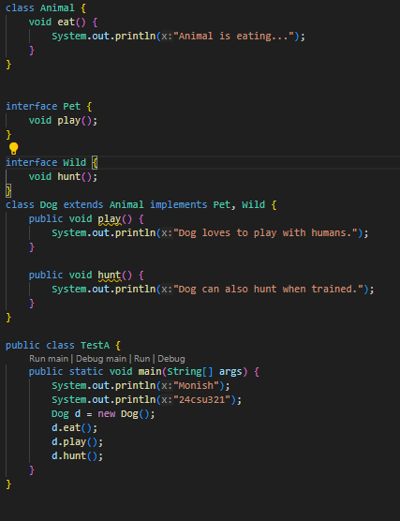

Output
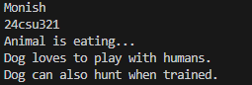
b)
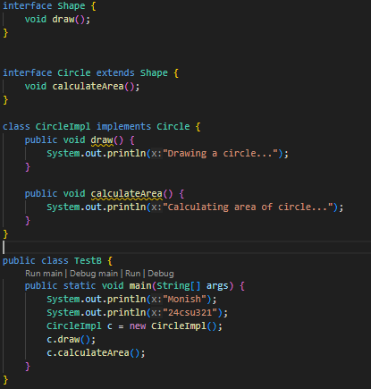
Output
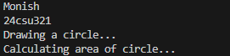

c)
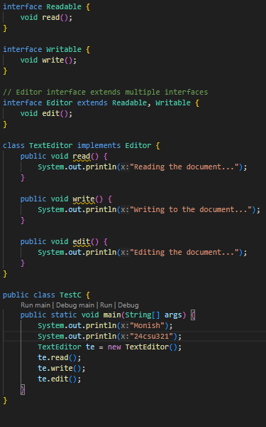
Output
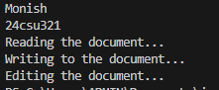
Ques 2
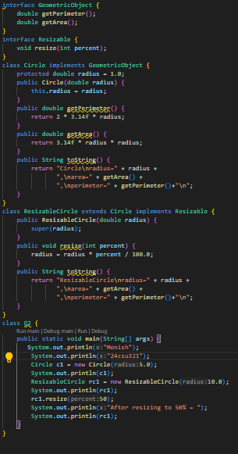

Output
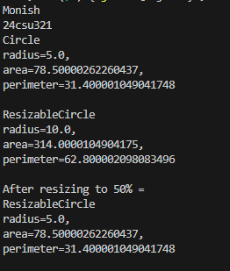
Ques 3
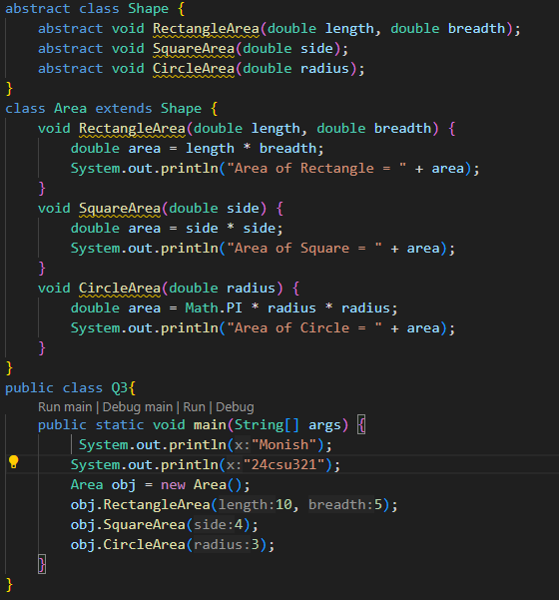
Output
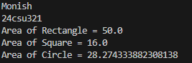
Ques4
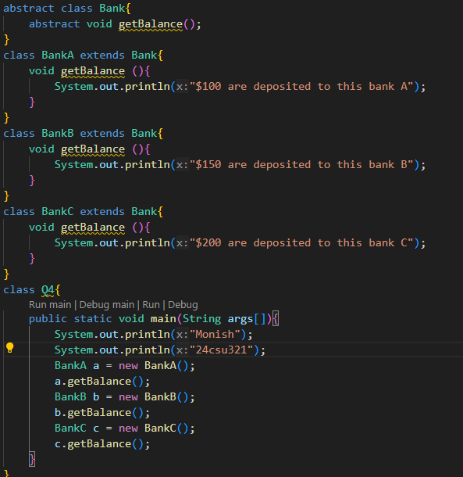
Output
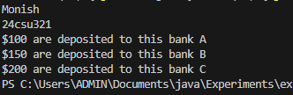
Ques5
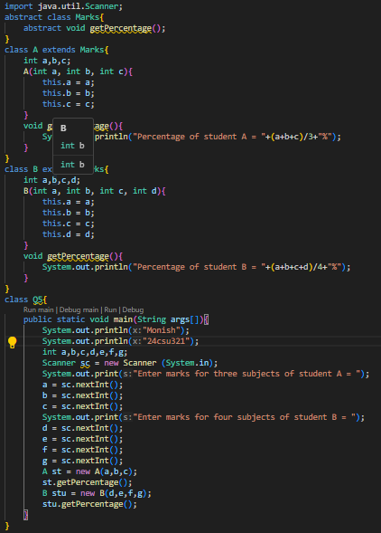
Output
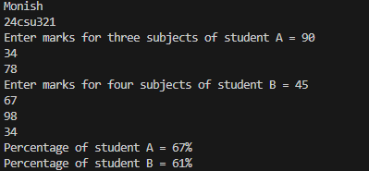
Flipped Practicals
A1. 4
A2. Java
A3. b is an instance of A followed by b is an instance of C
Question Bank
A1. No, an interface cannot be final
A2. Yes, an abstract class can implement an interface.
A3. Yes
A4. Abstract Class
1)Declared using the abstract keyword.
2)Can have abstract and non-abstract methods
3)Can have constructors.
4)Can have instance variables, static variables, and constants.
Interface
- Declared using the interface keyword
- All methods are abstract by default
- Cannot have constructors.
4) Can only contain public static final variables
A5. An object reference can be cast to an interface reference if the object’s class implements that interface, either directly or through inheritance
A6. All interface methods are public and abstract by default (unless static or default).
All variables in an interface are public, static, and final by default.
An interface cannot have constructors.
A class can implement multiple interfaces.

Experiment No: 7
Student Name and Roll Number:

Semester /Section:

Link to Code:

Date:

Faculty Signature:

Objective
To familiarize the students with package in Java.
Program Outcome
The students will learn the concept of package in Java. They will be able to understand
Problem Statement
1. Create a Java package called exercises. Inside the exercises package, create another package (subpackage) called java. Create a Java class called PackageDemo inside the java package. Insert a display() method inside the PackageDemo class. Inside the method, insert this statement:System.out.println("PackageDemo executed");Write a PackageDemoDriver class within the same package to run the display () method of PackageDemo class.

2. Write a java program outside the above defined package that imports the package PackageDemo and calls its display() function.
Background Study
A java package is a group of similar types of classes, interfaces and sub-packages.
Package in java can be categorized in two form, built-in package and user-defined package.
There are many built-in packages such as java, lang, awt, javax, swing, net, io, util, sql etc.

Flipped Practicals

1. What will be the output of the following Java program?
package pkg;
class display
{
int x;
void show()
{
if (x > 1)
System.out.print(x + " ");
}
}
class packages
{
public static void main(String args[])
{
display[] arr=new display[3];
for(int i=0;i<3;i++)
arr[i]=new display();
arr[0].x = 0;
arr[1].x = 1;
arr[2].x = 2;
for (int i = 0; i < 3; ++i)
arr[i].show();
}
}
Note : packages.class file is in directory pkg;
a) 0
b) 1
c) 2
d) 0 1 2
Qu Question Bank

1. What are packages ? what is use of packages ?

2. What is difference between importing "java.applet.Applet" and "java.applet.* "?

3.What do you understand by package access specifier?
4. By default,all program import the java.lang package.
True/False ?
5. Java compiler stores the .class files in the path specified in CLASSPATH environmental variable. True/False ?
6. User-defined package can also be imported just like the standard packages
True/False ?
7. A _______ is used to separate the hierarchy of the class while declaring an Import statement.
8. All standard classes of Java are included within a package called _____.

Student Work Area
Algorithm/Flowchart/Code/Sample Outputs

Ques1
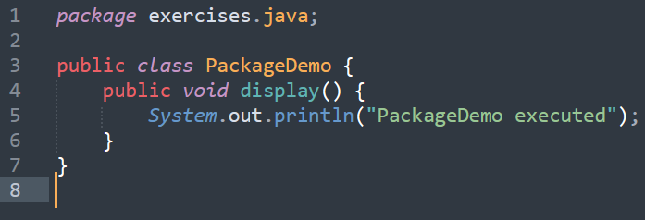
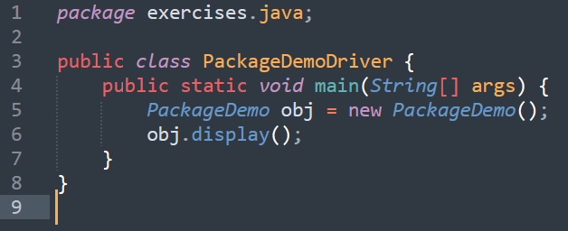
Output

Ques2
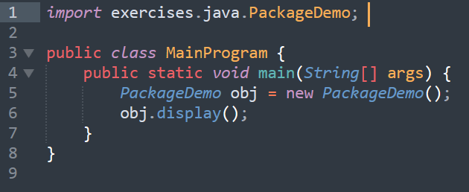
Output

Flipped Practicals
- 2
Question Bank
A1. Packages are containers that group related classes and interfaces together.
They are used to organize code, avoid name conflicts, and provide access control.
A2. java.applet.Applet → Imports only the Applet class.
java.applet.* → Imports all classes in the java.applet package.
A3. It means that members (classes, methods, variables) are accessible only within the same package.
A4. True
A5. True
A6. True
A7. (.)
A8. Java

PRACTICAL NO.8
Student Name and Roll Number:

Semester /Section:

Link to Code:

Date:

Faculty Signature:

Objective
To familiarize the students with exception in java.
Program Outcome
The students will learn the concept of exceptions in Java.
Problem Statement

- Write a program that takes 5 integer command line arguments. Create a user defined Exception named CheckArgumentException to check the number of arguments passed through command line. If the number of arguments is less than five, throw the CheckArgumentException, else print the addition of all five numbers.

Definition of Done:

DOD 1:Create a user-defined exception by the name CheckArgumentException
DOD 2:Ask the user to enter the number of arguments
DOD 3:Use for loop to enter the arguments
DOD 4: Calculate the sum of the values entered
- Create a class with a main() method that throws an object of class Exception inside a try block. Give the constructor for Exception a String argument. Catch the exception inside a catch clause and print the String argument. Add a finally clause and print a message to prove you were there.

- Create a three-level hierarchy of exceptions. Now create a base-class A with a method that throws an exception at the base of your hierarchy. Inherit B from A and override the method so it throws an exception at level two of your hierarchy. Repeat by inheriting class C from B. In main( ), create a C and upcast it to A, then call the method.
Definition of Done:
1. Create three classes A,B,C
2. Display appropriate messages according to the exceptions.
3. The program needs to be well commented.

5. Create your own exception class using the extends keyword. Write a constructor for this class that takes a String argument and stores it inside the object with a String reference. Write a method that prints out the stored String. Create a try-catch clause to exercise your new exception.

Definition of Done:
1. Accept a string argument
2. Create a separate function to print the string.
Background Study
An exception (or exceptional event) is a problem that arises during the execution of a program. When an Exception occurs the normal flow of the program is disrupted and the program/Application terminates abnormally, which is not recommended, therefore, these exceptions are to be handled.
An exception can occur for many different reasons. Following are some scenarios where an exception occurs.
- A user has entered an invalid data.
- A file that needs to be opened cannot be found.
- A network connection has been lost in the middle of communications or the JVM has run out of memory.

QuestionQuestion Bank

1. When does Exceptions in Java arises in code sequence?
a) Run Time
b) Compilation Time
c) Can Occur Any Time
d) None of the mentioned
3. Which of these keywords must be used to monitor for exceptions?
a) try
b) finally
c) throw
d) catch

4. Which of these keywords must be used to handle the exception thrown by try block in some rational manner?
a) try
b) finally
c) throw
d) catch
5. Which of these keywords is used to manually throw an exception?
a) try
b) finally
c) throw
d) catch

Flip Flipped Practicals

1. What will be the output of the following Java program?
class exception_handling
{
public static void main(String args[])
{
try
{
System.out.print("Hello" + " " + 1 / 0);
}
catch(ArithmeticException e)
{
System.out.print("World");
}
}
}
a) Hello
b) World
c) HelloWorld
d) Hello World
2. What will be the output of the following Java program?
class exception_handling
{
public static void main(String args[])
{
try
{
int a, b;
b = 0;
a = 5 / b;
System.out.print("A");
}
catch(ArithmeticException e)
{
System.out.print("B");
}
}
}
a) A
b) B
c) Compilation Error
d) Runtime Error

Student Work Area
Algorithm/Flowchart/Code/Sample Outputs
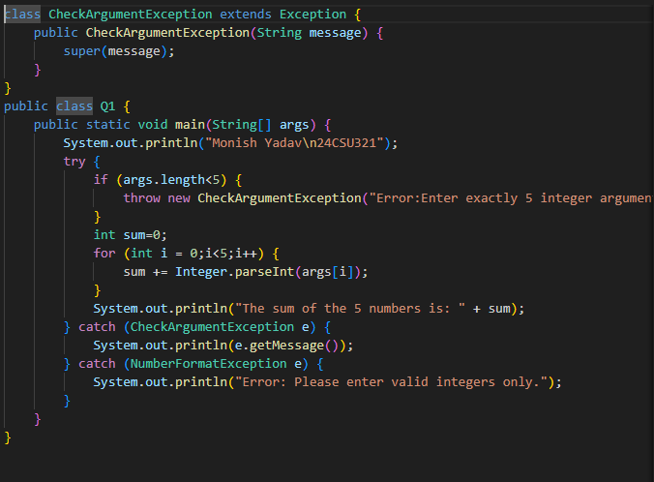
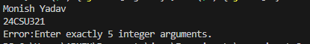
Question 2
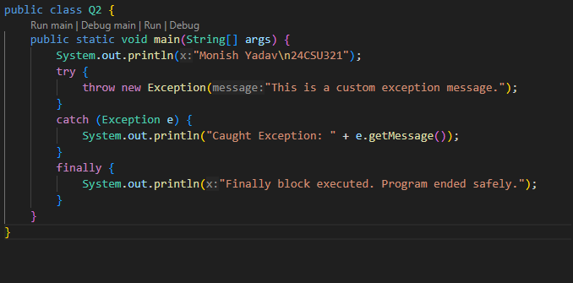
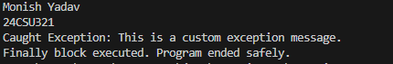
Ques 3
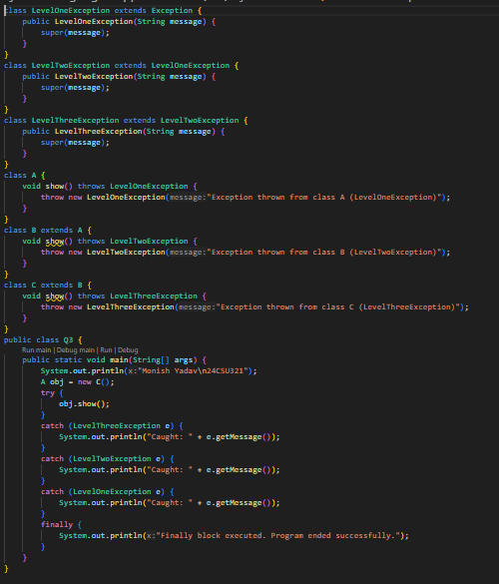
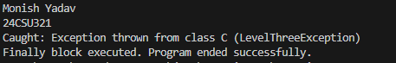

Ques 4
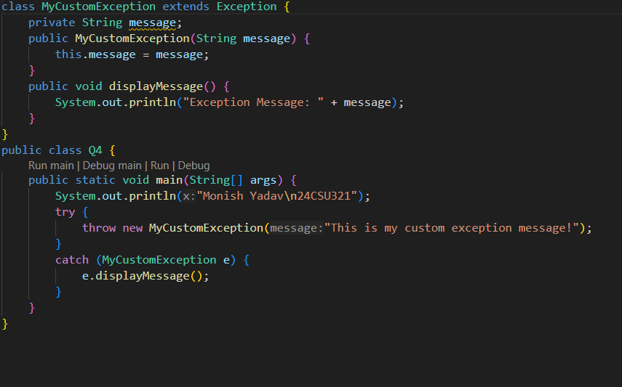
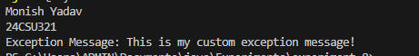
Question Bank
A1. Run Time
A2. Try
A3. Catch
A4. Throw
Flipped Practicals
A1. World
A2. B

Student Name and Roll Number:

Semester /Section:

Link to Code:

Date:

Faculty Signature:

PRACTICAL NO. 9

Objective
To familiarize the students with File handling.
Program Outcome
The students will learn the concept of files in Java.
Problem Statement

1. 1. Write a program to check if the file exist is a file or directory.

2. W 2. Write a program to change the file permissions.

3.W 3. Write a program to perform simple read and write operation into file.

4. Write a program that writes an Serial No.(int), First Name (String), CGPA (float) and Grade(char) into a text file using bufferedWriter and displays the contents using bufferedReader.

B
Background Study
File handling is an important part of any application. Java has several methods for creating, reading, updating, and deleting files.

Java File Handling
The File class from the java.io package, allows us to work with files.
To use the File class, create an object of the class, and specify the filename or directory name:

Example
import java.io.File; // Import the File class

File myObj = new File("filename.txt"); // Specify the filename

QuestiQ Question Bank

1. Which of these exception is thrown in cases when the file specified for writing is not found?
a) IOException
b) FileException
c) FileNotFoundException
d) FileInputException
2. Which of these methods are used to read in from file?
a) get()
b) read()
c) scan()
d) readFileInput()
3. Which of these values is returned by read() method is end of file (EOF) is encountered?
a) 0
b) 1
c) -1
d) Null

Flipped Practicals

1. What will be the output of the following Java program?
- import java.io.*;
- class filesinputoutput
- {
- public static void main(String args[])
- {
- InputStream obj = new FileInputStream("inputoutput.java");
- System.out.print(obj.available());
- }
- }
Note: inputoutput.java is stored in the disk.
a) true
b) false
c) prints number of bytes in file
d) prints number of characters in the file
2. What will be the output of the following Java program?
- import java.io.*;
- public class filesinputoutput
- {
- public static void main(String[] args)
- {
- String obj = "abc";
- byte b[] = obj.getBytes();
- ByteArrayInputStream obj1 = new ByteArrayInputStream(b);
- for (int i = 0; i < 2; ++ i)
- {
- int c;
- while((c = obj1.read()) != -1)
- {
- if(i == 0)
- {
- System.out.print(Character.toUpperCase((char)c));
- obj2.write(1);
- }
- }
- System.out.print(obj2);
- }
- }
- }
a) AaBaCa
b) ABCaaa
c) AaaBaaCaa
d) AaBaaCaaa

Student Work Area
Algorithm/Flowchart/Code/Sample Outputs
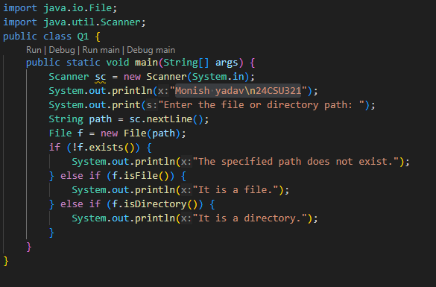
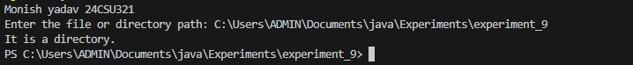
Ques 2
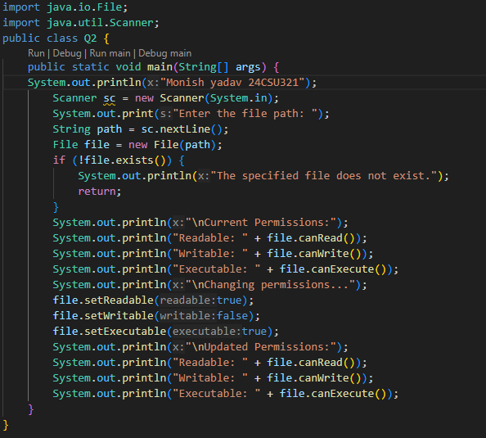
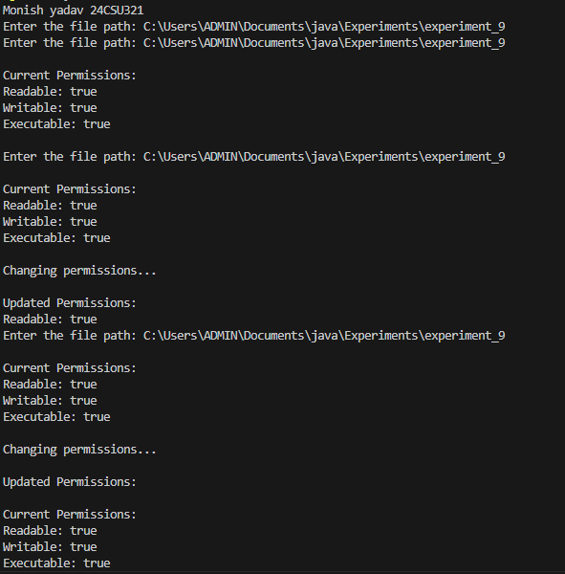
Ques 3
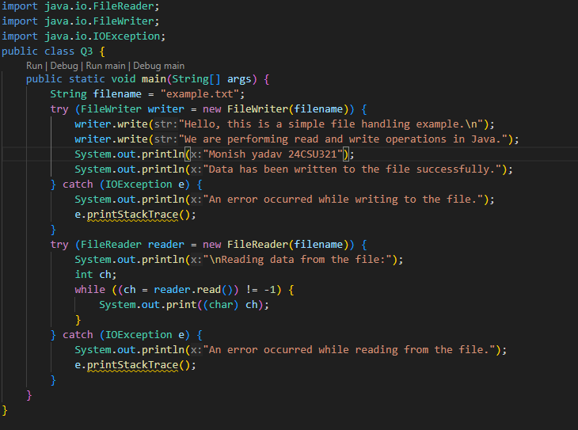
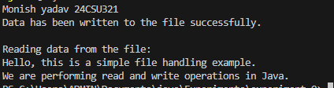

Ques 4
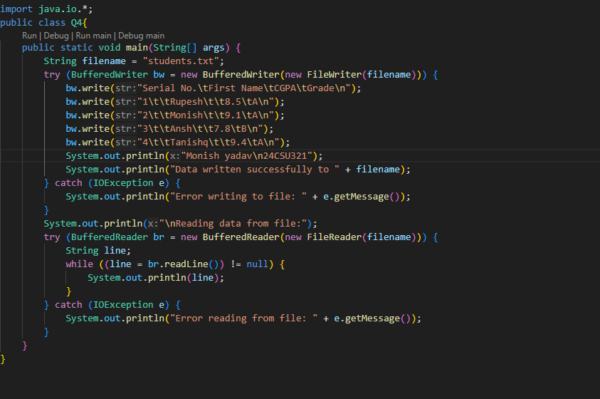
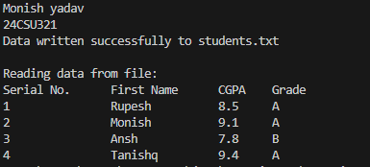
Question Bank
A1 c) FileNotFoundException
A2 b) read()
A3 c) -1
Flipped Practicals
A1 c) print number of bytes in a file
A2 b) ABCaaa

Annexure 1
Intro to Java
CSL215
Project Report


Faculty name: Student name:
Roll No.:
Semester:
Group:

Department of Computer Science and Engineering
The NorthCap University, Gurugram- 122017, India
Session 2025-26

Table of Contents
S.No |  | Page No.
1. | Project Title:
2. | Description of Project:  Problem Statement
3. | Problem Analysis  3.1 Hardware Requirements  3.2 Software Requirements
4. | Design  4.1 Data/Input Output Description:  4.2 Algorithmic Approach / Algorithm / DFD / ER diagram/Program Steps
5. | Implementation and Testing (stage/module wise)
6. | Output (Screenshots)
7. | Conclusion and Future Scope

