|  |
| --- |
| **Ex. No. 06 Implement an application that uses Multi-threading**  **Date:** |

**Aim:**

To develop an Android Application that implements Multi threading.

**Procedure:**

**Creating a New project:**

∙ Open Android Studio and then click on **File -> New -> New project**.

∙ Then type the Application name as **“exno6″**and click Next.

∙ Then **select the Minimum SDK** as shown below and click Next.

∙ Then **select the Empty Activity** and click Next.

∙ Finally click **Finish**.

∙ It will take some time to build and load the project.

∙ After completion it will look as given below.

**Designing layout for the Android Application:**

∙ Click on **app -> res -> layout -> activity_main.xml.**

∙ Now click on Text as shown below.

∙ Then delete the code which is there and type the code as given below.

**Code for Activity_main.xml:**

<?xml version="1.0" encoding="utf-8"?>

<LinearLayout xmlns:android="http://schemas.android.com/apk/res/android"

android:layout_width="match_parent"

android:layout_height="match_parent"

android:orientation="vertical" >

<ImageView

android:id="@+id/imageView"

android:layout_width="250dp"

android:layout_height="250dp"

android:layout_margin="50dp"

android:layout_gravity="center" />

<Button

android:id="@+id/button"

android:layout_width="wrap_content"

android:layout_height="wrap_content"

android:layout_margin="10dp"

android:layout_gravity="center"

android:text="Load Image 1" />

<Button

android:id="@+id/button2"

android:layout_width="wrap_content"

android:layout_height="wrap_content"

android:layout_margin="10dp"

android:layout_gravity="center"

android:text="Load image 2" />

</LinearLayout>

∙ Now click on Design and your application will look as given below.

∙ So now the designing part is completed.

**Java Coding for the Android Application:**

∙ Click on **app -> java -> com.example.exno6 -> MainActivity**. ∙ Then delete the code which is there and type the code as given below.

**Code for MainActivity.java:**

packagecom.example.exno6;

import android.os.Bundle;

//import android.support.v7.app.AppCompatActivity;

import android.view.View;

import android.widget.Button;

import android.widget.ImageView;

import androidx.appcompat.app.AppCompatActivity;

public class MainActivity extends AppCompatActivity

{

ImageView img;

Button bt1,bt2;

@Override

protected void onCreate(Bundle savedInstanceState)

{

super.onCreate(savedInstanceState);

setContentView(R.layout.activity_main);

bt1 = (Button)findViewById(R.id.button);

bt2= (Button) findViewById(R.id.button2);

img = (ImageView)findViewById(R.id.imageView);

bt1.setOnClickListener(new View.OnClickListener() {

@Override

public void onClick(View v)

{

new Thread(new Runnable()

{

@Override

public void run()

{

img.post(new Runnable()

{

@Override

public void run()

{

img.setImageResource(R.drawable.india1); }

});

}

}).start();

}

});

bt2.setOnClickListener(new View.OnClickListener() {

@Override

public void onClick(View v)

{

new Thread(new Runnable()

{

@Override

public void run()

{

img.post(new Runnable()

{

@Override

public void run()

{

img.setImageResource(R.drawable.india2); }

});

}

}).start();

}

});

}

}

Output:

Load Image 1

Load Image 2 :

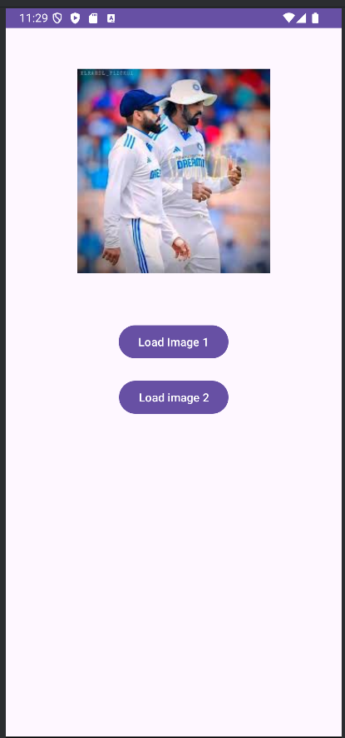

**Result:**

Thus Android Application that implements Multi threading is developed and executed successfully.