NISQ Noise Shifts the Quantum Amplitude Estimation Break-Even for Option Pricing
Prithvi Raghu
Vellore Institute of Technology, Vellore, India · prithviraghu080706@gmail.com
Abstract—Quantum amplitude estimation (QAE) is widely cited as offering a quadratic speedup over classical Monte Carlo for derivative pricing, with the canonical break-even occurring when the QAE oracle-query budget M falls below the classical sample budget N. Nearly all such analyses assume noiseless quantum hardware. We quantify how realistic depolarizing noise degrades QAE-based European call pricing across a 50-point parameter sweep at five noise levels (p ∈ {0, 10⁻⁴, 10⁻³, 5×10⁻³, 10⁻²}) using iterative QAE (IQAE) with three uncertainty qubits on a depolarizing-noise simulator, validated against a single-qubit state-preparation run on IBM hardware (ibm_marrakesh). We report three findings. First, at the current IBM hardware noise level (p ≈ 10⁻³) the mean absolute price error is $0.657 — roughly 66× the ε = 0.01 precision target that defines the theoretical break-even. Second, and more strikingly, even at p = 0 the mean error is $0.203, already ≈20× above target: the three-qubit discretization imposes an irreducible approximation error before any noise is introduced, so the asymptotic advantage is unattainable on near-term devices regardless of noise. Third, the IQAE oracle-query depth is noise-invariant at ≈14 queries across all p, because the amplitude-based stopping rule is blind to noise — the query budget never inflates; accuracy simply decays silently. Together these results show that the QAE break-even, evaluated under near-term conditions, sits entirely inside the regime where QAE provides no usable advantage.
Index Terms—quantum amplitude estimation, option pricing, NISQ, depolarizing noise, quantum finance, break-even analysis.

I. Introduction
Monte Carlo (MC) simulation is the workhorse of derivative pricing. Its central limitation is well known: the statistical error of an MC price estimate decays as O(1/√N) in the number of sample paths N, so halving the error requires quadrupling the computational budget. Quantum amplitude estimation (QAE) is the most frequently cited quantum remedy. By encoding the discounted payoff into the amplitude of a marked quantum state and applying amplitude estimation, QAE estimates the expectation with error decaying as O(1/M) in the number of oracle queries M — a quadratic improvement in the convergence exponent. This scaling underpins the widely reproduced claim that quantum computers will price options faster than classical machines once a break-even query budget is reached.
The break-even argument is almost always made in an idealized setting: perfect qubits, no decoherence, and an oracle whose cost is counted in abstract query units rather than transpiled physical gates. Real near-term (NISQ) devices satisfy none of these assumptions. The question this paper addresses is concrete: when the standard QAE option-pricing pipeline is run under realistic depolarizing noise at current hardware error rates, where does the break-even actually land?
We answer this empirically. Using iterative QAE (IQAE) with three uncertainty qubits — a configuration representative of the small instances that fit on present hardware — we price a European call across a 50-point parameter sweep and repeat the experiment at five depolarizing-noise levels spanning the noiseless ideal through an order of magnitude above current hardware. We complement the simulation with a single-qubit state-preparation circuit executed on IBM's ibm_marrakesh device to confirm that the simulator's noise behavior is representative of real hardware at the smallest scale. The contributions are: (i) a quantified noise-versus-error frontier for QAE option pricing showing the break-even lies entirely within the no-advantage regime at NISQ noise rates; (ii) the observation that the three-qubit discretization alone already pushes the error ≈20× above the precision target before noise is added; and (iii) the finding that IQAE's oracle-query depth is noise-invariant, so noise corrupts the answer without ever signaling increased cost.

II. Background and Related Work

A. QAE for Option Pricing
The standard QAE pricing pipeline, established by Stamatopoulos et al. (2020) building on Woerner and Egger (2019), proceeds in three stages. A state-preparation operator loads the discretized risk-neutral distribution of the underlying asset onto a register of n uncertainty qubits, producing 2ⁿ discretization points. A payoff operator rotates an ancilla so that the probability of measuring it in the |1⟩ state equals the (rescaled) discounted expected payoff. Amplitude estimation then extracts that probability to precision ε using O(1/ε) oracle queries, versus the O(1/ε²) samples a classical estimator requires for the same precision.
Two costs are routinely understated in this framing. The first is discretization: with n uncertainty qubits the distribution is represented at only 2ⁿ points, introducing a bias that is independent of — and additive to — the estimation error ε. The second is the gap between an abstract “oracle query” and the physical gate sequence that implements it after transpilation to a device's native gate set. Both costs are central to our results.

B. Noise in Near-Term Devices
NISQ hardware is characterized by gate error rates that, for two-qubit gates, currently sit near 10⁻³ on leading superconducting devices. We model this with the depolarizing channel, the standard worst-case-agnostic noise model, applying single-qubit depolarizing error of rate p to the native one-qubit gates and two-qubit depolarizing error of rate p to the entangling (CX) gates. This isolates the effect of gate noise from idling and readout effects and lets us sweep a single physical parameter.

III. Methodology

A. Experimental Configuration
We price European call options using IQAE with n = 3 uncertainty qubits. The risk-neutral distribution is a log-normal loaded via a standard state-preparation routine; the payoff is the truncated call payoff max(S − K, 0) rescaled into [0, 1]. Estimation uses the iterative amplitude-estimation algorithm of Grinko et al. (2021), which avoids the expensive quantum phase-estimation register and is the practical choice for NISQ-scale instances. The classical reference price is the closed-form Black–Scholes value; the error metric throughout is the absolute price deviation |Δ| = |price_QAE − price_BS| in dollars.

B. Validation Gate
Before running any noise experiments we established a Phase-0 validation gate. The IQAE circuit is transpiled to the simulator's native gate set and run at p = 0 against a precomputed price grid. The transpiled circuit expands from 2 high-level building blocks to 73 native gates — an early and quantitative illustration of the oracle-cost gap discussed in Section II-A. The validation run returned a deviation of δ = 0.0048 against the grid, comfortably inside the pass threshold, confirming the pipeline is correct before noise is introduced.

C. Noise Sweep
The main experiment is a 50-point parameter sweep (fixed random seed for reproducibility) repeated at five depolarizing-noise levels p ∈ {0, 10⁻⁴, 10⁻³, 5×10⁻³, 10⁻²}, for 250 IQAE runs in total. All 50 parameter points were resolved by IQAE without any classical fallback. For each run we record the absolute price error and the oracle-query count, computed as the sum over IQAE powers of (2k + 1).

D. Hardware Validation
To confirm the simulator's noise model is representative of real hardware, we executed a minimal single-qubit state-preparation primitive — an Rᵧ(2·arcsin√0.3) rotation encoding a benchmark amplitude of p = 0.30, followed by measurement — on IBM's ibm_marrakesh device (156-qubit Heron r2) with 1024 shots. This isolates the amplitude-encoding step that underlies the full pipeline and validates it against a value with an exact closed form, free of the multi-qubit confounds that would make a larger circuit's deviation hard to attribute.

IV. Results

A. Noise Degrades Price Accuracy Far Beyond the Precision Target
Table I reports the mean absolute price error at each noise level. The headline numbers are stark. At the noiseless ideal (p = 0) the mean error is already $0.203 — about 20× the ε = 0.01 precision target. At p ≈ 10⁻³, representative of current IBM hardware, the error rises to $0.657, roughly 66× the target and 3.2× worse than the ideal. At an order of magnitude above current hardware (p = 10⁻²) the error reaches $6.163, some 30× the ideal.
TABLE I
MEAN ABSOLUTE PRICE ERROR VERSUS DEPOLARIZING NOISE RATE
Noise rate p | Mean |Δ| ($) | Notes
0 (ideal) | 0.203 | Already ≈20× above ε = 0.01 target
10⁻⁴ | 0.220 | Negligible degradation
10⁻³ | 0.657 | Current IBM hardware — 3.2× worse than ideal
5×10⁻³ | 3.478 | 17× worse than ideal
10⁻² | 6.163 | 30× worse than ideal

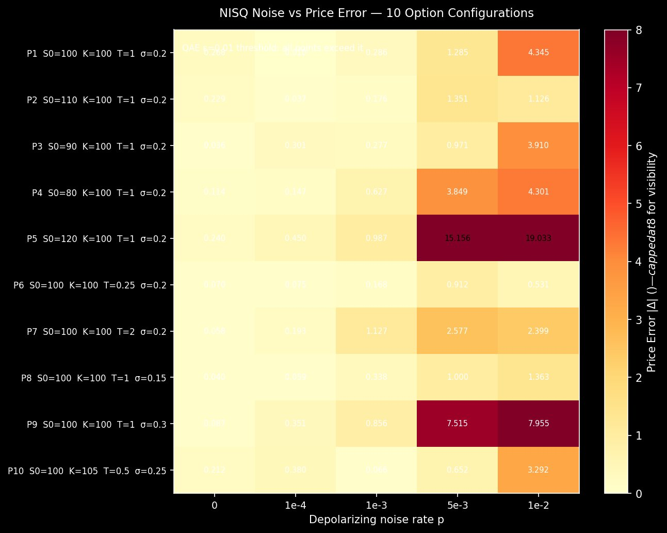
Fig. 1. Absolute price error across ten option configurations and five noise levels. The colorscale is capped at $8 for visibility; configuration P5 (deep in-the-money, S₀ = 120) is the principal outlier, reaching $19.0 at p = 10⁻². Errors exceed the ε = 0.01 break-even threshold at every cell in the grid.
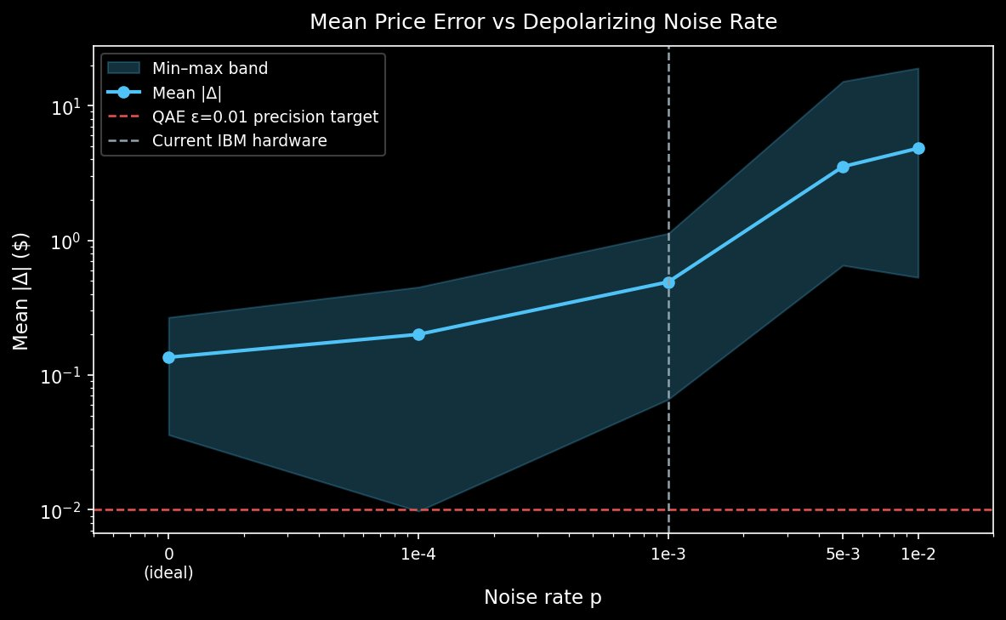
Fig. 2. Mean absolute price error versus depolarizing noise rate (log–log), with the min–max band across the sweep. The dashed lines mark the ε = 0.01 precision target and the current IBM hardware noise level (p ≈ 10⁻³). The mean curve never approaches the target, and even the lower edge of the band stays above it except marginally at p = 10⁻⁴.

B. The Discretization Floor
The most consequential result is the p = 0 value. That a noiseless simulation already misses the precision target by a factor of 20 shows the dominant error source at this scale is not decoherence but discretization. With n = 3 uncertainty qubits the risk-neutral distribution is represented at only eight points, and the resulting bias is irreducible: no improvement in qubit quality removes it. Noise then compounds an error that was already disqualifying. The practical implication is that the theoretical break-even, which presumes the estimation error ε is the only error, is inapplicable to instances small enough to run on near-term hardware — the advantage was lost to discretization before noise entered.

C. Oracle-Query Depth Is Noise-Invariant
Figure 3 (right panel) reports the mean oracle-query count as a function of noise rate. It is essentially flat at ≈14 queries (range 13.6–14.5) across all five noise levels. This follows from the structure of IQAE: its stopping criterion is amplitude-based and contains no term sensitive to noise, so the algorithm terminates at the same iteration depth regardless of p. The consequence is operationally important — the query budget, the quantity the break-even analysis tracks, does not inflate under noise. Instead the estimate the algorithm returns at that fixed depth becomes progressively more corrupted. Noise manifests as silent accuracy loss, not as visibly increased cost, which is precisely the failure mode a budget-based break-even analysis cannot detect.
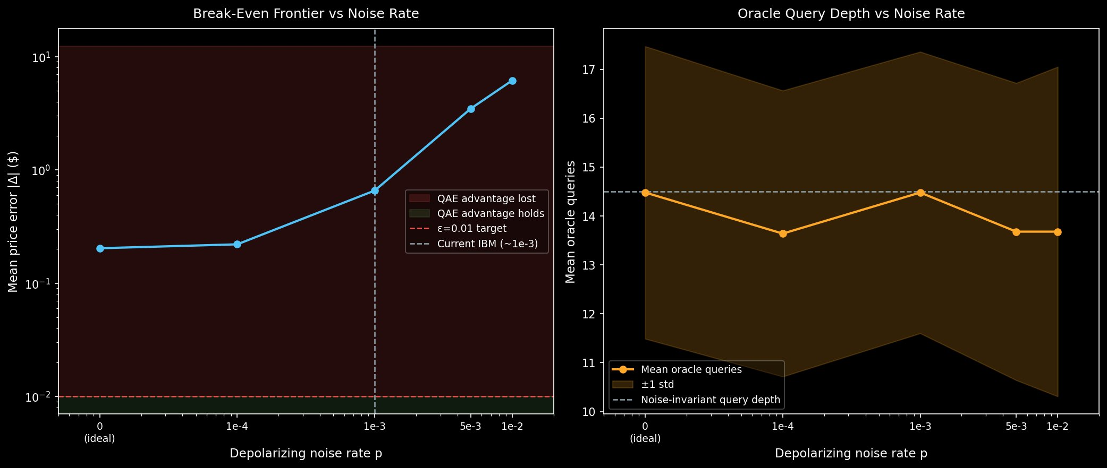
Fig. 3. Left: the break-even frontier (mean price error versus noise rate) lies entirely within the region where QAE's advantage is lost — the whole curve sits above the ε = 0.01 target across the swept noise range. Right: mean oracle-query depth is noise-invariant at ≈14 queries, with the ±1 standard-deviation band, confirming the query budget does not respond to noise.

D. Hardware Validation
The single-qubit state-preparation run on ibm_marrakesh returned an empirical estimate of p̂ = 0.2842 against the encoded target of 0.3000 — an absolute error of 0.0158. For 1024 shots the binomial sampling standard deviation at p = 0.3 is σ ≈ 0.0143, so the hardware deviation is 1.1σ, within the shot-noise band. A matched noiseless simulator draw (seed 42) gave p̂ = 0.2754 (1.7σ). In other words, for this minimal state-preparation primitive, gate noise on real hardware is negligible relative to sampling noise: the device behaves like the ideal simulator at this scale. This is the appropriate validation claim — it confirms the amplitude-encoding step is faithful on hardware, while the full-pipeline degradation reported above arises from circuit depth and discretization, which a one-qubit primitive does not exercise.
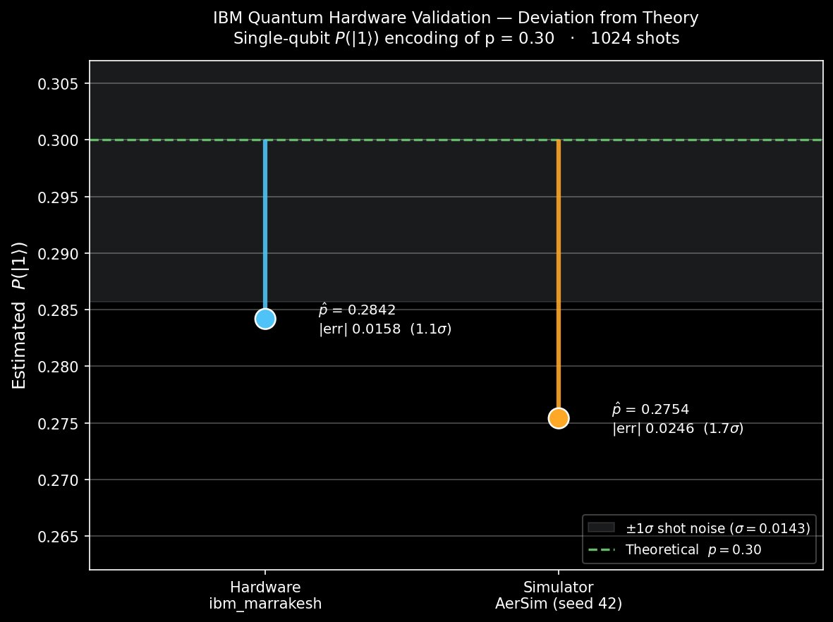
Fig. 4. Hardware validation as deviation from theory. Both the ibm_marrakesh hardware estimate (|err| = 0.0158, 1.1σ) and a matched simulator draw (|err| = 0.0246, 1.7σ) fall within the ±1σ shot-noise band (σ = 0.0143) around the theoretical p = 0.30. The hardware deviation is consistent with shot noise — no detectable device error at this scale. Job ID d8nvd2bqv2lc7389d9e0, 1024 shots.

V. Discussion
The results are best read as a separation of error sources. At NISQ scale the total QAE pricing error decomposes into a discretization floor set by the number of uncertainty qubits and a noise-dependent term that grows with the depolarizing rate. Our sweep shows the floor alone is already 20× above the precision target, and the noise term overtakes even the floor by p = 5×10⁻³. Increasing n to lower the floor multiplies circuit depth and therefore the accumulated noise, so the two error sources cannot be reduced independently on near-term hardware.
This reframes the break-even question. The canonical analysis asks at what query budget M the O(1/M) quantum estimator overtakes the O(1/√N) classical one, holding the target precision ε fixed and assuming ε is the only error. Our data show that on hardware small enough to run, ε is not the only error and is not even the dominant one. A budget-based crossover computed under the noiseless assumption therefore describes a regime that current devices cannot enter.
The noise-invariance of the oracle-query depth sharpens this point. Because IQAE does not lengthen its query schedule under noise, a practitioner monitoring only the query budget would observe the algorithm terminating on schedule and reporting a confident estimate, with no indication that the estimate has drifted by dollars. Any honest break-even accounting must track delivered accuracy, not query count, under realistic noise.
Limitations. The depolarizing model omits idling, crosstalk, and readout error, and the hardware validation exercises only the single-qubit encoding step rather than the full transpiled pipeline; a full-circuit hardware run is the natural next step but is beyond the open-plan runtime budget used here. The instances studied are deliberately small (n = 3), matching what near-term hardware can execute; the discretization floor we identify would recede at larger n on fault-tolerant hardware, where this paper's near-term conclusions no longer apply.

VI. Conclusion
We have measured, rather than assumed, the conditions under which QAE prices European options accurately on near-term hardware. Under realistic depolarizing noise the mean price error exceeds the ε = 0.01 precision target by 66× at current IBM error rates, and by 20× even with no noise at all, because the three-qubit discretization imposes an irreducible floor. The oracle-query depth that the break-even analysis tracks is noise-invariant, so the cost metric gives no warning as accuracy decays. A single-qubit run on ibm_marrakesh confirms the amplitude-encoding step is faithful to within shot noise, locating the degradation in depth and discretization rather than the encoding itself. The practical conclusion is that the QAE option-pricing break-even, evaluated under near-term conditions, lies entirely within the regime where QAE offers no usable advantage — a finding that motivates comparison against variance-reduced classical estimators, which we take up in companion work.

References
[1] N. Stamatopoulos, D. J. Egger, Y. Sun, C. Zoufal, R. Iten, N. Shen, and S. Woerner, “Option pricing using quantum computers,” Quantum, vol. 4, p. 291, 2020.
[2] S. Woerner and D. J. Egger, “Quantum risk analysis,” npj Quantum Information, vol. 5, no. 15, 2019.
[3] D. Grinko, J. Gacon, C. Zoufal, and S. Woerner, “Iterative quantum amplitude estimation,” npj Quantum Information, vol. 7, no. 52, 2021.
[4] G. Brassard, P. Høyer, M. Mosca, and A. Tapp, “Quantum amplitude amplification and estimation,” Contemporary Mathematics, vol. 305, pp. 53–74, 2002.
[5] A. Montanaro, “Quantum speedup of Monte Carlo methods,” Proc. R. Soc. A, vol. 471, no. 2181, 2015.
[6] P. Rebentrost, B. Gupt, and T. R. Bromley, “Quantum computational finance: Monte Carlo pricing of financial derivatives,” Phys. Rev. A, vol. 98, no. 022321, 2018.
[7] J. Preskill, “Quantum computing in the NISQ era and beyond,” Quantum, vol. 2, p. 79, 2018.
[8] Qiskit contributors, “Qiskit: An open-source framework for quantum computing,” 2024.

