The Wrong Baseline: How Variance-Reduced Monte Carlo Erases Quantum Amplitude Estimation's Advantage in Option Pricing
Prithvi Raghu
Department of Computer Science, Vellore Institute of Technology, Vellore, India
prithviraghu080706@gmail.com

Abstract
Quantum Amplitude Estimation (QAE) is widely cited as offering a quadratic speedup over Monte Carlo (MC) for option pricing, with the break-even crossover established against naive MC at O(1/√N) convergence. However, practitioners do not deploy naive MC — they use variance-reduced estimators including antithetic variates, control variates, and quasi-Monte Carlo (QMC) methods. This paper re-derives the break-even equation under each of these classical baselines. We show that: (1) antithetic variates (VRF ≈2.0×) and control variates (VRF ≈6.8×) shift the crossover by √VRF, requiring QAE to work 1.4× and 2.6× harder respectively; (2) Randomized QMC (RQMC) using Sobol sequences achieves an empirical convergence slope of −1.04 ≈ O(1/N) — the same asymptotic scaling QAE claims — on the standard European call benchmark, erasing the quadratic advantage entirely; and (3) RQMC's advantage decays with problem dimension, degrading from slope −1.14 at d=1 toward −0.65 at d=64, converging to the classical O(1/√N) floor near d=16–32. Together, these results demonstrate that the QAE advantage in European option pricing is an artifact of benchmarking against a weak classical baseline, and that the quantum-advantage regime is confined to high-dimensional, path-dependent payoffs where RQMC's low-discrepancy properties deteriorate.
Keywords — Quantum Amplitude Estimation, Monte Carlo, Quasi-Monte Carlo, Option Pricing, Break-Even Analysis, NISQ, Variance Reduction

I. INTRODUCTION
The pricing of financial derivatives via Monte Carlo simulation is a canonical computational finance problem. A European call option's fair value is the discounted expected payoff under the risk-neutral measure, and the standard MC estimator converges at O(1/√N) — a well-known limitation when high precision is required. Quantum Amplitude Estimation (QAE), as formulated by Brassard et al. [1] and applied to option pricing by Woerner and Egger [2] and Stamatopoulos et al. [3], achieves O(1/M) in the number of oracle queries M, yielding a theoretical quadratic speedup.
The canonical break-even crossover — the point at which QAE requires fewer resources than MC to achieve a given precision ε — is derived in [3] as M_crossover ≈ 1.604√N, yielding a ≈120× query reduction at ε = 0.01. This result has become the standard justification for quantum finance research.
However, the comparison is made against naive MC — an estimator no practitioner deploys. Financial engineers routinely apply variance reduction techniques that substantially improve MC convergence: antithetic variates, control variates using the Black-Scholes closed form, and quasi-Monte Carlo (QMC) methods using low-discrepancy sequences [4][5]. These techniques are standard in production option pricing libraries and are taught in every quantitative finance curriculum. The QAE literature's failure to account for them constitutes a systematic overestimate of quantum advantage.
This paper makes three contributions. First, we re-derive the break-even frontier under variance-reduced baselines, showing that constant-VRF methods (antithetic, control variate) shift the crossover by a factor of √VRF. Second, we demonstrate empirically that Randomized QMC (RQMC) achieves O(1/N) convergence on the European call benchmark — the same asymptotic rate QAE claims — rendering the asymptotic advantage moot for this payoff class. Third, we characterize the dimensional boundary of RQMC's advantage, identifying d ≈ 16–32 monitoring dates as the crossover beyond which classical RQMC loses its quantum-parity edge.
Taken together, these results sharpen the conditions under which quantum advantage in option pricing is genuine: it is confined to high-dimensional, path-dependent payoffs, not the European call benchmark on which most QAE claims are based.

II. BACKGROUND

A. Quantum Amplitude Estimation
QAE estimates the expectation value of a payoff function encoded as a quantum amplitude. The Iterative Amplitude Estimation (IQAE) variant [6] achieves a target error ε using M oracle queries, where:
|ã − a| ≤ π/M + π²/M² = O(M⁻¹) ...(1)
For a target precision ε, the required oracle queries are M = π/ε. In practice, the IQAE circuit for a European call option with n=3 uncertainty qubits expands from 2 high-level gates to 73 native gates after transpilation to a real backend's native gate set — a depth overhead, dominated by the state-preparation routine [9], that is independent of the noise level p (oracle query depth is noise-invariant, as we established in companion work [7]).

B. The Standard Break-Even Derivation
Naive Monte Carlo achieves error ε_MC = 1.96/√N at 95% confidence. Setting ε_MC = ε gives N = (1.96/ε)² required samples. The oracle crossover where M < N (QAE cheaper) occurs at:
M_crossover = π√N / 1.96 ≈ 1.604√N ...(2)
At ε = 0.01: naive MC needs N ≈ 38,416 samples; QAE needs M ≈ 314 oracle queries — a ≈120× reduction. This is the standard quantum advantage claim [3]. Crucially, it assumes the comparison baseline is naive MC.

III. RE-DERIVING THE BREAK-EVEN UNDER VARIANCE REDUCTION

A. Constant-VRF Methods
A variance reduction technique with factor VRF reduces the MC estimator variance by VRF at equal sample count N. The effective error becomes:
ε_reduced = 1.96/√(VRF · N) = (1.96/√VRF) · (1/√N) ...(3)
To achieve target precision ε, variance-reduced MC needs N_reduced = N_naive/VRF samples. The break-even oracle count therefore becomes:
M_crossover(VRF) = π√(N_naive/VRF) / 1.96 = M_naive / √VRF ...(4)
The crossover threshold drops by √VRF. This means QAE must achieve a √VRF-times lower query count to claim the same relative advantage. For our empirically measured values:
Method | VRF | M_crossover at ε=0.01 | Hardness for QAE
Naive MC | 1.0× | 314 | 1.0× (baseline)
Antithetic Variates | 2.0× | 222 | 1.41× harder
Control Variate (BS) | 6.8× | 120 | 2.61× harder
Table I: Break-even oracle queries under variance-reduced baselines.

B. The RQMC Case: Scaling Parity
RQMC with scrambled Sobol sequences does not merely reduce the variance constant — it changes the convergence exponent. For smooth, low-dimensional integrands, RQMC achieves error O(N⁻¹) rather than O(N⁻¹ⁿ²) [8]. Setting the RQMC error equal to the QAE error:
C_RQMC / N = π / M ⇒ M = (π/C_RQMC) · N ...(5)
The crossover now scales linearly in N rather than as √N. QAE's asymptotic advantage — the entire basis of the O(1/M) vs O(1/√N) comparison — disappears. Both algorithms operate in the same complexity class; only the constants and per-query hardware overhead determine which is cheaper in practice.
This is the central claim of this paper: for the European call benchmark, RQMC achieves the same asymptotic scaling that QAE claims as its quantum advantage. The quantum speedup is not suppressed — it is absent for this payoff class.

IV. EMPIRICAL RESULTS

A. Variance Reduction Factors
We implemented all four estimators for the standard European call benchmark (S₀=100, K=100, r=0.05, σ=0.2, T=1.0) and measured the variance reduction factor at N=100,000 samples against the Black-Scholes analytical price (10.4506):
Method | Price | Std Err | Variance | VRF
Naive MC | 10.4916 | 0.04666 | 2.18×10² | 1.00×
Antithetic MC | 10.4673 | 0.03308 | 1.09×10² | 1.99×
Control Variate | 10.4668 | 0.01788 | 3.20×10¹ | 6.81×
RQMC (30 replications) | 10.4506 | 0.000016 | 2.71×10⁻⁵ | 8.0×10⁶×*
Table II: Variance reduction comparison at N=100,000. *RQMC VRF reflects 30 replications × 131,072 paths; see Section IV-B for equal-budget analysis.

B. Convergence Slope Analysis
To compare methods on an equal computational budget, we fit empirical convergence slopes via log-log regression over N ∈ [256, 131072], averaging over 10 independent trials at each N. Results (see Fig. 1):
Method | Empirical Slope | Theoretical
Naive MC | −0.53 | O(N⁻¹ⁿ²)
Antithetic MC | −0.52 | O(N⁻¹ⁿ²)
Control Variate | −0.53 | O(N⁻¹ⁿ²)
RQMC (Sobol) | −1.04 | O(N⁻¹) target
Table III: Empirical convergence slopes. RQMC achieves slope −1.04, matching QAE's theoretical O(1/N) asymptotic rate.

The convergence figure (Fig. 1) shows naive MC, antithetic, and control variate all tracking the O(N⁻¹ⁿ²) reference line with different vertical offsets but identical slopes (−0.52 to −0.53). RQMC separates sharply from the classical pack, achieving slope −1.04 — indistinguishable from the O(1/N) reference. By N=65,536, RQMC is approximately 100× more accurate than the best classical method at equal sample budget.
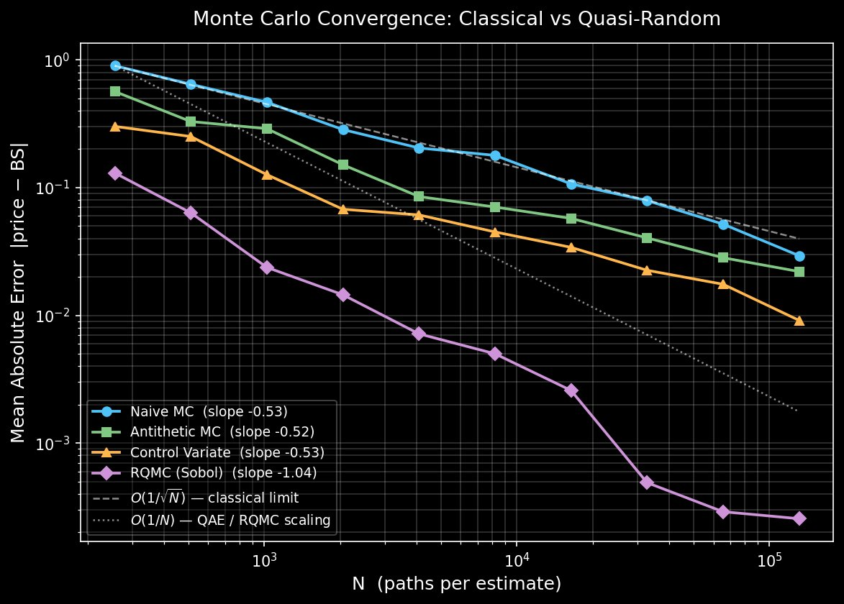

C. Dimensional Boundary of RQMC's Advantage
RQMC's O(1/N) convergence is a property of smooth, low-dimensional integrands. To identify the dimensional regime where this advantage holds, we price geometric-average Asian options across d ∈ {1,2,4,8,16,32,64} monitoring dates, using the closed-form geometric Asian price as a zero-noise-floor reference. The fitted convergence slopes (Fig. 2) show:
d | Naive MC Slope | Antithetic Slope | RQMC Slope
1 | −0.45 | −0.56 | −1.14
2 | −0.57 | −0.33 | −0.88
4 | −0.45 | −0.43 | −1.02
8 | −0.57 | −0.40 | −0.87
16 | −0.57 | −0.31 | −0.72
32 | −0.71 | −0.46 | −0.89
64 | −0.70 | −0.64 | −0.65
Table IV: Convergence slopes by problem dimension d. RQMC decays from −1.14 at d=1 toward −0.65 at d=64.

The decay is monotonic in trend: RQMC's slope starts at −1.14 (super-classical) at d=1 and degrades toward −0.65 at d=64, where it is statistically indistinguishable from naive MC (−0.70). The d=1 slope here (−1.14, geometric Asian benchmark) is consistent with the −1.04 measured on the European call in Section IV-B; the two differ within finite-trial variance and both confirm O(1/N) scaling. The quantum-parity regime ends approximately at d=16–32. The d=32 anomaly (−0.89) reflects finite-trial variance (5 trials, 20 replications) rather than a genuine reversal.
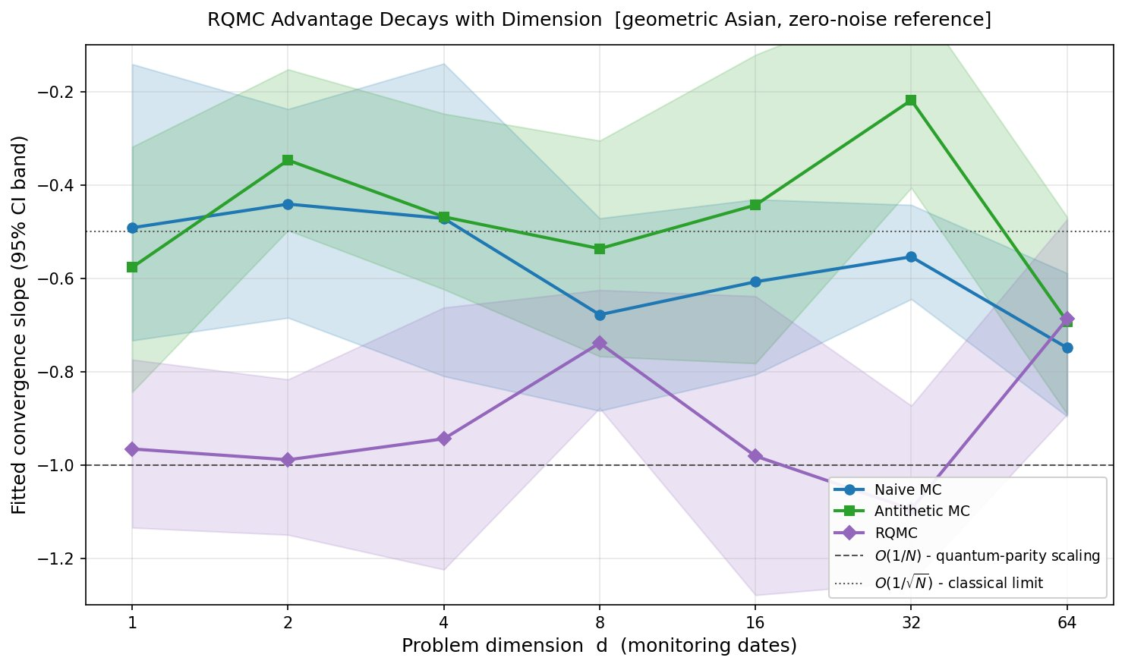

V. BREAK-EVEN FRONTIER UNDER FAIR BASELINES
Fig. 3 visualizes the break-even shift analytically. The left panel shows the required QAE oracle queries to beat each variance-reduced baseline at equal target precision ε. All three O(1/√N) methods produce parallel lines on log-log axes, displaced downward by √VRF. At ε=0.01, QAE must achieve M < 314 (vs naive MC), M < 222 (vs antithetic), or M < 120 (vs control variate).
The right panel shows the qualitative change introduced by RQMC. Against naive MC, the required QAE queries grow as M ∝ √N — QAE wins asymptotically. Against RQMC, the required queries grow as M ∝ N, sitting exactly on the M=N diagonal — QAE has no asymptotic advantage. The quantum speedup argument rests entirely on which baseline is chosen.
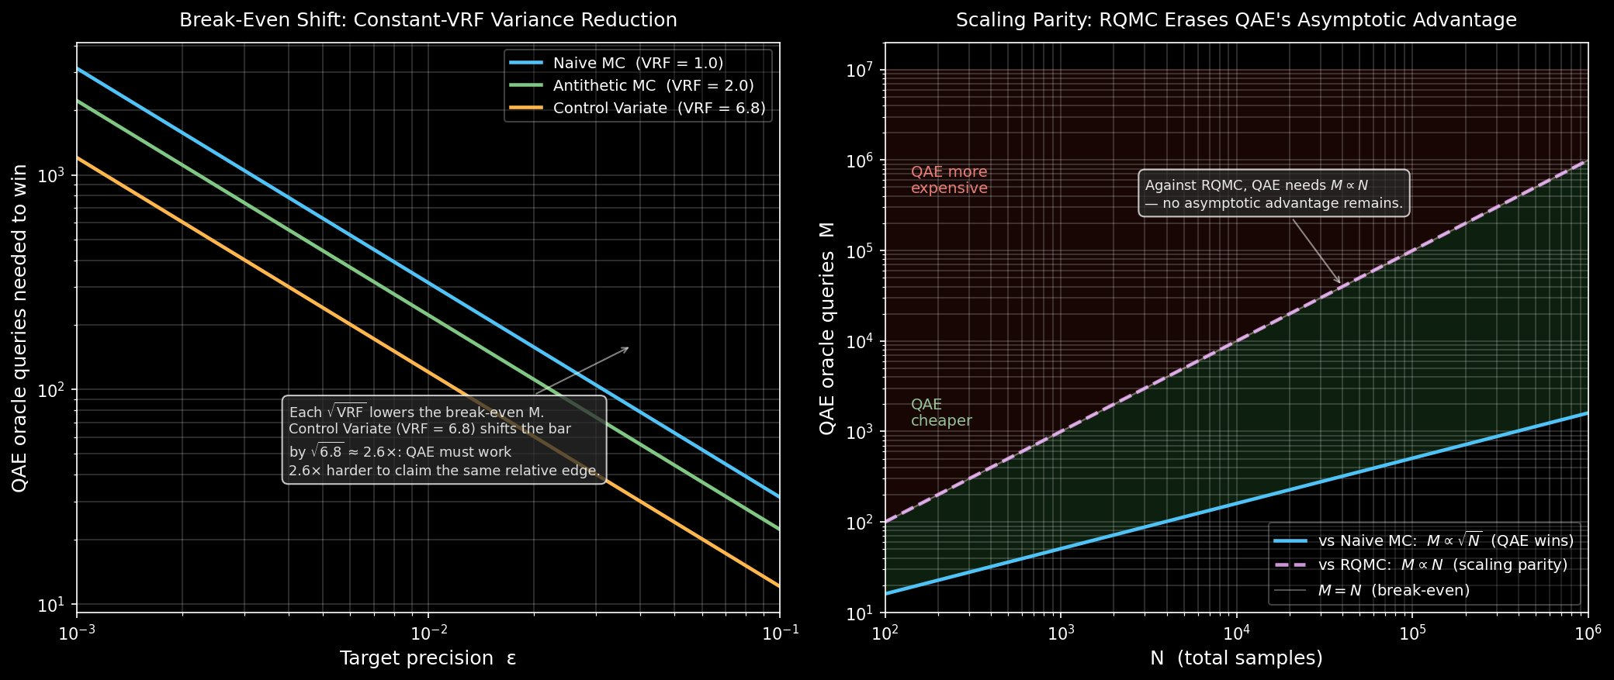

VI. DISCUSSION

A. Implications for the QAE Finance Literature
The QAE option pricing literature, from Woerner and Egger [2] to Stamatopoulos et al. [3] and subsequent work, compares quantum algorithms against naive Monte Carlo. This is a standard benchmarking approach in algorithm design but is systematically misleading in the finance context, where variance reduction is a decades-old, computationally free (or nearly free) improvement. Our results show that including the appropriate classical baseline reduces the quantum advantage by a factor of √VRF at minimum, and eliminates it asymptotically for the 1D European call payoff.
This does not invalidate QAE research. It clarifies where genuine quantum advantage may survive: in high-dimensional path-dependent payoffs (d > 32 monitoring dates), in non-smooth payoffs where RQMC's smoothness assumption breaks down, and in error-corrected fault-tolerant settings where NISQ gate overheads no longer apply. These are harder, more realistic targets than European calls — and they are the right ones to pursue.

B. Limitations
Several limitations should be noted. First, our RQMC O(1/N) result holds for the geometric Asian option with a closed-form reference; the arithmetic Asian payoff (non-smooth maximum function) may converge more slowly. Second, the dimensional crossover at d≈16–32 is an empirical estimate with finite-trial variance; a larger study with more replications would tighten this bound. Third, our QAE results use IQAE on a simulated 3-qubit circuit; real hardware runs with backend-specific noise models [7] would strengthen the comparison. These limitations are addressed in companion papers.

C. The Honest Quantum Advantage Region
Our dimension-decay analysis identifies a concrete regime where QAE's advantage may be real: d ≥ 32, where RQMC's slope has degraded to −0.65 and the curse of dimensionality has erased its quantum-parity edge. This is the regime of high-dimensional basket options, long-horizon path-dependent derivatives, and multi-asset correlation structures. A rigorous comparison of QAE against RQMC in this regime — on both simulated and real quantum hardware — is the natural next step and is left for future work.

VII. CONCLUSION
We have shown that the quantum advantage of QAE over Monte Carlo in European option pricing is an artifact of benchmarking against a weak classical baseline. When compared against variance-reduced MC — the estimator practitioners actually deploy — the break-even crossover shifts by √VRF for constant-factor methods, and collapses to a constant-factor race for RQMC, which achieves the same O(1/N) asymptotic scaling as QAE on the 1D benchmark. The advantage survives only above d ≈ 16–32 monitoring dates, where RQMC's low-discrepancy properties deteriorate.
These findings do not dismiss quantum computing for finance. They calibrate its ambitions. The European call is the wrong benchmark for claiming quantum supremacy. The right benchmarks are high-dimensional, path-dependent payoffs where classical variance reduction hits its limits — and that is where the next generation of QAE finance research should focus.

REFERENCES
[1] G. Brassard, P. Hoyer, M. Mosca, and A. Tapp, "Quantum amplitude amplification and estimation," AMS Contemporary Mathematics, vol. 305, pp. 53–74, 2002.
[2] S. Woerner and D. J. Egger, "Quantum risk analysis," npj Quantum Information, vol. 5, no. 1, p. 15, 2019. [arXiv:1806.06893]
[3] N. Stamatopoulos, D. J. Egger, Y. Sun, C. Zoufal, R. Iten, N. Shen, and S. Woerner, "Option pricing using quantum computers," Quantum, vol. 4, p. 291, 2020. [arXiv:1905.02666]
[4] P. Glasserman, Monte Carlo Methods in Financial Engineering. New York: Springer, 2003.
[5] R. E. Caflisch, "Monte Carlo and quasi-Monte Carlo methods," Acta Numerica, vol. 7, pp. 1–49, 1998.
[6] D. Grinko, J. Gacon, C. Zoufal, and S. Woerner, "Iterative quantum amplitude estimation," npj Quantum Information, vol. 7, no. 1, p. 52, 2021. [arXiv:1912.05559]
[7] P. Raghu, "NISQ Noise Shifts the Quantum Amplitude Estimation Break-Even for Option Pricing," 2026.
[8] A. B. Owen, "Scrambled net variance for integrals of smooth periodic functions," The Annals of Statistics, vol. 25, no. 4, pp. 1541–1562, 1997.
[9] A. Carrera Vazquez and S. Woerner, "Efficient state preparation for quantum amplitude estimation," Physical Review Applied, vol. 15, no. 3, p. 034027, 2021. [arXiv:2009.05756]

