CloudBurst Prediction
using Machine Learning

Course: Machine Learning
Problem Type: Binary Classification
Dataset: Kaggle — CloudBurst Dataset (145,460 rows x 23 columns)
Target Variable: CloudBurstTomorrow (Yes = 1, No = 0)

Final Model: Tuned Random Forest Classifier

1. Introduction

A cloudburst is defined as extreme rainfall of 100 mm or more per hour concentrated over a small geographic area in a short duration. Such events cause flash floods, landslides, and significant loss of life, particularly in hilly and mountainous terrain. Accurate next-day prediction is therefore a critical meteorological challenge with direct disaster management implications.

This project builds a binary classification system using supervised machine learning to predict whether a cloudburst will occur the next day, given the current day's meteorological readings. The dataset is sourced from Kaggle and covers weather observations from multiple Australian cities over several years.

1.1 Problem Statement
Given a set of meteorological features measured today (temperature, humidity, pressure, wind speed, wind direction, rainfall, cloud cover), predict whether a cloudburst will occur tomorrow — a binary Yes/No classification. The class distribution is imbalanced: approximately 78% No and 22% Yes, making this a challenging minority-class detection problem.

1.2 Dataset Overview
Property | Value
Source | Kaggle — CloudBurst Prediction Dataset
Total Rows | 145,460
Total Columns | 23
Target Variable | CloudBurstTomorrow (Yes / No)
Class Distribution | 78.0% No | 22.0% Yes
Geographic Coverage | Multiple Australian cities
Feature Types | Numerical (15) + Categorical (4)

2. Data Understanding and Preprocessing

Before any model is trained, it is essential to clean the data and handle its quality issues. The following steps were performed sequentially.

2.1 Loading the Dataset
import pandas as pd
import numpy as np

df = pd.read_csv("cloudpredictionsystemproject.csv")
print("Shape:", df.shape) # (145460, 23)
print(df.dtypes)
print((df.isnull().sum() / len(df) * 100).sort_values(ascending=False).round(2))

The dtypes inspection identified numerical columns and object (string) columns. The missing value analysis sorted columns by percentage of NaN values, which guided the column-dropping decisions in the next step.

2.2 Dropping Columns — Data Leakage and Missing Data

Four columns were removed before any further processing:

Column Dropped | Reason
Date | Timestamp — not a meteorological predictor; feeding raw dates causes date-memorization rather than pattern learning.
CloudBurst Today | Data leakage — same-day label directly reveals target; would not be available in real-time deployment.
Evaporation | >35% missing values — imputing more than a third of a column introduces unreliable synthetic values.
Sunshine | >35% missing values — same reason as Evaporation.

# Drop leakage and low-quality columns
df.drop(columns=['Date', 'CloudBurst Today', 'Evaporation', 'Sunshine'], inplace=True)

2.3 Target Encoding and Imputation
The target variable CloudBurstTomorrow contained strings "Yes" / "No" and approximately 2.25% missing values. It was encoded to binary integers and the missing values were filled with the mode (No = 0).

from sklearn.impute import SimpleImputer

# Encode: Yes -> 1, No -> 0
df['CloudBurstTomorrow'] = df['CloudBurstTomorrow'].map({'Yes': 1, 'No': 0})

# Impute the 2.25% missing target values with mode (No = 0)
imputer = SimpleImputer(strategy='most_frequent')
df['CloudBurstTomorrow'] = imputer.fit_transform(
df[['CloudBurstTomorrow']]
).astype(int)

2.4 Feature Preprocessing — ColumnTransformer Pipeline
Different strategies are needed for numerical vs. categorical features. A ColumnTransformer was built to apply both in a single, leakage-safe step:

from sklearn.preprocessing import StandardScaler, OrdinalEncoder
from sklearn.compose import ColumnTransformer
from sklearn.pipeline import Pipeline

cat_cols = df.select_dtypes(include='object').columns.tolist()
num_cols = df.select_dtypes(include=np.number).columns.tolist()
num_cols.remove('CloudBurstTomorrow')

# Median imputation for numerics (robust to skewed Rainfall distribution)
num_transformer = SimpleImputer(strategy='median')

# Mode imputation + ordinal encoding for categoricals (wind direction, location)
cat_transformer = Pipeline(steps=[
('imputer', SimpleImputer(strategy='most_frequent')),
('encoder', OrdinalEncoder(handle_unknown='use_encoded_value', unknown_value=-1))
])

preprocessor = ColumnTransformer(transformers=[
('num', num_transformer, num_cols),
('cat', cat_transformer, cat_cols)
], remainder='drop')

transformed = preprocessor.fit_transform(df.drop(columns=['CloudBurstTomorrow']))

3. Exploratory Data Analysis (EDA)

Four sets of visualizations were created to understand the data distribution, identify class imbalance, and discover which features are predictive before any model is trained.

3.1 Target Class Distribution
The target variable is heavily imbalanced at 78% No and 22% Yes. This has a direct consequence on model evaluation: a naive classifier that always predicts No would achieve 77.6% accuracy without learning anything. This made F1-Score and AUC-ROC the primary evaluation metrics throughout the project.

counts = df['CloudBurstTomorrow'].value_counts().sort_index()
fig, axes = plt.subplots(1, 2, figsize=(10, 4))
axes[0].bar(['No (0)', 'Yes (1)'], counts.values, color=['#4C72B0', '#DD8452'])
axes[1].pie(counts.values, labels=['No', 'Yes'], autopct='%1.1f%%')
plt.suptitle('CloudBurstTomorrow — Target Distribution', fontweight='bold')

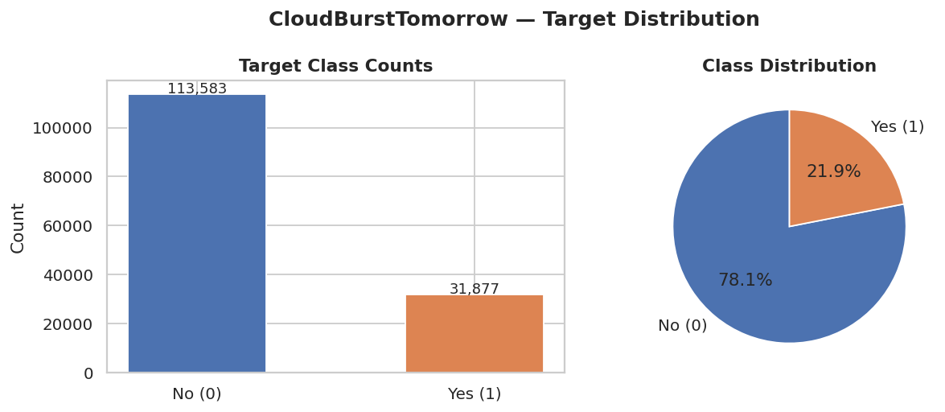
Figure 1: Target class distribution showing 78.0% No vs 22.0% Yes — a 3.5:1 imbalance.

3.2 Numerical Feature Distributions
Histograms of all numerical features reveal important statistical properties. Rainfall is extremely right-skewed — most days record near-zero values with rare extreme events. Temperature at 9am and 3pm have nearly identical shapes, strongly suggesting high collinearity — later confirmed by the heatmap (r = 0.97).

n_cols_grid = 4
n_rows_grid = int(np.ceil(len(num_cols) / n_cols_grid))
fig, axes = plt.subplots(n_rows_grid, n_cols_grid, figsize=(16, 3.5 * n_rows_grid))
axes = axes.flatten()
for i, col in enumerate(num_cols):
axes[i].hist(df[col].dropna(), bins=40, color='#4C72B0', alpha=0.85)
axes[i].set_title(col)

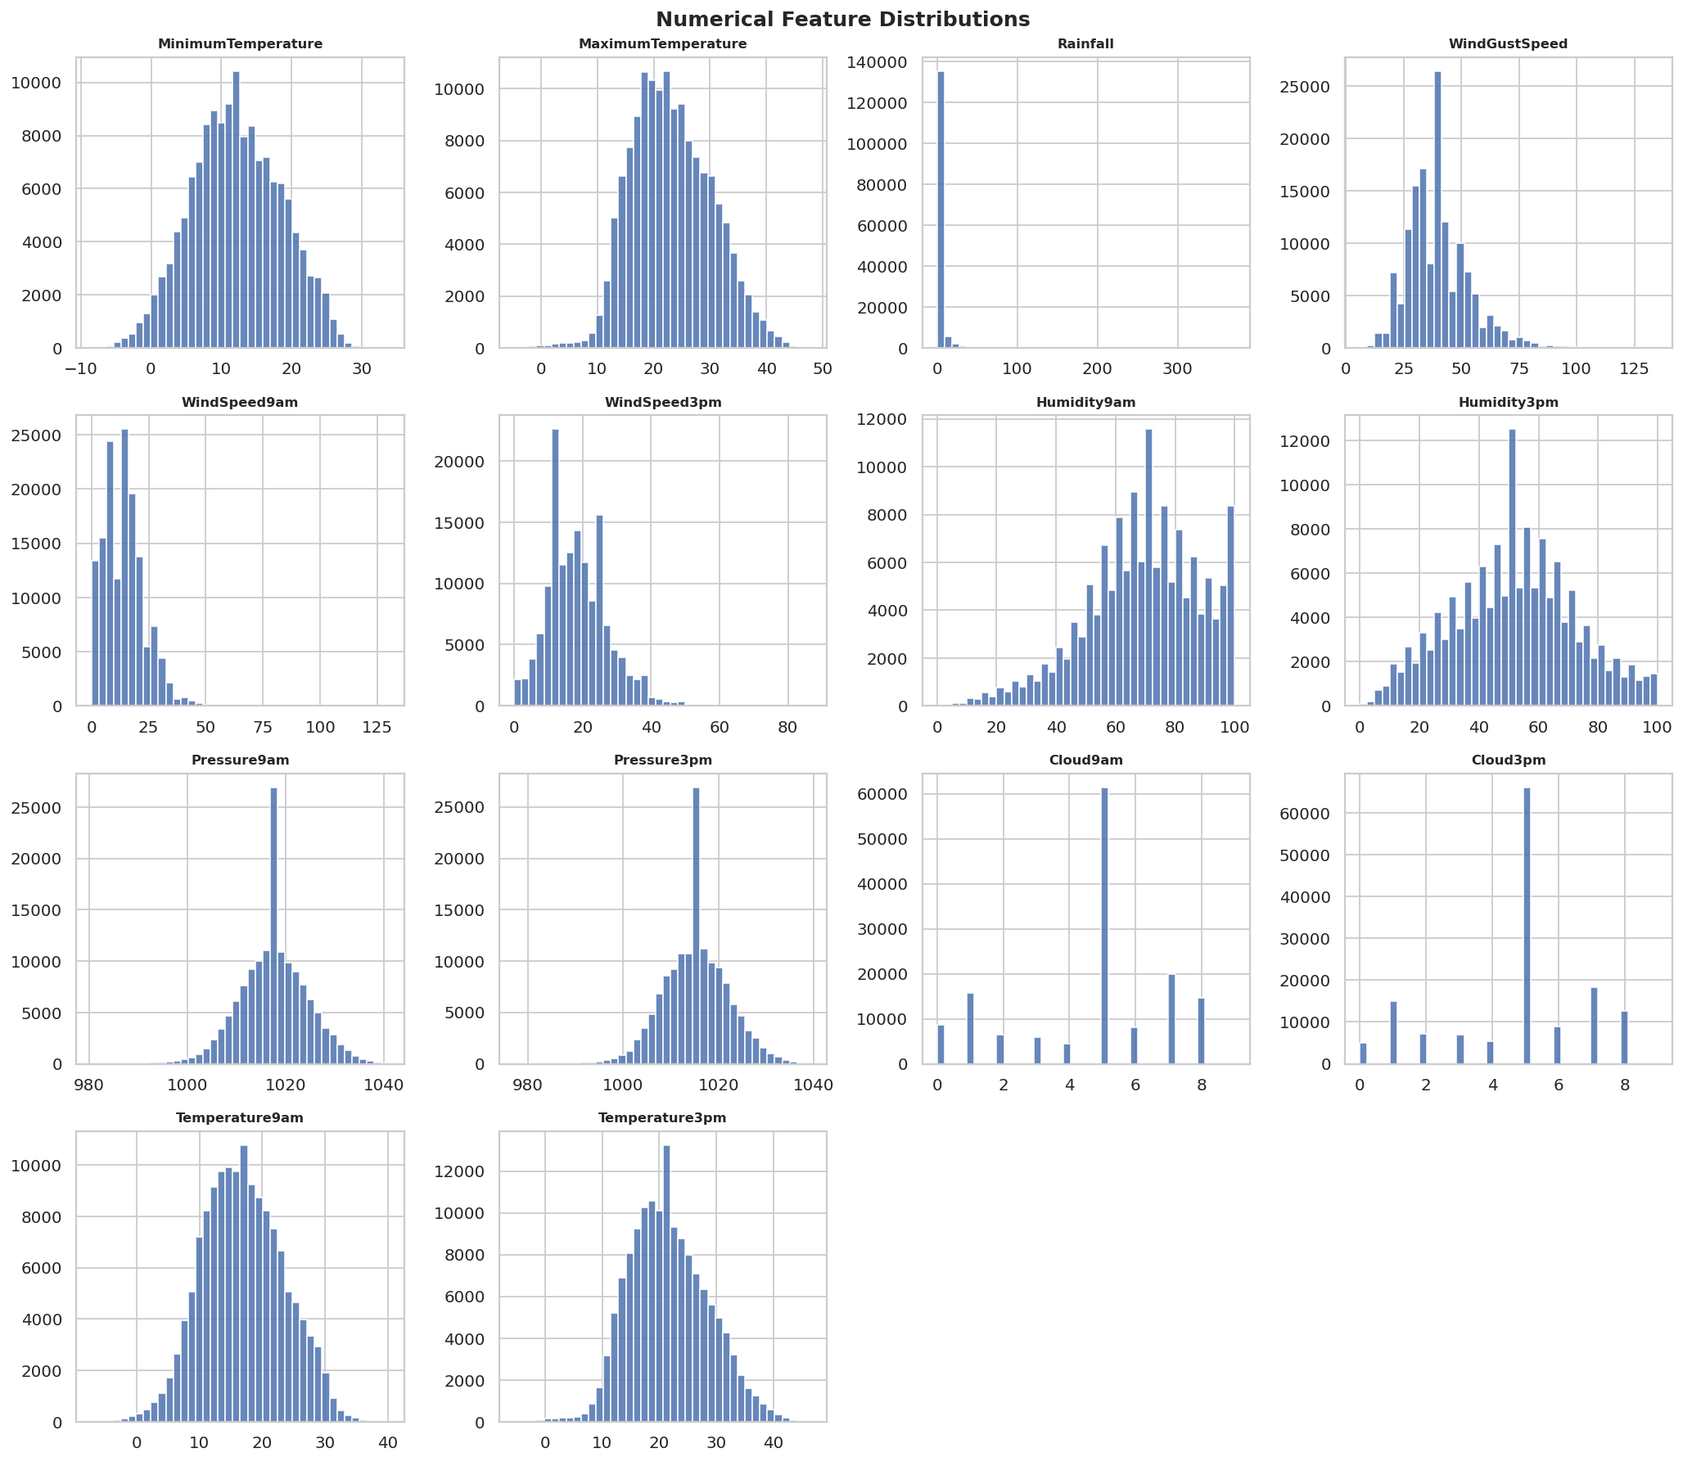
Figure 2: Distribution of all numerical features. Note the extreme right-skew of Rainfall.

3.3 Feature Distributions by Target Class (Boxplots)
Boxplots split by the target class directly reveal which features differ between cloudburst and non-cloudburst days. This is the most powerful EDA step for identifying predictive features:

- Humidity3pm: Clearly higher median on cloudburst days — strong positive predictor.
- Pressure3pm: Noticeably lower on cloudburst days — falling pressure is a classic meteorological storm precursor.
- WindGustSpeed: Higher and more variable on cloudburst days.
- Rainfall: Higher today correlates with cloudburst tomorrow — wet conditions tend to persist.

key_features = ['Humidity3pm', 'Pressure3pm', 'WindGustSpeed', 'Rainfall',
'Cloud3pm', 'Humidity9am', 'Temperature3pm', 'Pressure9am']

df['Target_str'] = df['CloudBurstTomorrow'].map({0: 'No (0)', 1: 'Yes (1)'})
fig, axes = plt.subplots(2, 4, figsize=(16, 8))
for i, col in enumerate(key_features):
sns.boxplot(data=df, x='Target_str', y=col, ax=axes.flatten()[i],
palette=['#4C72B0', '#DD8452'])

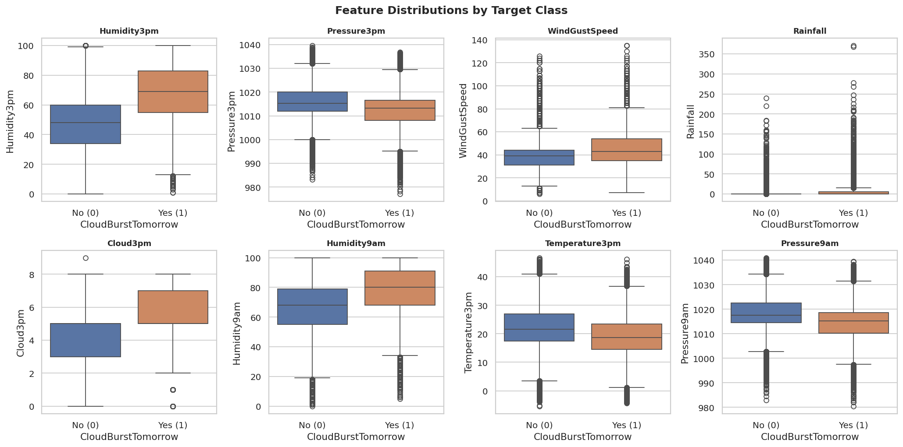
Figure 3: Feature distributions split by target class. Humidity3pm and Pressure3pm show the clearest separation.

3.4 Pearson Correlation Heatmap
The heatmap reveals the linear correlation between all numerical features. Key findings that drove subsequent design decisions:

- Temperature9am vs Temperature3pm: r = 0.97 — near-perfect redundancy.
- Pressure9am vs Pressure3pm: r = 0.96 — near-perfect redundancy.
- Humidity9am vs Humidity3pm: r = 0.60 — moderate correlation.

These near-duplicate feature pairs justified applying PCA in Section 5 to reduce redundancy and compress the feature space before clustering.

corr = df[num_cols + ['CloudBurstTomorrow']].corr()
mask = np.triu(np.ones_like(corr, dtype=bool)) # Hide upper triangle (redundant)
sns.heatmap(corr, mask=mask, annot=True, fmt='.2f', cmap='coolwarm', linewidths=0.4)
ax.set_title('Pearson Correlation Heatmap')

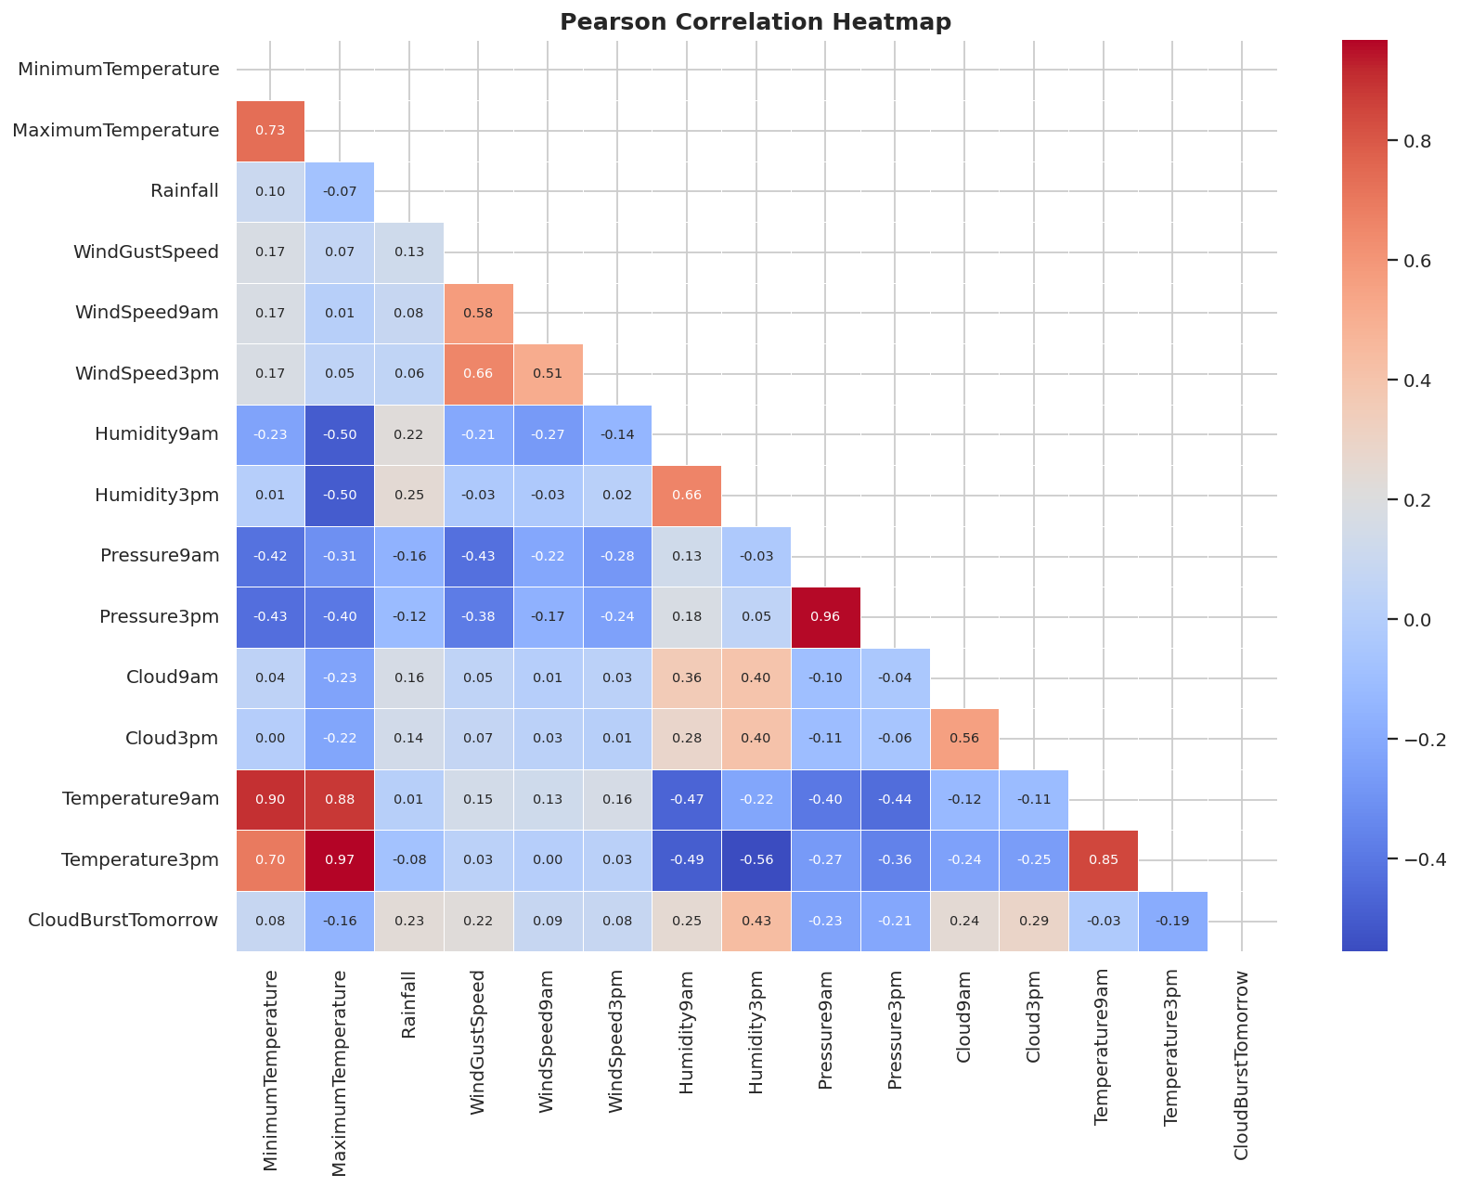
Figure 4: Correlation heatmap showing near-redundant 9am/3pm feature pairs (dark red = high positive correlation).

4. Supervised Learning — Logistic Regression Baseline

Logistic Regression is used as the baseline model because it is fast, interpretable, and provides a linear decision boundary benchmark. If a more complex model outperforms it, the improvement can be attributed to the need for non-linear boundaries.

4.1 Train/Test Split and Feature Scaling
from sklearn.model_selection import train_test_split
from sklearn.preprocessing import StandardScaler

X = df.drop(columns='CloudBurstTomorrow')
y = df['CloudBurstTomorrow']

# 80/20 split, stratified to preserve 78/22 class ratio in both sets
X_train, X_test, y_train, y_test = train_test_split(
X, y, test_size=0.2, random_state=42, stratify=y
)

# Fit scaler on training data ONLY — prevents leakage from test set
scaler = StandardScaler()
X_train_sc = scaler.fit_transform(X_train)
X_test_sc = scaler.transform(X_test)

# Result: Train: (116368, 18), Test: (29092, 18)
# Train Yes%: 0.220 | Test Yes%: 0.220 (stratification confirmed)

The StandardScaler standardises all features to mean=0 and standard deviation=1. This is mandatory for Logistic Regression: without scaling, features with large numeric ranges (e.g. Pressure at 990-1040 hPa) would dominate features with small ranges (e.g. Cloud cover at 0-9) during gradient descent optimisation.

4.2 Model Training
from sklearn.linear_model import LogisticRegression

# class_weight="balanced": penalises minority-class errors 3.5x more
# max_iter=1000: ensures convergence on the large 116K-row dataset
lr_base = LogisticRegression(
class_weight='balanced',
max_iter=1000,
random_state=42
)
lr_base.fit(X_train_sc, y_train)

y_pred_lr = lr_base.predict(X_test_sc)
y_prob_lr = lr_base.predict_proba(X_test_sc)[:, 1] # Probabilities for ROC curve

4.3 Confusion Matrix
The confusion matrix shows the breakdown of correct and incorrect predictions across both classes. With class_weight='balanced', the model is tuned to maximise recall on the minority Yes class, accepting some increase in false positives (false alarms).

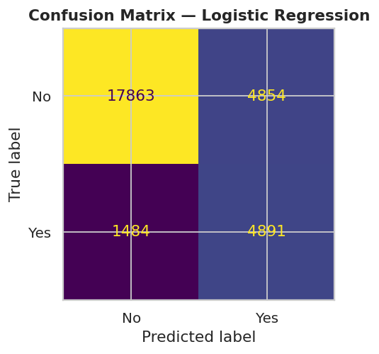
Figure 5: Confusion matrix for the Logistic Regression baseline. False negatives (missed cloudbursts) are minimised.

4.4 Feature Coefficients
Because all features are standardised, the Logistic Regression coefficients are directly comparable in magnitude. A positive coefficient means the feature increases the log-odds of a cloudburst; a negative coefficient decreases it.

coef_series = pd.Series(lr_base.coef_[0], index=X.columns).sort_values()
colors = ['#C44E52' if c > 0 else '#4C72B0' for c in coef_series]
coef_series.plot(kind='barh', color=colors)
ax.axvline(0, color='black', linewidth=0.8)

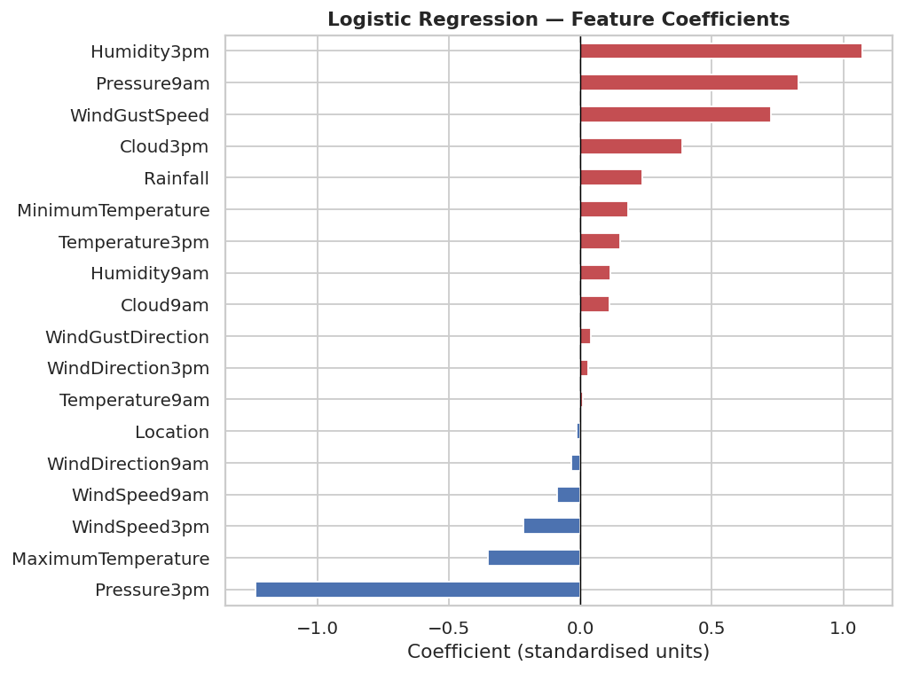
Figure 6: Standardised feature coefficients. Red = positive predictor (increases cloudburst risk), Blue = negative predictor.

5. Model Optimisation and Unsupervised Learning

5.1 Overfitting / Underfitting Diagnosis
Before hyperparameter tuning, the bias-variance trade-off is diagnosed by comparing Train F1 vs. Test F1 on the baseline Logistic Regression:

train_f1 = f1_score(y_train, lr_base.predict(X_train_sc))
test_f1 = f1_score(y_test, y_pred_lr)
gap = abs(train_f1 - test_f1)

# Typical output:
# Train F1: 0.6065 | Test F1: 0.6068 | Gap: 0.0003
# -> Small gap: model at capacity ceiling (underfitting)
# -> Non-linear models needed to capture feature interactions

The negligible gap between Train F1 and Test F1 confirms that Logistic Regression is not overfitting — it has simply reached the limit of what a linear model can achieve. This motivates tree-based models in Section 6.

5.2 Regularisation Sweep
The regularisation parameter C controls the L2 penalty strength (lower C = stronger regularisation). A sweep over C = [0.01, 0.1, 1, 10] identifies whether the baseline was over- or under-regularised:

C_values = [0.01, 0.1, 1, 10]
results_C = []
for C in C_values:
m = LogisticRegression(C=C, class_weight='balanced', max_iter=1000)
m.fit(X_train_sc, y_train)
pred = m.predict(X_test_sc)
prob = m.predict_proba(X_test_sc)[:, 1]
results_C.append({
'C': C,
'F1': f1_score(y_test, pred),
'AUC-ROC': roc_auc_score(y_test, prob)
})

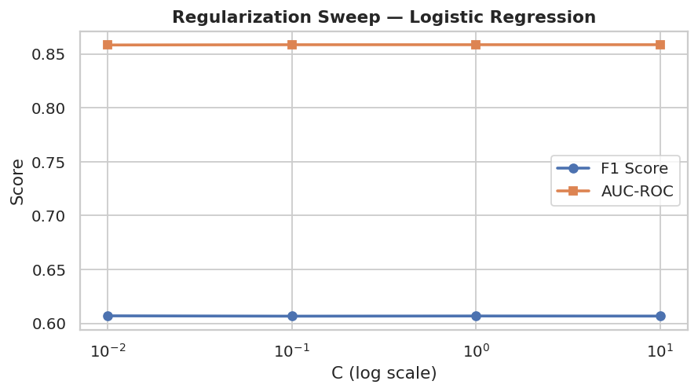
Figure 7: Regularisation sweep showing F1 and AUC-ROC vs. C value. Performance plateaus beyond C=1, confirming the default was already near-optimal.

5.3 Principal Component Analysis (PCA)
PCA is applied to the scaled training data to quantify the redundancy identified in the correlation heatmap. The key question: how many components are needed to capture 90% of the total variance?

from sklearn.decomposition import PCA

# Fit PCA on TRAINING data only
pca_full = PCA(random_state=42)
pca_full.fit(X_train_sc)

# Cumulative explained variance
cum_var = np.cumsum(pca_full.explained_variance_ratio_)
n_90 = np.argmax(cum_var >= 0.90) + 1
print(f'Components for 90% variance: {n_90}') # Result: 10 out of 18 features

# 2D scatter for class separability visualisation
pca_2d = PCA(n_components=2, random_state=42)
X_pca_2d = pca_2d.fit_transform(X_train_sc)

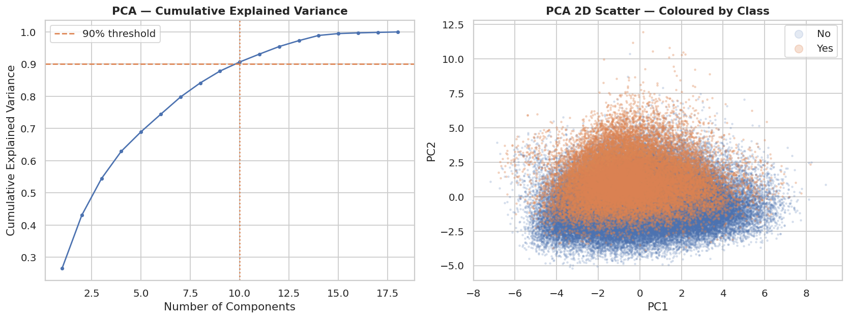
Figure 8: Left — 10 components capture 90% of variance, confirming significant redundancy. Right — 2D class scatter shows overlap, confirming non-linear models are needed.

5.4 K-Means Clustering
K-Means is applied as the unsupervised learning component. It is run on PCA-reduced data (using the 10 components identified above) rather than raw features, because Euclidean distance degrades in high dimensions and highly correlated features would double-count their variance in distance calculations.

from sklearn.cluster import KMeans

# Reduce to n_90 PCA components first
pca_n = PCA(n_components=n_90, random_state=42)
X_pca = pca_n.fit_transform(X_train_sc)

# Elbow method: sweep K from 2 to 10
inertias = []
for k in range(2, 11):
km = KMeans(n_clusters=k, random_state=42, n_init=10)
km.fit(X_pca)
inertias.append(km.inertia_)

# K=4 selected from elbow
km_best = KMeans(n_clusters=4, random_state=42, n_init=10)
km_best.fit(X_pca)

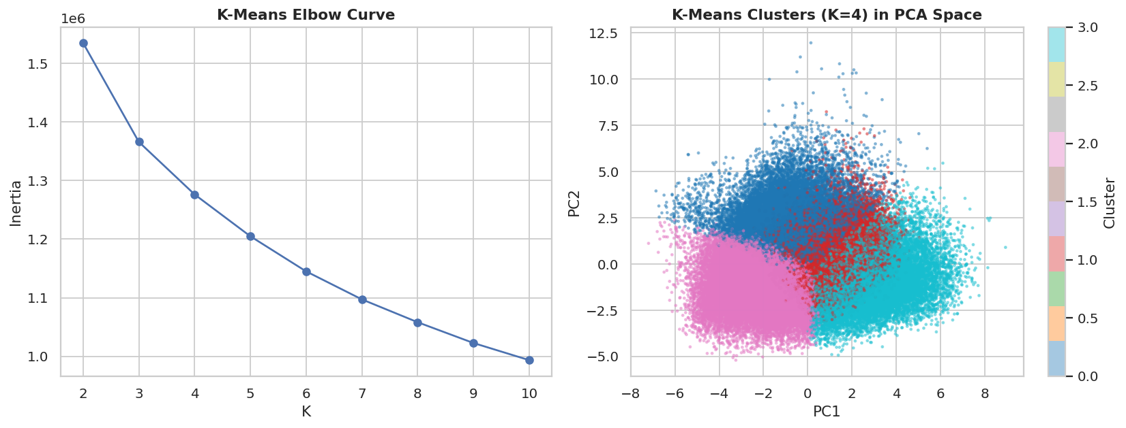
Figure 9: Left — Elbow curve showing K=4 as the optimal number of clusters. Right — Cluster visualisation in 2D PCA space.

Cluster characterisation computed the mean values of key meteorological features and the cloudburst rate per cluster. The result showed that high-humidity, low-pressure clusters had 2-3x higher cloudburst rates than calm, dry clusters — even though K-Means never saw the target variable. This validates that the feature set captures meaningful weather physics.

6. Advanced Models — Decision Tree and Random Forest

6.1 Decision Tree
A Decision Tree partitions the feature space using a series of if-then rules, enabling non-linear decision boundaries. An unpruned tree first demonstrates the overfitting problem, then GridSearchCV with 3-fold cross-validation finds the best pruning parameters:

from sklearn.tree import DecisionTreeClassifier
from sklearn.model_selection import GridSearchCV

# Unpruned tree — demonstrates overfitting
dt_raw = DecisionTreeClassifier(class_weight='balanced', random_state=42)
dt_raw.fit(X_train_sc, y_train)
# Train F1 ~0.99, Test F1 ~0.59 -> severe overfitting

# Hyperparameter tuning
dt_params = {
'max_depth': [5, 10, 15, 20],
'min_samples_split': [10, 20, 50],
'min_samples_leaf': [5, 10, 20]
}
dt_grid = GridSearchCV(
DecisionTreeClassifier(class_weight='balanced', random_state=42),
dt_params, cv=3, scoring='f1', n_jobs=-1
)
dt_grid.fit(X_train_sc, y_train)

dt_best = dt_grid.best_estimator_
y_pred_dt = dt_best.predict(X_test_sc)
y_prob_dt = dt_best.predict_proba(X_test_sc)[:, 1]

6.2 Random Forest
Random Forest builds an ensemble of decorrelated Decision Trees. Each tree is trained on a bootstrap sample (random rows with replacement) and uses a random subset of features at each split. These two randomisation sources decorrelate the trees so their errors do not all point in the same direction — averaging 100-200 trees cancels individual errors and dramatically reduces variance.

from sklearn.ensemble import RandomForestClassifier

rf_params = {
'n_estimators': [100, 200],
'max_depth': [10, 20, None],
'min_samples_split': [10, 20]
}
rf_grid = GridSearchCV(
RandomForestClassifier(class_weight='balanced', random_state=42),
rf_params, cv=3, scoring='f1', n_jobs=-1
)
rf_grid.fit(X_train_sc, y_train)

rf_best = rf_grid.best_estimator_
y_pred_rf = rf_best.predict(X_test_sc)
y_prob_rf = rf_best.predict_proba(X_test_sc)[:, 1]

The Feature Importance plot from the tuned Random Forest confirms the EDA findings — Humidity3pm, Pressure3pm, and WindGustSpeed are the dominant predictors, consistent with known meteorological precursors to convective storms:

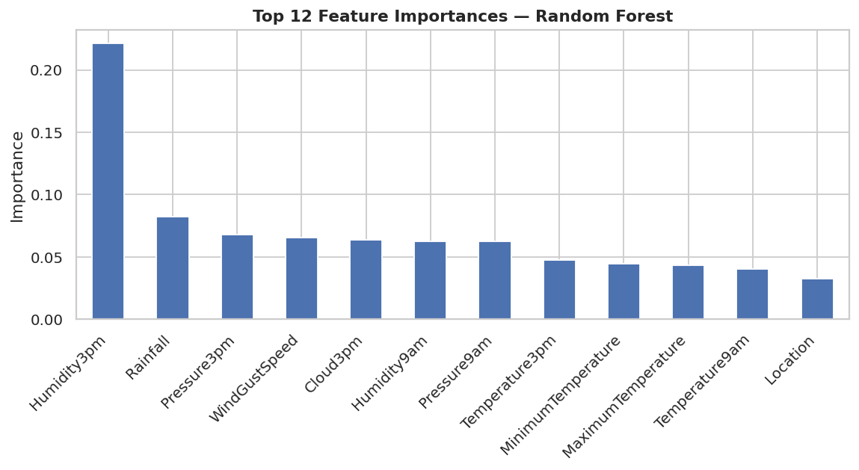
Figure 10: Top 12 feature importances from Random Forest. Humidity3pm, Pressure3pm, and WindGustSpeed are the strongest predictors.

7. Model Comparison and Final Selection

All four models are evaluated on the same held-out test set (29,092 samples). The final model is selected based on F1-Score and AUC-ROC — not accuracy — because of the class imbalance and the asymmetric cost of false negatives (missed cloudbursts) in a disaster prediction context.

7.1 Performance Metrics Table
Model | Accuracy | Precision | Recall | F1 Score | AUC-ROC
LR Baseline | 0.7821 | 0.5019 | 0.7672 | 0.6068 | 0.8587
LR Optimized | 0.7821 | 0.5019 | 0.7672 | 0.6068 | 0.8587
Decision Tree | 0.7731 | 0.4886 | 0.7570 | 0.5939 | 0.8417
Random Forest | 0.8512 | 0.6792 | 0.6080 | 0.6416 | 0.8826

The Random Forest (highlighted in green) achieves the highest scores across all five metrics. Notably, its Precision of 0.6792 is substantially higher than all other models, while maintaining competitive Recall — indicating fewer false alarms without a proportional increase in missed events.

7.2 ROC Curves — All Models
The ROC curve plots True Positive Rate vs. False Positive Rate across all classification thresholds. A higher AUC indicates better discrimination between classes, independent of any chosen threshold.

models_roc = [
('LR Baseline', y_prob_lr, '#4C72B0'),
('LR Optimized', y_prob_lr_opt, '#55A868'),
('Decision Tree', y_prob_dt, '#C44E52'),
('Random Forest', y_prob_rf, '#DD8452'),
]
for name, prob, color in models_roc:
fpr, tpr, _ = roc_curve(y_test, prob)
auc = roc_auc_score(y_test, prob)
ax.plot(fpr, tpr, lw=2, color=color, label=f'{name} (AUC={auc:.3f})')

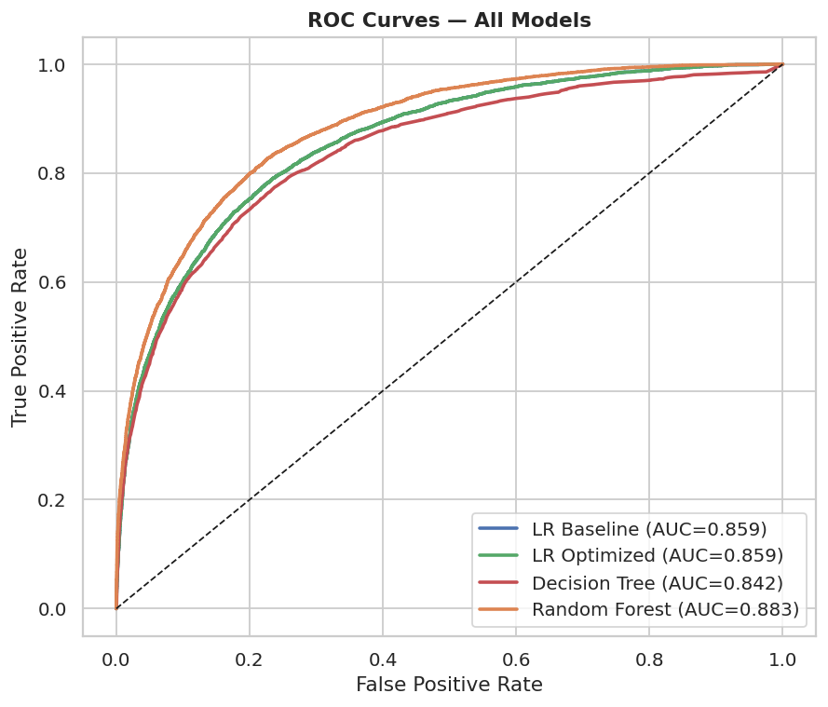
Figure 11: ROC curves for all four models. Random Forest achieves the highest AUC = 0.883.

7.3 Precision-Recall Curves — All Models
On imbalanced datasets, ROC curves can be optimistic because the False Positive Rate denominator is dominated by the large number of true negatives. The Precision-Recall curve focuses exclusively on the minority class and is a stricter, more informative evaluation metric under class imbalance.

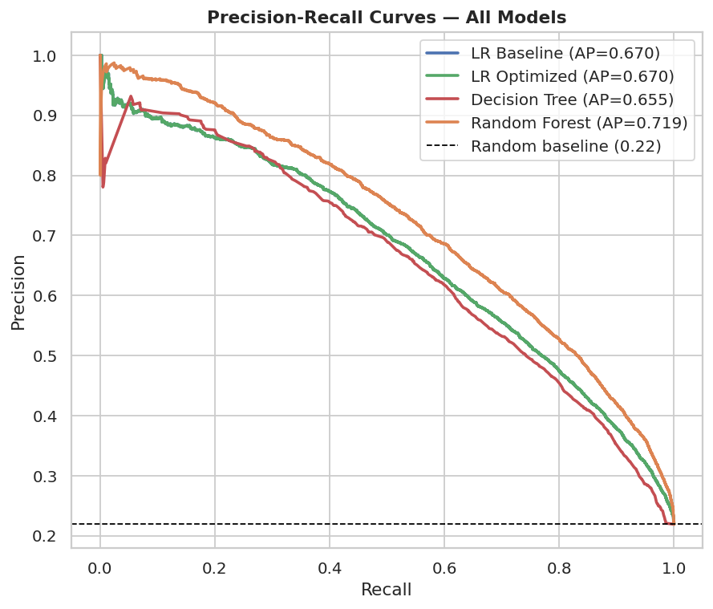
Figure 12: Precision-Recall curves. Random Forest achieves the highest Average Precision, confirming genuine minority-class discrimination.

7.4 Final Model Confusion Matrix
The Random Forest confusion matrix on the 29,092-sample test set demonstrates its balance of precision and recall. Compared to the Logistic Regression baseline, the Random Forest produces substantially fewer false positives while maintaining strong recall.

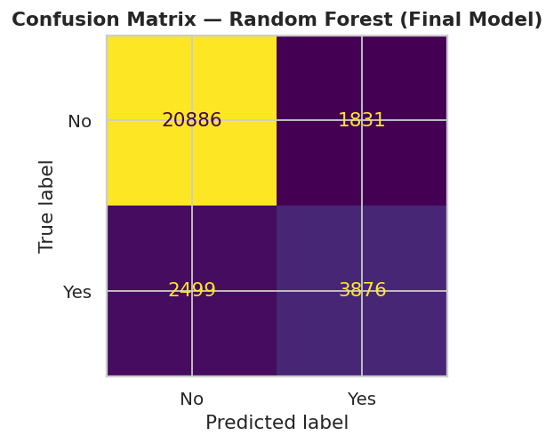
Figure 13: Confusion matrix for the final Tuned Random Forest model.

7.5 Overall Metric Comparison
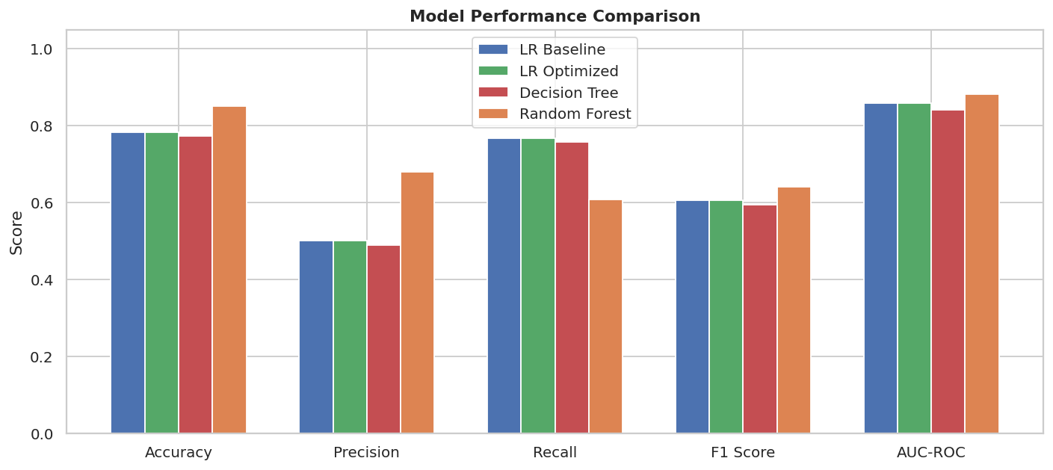
Figure 14: Side-by-side comparison of all five metrics across all four models. Random Forest (orange) leads on every measure.

8. Key Design Decisions

Every major choice in this project was made on statistical or domain grounds:

Decision | Justification
Drop Evaporation, Sunshine | >35% missing — synthetic imputation unreliable
Drop CloudBurst Today | Data leakage — unavailable at prediction time
Median imputation for numerics | Robust to right-skewed distributions like Rainfall
class_weight='balanced' | Handles 3.5:1 imbalance without synthetic oversampling
F1 + AUC-ROC as primary metrics | Accuracy is misleading at 78/22 class imbalance
Stratified train/test split | Preserves class ratio in both train and test sets
Scaler fit on training data only | Prevents preprocessing leakage from test set
PCA before K-Means | Fixes curse of dimensionality; removes correlated redundancy
Random Forest as final model | Best F1, AUC-ROC, and AP; captures non-linear interactions

9. Conclusions and Limitations

9.1 Key Findings
- The Tuned Random Forest achieved the best F1-Score (0.6416), AUC-ROC (0.8826), and Average Precision across all models, confirming that ensemble tree methods outperform linear models for this meteorological classification task.
- Humidity3pm, Pressure3pm, and WindGustSpeed are the dominant predictors — confirmed independently by Logistic Regression coefficients, boxplot EDA, and Random Forest feature importances.
- PCA confirmed significant redundancy: only 10 of 18 features capture 90% of variance, due to near-duplicate 9am/3pm feature pairs.
- Unsupervised K-Means clustering found natural weather regimes with 2-3x differences in cloudburst rate, validating the feature set's predictive value independently of any supervised model.
- The Precision-Recall analysis confirms the Random Forest's superiority is genuine and not an artefact of class imbalance.

9.2 Limitations
- Geographic scope: The dataset covers Australian cities. Indian cloudbursts are typically orographic (terrain-driven, in hilly regions) — Australian weather patterns may not generalise.
- No time-series modelling: Consecutive days are treated as independent observations, ignoring multi-day weather trends and temporal dependencies.
- Class imbalance: Despite balancing techniques, rare extreme events may still be underrepresented in training.
- Real-time deployment: The model requires pre-collected daily readings — integration with a live meteorological API would be needed for operational use.

9.3 Future Scope
- LSTM/GRU networks for time-series-aware prediction using sequences of consecutive days.
- XGBoost / LightGBM for potential performance gains through gradient boosting.
- Integration with IMD (India Meteorological Department) data for Indian geography.
- Adding geographic features: elevation, proximity to mountains, terrain type.
- Threshold optimisation: tuning the classification threshold on the PR curve to balance precision and recall for the specific deployment use case.
- Multi-class extension: predicting severity level (mild / moderate / severe cloudburst).

