**Scaling the EC2 Instance Based on Monitored Cloud Watch Metrics:**

Tools required**:**AWS Services - Cloud Watch, Auto Scaling, EC2

**Step 1**: Logged into AWS account and created a Auto Scaling Group

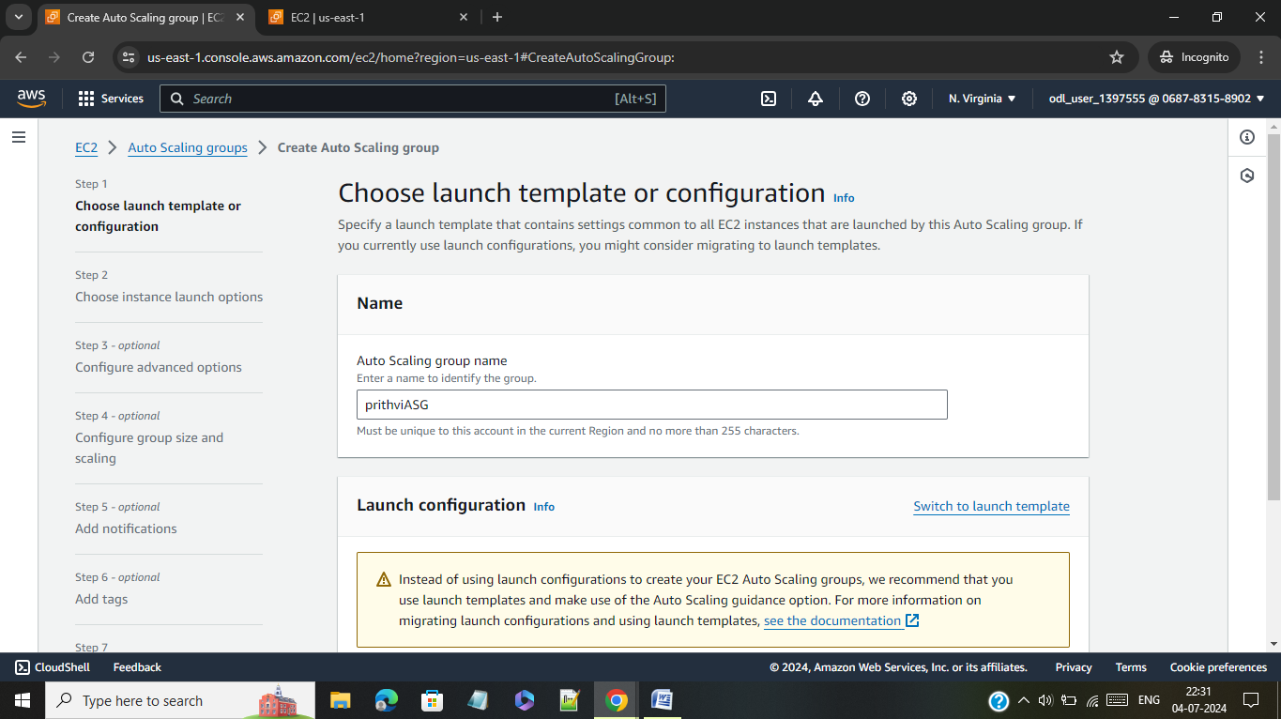

**Step 2**: Launched a Template of Amazon Linux free tier eligible

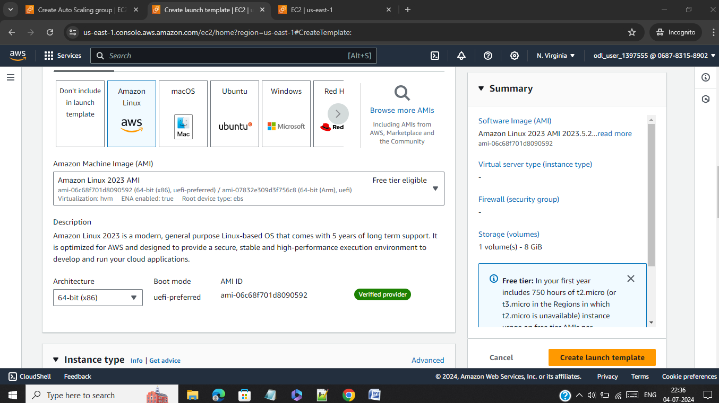

**Step 3**: Launched Template with instance type t2.micro free tier eligible

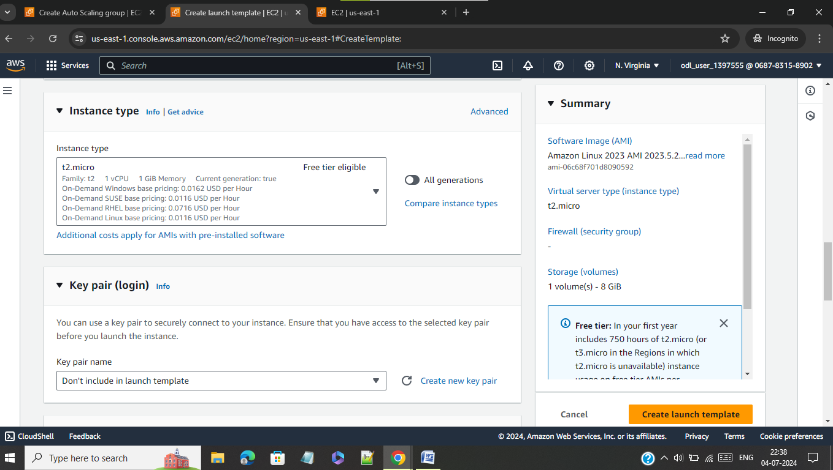

**Step 4**: Created a key pair for the Template

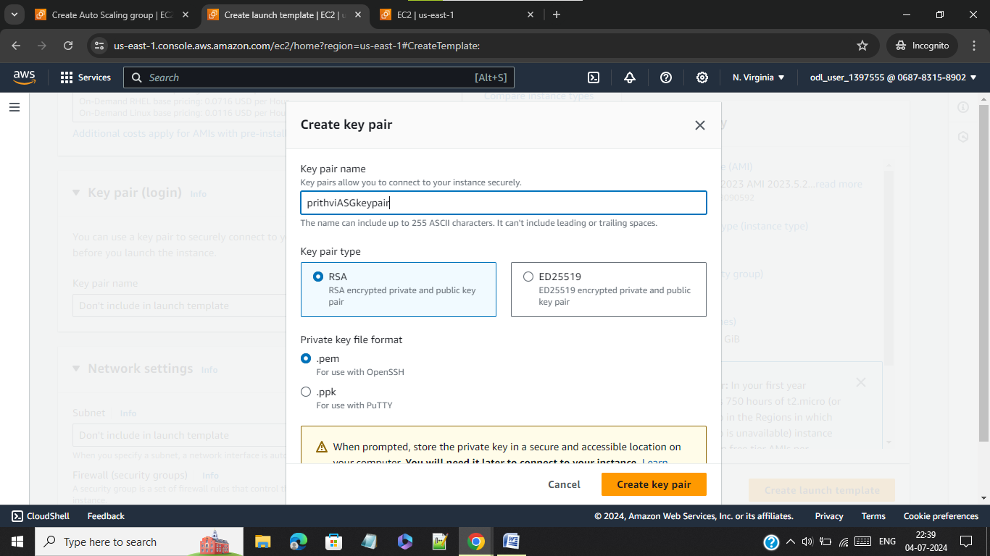

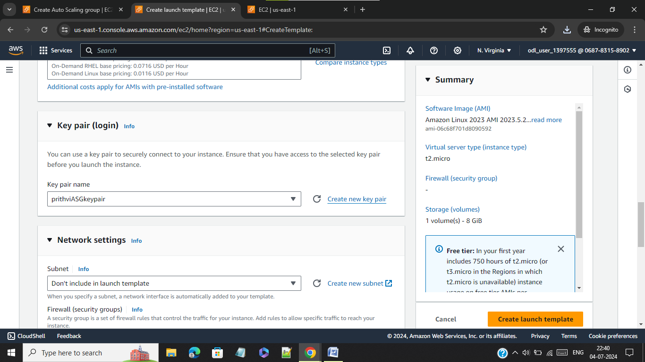

**Step 5**: Created a new security group for the Template and added ssh and http in inbound firewall setting.

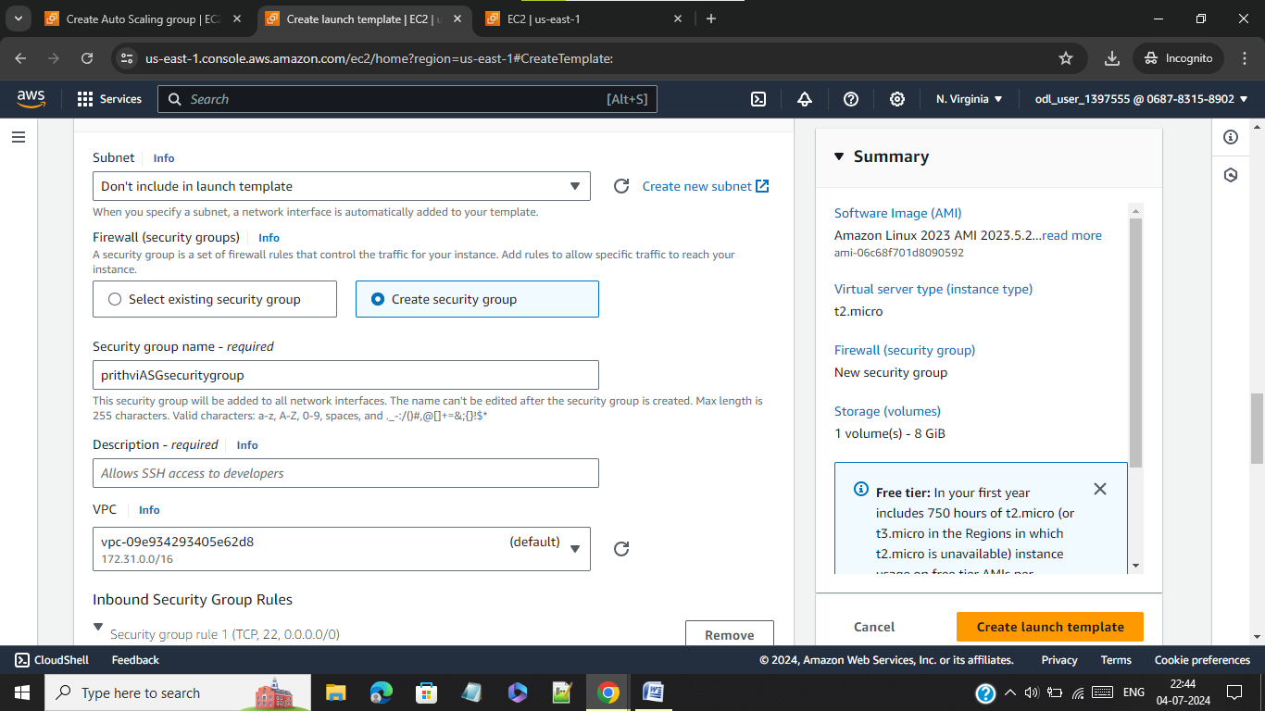

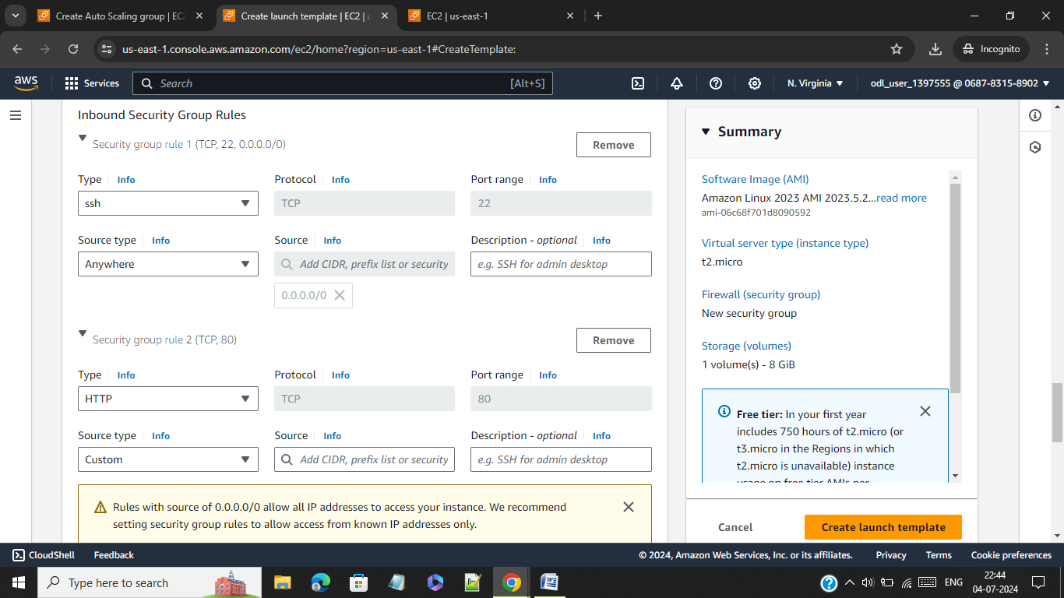

**Step 6**: Successfully created template

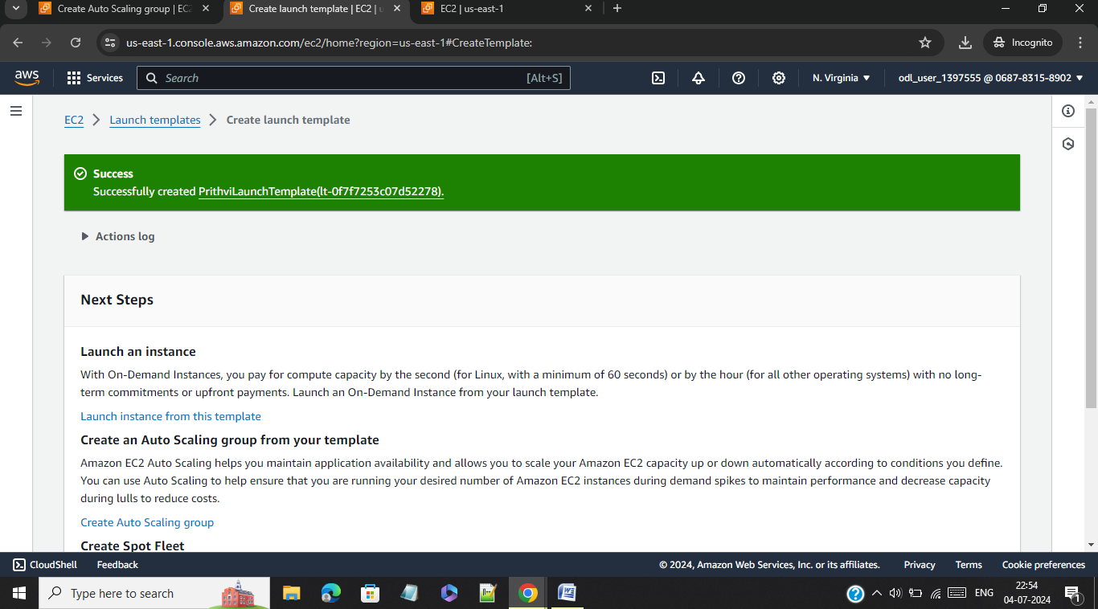

**Step 7**: In this step I have configured Network settings with subnets

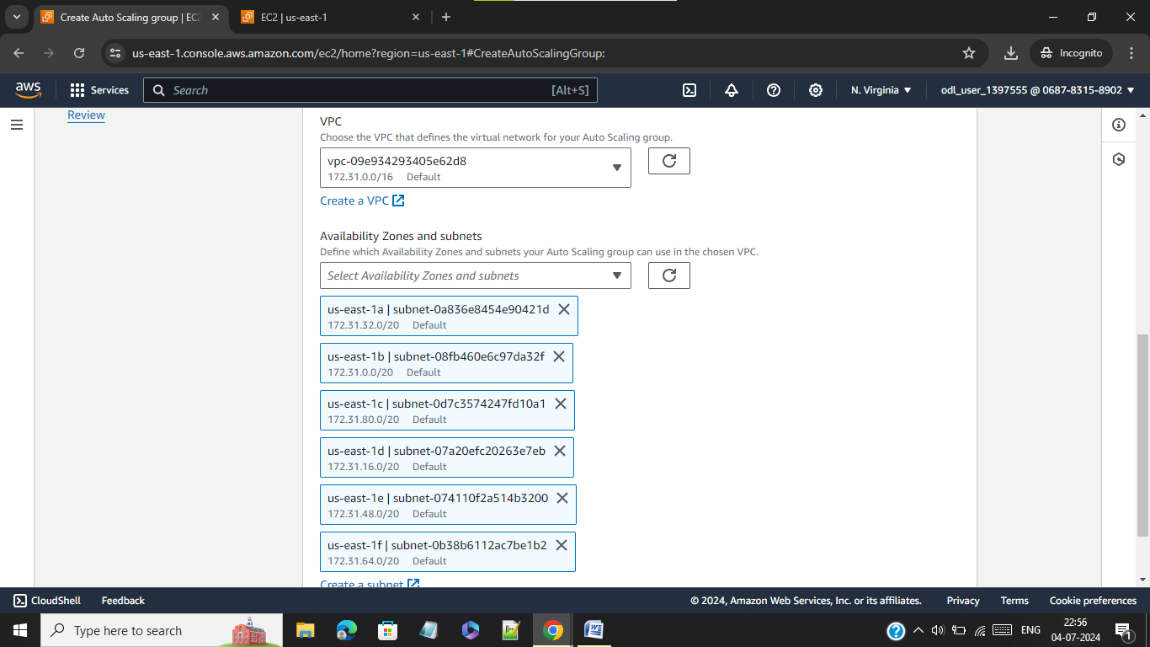

**Step 8**: Attached a application load balancer to the template with Health check of target group

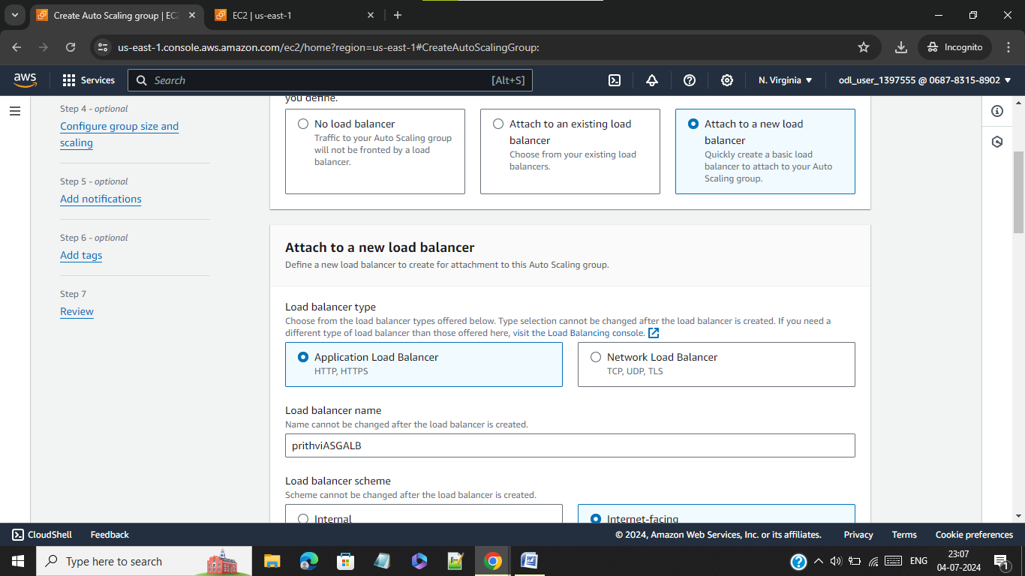

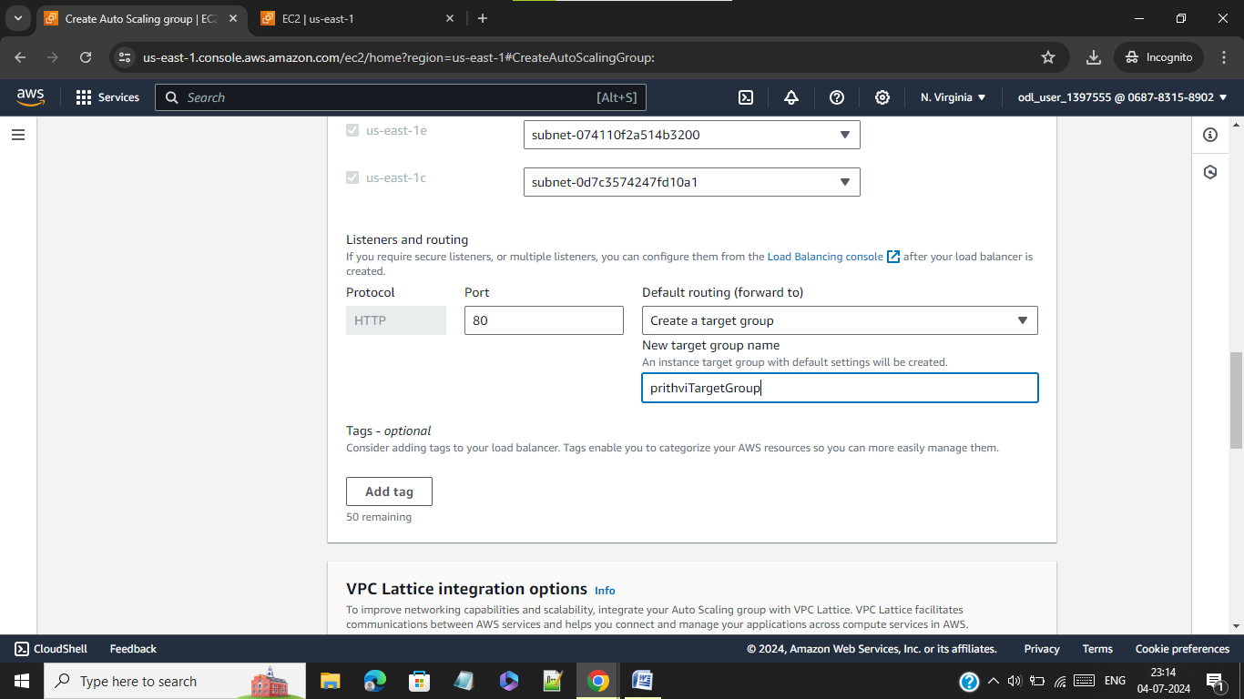

**Step 9**: Configured group size and scaling option with desired capacity of 3 units, minimum desired capacity of 2 and maximum capacity of 5

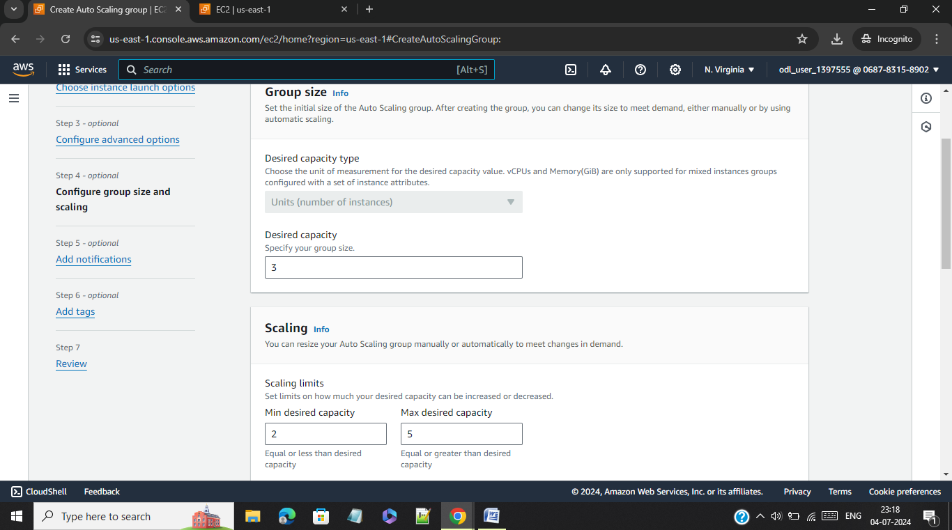

**Step 10**: Enabled auto scaling group and 3 instances are running now.

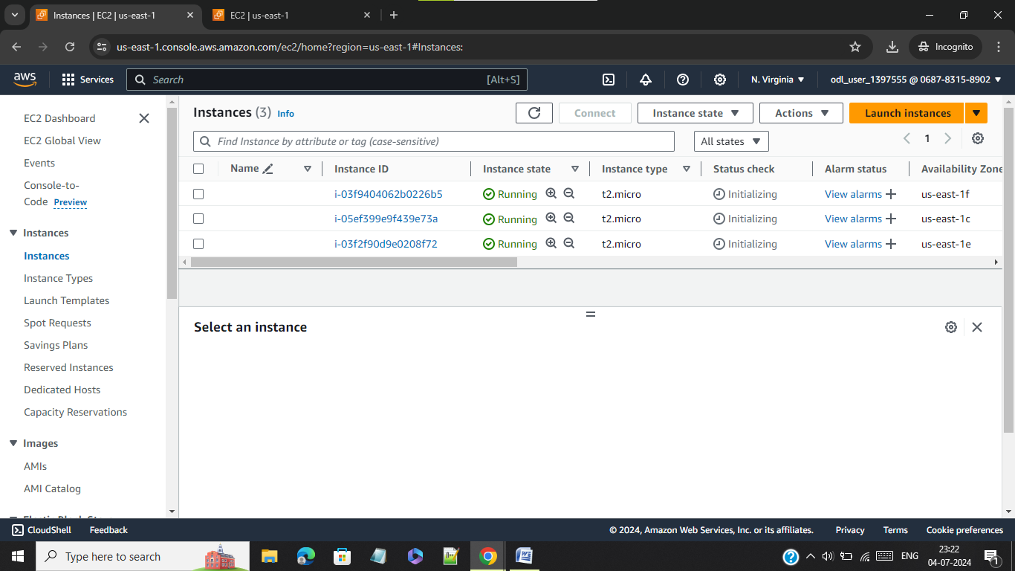

**Step 11**: Load balancer target group health check.

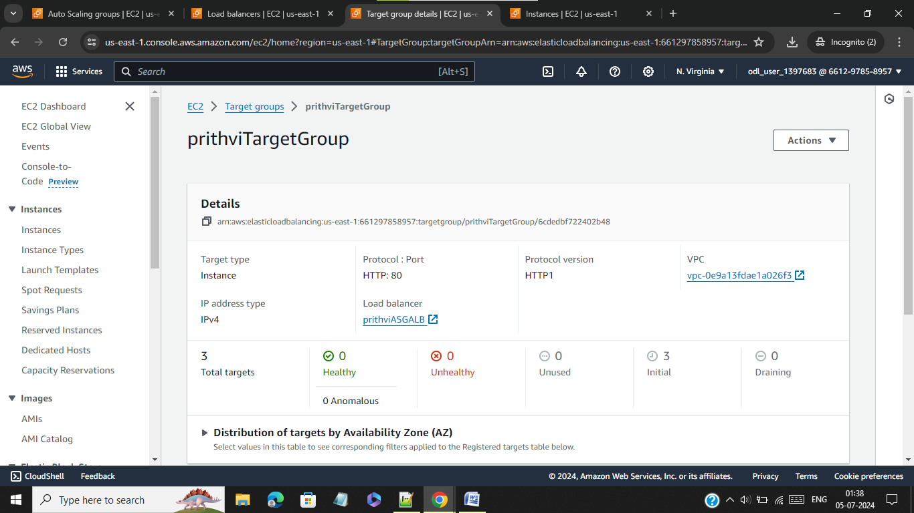

**Step 12**: Auto scaling is working properly as I deliberately terminated a instance auto scaling group has replaced it with new instance

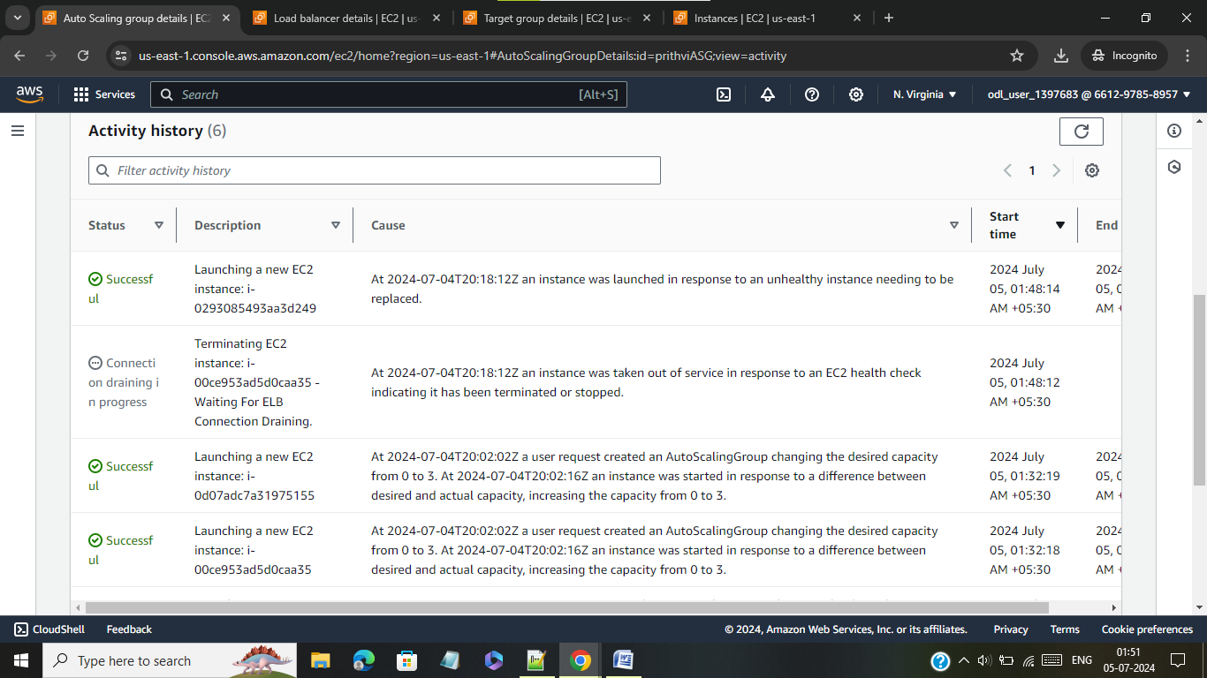

**Step 13**: Have created dynamic scaling policy under ASG and given the criteria as avg cpu utilization of 60

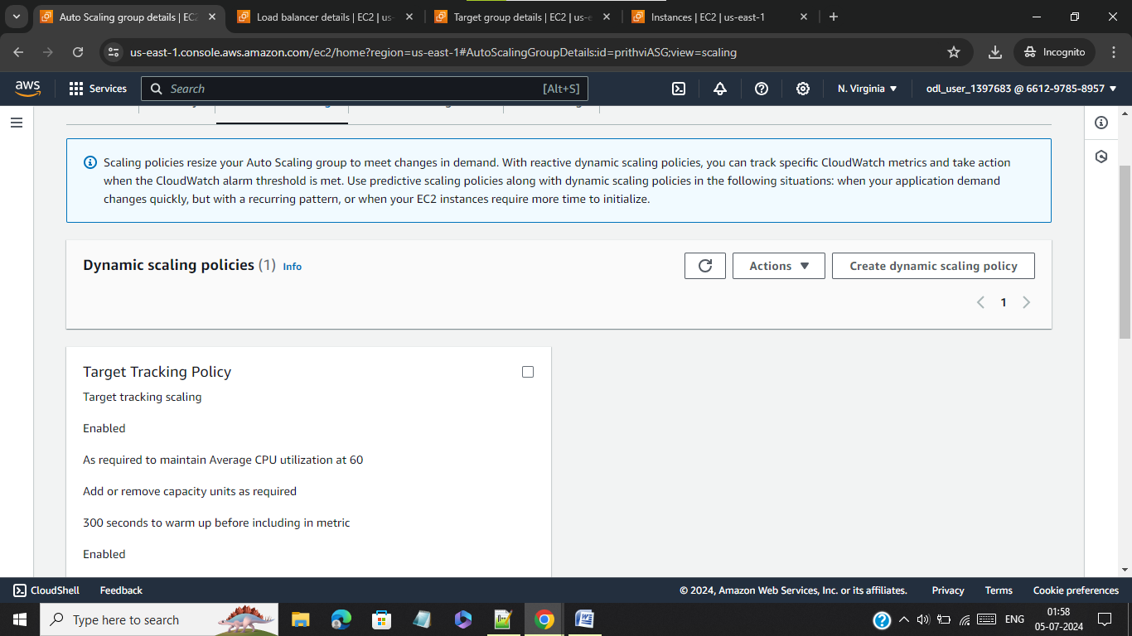

**Step 14**: The dynamic scaling policy is captured under cloud watch it has created 2 alarms one is high alarm another is low alarm. Since there are no applications running in the instances so alarm low is triggered.

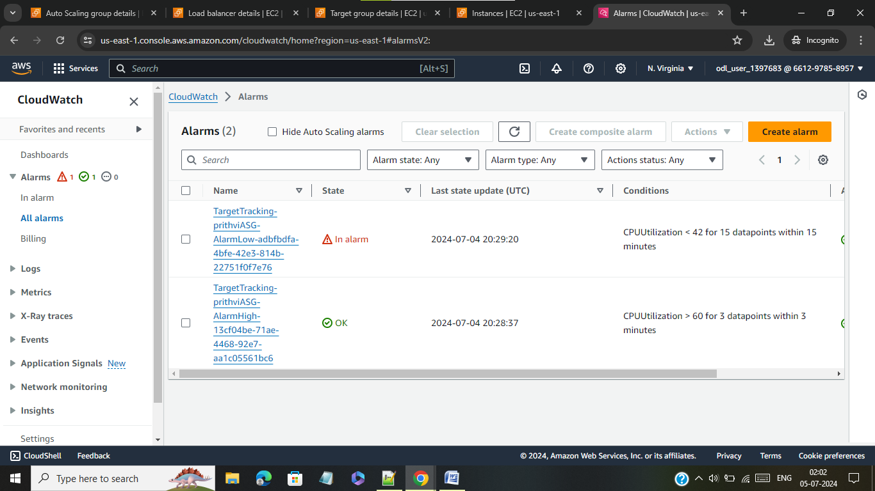

**Step 15**: Since we have given criteria as minimum 2 instances and maximum 5 instances during building auto scaling policy one instance have been terminated because of low usage of cpu and low usage alarm is triggered.

