Algorithms_Data Structures (Mandatory Hands On)
Exercise 2: E-commerce Platform Search Function
Big O Notation is a mathematical way to describe the time or space complexity of an algorithm in terms of input size n. It focuses on the growth rate as input increases, helping us analyze and compare algorithms for performance.
Complexity | Name | Example Use Case
O(1) | Constant time | Accessing an array element by index
O(n) | Linear time | Linear search in an array
O(log n) | Logarithmic time | Binary search on a sorted array
O(n²) | Quadratic time | Bubble sort, nested loops on array

Search Type | Best Case | Average Case | Worst Case
Linear Search | O(1) | O(n/2) ≈ O(n) | O(n)
Binary Search | O(1) | O(log n) | O(log n)

Code:
Product.cs
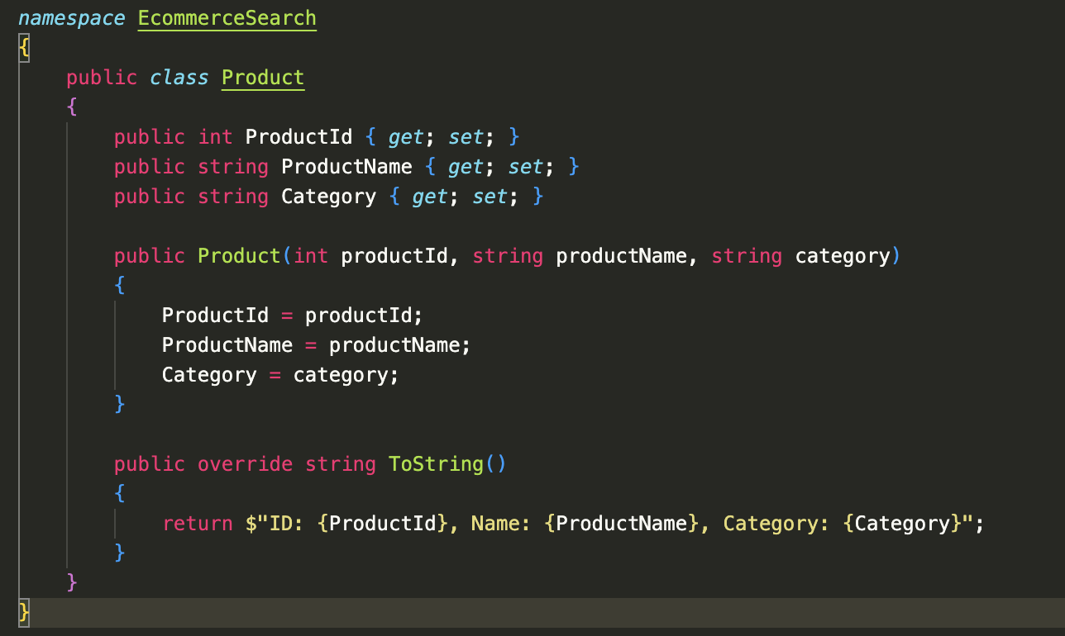
SearchAlgorithms.cs
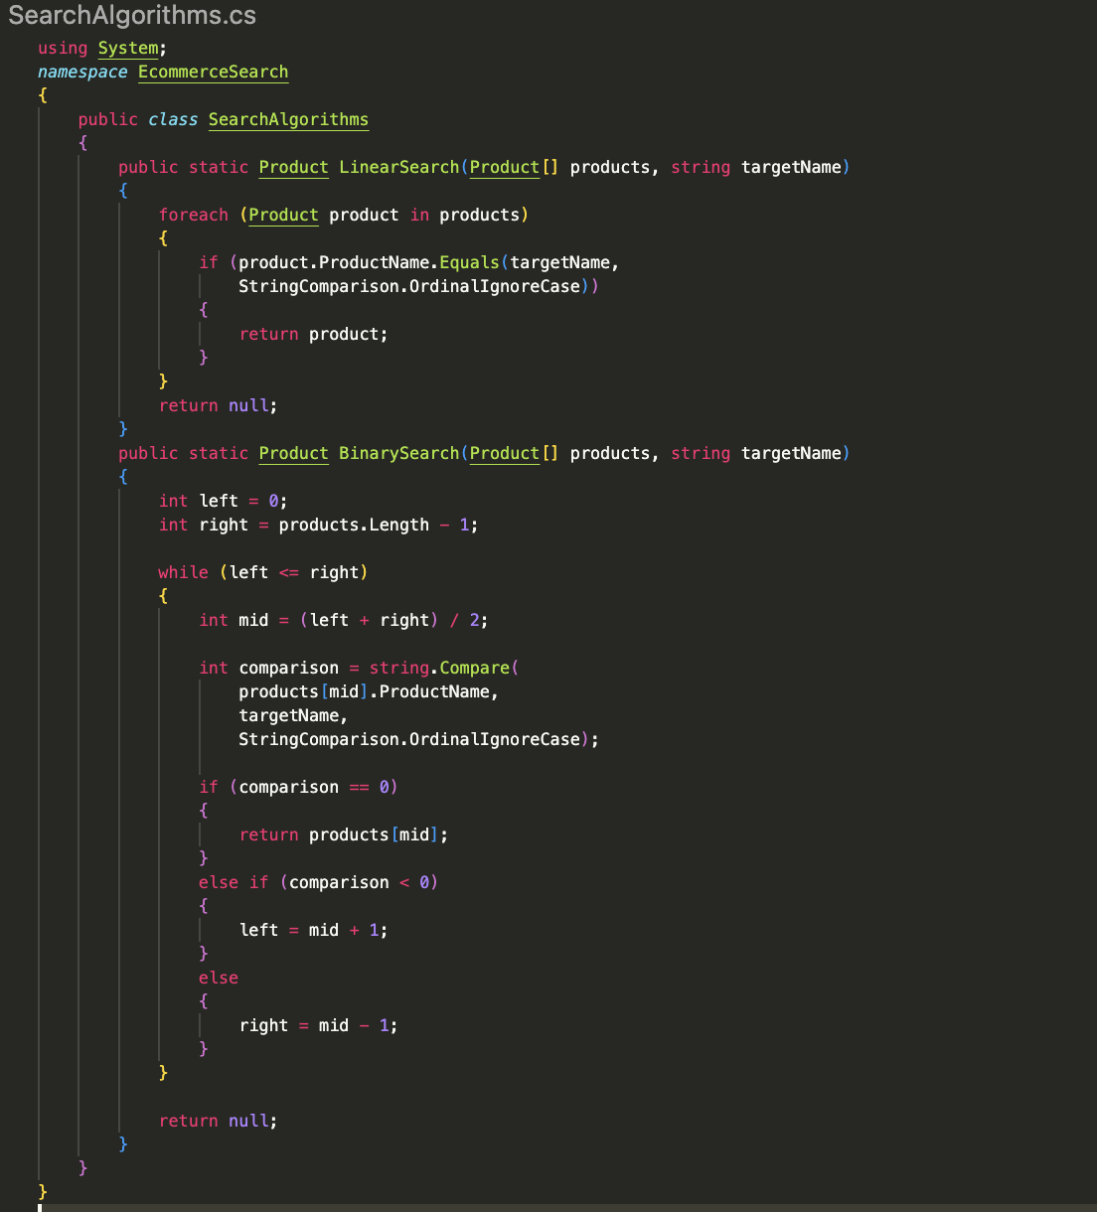
Program.cs
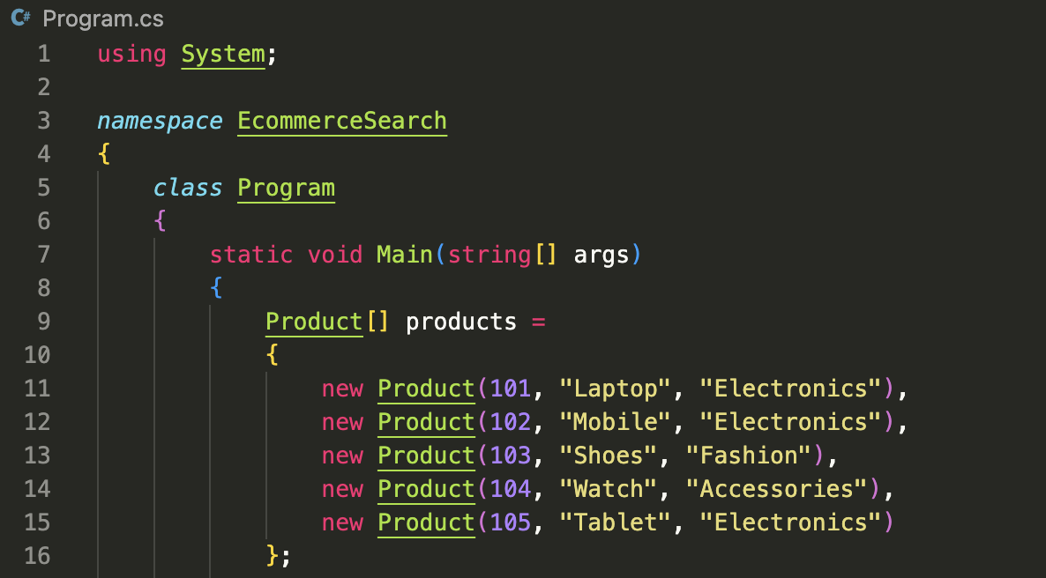

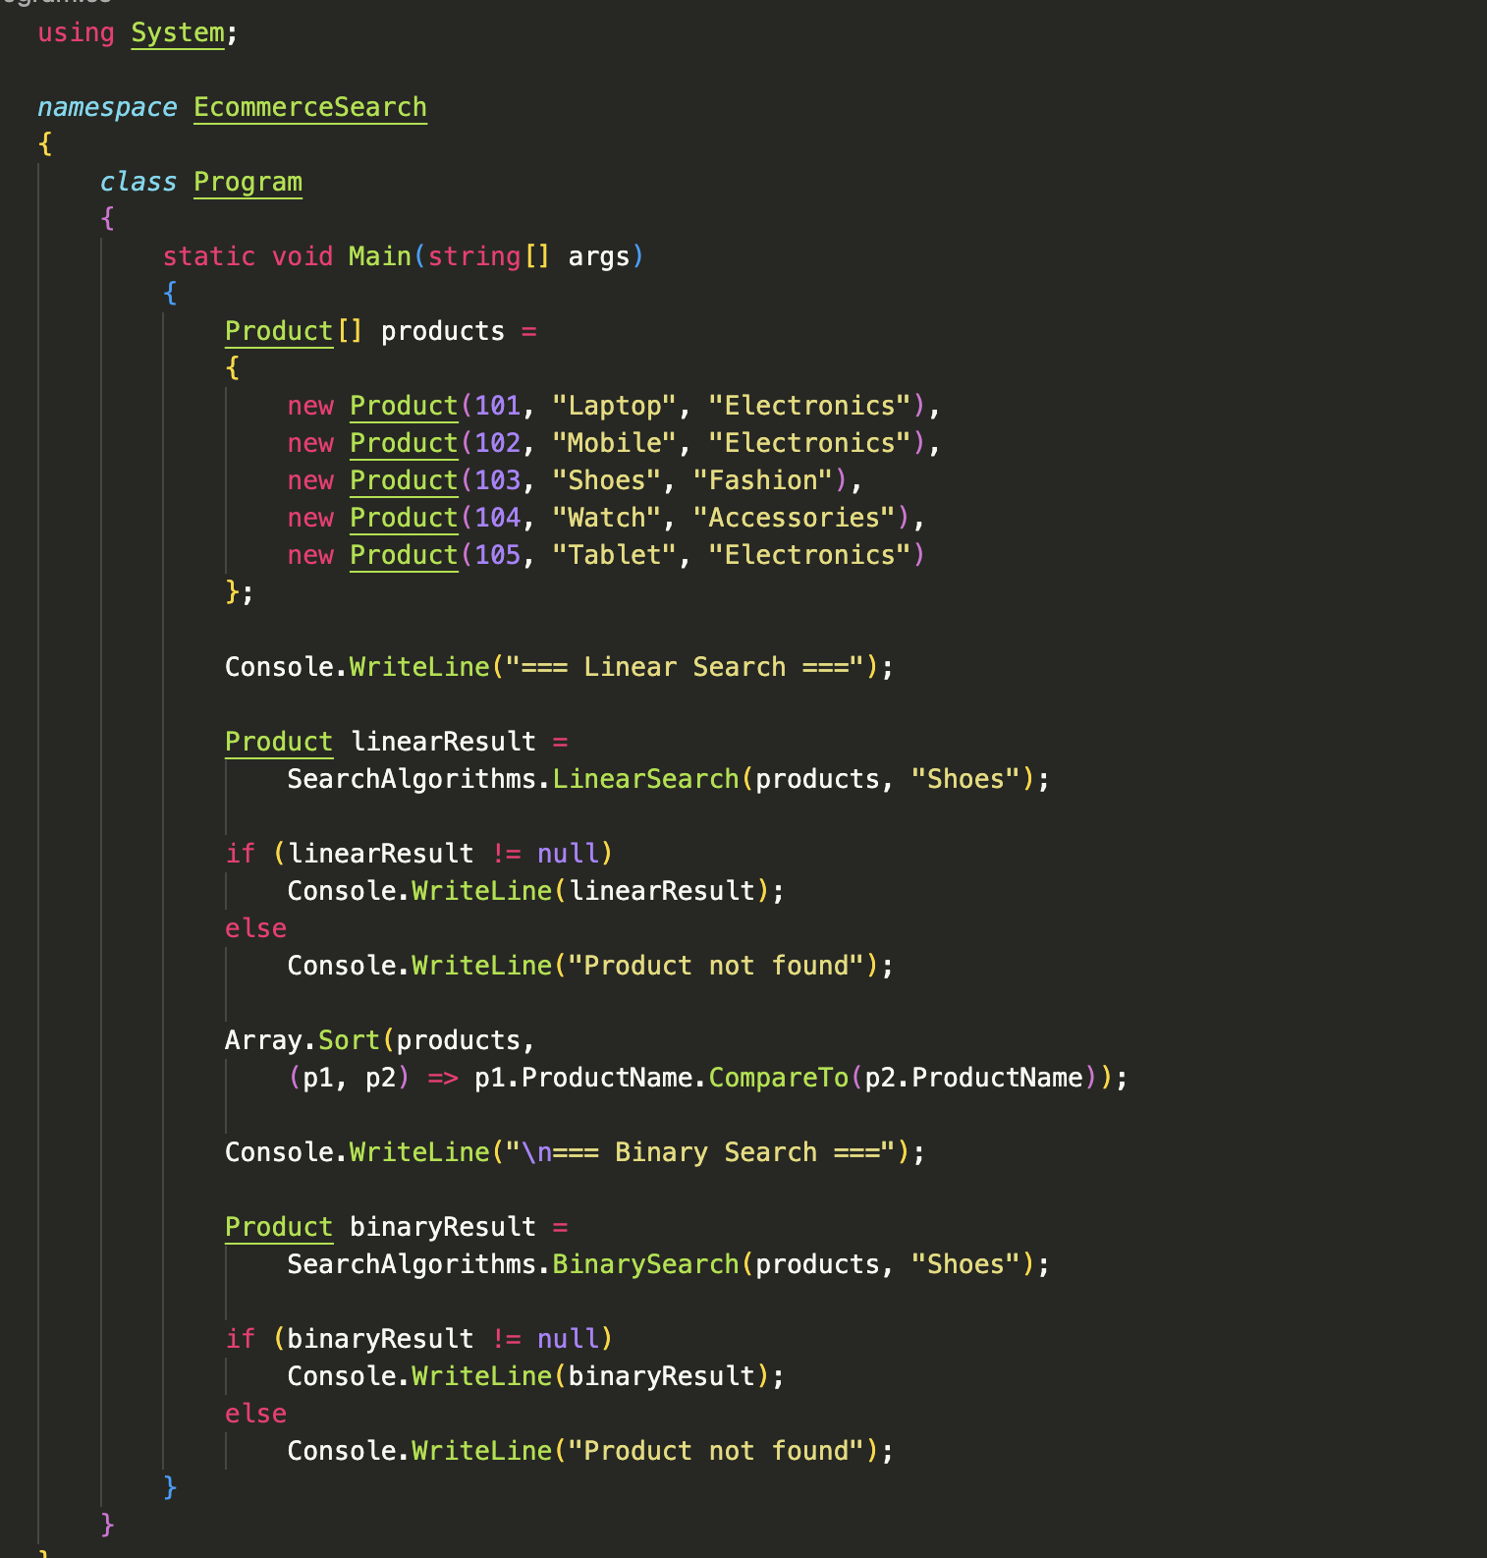
Output:
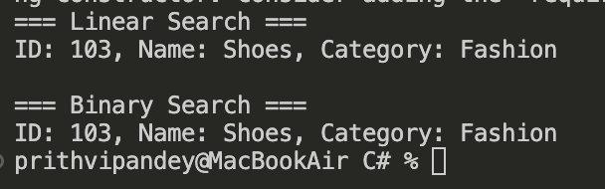
Algorithm | Time Complexity | Sorted Required | Suitability
Linear Search | O(n) | No | Simple, but slower for large data
Binary Search | O(log n) | Yes | Much faster, efficient, but requires sorting

Exercise 7: Financial Forecasting
Recursion is a programming technique where a method calls itself to solve a smaller version of the same problem until a base condition is reached.
Advantages
Simplifies complex problems.
Makes code shorter and easier to understand.
Useful for mathematical calculations and forecasting models.
Code:
FinancialForecast.cs
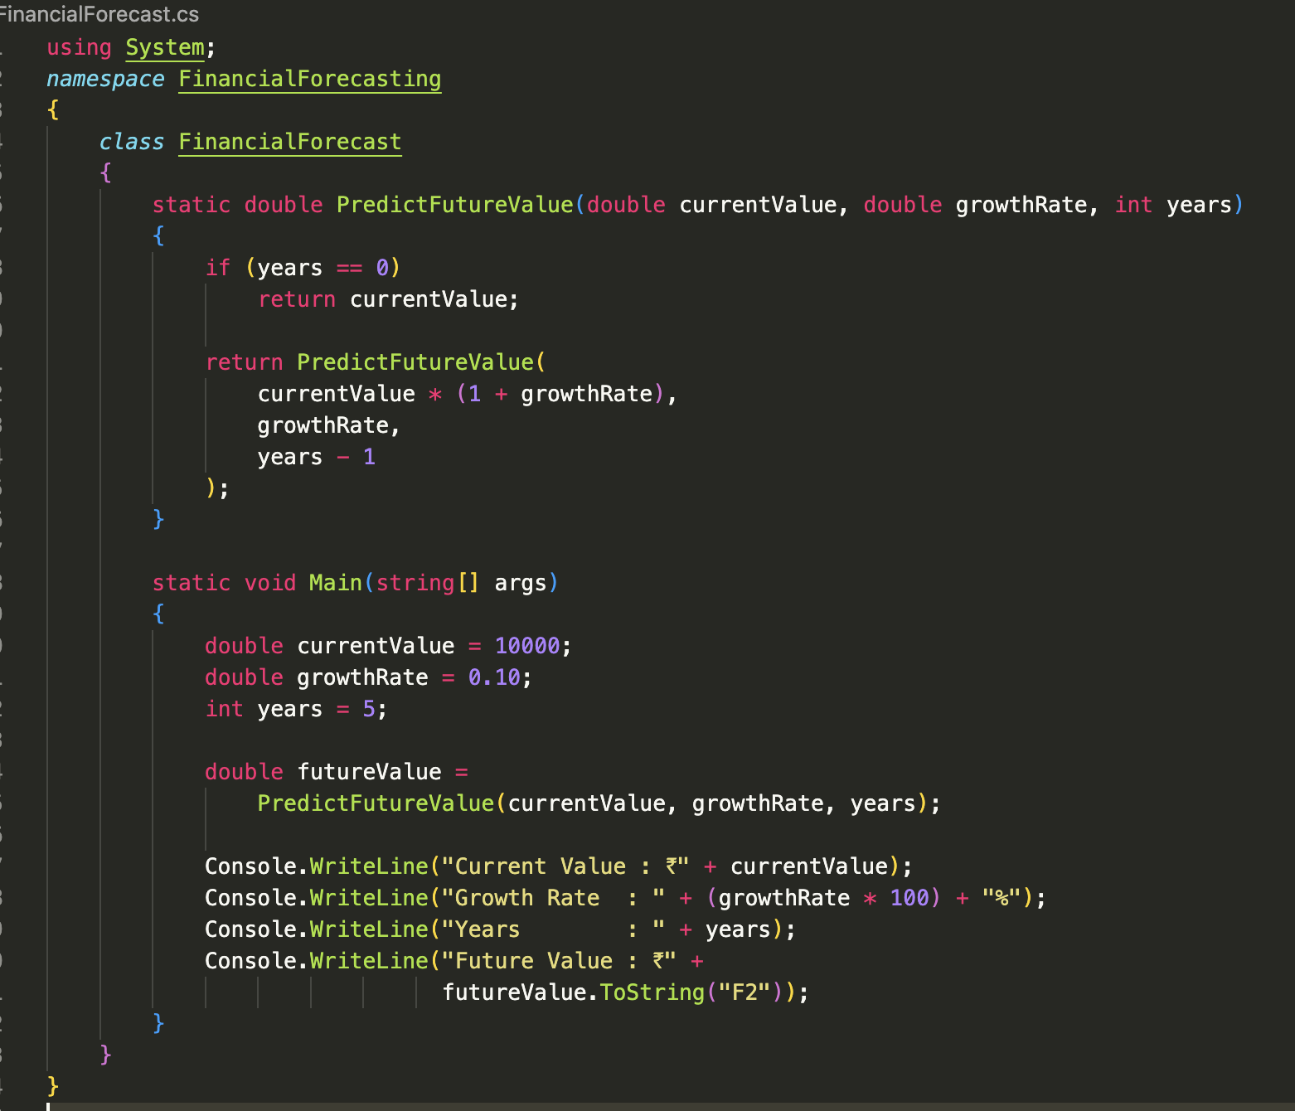
Output:
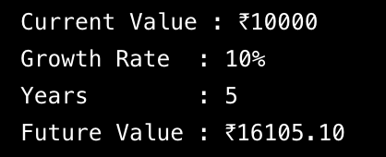

Time Complexity Analysis

Recursive Algorithm
For each year, one recursive call is made.
T(n) = T(n-1) + O(1)
Therefore:
Time Complexity = O(n)
where n = number of years.

Space Complexity
The recursion stack stores one call per year.
Space Complexity = O(n)

