Advance SQL Server(Mandatory + Additional HandsOn)
Exercise 1 : Ranking and Window Function
Scenario:
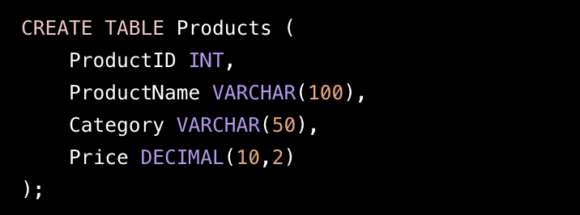
Using ROW_NUMBER ()
- Assigns a unique rank within each category.
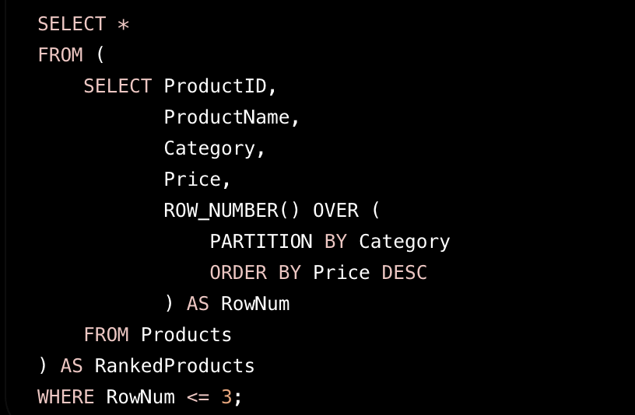
Using RANK ()
- Handles ties by giving the same rank and skipping the next rank.
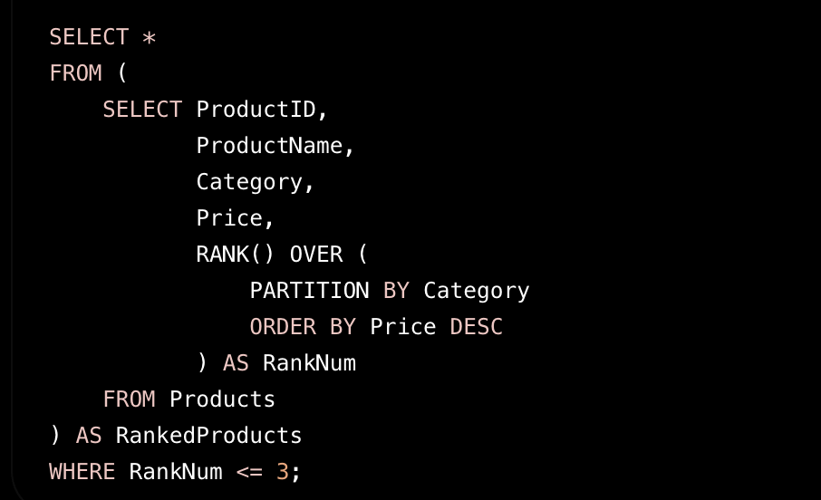
Using DENSE_RANK ()
- Handles ties without skipping ranks.
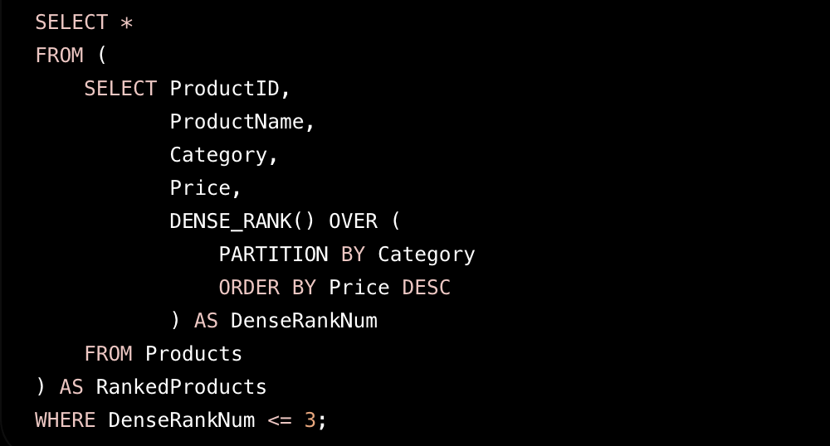
Stored Procedure
Exercise 1 : Create a Stored Procedure
Get Employees by Department
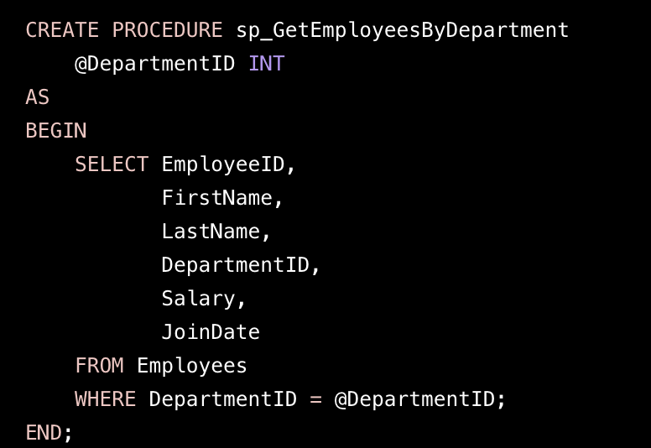
Execute the Procedure
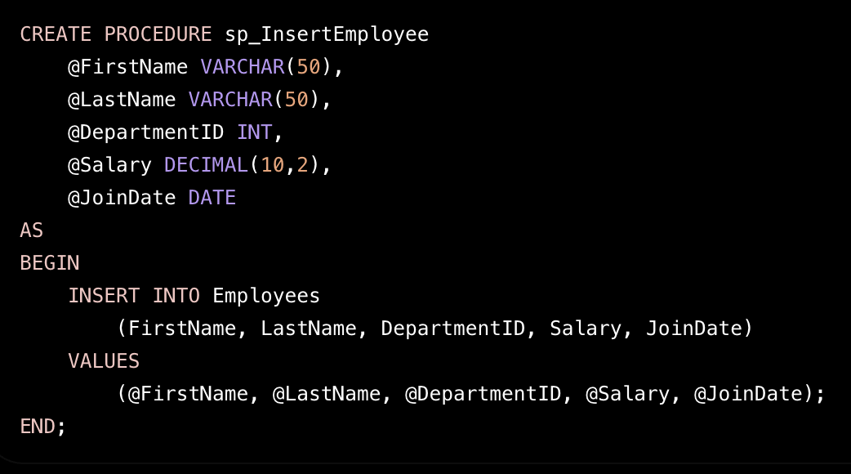
Execute the Insert Procedure
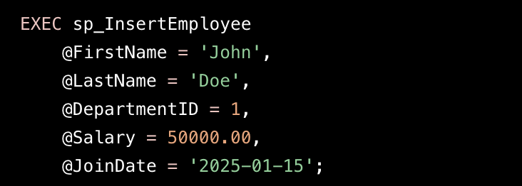

Exercise 5 : Return Data From Stored Procedure
Count Employees in a Department
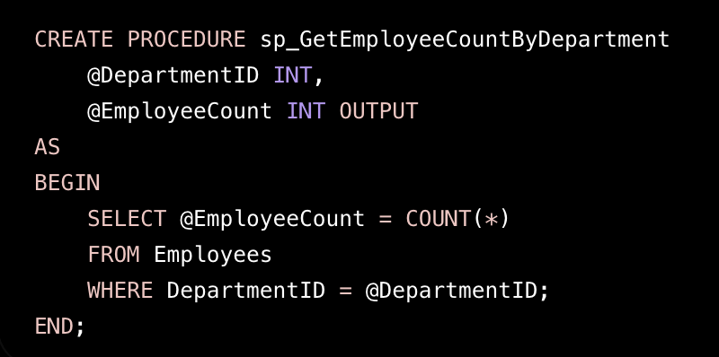
Execution
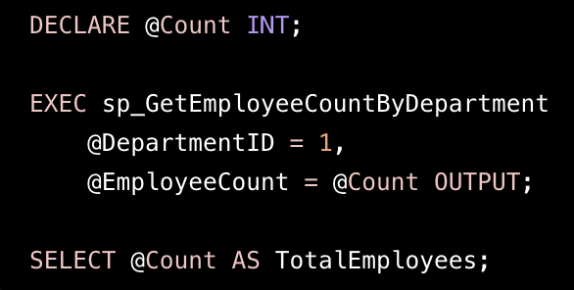
Output:

TotalEmployees
3

