Design Patterns and Principles (Mandatory Hands On)
Exercise 1: Implementing the Singleton Pattern
Logger.java
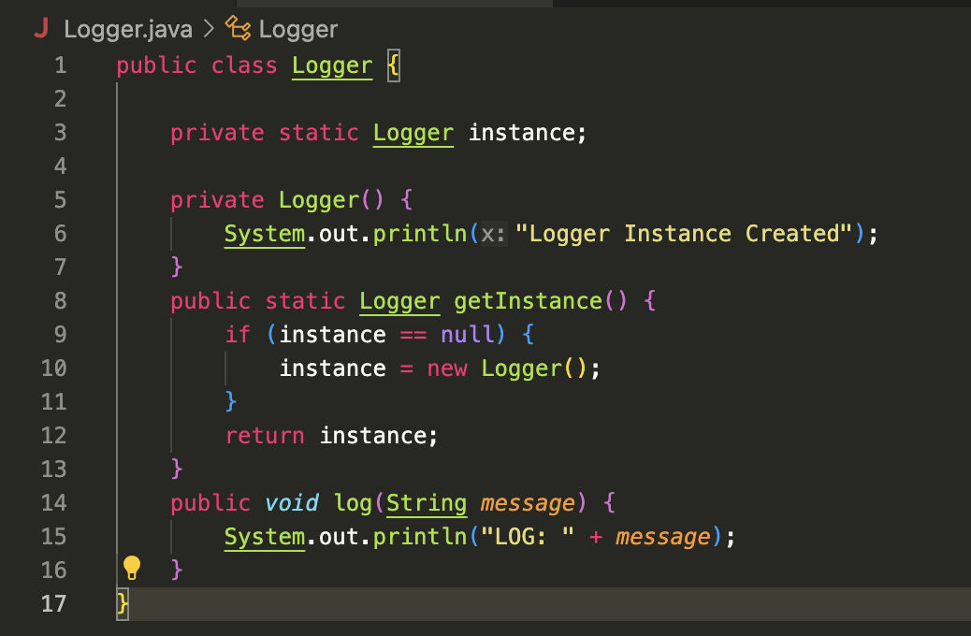

SingletonTest.java
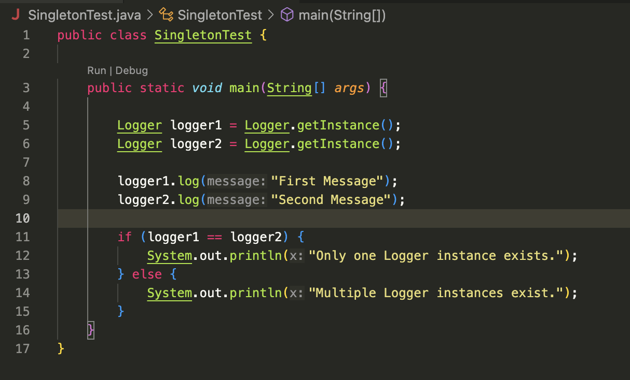

Output:
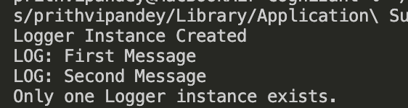

Exercise 2: Implementing the Factory Method Pattern
Document.java
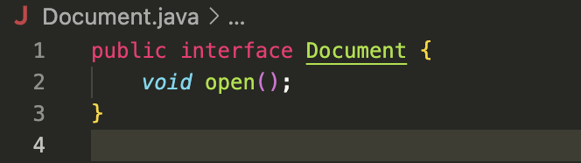
DocumentFactory.java

WordDocumnet.java
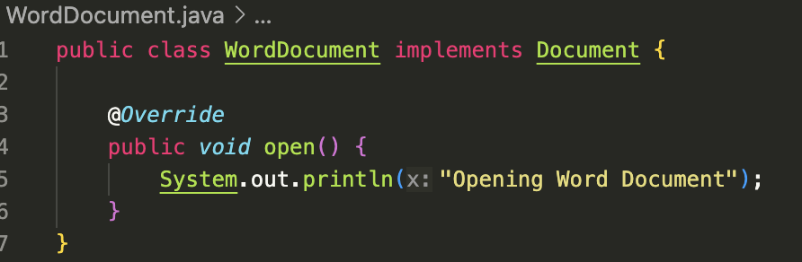
PdfDocument.java
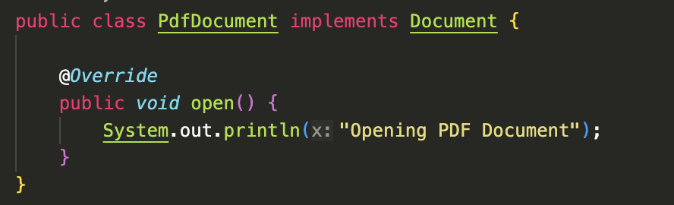
ExcelDocument.java
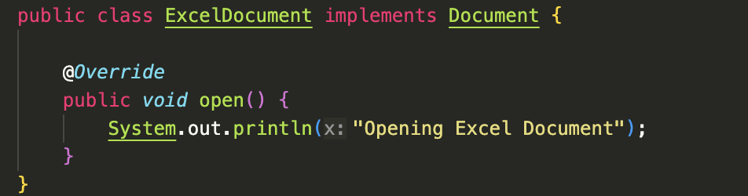
WordFactory.java
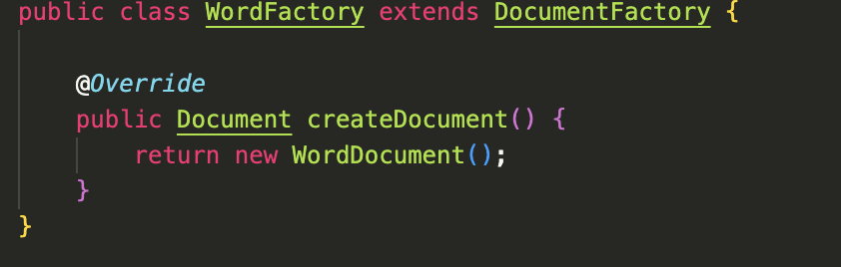
PdfFactory.java
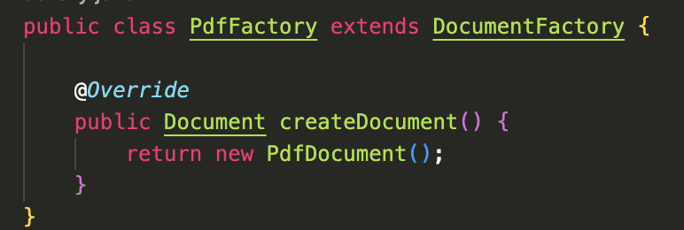
ExcelFactory.java
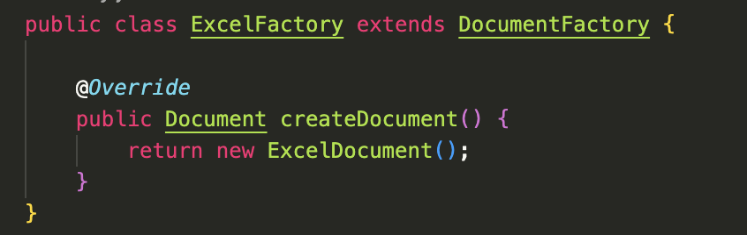
FactoryMethodDemo.java or Test File
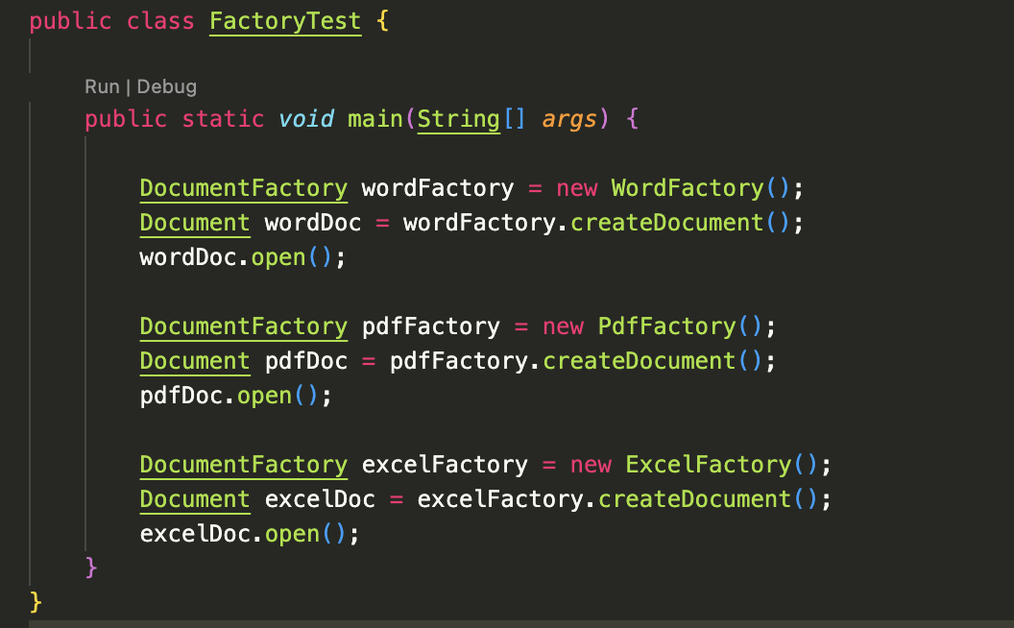
Output:
