|  |  |
| --- | --- |
|  | **School of Electronics and Communication Engineering** |

ADLD COURSE PROJECT

**TEAM – 7**

**HIGH SPEED CAM**

|  |  |
| --- | --- |
| **Name** | **USN** |
| Prithvi Patil | 01FE20BEC045 |
| Madur Hiremath | 01FE20BEC013 |

1. PROBLEM STATEMENT : **HIGH SPEED CAM**
2. THEORY:

Content-addressed memory or CAM is like the combination of an SRAM with some added searching functionality to it. It does work like an SRAM such as it can read data from the memory location and it can write data on the intended memory location.

Its main operation other than acting like an SRAM is performing a matching or searching operation. A valid search asserts the output match-line in other words an input value being found in the particular memory location. It compares the input data value with the lookup table.

This CAM has the ability to look for the whole table of contents in a single clock cycle.

* CAM – content addressable memory.
* It is a data storge device, that stores memory in cells.
* When any aspect of memory is entered , the CAM compares the input with all stored data.
* It is a high speed technology, used for hight speed searching applications.
* CAM is suitable for parallel search.
* It returns the list of data word address that was located.
* CAM is accurate.
* In one clock cycle , the input is associated with their memory contents.

1. TYPICAL CAM ARCHITECTURE :

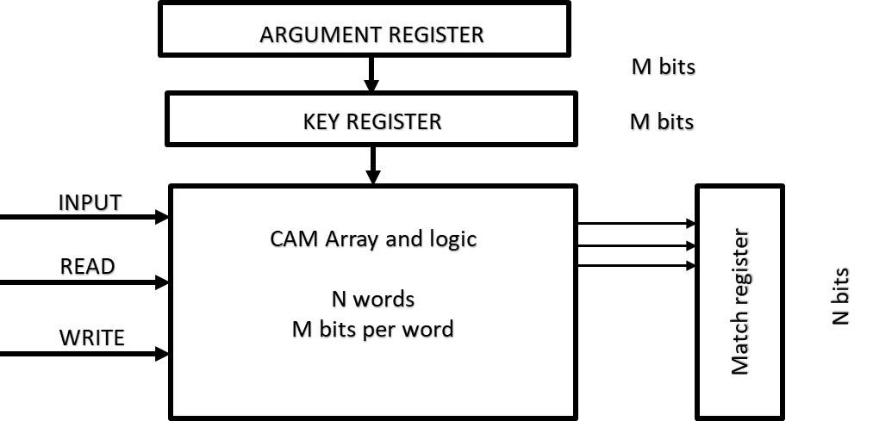

Argument Register It contains the data to be compared with the content of the memory array.

Key Register It is used to mask off portions of the data word(s) which do not participate in the operations.

Memory Array It provides storage and search (compare) medium for data.

Address bus

DATA

Memory block

Status bits

1. READ AND WRITE OPERATION:

Read -

When any aspect of memory is entered , the CAM compares the input with all stored data in one clock cycle. When data is matched with the data in the memory the address of that memory location is sent to the encoder then the match register.

Write –

Data in CAM is stored in memory location in random fashion. Memory location maybe specified by a address bus or data can be written into first empty location using status bits.

1. RESULTS:

The code is written in such a way that the CAM can search for the given data without knowing the address location of the data. The status register shows where the data has been stored (the location).

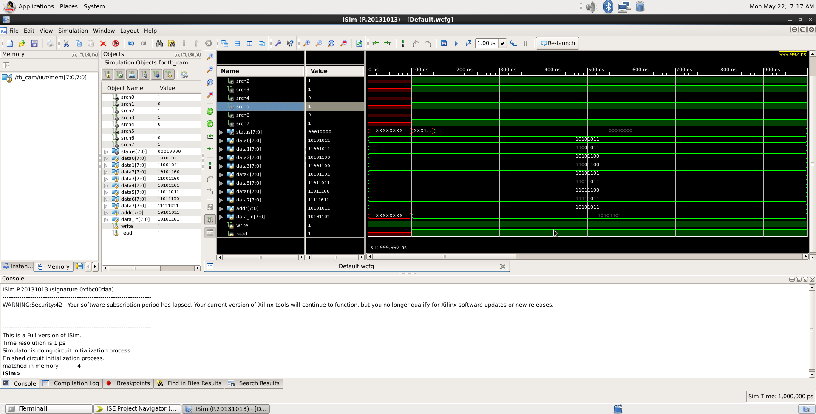

The above figure depicts the data stored in each memory block. The value of the status register is also shown.

The data to be searched is written in data_in. It is matched in data4 hence the 4th bit of the status register is high.



The above figure shows the data location.