EXPT NO:6 | IMPLEMENTATION OF MULTIVARIATE DISPLAYS
DATE: 24.01.2026 | IMPLEMENTATION OF MULTIVARIATE DISPLAYS

PRE-LAB QUESTIONS

- Why are multivariate displays important in AI analytics?
Ans: Multivariate visualization is crucial in AI analytics because it facilitates the simultaneous examination of interactions between three or more variables. This capability is vital for identifying high-dimensional correlations, eliminating redundant features during the pre-processing phase, and understanding complex decision boundaries that simple bivariate analysis cannot capture.

- How do parallel coordinates differ from scatter plots?
Ans: A scatter plot employs a Cartesian coordinate system to map relationships between two variables (X and Y) using points. In contrast, parallel coordinates visualize N-dimensional data by arranging axes parallel to one another vertically. A single data record is depicted as a continuous line traversing these axes, enabling the observation of patterns across multiple dimensions simultaneously rather than just two.

- What challenges exist in interpreting multivariate plots?
Ans: The main obstacles include visual occlusion (overplotting), where an excessive number of data points obscure underlying patterns; scaling discrepancies, where variables with differing units or magnitudes distort the visual representation; and cognitive load, as interpreting simultaneous interactions among multiple variables requires significantly greater mental effort than analysing standard 2D plots.

- Where are trellis displays commonly used?
Ans: Trellis displays are most effective in exploratory data analysis when investigating conditional relationships. They are used to observe how the correlation between two continuous variables shifts across different levels of a categorical variable (e.g., assessing Sales versus Profit performance separately for each geographic Region).

- How does multivariate visualization aid model evaluation?
Ans: Trellis displays are most effective in exploratory data analysis when investigating conditional relationships. They are used to observe how the correlation between two continuous variables shifts across different levels of a categorical variable (e.g., assessing Sales versus Profit performance separately for each geographic Region).

OBJECTIVE: To implement advanced multivariate displays for complex data analysis.

SCENARIO A retail analytics firm studies sales, profit, customer segment, and region to optimize business strategy.

IN-LAB TASKS (Using R Language) • Create parallel coordinate plots • Generate bubble charts • Implement trellis displays by region

CODE:
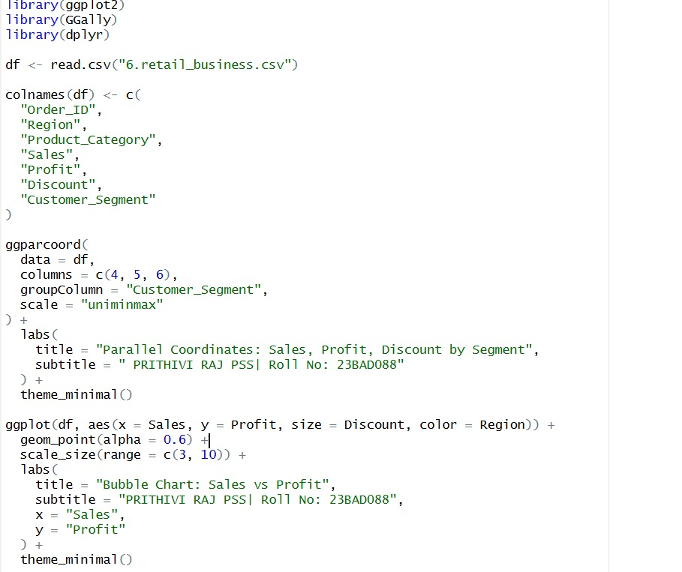
OUTPUT:
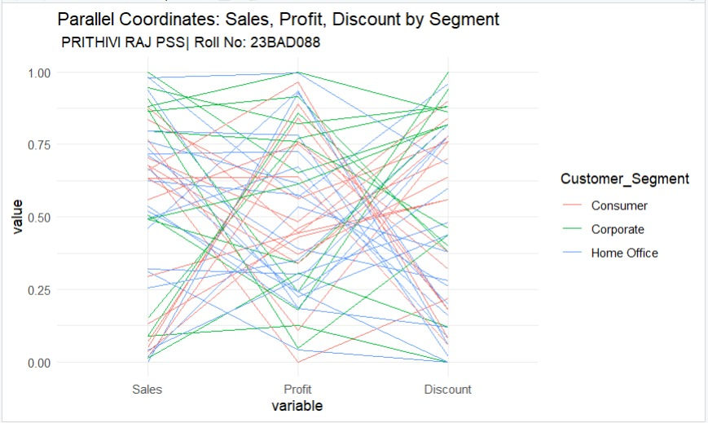

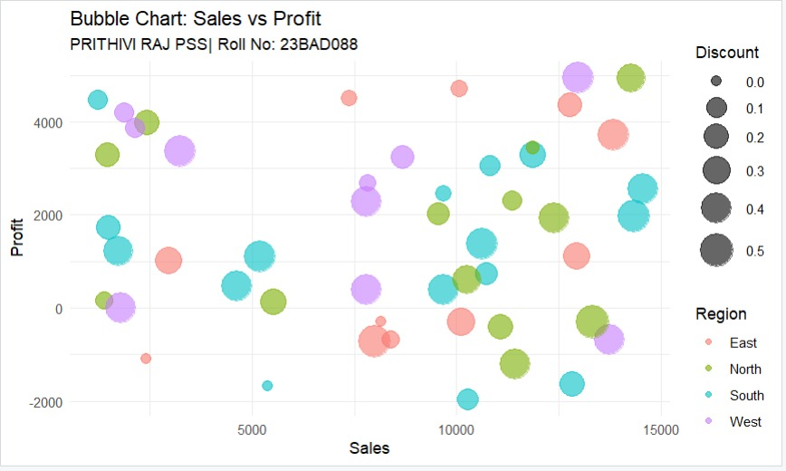

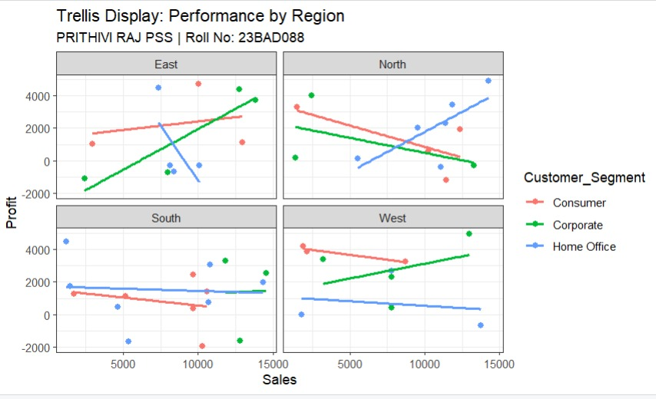
POST-LAB QUESTIONS

- What insights are gained from parallel coordinates?
Ans: The parallel coordinates plot highlighted inverse correlations and multidimensional outliers. Specifically, the visualization revealed a "crossing" pattern between the Discount and Profit axes, suggesting that higher discount rates are inversely related to profitability. Additionally, the use of normalized scales facilitated the direct comparison of relative magnitudes between disparate variables such as Sales and Discount.

- How does faceting simplify complex data?
Ans: Faceting reduces complexity by decomposing the dataset into subsets based on categorical attributes, thereby exposing local trends that may be hidden in an aggregated view. In this experiment, faceting by Region uncovered distinct performance heterogeneities; for example, the East region demonstrated a positive Sales-Profit correlation for the Corporate segment, while the North region exhibited a negative trend for the Consumer segment.

- What limitations exist in bubble charts?
Ans: Bubble charts suffer from limitations related to data occlusion and perceptual accuracy. In dense regions of the graph, larger bubbles often overlap and hide smaller data points, resulting in information loss. Furthermore, human visual perception is less accurate when estimating differences in area (bubble size) compared to judging position along an axis, making it challenging to precisely quantify the third variable (Discount).

- How can these display support AI-driven recommendations?
Ans: These techniques inform AI development by guiding feature engineering and constraint formulation. The distinct behavioral variances across regions indicate that 'Region' is a high-value predictive feature for inclusion in machine learning models. Furthermore, the visualized profit erosion associated with high discounts supports the implementation of deterministic rules (or "guardrails") within AI pricing algorithms to prevent unprofitable recommendations.

- Suggest improvements for large multivariate datasets.
Ans: To mitigate issues like overplotting in large datasets, advanced techniques include:
- Interactive Brushing: Enabling users to select specific data subsets in one view and observe their distribution across linked views.
- Density Mapping: Replacing individual data points with 2D density heatmaps or contours to represent data concentration without clutter.
- Dimensionality Reduction: Applying algorithms such as PCA (Principal Component Analysis) or t-SNE to project high-dimensional data into interpretable 2D or 3D clusters.

LEARNING OUTCOME: Students apply multivariate visualization for business intelligence.

ASSESSMENT
Description | Max Marks | Marks Awarded
Pre Lab Exercise | 5
In Lab Exercise | 10
Post Lab Exercise | 5
Viva | 10
Total | 30
Faculty Signature

