ASSIGNMENT-1(20/09/2024)
1.GITHUB

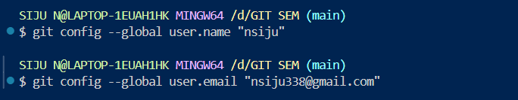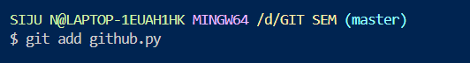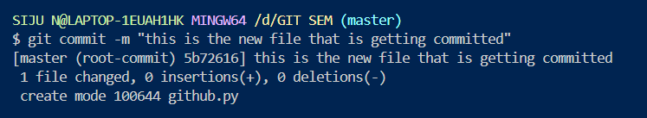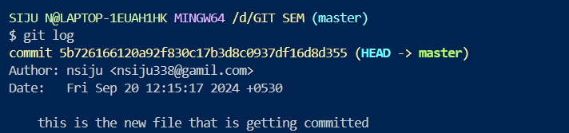

2.WIX-WEBSITE
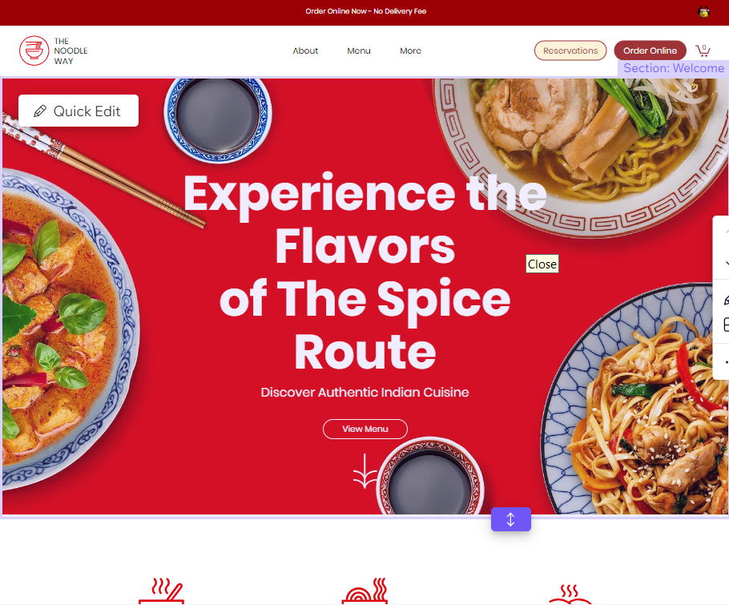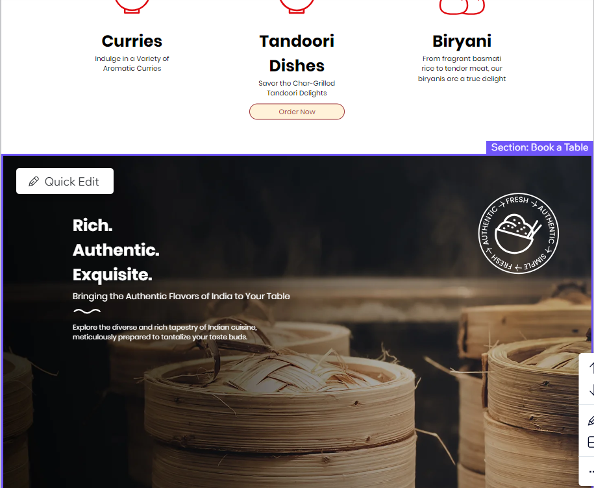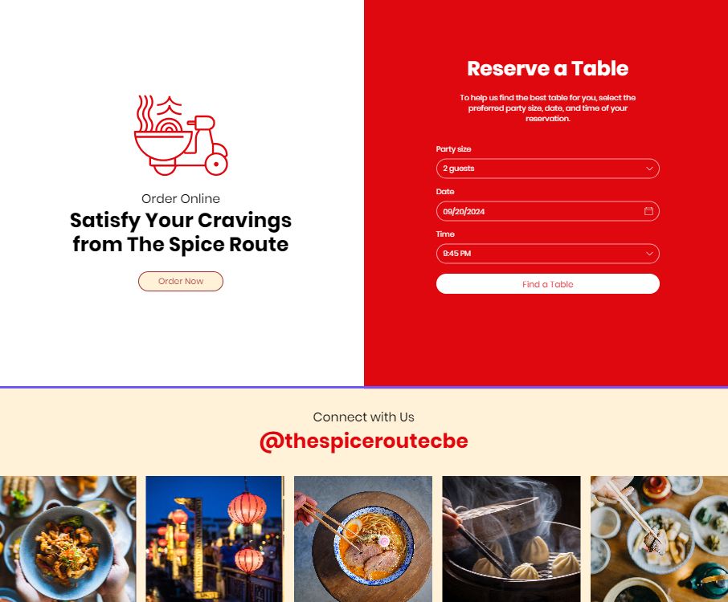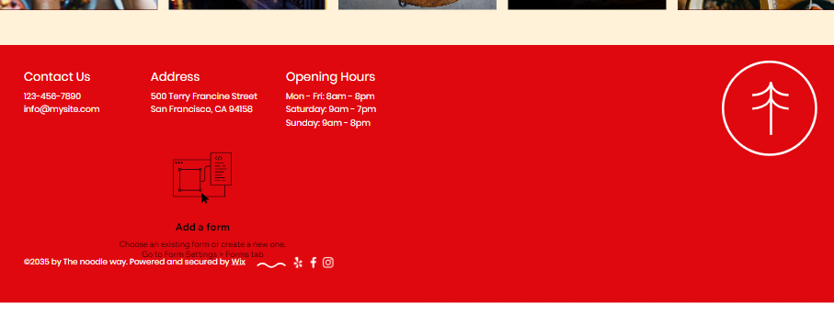

3.TEAM NUMBER: DSH0022
SAMPLE FIGMA LOGIN WEBPAGE
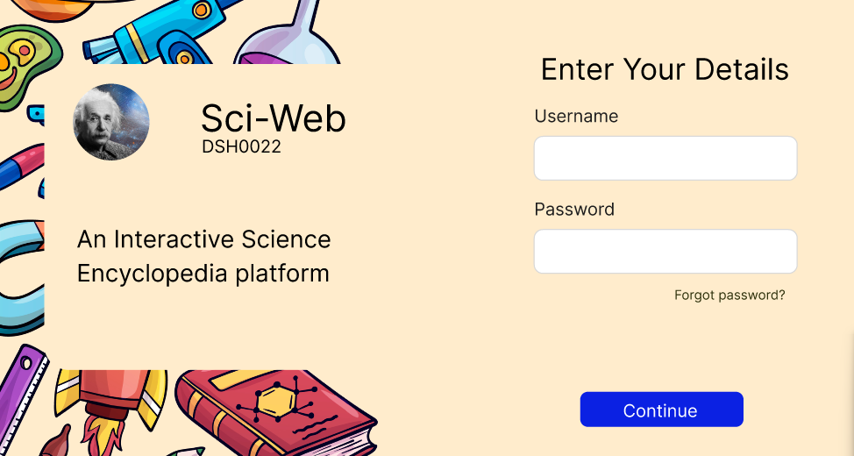

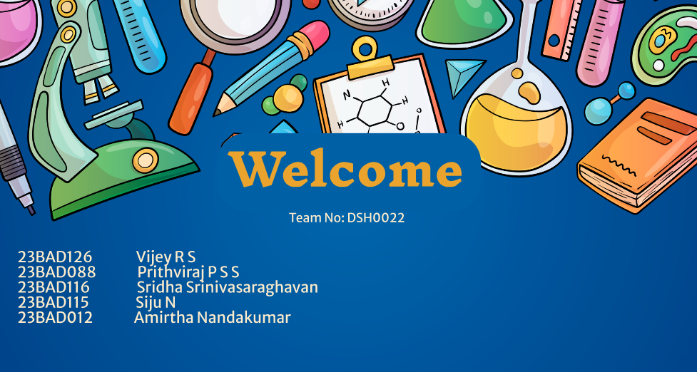

Project Link:
https://www.figma.com/design/6FG0COuZfXsFFuck4h1ZeH/Design-Sprints-DSH0022?node-id=0-1&t=bHSJX8MVSpzGV16B-1

