Assignment 3 - RDS and EC2

**Project Deliverable**

1. **Document the creation of two security groups sgRDS and sgWEB that includes:**

* 1. Screenshot of the sgRDS that shows the inbound rules **(5pts)**
  2. 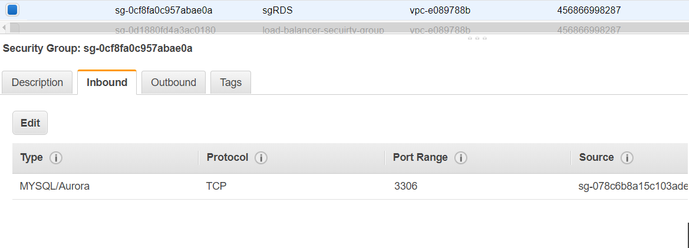

   1.2 Screenshot of the sgWEB that shows the inbound rules **(5pts)**

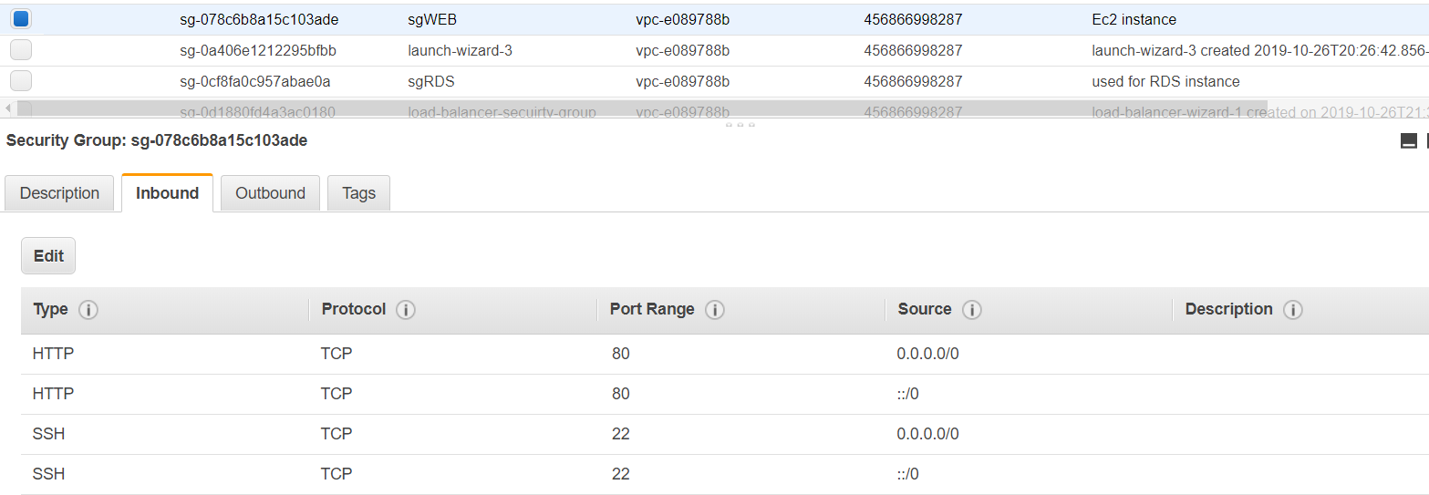

1. **Document the creation of RDS that includes:**

    2.1 Screenshot of the RDS database summary page, “connectivity & security” part that includes **Endpoint&Port, Networking, Security and Security Group Rules**. **(10pts)**

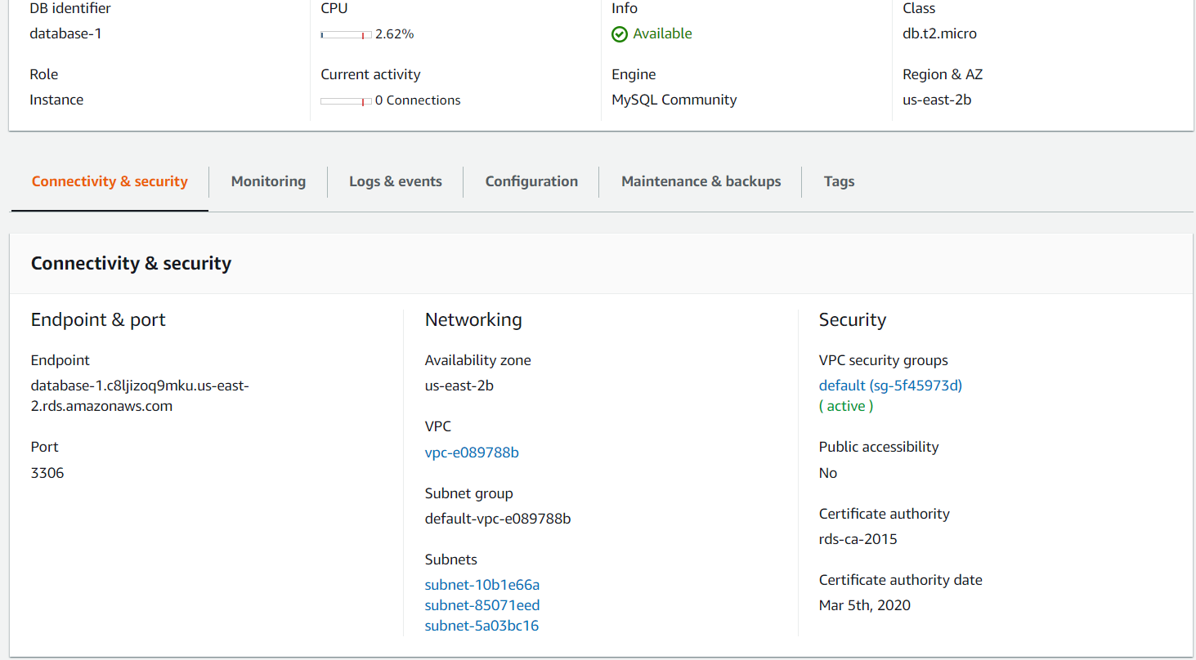

1. **Document the connection from EC2 to RDS:**

   3.1 Screenshot of the running results of step 5: the output of executing createDB.sql: the output of show databases; the output of show tables; the output of select query.**(10pts)**

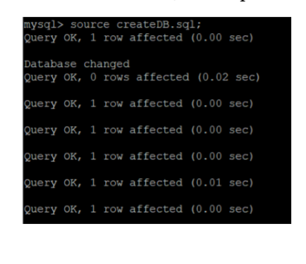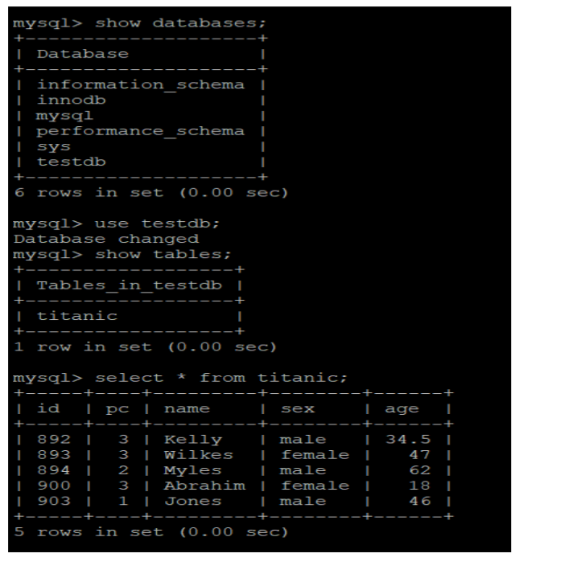

   3.2 Screenshot of the running result of step 6: the output of test.py **(5pts)**

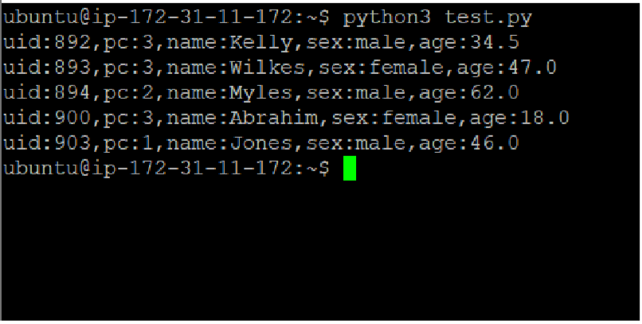

1. **Coding**

4.1 attachment of updated file server.py in step 7 **(8pts)**

**Please check attached server.py**

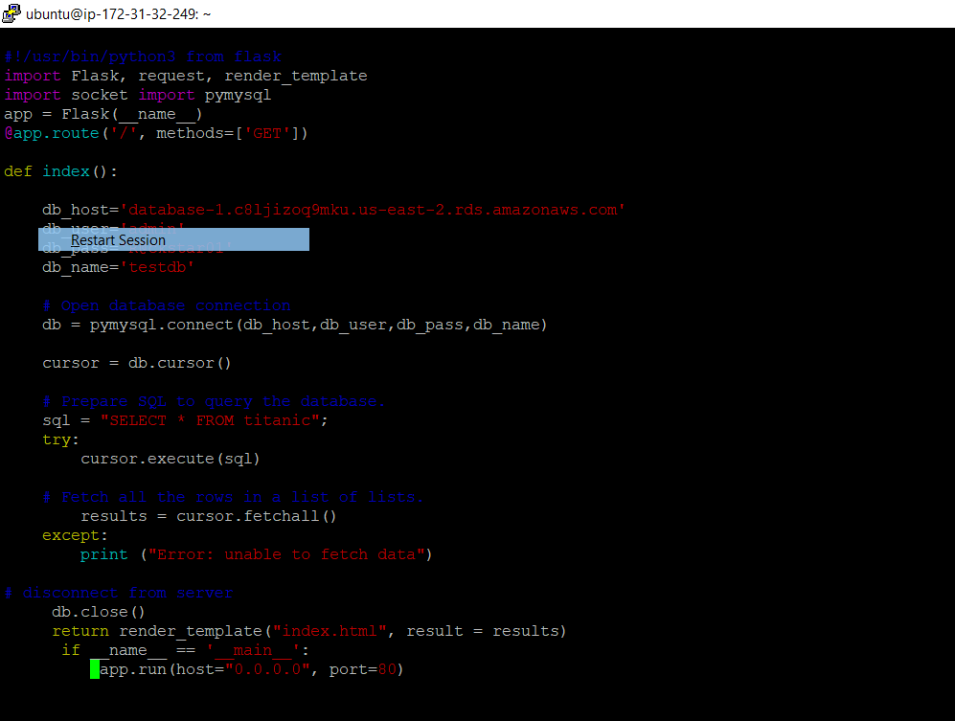

4.2 attachment of updated file index.html at step 8 **(12pts)**

Attached is the index.html

<!doctype html>

<table> <tr>

<th>UID</th>

<th>pc</th>

<th>name</th>

<th>sex</th>

<th>age</th> </tr>

{% for r in result %} <tr>

<td>{{ r[0] }}</td>

<td>{{ r[1] }}</td>

<td>{{ r[2] }}</td>

<td>{{ r[3] }}</td>

<td>{{ r[4] }}</td>

</tr> {% endfor %} </table>

4.3 Screenshot of the webpage at step 9.**(5pts)**



