Write the title of your project. https://studio.code.org/projects/gamelab/8rOfUA3xnREjuWNnLJlvj8hSc3EV3Addk-l0cwj9Pd8/editGame Design Document

Fill up the Following document

Pac man infinite and beyond

1. What is the goal of the game?

The goal is that the pac man have to eat all the coins before it gets caught by the ghosts

1. Write a brief story of your game?

The pac man well have to eat all the coins and in the same heve to escape 4 ghost during the game pac man will also get few special coins which will help him to eat the ghost .

1. Which are the playing characters of this game?

* Playing characters are the ones which respond to the user based on the input from the user
* Cars, monkeys, dinos, wizards etc, are the playing characters in the game.

|  |  |  |
| --- | --- | --- |
| Number | Character Name | What can this character do? |
| 1 | Pac man | It can feed on coins and special coins and kill the ghosts |
| 2 |  |  |
| 3 |  |  |
| 4 |  |  |
| 5 |  |  |
| 6 |  |  |
| 7 |  |  |
| 8 |  |  |

1. Which are the Non Playing Characters of this game?

* Non Playing characters are the ones which don't have an action or a behaviour when the user interacts with the game.
* Hurdles, stones, bananas, coins, etc are non playing characters in the game.

|  |  |  |
| --- | --- | --- |
| Number | Character Name | What can this character do? |
| 1 | ghosts | They will try catch the pac man |
| 2 | coins | They have points if they are touched by the pac man |
| 3 | Special coins | They give special ability to pacman to feed on ghosts |
| 4 |  |  |
| 5 |  |  |
| 6 |  |  |
| 7 |  |  |
| 8 |  |  |

Draw your imagination of this game. What does this game look like?

* Draw the game either on your computer or on paper,
* Add images of scenes of the game to show each of the playing and non-playing characters at least once.

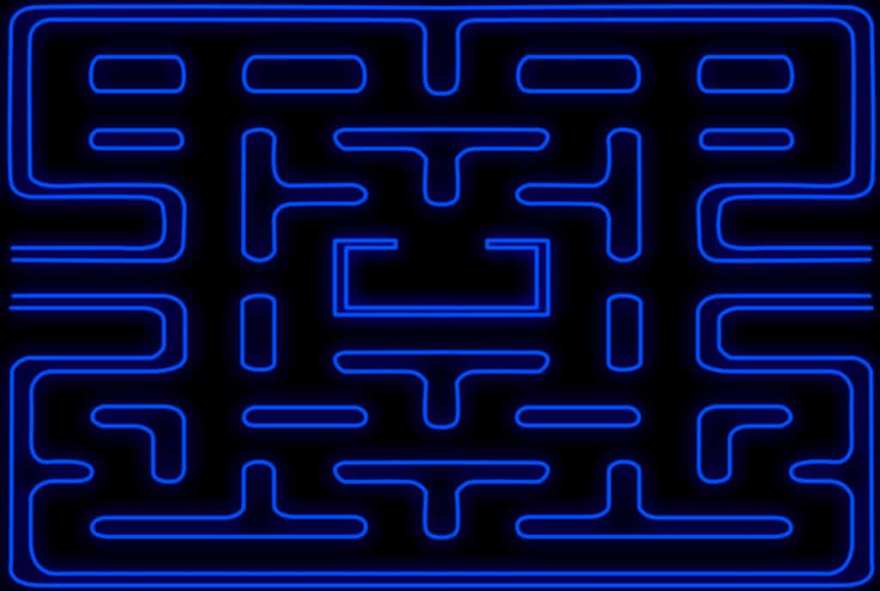

How do you plan to make your game engaging?

It is a challenging game where u have to complete the game without getting caught by the ghost