# Two-Way Communication Between AWS IoT to Serial Monitor

## Screenshots

Below are the screenshots showing the communication process:

1. Message sent from AWS IoT to Serial monitor

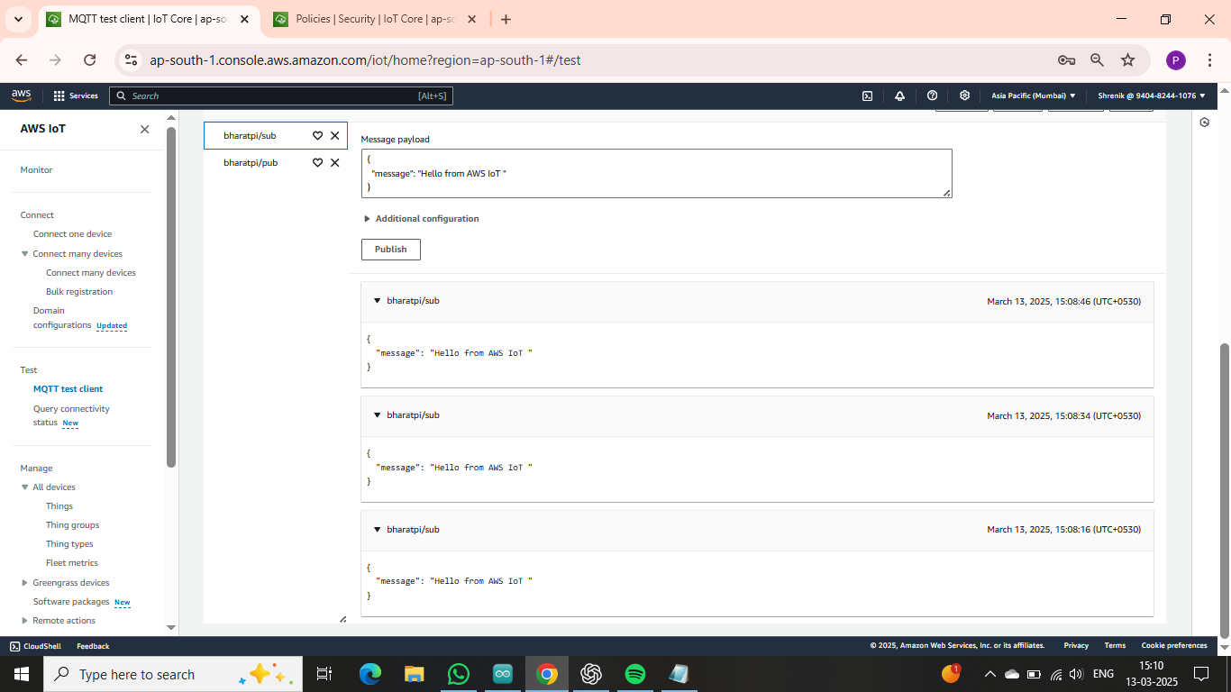

2. Message received at AWS IoT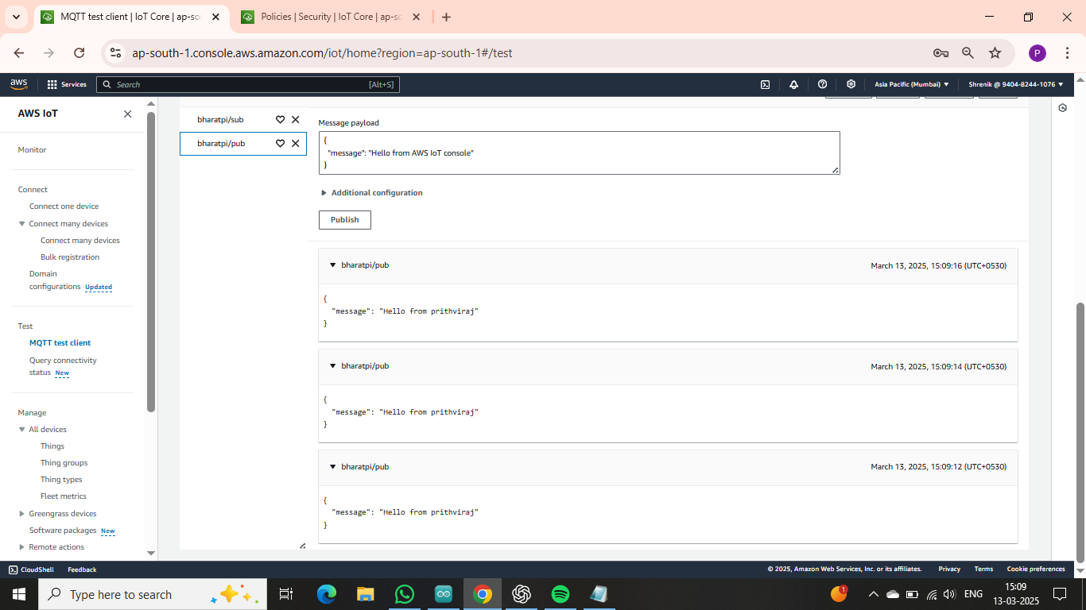

3. Message received from AWS IoT and sent back to Serial Monitor

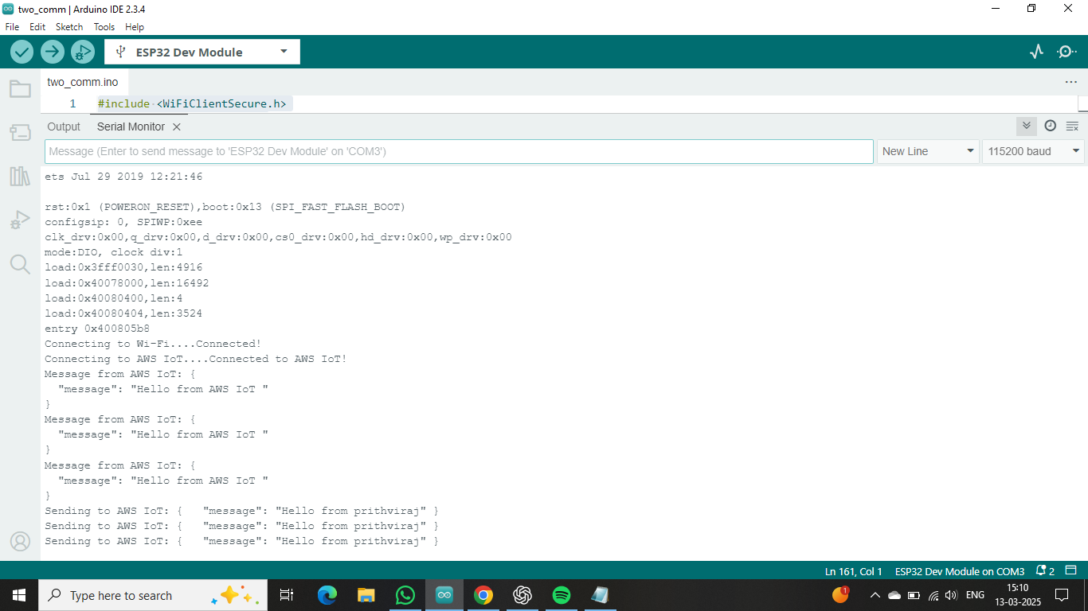

## Arduino IDE Code

The following is the Arduino IDE code used for this implementation:

