## Introduction

## ****Two-Way Communication Using Bharat Pi****

Two-way communication is essential for real-time data transmission in IoT applications. This report explores how Bharat Pi facilitates communication between a serial monitor and various endpoints, including AWS IoT, a host computer, and another Bharat Pi module.

## 1. Two-Way Communication Between Serial Monitor and AWS IoT

### Objective

To establish a communication channel between the Arduino serial monitor and AWS IoT using Bharat Pi.

### Methodology

1. Configure AWS IoT Core and obtain MQTT credentials.  
2. Connect Bharat Pi to AWS IoT via MQTT.  
3. Send and receive messages using the serial monitor.

### Implementation Steps

- Setup AWS IoT policies and create a Thing.  
- Install required libraries and configure MQTT on Bharat Pi.  
- Write and upload Arduino IDE code for communication.

### Observations & Results:

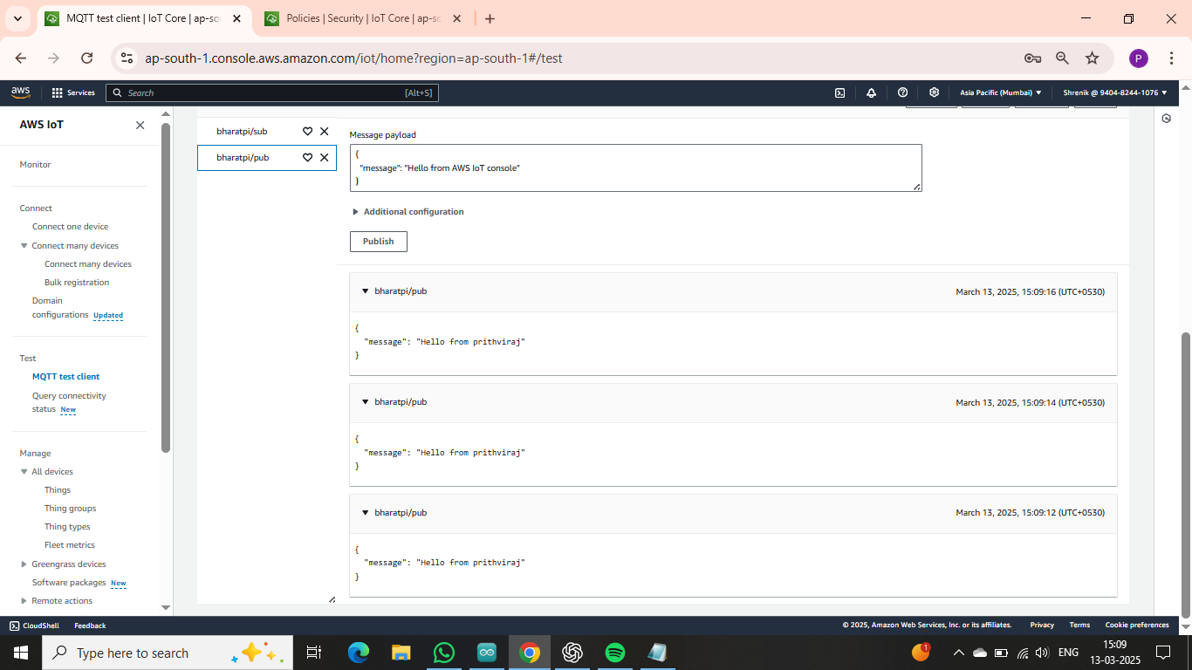

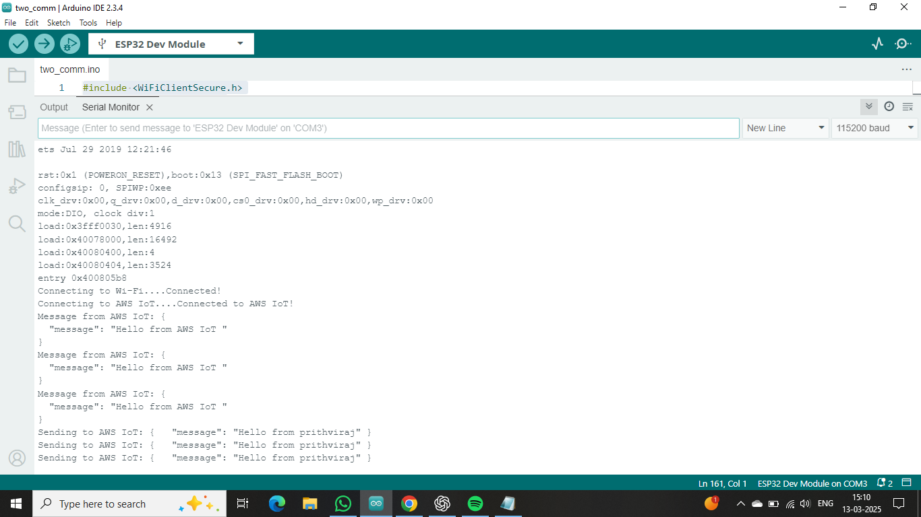

## 2. Two-Way Communication Between Serial Monitor and Host (Computer)

### Objective

To facilitate communication between Bharat Pi and a Host (computer) via the serial monitor.

### Methodology

1. Establish a USB connection between Bharat Pi and the computer.  
2. Use serial communication to send and receive messages.

### Implementation Steps

- Connect Bharat Pi to a computer using a Micro USB cable.  
- Open Arduino IDE serial monitor.  
- Send and receive messages through the serial interface.

### Observations & Results:

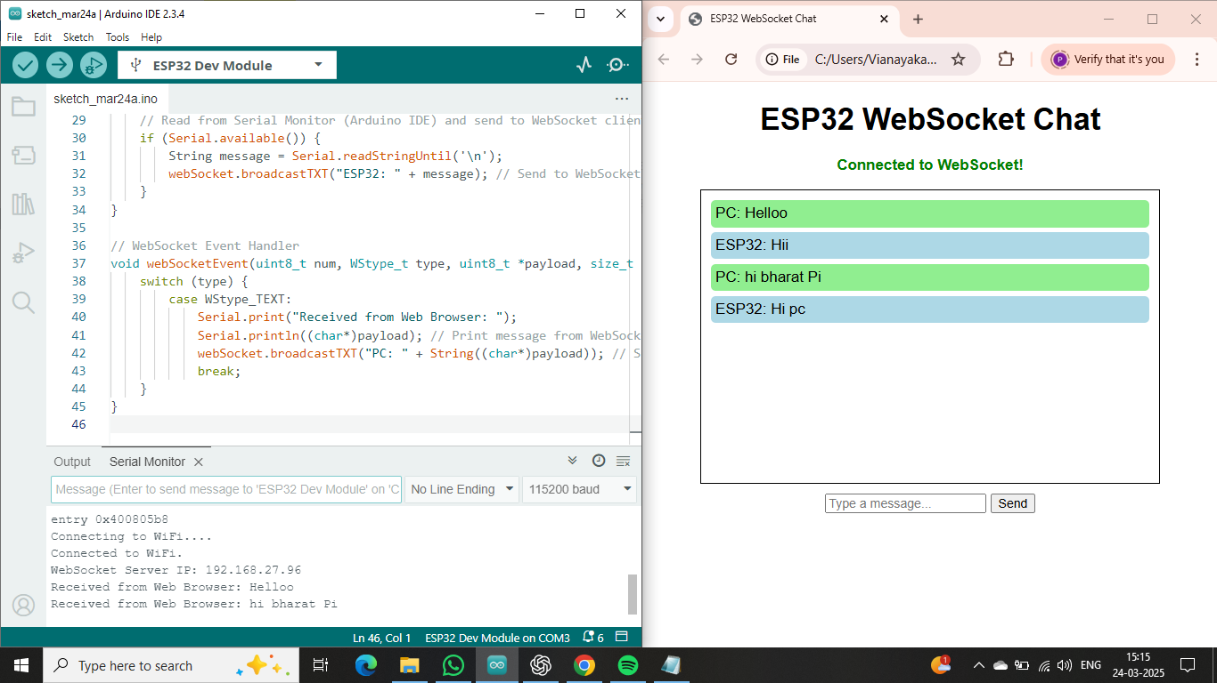

## 3. Two-Way Communication Between Serial Monitor and Bharat Pi

### Objective

To enable communication between two Bharat Pi devices through the serial monitor.

### Methodology

1. Establish a UART connection between two Bharat Pi modules.  
2. Use serial communication to exchange messages.

### Implementation Steps

- Connect the TX pin of one Bharat Pi to the RX pin of the other.  
- Write and upload Arduino IDE code to handle data transmission.  
- Monitor communication via the serial monitor.

### Observations & Results:

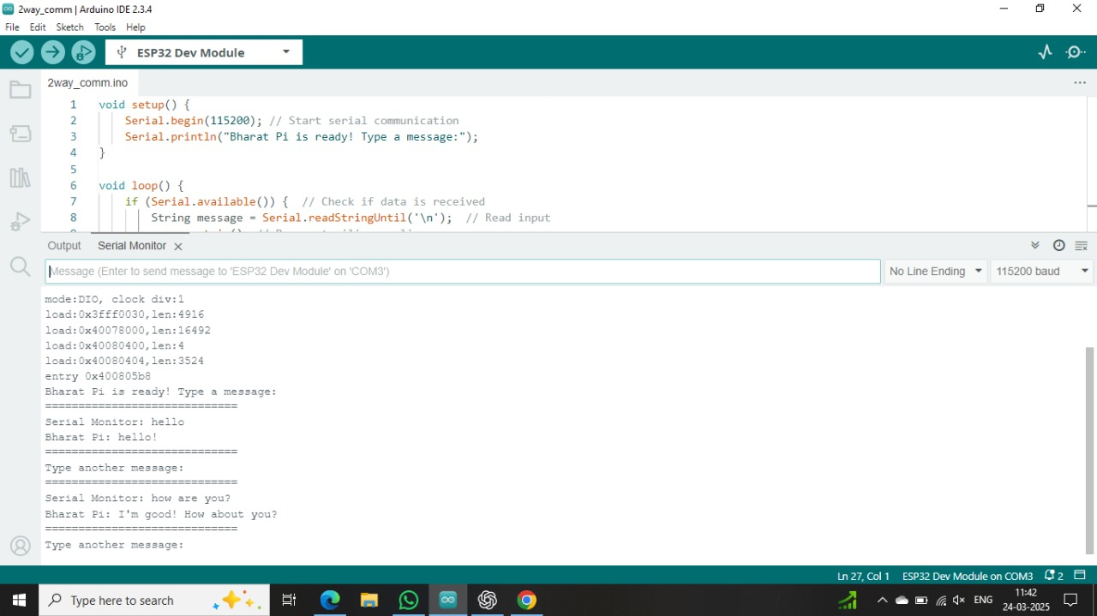

## Conclusion

This report demonstrates how Bharat Pi enables two-way communication in different scenarios. The implementation of serial and MQTT-based communication can enhance IoT applications, improving real-time data transfer capabilities.