VOICE CONVERSION
By
Aditya Bhattacharya 13BEC1005
Prithvish Nembhani 13BEC1100
Shraddha Agrawal 13BEC1138
Vanshika Gupta 13BEC1162

A report submitted to the
Prof. John Sahaya Rani Alex
SCHOOL OF ELECTRONICS AND COMMUNICATION ENGINEERING
for
ECE303: Digital Signal Processing
B.Tech. ELECTRONICS AND COMMUNICATION ENGINEERING


VIT UNIVERSITY, CHENNAI
Vandalur – Kelambakkam Road
Chennai – 600 127
October 2015

BONAFIDE CERTIFICATE

Certified that this project report entitled
“Voice conversion” is a bonafide work of Aditya Bhattacharya (13BEC1005), Prithvish Nembhani (13BEC1100),Shraddha Agrawal (13BEC1138),Vanshika Gupta (13BEC1162) who carried out the Project work under my supervision and guidance.

Prof. John Sahaya Rani Alex
School of Electronics Engineering (SENSE)
VIT University, Chennai

CONTENTS

Chapter Topics Page
1. Abstract 4
2. Introduction 5
3. Algorithm 6
4. Code 10
5. Snapshots 15
6. Future work 16
8. References 18

ABSTRACT
Speech processing is currently a key focus for many researchers in the area of DSP. In this project, we focus on the topic of voice conversion, which involves producing the words from one person (the “source speaker”) in the voice of another person (the “target speaker”).
We can do this using DSP because every person’s distinct vocal qualities are essentially caused by their vocal tract, which forms a transfer function between the input excitation and the output signal that we hear. We can isolate this transfer function through methods such as cepstral analysis and linear prediction coding, which we describe in detail. The second major identifier between different speakers is the pitch range of their words. We can change the pitch through methods such as the PSOLA, which we also describe.
The vocal tract transfer function and pitch range are different for different sounds. Thus, in synthesizing a phrase, we must first break the signal into smaller segments and analyse each individually. Our windowing algorithm divides the signal based on breaks between different syllables and words. We then use functions from the Praat program to perform the analysis and synthesis.
Voice conversion has numerous applications, such as the areas of foreign language training and movie dubbing. It is closely related to the process of speech synthesis, which usually refers to converting text into spoken language, and has many applications, especially relating to assistance for the blind and deaf. Other areas in speech processing, such as speaker verification, have applications in security. All of these different types of speech signal processing involve related methods that we investigated through this project, especially cepstral analysis, linear prediction coding, and the PSOLA method.

Introduction
Voice conversion (VC) is an area of speech processing that deals with the conversion of the perceived speaker identity.
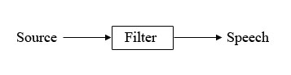
The source filter model can easily be extended to signal processing. The source is simply a signal x (t). This signal is the input to the filter and is called the excitation signal since it excites the vocal tract. The vocal tract is a filter similar to all filters we have studied so far: it is a linear time-invariant system with impulse response h (t). This is sometimes called the transfer function of speech since it is what transfers the excitation signal to speech - it adds voice to words. Speech is the output y (t) of the source signal x (t) passed through the filter with impulse response h(t). Thus, the output is given by y (t) =x (t)*h (t). This is depicted below:
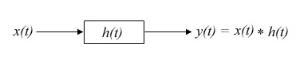
So first phase of our project is to identify these speaker characteristics for source and target speakers. And then using various techniques like phase vocoder, voice conversion is to be achieved in the second phase.

ALGORITHM
CEPSTRAL ANALYSIS

A cepstrum is the result of taking the Inverse Fourier transform (IFT) of the logarithm of the estimated spectrum of a signal.
To linearly combine the E (ω) and H (ω) in the frequency domain, logarithmic representation is used. So the logarithmic representation

The log operation transforms the magnitude speech spectrum where the excitation component and vocal tract component are multiplied, to a linear combination (summation) of these components i.e. log operation converted the "*" operation into "+" operation in the frequency domain. The separation can be done by taking the inverse discrete Fourier transform (IDFT) of the linearly combined log spectra of excitation and vocal tract system components.

BLOCK DIAGRAM OF CEPSTRUM ANALYSIS

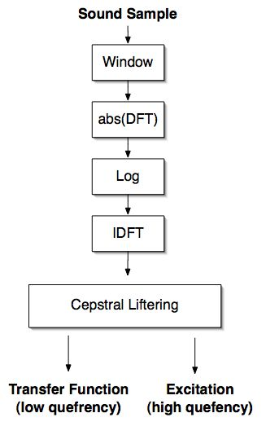
Fig 1 Cepstral analysis

LINEAR PREDECTIVE CODING

Linear Predictive Coding (or “LPC”) is a method of predicting a sample of a speech signal based on several previous samples. Similar to the method employed by the cepstrum, we can use the LPC coefficients to separate a speech signal into two parts: the transfer function (which contains the vocal quality) and the excitation (which contains the pitch and the sound). The method of looking at speech as two parts which can be separated is known as the Source Filter Model of Speech.

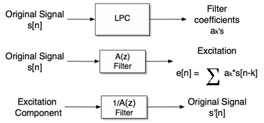
Fig 2

PHASE VOCODER

The phase-vocoder is a well-known technique that uses frequency—domain transformations to implement a variety of digital audio effects.
A short-time Fourier transform (STFT) is performed on a windowed time-domain real signal to obtain a succession of overlapped spectral frames with minimal side-band effects (analysis stage). The time delay at which every spectral frame is picked up from the signal is called the hop size. The time domain signal may be rebuilt by performing an inverse Fast-Fourier transform on all frames followed by a successive accumulation of all frames (an operation termed overlap-add) (resynthesis stage).
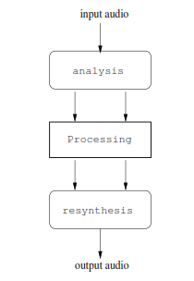

Fig 3 Phase Vocoder
ANALYSIS :

The basis for the phase vocoder is the Short-Term Fourier Transform (STFT), in which a
vector of sound samples is divided into multiple N-sized blocks referred to as frames. Frames
are usually overlapped and windowed

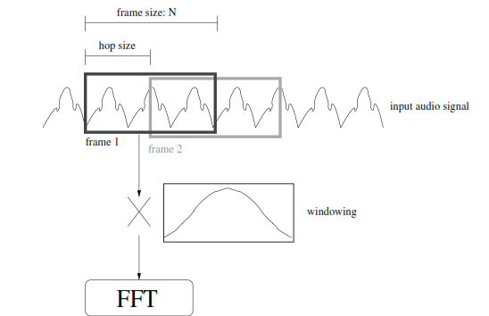

Fig. 4 Analysis

PROCESSING AND RESYNTHESIS :

The synthesis stage is basically the analysis stage in reverse: a list of sinusoids in complex
number representations are converted resynthesized using an inverse Fourier transform
(IFFT) into a sound signal. While resynthesis can be accomplished using other techniques,
such as direct additive synthesis, the IFFT method is much faster, and with today’s computers
can easily be done in real time.
If the output of the analysis stage is used directly for resynthesis, the result will be the
original sound ﬁle with no perceptible diﬀerence from the original (and we would have nothing
more than a very computationally-expensive way to copy sound information). However, one
of the strengths of the phase vocoder is the possibility of introducing additional processing
between the analysis and synthesis stages.
Unlike time-domain procedures, phase vocoder operations are undertaken in the frequency
domain, and can be used to achieve a variety of eﬀects that are diﬃcult or impossible
using other means.
Two common techniques are time stretching and pitch shifting. Other effects include effects like robotization and chorus.
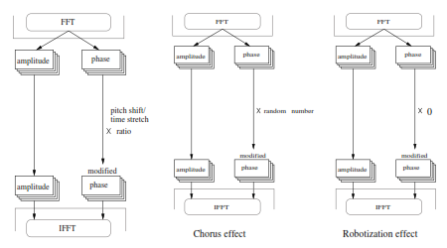
Fig. 3 Effects using phase vocoder

PITCH ESTIMAION METHOD
All the methods show a peak at the pitch period 'T₀'. Cepstral and the SIFT method sequences have less ambiguity compared to autocorrelation of speech. Hence either cepstrum or SIFT method is equally preferable for the estimation of pitch. In case of speech coding, the mostly used are in LP analysis and hence SIFT method is preferred over Cepstrum pitch estimation. Alternatively, in tasks like speaker recognition, since cepstral analysis is used for the feature extraction tasks, cepstrum pitch estimation may be employed. Apart from the average pitch value, the other interest is in plotting time varying pitch values resulting in pitch contour information

CODING

CEPSTRUM AND PITCH ESTIMATION

clc
clear all
close all
fs=8000;
%recobj=audiorecorder;
%disp('Start');
%recordblocking(recobj,2);
%disp('Stop');
%play(recobj);
%rec=getaudiodata(recobj);
rec=wavread('data2.wav');
subplot(3,2,1);
plot(rec);

%normalised_rec=rec./(1.01*abs(max(rec)));
l=length(rec);
N=160;
s=l-N;
y1=rec(s+1:l);
w=window(@hamming,N);
yw=y1.*w;
subplot(3,2,2);
plot(yw);

yf=fft(yw);
subplot(3,2,3);
plot(abs(yf));
lyf=log(abs(yf));
subplot(3,2,4);
plot(lyf);
yc=ifft(lyf)
subplot(3,2,5);
plot(yc);
yc1=yc(1:length(yc)/2);
L=zeros(length(yc1),1);
L(15:length(yc1))=1;
y4=real(yc1.*L);
subplot(3,2,6);
plot(y4);
[y_val,y_loc]=max(y4)
pitch_period=y_loc
pitch_frequency=(1/pitch_period)*fs
ROBOTIZATION USING PHASE VOCODER

clc
clear all
close all
[A fs] = wavread('prithvish_audio.wav');
windowSize = 2048;
A=A';
% Fixed window size = 2048
windowSize = 256;
halfSignal =1:windowSize;
%define window functino
%Y2 = .5*(1-cos(2*pi*halfSignal*1/(2048)));
Y2=window(@hamming,windowSize);
Y2=Y2';
%initialization
output2 = A(1:windowSize).*Y2;
hopSize = windowSize/2;
out=zeros(1,length(A));
for d=1 : length(A)/hopSize-1
%In time domain
wA = A((d-1)*hopSize+1: (d-1)*hopSize+windowSize);
wX = Y2.*wA;
%wX = wA;
specSegment = wX;
%In frequency domain
Wx=fft(wX);
abs(Wx);
%take ifft of absolute value of FFT only
YY = ifft(abs(Wx));
%overlap add to reconstruct the audio signal
out((d-1)*hopSize+1: (d-1)*hopSize+windowSize)=YY+out((d-1)*hopSize+1: (d-1)*hopSize+windowSize);
end
%soundsc(out, 44100);
%normalize
out = out ./ max(out);
soundsc(out)
%wavwrite(out, 44100, 'robotize.wav');

CHORUS EFFECT USING PHASE VOCODER
[A fs] = wavread('prithvish_audio.wav');
A=A';
% Fixed window size
windowSize = 256;
halfSignal =1:windowSize;
Y2 = .5*(1-cos(2*pi*halfSignal*1/(windowSize)));
output2 = A(1:windowSize).*Y2;
hopSize = windowSize/2;
out=zeros(1,length(A));
for d=1 : length(A)/hopSize-1
%In time domain
wA = A((d-1)*hopSize+1: (d-1)*hopSize+windowSize);
wX = Y2.*wA;
%In frequency domain
Wx=fft(wX);
r = abs(Wx);
phi = 2*pi*rand(1,length(Wx));
Wx = r.*exp(i*phi);

YY = real(ifft(Wx));
fft_x = ifft(Wx);
out((d-1)*hopSize+1: (d-1)*hopSize+windowSize)=YY+out((d-1)*hopSize+1: (d-1)*hopSize+windowSize);
end
soundsc(out, fs);
%Normalizing
out = out ./ max(out);
soundsc(out)
%wavwrite(out, fs, 'whisperize.wav');

PITCH SHIFT USING PHASE VOCODER

function out_signal=pitch_shift(pit_ratio,source)

n1 = 256;

%pitch shift ratio

%pit_ratio = .8;

WLen = 2048;

w1 = hanning(WLen);

w2 = w1;

%[in_signal, FS] = wavread('prithvish_audio.wav');

%soundsc(in_signal, FS);

in_signal=source;

L = length(in_signal);

%in_signal = [zeros(WLen, 1);in_signal;zeros(WLen-mod(L, n1),1)] / max(abs(in_signal));

out_signal = zeros(length(in_signal), 1);

grain = zeros(WLen, 1);

ll = WLen/2;

omega = 2*pi*n1*[0:ll-1]'/WLen;

phi0 = zeros(ll, 1);

r0 = zeros(ll, 1);

psi = zeros(ll, 1);

res = zeros(n1, 1);

pin = 0;

pout = 0;

pend = length(in_signal)-WLen;

while pin<pend

%multiply audio segment with window function

grain = in_signal(pin+1:pin+WLen).*w1;

%compute magnitude and phase of FFT

fc = fft(fftshift(grain));

f = fc(1:ll);

r = abs(f);

phi = angle(f);

%unwrap phase to get phase increment

delta_phi = omega + princarg(phi - phi0-omega);

delta_r = (r-r0)/n1;

%multiply the phase with the pitch ratio factor

delta_psi = pit_ratio*delta_phi/n1;

%reconstruct the audio signal

for k = 1:n1

r0 = r0 + delta_r;

psi = psi + delta_psi;

res(k) = r0'*cos(psi);

end

phi0 = phi;

r0 = r;

psi = princarg(psi);

out_signal(pout+1:pout+n1) = out_signal(pout+1:pout+n1)+res;

pin = pin + n1;

pout = pout + n1;

end

%Normalize output signal

%out_signal = out_signal(WLen/2 + n1 + 1:length(out_signal))/max(abs(out_signal));

%soundsc(out_signal, FS);

out_signal = out_signal./max(out_signal);

%wavwrite(out_signal, FS, 'pitch_shift.wav');

End
function phase=princarg(phasein)
two_pi=2*pi;
a=phasein/two_pi;
k=round(a);
phase=phasein-k*two_pi;
end

SNAPSHOTS:

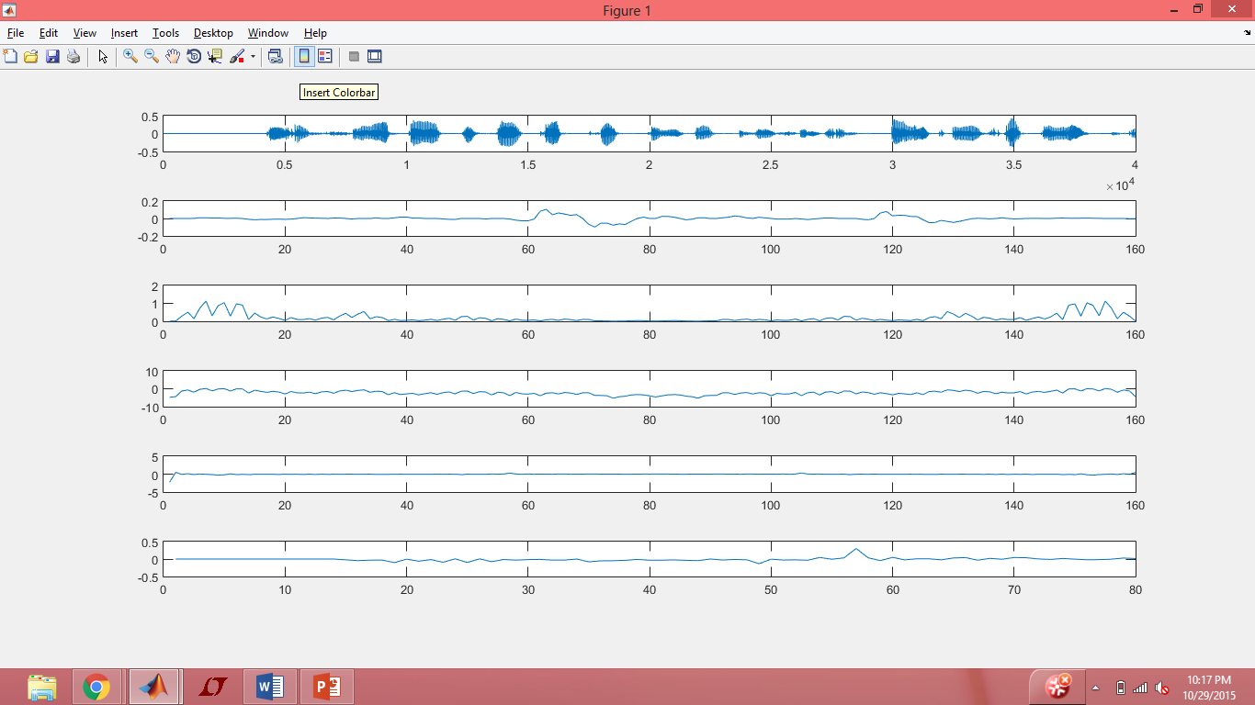
Fig 1.Cepstrum plot

FUTURE WORK

We have completed the pitch estimation, cepstral analysis part and will try to implement coding for other characteristic parameters necessary for voice conversion. We will try to identify the speaker characteristics more accurately so as to perform voice conversion efficiently. We will also try to implement different techniques to get a perfect pitch estimation using median filter and other techniques cascaded. After getting perfect results a GUI will be made to make the project user friendly

REFRENCE

Related websites:
- http://matlabsproj.blogspot.in/2012/05/voice-conversion-in-matlab.html
- http://iitg.vlab.co.in/?sub=59&brch=164&sim=616&cnt=1109
- http://iitg.vlab.co.in/?sub=59&brch=164&sim=615&cnt=1

