**Module - 2**

**Q.1)** **Give the name of the Traditional and Digital platform where we can promote TOPS Technologies Pvt. Ltd, and suggest which platform will be better for their marketing activity with a reason?**

**Tops technology**

**Digital Marketing –**

**SEO-**

Search Engine Optimization

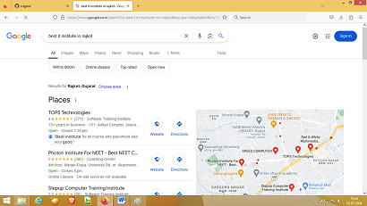

**SMM-**

Social Media Marketing

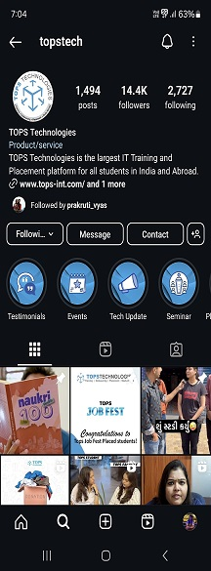 

**Website marketing**

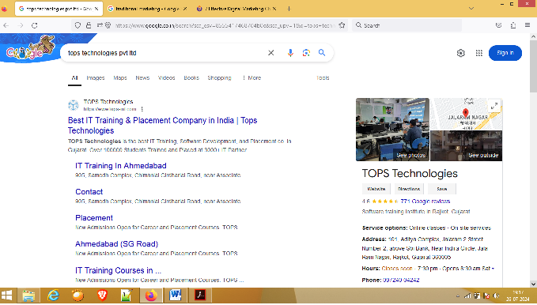

**Email marketing-**

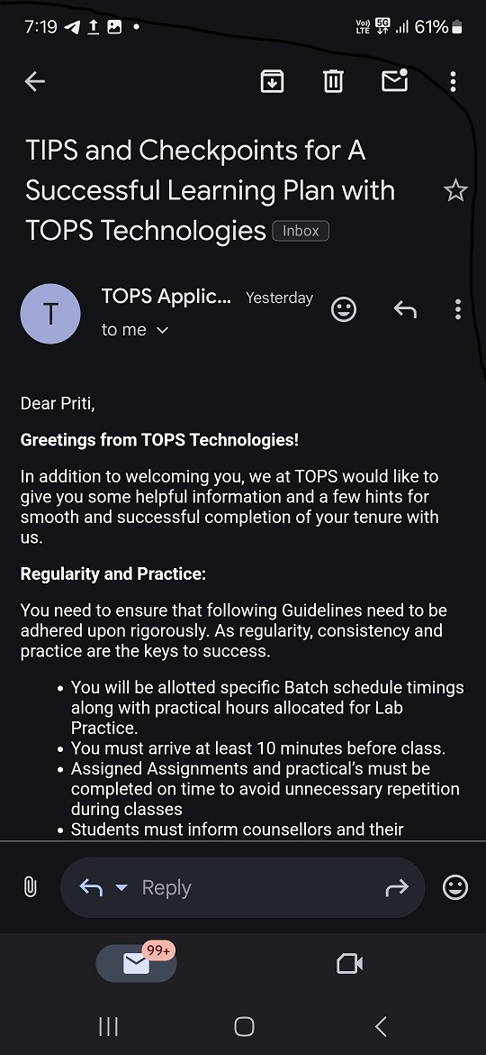

**Display Advertising-**

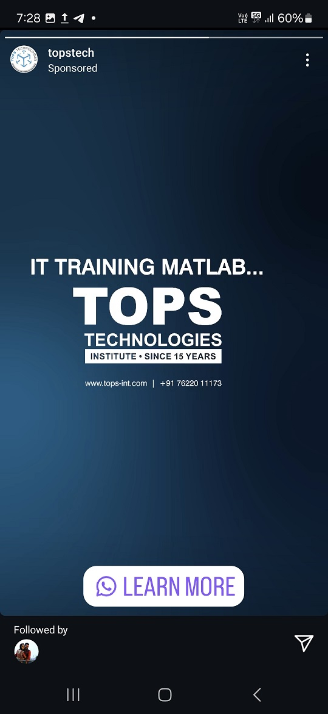

**Content Marketing-**

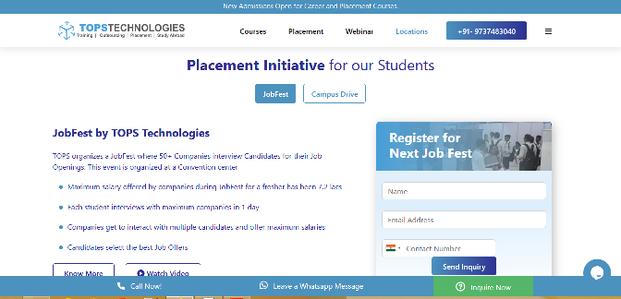

**Pay- per-click –**

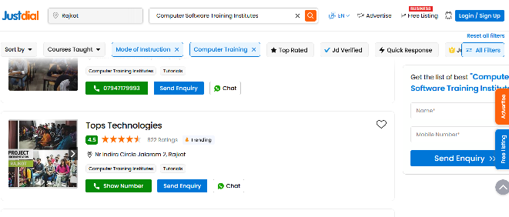

**Traditional Marketing -**



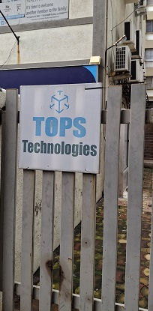

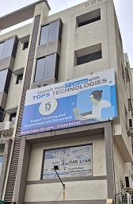 

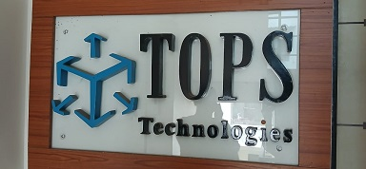

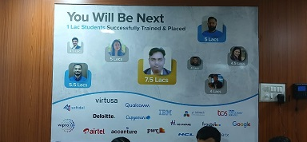

**which platform will be better for their marketing activity with a reason?**

## Digital platform is better because Faster time to launch. Automating and abstracting cloud setup and simplifying governance processes means a new Digital Service can be launched to customers within days. And also it give Frequent updates.Faster rollback. Creating an effective rollback system with health checks means deployment failures can be fixed quickly.

## Digital plateform have the best available technologies. Standardising cloud building blocks means the best available technology stack can be provided to Digital Service teams.

**Q.2)** **What are the Marketing activities and their uses?**

Marketing activities are strategies that help a company develop and promote its products or services to customers. Successful marketing activities can help companies gain visibility with consumers and improve their brand, which is the public perception of a business.

**Marketing Activities**

1. **Search Engine Optimization (SEO)**

SEO is the practice of orienting your website to rank higher on a search

engine results page (SERP) so that you receive more traffic.

SEO is the process used to optimize a website's technical configuration ,

content relevance and link popularity so its pages can become easily

findable , more relevant and popular towards user search queries, and as a

consequence , search engines rank them better.

1. **Search Engine Marketing (SEM)**

Generally, “search engine marketing” refers to paid search marketing, a

system where businesses pay Google to show their ads in the search results.

Search engine marketing (SEM) is a digital marketing strategy used to increase the visibility of a website in search engine results pages (SERPs).

1. **Content Marketing**

Content marketing is the development and distribution of relevant, useful

content—blogs, newsletters, white papers, social media posts, emails, videos, and the like—to current and potential customers.

Content marketing is a marketing strategy used to attract, engage, and

retain an audience by creating and sharing relevant articles, videos, podcasts, and other media

1. **Content Automation**

Content automation uses software to streamline the processes involved in

creating , managing and distributing content. and also uses for automate repetitive tasks, ensure accuracy with your organization’s brand guidelines, and improve creative workflows within the content lifecycle.

1. **Campaign Marketing**

A digital marketing campaign is a well-planned and coordinated effort to

promote a product, service, or brand to a specific audience through digital

channels. It entails using various tactics, such as Search Engine Optimization

(SEO), Pay-Per-Click (PPC), social media marketing, email marketing, and

content marketing.

1. **E-commerce Marketing**

E-Commerce (Electronic Commerce) is the process of buying or selling

products or services over the internet.

E-Commerce is commonly used to refer to online shopping of products

and services. It includes monetary or data transactions through the internet.

For example, along with online shopping stores, online auctions, wholesalers, subscription-based businesses, sales of digital products (such as e-books, software, video courses, audio, etc.), crowdfunding platforms ,online marketplaces, etc. are all part of e-commerce.

1. **Social Media Optimization (SMO)**

Social media optimization (SMO) is the use of social media sites

to manage and enhance an organization’s message and online presence.

As a digital marketing strategy, social media optimization can be used to

increase awareness of new products and services, connect with customers,

and mitigate potentially damaging news.

1. **Social Media Marketing (SMM)**

Social media marketing (also known as digital marketing and e-

marketing) is the use of social media—the platforms on which users build

social networks and share information—to build a company's brand, increase

sales, and drive website traffic.

Social media marketing uses social media and social networks—like Facebook, X (formerly Twitter), and Instagram—to market products and services, engage with existing customers, and reach new ones.

1. **E-mail Direct Marketing**

Direct email marketing is a format for email-based campaigns in which standalone advertisements are sent to a targeted list of recipients and also is one of the most common digital marketing tactics today. It typically comes from communicating an offer directly to pre-selected customers.

Email marketing is the use of email to promote products or services, as well as incentivize customer loyalty.

1. **Display Advertising**

**Display advertising is defined as a mode of online advertising where marketers use banner ads along with other visual ad formats to advertise their product on websites, apps, or social media.**

Display advertising is completely driven by the visuals it uses to attract attention and spread brand awareness across the internet.

**Q.3)** **What is Traffic?**

Traffic refers to the number of visitors or users who come to a website, mobile app, or other digital platform. Traffic is a key metric for measuring the success of digital marketing efforts, as it indicates the reach and engagement of a brand's online presence.

**Traffic generation happens in 2 ways:--**

* **Organic Traffic (inbound)-**

Traffic refers to all the visits that a digital channel, such as a company’s website or blog, receives. Organic traffic, specifically, is the visits you get **without relying on paid ads.** This type of traffic typically comes from search engines like Google and Bing.

* **Inorganic Traffic (outbound)-**

Inorganic traffic, sometimes also referred to as paid traffic, includes

visitors who arrive at a website through paid advertising efforts. This can include various forms of online advertising such as pay-per-click (PPC) ads, display ads, social media ads, etc.

**Q.4)** **Things we should see while choosing a domain name for a company.**

### ****Use a proper extension.****

You’ve surely visited many websites, and it’s not hard to see that the most popular domain extension is .com, while other trusted or common options include .org and .net.

One thing to be mindful of: If someone already has the .com domain extension, you can still buy .co, .net, or whatever works, but it is worth considering broader implications. For example, you might end up with a trademark issue. If a .com domain extension is taken, it might be an indicator that you need a new domain altogether.

### ****Keep it short and simple.****

If your domain name is long, it’ll be harder for people to remember, which could spell out less traffic for you. Beyond that, a short domain name isn’t helpful if it is hard to spell or pronounce, as users will likely lose their way when trying to type your website URL.

### ****Stay unique, specific, and on-brand.****

With all of these things to keep in mind, it can be hard to brainstorm a domain name that is clear and concise while also remaining unique and true to your business.But it’s certainly doable. Keep your business name and what you sell at the forefront of your mind, and dig into your niche to ensure that your domain name attracts the online audience you want.

### ****Avoid hyphens, numbers, and double letters.****

Each of these elements is another hurdle for users to attempt to jump just to access your website. It’s not exactly intuitive to keep these characters in mind, and double letters can make the domain name messy and hard to read.

### ****Think about local keywords.****

If you’re serving a local area or a country, you might want to choose a domain with the [country code domain extension](https://en.wikipedia.org/wiki/Country_code_top-level_domain). This will help them rank the right site in the right country.

### ****Do your research.****

Ensure your chosen domain is truly original to you to avoid dealing with legal troubles and the painstaking process of finding yet another unique, SEO-friendly domain name.

**Q.5)** **What is the difference between a Landing page and a Home page?**

**Q.6) List out some call-to-actions we use, on an e-commerce website.**

**call-to-actions-**

A call to action or CTA is a prompt/button that tells the prospect what to do on the webpage. It is generally used to guide customers toward a conversion.

Common examples of CTAs in eCommerce stores include ‘Buy Now’, ‘Shop Now’, and ‘Checkout Now’. But you can be more creative and create a call to action relevant to the customers.

### 1. Create Urgency-

The ultimate goal of an eCommerce call to action button is to urge customers to take action. You can easily do that by adding a psychological trigger to your CTA.

**2. Using Action words-**

A call to action should motivate the visitor to engage with the website, and an effective way to do it is by using actionable words.

**3. Leverage the value-**

Instead of using an action-based call to action, you can use a value-based CTA to convert customers. A CTA like’ Buy Now’ will not convince customers if you’re running a special season deal. You must show the value that a customer can earn, so use a CTA like ‘Buy now and earn 30%’ to convince customers.

**4. Design your own CTA-**

Personalization is the most important aspect of creating a successful call to action for an eCommerce store. Because only you know the type of users your website will attract, so design your CTA relevant to your visitors.

**5. Optimize for multiple devices-**

One common mistake of eCommerce stores is that most businesses do not optimize their CTAs for multiple devices. More than two-thirds [(67.2%)](https://www.hostinger.in/tutorials/ecommerce-statistics#:~:text=Mobile%20commerce%20contributes%20over%2067.2%25%20of%20all%20online%20sales.) of online sales come from mobile commerce. So, ensure your CTA can fit different devices, or you’ll lose valuable conversion.

**6. Color of the CTA-**

Color differentiates the CTA from the rest of the page, making the button stand out.But you must use the color well and be relevant to customers and your brand. CTA color should be vibrant, attractive, and different from the color of your webpage.

**7. Keep it above the fold.**

A Fold is the section of your website that visitors see before scrolling down. Display a banner with a compelling CTA above the Fold to grab your visitor’s attention right away and allow them to engage with your store right after they enter.

**Q.7) What is the meaning, of keywords and what add-ons we can use with them?**

**Meaning of keywords-**

A keyword is a term used in digital marketing to describe a word or a group of words an Internet user uses to perform a search in a [search engine](https://atinternet.com/en/glossary/search-engine) or search bar. In an [SEO](https://atinternet.com/en/glossary/semseo-2) strategy, keywords are very important and should be the core of any copy written for the web (present in the content, titles and SEO elements).

**What add-ons we can use with them-**

Keyword Add-ons are words that you add to the basic keyword to make it simpler for you to rank.

There are a lots of keyword tools that are available that can help you find add-ons to your keywords. some are paid and some are free you can select whatever you are comfortable with.

* Price Quality- Best , Top, New, Popular
* Time Date- Month or Year or Date
* Intent- Buy Sell
* Location- City, State, Online

**Q.8) Please write some of the major Algorithm updates and their effect on Google rankings.**

Topic explanation pending...

**Q.9) What is the Crawling and Indexing process and who performs it?**

**Crawling-**

Crawling is the process search engine bots (also known as search spiders, crawlers, or Googlebot) use to systematically browse the internet to discover and access web pages.

These bots start from a list of known web addresses (URLs) and then follow links from one page to another, effectively creating a vast interconnected network of web pages.

**who performs it:**

* Crawling is performed by software robots called web spiders or web crawlers. Each search engine has its web spiders to perform crawling. In this step, the spiders visit websites or web pages and read them and follow the links to other web pages of the site.
* A web crawler works by discovering URLs and downloading the page content. During this process, they may pass the content over to the search engine index and will extract links to other web pages.

**Indexing-**

Once the crawlers have found and fetched your web pages, the next step in the process is [indexing](https://aioseo.com/indexing-in-seo/). Indexing involves analyzing and storing the information collected during the crawling process.

The gathered data is organized and added to Google’s index (or any other search engine), a massive database containing information about all the web pages the search engine has discovered.

**who performs it:**

* **Indexing happens when** [**Google crawlers**](http://growhackscale.com/marketing-glossary/google-crawlers) **jump from link to link finding new web pages**. They use either a [sitemap](https://growhackscale.com/marketing-glossary/xml-sitemap-seo) or previous tracking data to locate content and information.
* It is like a book that contains a copy of each webpage crawled by the spider. Thus, it collects and organizes the information from all over the internet.

**Q.10) Difference between Organic and Inorganic results.**

**Q.11) Create a blog for the latest SEO trends in the market using any blogging site.**

Topic explanation pending...

**Q.12) Create a website for the business using Wix.com / Wordpress.com / Google Sites.**

**Website for the business using Wix.com-**

https://pritisankhala94.wixsite.com/geeta-sarees

**Other topic is pending…**

**Q.13) Perform Keyword Research for www.designer2developer.com**