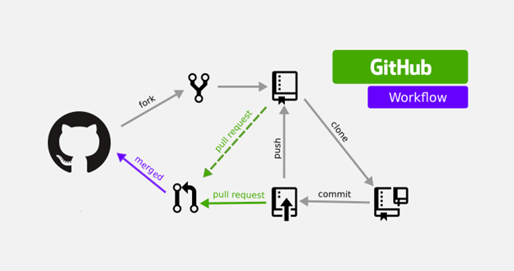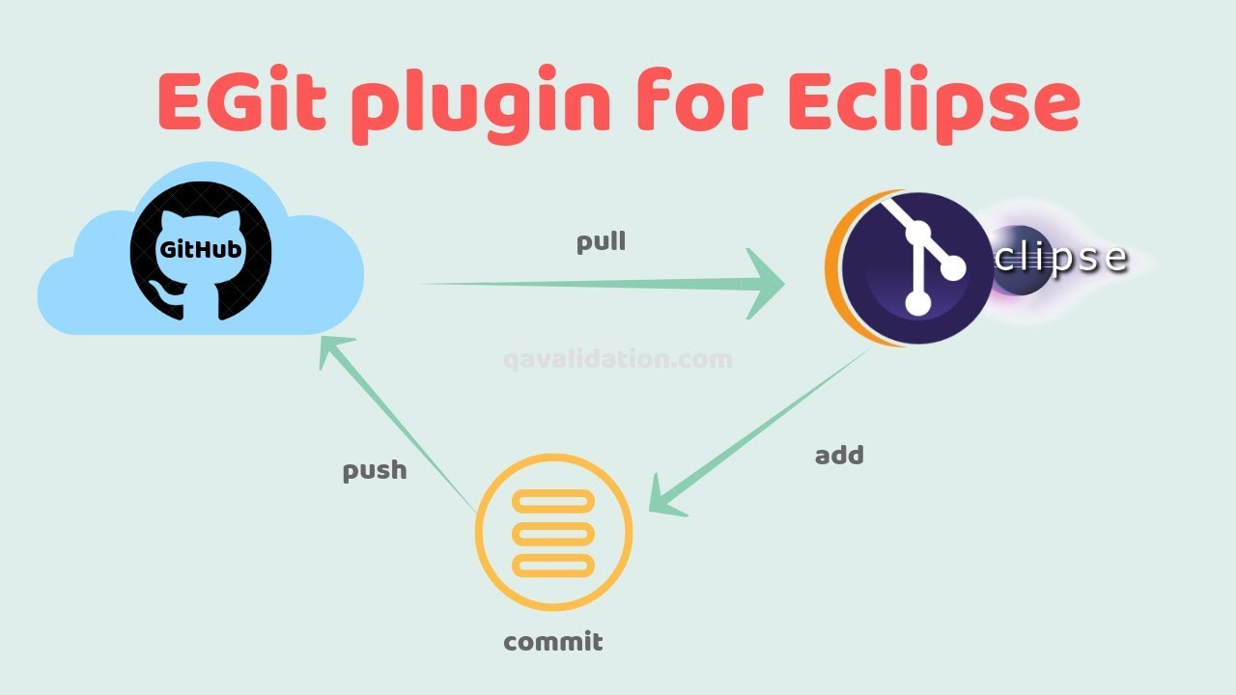

View and check collaborator code

Github upload code Owner

Upload

updated codes Access the Owner code

collaborator

<---make repo------

github Owner

| |



Owners create repository/file/Issues/milestones

import repo add code

| |

Eclipse



2. Owners creates maven project

1.Owner copy HTTPS path of repository

(project)



2. Collaborator import the repository project

1.Collaborator copy HTTPS path of repository (created by owner)



Owner pull the collaborator code/work



2. Collaborator import the repository project

1.Collaborator copy HTTPS path of repository (created by owner)

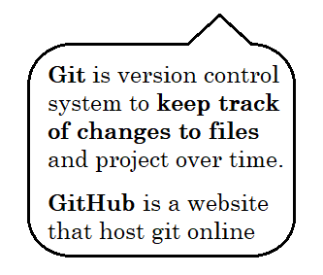

7.Receive updated file (Owner validate that file)

Assign task



5. Push up assign task to GitHub

Assign task Done task

Updated file

1. Owner write a task for collaborator and save all the task

4. Collaborator done the assign task and save all the task.

3. Pull down all the task (which is assign by owner to collaborator) to collaborator eclipse

2. Push up all the saved task from owner eclipse



**Owner**



**Collaborator**



------ >

6. Pull down the updated file



Received Updated file