Loans Controller
Loans Url Controller
Loans/show
Loans/loan_url_form
Routes

******************************8
Id=13, 24, 29

http://localhost/CPC/diversified_html/index.php?r=sls/loan/viewDueDiligence&id=188

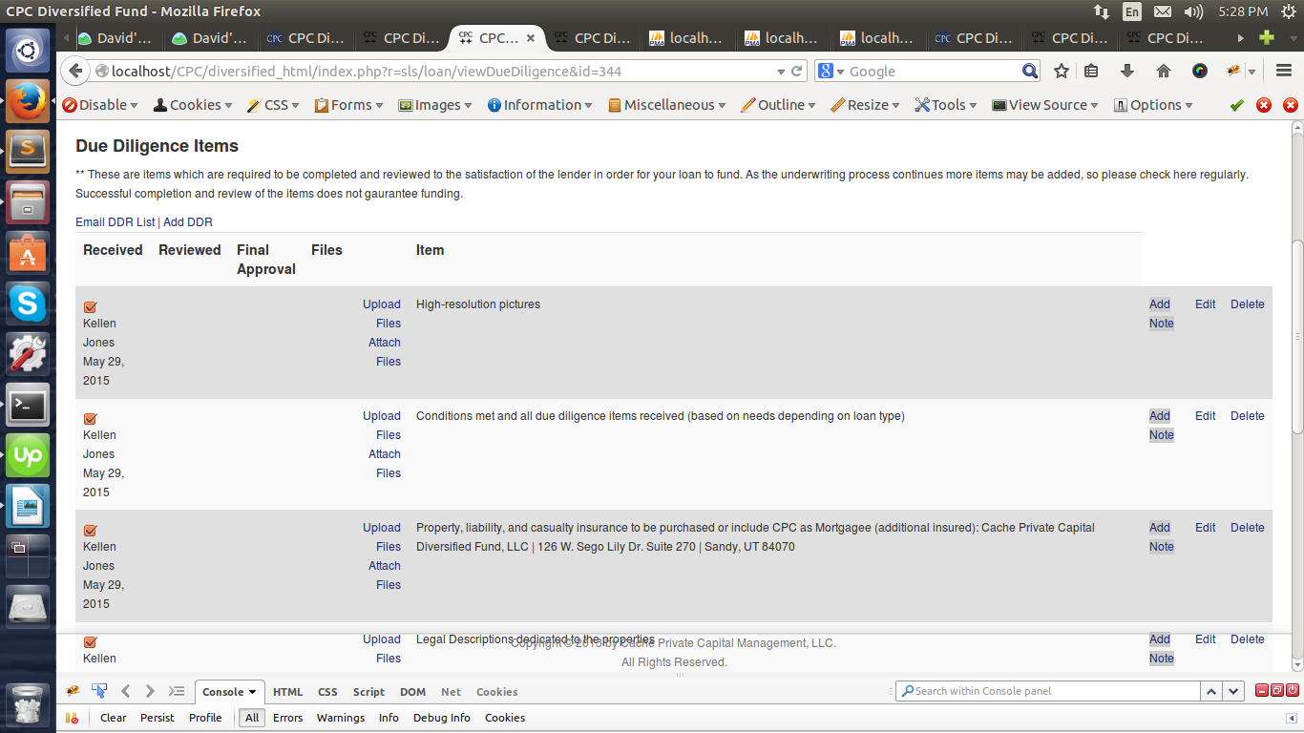
In order to mark it complete

