**MANUFACTURING EXECUTION SYSTEM OF**

**MACHINE PRODUCTION INDUSTRY**

**A MINI PROJECT REPORT**

***Submitted by***

**PRITIKAA.S (211422104356)**

***in partial fulfillment for the award of the degree***

***of***

**BACHELOR OF ENGINEERING**

***in***

**COMPUTER SCIENCE AND ENGINEERING**



**PANIMALAR ENGINEERING COLLEGE**

**(An Autonomous Institution, Affiliated to Anna University, Chennai)**

**NOVEMBER 2024**

**ACKNOWLEDGEMENT**

We express our deep gratitude to our respected Secretary and Correspondent **Dr.P.CHINNADURAI, M.A., Ph.D.** for his kind words and enthusiastic motivation, which inspired us a lot in completing this project.

We would like to extend our heartfelt and sincere thanks to our Directors

**Tmt. C. VIJAYARAJESWARI , Dr. C . SAKTHIKUMAR , M.E. , Ph.D.,** and **Tmt. SARANYASREE SAKTHIKUMAR B.E.,M.B.A.,** for providing us with the necessary facilities for completion of this project.

We also express our gratitude to our Principal **Dr.K.Mani, M.E., Ph.D.,** for his timely concern and encouragement provided to us throughout the course.

We thank the HOD of CSE Department , **Dr. L. JABA SHEELA, M.E.,Ph.D.** for the support extended throughout the project.

We would like to thank my Project Guide **Mrs.M,Dhivya ,M.TECH.** and all the faculty members of the Department of CSE for their advice and suggestions for the successful completion of the project.

**NAME OF THE STUDENT**

**PRITIKAA.S (211422104356)**

**Organizational History and Structure**

Panimalar Engineering College, a Christian Minority Institution of Higher Education governed by JAISAKTHI Educational Trust aims at imparting quality engineering education for the aspiring youth. The College is accredited by National Board of Accreditation (NBA), New Delhi, approved by All India Council for Technical Education (AICTE) and recognized by UGC with 12(B) & 2(f) status. The college is located near Poonamallee, Chennai, and is well connected by road covering, Chennai, Kancheepuram and Thiruvallur districts. The Trust started Panimalar Engineering College in the year 2000 in accordance with the general policy of the Government of Tamil Nadu. The policy emphasizes to give high priority to meet the demand for trained engineers for various industrial and development projects in the state of Tamil Nadu and the rest of India.

This sprawling campus provides a holistic education in an ambience that makes no compromise on discipline, dedication and commitment. It strives to inculcate the spirit of learning in the campus offering state of art facilities to the students. The college ensures that the students, who pass out of the college, turn out to be academically brilliant, morally upright and empowered individuals.

**Vision**

To transform the budding engineers into academically excellent, highly intellectual and self-disciplined engineering graduates to mould them as good citizens with the spirit of integrity and morality that would cater to the needs of our nation.

**Mission**

To impart quality education with high standards of excellence in engineering and technology, to provide an excellent infrastructure in a serene and conductive atmosphere that would motivate the students in their pursuit of knowledge in the field of engineer and technology.

TABLE OF CONTENTS

| **CHAPTER NO.** | **TITLE** | **PAGE NO.** |
| --- | --- | --- |
| **1.** | **ABSTRACT** | 1 |
| **2.** | **PROBLEM STATEMENT** | 2 |
| **3.** | **INTRODUCTION** | 3 |
| **4.** | **EXISTING METHODS** | 4 |
|  | 4.1 Disadvantages |  |
| **5.** | **PROPOSED WORK** | 5 |
|  | 5.1 Advantages |  |
| **6.** | **SYSTEM REQUIREMENTS** | 6 |
|  | 6.1 Hardware requirements |  |
|  | 6.2 Software requirements |  |
| **7.** | **SYSTEM ARCHITECTURE** | 7 |
|  | 7.1 Architecture overview |  |
|  | 7.2 Description of the modules |  |
| **8.** | **SYSTEM DESIGN** | 11 |
|  | 8.1 Use case diagram |  |
|  | 8.2 Class diagram |  |
|  | 8.3 Sequence diagram |  |
|  | 8.4 Collaboration diagram |  |
| **9.** | 8.5 Deployment diagram  8.6 Data flow diagram  8.7 Entity relationship diagram  **SYSTEM IMPLEMENTATION** | 20 |
|  | 9.1 Client-side coding |  |
|  | 9.2 Server-side coding |  |
| **10.** | **SYSTEM TESTING** | 34 |
|  | 10.1 Test Cases  10.2 Performance Analysis |  |
| **11.** | **CONCLUSION** | 40 |
|  | 11.1 Future Enhancements |  |
| **12.** | **APPENDICES** | 43 |
|  | 12.1 Sample Screenshots |  |
| **13.** | **REFERENCES** | 49 |

**1. ABSTRACT**

Internet has converted a world into a global village. With the popularization of internet, online import and export has become a new and unique trend. From Machine to electronics, all the things are available on internet.

Keeping up this trend, a need for the store is felt because it can enhance the existing system even more. Consumers do not even need to go to a local store anymore; they can buy each and everything by just sitting in a home at anytime.

It is fast, simple, and flexible. The Import and Export is based on B2C business model. The consumer is provided with the facility of registering, signing in, viewing and ordering the items and secured online transaction.

The consumers may give feedbacks and comments regarding each and every product as well. HTML/CSS, JAVASCRIPT and JAVA are used to build the basic framework of web pages. MySQL is used for storing information about the consumer and vendors (sellers). Keywords: Import and Export store, e-commerce, shopping cart, web store.

**2.PROBLEM STATEMENT**

Industries today face significant challenges in managing production data, ensuring operational efficiency, and maintaining security and compliance. These existing problems hinder effective delivery and operational effectiveness, underscoring the need for innovative solutions.

This can lead to a number of problems, including:

1. The company faces frequent and unpredictable production downtime due to equipment failures and inadequate maintenance practices, leading to increased costs and production delays.
2. Inconsistent product quality results in high defect rates and rework, negatively impacting customer satisfaction and increasing production expenses.
3. Problems with vendor reliability and inefficient inventory management cause delays in acquiring essential components and materials, further disrupting production schedules.
4. The lack of integrated data systems hinders the company’s ability to effectively analyze and utilize production data, limiting insights into operational performance and predictive maintenance.
5. Current production workflows are not optimized, resulting in bottlenecks and resource waste, which decreases overall operational efficiency and productivity.

**3.INTRODUCTION**

In the Machinery retailing industry, due to the prevalence of digital technology and e-commerce, multiple companies have added an online channel to complement their traditional/offline in-store portfolio of offerings. These are known as multiple-channel retailers or ‘bricks and clicks’ retailers. Others have entered the Machinery industry by offering their products online with an e-fulfilment option in-stores only, at dedicated sites only, or a combination of both in-stores and dedicated sites. These are known as pure online or ‘clicks’ retailers. The term Machinery retailers was coined to refer to these companies (Hays, Keskinocak, & de López, 2005). In recent years, some of these organizations have reported a significant increase in their e-grocery channel market share. For instance, in the United Kingdom (UK), in 2016, Ocado increased its market share from 12% to 14% .Similarly, multichannel traders such as: Tesco's online Machinery market share of 35% surpassed its offline share of 28.4%; Sainsbury's 15% online Machinery market share trailed its offline market share by 1.8%; Asda/Walmart showed a difference of 5.2% between its online and offline Machinery market share . Some of the biggest challenges Machinery retailers face is that of order fulfilment and last mile delivery, especially while offering customers a seamless service experience. The issues retailers have to deal with include where orders should be fulfilled, what logistics solutions should be adopted in the last mile delivery (e.g., customer pick-up vs attended or unattended delivery at home), coping with the perishable nature of items and their different handling requirements, the size of the shopping Machinery the range of product offerings , the geographical market reach, the increasing importance of customers receiving their orders the same day and within a shorter order-to-delivery cycle, and the opportunities for synergies offered by the offline and online channels, or within a pure online channel .

**4.EXISTING METHODS**

In this existing system the popularization of internet has encouraged E-commerce as well. E-commerce (Electronic Commerce) is nothing but the selling or buying of the goods and services online. The main objective of e-commerce is to provide a hassle-free and enhanced shopping experience. It has not only replaced the traditional way of store but also provided the comfort and ease to shop from your desk. Consumers don’t have to go to stores during restricted timings; they can buy almost everything at anytime from anywhere. It provides one window-multi vendor retail.

* The ability to shop from home or anywhere with an internet connection means consumers can avoid the inconvenience of store hours and travel time.
* E-commerce has effectively replaced the need for physical stores by offering a comprehensive online shopping experience. This transformation offers a modern alternative to traditional retail.
* The ability to shop from one’s desk or any convenient location provides a significant comfort advantage. This ease of access enhances the overall shopping experience by minimizing physical effort and time.

**4.1 DISADVANTAGES**

**1.** Site crash

**2.** No possibility of tried and tested product

**3.** Some products are difficult to buy online

**4.** Lack of privacy

**5. PROPOSED WORK**

Our aim at developing an Import and Export store having simple and easy to use interface and secured transaction. It will provide convenience to consumer.It is user- friendly and easy to use for both consumers and vendors.The consumers are allowed to give feedbacks about any item. The consumers are also allowed to modify their carts individually. They can add/remove Machinery item.

Java will be used as the primary programming language, facilitated by NetBeans for efficient development and coding. SQLyog Community will handle database management, offering advanced tools for SQL querying and optimization.

**5.1 ADVANTAGES**

1. Scalability and reliability through cloud computing.

2. Enhanced security and transparency with blockchain.

3. Efficient development using Java and NetBeans.

4. Optimized database management with SQLyog Community.

5. Improved customer interactions and modernized digital experience.

1. **SYSTEM REQUIREMENTS**

Software needs include the Java Development Kit (JDK) and NetBeans IDE for development, SQLyog Community for database management. Hardware should include reliable network infrastructure and servers with adequate CPU, memory, and storage. Users need compatible web browsers and accounts with appropriate permissions for various roles, while development and testing environments should be separated from production.

* 1. **HARDWARE REQUIREMENTS**
* System : Pentium IV 2.4 GHz.
* Hard Disk : 40 GB.
* Floppy Drive : 1.44 Mb.
* Monitor : 15 VGA Colour.
* Mouse : Logitech.
* Ram : 4 GB
  1. **SOFTWARE REQUIREMENTS**
* Operating system : Windows 7/10.
* Coding Language : JAVA
* Data Base : MYSQL
* IDE : NetBeans 8.0.1

1. **SYSTEM ARCHITECTURE**

**7.1 ARCHITECTURE OVERVIEW**



Fig 1. Architecture Diagram

The architecture diagram for the machine production company's website outlines a streamlined system integrating various components to ensure efficient operations. The front-end interface enables users to interact with the system, while the back-end server manages business logic and processes data requests. A robust database stores critical information, including product details, orders, and user profiles. Secure authentication mechanisms safeguard user access, and a notification system provides real-time updates on order statuses and deliveries. Additionally, the integration of a payment gateway facilitates secure financial transactions, enhancing overall system reliability and user experience.

**7.2 DESCRIPTION OF THE MODULES**

1. **MODULE:**

* **Login:**

Login the account with correct user name and the passwordView Profile

* **View all the employee**:

Add the employee with the basic information

If we don’t want this employee means delete, If we need made some changes means edit, and make enable means view.

* **Add employee salary :**

View all the employee and update the salary amount for the particular employee

* **Add the product:**

Add the product with the full details

* **View all the Machinery items:**

If we dont't want this product means delete, If we need made some changes means edit, and make enable means view.

* **New orders by the customer:**

View all the new orders and assign the works to delivery boy.

* **View all the assign work status**

View the status of all tasks across different roles within the system.

* **Logout.**

Securely exit the system to protect data.

1. **DELIVERY BOY OR EMPLOYEE MODULE:**

* **Login:**

Login the account with correct username and the password.

* **View Profile:**

View their own profile.

* **Put the attendance details:**

Mark the attendance for the current day.

* **View all the salary details:**

View salary amount and withdraw the amount.

* **View status:**

View all assigned works and uploaded status by the admin.

* **Logout:**

Securely exit the system to protect personal information.

1. **CUSTOMER MODULE:**

* **Register:**

Register the account with basic information.

* **Login:**

Login the account with the correct user’s name and password.

* **View Profile:**

View their own profile and update information.

* **Add to cart:**

View the menu of products available in the Machinery store, add to cart.

* **Delivery:**

If you want choose online payment means, enter your bank details and the cash on delivery.

* **Order Status:**

View all the order status and track the shipping process.

* **Transaction History:**

View all your transaction detail. Once the product is delivered, you can view the complete process.

* **Logout:**

Securely exit the system to protect sensitive information.

**8. SYSTEM DESIGN**

The feasibility of the project is analyzed in this phase and business proposal is put forth with a very general plan for the project and some cost estimates. This is to ensure that the proposed system is not a burden to the company.

At the heart of the system is a web-based interface that provides customers, employees and admin with intuitive access to various functionalities from any internet-enabled device. This interface is developed using Java, facilitated by the NetBeans Integrated Development Environment (IDE), which streamlines the coding process and enhances development efficiency. For managing and optimizing database operations, the system employs SQLyog Community, a powerful tool that supports advanced SQL querying, indexing, and overall database management. Security and data integrity are paramount, which is why the system integrates blockchain technology to handle medical records and transactions. This technology enhances trust and accountability in data handling, critical for maintaining the integrity of industry records. The system is hosted on a cloud infrastructure, which offers scalability and reliability, accommodating varying workloads and ensuring high availability. Cloud computing allows for flexible resource management, providing the necessary computational power and storage capacity as needed.

To protect sensitive information, the system uses AES (Advanced Encryption Standard) for encryption. AES is a highly secure encryption algorithm that protects data both in transit and at rest, ensuring that customer information and product records remain confidential and secure against unauthorized access. This encryption, coupled with secure cloud hosting and blockchain technology, forms a robust security framework designed to meet the demanding needs of modern industry environments. This comprehensive design aims to enhance operational efficiency, improve data security, and provide a modern, reliable digital experience for all users.

**8.1 USE CASE DIAGRAM**

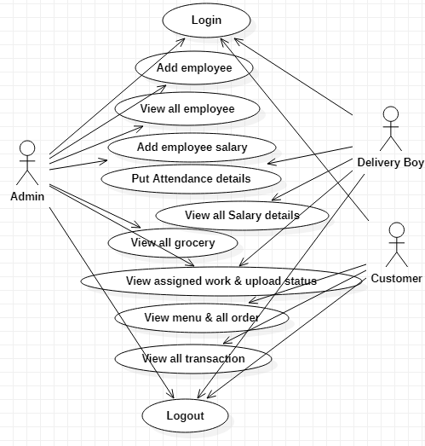

Fig 2. Use Case Diagram

The use case diagram for the manufacturing execution system illustrates the interactions between different user roles—admin, delivery boy, customer. Customers can , view product details, shopping cart and make transactions, while delivery boy or employee can update personal information and manage work status and checks his salary. Administrators oversee customer accounts and system operations, ensuring data security and compliance. This diagram provides a clear overview of how customers interact with the system and the key processes involved.

**8.2 CLASS DIAGRAM**

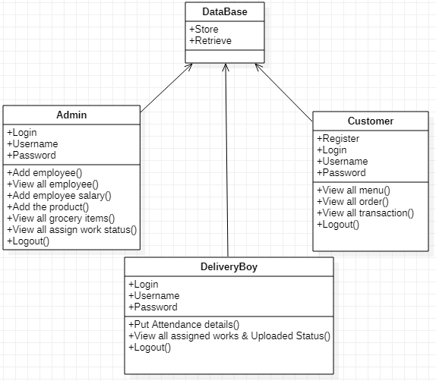

Fig 3. Class Diagram

The class diagram for the manufacturing execution system outlines the main classes and their relationships. The class diagram includes four key components: Admin, Customer, Delivery Boy, and Database. The Admin class manages system operations such as product and order management and interacts with the Database to store and retrieve relevant data. The Customer class handles product browsing, order placement, and tracking, with all activities recorded in the Database. The Delivery Boy class oversees delivery tasks, updating delivery statuses and viewing assigned orders, also through the Database. This setup ensures efficient coordination between users and data management, enabling seamless operation and interaction across different roles within the system. This diagram provides a structured view of the system's data and its interactions.

**8.3 SEQUENCE DIAGRAM**

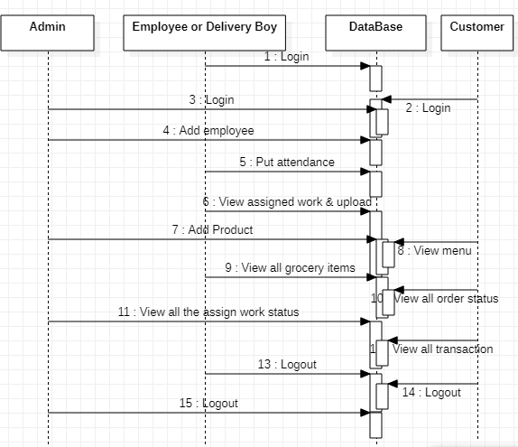

Fig 4. Sequence Diagram

The sequence diagram for the machine execution system details the interactions between users and the system over time. The sequence diagram for the machine production company’s website depicts interactions among Admin, Customer, Delivery Boy, and Database. When an Admin adds a new product, they send the product details to the Database, which then updates its records and returns a confirmation. A Customer browsing the catalog requests product information from the Database, which responds with the relevant details. If the Customer places an order, the Database records the order and confirms receipt. The Delivery Boy retrieves their delivery assignments from the Database and updates the delivery status, which the Database reflects in real-time. This diagram illustrates how these components communicate to handle tasks efficiently and maintain system operations

**8.4 COLLABORATION DIAGRAM**

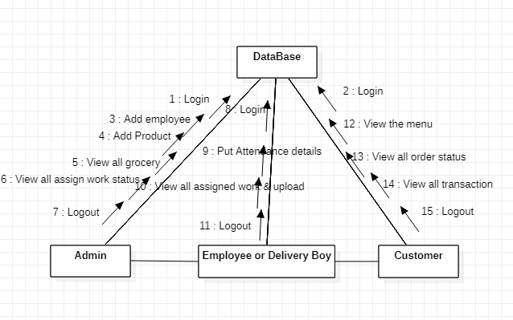

Fig 5. Collaboration Diagram

The collaboration diagram for the machine execution system shows the interactions between various objects and their relationships during a process. The collaboration diagram outlines how Admin, Customer, and Delivery Boy interact through the Database, which acts as the central data repository. It demonstrates how these components communicate with each other to manage and process various tasks. The Admin oversees system functions, while Customers place orders and Delivery Boys update delivery statuses. The diagram highlights the flow of information and the interdependencies between these roles, ensuring a streamlined and efficient operational process within the system.

**8.5 DEPLOYMENT DIAGRAM**

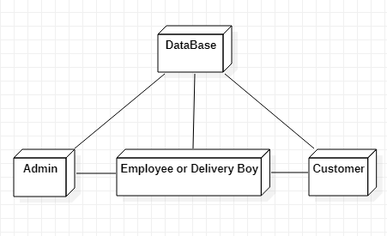

Fig 6. Deployment Diagram

The deployment diagram for the machine execution system illustrates the physical setup of the system's components across different servers. It shows how Admin, Customer, and Delivery Boy interact with the application through various hardware and software nodes. It highlights how the Database is deployed on a server and connected to the application, which is accessible via web interfaces for different user roles. The diagram details the distribution of components across servers, network connections, and the physical infrastructure that supports the system. It emphasizes the deployment of software and hardware to ensure seamless operation and communication among users.

**8.6 DATA FLOW DIAGRAM**

**LEVEL 0:**

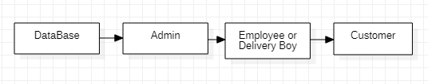

Fig 7. DFD Level 0

**LEVEL 1:**

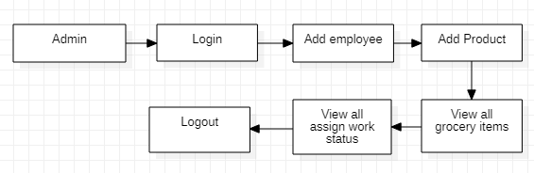

Fig 8. DFD Level 1

**LEVEL 2:**

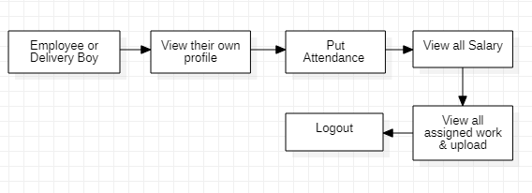

Fig 9. DFD Level 2

**LEVEL 3:**

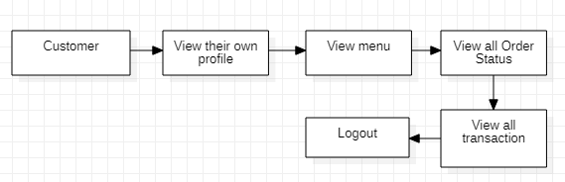

Fig 10. DFD Level 3

The data flow diagram for the machine execution system outlines the movement of information through the system, detailing how data is exchanged between Admin, Customer, Delivery Boy, and the Database. It shows how Customers interact with the system by placing orders and updating their profiles, with all data being captured and stored in the Database. Delivery Boys update the statuses of deliveries, which are also recorded and managed in the Database. The Admin accesses this central repository to oversee and manage all system data, including product information, order details, and user accounts. The diagram illustrates the seamless flow of data between these components, highlighting how information is processed, stored, and retrieved, ensuring efficient system operations and accurate data management.

**8.7 ENTITY RELATIONSHIP DIAGRAM**

Employee or Delivery Boy

Data Base

Customer

Admin

Fig 11. Entity Relationship Diagram

The Entity-Relationship (ER) diagram illustrates the data structure of the system by defining various entities and their relationships. It shows how different entities admin, delivery boy ,customer and database are interconnected and how they interact with one another. The diagram maps out how data is organized, including how entities are related through specific attributes and associations. It provides a clear view of how data flows between these entities, ensuring efficient data management and integrity within the system. The ER diagram serves as a blueprint for understanding the underlying data architecture and relationships.

**9. SYSTEM IMPLEMENTATION**

**9.1 CLIENT-SIDE CODING (FRONT END)**

<!DOCTYPE html>

<html>

<head>

<title>Import & Export Management System</title>

<!-- for-mobile-apps -->

<meta name="viewport" content="width=device-width, initial-scale=1">

<meta http-equiv="Content-Type" content="text/html; charset=utf-8" />

<meta name="keywords" content="Grocery Store Responsive web template, Bootstrap Web Templates, Flat Web Templates, Android Compatible web template,

Smartphone Compatible web template, free webdesigns for Nokia, Samsung, LG, SonyEricsson, Motorola web design" />

<script type="application/x-javascript"> addEventListener("load", function() { setTimeout(hideURLbar, 0); }, false);

function hideURLbar(){ window.scrollTo(0,1); } </script>

<!-- //for-mobile-apps -->

<link href="css/bootstrap.css" rel="stylesheet" type="text/css" media="all" />

<link href="css/style.css" rel="stylesheet" type="text/css" media="all" />

<!-- font-awesome icons -->

<link href="css/font-awesome.css" rel="stylesheet" type="text/css" media="all" />

<!-- //font-awesome icons -->

<!-- js -->

<script src="js/jquery-1.11.1.min.js"></script>

<!-- //js -->

<link href='//fonts.googleapis.com/css?family=Ubuntu:400,300,300italic,400italic,500,500italic,700,700italic' rel='stylesheet' type='text/css'>

<link href='//fonts.googleapis.com/css?family=Open+Sans:400,300,300italic,400italic,600,600italic,700,700italic,800,800italic' rel='stylesheet' type='text/css'>

<!-- start-smoth-scrolling -->

<script type="text/javascript" src="js/move-top.js"></script>

<script type="text/javascript" src="js/easing.js"></script>

<script type="text/javascript">

jQuery(document).ready(function($) {

$(".scroll").click(function(event){

event.preventDefault();

$('html,body').animate({scrollTop:$(this.hash).offset().top},1000);

});});

</script>

<!-- start-smoth-scrolling -->

</head>

<body>

<!-- header -->

<div class="agileits_header">

<div class="w3l_offers">

<a href="#"> B.R.J Precisions </a>

</div>

<div class="w3l_search">

<form action="#" method="post"><input type="text" name="Product" value="Search a product..." onfocus="this.value = '';" onblur="if (this.value == '') {this.value = 'Search a product...';}" required="">

<input type="submit" value=" ">

</form>

</div>

<div class="product_list_header">

<form action="#" method="post" class="last">

<fieldset>

<input type="hidden" name="cmd" value="_cart" />

<input type="hidden" name="display" value="1" />

</fieldset> </form>

</div>

<div class="w3l_header_right1">

<h2><a href="#">Contact Us</a></h2>

</div>

<div class="clearfix"> </div>

</div>

<!-- script-for sticky-nav -->

<script>

$(document).ready(function() {

var navoffeset=$(".agileits_header").offset().top;

$(window).scroll(function(){

var scrollpos=$(window).scrollTop();

if(scrollpos >=navoffeset){

$(".agileits_header").addClass("fixed");

}else{

$(".agileits_header").removeClass("fixed");}

});});

</script>

<!-- //script-for sticky-nav -->

<div class="logo_products">

<div class="container">

<div class="w3ls_logo_products_left">

<h1><a href="index.html"><span style="font-weight: bold;">Import &</span>Export<span style="font-weight: bold; font-size:14px;">System</span></a></h1>

</div>

<div class="w3ls_logo_products_left1">

<ul class="phone_email" style="font-weight: bold; font-family: cursive;">

<li><i class="fa fa-phone" aria-hidden="true" style="font-weight: bold;"></i>044-2624-4753</li>

<li><i class="fa fa-envelope-o" aria-hidden="true" style="font-weight: bold;"></i><a href="#">machinesbrj@gmail.com</a></li>

</ul>

</div>

<div class="clearfix"> </div>

</div>

</div>

<!-- //header -->

<!-- banner -->

<div class="banner">

<div class="w3l_banner_nav_left">

<nav class="navbar nav_bottom">

<!-- Brand and toggle get grouped for better mobile display -->

<div class="navbar-header nav_2">

<button type="button" class="navbar-toggle collapsed navbar-toggle1" data-toggle="collapse" data-target="#bs-megadropdown-tabs">

<span class="sr-only">Toggle navigation</span>

<span class="icon-bar"></span>

<span class="icon-bar"></span>

<span class="icon-bar"></span>

</button> </div>

<div class="collapse navbar-collapse" id="bs-megadropdown-tabs">

<ul class="nav navbar-nav nav_1">

<li><a href="AddEmply.jsp">Add Employee</a></li>

<li><a href="Viewempy.jsp">View Employee</a></li>

<li><a href="Addsalar.jsp">Add Salary</a></li>

<li><a href="Addfood.jsp">Add Item</a></li>

<li><a href="Viewitem.jsp">View,Edit,Delete,Enable</a></li>

<li><a href="Vieworder.jsp"> New Order& Assign Work</a></li>

<li><a href="Viewtransaction.jsp">View all Assign Work Detail</a></li>

<li><a href="index.jsp">Logout</a></li>

</ul>

</div></div>

<div class="w3l_banner_nav_right">

<section class="slider">

<div class="w3_login" style="margin-right : 200px;">

<h3 align="center" style="color: red; font-family:cursive;">Add Employee</h3>

<div class="w3_login_module">

<div class="module form-module">

<div class="toggle"><i class="fa fa-times fa-pencil"></i>

</div>

<div class="form">

<h2>Create an account for Delivery Boy</h2>

<form action="Register_Action1" method="post" enctype="multipart/form-data">

<strong style="font-weight: 5px;">Profile</strong><input type="file" name="image" placeholder="Profile" required=" "><br>

<input type="text" name="sno" placeholder="Customer ID" required=" ">

<input type="text" name="user" placeholder="Customer name" required=" ">

<input type="password" name="pass" placeholder="Password" required=" "> <input type="email" name="email" placeholder="Email Address" required=" "> <input type="text" name="mobile" placeholder="Phone Number" required=" "> <input type="text" name="dob" placeholder="DOB" required=" ">

<input type="text" name="ano" placeholder="Account Number" required=" ">

<input type="text" name="ifsc" placeholder="IFSC Code" required=" ">

<input type="text" name="micr" placeholder="MICR Number" required=" ">

<input type="text" name="brach" placeholder="Brach Name" required=" ">

<textarea name="address" placeholder="Address" required=" "></textarea>

<input type="submit" value="Add">

</form>

</div>

</div>

</div>

</section>

<!-- flexSlider -->

<link rel="stylesheet" href="css/flexslider.css" type="text/css" media="screen" property="" />

<script defer src="js/jquery.flexslider.js"></script>

<script type="text/javascript">

$(window).load(function(){

$('.flexslider').flexslider({

animation: "slide",

start: function(slider){

$('body').removeClass('loading');

} });});

</script>

<!-- //flexSlider -->

</div>

<div class="clearfix"></div>

</div>

<!-- banner -->

<!-- //footer -->

<!-- Bootstrap Core JavaScript -->

<script src="js/bootstrap.min.js"></script>

<script>

$(document).ready(function(){

$(".dropdown").hover(

function() {

$('.dropdown-menu', this).stop( true, true ).slideDown("fast");

$(this).toggleClass('open');

},

function() {

$('.dropdown-menu', this).stop( true, true ).slideUp("fast");

$(this).toggleClass('open');

} );

});

</script>

<!-- here stars scrolling icon -->

<script type="text/javascript">

$(document).ready(function() {

var defaults = {

containerID: 'toTop', // fading element id

containerHoverID: 'toTopHover', // fading element hover id

scrollSpeed: 1200,

easingType: 'linear'

};

$().UItoTop({ easingType: 'easeOutQuart' });});

</script>

<!-- //here ends scrolling icon -->

<script src="js/minicart.js"></script>

<script>

paypal.minicart.render();

paypal.minicart.cart.on('checkout', function (evt) {

var items = this.items(),

len = items.length,

total = 0,

i;

// Count the number of each item in the cart

for (i = 0; i < len; i++)

{

total += items[i].get('quantity');

}

if (total < 3) {

alert('The minimum order quantity is 3. Please add more to your shopping cart before checking out');

evt.preventDefault();

}

}

);

</script>

</body>

</html>

**9.2 SERVER-SIDE CODING (BACK END)**

/*

SQLyog Community v12.02 (32 bit)

MySQL - 5.5.29 : Database - canteen

*******************************************************/

/*!40101 SET NAMES utf8 */;

/*!40101 SET SQL_MODE=''*/;

/*!40014 SET @OLD_UNIQUE_CHECKS=@@UNIQUE_CHECKS, UNIQUE_CHECKS=0 */;

/*!40014 SET @OLD_FOREIGN_KEY_CHECKS=@@FOREIGN_KEY_CHECKS, FOREIGN_KEY_CHECKS=0 */;

/*!40101 SET @OLD_SQL_MODE=@@SQL_MODE, SQL_MODE='NO_AUTO_VALUE_ON_ZERO' */;

/*!40111 SET @OLD_SQL_NOTES=@@SQL_NOTES, SQL_NOTES=0 */;

CREATE DATABASE /*!32312 IF NOT EXISTS*/`canteen` /*!40100 DEFAULT CHARACTER SET latin1 */;

USE `canteen`;

/*Table structure for table `attendance` */

DROP TABLE IF EXISTS `attendance`;

CREATE TABLE `attendance` (

  `reg` varchar(200) DEFAULT NULL,

  `sanme` varchar(200) DEFAULT NULL,

  `times` varchar(200) DEFAULT NULL,

  `dates` varchar(200) DEFAULT NULL,

  `atten` varchar(200) DEFAULT NULL

) ENGINE=InnoDB DEFAULT CHARSET=latin1;

/*Data for the table `attendance` */

insert  into `attendance`(`reg`,`sanme`,`times`,`dates`,`atten`) values ('4','niki','09:50 AM','2024-07-17','1');

/*Table structure for table `dregister` */

DROP TABLE IF EXISTS `dregister`;

CREATE TABLE `dregister` (

  `id` int(11) NOT NULL AUTO_INCREMENT,

  `simage` varchar(200) DEFAULT NULL,

  `sno` varchar(200) DEFAULT NULL,

  `sname` varchar(200) DEFAULT NULL,

  `pass` varchar(200) DEFAULT NULL,

  `mail` varchar(200) DEFAULT NULL,

  `mobile` varchar(200) DEFAULT NULL,

  `dob` varchar(200) DEFAULT NULL,

  `ano` varchar(200) DEFAULT NULL,

  `ifsc` varchar(200) DEFAULT NULL,

  `brach` varchar(200) DEFAULT NULL,

  `micr` varchar(200) DEFAULT NULL,

  `address` varchar(200) DEFAULT NULL,

  `status` varchar(200) DEFAULT 'Enable',

  `tcost` varchar(200) DEFAULT NULL,

  `atten` varchar(200) DEFAULT '0',

  KEY `id` (`id`)

) ENGINE=InnoDB AUTO_INCREMENT=5 DEFAULT CHARSET=latin1;

/*Data for the table `dregister` */

insert  into `dregister`(`id`,`simage`,`sno`,`sname`,`pass`,`mail`,`mobile`,`dob`,`ano`,`ifsc`,`brach`,`micr`,`address`,`status`,`tcost`,`atten`) values (4,'emirates (2).jpg','123','niki','niki','niki@gmail.com','9987654321','12/12/2222','20385728380723','IbIc3478652','chennai','123','chennai','Enable',' 15000','0');

/*Table structure for table `food` */

DROP TABLE IF EXISTS `food`;

CREATE TABLE `food` (

  `id` int(11) NOT NULL AUTO_INCREMENT,

  `fno` varchar(200) DEFAULT NULL,

  `fimage` varchar(200) DEFAULT NULL,

  `fname` varchar(200) DEFAULT NULL,

  `fdes` varchar(200) DEFAULT NULL,

  `cost` varchar(200) DEFAULT NULL,

  `ready` varchar(200) DEFAULT NULL,

  `status` varchar(200) DEFAULT 'Enable',

  KEY `id` (`id`)

) ENGINE=InnoDB AUTO_INCREMENT=6 DEFAULT CHARSET=latin1;

/*Data for the table `food` */

insert  into `food`(`id`,`fno`,`fimage`,`fname`,`fdes`,`cost`,`ready`,`status`) values (5,'123','download.jpg','machine','manual machine','12000','1','Enable');

/*Table structure for table `orders` */

DROP TABLE IF EXISTS `orders`;

CREATE TABLE `orders` (

  `id` int(11) NOT NULL AUTO_INCREMENT,

  `sid` varchar(200) DEFAULT NULL,

  `sname` varchar(200) DEFAULT NULL,

  `fimage` varchar(2000) DEFAULT NULL,

  `fname` varchar(200) DEFAULT NULL,

  `fdes` varchar(200) DEFAULT NULL,

  `cost` varchar(200) DEFAULT NULL,

  `ready` varchar(200) DEFAULT NULL,

  `pay` varchar(200) DEFAULT NULL,

  `qan` varchar(200) DEFAULT NULL,

  `totcost` varchar(200) DEFAULT NULL,

  `address` varchar(2000) DEFAULT NULL,

  `status` varchar(200) DEFAULT NULL,

  PRIMARY KEY (`id`)

) ENGINE=InnoDB AUTO_INCREMENT=5 DEFAULT CHARSET=latin1;

/*Data for the table `orders` */

/*Data for the table `ordertran` */

insert  into `ordertran`(`id`,`sid`,`sname`,`fimage`,`fname`,`fdes`,`cost`,`ready`,`pay`,`qan`,`totcost`,`address`,`bank`,`brach`,`ifsc`,`exp`,`status`) values (2,'123','niki','download.jpg','machine','manual machine','12000','1','Online_Payment','2','null','chennai','Indian Bank','chennai','IbIc3478652','12/24','Waiting');

/*Table structure for table `register` */

DROP TABLE IF EXISTS `register`;

CREATE TABLE `register` (

  `id` int(200) NOT NULL AUTO_INCREMENT,

  `sno` varchar(200) DEFAULT NULL,

  `simage` varchar(200) DEFAULT NULL,

  `sname` varchar(200) DEFAULT NULL,

  `pass` varchar(200) DEFAULT NULL,

  `mail` varchar(200) DEFAULT NULL,

  `mobile` varchar(200) DEFAULT NULL,

  `dob` varchar(200) DEFAULT NULL,

  `address` varchar(200) DEFAULT NULL,

  PRIMARY KEY (`id`)

) ENGINE=InnoDB AUTO_INCREMENT=4 DEFAULT CHARSET=latin1;

/*Data for the table `register` */

insert  into `register`(`id`,`sno`,`simage`,`sname`,`pass`,`mail`,`mobile`,`dob`,`address`) values (3,'123','emirates (2).jpg','niki','123','niki@gmail.com','9987654321','12/12/2222','chennai');

/*!40101 SET SQL_MODE=@OLD_SQL_MODE */;

/*!40014 SET FOREIGN_KEY_CHECKS=@OLD_FOREIGN_KEY_CHECKS */;

/*!40014 SET UNIQUE_CHECKS=@OLD_UNIQUE_CHECKS */;

/*!40111 SET SQL_NOTES=@OLD_SQL_NOTES */;

1. **. SYSTEM TESTING**

The purpose of testing is to discover errors. Testing is the process of trying to discover every conceivable fault or weakness in a work product. It provides a way to check the functionality of components, sub-assemblies, assemblies and/or a finished product It is the process of exercising software with the intent of ensuring that the

Software system meets its requirements and user expectations and does not fail in an unacceptable manner. There are various types of test. Each test type addresses a specific testing requirement.

**10.1 TEST CASES**

**UNIT TESTING:**

Unit testing involves the design of test cases that validate that the internal program logic is functioning properly, and that program inputs produce valid outputs. All decision branches and internal code flow should be validated. It is the testing of individual software units of the application .it is done after the completion of an individual unit before integration. This is a structural testing, that relies on knowledge of its construction and is invasive. Unit tests perform basic tests at component level and test a specific business process, application, and/or system configuration.

Unit tests ensure that each unique path of a business process performs accurately to the documented specifications and contains clearly defined inputs and expected results.

**Test strategy and approach:**

**Test objectives:**

* All field entries must work properly.
* Pages must be activated from the identified link.
* The entry screen, messages and responses must not be delayed.

**Features to be tested:**

* Verify that the entries are of the correct format
* No duplicate entries should be allowed
* All links should take the user to the correct page.

**INTEGRATION TESTING:**

Integration tests are designed to test integrated software components to determine if they actually run as one program. Testing is event driven and is more concerned with the basic outcome of screens or fields. Integration tests demonstrate that although the components were individually satisfaction, as shown by successfully unit testing, the combination of components is correct and consistent. Integration testing is specifically aimed at exposing the problems that arise from the combination of components.

Software integration testing is the incremental integration testing of two or more integrated software components on a single platform to produce failures caused by interface defects.The task of the integration test is to check that components or software applications, e.g. components in a software system or – one step up – software applications at the company level – interact without error.

**Test Results:** All the test cases mentioned above passed successfully. No defects encountered.

**FUNCTION TESTING:**

Functional tests provide systematic demonstrations that functions tested are available as specified by the business and technical requirements, system documentation, and user manuals.

Functional testing is centered on the following items:

Valid Input : identified classes of valid input must be accepted.

Invalid Input : identified classes of invalid input must be rejected.

Functions : identified functions must be exercised.

Output : identified classes of application outputs must be exercised.

Systems/Procedures: interfacing systems or procedures must be invoked.

Organization and preparation of functional tests is focused on requirements, key functions, or special test cases. In addition, systematic coverage pertaining to identify Business process flows; data fields, predefined processes, and successive processes must be considered for testing. Before functional testing is complete, additional tests are identified and the effective value of current tests is determined.

**SYSTEM TESTING:**

System testing ensures that the entire integrated software system meets requirements. It tests a configuration to ensure known and predictable results. An example of system testing is the configuration-oriented system integration test. System testing is based on process descriptions and flows, emphasizing pre-driven process links and integration points.

**WHITE BOX TESTING:**

White Box Testing is a testing in which in which the software tester has knowledge of the inner workings, structure and language of the software, or at least its purpose. It is purpose. It is used to test areas that cannot be reached from a black box level.

**BLACK BOX TESTING:**

Black Box Testing is testing the software without any knowledge of the inner workings, structure or language of the module being tested. Black box tests, as most other kinds of tests, must be written from a definitive source document, such as specification or requirements document, such as specification or requirements document. It is a testing in which the software under test is treated, as a black box. you cannot “see” into it. The test provides inputs and responds to outputs without considering how the software works.

**ACCEPTANCE TESTING:**

User Acceptance Testing is a critical phase of any project and requires significant participation by the end user. It also ensures that the system meets the functional requirements.

**Test Results:**

All the test cases mentioned above passed successfully. No defects encountered.

**10.2 PERFORMANCE ANALYSIS**

The performance analysis of the web application developed for a machine production industry using cloud technology and Java demonstrates its effectiveness in streamlining operations across different user roles, including delivery personnel, administrators, and customers. By utilizing cloud infrastructure, the application achieves enhanced scalability and reliability, allowing it to handle varying workloads seamlessly. During peak demand periods, such as during product launches or promotional events, the cloud services can dynamically allocate resources, ensuring high availability and consistent performance without degradation in service quality.

The modular architecture of the application is a critical factor in its performance. Each module—delivery boy, admin, and customer—operates independently yet interacts in real-time to provide a cohesive user experience. For instance, the delivery boy module allows for efficient route optimization and real-time tracking of shipments, significantly improving delivery times. The admin module facilitates inventory management and order processing, providing insightful analytics that help optimize production schedules. Meanwhile, the customer module enhances user engagement by offering a streamlined interface for order placement, status tracking, and customer support.

Java’s performance capabilities further bolster the application’s efficiency, allowing it to process complex data and execute multiple tasks simultaneously with minimal latency. The language's robustness and extensive libraries provide the necessary tools for handling business logic, ensuring smooth interactions among modules. Furthermore, Java's inherent security features help safeguard sensitive data, establishing a secure environment for transactions and communications.

In addition to performance optimization, the cloud application architecture supports continuous integration and deployment (CI/CD), enabling rapid updates and feature enhancements without disrupting service. This adaptability is crucial in a dynamic market environment, where responsiveness to customer feedback and changing demands is essential for success.

To further enhance performance, the application can employ caching mechanisms to reduce database load and speed up data retrieval for frequently accessed information. Implementing load balancers ensures even distribution of incoming traffic, preventing bottlenecks and improving overall system responsiveness. Additionally, comprehensive monitoring and analytics tools provide insights into system performance, allowing for proactive identification and resolution of potential issues before they impact users.

Overall, the integration of cloud services with Java technology delivers a high-performing, efficient, and reliable web solution tailored to the specific needs of the machine production industry. This approach not only enhances operational efficiency but also positions the business for scalable growth in a competitive market. As the industry evolves, this robust architecture will provide the foundation for future innovations and enhancements, ensuring the application remains relevant and effective.

**11. CONCLUSION**

The development of the software includes so many people like user system developer, user of the system and the management, It is important to identify the system requirements by properly collecting required data to interact with the system. Proper design builds upon this foundation give a blue print, which is actually implemented by the developers. On realizing the importance of the systematic documentation all the processes are implemented using a software engineering approach. Working in a live environment enables one to appreciate the intricacies involved in the System Development Life Cycle (SDLC)). In one place we can get Everything for the Customer comfort.

In conclusion, the development of a web application for the machine production industry utilizing cloud technology and Java represents a transformative step towards achieving operational excellence and superior customer satisfaction. This solution addresses the unique challenges faced by the industry by providing a scalable and reliable platform that can adapt to varying workloads and user demands. By harnessing the power of cloud computing, the application offers unparalleled availability and performance, ensuring that stakeholders, including delivery personnel, administrators, and customers, can interact seamlessly and efficiently.

The modular design of the application enhances collaboration among the different user roles, allowing for real-time communication and streamlined workflows. The delivery boy module facilitates efficient logistics and tracking, ensuring timely deliveries, while the admin module provides critical insights for effective inventory management and production planning. Meanwhile, the customer module empowers users with an intuitive interface for placing orders and receiving updates, thereby enhancing the overall user experience and fostering customer loyalty.

Furthermore, Java’s robustness ensures that the application can handle complex data processing tasks while maintaining high performance and security standards. This is particularly important in an industry where data integrity and confidentiality are paramount. The implementation of caching strategies and load balancing not only improves response times but also contributes to a smoother user experience, mitigating the risk of service interruptions during peak demand.

Moreover, the adoption of continuous integration and deployment practices allows for rapid iteration and enhancement of the application. This agility is essential for staying competitive in a fast-evolving market, where responsiveness to customer feedback and technological advancements can significantly impact business success. Comprehensive monitoring and analytics capabilities provide valuable insights into application performance, enabling proactive management and timely adjustments to optimize operations further.

In summary, this web application serves as a robust foundation for the machine production industry, fostering improved communication, operational efficiency, and customer engagement. As the industry continues to evolve, the integration of cloud services and Java technology will enable businesses to not only keep pace with market demands but also drive innovation and growth. Ultimately, this strategic investment in technology positions the machine production industry for sustained success, allowing it to navigate future challenges while capitalizing on emerging opportunities.

**11.1 FUTURE ENHANCEMENTS**

A store of the future this includes dwell sensing, RFID, heavy investments in the data lake, and the logic needed to map the customer journey. But technology is only one piece of the puzzle; solving the operations equation also involves analytics, new store processes, and upskilling the store team. Such a transformation can add several points of profitability to the average store.

In supply chain, we identify the measures successful companies have taken, which include fundamentally transforming their supply chain to enable a true omnichannel experience, taking more agile approaches when designing their supply chain network, building new capabilities, and adjusting their operating model. We take a look at how retailers can keep up with customer expectations as omnichannel shopping becomes the new normal—including building and maintaining a connected inventory strategy, which increases transparency and access to stock wherever it sits in the supply chain to better fulfill customer needs.

In procurement, we explore the unrealized opportunity in indirect spending—spend on goods or services not for resale. Companies can and should take a closer look at indirect spending and embed new processes and ways of working—including using more sophisticated analytics tools, strengthening supplier collaboration, and taking a broader, business-level view of indirect spend, rather than making it simply a procurement issue. Retailers that elevate indirect spending initiatives can cut costs, capture more value, and uncover cash that can be reinvested as part of a broader business transformation.

**12. APPENDICES**

**12.1 SAMPLE SCREENSOTS**

**HOME PAGE**

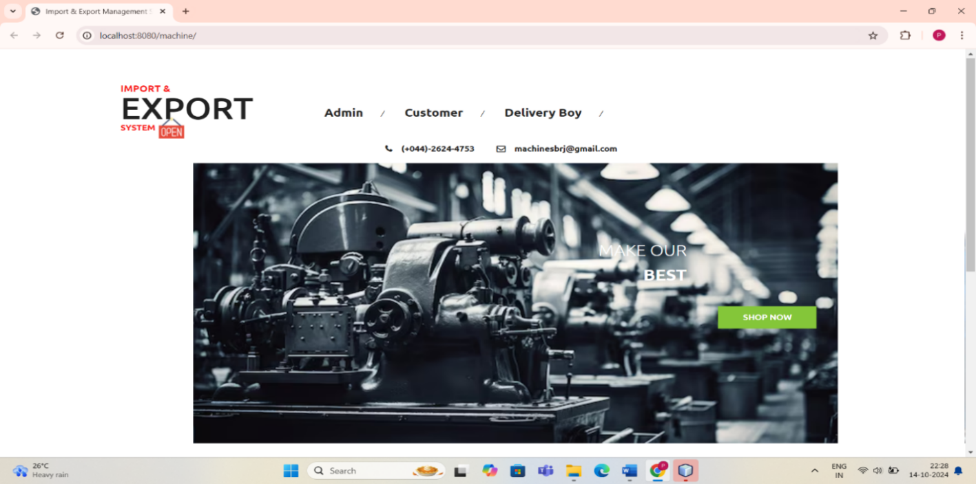

Fig 12. Home page screenshot

**ADMIN LOGIN PAGE**

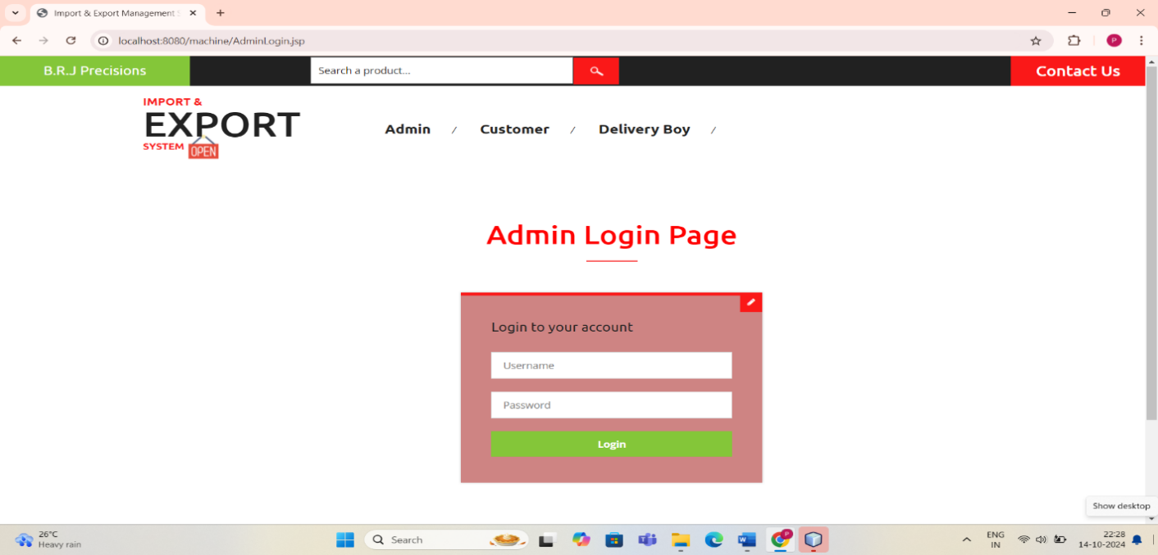

Fig 13. Admin login page screenshot

**ADMIN PROFILE PAGE**

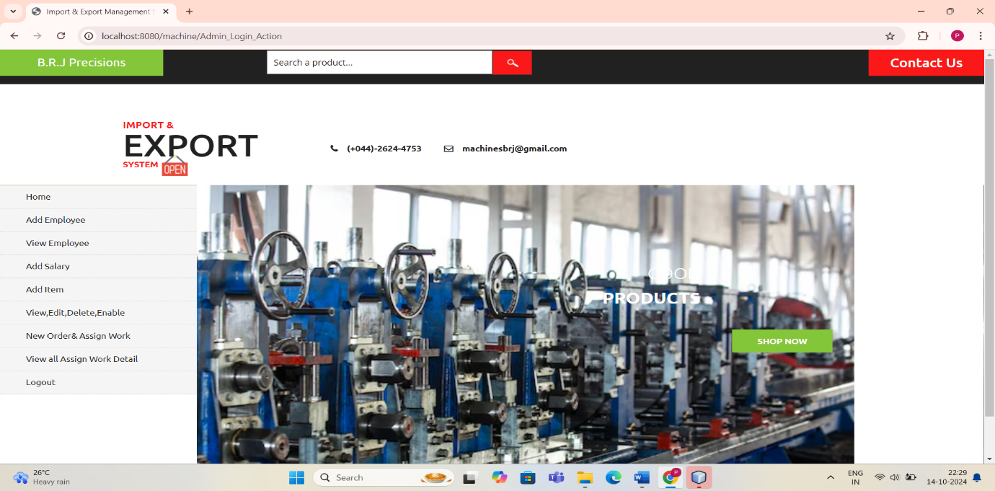

Fig 14. Admin profile page screenshot

**ADD EMPLOYEE PAGE**

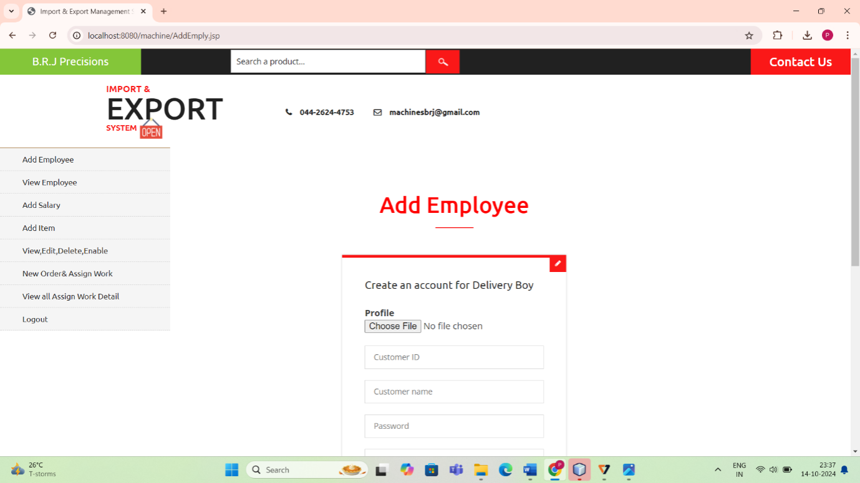

Fig 15. Add employee page screenshot

**ADD MACHINERY ITEM PAGE**

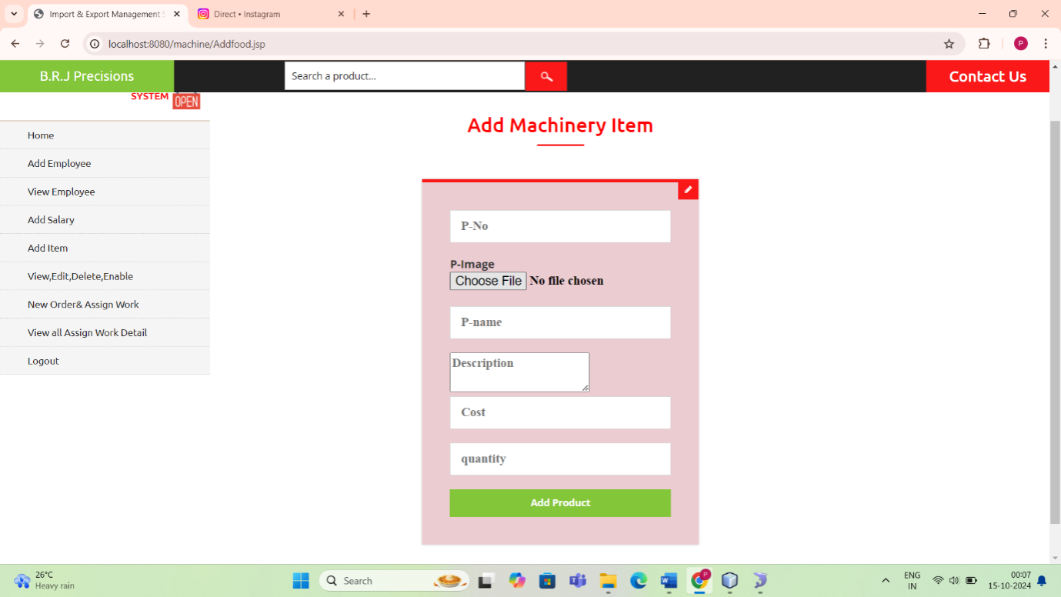

Fig 16. Add machinery item page screenshot

**CUSTOMER REGISTRATION PAGE**

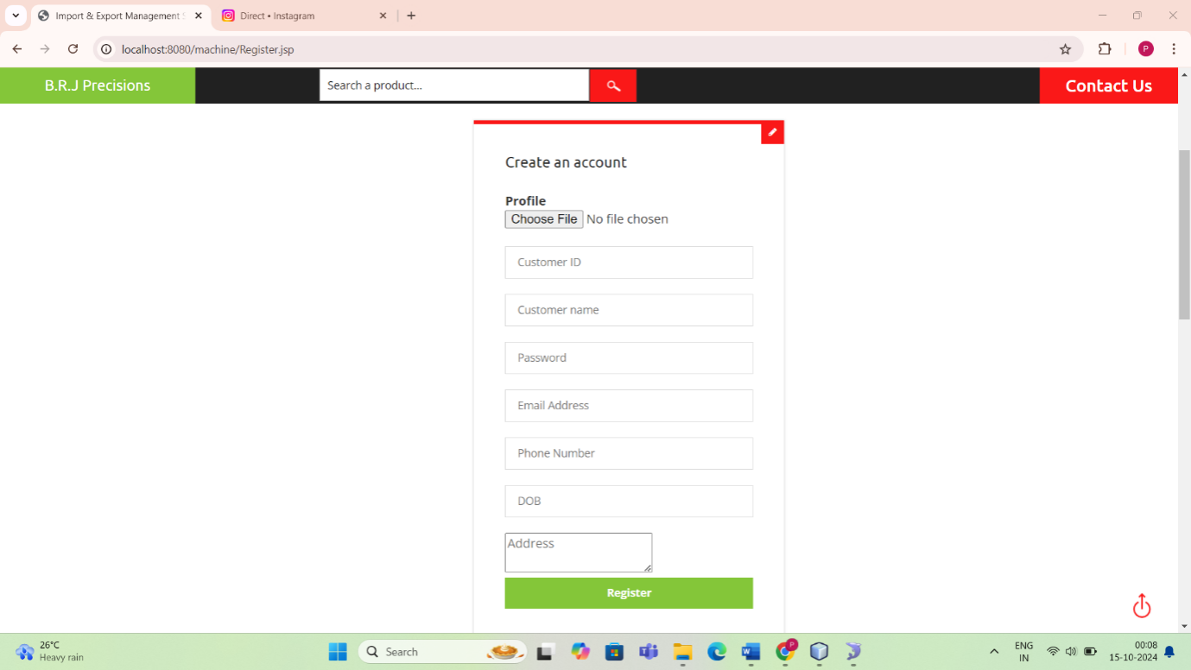

Fig 17. Customer Registration page screenshot

**CUSTOMER LOGIN PAGE**

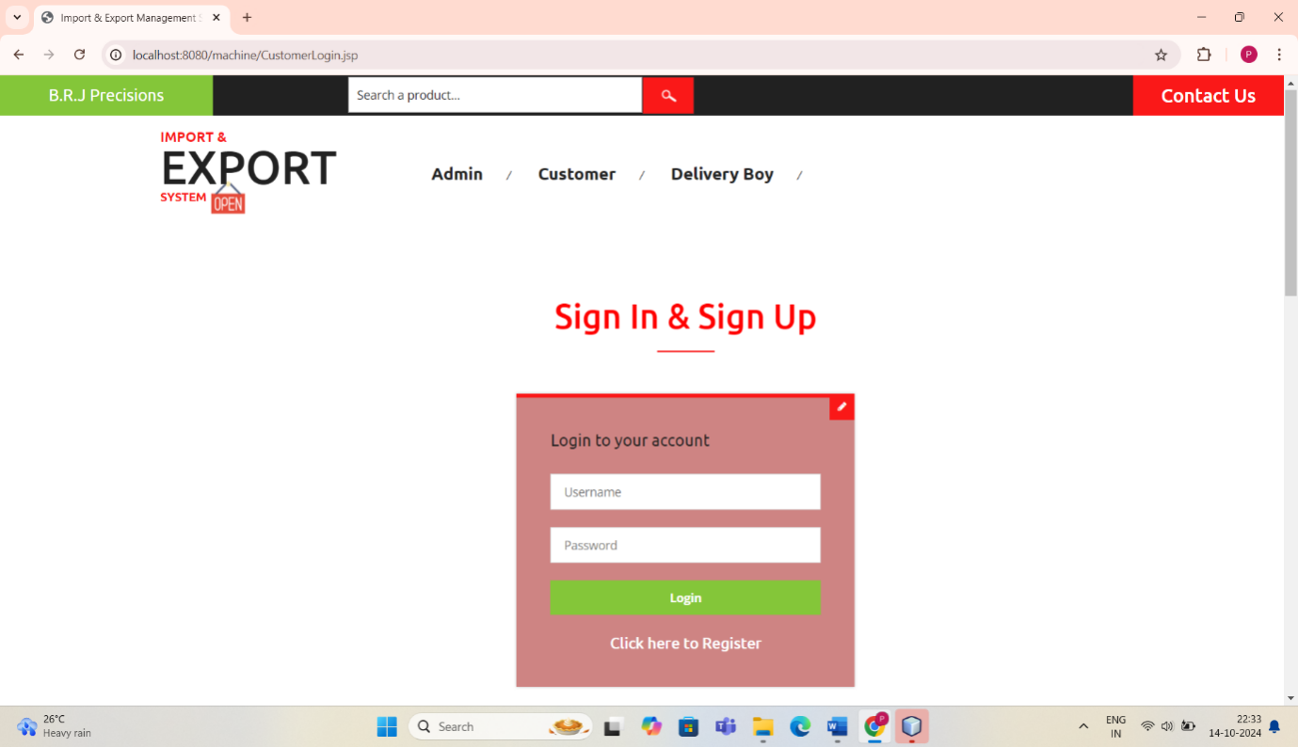

Fig 18. Customer login page screenshot

**CUSTOMER MENU PAGE**

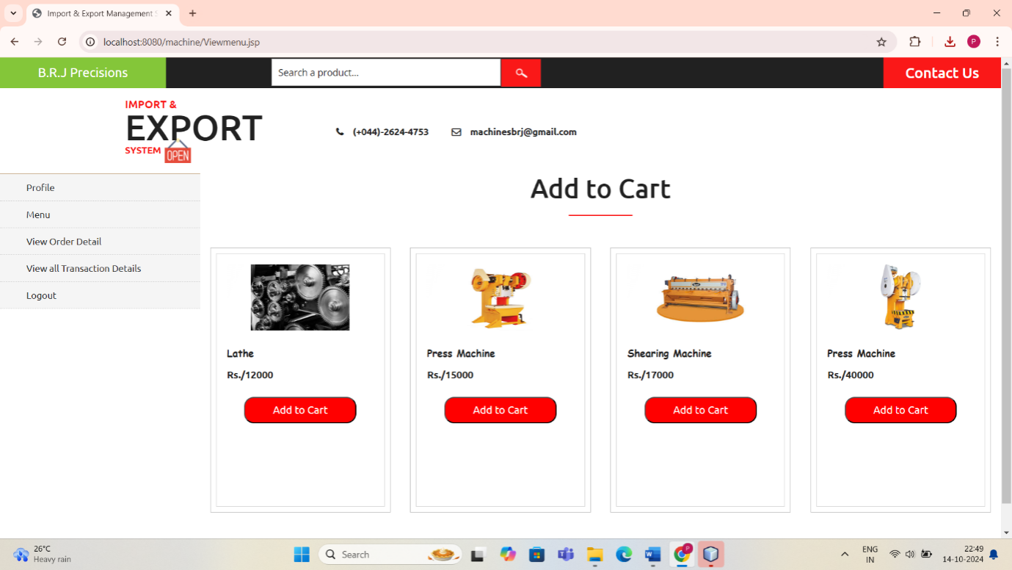

Fig 19. Customer menu page screenshot

**CUSTOMER ORDER STATUS PAGE**

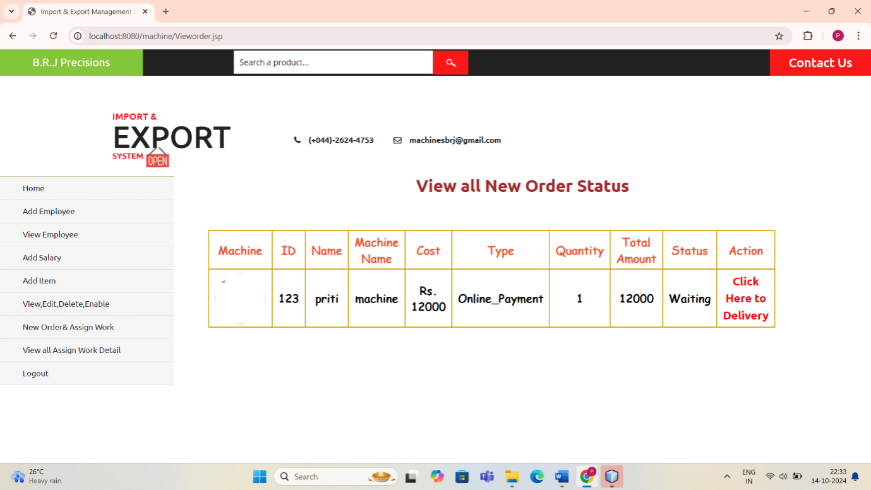

Fig 20. Customer order status page screenshot

**DELIVERY BOY LOGIN PAGE**

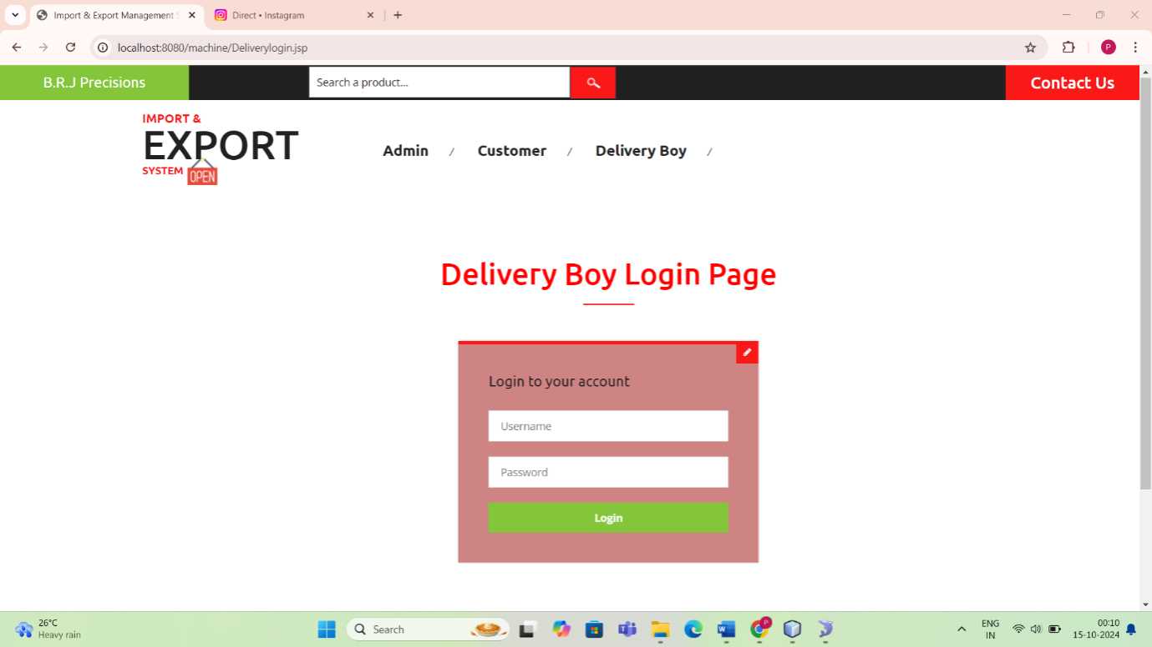 Fig 21. Delivery boy login page screenshot

**DELIVERY BOY PROFILE PAGE**

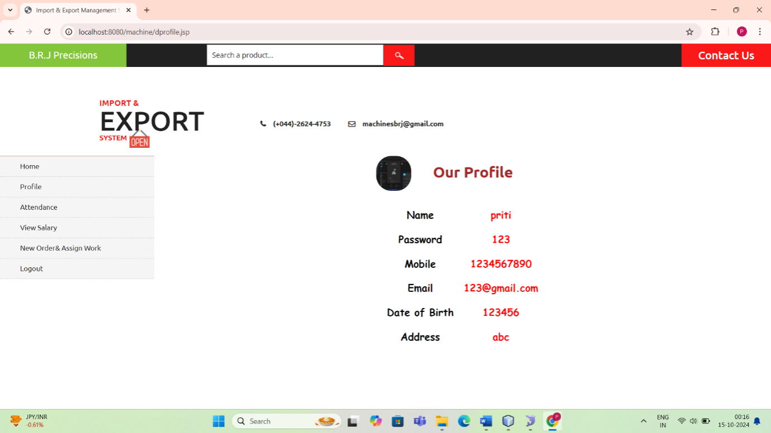 Fig 22. Delivery boy profile page screenshot

**DELIVERY BOY ATTENDANCE PAGE**

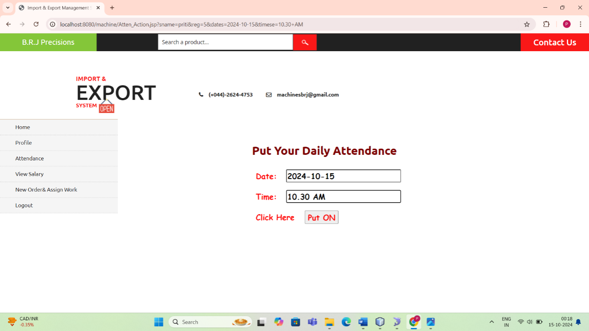 Fig 23. Delivery boy attendance page screenshot

**13. REFERENCES**

[1] Bergeron, F. and Begin, C.: “The use of Critical Success Factors on Evaluation of Information Systems: A case Study,”, Journal of MIS.Vol. 5, No. 4, pp. 111-124

[2] Boyton, A.C. and Zmud, R. W.: “An Assessment of Critical Success Factors”, Sloan Management Review, Vol. 25, No. 4, pp. 17

[3] Croteau, A. M. and Li, P.: “Critical success factors of CRM technological Initiatives”, Canadian Journal of Administration Sciences Halifax: Mar 2003, Vol. 20, No. 1, pp. 21-34.

[4] Daniel, D. R. : “Management Information Crises”, Harvard Business Review, Vol. 39, No. 5, p 111.

[5] Drucker, P. F. . Managing for the Future: The 1990s and Beyond, New York: Truman Talley Books.

[6] Goldsmith, N. : “Linking IT Planning to Business Strategy”, Long Range Planning, Vol. 24, No. 6, pp. 67-77.

[7] Garvin, D.A. : “Building a learning organization”, Harvard Business Review, vol. 71, pp. 78-78.

[8] Gide, E. (1999): “A Model for Successful Implementation of Internet Based Electronic Commerce in Business Operations”, PhD dissertation, University of Technology, Sydney.

[9] Croteau, A. M. and Li, P. (2003): “Critical success factors of CRM technological Initiatives”, Canadian Journal of Administration Sciences Halifax: Mar 2003, Vol. 20, No. 1, pp. 21-34.

[10] Daniel, D. R. (1961): “Management Information Crises”, Harvard Business Review, Vol. 39, No. 5, p 111.

[11] Drucker, P. F. (1992). Managing for the Future: The 1990s and Beyond, New York: Truman Talley Books.

[12] Goldsmith, N. (1991): “Linking IT Planning to Business Strategy”, Long Range Planning, Vol. 24, No. 6, pp. 67-77.

[13] Garvin, D.A. (1993): “Building a learning organization”,Harvard Business Review, vol. 71, pp. 78-78.

[14] Gide, E. (1999): “A Model for Successful Implementation of InternetBased Electronic Commerce in Business Operations”, PhD dissertation, University of Technology, Sydney.

[15] Hall, G, Rosenthal, J and Wade, J. (1993): “How to make Reengineering Really Work”, Harvard Business Review, NovemberDecember, 1993, pp. 119-131.