WEEK 4
Comprehensive Data Science Report
and Insights Presentation Plan
Hypothetical Project: Customer Churn Analysis and Prediction

Data Science Internship
Prepared by: Priti Kumari

Report Overview
This report presents a comprehensive plan for communicating data science insights from a hypothetical Customer Churn Analysis and Prediction project. It consolidates the analytical workflow into an executive-friendly narrative covering the business problem, methodology, hypothetical insights, visual communication, actionable recommendations, presentation strategy, and future work.
All findings, charts, and numerical examples in this report are illustrative planning material. They are not claims about a real telecom dataset or a deployed model. Actual conclusions would require real data, analysis, validation, and business review.

1. Executive Summary
Customer churn is a business problem in which existing customers discontinue a product or service. The purpose of this hypothetical project is to demonstrate how customer information can be analyzed to understand potential churn patterns and translate those patterns into practical retention actions.
The proposed analysis considers customer tenure, contract type, service usage, billing information, payment behavior, and support interactions. The reporting approach combines exploratory analysis with predictive modeling concepts and focuses on communicating findings in a way that can be understood by non-technical stakeholders.
Illustrative insights suggest that flexible contracts, shorter tenure, repeated support interactions, changes in charges, late payments, and declining usage can be useful areas for further investigation. These patterns should be treated as hypotheses until confirmed using real data.

2. Business Problem and Project Purpose
The central business question is: Which customer characteristics and behaviors are associated with higher churn risk, and how can those insights support targeted retention strategies?
- Identify customer attributes and behaviors that may be associated with churn.
- Summarize important patterns using clear visualizations.
- Translate analytical observations into understandable business insights.
- Develop recommendations that can be evaluated by business stakeholders.
- Define a communication structure suitable for executive-level review.
Audience | Information Need
Executives | Business impact, major findings, priorities and decisions.
Retention Team | Customer segments, warning signals and possible actions.
Data/Analytics Team | Methodology, validation, assumptions and limitations.
Product/Service Team | Usage, support and pricing patterns requiring investigation.

3. Dataset and Analytical Context
The hypothetical dataset is organized around customer-level information. The structure is designed to demonstrate how different data categories can contribute to churn analysis.
Category | Example Variables
Customer | Age, region, dependents
Account | Tenure, contract type
Usage | Monthly minutes, data usage, roaming charges
Billing | Monthly charges, total charges
Payment | Payment method, late payments
Support | Support calls, complaints, plan changes
Target | Churn (0/1)

4. Methodology Overview
The methodology follows a structured data science workflow. The objective is not only to produce a prediction but also to create an understandable chain from the business question to evidence and action.
- Define the business problem and analytical objective.
- Collect and understand relevant customer information.
- Check data quality, missing values, duplicates and unusual observations.
- Perform exploratory analysis using univariate, bivariate and multivariate techniques.
- Engineer and select useful features for analysis and modeling.
- Develop and evaluate a suitable classification model.
- Interpret patterns and model outputs using appropriate visualizations.
- Translate findings into business actions and define how success would be monitored.

5. End-to-End Insight Generation Workflow
Business Problem → Data Understanding → Data Preparation → Analysis → Modeling → Evaluation → Insights → Recommendations → Communication

6. Hypothetical Insights and Analysis
The following insights are illustrative examples of the type of findings that would be communicated after analysis. They should not be interpreted as measured results from a real dataset.
Area | Illustrative Insight | Analytical / Business Interpretation
Contract Type | Customers on flexible or month-to-month arrangements may show higher churn tendency because switching barriers can be lower. | Compare churn rates across contract categories and investigate whether contract duration is associated with retention.
Customer Tenure | Newer customers may require additional attention because they have had less time to establish a long-term relationship with the service. | Review early-tenure behavior and strengthen onboarding or early engagement where appropriate.
Support Interactions | Repeated support calls or complaints may indicate dissatisfaction or unresolved service problems. | Create a proactive follow-up process for customers showing repeated support interactions.
Price Changes | Recent increases in charges may be associated with increased churn risk for price-sensitive customers. | Review pricing communication and investigate whether customers understand the value received.
Payment Behavior | Frequent late payments can be a useful signal for further investigation of customer risk. | Consider appropriate payment support or communication rather than treating late payment as proof of churn intent.
Usage Decline | A sustained reduction in usage may indicate declining engagement. | Use declining usage as an early-warning signal for re-engagement analysis.

7. Mock-Up Visualizations
The following charts are mock-ups intended to demonstrate how results could be presented. Their values are illustrative and are included for communication planning rather than as actual findings.
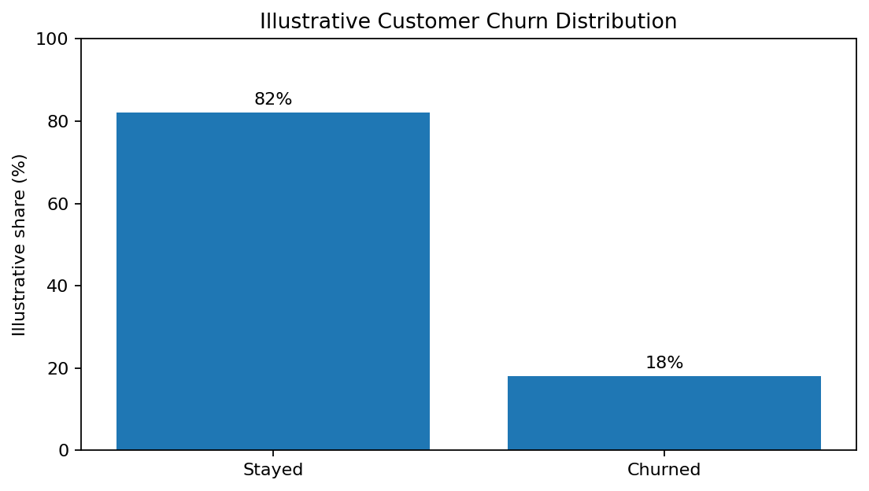
Figure 1. Illustrative customer churn distribution.
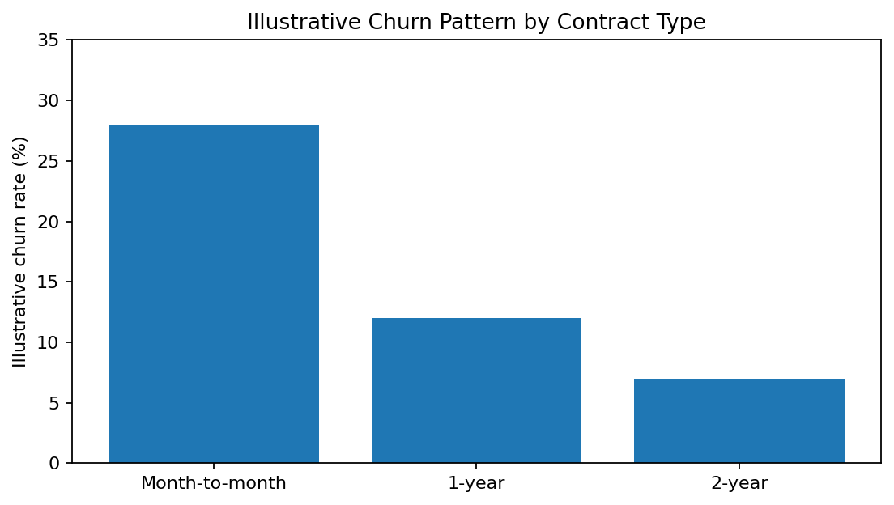
Figure 2. Illustrative churn pattern by contract type.
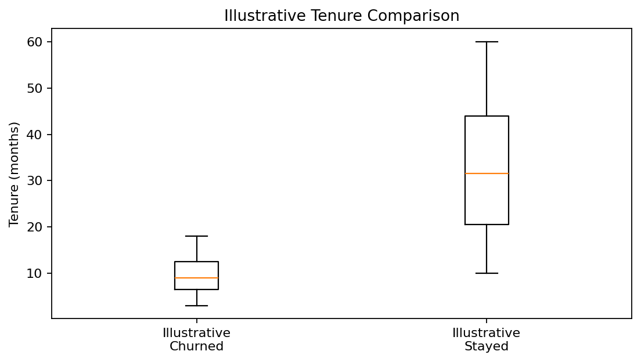
Figure 3. Illustrative tenure comparison between customer groups.
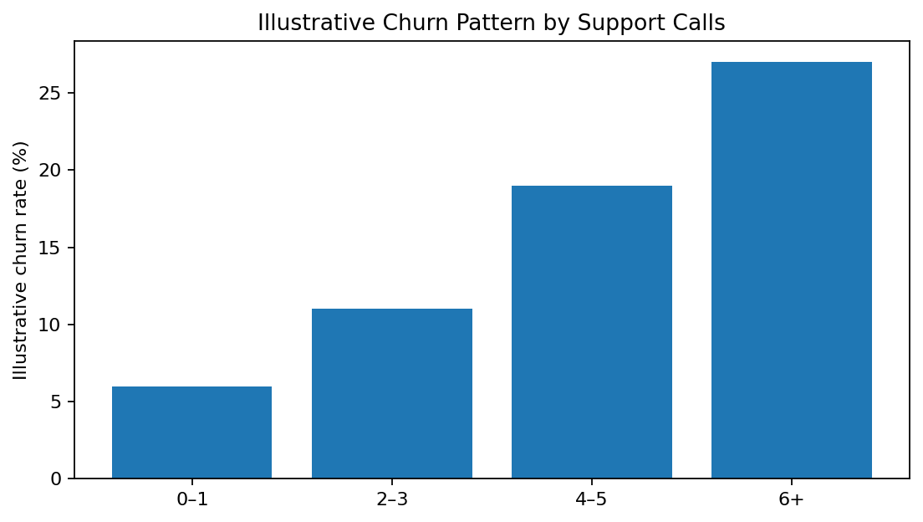
Figure 4. Illustrative churn pattern by support-call frequency.
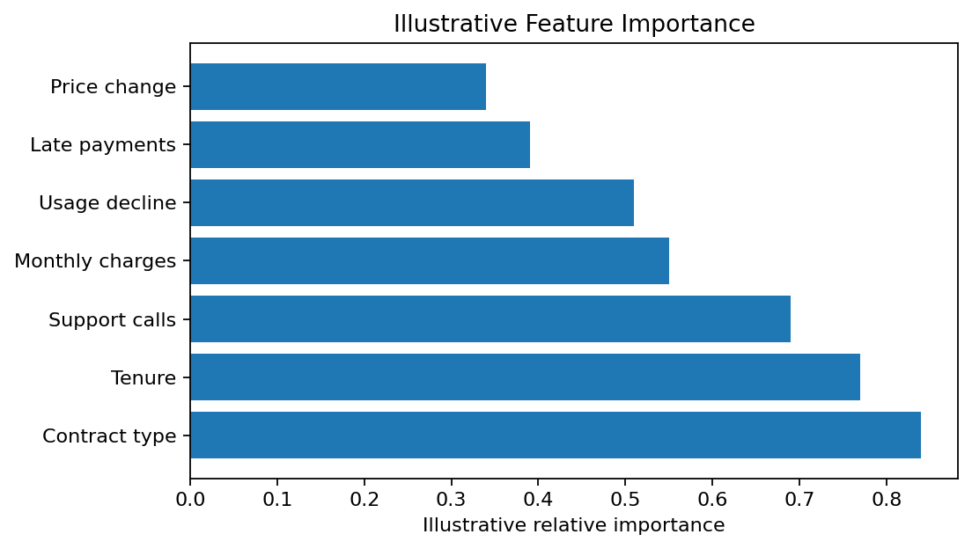
Figure 5. Illustrative relative feature importance.

8. Visualization Strategy and Rationale
Visualization | Purpose | Why It Helps
Churn distribution | Show target balance | Provides immediate context for the audience.
Contract-type bar chart | Compare groups | Makes differences between categories easy to see.
Tenure box plot | Compare distributions | Shows central tendency and spread without excessive detail.
Support-call chart | Show relationship with churn | Connects service interaction with a business question.
Correlation heatmap | Explore numerical relationships | Helps identify relationships and potential redundancy.
Feature-importance chart | Prioritize factors | Converts model information into a simple ranked visual.
Risk segmentation table | Translate analysis into action | Provides a direct bridge from insight to business response.

9. From Insight to Action
Observed / Hypothetical Pattern | Business Meaning | Possible Action
Higher churn tendency in flexible contracts | Lower switching barriers may increase retention risk. | Review suitable retention plans and communication.
Repeated support interactions | May indicate unresolved dissatisfaction. | Prioritize proactive service follow-up.
Declining usage | May indicate reduced engagement. | Design re-engagement interventions for testing.
Recent price change | Price sensitivity may influence retention. | Improve value communication and review pricing response.
Short tenure | Early customer relationship may be less established. | Strengthen onboarding and early engagement.

10. Presentation Strategy for Non-Technical Stakeholders
The presentation should avoid unnecessary technical terminology and focus on the business question, evidence, implications, and actions. Technical methods can be included in supporting material when required.
- Start with the business problem and why it matters.
- Show a small number of clear visuals rather than a large number of technical charts.
- Explain each visual with one key message.
- Connect every important pattern to its possible business meaning.
- Distinguish observed evidence from hypotheses and assumptions.
- Present recommendations only after explaining the evidence behind them.
- End with measurable next steps and how success would be monitored.
For example, instead of saying that a model has improved classification performance, the presentation can explain that the analysis is intended to help the retention team identify customers who may require attention before they leave.

11. Executive Presentation Plan
Slide | Topic | Main Message
1 | Project Title | Customer churn is the central business problem.
2 | Business Problem | Explain why understanding churn matters.
3 | Data Overview | Introduce the customer information used for analysis.
4 | Key Patterns | Show the most important illustrative patterns.
5 | Major Insights | Summarize what the patterns could mean.
6 | Risk Factors | Present important customer characteristics to investigate.
7 | Recommended Actions | Connect insights with practical next steps.
8 | Expected Business Impact | Explain how actions could support retention.
9 | Future Work | Identify validation and improvement activities.
10 | Conclusion | Summarize the message and next decision points.

12. Recommendations
- Prioritize analysis of customers showing multiple potential churn indicators rather than relying on a single variable.
- Investigate repeated complaints and support interactions to identify unresolved service issues.
- Evaluate how pricing changes and customer value communication relate to retention.
- Strengthen onboarding and engagement activities for newer customers.
- Use predictive modeling as decision support and validate recommendations using real business outcomes.
- Create a monitoring framework to measure whether retention interventions are effective.

13. Future Work
- Apply the framework to real customer data after appropriate privacy and governance checks.
- Train and validate the final machine learning model using real historical outcomes.
- Perform time-based validation to test performance on future customer behavior.
- Monitor data drift and model performance after deployment.
- Improve model explainability for business users.
- Test retention strategies and measure actual business impact.
- Periodically retrain the model when customer behavior changes.

14. Limitations and Assumptions
- The project is hypothetical and does not use real customer records.
- Charts and numerical examples are illustrative mock-ups.
- Illustrative patterns must be validated before being treated as business findings.
- Actual model performance cannot be established without training and validation on real data.
- Business recommendations require domain, financial, operational and ethical review.
- Any cost-benefit assumptions would need to be replaced with verified organizational data.

15. Planned Work Timeline – 34 Hours
Phase | Activities | Hours
1 | Executive summary and business problem | 4
2 | Methodology and dataset overview | 4
3 | Hypothetical insights and analysis | 6
4 | Mock visualizations | 6
5 | Insight-to-action recommendations | 4
6 | Non-technical presentation strategy | 4
7 | Future work, limitations and conclusion | 2
8 | Formatting, review and quality check | 4
Total |  | 34

16. Tools and Technologies
Tool | Planned Use
Python | Data analysis and analytical workflow
Pandas / NumPy | Data preparation and numerical analysis
Matplotlib / Seaborn | Charts and statistical visualizations
Scikit-learn | Machine learning and evaluation
Jupyter Notebook | Analysis documentation
Microsoft Word | Final report and presentation plan
Git / GitHub | Version control and project documentation

17. Conclusion
This comprehensive report demonstrates how a data science project can transform customer information into understandable business insights. The proposed structure connects the business problem, analytical methodology, visual evidence, interpretation, recommendations, and presentation strategy.
A successful executive presentation should focus on a small number of clear messages, explain why each finding matters, and connect evidence to practical next steps. Because this project is hypothetical, the mock visualizations and illustrative insights are intended to demonstrate communication and reporting skills rather than claim measured results. With real data, the same framework can be extended through validated analysis, model monitoring, experimentation, and measurement of actual business outcomes.

